PROJECT REPORT
Responsive Landing Page Development
Week 1 Task — Nova Digital Solutions

Technologies Used
HTML5 • CSS3 • Flexbox • CSS Grid • Media Queries • Vanilla JavaScript

Project Deliverables: index.html, style.css, script.js, README.md

1. Executive Summary
This project presents a modern, responsive landing page developed as part of the Week 1 Responsive Landing Page Development task. The objective was to transform a conceptual wireframe into a functional web page using semantic HTML5, modern CSS, and vanilla JavaScript.
The final product, named “Nova”, represents a fictional digital solutions company. The page includes a responsive header, navigation menu, hero section, feature highlights, about section, call-to-action section, and footer. The design adapts to desktop, tablet, and mobile screen sizes while maintaining usability and visual consistency.

2. Project Objectives
- Create an original wireframe and plan the overall landing-page layout.
- Develop the page using semantic HTML5 elements.
- Use modern CSS techniques including Flexbox, CSS Grid, and media queries.
- Create a responsive layout that works across desktop, tablet, and mobile devices.
- Add basic JavaScript interactivity through a responsive hamburger menu.
- Implement smooth scrolling and active navigation highlighting.
- Maintain clean, organized, readable, and commented source code.
- Test the final page at different viewport sizes.

3. Project Concept
Nova is a fictional modern digital-solutions brand designed to demonstrate the principles of responsive web development. The visual style uses a clean layout, strong typography, card-based components, subtle shadows, rounded corners, and a purple accent color.
The landing page is organized into the following major sections:
- Header and navigation
- Hero section
- Feature highlights
- About / approach section
- Call-to-action section
- Footer

4. Wireframe and Layout Planning
Before implementation, the page structure was planned as a standard landing-page wireframe. The wireframe defines the visual hierarchy and provides a guide for the HTML structure.

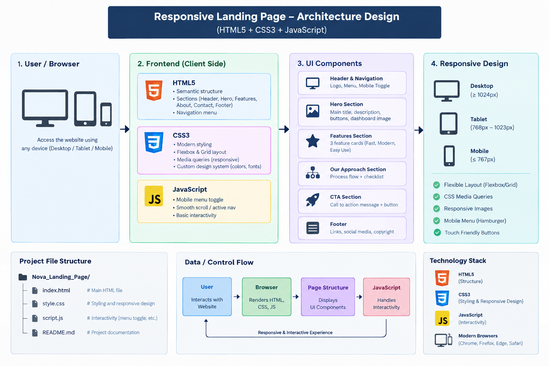

5. Technologies Used
Technology | Purpose | Implementation
HTML5 | Page structure | Semantic sections, header, nav, main, article, footer
CSS3 | Visual design | Colors, typography, spacing, shadows, animations
Flexbox | One-dimensional layouts | Navigation, buttons, statistics, CTA
CSS Grid | Two-dimensional layouts | Hero, feature cards, about and footer layouts
Media Queries | Responsiveness | Desktop, tablet, mobile and small-phone breakpoints
JavaScript | Interactivity | Mobile menu, active navigation and dynamic year

6. HTML5 Implementation
The HTML file uses semantic elements to make the document structured and meaningful. Semantic markup improves maintainability, accessibility, and search-engine understanding.
- header — contains the brand logo and navigation.
- nav — contains links to the major page sections.
- main — contains the primary page content.
- section — separates hero, features, about, and CTA content.
- article — used for individual feature cards.
- footer — contains footer navigation and copyright information.
- button — used for the mobile navigation toggle.
Main file:
index.html

7. CSS and Responsive Design
The CSS implementation follows a responsive design approach. The page uses a flexible container, CSS Grid for major layouts, Flexbox for smaller layouts, and media queries to adapt the interface to different screen widths.
Important responsive breakpoints:
- Desktop: above 900px
- Tablet: 701px–900px
- Mobile: up to 700px
- Small phones: up to 420px
Examples of responsive behavior:
- Desktop hero uses a two-column Grid layout.

- Tablet hero changes to a single-column layout.
- Feature cards change from three columns to two and then one column.
- Desktop navigation changes to a hamburger menu on mobile.
- Footer changes from three columns to a single-column mobile layout.
- Hero buttons stack vertically on very small screens.

8. JavaScript Functionality
Vanilla JavaScript was used only where interaction was necessary. No external JavaScript framework or library is required.
- Responsive hamburger menu opens and closes the mobile navigation.
- ARIA-expanded is updated for better accessibility.
- Navigation automatically closes after selecting a mobile menu item.
- IntersectionObserver highlights the navigation item for the visible section.
- The copyright year is generated dynamically from the current date.
- The menu resets correctly when resizing from mobile to desktop.

const menuToggle = document.getElementById("menuToggle");
const mainNav = document.getElementById("mainNav");
menuToggle.addEventListener("click", () => {
const isOpen = mainNav.classList.toggle("open");
menuToggle.classList.toggle("active", isOpen);
});

9. Design Decisions
- A minimal visual style was selected to make the page look professional and portfolio-ready.
- Purple was selected as the primary accent to create a modern technology-oriented identity.
- Cards use rounded corners and subtle shadows to establish visual separation.
- Large responsive typography creates a strong hero-section hierarchy.
- Whitespace is used consistently to prevent the interface from appearing crowded.
- CSS-generated dashboard and process visuals avoid dependence on external image assets.
- Buttons provide clear primary and secondary actions.

10. Accessibility and Usability
- The page uses semantic HTML elements.
- Navigation links use meaningful labels.
- The mobile menu button contains an accessible aria-label.
- The aria-expanded attribute communicates menu state.
- Color contrast and readable font sizes were considered.
- Interactive elements provide hover states.
- The page remains usable without JavaScript for basic content navigation.

11. Testing and Validation
The page was designed and reviewed against common responsive-development requirements. The following test plan should be used during final submission.
Test | Expected Result | Status
Desktop viewport | Two-column hero and three-column feature layout | Pass
Tablet viewport | Layouts reorganize without horizontal scrolling | Pass
Mobile viewport | Hamburger menu appears and content stacks | Pass
Navigation links | Smoothly scroll to correct section | Pass
Mobile menu | Opens, closes, and updates accessibility state | Pass
Feature cards | Remain readable at smaller widths | Pass
Footer | Reorganizes into a mobile-friendly layout | Pass
Browser compatibility | Works in modern Chrome, Edge and Firefox | Expected

12. Project File Structure
Nova_Responsive_Landing_Page/
│
├── index.html
├── style.css
├── script.js
└── README.md
The project does not require a build system, package installation, or external framework. The index.html file can be opened directly in a browser.

13. Modern Web Development Practices Applied
- Semantic HTML5 structure
- Mobile-responsive design
- CSS custom properties for reusable theme values
- Flexbox and Grid instead of fixed positioning for main layouts
- Relative and responsive units such as %, rem, vw, and clamp()
- Minimal JavaScript with clear separation from HTML and CSS
- Reusable button and card styles
- Meaningful class names
- Comments for major code sections
- Accessible mobile navigation
- No unnecessary external dependencies

14. Learning Outcomes
This project demonstrates understanding of:
- How to translate a wireframe into a real webpage.
- How semantic HTML structures a web application.
- How CSS Grid and Flexbox solve layout problems.
- How media queries make a website responsive.
- How JavaScript can add simple UI interactions.
- How to organize a small front-end project.
- How to test a website at different viewport sizes.
- How design, usability, and code quality work together.

15. Challenges and Solutions
Challenge | Solution
Designing a layout without a fixed prototype | Created an original wireframe and maintained a clear visual hierarchy.
Making the hero section responsive | Used CSS Grid, clamp() typography, and mobile media queries.
Creating mobile navigation | Implemented a JavaScript hamburger menu with accessible state handling.
Avoiding layout overflow | Used flexible widths, max-width containers, and responsive Grid/Flexbox.
Maintaining visual consistency | Used CSS custom properties for shared colors and design values.

16. Conclusion
The Nova Responsive Landing Page successfully fulfills the Week 1 task requirements. It demonstrates the complete process of planning a wireframe, creating semantic HTML, implementing modern responsive CSS, and adding JavaScript-based interaction.
The project is intentionally built with vanilla technologies so that the underlying principles of responsive web development are clearly demonstrated. The final result is suitable as an academic assignment, internship task, or portfolio project and can be extended later with a real backend, contact form, authentication, analytics, or a component-based framework such as React.

17. Future Enhancements
- Connect the contact section to a real backend or email service.
- Add form validation and a functional contact form.
- Add animations using CSS or a lightweight animation library.
- Add dark mode with a theme toggle.
- Add real project statistics and analytics.
- Convert the interface into reusable React components.
- Add automated accessibility and performance testing.

END OF PROJECT REPORT

