Tiny book of EMT simulation
Closing a switch
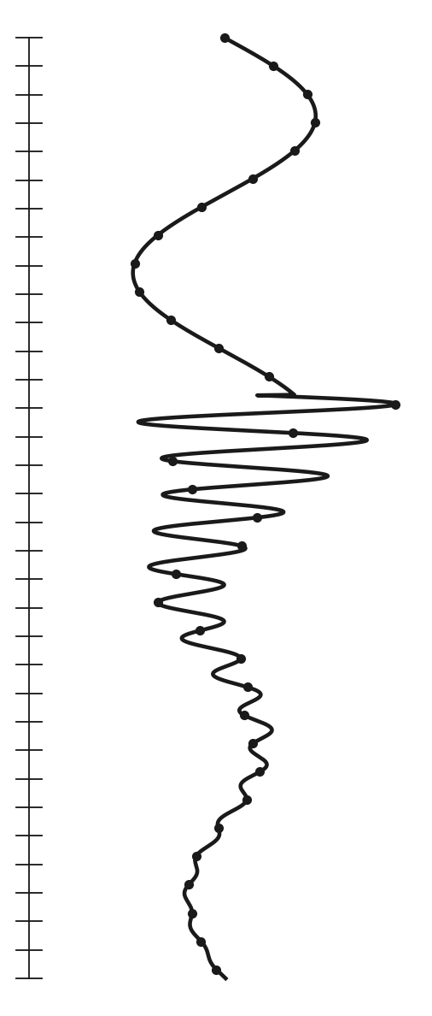
By Amila Pathirana

1. Introduction
Flip a light switch. The light comes on. Boring?
Not for the network behind the switch. For a few thousandths of a second, its voltages and currents swing, overshoot and ring like a bell before they calm down. Close a big circuit breaker, or let lightning hit a line, and the same thing happens, only much more violently. These short, wild moments are called electromagnetic transients. EMT simulation is how we calculate them on a computer, so we can check that cables, transformers and breakers will survive them.
You do not need to be a maths wizard for this. If you know Ohm's law, you can do EMT simulation. There is one clever trick in the middle, called the companion model, and this book will walk you through it with real numbers, one step at a time.
The best way to learn it is with a simple example. But first, let us meet the cast.

2. Meet the cast
Every circuit in this book is built from three characters (Figure 1).
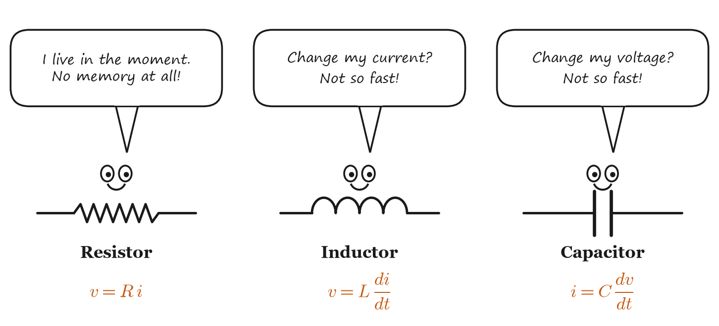
Figure 1: The cast. The resistor has no memory; the inductor and the capacitor do.
The resistor is the easy one. Its current depends only on its voltage right now: v = R i. It does not care what happened a moment ago.
The inductor hates sudden changes in its current. Its voltage is L times how fast its current changes. To change the current suddenly, you would need an enormous voltage.
The capacitor is the mirror image. It hates sudden changes in its voltage. Its current is C times how fast its voltage changes.
Remember
The inductor and the capacitor have memory: what they do now depends on what they did a moment ago. That memory is the whole difficulty of EMT simulation, and, as you will see, also the whole trick.

3. A photo and a movie
Meet Phasor Pete and EMT Emma (Figure 2).
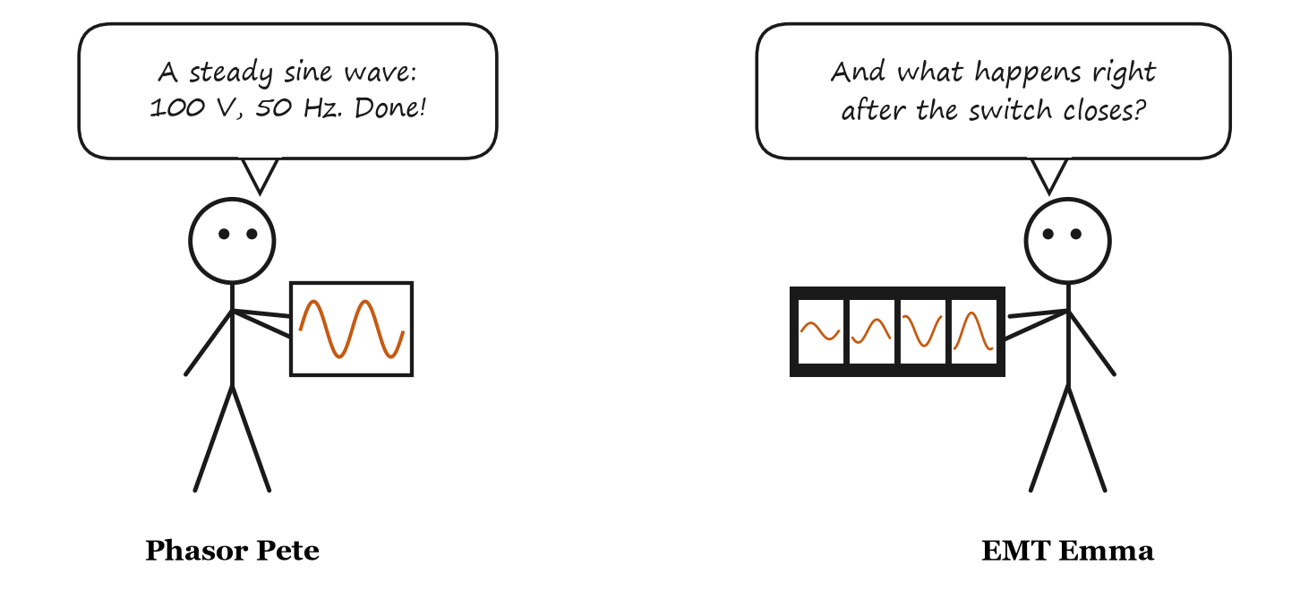
Figure 2: Pete has a photo. Emma has a movie.
Pete uses phasors, like most power-system programs (load flow, short circuit). A phasor is like one photo of a sine wave, with a note on the back: "100 V, 50 Hz". That is all you need, as long as the wave keeps going the same way forever.
But right after a switch closes, nothing is a steady sine wave yet. A photo cannot show what happens next. For that, you need Emma's movie: one picture every small time step, Δt, where each picture is worked out from the one before it (Figure 3).
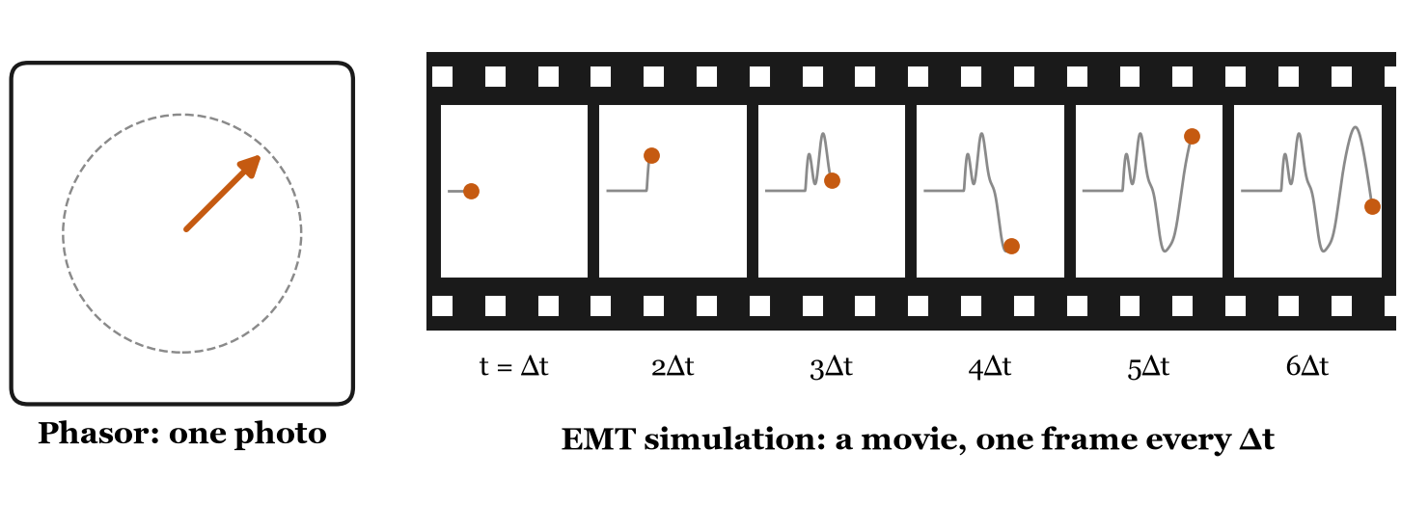
Figure 3: A phasor is one photo. An EMT simulation is a movie with one frame every Δt.
A small Δt gives a smooth movie, but more frames to calculate. Typical time steps are 20 to 100 μs for switching studies, a few μs for power electronics, and less than a microsecond for lightning.

4. Our first EMT simulation
Here is our circuit (Figure 4): a 10 V battery, a switch, a 1 Ω resistor and a 1 mH inductor. Everything is at rest. At t = 0, the switch closes. What does the current i do?
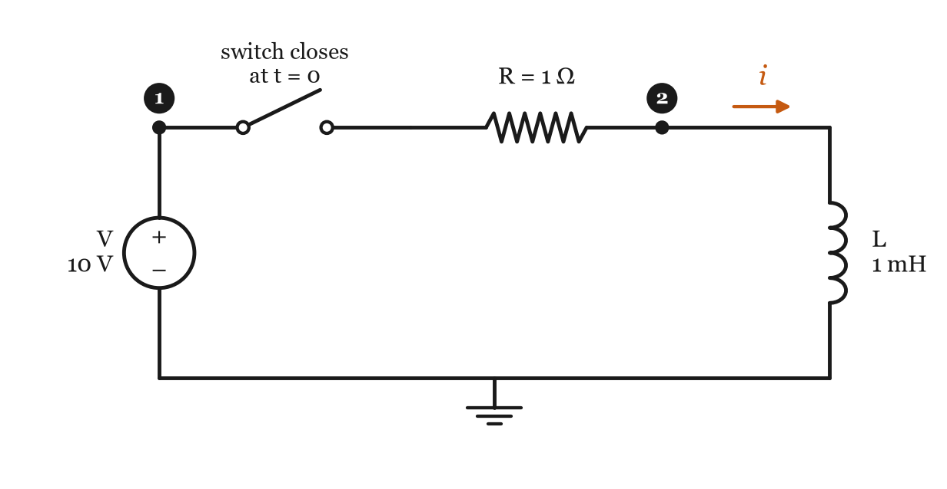
Figure 4: Our first circuit. Node 1 is the battery's terminal; node 2 is the top of the inductor.
We picked this circuit for a reason: it is simple enough to solve exactly with pen and paper, so we can check our simulation against the right answer:
$$i(t)=\frac{V}{R}\left(1−e^{−t/τ}\right), τ=\frac{L}{R}=1\text{ ms}$$
In words: the current climbs from 0 towards V/R = 10 A. After one time constant τ = 1 ms it has made it 63 % of the way.
Our goal: get the same answer with nothing but Ohm's law and a calculator. No differential equations.

a. Chop time into small steps
We pick a time step Δt = 0.1 ms, and only calculate the circuit at t = Δt, 2Δt, 3Δt, and so on. The resistor is happy with that: at every instant, its current is just its voltage divided by R. The inductor is the problem. Its rule links "now" to "a moment ago":
$$v=L\frac{\text{di}}{\text{dt}}$$

b. The inductor's memory
Turn the inductor's rule around, and add up its voltage over one time step:
$$i(t)=i(t−Δt)+\frac{1}{L}\int_{t−Δt}^{t}{v\text{dt}} (1)$$
In words: current now = current one step ago + (1/L) × the area under the voltage curve during the step.
We do not know exactly how the voltage changed during the step. So we guess the simplest thing: a straight line from its old value to its new value. The area under a straight line is a trapezoid (Figure 5). This guess is called the trapezoidal rule.
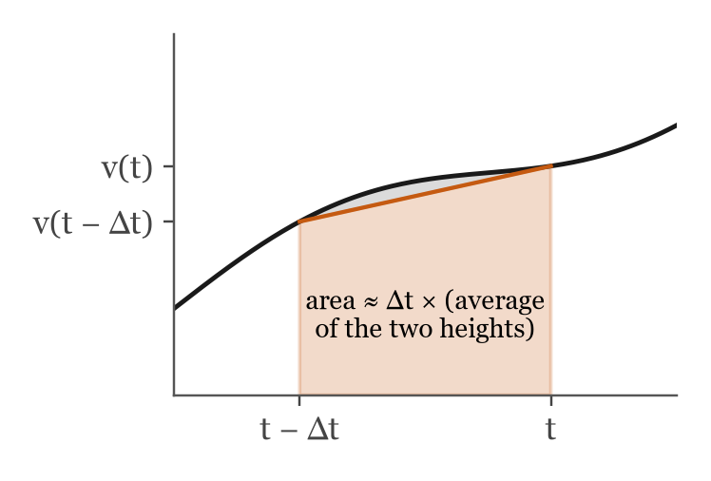
Figure 5: The trapezoidal rule. The area under the curve is replaced by the orange trapezoid. The small grey sliver is our error.
$$\int_{t−Δt}^{t}{v\text{dt}}≈\frac{Δt}{2}\left[v(t)+v(t−Δt)\right] (2)$$
In words: area ≈ width × the average of the two heights.
Put (2) into (1), and sort everything into two piles: things that belong to now, and things that belong to the last step:
$$i(t)=\frac{Δt}{2L}v(t)+\left[i(t−Δt)+\frac{Δt}{2L}v(t−Δt)\right] (3)$$
The bracket only holds things from the last step, which we already know. It is the inductor's memory: a little note it writes to itself at the end of every step (Figure 6). We call it the history current, I_{hist}.
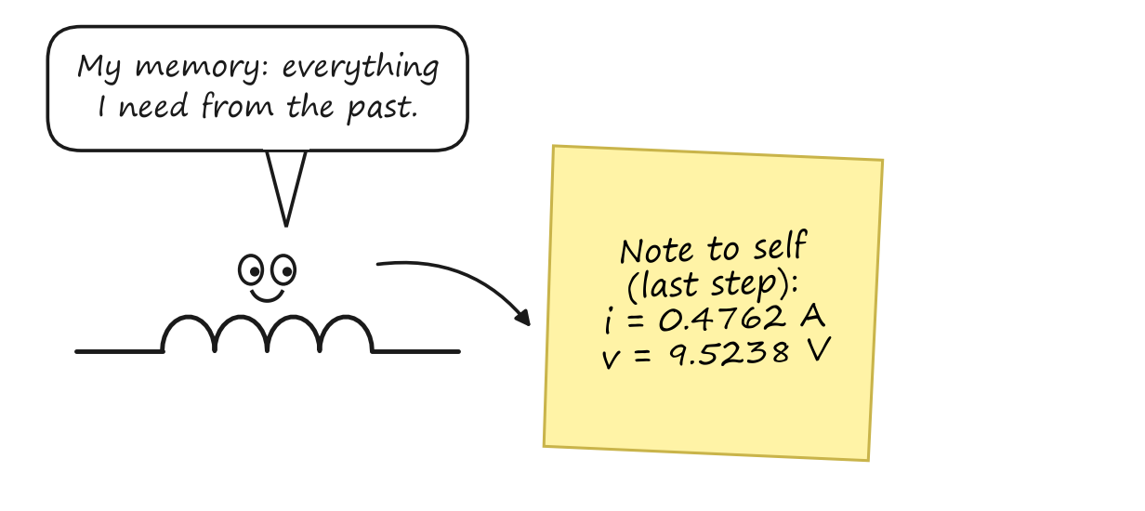
Figure 6: The inductor's note to itself after step 1. These two numbers are all it needs to remember.

c. The disguise: the companion model
"Companion model" sounds complex, but it is not. Look at equation (3) again:
- The first part, (Δt/2L) × v(t), is a conductance times the voltage now. That is exactly what a resistor does, with resistance R_{L} = 2L/Δt.
- The second part, I_{hist}, is already known. A current that is already known is just a current source.
$$i(t)=\frac{v(t)}{R_{L}}+I_{\text{hist}}(t), R_{L}=\frac{2L}{Δt}, I_{\text{hist}}(t)=i(t−Δt)+\frac{v(t−Δt)}{R_{L}} (4)$$
So for one time step, the inductor puts on a disguise: a resistor in parallel with a current source. The resistor never changes (as long as Δt stays the same). Only the current source is updated, once per step. The capacitor gets the same disguise, with R_{C} = Δt/2C and a minus sign in its history current (Figure 7).
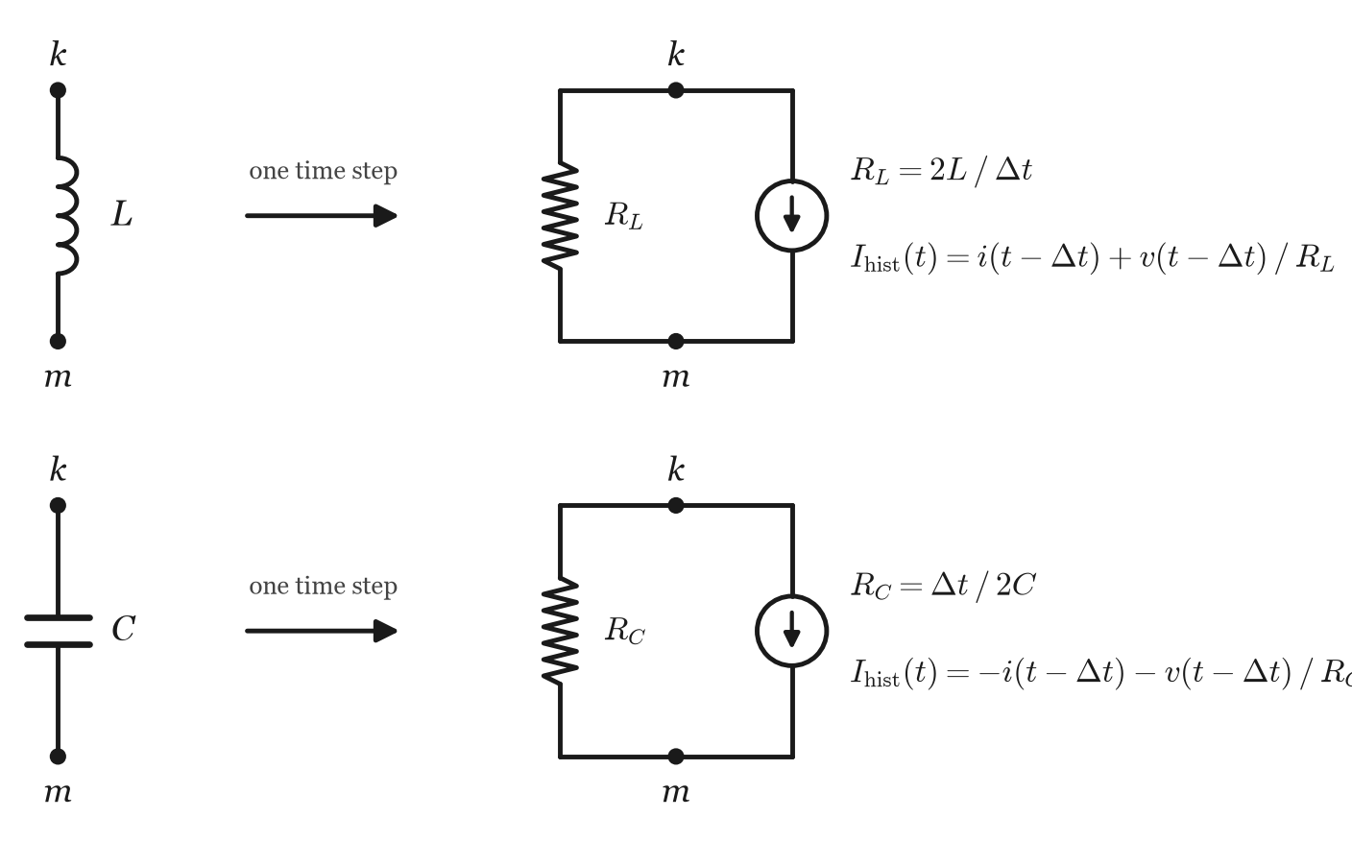
Figure 7: The companion models. For one time step, an inductor or a capacitor between nodes k and m becomes a resistor and a current source.
For our inductor: $R_{L}=\frac{2×0.001}{0.0001}=20\text{ Ω}$.

d. Solving one time step
Swap the inductor for its disguise. Now the circuit has only a battery, two resistors and a current source (Figure 8). Ohm's law can handle that.
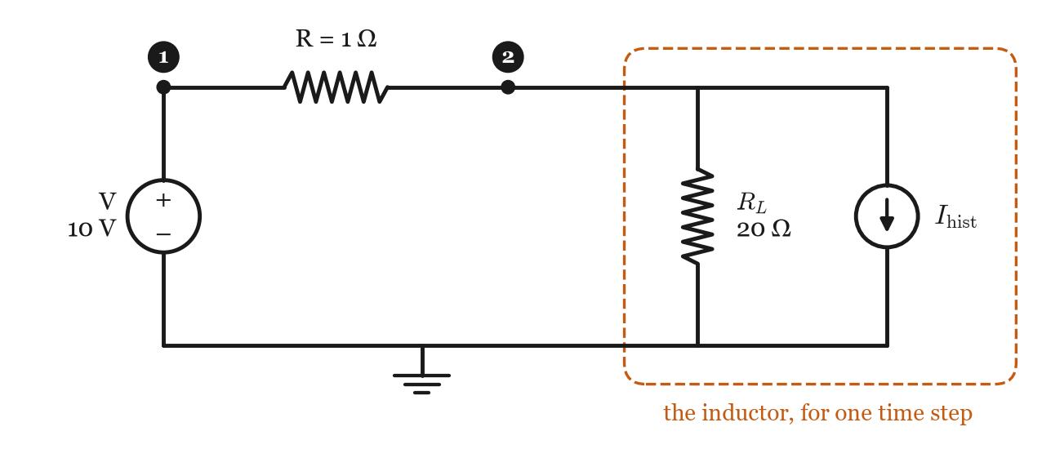
Figure 8: The circuit of Figure 4 for one time step, with the inductor in disguise.
Node 1 is easy: the battery holds it at V = 10 V. Node 2 is unknown; call its voltage v₂. Whatever current flows in through R must flow out through the companion model (Kirchhoff's current law):
$$\left.\frac{V−v_{2}}{R}=\frac{v_{2}}{R_{L}}+I_{\text{hist}} ⇒ v_{2}=\frac{\frac{V}{R}−I_{\text{hist}}}{\frac{1}{R}+\frac{1}{R_{L}}}\right. (5)$$
In words: current in through R = current out through the disguised inductor. Solve for v₂.
Then equation (4) gives the inductor current.

e. Step by step, with numbers
Before t = 0, everything is at rest: i = 0 and v₂ = 0. Grab a calculator and follow along. I tried not to skip a single step.
Step 1, t = 0.1 ms
Read the note from the last step (everything was zero):
$$I_{\text{hist}}=0+\frac{0}{20}=0.0000\text{ A}$$
$$v_{2}=\frac{10/1−0}{1/1+1/20}=\frac{10}{1.05}=9.5238\text{ V}$$
$$i=\frac{9.5238}{20}+0=0.4762\text{ A}$$
Step 2, t = 0.2 ms
Now the note says what happened in step 1:
$$I_{\text{hist}}=0.4762+\frac{9.5238}{20}=0.9524\text{ A}$$
$$v_{2}=\frac{10−0.9524}{1.05}=8.6168\text{ V}$$
$$i=\frac{8.6168}{20}+0.9524=1.3832\text{ A}$$
Step 3, t = 0.3 ms
$$I_{\text{hist}}=1.3832+\frac{8.6168}{20}=1.8141\text{ A}$$
$$v_{2}=\frac{10−1.8141}{1.05}=7.7961\text{ V}$$
$$i=\frac{7.7961}{20}+1.8141=2.2039\text{ A}$$
The recipe
Every step is the same three lines, over and over:
1. Read the note: work out the history current from the last step.
2. Solve: find the node voltage with Ohm's law.
3. Write a new note: work out the current, and keep it for the next step.
That is all a real EMT program does, just a few million times faster than you.

Try it
Work out step 4 yourself, using the step 3 numbers. Then check your answer in Table 1.
Answer: I_{hist} = 2.5937 A, v₂ = 7.0536 V, i = 2.9464 A.

Table 1: The first ten steps, next to the exact current from the formula.
step | t (ms) | I_{hist} (A) | v₂ (V) | i (A) | exact i (A)
1 | 0.1 | 0.0000 | 9.5238 | 0.4762 | 0.9516
2 | 0.2 | 0.9524 | 8.6168 | 1.3832 | 1.8127
3 | 0.3 | 1.8141 | 7.7961 | 2.2039 | 2.5918
4 | 0.4 | 2.5937 | 7.0536 | 2.9464 | 3.2968
5 | 0.5 | 3.2990 | 6.3819 | 3.6181 | 3.9347
6 | 0.6 | 3.9372 | 5.7741 | 4.2259 | 4.5119
7 | 0.7 | 4.5146 | 5.2242 | 4.7758 | 5.0341
8 | 0.8 | 5.0370 | 4.7266 | 5.2734 | 5.5067
9 | 0.9 | 5.5097 | 4.2765 | 5.7235 | 5.9343
10 | 1.0 | 5.9374 | 3.8692 | 6.1308 | 6.3212

f. How good is the answer?
Figure 9 puts our simulation next to the exact answer. After a few steps the two curves almost overlap, but the simulation is always a little behind. Why?
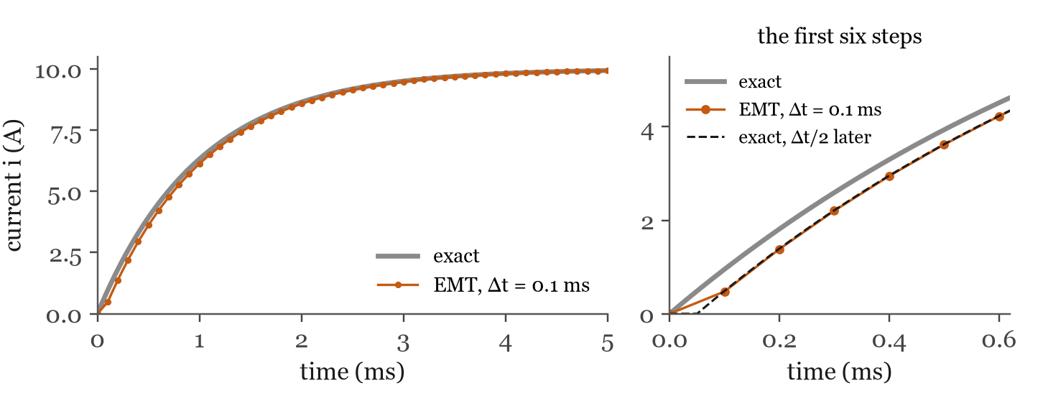
Figure 9: Simulated (orange dots) and exact (grey) current. Right: the first six steps. The simulation matches the exact curve shifted by half a time step (black dashes).
Our simulation has slow reflexes. In step 1, the trapezoidal rule assumed the inductor voltage rose in a straight line from 0 V (when everything was at rest) to 9.52 V. In reality it jumped to 10 V the instant the switch closed. A voltage that ramps up over one step acts, on average, like a voltage that jumps halfway through the step. So the simulation behaves as if the switch had closed half a step late, at Δt/2. Shift the exact curve by Δt/2 and the two agree very well (right of Figure 9). A smaller Δt means smaller reflex delay:
Table 2: The current at t = 1 ms for three time steps (exact answer: 6.3212 A).
Δt (ms) | simulated i (A) | error (A) | error after the Δt/2 shift (A)
0.5 | 5.2000 | 1.12121 | 0.07633
0.1 | 6.1308 | 0.19039 | 0.00177
0.02 | 6.2842 | 0.03704 | 0.00006
Remember
Δt must be small compared with the fastest thing you want to see. Here the circuit's time constant is 1 ms, so a step of 0.1 ms is plenty.

5. A bigger network
Writing Kirchhoff's law by hand for every node gets boring fast. Computers do it with a matrix. Figure 10 shows a slightly bigger circuit: a 100 V, 50 Hz source feeding a line (R1 and L), a cable that adds some capacitance C, and a 100 Ω load. The time step is Δt = 50 μs.
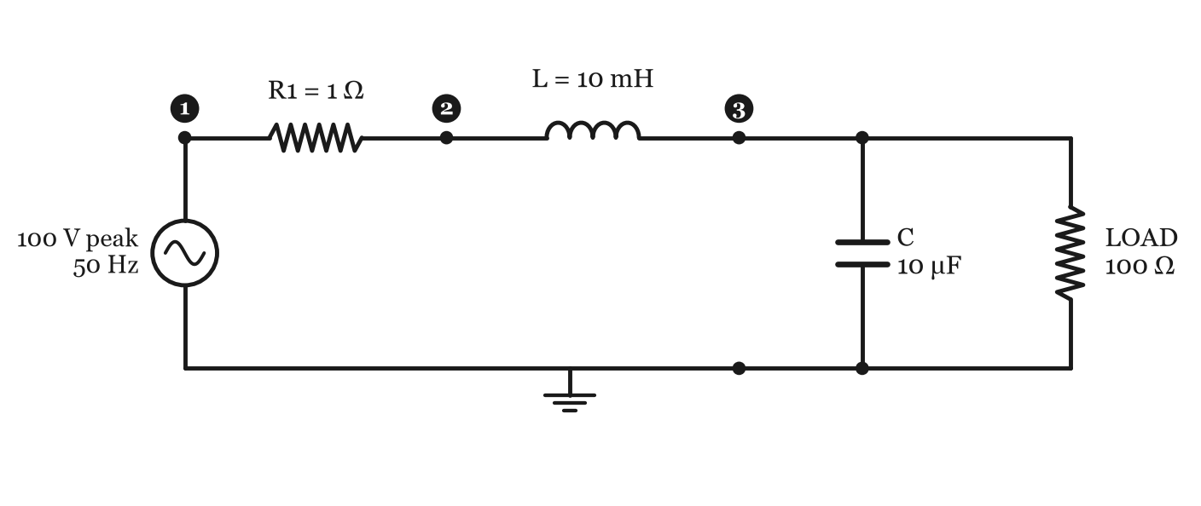
Figure 10: The network of chapters 5 and 6. Nodes 1, 2 and 3; node 0 is ground.

a. Everything becomes a conductance
In disguise, every element is a conductance (1 / resistance), plus maybe a current source:
element | between nodes | conductance
R1 = 1 Ω | 1 and 2 | 1/1 = 1 S
L = 10 mH | 2 and 3 | Δt/2L = 0.0025 S
C = 10 μF | 3 and ground | 2C/Δt = 0.4 S
LOAD = 100 Ω | 3 and ground | 1/100 = 0.01 S

b. The rubber stamp
Now we build the conductance matrix G, one element at a time, with a rubber stamp (Figure 11). The stamp for a conductance g between nodes k and m adds +g to the two diagonal spots (k,k) and (m,m), and −g to the two off-diagonal spots (k,m) and (m,k). If one end is ground, only the diagonal spot of the other end gets stamped.
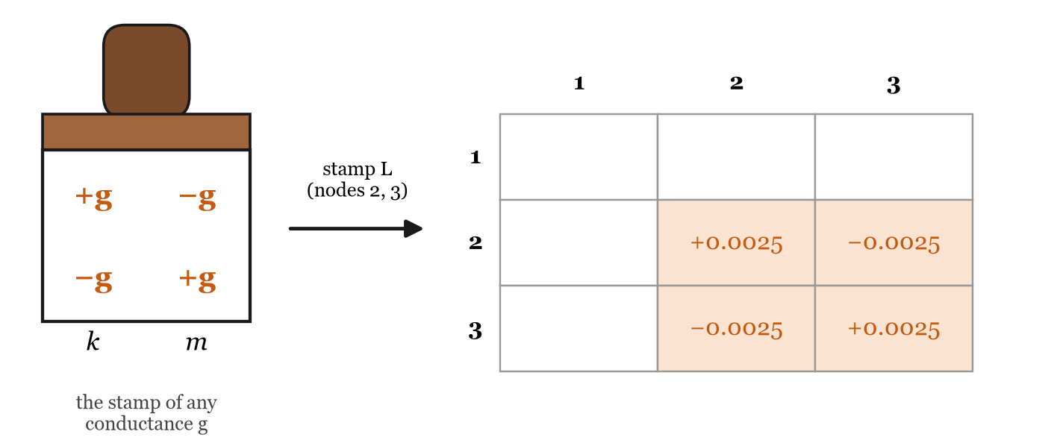
Figure 11: Stamping the inductor (between nodes 2 and 3) into G.
Stamp all four elements, and you get:
$$G=\left[\begin{matrix}1.0000 & −1.0000 & 0.0000 \\ −1.0000 & 1.0025 & −0.0025 \\ 0.0000 & −0.0025 & 0.4125\end{matrix}\right]$$
Kirchhoff's current law for all the nodes at once is then one neat line:
$$Gv=i (6)$$
In words: conductances × node voltages = currents pushed into the nodes by the history current sources.
A history current I_{hist} flowing from node k to node m takes I_{hist} out of i_{k} and puts it into i_{m}.

c. The boss node
The source is the boss of node 1: it tells node 1 exactly what voltage to have. So node 1 is known (K), and nodes 2 and 3 are unknown (U). Split G into those parts:
$$G_{\text{UU}}=\left[\begin{matrix}1.0025 & −0.0025 \\ −0.0025 & 0.4125\end{matrix}\right], G_{\text{UK}}=\left[\begin{matrix}−1 \\ 0\end{matrix}\right]$$
and solve only for the unknown voltages:
$$G_{\text{UU}}v_{U}=i_{U}−G_{\text{UK}}v_{K} (7)$$
In words: move everything we already know (the boss's voltage) to the right-hand side, then solve for the rest.
Here is the beautiful part: G stays the same from one step to the next. Only the right-hand side changes. So the computer does the hard work (factorising G_{UU}, with an LU or LDL^{T} factorisation in EMTSim) only once. After that, each step is quick. That is why an EMT program can run millions of steps.

d. One step, with numbers
Step 1, t = 50 μs
The boss sets node 1 to $100\text{cos}(2π×50×0.00005)=99.9877\text{ V}$. Everything was at rest before, so every note is blank: all history currents are zero, and i_{U} = 0.
$$i_{U}−G_{\text{UK}}v_{K}=\left[\begin{matrix}0 \\ 0\end{matrix}\right]−\left[\begin{matrix}−1 \\ 0\end{matrix}\right]\left[\begin{matrix}99.9877\end{matrix}\right]=\left[\begin{matrix}99.9877 \\ 0.0000\end{matrix}\right]$$
$$v_{U}={G_{\text{UU}}}^{−1}\left[\begin{matrix}99.9877 \\ 0.0000\end{matrix}\right]=\left[\begin{matrix}99.7398 \\ 0.6045\end{matrix}\right]$$
Node 2 jumps to 99.74 V, while node 3 barely moves: the inductor is not letting much current through yet. Its current is $0.0025×(99.7398−0.6045)=0.247838\text{ A}$, and the capacitor's is $0.4×0.6045=0.241794\text{ A}$.
Step 2, t = 100 μs
First, read the notes (equation 4 and Figure 7):
$$I_{\text{hist},L}=0.247838+0.0025×99.1353=0.495677\text{ A}$$
$$I_{\text{hist},C}=−0.241794−0.4×0.6045=−0.483587\text{ A}$$
I_{hist,L} flows from node 2 to node 3, and I_{hist,C} from node 3 to ground. Then solve:
$$i_{U}=\left[\begin{matrix}−0.495677 \\ 0.979264\end{matrix}\right], v_{K}=99.9507\text{ V}, v_{U}=\left[\begin{matrix}99.2144 \\ 2.9753\end{matrix}\right]$$
And so on, step after step. Figure 12 shows the movie of node 3 for the first 80 ms. When the source switches on, the inductor and the capacitor play catch with the energy, at their natural frequency $1/(2π\sqrt{\text{LC}})≈503\text{ Hz}$. The voltage overshoots to 153.2 V. Then the load calms the ringing down, and we end up exactly where Phasor Pete's photo says we should.
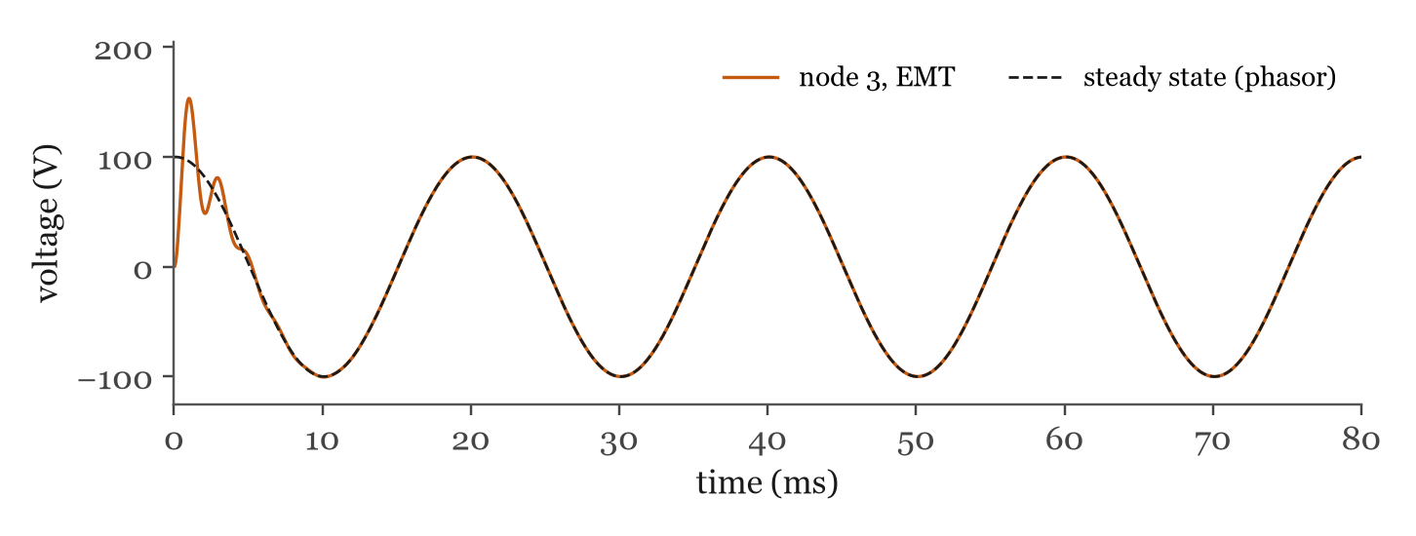
Figure 12: Voltage of node 3 after the source switches on, and Pete's steady state (a phasor calculation of the same circuit).
The recipe of every EMT program
Once: put every element in disguise, stamp G, and factorise G_{UU}.
Every step (t = t + Δt):
1. Did a switch or a fault change? Then re-stamp G and factorise it again.
2. Ask the bosses (the sources) for the known voltages v_{K}.
3. Read every inductor's and capacitor's note: the history currents. Add them up into i.
4. Solve G_{UU} v_{U} = i_{U} − G_{UK} v_{K}.
5. Work out every element's current, write the new notes, and save the results.
This is exactly the order EMTSim uses.

6. Switches and faults
A switch is just a resistor with two moods: tiny when it is closed (EMTSim uses 0.01 Ω) and huge when it is open (1 MΩ). A fault is a switch from a node to ground.
When a switch changes its mood, its conductance changes, so G changes. That is step 1 of the recipe: re-stamp G, factorise it again, and carry on. The notes (history currents) are not touched, so the inductors and capacitors remember their currents and voltages across the switching instant, just like real ones.
Let us short-circuit node 3 to ground at 30 ms and remove the short at 60 ms (Figure 13).
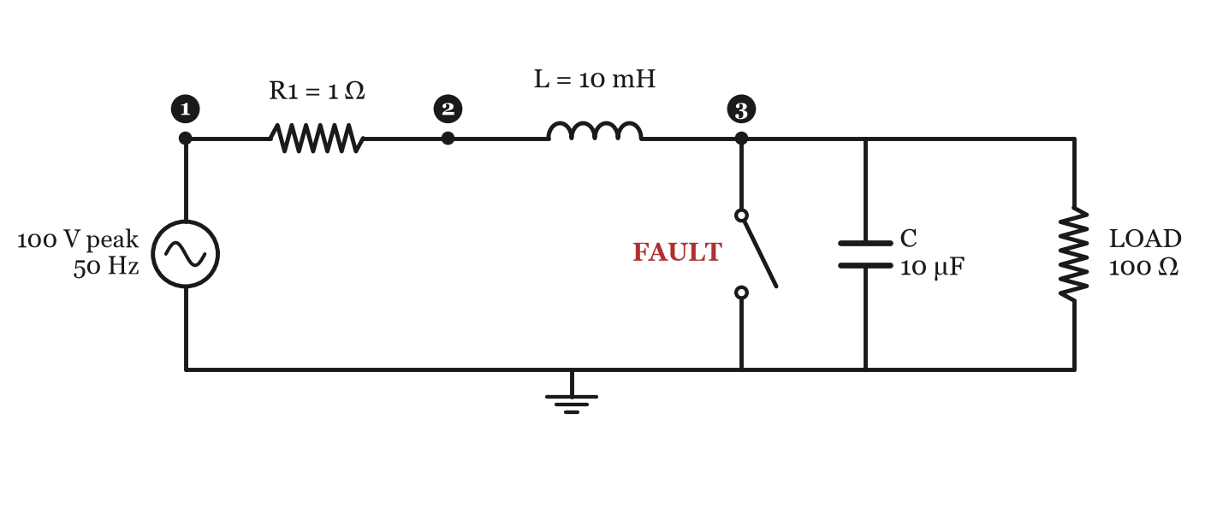
Figure 13: The network of Figure 10, with a fault from node 3 to ground.
While the fault is open, it stamps a tiny 1/10⁶ S onto G₃₃. When it closes, it stamps 1/0.01 = 100 S:
$$\text{before}: G_{\text{UU}}=\left[\begin{matrix}1.002500 & −0.002500 \\ −0.002500 & 0.412501\end{matrix}\right] \text{during}: G_{\text{UU}}=\left[\begin{matrix}1.0025 & −0.0025 \\ −0.0025 & 100.4125\end{matrix}\right]$$
Figure 14 shows what happens. When the fault hits, node 3 collapses to almost zero, and the capacitor dumps its charge into the fault. The current in L grows to about 32.3 A; the inductor is the only thing limiting it. When the fault is removed, the capacitor and the inductor play catch again at about 503 Hz, until the network settles back to normal.
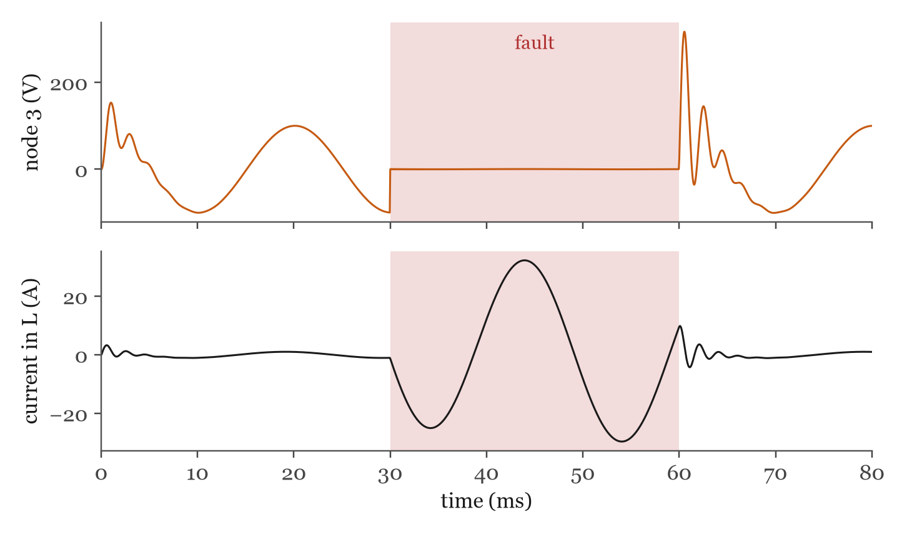
Figure 14: Voltage of node 3 and current in the inductor, with the fault (shaded) from 30 to 60 ms.

7. Try it yourself with EMTSim
Every number in this book was calculated with the same recipe EMTSim uses, and checked against it. EMTSim gives the same numbers, to the last digit. So you can run every example yourself.
An EMTSim netlist has one line per element: its type, the two nodes it connects (0 is ground) and its value. This is the circuit of chapter 4:
# Tiny book of EMT simulation, chapter 4: closing a switch on a 10 V battery, 1 ohm, 1 mH.
# The circuit is at rest before t = 0; the battery is connected at t = 0.
.tran 0.0001 0.005
V 0 1 10 0 0 # BATTERY (peak 10 V, angle 0, frequency 0 = DC)
R 1 2 1 # R
L 2 0 0.001 # L
and this is the network with the fault, from chapter 6:
# Tiny book of EMT simulation, chapter 6: the network of chapter 5 with a fault at node 3
# from 30 ms to 60 ms.
.tran 0.00005 0.08
V 0 1 100 0 50 # SOURCE
R 1 2 1 # R1
L 2 3 0.01 # L
C 3 0 10e-6 # C
R 3 0 100 # LOAD
F 3 0 0.03 0.06 # FAULT
Run them from the EMTSim folder, with either the C++ or the Python solver:
build\emtsim.exe docs\book\circuits\rl.net
python main.py docs\book\circuits\network_fault.net
python plot.py
The node voltages go to results.csv, and the element currents to currents.csv. Compare the first lines of results.csv with Table 1. Or open the circuit editor with gui.bat, draw the circuit, press Run, and drag across a plot to zoom in on the first few steps.
Try it
– Make Δt ten times bigger. How big does the error in Table 2 get?
– Move the fault to node 2. Is the fault current bigger or smaller? Why?
– Change the load to 10 Ω. Does the ringing die out faster or slower?

8. The ghost in the machine
So far we have only closed switches. Let us take the circuit of chapter 4 again, wait until the current has almost reached 10 A, and then open the switch at t = 3 ms (Figure 15).
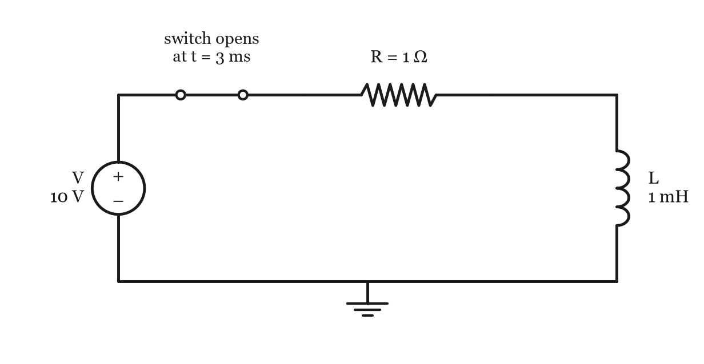
Figure 15: The circuit of chapter 4, with a switch that opens at 3 ms.
Remember the inductor's personality: it hates sudden changes in its current. In a real circuit, when the switch opens, the inductor fights back by pushing the voltage across the opening contacts up very high (that is why breakers draw arcs), and the current dies away very quickly. Now look at what our simulation says (Figure 16).
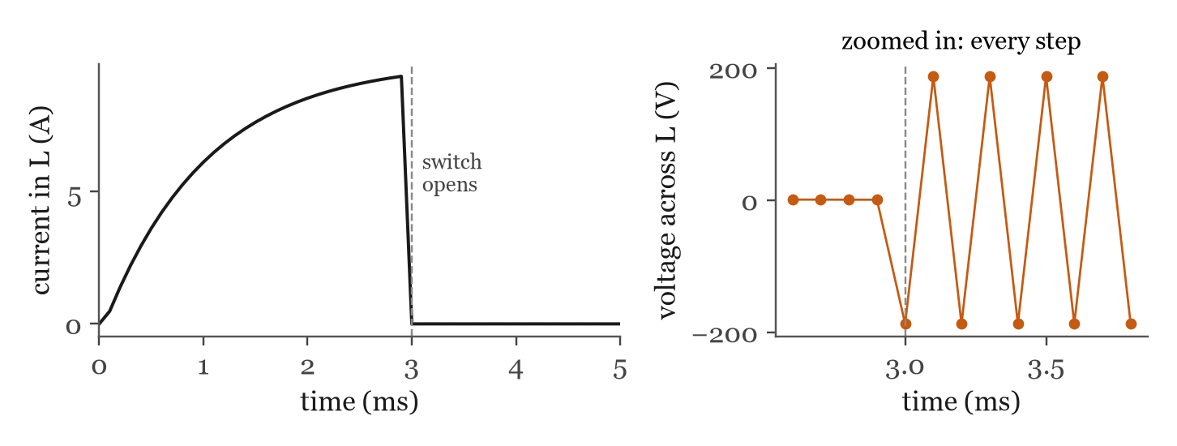
Figure 16: Left: current in the inductor. Right: voltage across the inductor at every step around the opening. Both calculated with the trapezoidal rule and Δt = 0.1 ms.
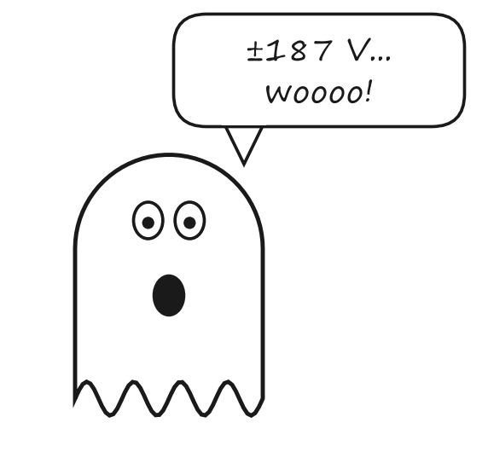
The current looks fine. Just before the switch opens, it is 9.35 A, and from the next step on, it is practically zero (less than 0.0002 A).
But look at the voltage across the inductor. Just before the opening, it is 0.56 V. In the steps after it, the simulation says −187.5, 187.5, −187.4, 187.4, −187.4 V, and so on. It flips sign at every single step, for as long as we care to simulate. No current flows, and yet the inductor voltage keeps jumping between plus and minus 187 V. Spooky.
Does the voltage in a real circuit do that? Or is there a ghost in our simulation?
Ghost hunting
Use equation (4), with the 1 MΩ of the open switch in series with R_{L} = 20 Ω. What happens to I_{hist} from one step to the next? Who wrote the wrong note?

Cheat sheet
The cast
$$v=Ri, v=L\frac{\text{di}}{\text{dt}}, i=C\frac{\text{dv}}{\text{dt}}$$

Inductor in disguise (trapezoidal rule)
$$i(t)=\frac{v(t)}{R_{L}}+I_{\text{hist}}(t), R_{L}=\frac{2L}{Δt}$$
$$I_{\text{hist}}(t)=i(t−Δt)+\frac{v(t−Δt)}{R_{L}}$$

Capacitor in disguise
$$i(t)=\frac{v(t)}{R_{C}}+I_{\text{hist}}(t), R_{C}=\frac{Δt}{2C}$$
$$I_{\text{hist}}(t)=−i(t−Δt)−\frac{v(t−Δt)}{R_{C}}$$

The stamp of a conductance g between nodes k and m
$$G_{\text{kk}}+=g, G_{\text{mm}}+=g, G_{\text{km}}-=g, G_{\text{mk}}-=g$$

One time step
$$G_{\text{UU}}v_{U}=i_{U}−G_{\text{UK}}v_{K}$$

Choosing Δt
much smaller than the fastest thing you want to see: the simulation acts about Δt/2 late after a sudden jump.

Switches and faults
closed 0.01 Ω, open 1 MΩ. When one changes: re-stamp G, factorise again, keep the notes.

