An attempt to build
Drehteller
made from scratch parts
and new components


AXL / 2012
Inhaltsverzeichnis
1.Zielsetzung 3
1.1.Revisionen 3
2.Inhalt 4
2.1.Blah 4
3.Befehle 5
3.1.1.Firmware - Commands 5
4.Software-Konzept 6
4.1.1.Marker 7
4.1.2.Tabelle 8
4.2.IC 9
4.2.1.Tabelle 9
4.2.2.Tabelle 2 10
4.2.3.Tabelle 3 11

Zielsetzung
- wann
- was
- warum
- wie
- Arduino
- 5 Volt
- Steuerung über TTL / 5 Volt Pegel
- Debugging per LEDs
- Zentrale Komponenten

Revisionen

Beschaltung
Stepper unter Drehteller:
1 – gelb
2 – rot
3 – braun
4 – orange

720 steps / revolution

Serial interpreter

Commands

command | parameter
i |  | initialize
s | long | set speed [steps / sec]
a | long | set acceleration [steps / sec / sec]
m | long | move to step [steps]
d | long | move to degree [degrees]
h |  | halt immediately
w | long | wait [msec]
'0' - '9' |  | adds to the parameter  (val = val * 10 + new)
- |  | negative parameter (val = -val)
LF |  | execute at line end (line feed, char(10))

Resonses
k;d;0
command accepted
d;d;0
target position reached

Stepper SY35ST23-0504A bi-polar Anschluß an Pololu Treiber

_Enable
Vmot
MS1
MS2
_Reset
MS3
_Sleep
STEP
DIR
GND
2B
2A
1A
1B
VDD
GND
+9 Volt
GND
BLACK
GREEN
RED
BLUE
+5 Volt
GND
GND
GND or
100k to VDD
VDD
VDD
Arduino
Arduino
{
Pololu
A4988

microstepping bipolar stepper motor driver

A4988 Microstepping
MS1 | MS2 | MS3 | Microstep Resolution | Excitation Mode
L | L | L | Full Step | 2 Phase
H | L | L | Half Step | 1-2 Phase
L | H | L | Quarter Step | W1-2 Phase
H | H | L | Eighth Step | 2W1-2 Phase
H | H | H | Sixteenth Step | 4W1-2 Phase

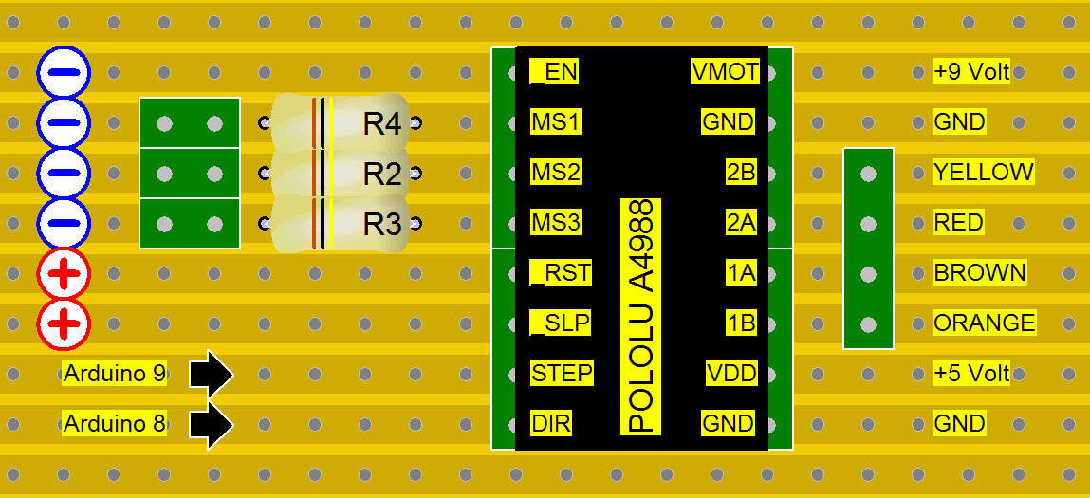
Platine – Entwurf

