Camera Calibration using Random Sample Consensus Algorithm (RANSAC)
Unfortunately, the linear square methods are sensitive to image errors and outliers. In the real world condition, the corresponding 2D image data is obtained by some feature extraction methods. These LSQ camera calibration algorithms will corrupt due to outliers resulting from mismatching and occlusion. Various methods have been proposed to improve the robustness and accuracy of camera calibration methods. In this project, RANSAC is used to robustify model fitting by selecting a minimum sample set required for the model among the remaining samples. Thus, models containing outliers are rejected since they do not generate sufficient consensus.
The assumptions in RANSAC are:
- The model can be estimated from K data items;
- There are N (N>K) data items in total.
The first issue in RANSAC is to determine the minimum number of subsets data needed to produce the correct camera calibration [4]. Assuming that the whole set of data may contain up to a fraction of outliers, then the probability that all K data in a subset are good is 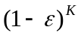, and the probability that all s different subsets will contain at least one or more ourliers is 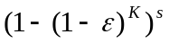. So the probability that at least one random subset has no outliers is given by
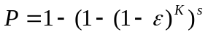 (2.5.1)
Thus the number of iterations (subsets) needed is computed as
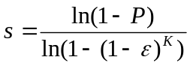 (2.5.2)

The RANSAC algorithm works as follows:
- Step1: Randomly pick a subset of K (K>=6) pairs of points from N (N>K) pairs, compute the projection matrix P using these points.
- Step2: Using P matrix, compute the projection error for all of the remaining points. If it is within a threshold distance, increment a counter of the number of the “inliers”.
- Step3: Repeat Step1 and 2 s times and select the subset of points with the largest number of “inliers”, which agree with the hypothesized P.
- Step4: Using all of the “inlier”, recompute the best P.

