
Intervals ICU Coach V5 (Railway T2 Engine)
AI-Driven Endurance Performance Framework • Unified Reporting v5.1

🧪 How to Set Up Your LT1 (HRTLND_LT1) Field in Intervals.icu
Step 1 — Add the Field to Your Athlete Settings
- Go to Athlete → Settings (top right gear icon).
- Scroll down to Custom Fields.
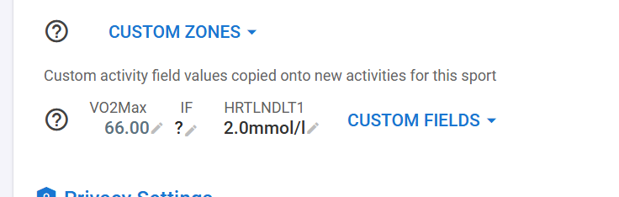

- Click the search icon 🔍 and type HRTLNDLT1.
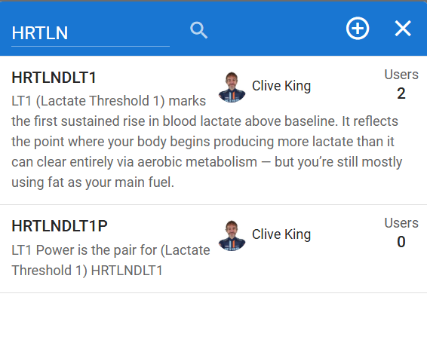
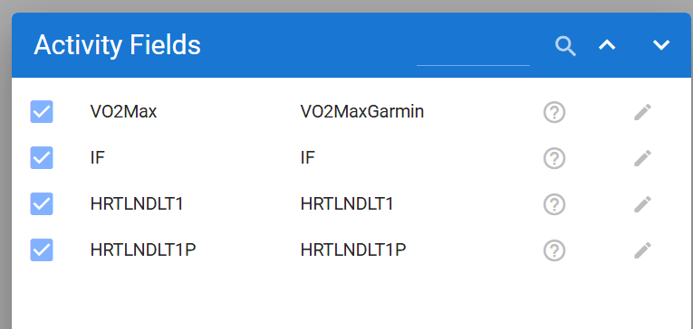
- Select Edit icon HRTLNDLT1 (LT1 – Lactate Threshold 1) and HRTLNDLT1P (LT Power pair) from the list.
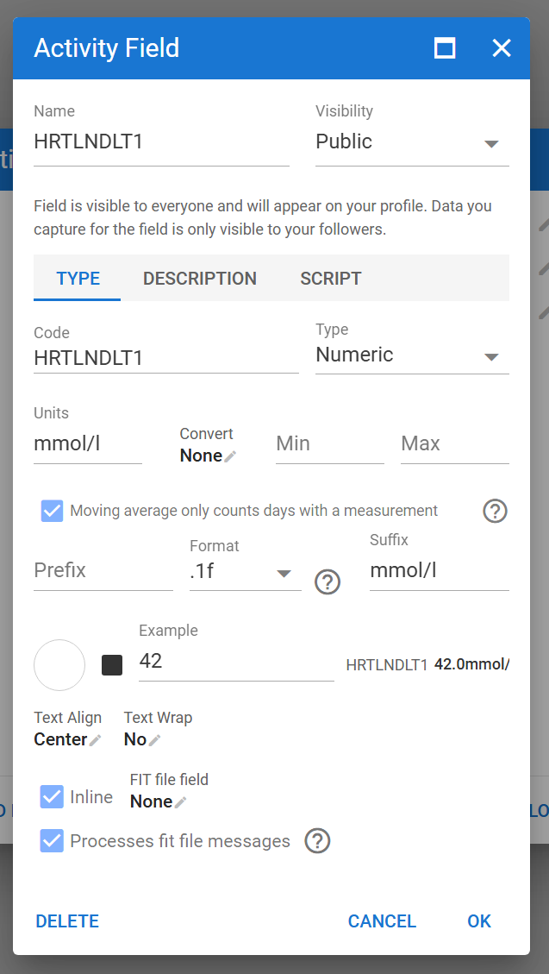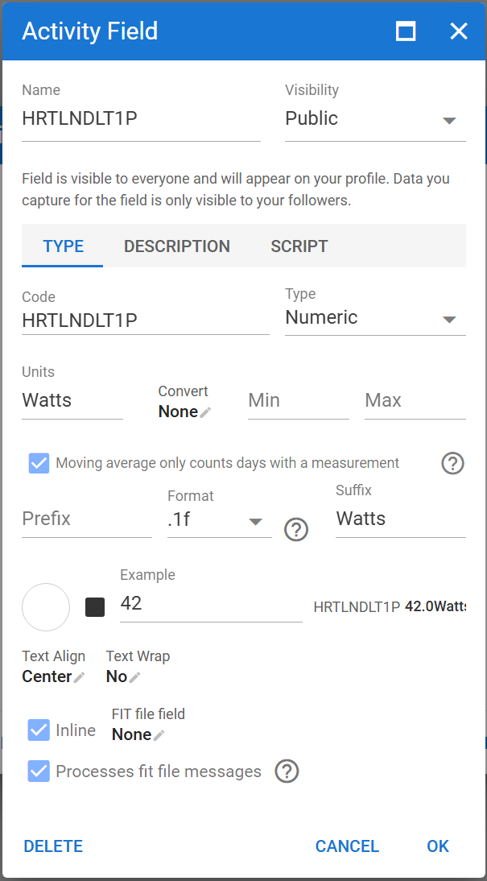
- Click OK
- Tick the checkbox ✅ to activate it.
- Click Close to save.
💡 You should now see “HRTLNDLT1” and “HRTLNDLT1P” under your Custom Fields list.

Step 2 — Enter Your LT1 and Power Value
- In the same Athlete Settings → Custom Fields, locate HRTLNDLT1.
- Enter your latest LT1 value in mmol/L (for example 2.0).
- Click Save ✓.
🧠 Typical LT1 range: 1.5 – 2.5 mmol/L
for HRTLNDLT1; If you’re unsure, start with 2.0 mmol/L – the standard aerobic threshold.
for HRTLNDLT1P; add power pair for LT1 eg. 195

Step 3 — Apply It to Activities
- Open one of your recent activities with power.
- Scroll to the bottom and click Custom▾.
- Tick HRTLNDLT1 and HRTLNDLT1P to enable them for that activity and future activities.
- Refresh the page — your LT1 and LT1P value will now appear automatically for all new activities (if this doesn’t appear for an activity you can actions/reload from source or just change an interval temporarily and it will refresh and populate values from athlete settings).

Step 4 — Keep It Updated
Whenever you do a new lactate or endurance test, update your LT1 and LT1P values in Athlete Settings → Custom Fields.
The new number will instantly flow into:
- Your future activities
- Your reporting pipeline (used in endurance-zone calibration)
⚙️ FTP acts as your LT2 anchor, while HRTLNDLT1 and pair HRTLNDLT1P defines your aerobic base. Together, they shape your personalized endurance (Z2) range.

✅ Summary
Field | Example | Unit | Purpose
VO2Max | 66 | — | Your current aerobic capacity
HRTLNDLT1 | 2.0 | mmol/L | Aerobic threshold (top of easy endurance)
HTTLNDLT1P | 195 | Watts power pair for LT1 | Aerobic threshold (top of easy endurance)
FTP | 300 | W | Functional Threshold Power (approx. LT2)

Inside the ChatGPT app – what does this mean?

🧪 Lactate Summary
🔍 Data Status
🧩 At this time we are using the generic lab model (Mader & Heck 1986):

📊 Your Lactate Metrics
Metric | Value | Meaning
Average lactate | 2.0 mmol/L | Represents aerobic threshold (LT1) level
Latest lactate | 2.0 mmol/L | Most recent data point used for calibration
Range (min–max) | 2.0 – 2.0 mmol/L | Flat, no variability detected
Samples detected | 1 | Just your profile default
Correlation with power | r = 0.0 (weak) | No measurable link to power yet
Lactate-power model | FTP-based fallback | Zones derived from FTP, not measured test (unless you updated these in Intervals post LT2)

⚙️ Threshold Calibration (Applied)
Threshold | Value | Description
LT1 | 2.0 mmol/L | Aerobic threshold — where lactate first rises above baseline. Equivalent to ~200 W for you.
LT2 | 4.0 mmol/L | Anaerobic threshold — near your maximal steady-state (~300 W).
Calibration source | FTP-based default | Standard lab defaults used.
Confidence | 0 % | Because correlation with power = 0.0 (no true data link).

🧠 Interpretation
- You’re training in a Z2-dominant aerobic base, which is ideal for lifting your LT1.
- Your fat oxidation efficiency (0.59) supports this — it’s close to the fat/carb crossover zone around LT1.
- No sign of threshold overload or excessive glycolytic work.
Essentially:
“You’re operating right around your aerobic threshold — exactly where your endurance engine grows strongest.”

🧭 Coach Recommendations
Goal | What to Do
Refine LT1 | Add a 30–40 min steady ride at 200–220 W, track HR stability and drift (< 5 %).
Refine LT2 | Do short threshold intervals (~300 W) and note HR — if it rises rapidly, your true LT2 is slightly lower.
Future improvement | Upload any lactate test file (.csv or .fit with mmol/L field) — the system will instantly replace FTP defaults with your real curve.

✅ Bottom Line
- Lactate data: available (1 point)
- LT1: 2.0 mmol/L (~200 W)
- LT2: 4.0 mmol/L (~300 W)
- Confidence: low (FTP-based)
- Next step: optional test upload for precision

