Unit 13 In Class Assignment

Daniel Byrne

11/19/2019

## RNN Analysis of Sunspot Data

Predicting Melonoma using Sunspot and previous Melonoma data.

sstrain = ts(ss$Melanoma[1:29],start= c(1936,1),frequency = 1)  
sstest = ts(ss$Melanoma[30:37],start= c(1965,1),frequency = 1)  
  
set.seed(2)  
  
melonomatrain = data.frame(ts(ss$Sunspot,start= c(1936,1),frequency = 1))  
fit.mlp = mlp(sstrain, hd.auto.type = "elm", xreg = melonomatrain)  
fit.mlp

## MLP fit with 4 hidden nodes and 20 repetitions.  
## Series modelled in differences: D1.  
## Univariate lags: (1,2,3)  
## 1 regressor included.  
## - Regressor 1 lags: (1,2,3)  
## Forecast combined using the median operator.  
## MSE: 0.003.

plot(fit.mlp)

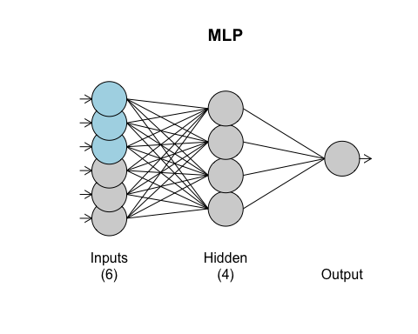

fore.mlp = forecast(fit.mlp, h = 8,xreg = melonomatrain)  
plot(fore.mlp, main="Melonoma Forecasts using Sunspot Yearly Data")

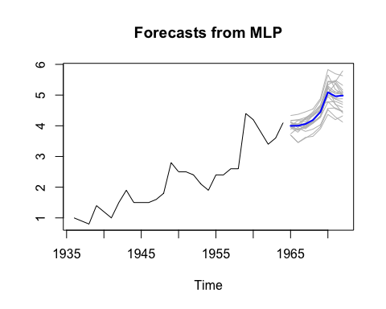

ASE = mean((sstest - fore.mlp$mean)^2)  
ASE

## [1] 0.07093303

## RNN Analysis of Pollution Data to Predict Mortality

train = ts(pol$cmort[1:498],start=1,frequency = 1)  
test = ts(pol$cmort[499:508],start=499,frequency = 1)  
  
set.seed(2)  
  
regs = data.frame(temp=ts(pol$temp,frequency = 1),part =ts(pol$part,frequency = 1))  
fit.mlp = mlp(train, hd.auto.type = "elm", xreg = regs)  
fit.mlp

## MLP fit with 5 hidden nodes and 20 repetitions.  
## Univariate lags: (1,2)  
## 2 regressors included.  
## - Regressor 1 lags: (1,2,4)  
## - Regressor 2 lags: (2)  
## Forecast combined using the median operator.  
## MSE: 22.0032.

plot(fit.mlp)

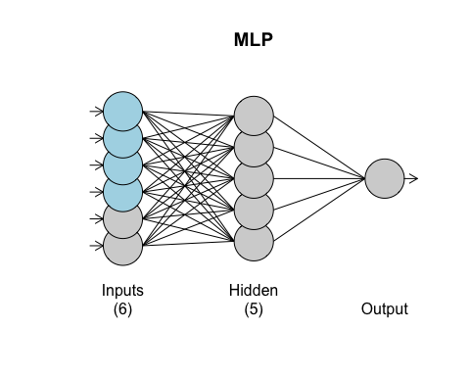

fore.mlp = forecast(fit.mlp, h = 10,xreg = regs)  
plot(fore.mlp)

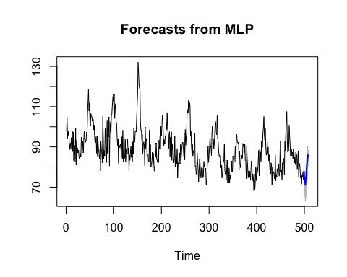

ASE = mean((test - fore.mlp$mean)^2)  
ASE

## [1] 30.19683

### Google Stock Price Predictions using RNN

# Get quantmod  
if (!require("quantmod")) {  
 install.packages("quantmod")  
 library(quantmod)  
}

## Loading required package: quantmod

## Loading required package: xts

## Loading required package: zoo

##   
## Attaching package: 'zoo'

## The following objects are masked from 'package:base':  
##   
## as.Date, as.Date.numeric

## Loading required package: TTR

## Version 0.4-0 included new data defaults. See ?getSymbols.

start <- as.Date("2016-01-01")  
end <- as.Date("2019-10-01")  
  
getSymbols("GOOGL", src = "yahoo", from = start, to = end)

## 'getSymbols' currently uses auto.assign=TRUE by default, but will  
## use auto.assign=FALSE in 0.5-0. You will still be able to use  
## 'loadSymbols' to automatically load data. getOption("getSymbols.env")  
## and getOption("getSymbols.auto.assign") will still be checked for  
## alternate defaults.  
##   
## This message is shown once per session and may be disabled by setting   
## options("getSymbols.warning4.0"=FALSE). See ?getSymbols for details.

## [1] "GOOGL"

googl = GOOGL$GOOGL.Close  
z <- fortify.zoo(GOOGL, name = "Date")  
train = ts(z$GOOGL.Close[1:(nrow(z)-10)],start=1,frequency = 1)  
test = ts(z$GOOGL.Close[(nrow(z)-10):nrow(z)],start=(nrow(z)-10),frequency = 1)  
  
regs = data.frame(volume = ts(z$GOOGL.Volume, frequency = 1),high = ts(z$GOOGL.High,frequency = 1),low = ts(z$GOOGL.Low,frequency = 1))  
  
set.seed(2)  
fit.mlp = mlp(train, hd.auto.type = "elm",xreg=regs)  
fit.mlp

## MLP fit with 8 hidden nodes and 20 repetitions.  
## Univariate lags: (1,2,3)  
## 3 regressors included.  
## - Regressor 1 lags: (1)  
## - Regressor 2 lags: (1,3,4)  
## - Regressor 3 lags: (3)  
## Forecast combined using the median operator.  
## MSE: 202.4603.

plot(fit.mlp)

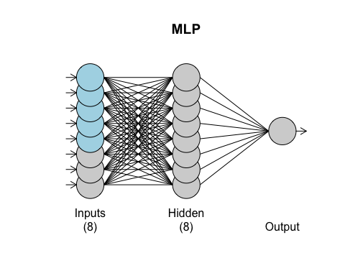

fore.mlp = forecast(fit.mlp, h = 10,xreg=regs)  
plot(fore.mlp)

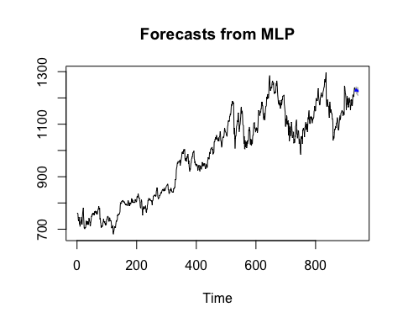

ASE = mean((test - fore.mlp$mean)^2)  
ASE

## [1] 84.28325