Live Session 6

Daniel Byrne

10/8/2019

## Question 1

#### Which model do you think is appropriate to use to forecast your time series? Why? Add this to the Google Doc as well as to your PowerPoint deck.

The model that seems most appropriate would be an airline model, with a 1-B trend component if the appropriate phi values can be found.

library(tswge)  
data(dowjones2014)  
  
plotts.wge(dowjones2014)

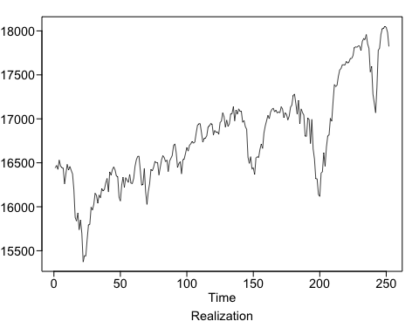

dlog = log(dowjones2014)  
plotts.wge(dlog)

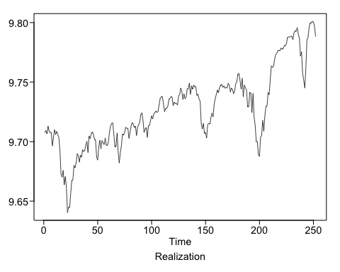

fore.aruma.wge(dlog,s=12,phi=c(-.36,-.05,-.14-.11,.04,.09,-.02,.02,.17,.03,-.1,-.38),d=1,n.ahead=36,lastn = TRUE,plot=TRUE,limits = FALSE)

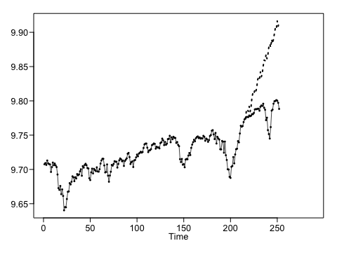

## $f  
## [1] 9.785805 9.787895 9.784569 9.791877 9.784300 9.791738 9.805887  
## [8] 9.811533 9.809866 9.816210 9.813367 9.818444 9.830627 9.834547  
## [15] 9.831852 9.842193 9.835122 9.840198 9.851118 9.859501 9.858598  
## [22] 9.867769 9.861494 9.867493 9.878521 9.882802 9.878139 9.889557  
## [29] 9.883702 9.890058 9.898567 9.906767 9.905023 9.916447 9.908905  
## [36] 9.915759  
##   
## $ll  
## [1] 9.762495 9.760220 9.752208 9.757794 9.746722 9.751059 9.762253  
## [8] 9.765393 9.760063 9.763498 9.758478 9.763200 9.764110 9.762678  
## [15] 9.752768 9.760310 9.748340 9.749143 9.755662 9.760969 9.755353  
## [22] 9.760154 9.749259 9.753933 9.754518 9.753069 9.739802 9.747297  
## [29] 9.735312 9.736339 9.738746 9.742797 9.735443 9.741881 9.728220  
## [36] 9.732592  
##   
## $ul  
## [1] 9.809115 9.815570 9.816931 9.825961 9.821877 9.832417 9.849520  
## [8] 9.857672 9.859669 9.868922 9.868256 9.873687 9.897143 9.906416  
## [15] 9.910936 9.924075 9.921904 9.931252 9.946574 9.958033 9.961844  
## [22] 9.975385 9.973728 9.981052 10.002525 10.012534 10.016475 10.031818  
## [29] 10.032091 10.043776 10.058388 10.070736 10.074603 10.091013 10.089591  
## [36] 10.098925  
##   
## $resid  
## [1] 0.000000e+00 0.000000e+00 0.000000e+00 0.000000e+00 0.000000e+00  
## [6] 0.000000e+00 0.000000e+00 0.000000e+00 0.000000e+00 0.000000e+00  
## [11] 0.000000e+00 0.000000e+00 0.000000e+00 0.000000e+00 0.000000e+00  
## [16] 0.000000e+00 0.000000e+00 0.000000e+00 0.000000e+00 0.000000e+00  
## [21] 0.000000e+00 0.000000e+00 0.000000e+00 0.000000e+00 4.110947e-03  
## [26] 1.668044e-02 9.388776e-03 3.808201e-02 2.011613e-02 3.448954e-03  
## [31] 3.050181e-02 -1.237681e-02 -1.355047e-02 3.346216e-02 -2.022890e-03  
## [36] 6.362482e-03 1.019217e-03 -9.879197e-03 8.702175e-03 -9.883880e-03  
## [41] -1.276086e-02 1.179419e-02 -1.134756e-02 3.542955e-03 2.439914e-02  
## [46] -7.193222e-03 -3.088190e-03 -1.016390e-02 -1.995746e-02 -1.017320e-02  
## [51] 9.022213e-04 -7.497513e-04 5.337938e-03 -5.635627e-03 1.883296e-03  
## [56] -2.151409e-03 -9.875969e-04 -3.361799e-03 -3.104568e-03 6.066832e-04  
## [61] 2.240547e-02 2.014202e-02 -2.289762e-03 -2.246307e-03 -7.625460e-03  
## [66] -2.244937e-02 -7.361313e-03 1.288373e-02 -2.630638e-02 -8.569712e-03  
## [71] 1.707518e-02 9.096031e-03 4.769566e-03 -1.116297e-03 -4.456313e-03  
## [76] -1.332401e-03 6.141431e-03 1.686437e-02 -2.441860e-03 -1.585505e-02  
## [81] 2.055487e-02 2.038080e-02 -5.987006e-03 -5.548840e-03 -1.392252e-02  
## [86] -1.702068e-02 3.243030e-03 3.865043e-03 6.438169e-04 3.212345e-03  
## [91] 1.361101e-02 3.916328e-03 -1.185803e-02 -7.717909e-03 -6.588416e-03  
## [96] -1.269740e-02 5.838693e-03 1.323184e-02 -3.761933e-03 7.224855e-03  
## [101] 4.948019e-03 -3.395470e-03 -7.431168e-03 1.611688e-03 9.590832e-03  
## [106] 1.096930e-03 5.510439e-03 2.094339e-02 -1.266954e-03 -2.677942e-03  
## [111] -6.554350e-03 -2.085916e-02 -2.992408e-03 -3.072979e-03 -1.351795e-04  
## [116] 7.713109e-03 4.195639e-03 4.848181e-03 1.549811e-03 -1.560171e-02  
## [121] -4.841827e-03 -7.498533e-03 -4.990409e-04 9.564566e-03 6.034337e-03  
## [126] 4.823926e-03 8.663208e-03 -3.389933e-03 -1.128790e-02 -3.159792e-03  
## [131] -1.069315e-02 5.083650e-03 7.580708e-03 5.383525e-03 8.769331e-03  
## [136] -1.900536e-03 -1.465912e-03 -3.380726e-03 -9.121410e-03 -4.074061e-03  
## [141] 6.777141e-03 -1.076794e-02 5.280621e-03 1.990829e-05 -1.224230e-02  
## [146] -1.981994e-02 -1.926364e-02 6.511315e-03 -1.758791e-02 -9.180217e-04  
## [151] -1.618637e-03 8.380895e-03 3.481014e-03 1.241354e-02 8.268248e-03  
## [156] 3.339689e-03 -3.838271e-03 2.845688e-02 2.558241e-02 -4.772009e-03  
## [161] 1.873974e-02 -5.603258e-04 9.124940e-03 -3.957686e-03 -1.706334e-03  
## [166] -3.913520e-03 -6.831883e-03 -5.519801e-03 1.217050e-02 -7.863359e-03  
## [171] -6.094794e-03 1.228756e-03 -1.354370e-02 4.560638e-03 -6.966701e-03  
## [176] -8.584587e-03 2.318736e-04 7.392067e-03 4.986681e-04 1.129475e-02  
## [181] 2.870490e-03 -7.100169e-03 -1.347424e-02 4.269027e-03 -7.443855e-03  
## [186] -2.843128e-03 1.828086e-03 -1.127331e-04 -1.205909e-02 -9.386472e-03  
## [191] 1.251380e-02 -9.536756e-03 -2.218119e-02 1.669376e-02 -4.884876e-03  
## [196] -2.757457e-02 7.975689e-03 -1.206803e-02 -2.007592e-02 -6.258760e-03  
## [201] 2.987822e-02 1.049855e-02 1.389758e-03 -9.481539e-04 3.287679e-02  
## [206] -5.903159e-03 1.321823e-02 3.196837e-02 6.790249e-03 1.686503e-02  
## [211] 3.548235e-02 2.130936e-02 -1.634666e-02 3.032546e-03 -1.377197e-02  
## [216] 8.173255e-03 -9.370630e-03 -5.397606e-03 1.975485e-03 -6.307814e-03  
## [221] 4.779702e-03 -2.873783e-03 -1.534885e-02 -8.675985e-03 1.087055e-03  
## [226] -3.060439e-03 1.475085e-03 -5.207892e-03 -5.264150e-03 -5.638847e-04  
## [231] -4.317408e-03 1.575746e-03 -1.635846e-03 -3.941147e-03 2.800593e-03  
## [236] -4.085868e-03 -7.941379e-03 -2.355150e-02 -5.937529e-03 -2.003498e-02  
## [241] -1.800954e-02 -8.452812e-03 1.564637e-02 2.535185e-02 8.429350e-03  
## [246] 1.885878e-02 5.645901e-03 3.389121e-03 1.937016e-03 1.656242e-02  
## [251] -1.155856e-02 1.612098e-03  
##   
## $wnv  
## [1] 0.000141438  
##   
## $se  
## [1] 0.01189277 0.01411988 0.01651094 0.01738971 0.01917218 0.02075471  
## [7] 0.02226208 0.02354060 0.02540963 0.02689387 0.02800456 0.02818537  
## [13] 0.03393681 0.03666787 0.04034897 0.04177697 0.04427659 0.04645640  
## [19] 0.04870209 0.05027131 0.05267620 0.05490584 0.05726258 0.05793865  
## [25] 0.06326733 0.06619002 0.07057978 0.07258191 0.07570885 0.07842782  
## [31] 0.08154142 0.08365792 0.08652035 0.08906437 0.09218654 0.09345224  
##   
## $psi  
## [1] 0.6400000 0.7196000 0.4589440 0.6788002 0.6683847 0.6770895 0.6434503  
## [8] 0.8042722 0.7408576 0.6565882 0.2680102 1.5893842 1.1676127 1.4157900  
## [15] 0.9105873 1.2332122 1.1825223 1.2291812 1.0478958 1.3230366 1.3022820  
## [22] 1.3671249 0.7420640 2.1369210 1.6355806 2.0603086 1.4235634 1.8106488  
## [29] 1.7213590 1.8765805 1.5722805 1.8558212 1.7771353 2.0002574 1.2888916  
## [36] 2.7273017  
##   
## $ptot  
## [1] 24  
##   
## $phitot  
## [1] 0.64 0.31 -0.20 0.29 0.05 -0.11 0.04 0.15 -0.14 -0.13 -0.28  
## [12] 1.38 -0.64 -0.31 0.20 -0.29 -0.05 0.11 -0.04 -0.15 0.14 0.13  
## [23] 0.28 -0.38

## Question 2

#### Find the first 5 psi weights for the model below, and use them to find the half-width of the 95 percentile probability interval for the third forecast (Xhat(3)). Please show your work as well as a plot of the series and the first eight forecasts with probability intervals.

w = psi.weights.wge(phi=c(.9,-.8),lag.max=5)

psi weights = 0.9, 0.01, -0.711, -0.6479, -0.01431

data = c(5,8,9,8,7,6,4,3)  
fore.arma.wge(data,phi=c(.9,-.8),plot=TRUE,limits = TRUE)

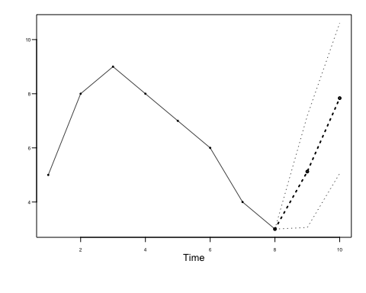

## $f  
## [1] 5.1250 7.8375  
##   
## $ll  
## [1] 3.059431 5.058561  
##   
## $ul  
## [1] 7.190569 10.616439  
##   
## $resid  
## [1] 0.000 0.000 0.175 0.675 1.375 0.475 -1.425 -1.425  
##   
## $wnv  
## [1] 1.110625  
##   
## $se  
## [1] 1.053862 1.417826  
##   
## $psi  
## [1] 0.90 0.01

## Question 3

Using the three models below and the Amtrak ridership data, which model has the smallest ASE in forecasting the next year (12 months)?  Show your code in forecasting the 12 observations as well as in calculating the ASE.

m1 = gen.arma.wge(n=12,phi=c(0.5511, 0.1680, -0.0145, 0.0651, 0.1388, -0.2966, 0.1539, 0.1270, -0.1815, 0.0364, 0.1456, 0.6287, -0.3832, -0.0199, -0.1679) , sn=24)  
m2 = gen.aruma.wge(n=12,phi=c(-0.02709541, 0.74213105) , theta=c(-0.5844596, 0.3836931), sn = 24)  
m3 = gen.aruma.wge(n=12,phi=0.306943,theta=0.7431719,s=12,d=1, sn = 24)  
  
f1 = fore.arma.wge(m1,phi=c(0.5511, 0.1680, -0.0145, 0.0651, 0.1388, -0.2966, 0.1539, 0.1270, -0.1815, 0.0364, 0.1456, 0.6287, -0.3832, -0.0199, -0.1679),n.ahead=12,lastn = TRUE,plot=TRUE,limits = FALSE)  
  
f2 =fore.aruma.wge(m2,phi=c(-0.02709541, 0.74213105) , theta=c(-0.5844596, 0.3836931),n.ahead=12,lastn = TRUE,plot=TRUE,limits = FALSE)  
  
f3 =fore.aruma.wge(m3,s=12,d=1,phi=0.306943,theta=0.7431719,n.ahead=12,lastn = TRUE,plot=TRUE,limits = FALSE)