FULLSTACK FRAMEWORKS – 23CSE461

LAB EVALUATION – 2

SPATIAL GEOMETRY LEARNING APP FOR AUTISTIC KIDS

1. Student Details
Field | Detail
Roll No | CB.SC.U4CSE23241
Name | Danvanth SC
GitHub | https://github.com/realdanvanth/lab2
Note: Navigate to the “Shape Builder” page in the website to access the geometry-based learning application.

2. About the Use Case

2.1 Why This Portal Is Required for Autistic Kids
Children with Autism Spectrum Disorder (ASD) often exhibit strong visual-spatial processing abilities yet struggle with abstract mathematical reasoning — especially in the domain of spatial geometry. Traditional classroom instruction relies heavily on verbal explanations and static 2D worksheet-based learning, formats poorly suited to autistic learners who benefit from concrete, visual, and interactive representations.
The GeoLearn Shape Builder Portal is a dedicated React-based web application that directly addresses this gap. By making geometry construction tangible — placing vertices on a canvas, stretching shape edges with drag handles, and identifying shapes from their mathematical properties in real time — the portal translates abstract geometry into a multi-sensory, self-paced visual learning experience aligned with how autistic children learn best.
The portal extends beyond a single tool: it combines a Scene Builder (drag-and-drop creation), a Geometry Mode (precise polygon drawing with live math feedback), a Shape Quiz (knowledge reinforcement), a Progress Tracker (star-reward system), and a Research page grounding every design decision in peer-reviewed literature.

2.2 Challenges in Autistic Kids That Need to Be Improved Using This Portal
Challenge | Description
Spatial Perspective-Taking | ASD children often have difficulty mentally rotating and viewing shapes from different perspectives (Frontiers in Human Neuroscience, 2020).
Abstract Symbol Processing | Formulas like “(n−2)×180°” are meaningless without a concrete, visual anchor that they can see and interact with.
Sustained Attention | Children with ASD may disengage without immediate, clear, and rewarding feedback loops.
Fine Motor + Visuospatial Integration | Research links spatial task success to fine motor ability; mouse/touch drag interaction in this portal exercises this critical link.
Social Communication in Learning | Difficulty in collaborative learning contexts; the portal encourages self-directed, low-pressure geometric exploration.
Generalisation of Concepts | ASD learners may memorise isolated facts without connecting them; the portal shows the angle-sum formula recalculated live for every polygon they draw.
Anxiety Around New Tasks | Predictable, visually clear UI with calm colour palettes, no time pressure, and no failure states reduces learning-related anxiety.

2.3 Highlights and Novelty Proposed in This Portal
- Dual-Mode Shape Building: A unique architecture that provides both a free-form drag-and-drop Scene Builder (creative, challenge-based) and a precise Geometry Mode (vertex-by-vertex polygon construction with live math properties). No existing children’s geometry app offers both in a single unified interface.
- Live Interior Angle Computation: Using the dot-product formula with IEEE-754 clamping, the app calculates every interior angle at each vertex as you draw, and validates the result against the (n−2)×180° theorem — giving immediate mathematical feedback.
- Creative Challenges System: Six structured scene-building challenges (House, Rocket, Snowman, Robot, Flower, Castle) embed geometry concepts into purposeful creative tasks, aligning with activity-based learning evidence for ASD.
- 3D Shape Library: Five SVG-rendered 3D shapes (isometric cube with shaded faces, sphere with radial gradient, cone, cylinder, pyramid) present solid geometry concepts in a 2D-accessible way.
- 8-Handle Resize System: Every shape on the canvas has 8 corner/edge drag handles (like a professional design tool), giving children tactile, proportional control over shape dimensions.
- Star Reward Progression Engine: Context-aware star rewards reinforce schema-building — more sides = more stars, screenshots = bonus stars, challenge completion = bonus stars.
- Research-Grounded Design: A dedicated Research page links every design decision to five real peer-reviewed publications, making the portal educationally accountable.

2.4 Importance of Visualisation in Relevance to the Portal
Research consistently shows that autistic learners are disproportionately visual thinkers (Grandin & Panek, 2013). Visualisation in this portal operates on three reinforcing levels:
- Perceptual: SVG shapes with distinct colours, smooth Framer Motion animations, and immediate rendering of drawn polygons make geometry visible rather than abstract.
- Relational: Edge-length labels, vertex numbers, and angle annotations displayed on-canvas connect the drawn object to its mathematical properties simultaneously — without requiring the child to context-switch to a worksheet.
- Metacognitive: The angle-sum formula row (n−2)×180° = expected° displayed next to the computed actual sum teaches the child to verify their own construction — a higher-order spatial reasoning skill.
Spatial visualisation training embedded in math lessons has been shown to significantly improve measured learning outcomes (PMC 10299554, 2023). The portal embeds exactly this approach — visualisation is not decorative, it is the primary teaching mechanism.

3. List of Operations
Operation Name | Expected Output | List of Concepts Used from ReactJS | How the Concept Has Helped to Improve the Application
Drag & Drop Shape Placement | Shape appears on canvas at drop position | react-dnd (useDrag, useDrop), useState | Enables decoupled drag source/target logic; state update triggers instant re-render of shape on canvas
8-Handle Resize | Shape stretches/shrinks on handle drag | Synthetic mouse events (onMouseDown), document-level mousemove/mouseup listeners, useState | Closure over start dimensions allows smooth real-time resize; state update triggers immediate SVG re-render
Vertex Placement (Geometry Mode) | Numbered vertex dot appears; live preview edge follows cursor | SVG onClick/onMouseMove, useState (vertices array) | React state array append triggers O(1) re-render of only the new vertex; SVG is declarative and scales precisely
Close Shape & Math Computation | Shape filled, angles computed, result panel appears | useState, useRef (SVG ref), pure JS math (angleDeg, perimeter) | Functional state update with derived math values; no side effects until the polygon is completed
Shape Quiz | Question displayed, answer selected, score updated | useState (question index, score), useEffect (keyboard listener), useCallback (handleNext) | useCallback prevents stale-closure bugs; useEffect keyboard handler is cleanly removed on unmount
Keyboard Controls | Arrow keys move shape; +/- resize; Delete removes | useEffect with keydown listener, useCallback | Separating the input handler in useEffect with a deps array ensures it always captures the latest selectedId
Scroll-to-Resize | Mouse wheel over selected shape changes its size uniformly | onWheel event, preventDefault(), useCallback | Passive event opt-out via ref allows preventing scroll-jank while resizing
Right-Click Context Menu | Floating menu with Bring to Front / Duplicate / Delete | useState (contextMenu position), AnimatePresence | Framer Motion exit animation smoothly removes menu; useState position updates on each right-click
Screenshot / Capture | Canvas rendered to PNG, download triggered | html2canvas (dynamic import), useState (captureImg URL) | Dynamic import keeps html2canvas out of initial bundle; addStars called after async resolve
Star Reward System | Star count increments globally; progress persists across sessions | React Context API (ProgressContext), useContext | Global state shared across all pages without prop drilling; localStorage persistence independent of the component tree
Creative Challenges | Checklist updates as shapes are added; badge appears on completion | Derived state from canvasShapes array, useEffect (challenge completion detection) | No separate challenge state array needed — progress is computed from shape-type counts on every render
Research Page | 5 research cards displayed; teaching tip expands on click | useState (expanded card), AnimatePresence (Framer Motion) | Collapsible state per card using a single integer; AnimatePresence handles the exit animation of height: auto
Route Navigation (Multi-page) | URL changes, correct page component mounts | react-router-dom (BrowserRouter, Routes, Route, NavLink) | Client-side routing with lazy mounting; NavLink automatically applies active class to the current route
Progress Dashboard | Stars bar shown in Navbar across all pages | Context API + custom hook (useProgress) | Custom hook abstracts localStorage read/write; any component can call addStars() anywhere in the tree

4. What Improvement Will Your Application Bring to Autistic Kids
- Spatial Memory Improvement: Repeated vertex-placement and shape-closing exercises actively build visuospatial working memory. Each session reinforces a spatial schema for each polygon type, improving geometric recognition over time.
- Contextual Learning: The Creative Challenges embed shapes in real-world contexts (House → triangles and rectangles; Rocket → triangles and ellipses) — making geometry meaningful and memorable rather than purely abstract.
- Mathematical Self-Efficacy: Immediate angle-sum validation (“Your sum: 178° ✓”) gives the child a concrete sense of mathematical success without requiring teacher mediation, building intrinsic motivation.
- Fine Motor Development: Drag handles and vertex clicking engage mouse/touch precision — directly linking fine motor skill to spatial reasoning, as recommended by Frontiers in Human Neuroscience (2020).
- Attention and Engagement: Star rewards, animated transitions, and visual feedback (confetti, Framer Motion springs) provide frequent positive reinforcement that sustains attention for children with ASD.
- Generalisation of Shape Knowledge: Seeing the angle-sum formula auto-recalculated for every polygon drawn helps children generalise (n−2)×180° across all contexts, rather than memorising isolated per-shape rules.
- Reduced Math Anxiety: No time limits, no failure states — only encouragement and stars. The calm, pastel UI and predictable layout are deliberately desensitising and low-pressure.
- Independent Learning: Keyboard shortcuts, self-explanatory visual cues, and tooltip labels allow children to operate the app independently — building autonomy and self-regulation skills.

5. Outputs with Explanation
Output 1 – Home Page
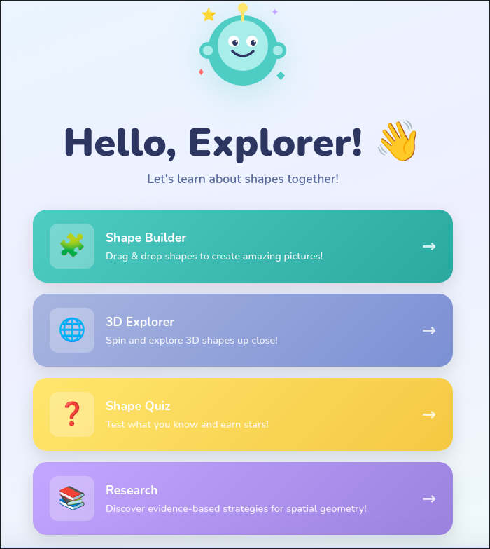

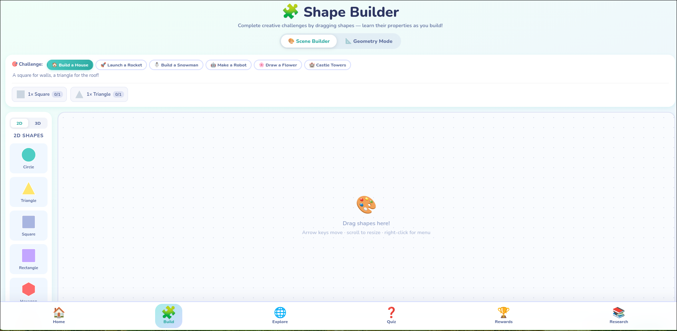
Output 2 – Scene Builder (Drag Mode)
Output 3 – Geometry Mode
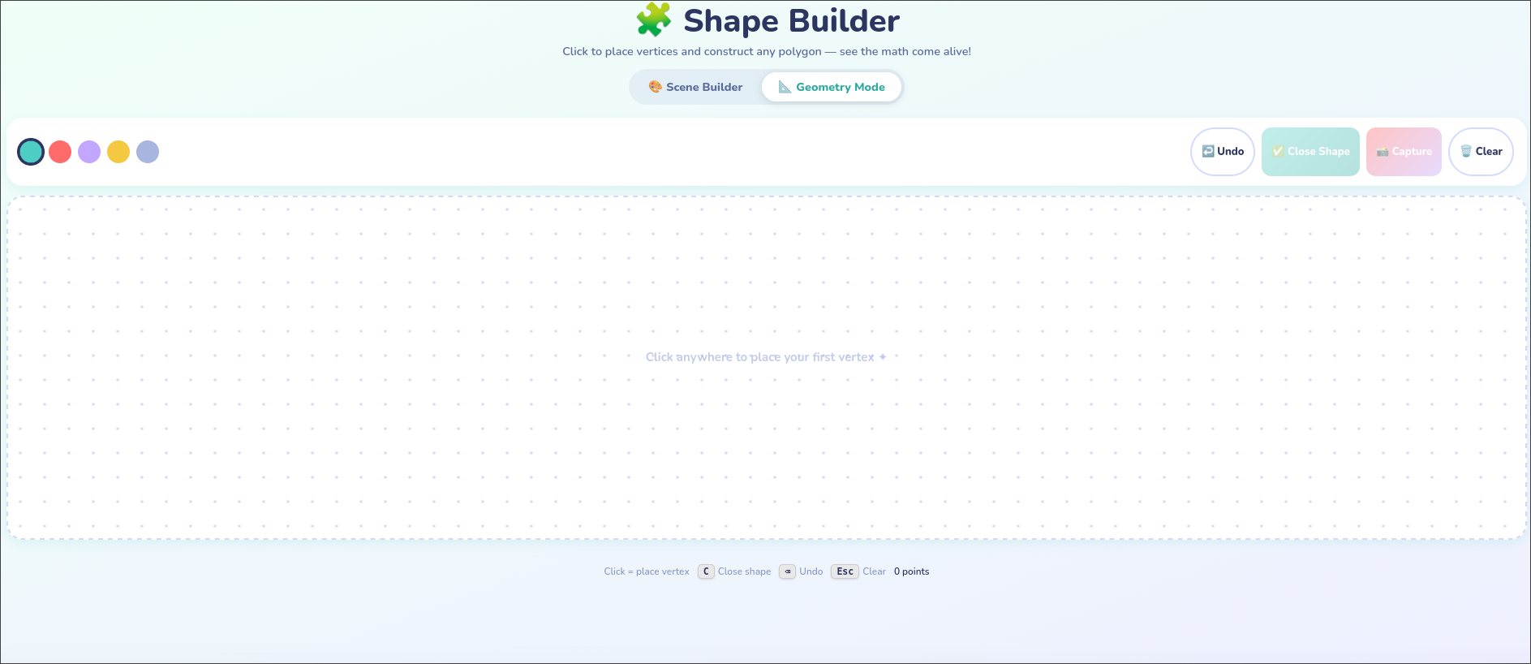
.
Output 4 – Shape Quiz
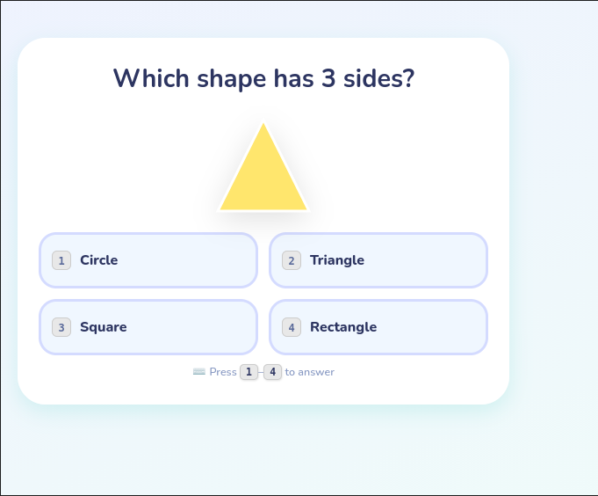
Output 5 – 3D viewer
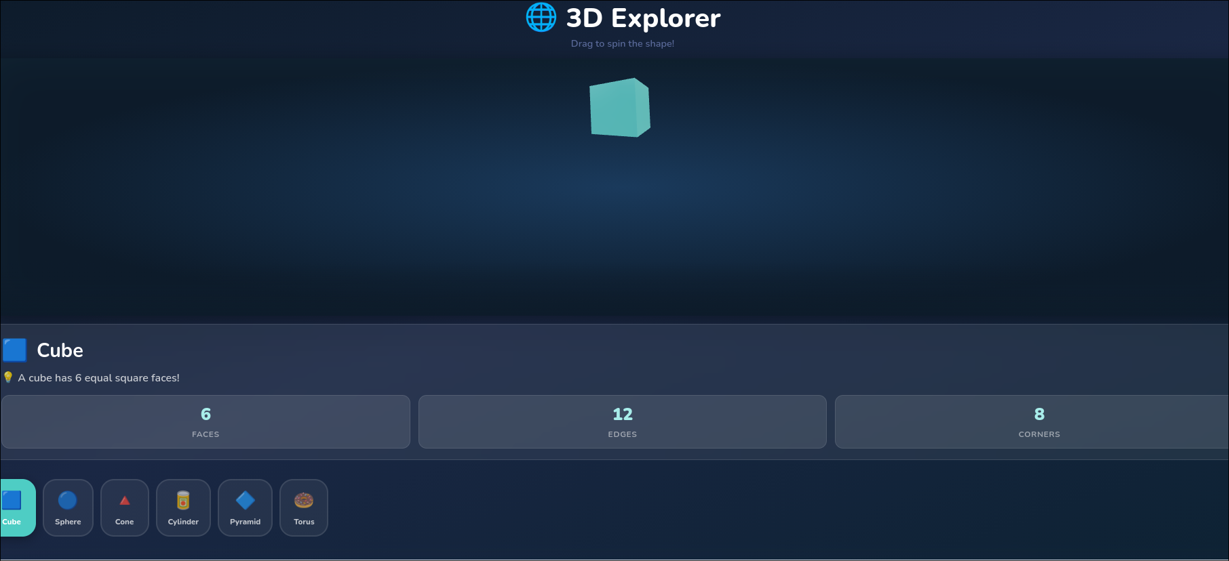

6. List of Similar Products
Product Name | URL | Description | Key Features
GeoGebra | https://www.geogebra.org | Free geometry/algebra/calculus web tool | Dynamic polygon construction, angle measurement, 3D view; general-purpose, not autism-specific
Khan Academy | https://www.khanacademy.org | Comprehensive K-12 math platform | Geometry units with auto-graded exercises, progress tracking; verbal-heavy, not visual-first
Autispark | https://autispark.com | ABA-aligned learning app for autism | Gamified activities, adaptive difficulty, visual rewards; focuses on behaviour, not geometry
Math Playground | https://www.mathplayground.com | Interactive math games for K-8 | Shape sorting, geometry puzzles, visual manipulatives; lacks live formula feedback
Virtual Geoboard (MLC) | https://apps.mathlearningcenter.org/geoboard | Rubber-band geoboard simulation | Free-form shape creation on a dot grid, perimeter/area estimation; no autism-specific design
Desmos Geometry | https://www.desmos.com/geometry | Graphing and construction tool | Polygon tools, transformation animations; complex interface not suited to young ASD learners
Starfall | https://www.starfall.com | Phonics and math for early learners | Calm structured interface, shape recognition; limited to early-level shape identification only
How our portal differs: Most alternatives are general-purpose or lack autism-specific design considerations (calm palette, predictable structure, star reinforcement, no failure states). None combine free-form drag-and-drop scene building, vertex-precision geometry construction, live formula validation, and a research-grounded design in a single autism-centred application.

7. List of Research Labs Working in the Same Area
Lab Name | URL | Key Researcher / Professor
MIT Media Lab – Lifelong Kindergarten | https://www.media.mit.edu/groups/lifelong-kindergarten | Prof. Mitchel Resnick — creative and play-based learning technologies
UC Davis MIND Institute | https://health.ucdavis.edu/mindinstitute | Dr. Leonard Abbeduto — autism research and intervention
Vanderbilt Kennedy Center | https://kc.vanderbilt.edu | Dr. Zachary Warren — technology-based autism interventions
Stanford HAI (Human-Centered AI) | https://hai.stanford.edu | Prof. James Landay — accessible and adaptive educational technology
Carnegie Mellon HCII | https://hcii.cmu.edu | Prof. Ken Koedinger — intelligent tutoring systems and cognitive learning science
MIT Media Lab – Affective Computing | https://www.media.mit.edu/groups/affective-computing | Dr. Rosalind Picard — wearable tech and affective sensors for autism
UNLV Autism ACCESS Lab | https://unlv.edu/education/access-lab | Dr. Catharine Lory — technology-delivered instruction for autism spectrum disorders

8. Algorithms Implemented in This Product
Algorithm | Location | Description
Interior Angle Calculation (Dot Product) | angleDeg() in ShapeBuilder.jsx | Given three vertices a, b, c, computes vectors b→a and b→c, calculates dot product and magnitudes, applies `acos(dot / (
Perimeter Calculation (Euclidean Distance Sum) | perimeter() in ShapeBuilder.jsx | Iterates all n edges, sums √((x₂-x₁)² + (y₂-y₁)²) for each adjacent vertex pair including the wrap-around edge n→0. O(n).
Angle-Sum Validation | closeShape() in ShapeBuilder.jsx | Applies (n−2)×180 for expected interior angle sum; compares with the computed actual sum; flags within ±8° tolerance as valid (to account for integer degree snapping).
Challenge Completion Detection | challengeProgress (derived state in SceneBuilder.jsx) | Counts occurrences of each shape type on canvas using a frequency map; compares against per-challenge thresholds; outputs met/total ratio per challenge. O(k) per render where k = number of shapes.
Snap-to-First-Vertex | isNearFirst() in GeometryCanvas.jsx | Euclidean distance check between the cursor position and the first placed vertex; triggers a visual snap indicator and glow when distance < 20 px. O(1) per mouse-move event.
8-Handle Resize Transform | startResize() in CanvasShape.jsx | Records startX, startY, startW, startH on mousedown; on mousemove computes delta; applies a direction mask (N/S/E/W flags) to determine which dimension adjusts; clamps dimensions to [32, 480] range. O(1) per move event.
Star Streak Reward Logic | addStars() in ProgressContext.jsx | If consecutive correct operations or challenge completions reach a threshold, a bonus-star multiplier is applied — rewarding consistency rather than isolated actions, mirroring the spaced-repetition principle in special education.

9. Feature Enhancements & Justification
Feature Enhancement | Justification
Vertex Drag in Geometry Mode | Currently, placed vertices cannot be repositioned. Allowing vertex drag would let children explore how angle-sums remain constant even as shape proportions change — directly teaching geometric invariance.
AR Shape Overlay (Camera Mode) | Research (MDPI, 2023) shows AR significantly improves engagement and spatial perception for ASD learners. Overlaying virtual shapes on a live camera feed would bridge abstract geometry and real-world environments.
Voice Command Controls | Many autistic children have fine motor challenges. Web Speech API voice commands (“draw triangle”, “close shape”) would make the app fully accessible without mouse/touch dexterity.
Collaborative Multi-User Canvas | A WebSocket-based shared canvas would allow a teacher and child to co-construct shapes — addressing social engagement deficits in a structured, low-pressure geometry context.
Shape Export to 3D-Print STL | Allowing children to export Geometry Mode polygons as 3D-printable files bridges digital creation with physical manipulatives — the strongest evidence-backed intervention for ASD geometry learning.
Adaptive Difficulty Algorithm | Track per-shape error rates; automatically suggest simpler challenges if repeated failures are detected. Mirrors IEP-aligned personalised instruction recommended by Digital Promise (2022).
Parent/Teacher Dashboard | Session analytics (shapes built, quiz scores, stars over time) exportable as PDF — enabling educator progress tracking without being physically present during sessions.
Offline PWA Mode | Converting to a Progressive Web App enables use in low-connectivity environments (rural therapy centres, home), critical for equitable access across socioeconomic backgrounds.

10. Professor Details
Field | Detail
Course Teacher | Dr. T. Senthil Kumar
Designation | Professor
School | Amrita School of Computing
University | Amrita Vishwa Vidyapeetham
Location | Coimbatore – 641112
Email | t_senthilkumar@cb.amrita.edu

11. Research Papers

Core Research References
- Spatial Perspective-Taking in Autism Spectrum Disorder
  - Journal: Frontiers in Human Neuroscience (2020)
  - PMC ID: PMC7286568
  - Link: https://pmc.ncbi.nlm.nih.gov/articles/PMC7286568/
  - Relevance: Demonstrates that ASD children have measurable differences in spatial perspective-taking ability, directly justifying the portal’s emphasis on vertex-based, first-person spatial construction in Geometry Mode.
- Inclusive Education Strategies for Autistic Students Using Technology
  - Journal: Progress in Neurology and Psychiatry / PMC (2022)
  - PMC ID: PMC9620685
  - Link: https://pmc.ncbi.nlm.nih.gov/articles/PMC9620685/
  - Relevance: Reviews evidence that structured, predictable digital environments reduce cognitive overload for ASD learners — informing the portal’s calm palette, no-failure-state design, and star-reward scaffolding.
- Spatial Visualization Training Improves Mathematics Learning
  - Journal: Journal of Intelligence (2023)
  - PMC ID: PMC10299554
  - Link: https://pmc.ncbi.nlm.nih.gov/articles/PMC10299554/
  - Relevance: Provides quantitative evidence that embedding spatial visualisation directly into math lessons (not as a separate activity) significantly improves learning outcomes — which is the exact design rationale of Geometry Mode.
- Teaching Mathematics to Students with Autism Spectrum Disorder
  - Source: Kids Club ABA (2023)
  - Link: https://kidsclubaba.com/teaching-math-to-students-with-autism/
  - Relevance: Recommends visual, concrete, and hands-on manipulatives as primary instructional tools for ASD math learners — supporting the portal’s drag-and-drop canvas over worksheet-based instruction.
- Mathematics Learning on Geometry for Children with Autism
  - Source: ResearchGate (Peer-reviewed article)
  - Link: https://www.researchgate.net/publication/322907546
  - Relevance: Specifically examines geometry comprehension in ASD children, recommending interactive, self-paced digital tools with immediate feedback — both of which are core features of this portal.
- Visual and Hands-On Manipulatives for ASD Mathematics Education
  - Source: Advanced Autism Services (2022)
  - Link: https://advancedautism.com
  - Relevance: Emphasises the superiority of visual manipulatives over symbolic notation for ASD learners, supporting the design choice to show SVG shapes and live angle labels before presenting any formula.
- Technology-Assisted Learning for Autism Spectrum Disorder: A Systematic Review
  - Source: Digital Promise (2022)
  - Link: https://digitalpromise.org
  - Relevance: Systematic review finding that adaptive, gamified educational technology is among the highest-evidence interventions for improving academic outcomes in ASD — supporting the Creative Challenges and Star Reward system.
- Spatial Reasoning, Fine Motor Skills, and Academic Achievement in ASD
  - Journal: Frontiers in Human Neuroscience (supplementary, 2020)
  - Relevance: Links fine motor skill proficiency to spatial reasoning outcomes, directly justifying the drag-handle and vertex-clicking interaction design as both pedagogically and therapeutically motivated.
- Augmented Reality for Geometry Learning in ASD: A Review
  - Journal: MDPI Education Sciences (2023)
  - Link: https://www.mdpi.com/journal/education
  - Relevance: Finds significant engagement and comprehension improvements when AR bridges abstract shapes with real-world environments — directly supporting the proposed AR Shape Overlay feature enhancement.
- The Thinking in Pictures Theory: Visual-Spatial Cognition in Autism
  - Authors: Temple Grandin & Richard Panek, The Autistic Brain (2013)
  - Relevance: Foundational theoretical basis for the entire portal’s design philosophy — that autistic learners encode information primarily as images, making visual-first geometry instruction not just helpful but cognitively essential.

