V1.1 5-23-2018
Server Based GhostBuster Application Note
- Interface Specification
entity Ghost_Buster_Top is
port (
clock : in std_logic ;
reset : in std_logic ;
byPass : in std_logic ;
--
delay : out integer ;
H_ready : out std_logic ;
V_ready : out std_logic ;
--
data_from_uP : in std_logic_vector (15 downto 0) ;
data_to_uP : out std_logic_vector (15 downto 0) ;
uP_addr : in std_logic_vector (7 downto 1) ;
wr_en : in std_logic ;
chip_sel : in std_logic ;
--
horz_in : in std_logic ;
vert_in : in std_logic ;
field_in : in std_logic ;
--
RED_left_in : in std_logic_vector (15 downto 0) ;
GRN_left_in : in std_logic_vector (15 downto 0) ;
BLU_left_in : in std_logic_vector (15 downto 0) ;
--
RED_right_in : in std_logic_vector (15 downto 0) ;
GRN_right_in : in std_logic_vector (15 downto 0) ;
BLU_right_in : in std_logic_vector (15 downto 0) ;
--
act_image_out : out std_logic ;
horz_out : out std_logic ;
vert_out : out std_logic ;
field_out : out std_logic ;
--
RED_left_out : out std_logic_vector (15 downto 0) ;
GRN_left_out : out std_logic_vector (15 downto 0) ;
BLU_left_out : out std_logic_vector (15 downto 0) ;
--
RED_right_out : out std_logic_vector (15 downto 0) ;
GRN_right_out : out std_logic_vector (15 downto 0) ;
BLU_right_out : out std_logic_vector (15 downto 0)
) ;

  - Signal Description :
    - System Interface :
clock :
Pixel clock, the design assumes that all image and timing reference signals are referenced to the rising edge of this clock.

reset :
Active high reset which clears all registers, note that some registers utilize this signal as a synchronous reset so it should be held for several clock cycles.

delay :
This signal is drive by an integer constant, it indicates the Ghost Buster pipe delay in pixel clocks. This signal can be used to assist in the creation of a bypass function whose depth is equal to the processing path pipe delay.

byPass :
Activates the internal by-pass data path. The GhostBuster and internal by-pass paths are of equal length so this signal can be activated on any pixel clock leading edge without disrupting the sequencing of the image timing signals.

H_ready :
An active high status signals which indicates that the GhostBusting process has identified and locked onto the horizontal timing of the input image.

V_ready :
An active high status signals which indicates that the GhostBusting process has identified and locked onto the vertical timing of the input image.

    - Processor Interface:
Note that the processor interface is assumed to be asynchronous with the pixel clock (clock).

data_from_uP :
Sixteen bit data bus which drives the data input of the LUTs and control registers of this module. All accesses to the LUTs and registers are always 16 bit.

data_to_uP:
Sixteen data bus which allows read back of the Ghost Factor LUT. NOTE the GhostBuster MUST be in bypass mode in order to read the values in the LUT.

uP_addr:
Seven bit word (16 bit) address used to select the target for writes to the LUTs and control registers in this module. Address bits 7:6 select the RED (“00”), GREEN (“01”) or BLUE (“10”) LUT. Address bits select the GhostBuster zone (0-31) within each LUT.

wr_en:
Active high write enable, this signal must be at least 4 pixel clocks wide.

chip_sel:
Active high chip select , this signal must be at least 4 pixel clocks wide and it must be active along with wr_en for writes.
    - Image Timing Interface :
horz_in :
Active high horizontal timing reference, this signal must be driven active during any horizontal blanking period (EAV to SAV). This signal is delayed by the GhostBuster pipe delay and output at horz_out.

vert_in:
Active high vertical timing reference, this signal must be driven active during any vertical blanking period (EAV to SAV). This signal is delayed by the GhostBuster pipe delay and output at vert_out.

field_in :
This signal is delayed by the pipe delay of the GhostBuster module and output at field_out, it is not utilized by this module.

act_image_out :
act_image_out is an internally generated signal equal to horz_in NOR vert_in delayed by the pipe delay of the GhostBuster.

horz_out :
horz_in delayed by the pipe delay of the GhostBuster.

vert_out :
vert_in delayed by the pipe delay of the GhostBuster.

field_out :
field_in delayed by the pipe delay of the GhostBuster.

Image Interface :
RED_left_in, GRN_left_in, BLU_left_in :
Sixteen bit unsigned RGB pixel data input for the left eye image.

RED_right_in, GRN_right_in, BLU_right_in :
Sixteen bit unsigned RGB pixel data input for the right eye image.

RED_left_out, GRN_left_out, BLU_left_out :
Sixteen bit unsigned RGB pixel data output for the left eye image. When the byPass signal is low the output will be the GhostBusted image. When the byPass signal is high the output will be RED_left_in, GRN_left_in and BLU_left_in delayed by the pipe delay of the GhostBuster module.

RED_right_out, GRN_right_out, BLU_right_out :
Sixteen bit unsigned RGB pixel data output for the right eye image. When the byPass signal is low the output will be the GhostBusted image. When the byPass signal is high the output will be RED_right_in, GRN_right_in and BLU_right_in delayed by the pipe delay of the GhostBuster module.

  - Server Support :
At system initialization the server must copy the contents of the default Ghost Factor file to the GhostBuster FPGA IP, this file will contain 96 16bit values. It must be possible to provide a set of auditorium specific Ghost Factor by either over writing the default file or specifying a file to load before any 3D content is played. A set of GhostFactor files which support RGB or XYZ formats as well as system testing are provided in the release package.

In order to support system validation and testing some facility must be provided for controlling the by-pass signal to the GhostBuster FPGA IP. This feature should not be customer accessible.

  - Basic Operation:
The GhostBuster evaluates the video timing and splits the image into 32 zones (8 columns by 4 rows) each of which can be assigned a unique GhostFactor for each color (RGB or XYZ). This 96 element array of 16 bit unsigned integers ordered as zone 0-31 RED (or X) followed by 0-31 GREEN (or Y) followed by 0-31 BLUE (or Z).
The unsigned integer values are equal to (2^17)*(GhostFactor% / 100). So 1723/(2^17) * 100 = 1.315% , 1638/(2^17) * 100 = 1.25%, and 1808/(2^17) * 100 = 1.38% . Note that since the values in the file are treated as 16 bit unsigned values the maximum GhostFactor supported is 50%

The zones are physically mapped as :
0 | 1 | 2 | 3 | 4 | 5 | 6 | 7
8 | 9 | 10 | 11 | 12 | 13 | 14 | 15
16 | 17 | 18 | 19 | 20 | 21 | 22 | 23
24 | 25 | 26 | 27 | 28 | 29 | 30 | 31

- Resource Requirements
Note that the resource requirements shown are only an example based on builds for a specific family with no attempt at optimization, and the use of FPGA vendor Memory IP. These resource numbers can be used to sanity check a build to verify that no significant resources have been optimized out due to missing files or system settings.
Family | Device | Multipliers | Memory | Registers | Logic | Pins
Altera Cyclone V | 5CSEMA5F31C7 | 6 DSP Blocks | 4,928 bits | 815 | 367 ALM’s | 277
Xilinx Kintex-7 | 7k70tfbv676-1 | 6 DSP Blocks | 154 LUT’s | 1213 | 345 LUT’s | 277

The above information is based on Xilinx Vivado (Web edition) 2018.1 and Altera Quartus Prime 17.1.0 (Lite edition).

- GhostBuster IP Source Files
The source files common to all FPGA architectures are found in the “GB_VHDL_source: directory.

Ghost_Buster_Top.vhd is the top level of the design which is instantiated in the target system. It is a wrapper for the GhostBuster source and a set of output registers.

Ghost_Buster_RGB_16b.vhd contains the component which performs the calculations, the bypass memory, bus interface logic, output registers, and pixel value saturation logic.

deGhost_RGB_8x4.vhd performs the GhostBuster calculations, it access the GhostFactor lookup tables and evaluates the video timing to create the 32 image zones. The GhostFactor LUT’s are built from architecture specific 32x18 dual port RAMs.

ByPass_72bits.vhd contains the RAM’s which implement the GhostBuster bypass function. The bypass functions uses architecture specific 32x36 dual port RAMs.

- GhostBuster Simulation Source Files.
The test benches are found in the “TestBench” directory.
  - GhostFactors
This test bench uses “TB_deGhost.vhd” and “utilities.vhd”, it loads the GhostFactor LUT’s with a set of 96 factors and applies five sets of six pixel values. The test bench checks that the GhostFactors calculated from the input and output pixel values in each image zone is within +/- 10% of the LUT value for that zone and color. A “.CSV” file is created which lists the input and output pixel values, the GhostFactor from the LUT, and the calculated GhostFactor for each eye.

  - PixelValues
This test bench uses “TB_deGhost.vhd” and “utilities.vhd”, it loads the GhostFactor LUT’s with all factors set to 0 and applies a new set of six pixel values at each clock during the valid video period. This test bench can be used to evaluate the GhostBuster pipe delay.

- Altera Specific Information
  - Files
dpRAM_32x36.vhd ; Simulation model for the 32x36 GhostBuster bypass RAM, in “FPGA_IP\Altera” folder.
dpRAM_32x18.vhd ; Simulation model for the 32x18 Ghost Factor LUT RAM, in “FPGA_IP\Altera” folder.

  - Procedure
- Copy the “GB_FPGA_IP\Altera” and “GB_VHDL_source” directories into the project directory structure.
- Include Ghost_Buster_RGB_16b.vhd, deGhost_RGB_8x4.vhd, ByPass_72bits.vhd, dpRAM_32x36.vhd, Ghost_Buster_Top.vhd, and dpRAM_32x18.vhd in the project.
- Run “Analysis & Synthesis”
- In the Hierarchy project navigator drill down to the RAM IP and use the MegaWizard Plug in Manager to modify the RAM parameters for the target architecture. Also turn off “use file for initial contents”
- Run “Analysis & Synthesis” and “Fitter” to verify resource usage.
  - dpRAM_32x36 RAM Parameters
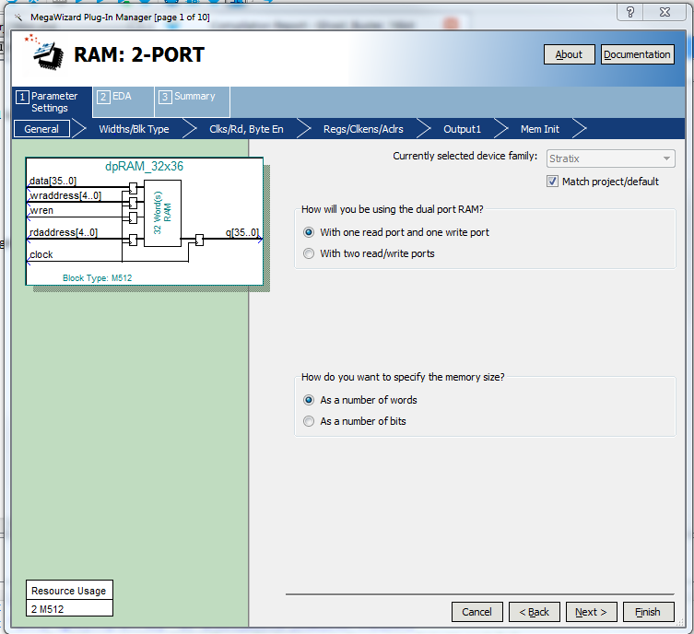
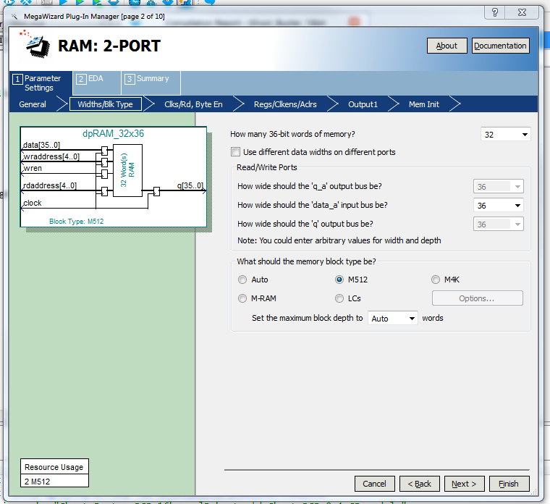
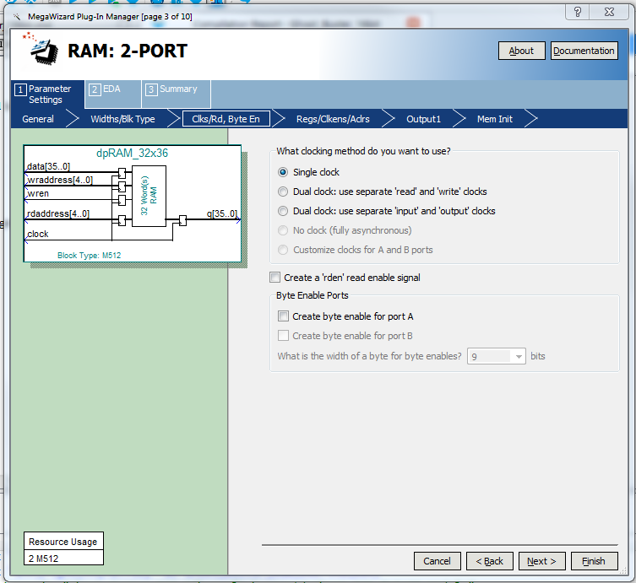
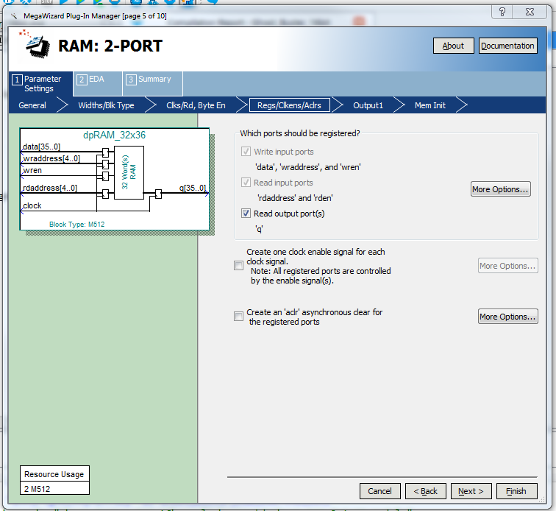
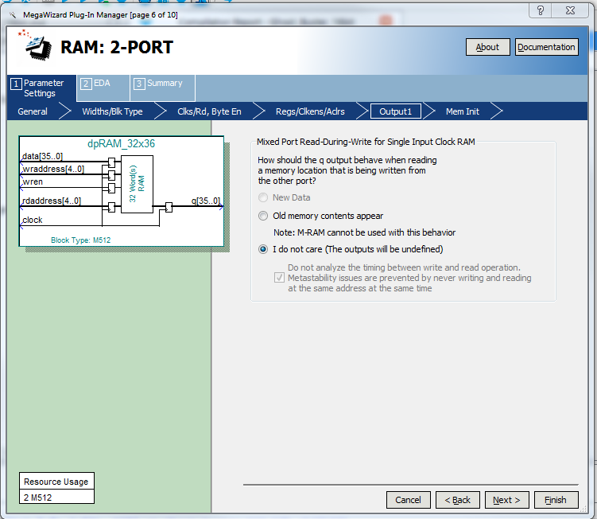
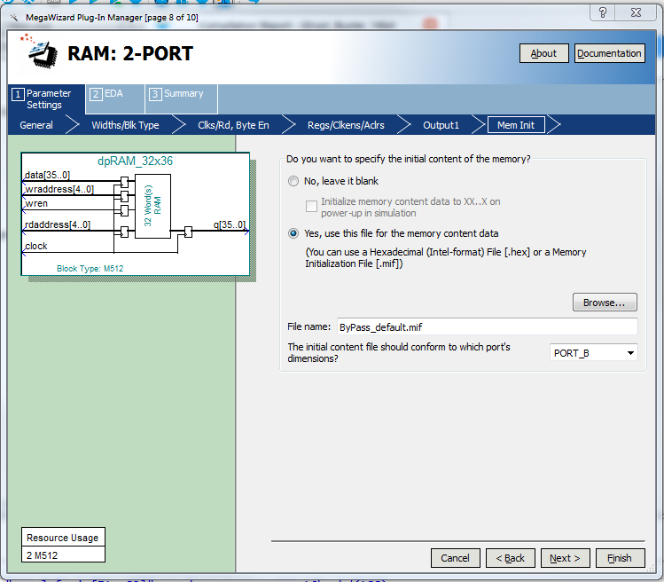
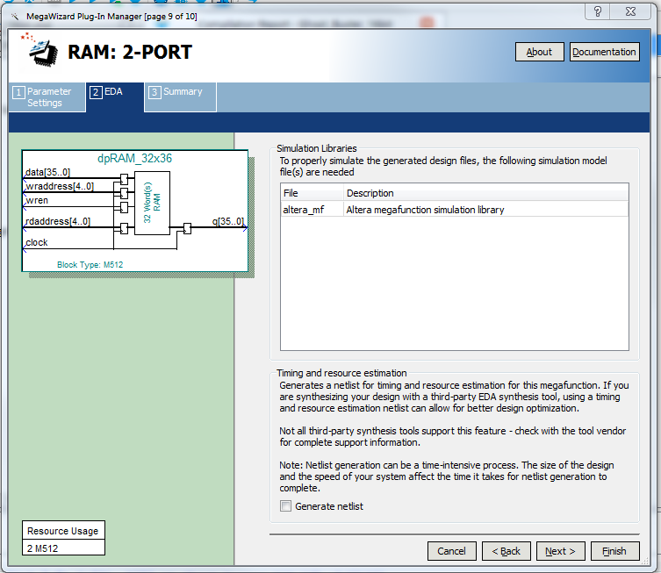
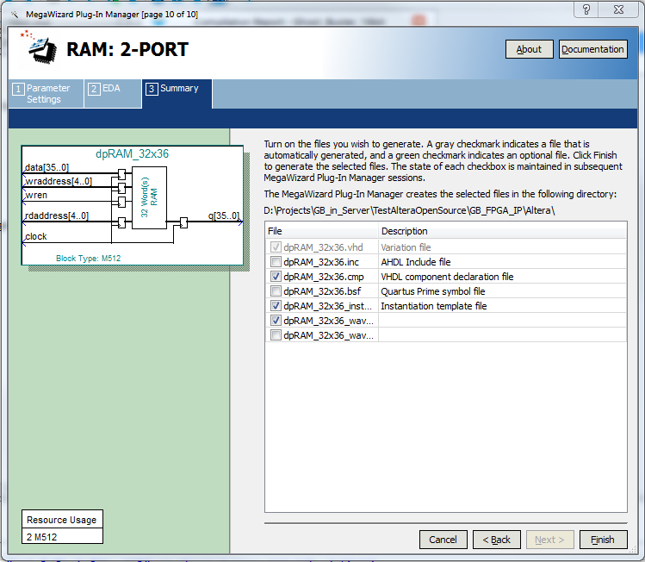

  - dpRAM_32x18 RAM Parameters
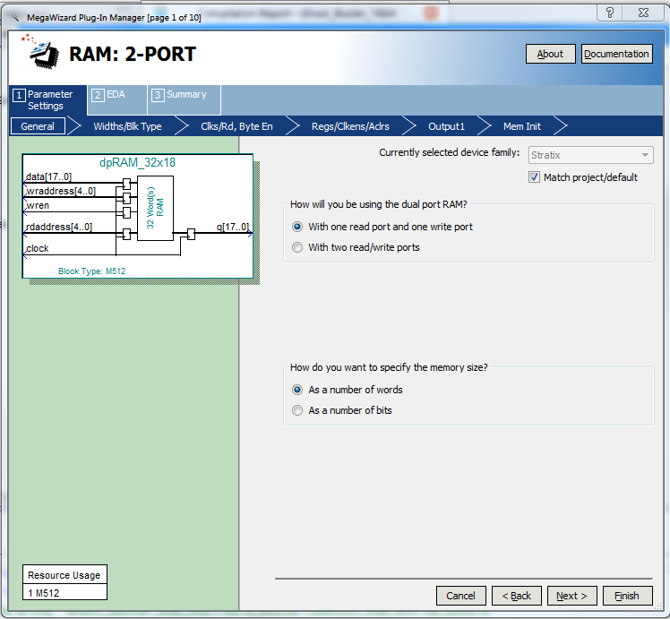
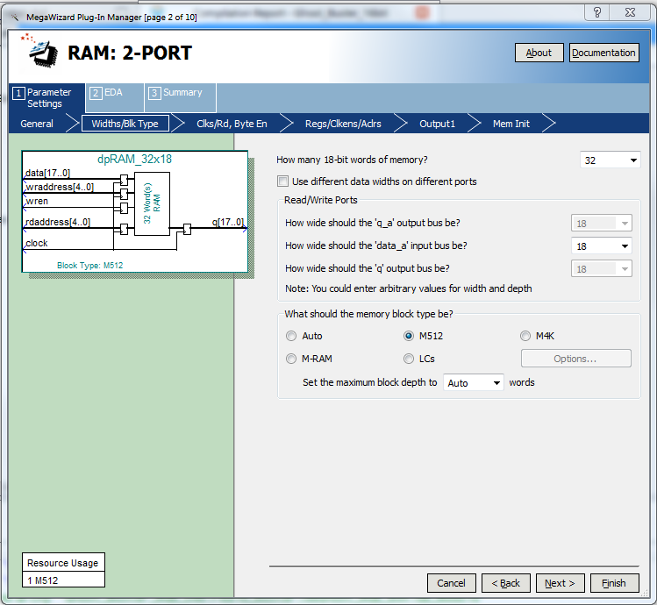
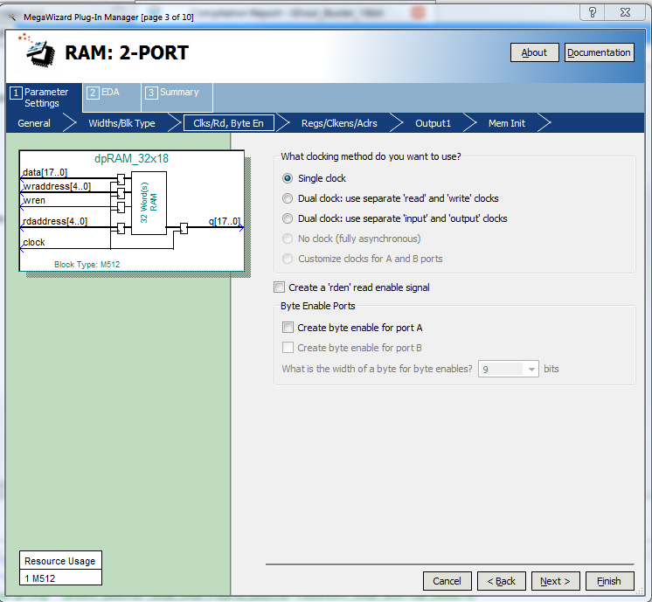
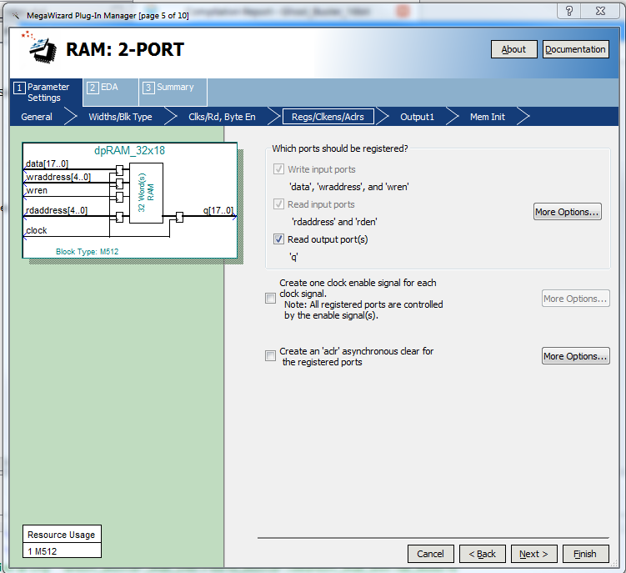
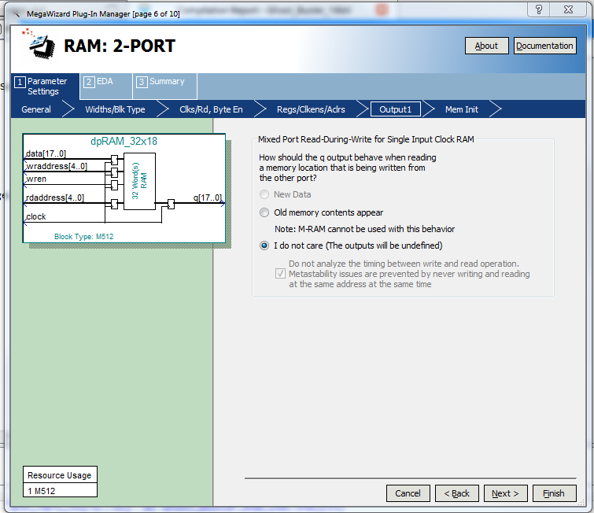
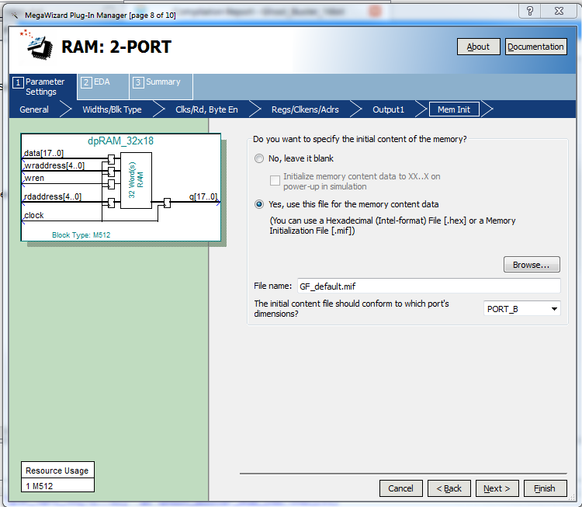
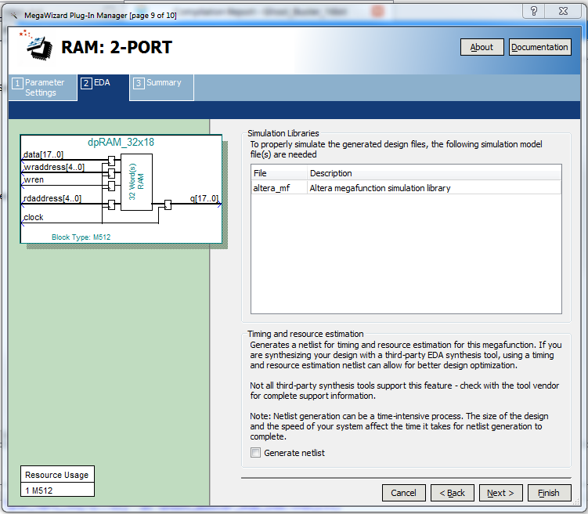
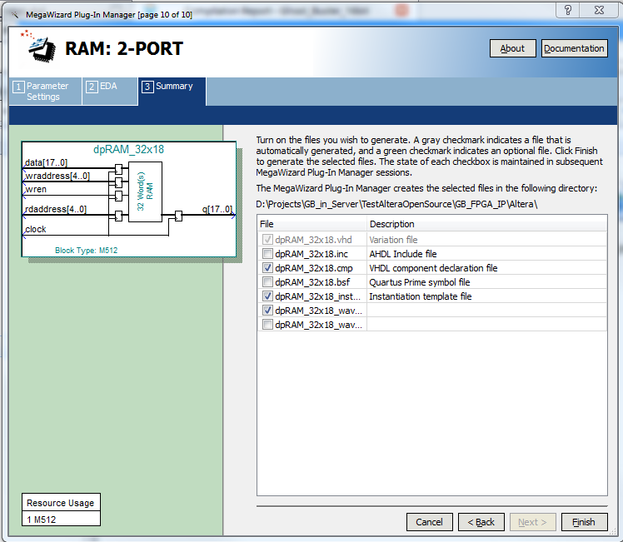

- Xilinx Specific Information
  - Files
RAM_32x18; A Xilinx memory IP file created by the development tools, in “FPGA_IP\Xilinx” folder.
dpRAM_32x36.vhd ; A wrapper for the two RAM_32x18 Xilinx IP files, in “FPGA_IP\Xilinx” folder.
dpRAM_32x18.vhd ; A wrapper for the RAM_32x18 Xilinx IP file, in “FPGA_IP\xilinx” folder.

  - Procedure
- Copy the “GB_VHDL_source” and “\GB_FPGA_IP\Xilinx” into the FPGA project directory structure.
- Include the “GB_VHDL_source” files in the FPGA project.
Ghost_Buster_RGB_16b.vhd, deGhost_RGB_8x4.vhd, ByPass_72bits.vhd, and Ghost_Buster_Top.vhd
- Include the “\GB_FPGA_IP\Xilinx” files in the FPGA project.
dpRAM_32x18 , dpRAM_32x36
- Create a disturbed RAM IP named “RAM_32x18” in the FPGA project
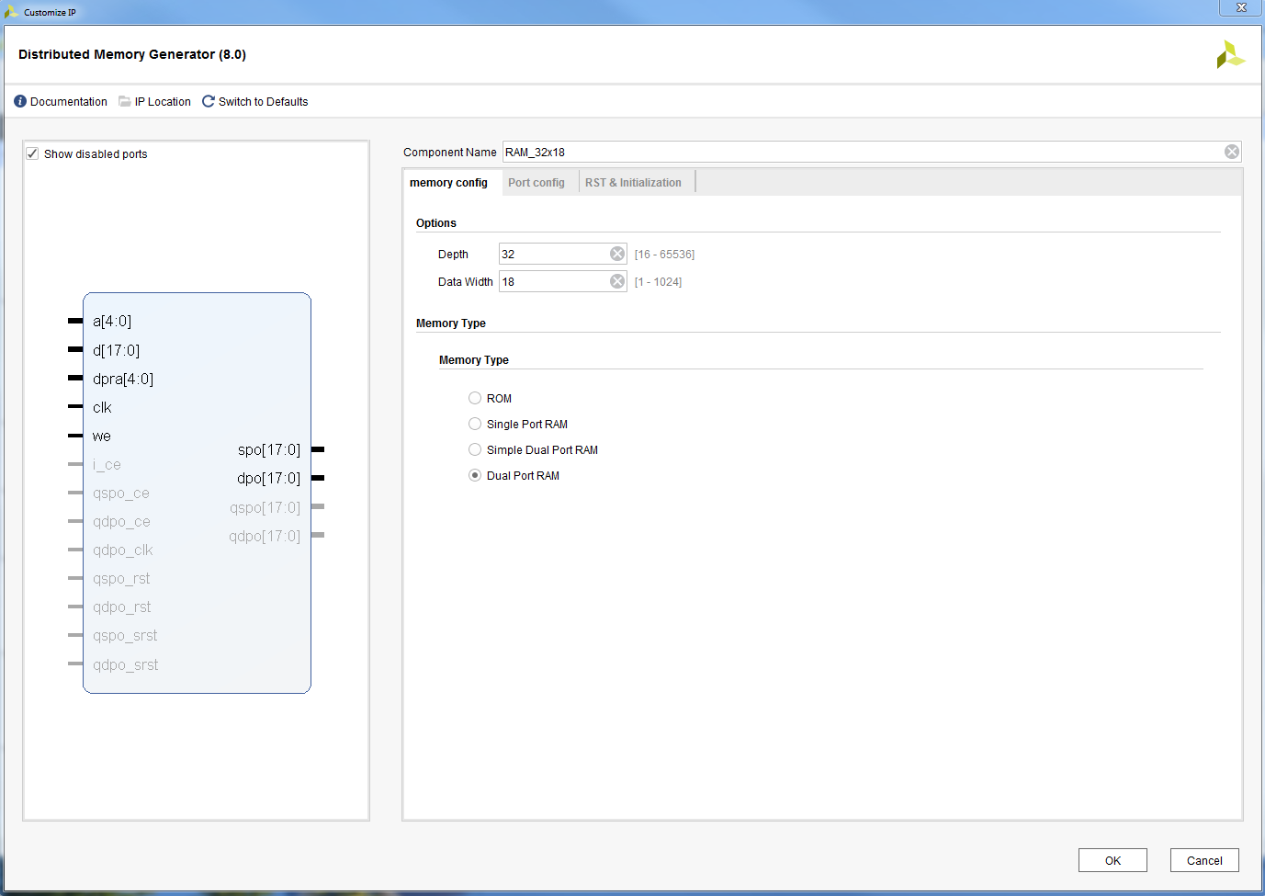
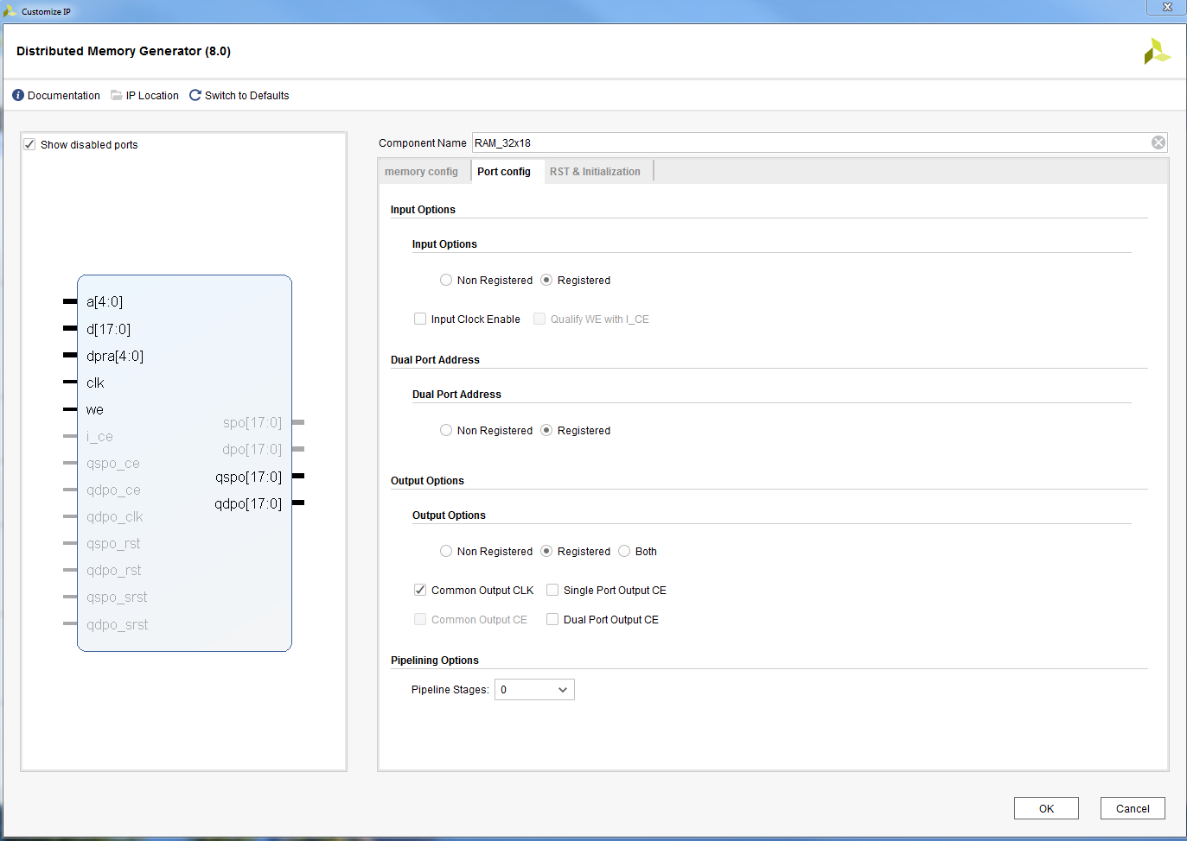
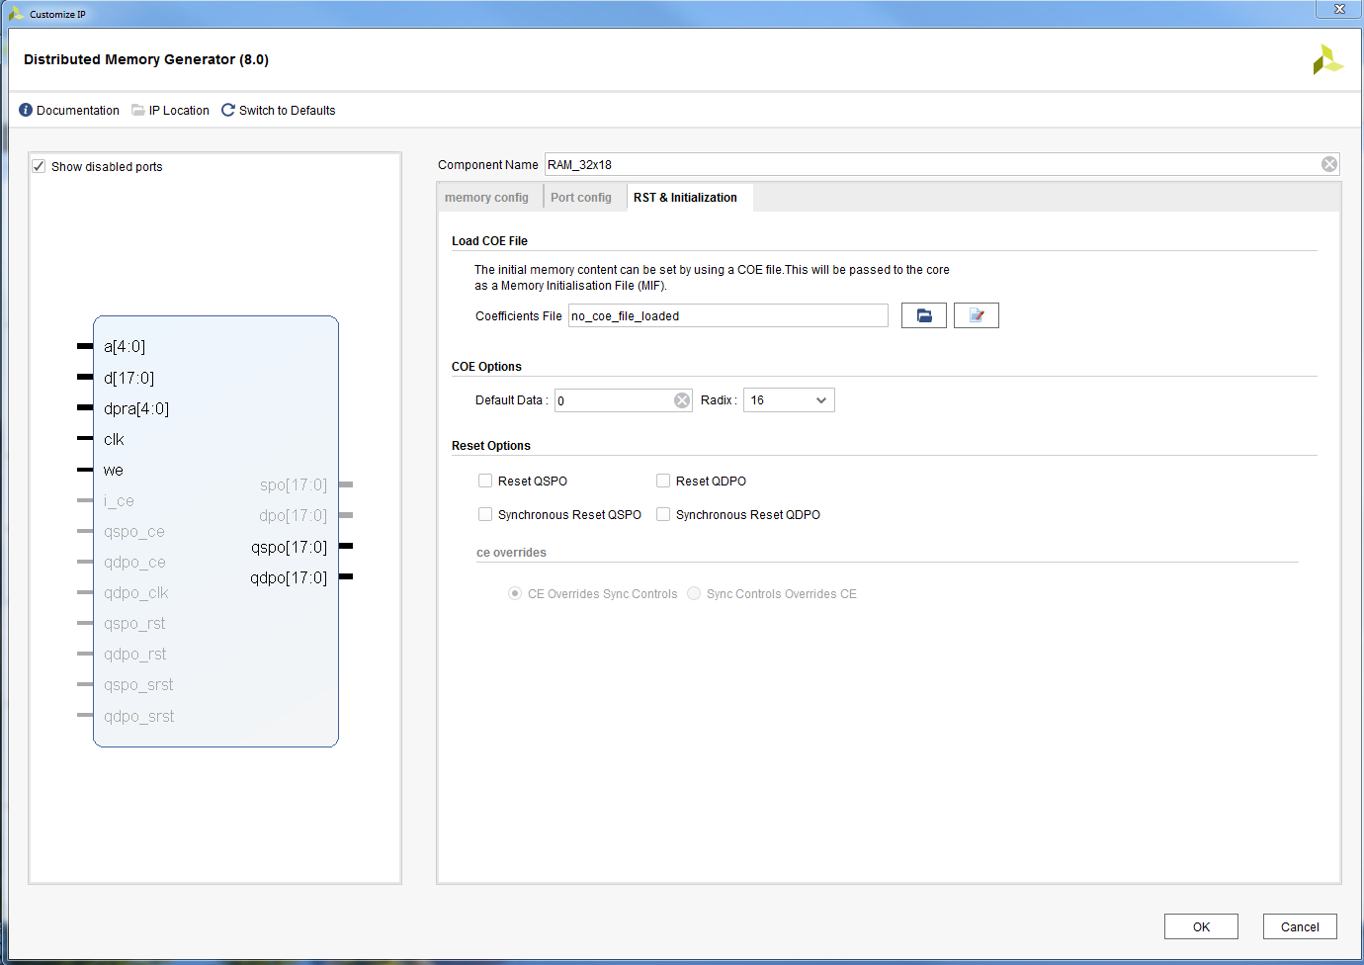

- Run Synthesis & Implementation & verify utilization

  - Original dpRAM_32x52 RAM Parameters
These are the PAM parameters from the very first GhostBuster IP build and are provided as reference.
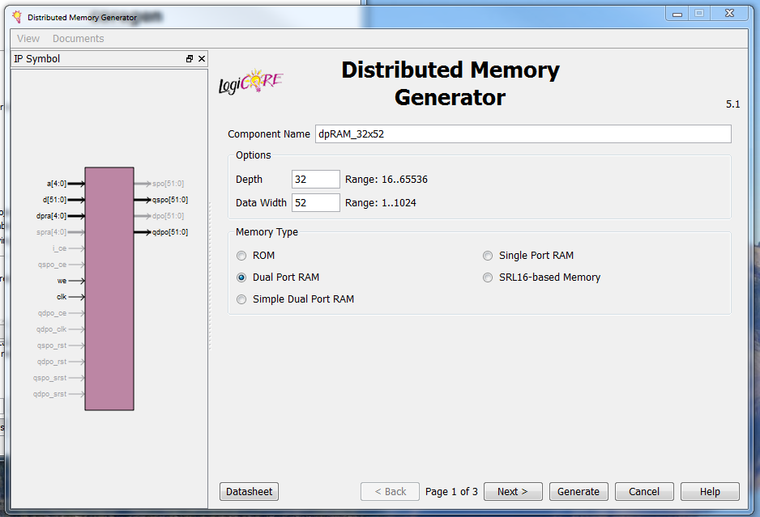
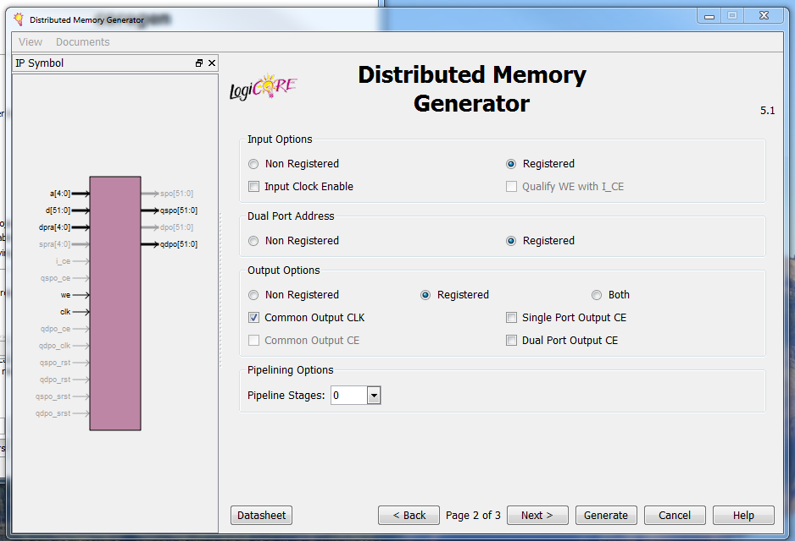
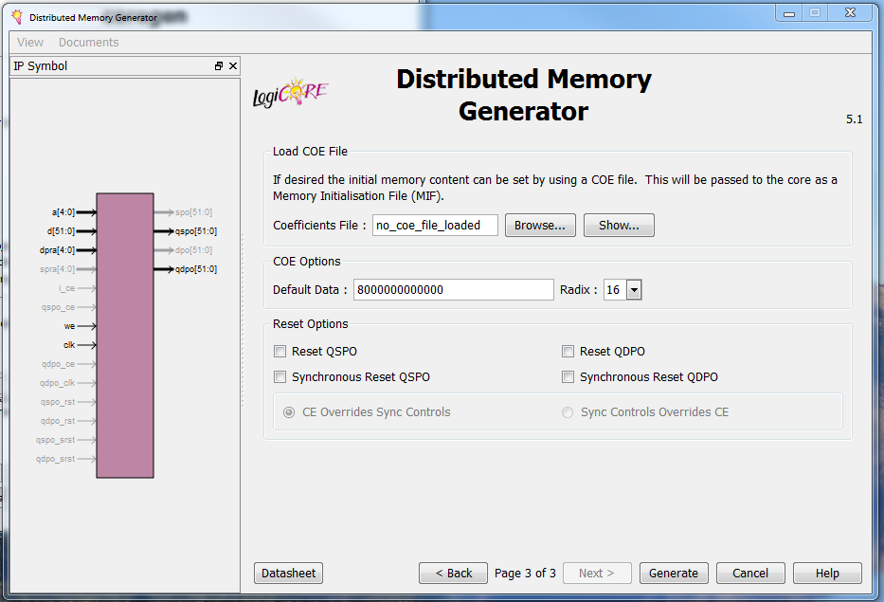
  - Original dpRAM_32x18 RAM Parameters
These are the RAM parameters from the very first GhostBuster IP build and are provided as reference.
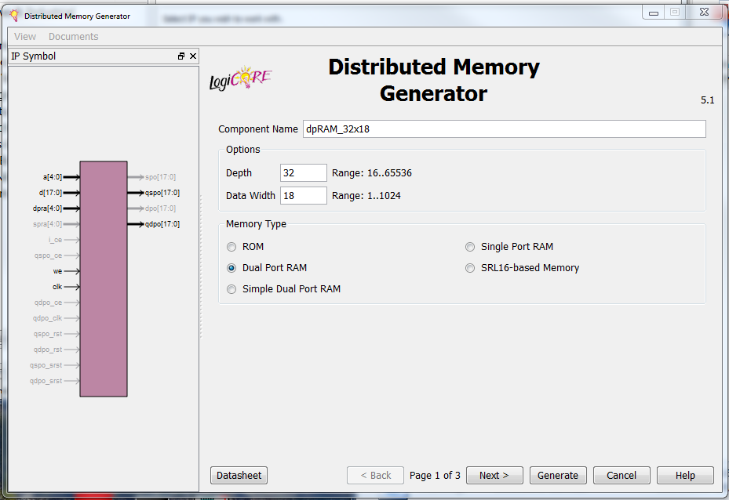
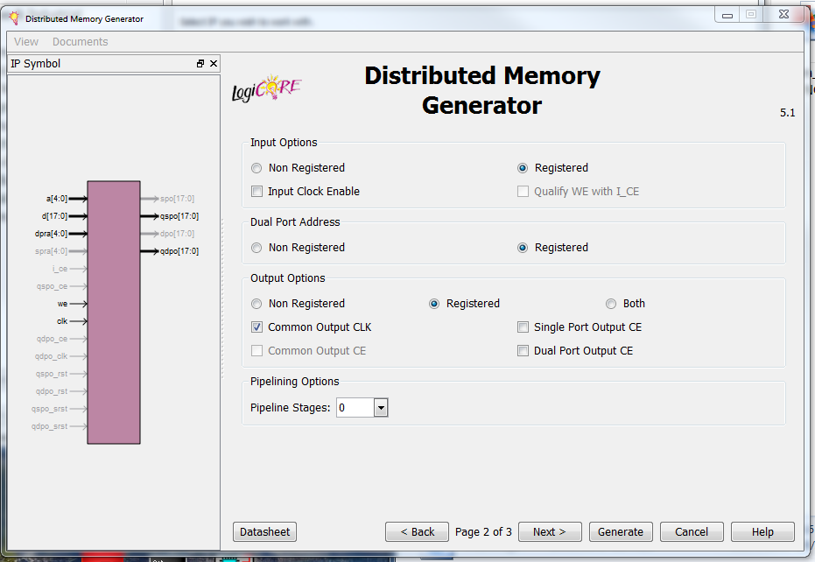
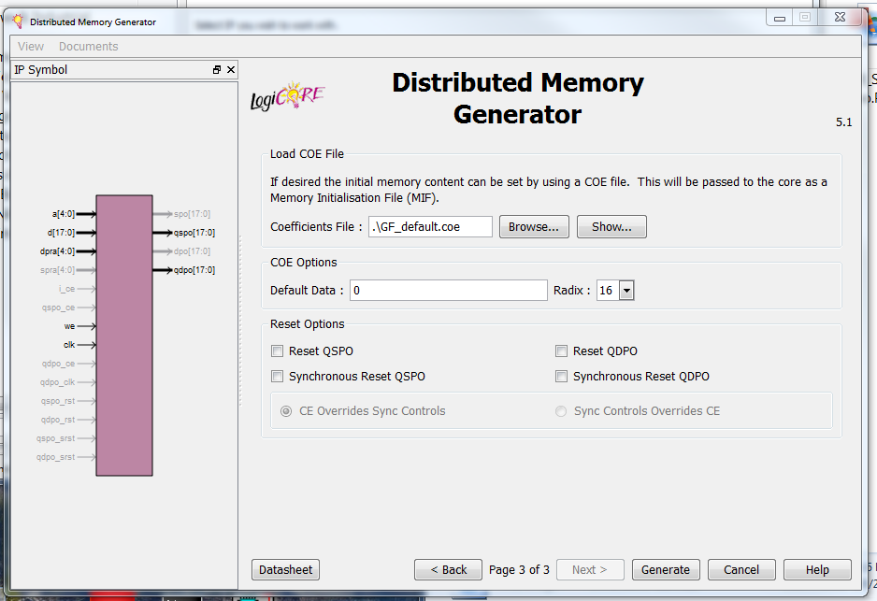

- FPGA Architecture Agnostic Design
When using the Altera and Xilinx specific designs described in the previous two sections the RAM used in the RealD GhosterBuster IP must either be re-built for the target architecture (Altera) or created based on specific RealD requirements using the FPGA vendor tools (Xilinx). In addition the use of FPGA vendor specific IP precludes the use of the RealD IP in an ASIC or unsupported FPGA architecture.

In order to provide a more general purpose design a set of FPGA vendor agnostic source files which should infer the desired RAM functionality are provided in the “OpenSourceReleasePackage\GB_FPGA_IP\Agnostic” directory.
- RAM_32x18.vhd implements the RAM functionality.
- dpRAM_32x18.vhd is a wrapper which provides compatibility with the RealD GhostBuster IP.
- dpRAM_32x36.vhd instantiates two RAM models and provides a wrapper which is compatible with the RealD IP.

Note that these RAM models have been verified for Xilinx Vivado (Web edition) 2018.1 and Altera Quartus Prime 17.1.0 (Lite edition), the user must verify that these models create the expected behavior when compiled using the desired tool set. The resource requirements for test builds are:
Family | Device | Multipliers | Memory | Registers | Logic | Pins
Altera Cyclone V | 5CSEMA5F31C7 | 6 DSP Blocks | 4,928 bits | 948 | 395 ALM’s | 277
Xilinx Kintex-7 | 7k70tfbv676-1 | 6 DSP Blocks | 104 LUT’s | 1100 | 345 LUT’s | 277

The operation of the RAM can be checked using the two test benches described in section 4 of this document.

An FPGA architecture specific test bench for the RAM is also provided for both Altera and Xilinx in the “OpenSourceReleasePackage\TestBench\CompareMemory” directory. These test benches will output an error to the simulation console if the output of the inferred RAM and FPGA vendor RAM IP do not match or are not the expected value.

The Xilinx RAM test bench compares the operation of the“OpenSourceReleasePackage\GB_FPGA_IP\Agnostic\dpRAM_32x18.vhd” to a Xilinx FPGA IP RAM which must be named “FPGA_IP_RAM_32x18” built with the parameters specified in section 6.2 of this document.

The Altera RAM test bench compares the operation of the “OpenSourceReleasePackage\GB_FPGA_IP\Agnostic\RAM_32x18.vhd” to the Altera FPGA IP RAM “OpenSourceReleasePackage\GB_FPGA_IP\Altera\ dpRAM_32x18.vhd”.

