# Site Flow and Sketches

## Step 1: Competitive Analysis

|  |  |
| --- | --- |
| Competitor Site 1: Unexpected ProductionsURL: http://www.unexpectedproductions.org/AnalysisWhat is good about this site? It gives you direct information about what is happening each day of the current week right on the home page, and also has tabs on top so you can navigate the website easily. What is bad about this site?It has too many advertisements on the right side of the page and the website overall looks kind of low level and like it hasn’t been updated in a while. | Competitor Site 2s: Ticket MasterURL: http://www.ticketmaster.com/AnalysisWhat is good about this site? It has the main information in the front page, but has tons of categories on options that are easily found. It has a “happening soon” section and is organized in general. What is bad about this site?It has a little too many options and information on the front page and one may be confused or overwhelmed with how many options there are. |

### Competitor 1 Pages

#### Page (or Screen) where you ask “What should I do tonight?”

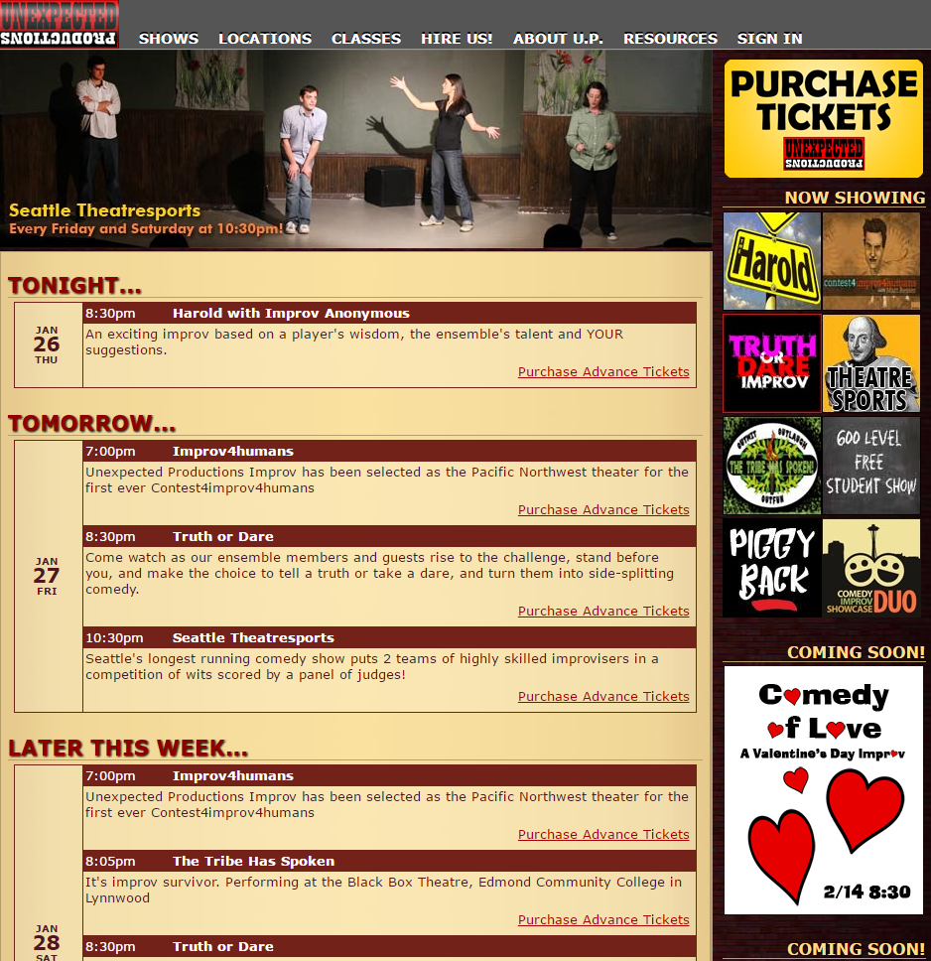

#### Pages (or Screens) look for the answer

#### 

#### Page where you get an answer

### Competitor 2 Pages

#### Page (or Screen) where you ask “What should I do tonight?”

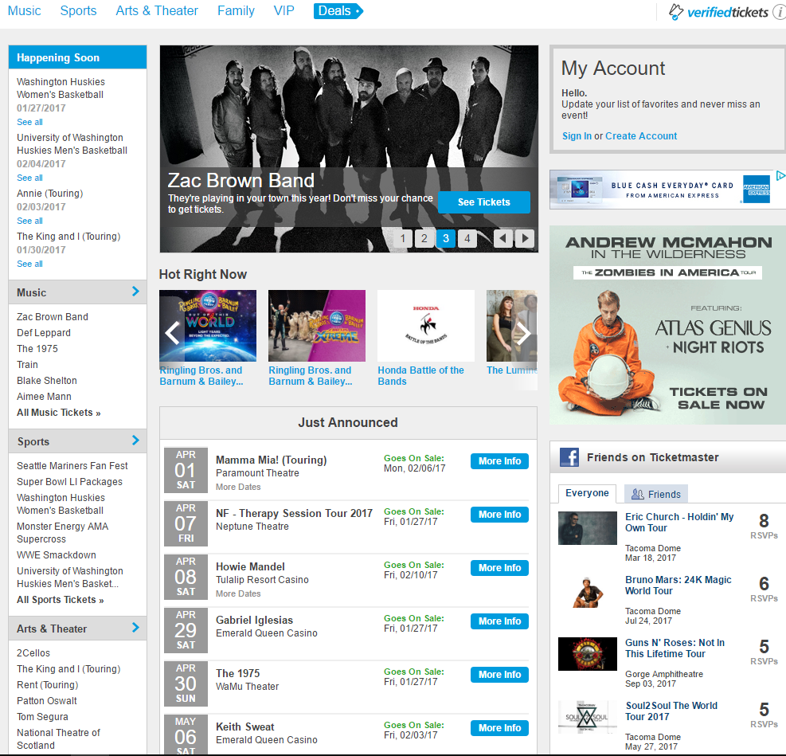

#### Pages (or Screens) look for the answer

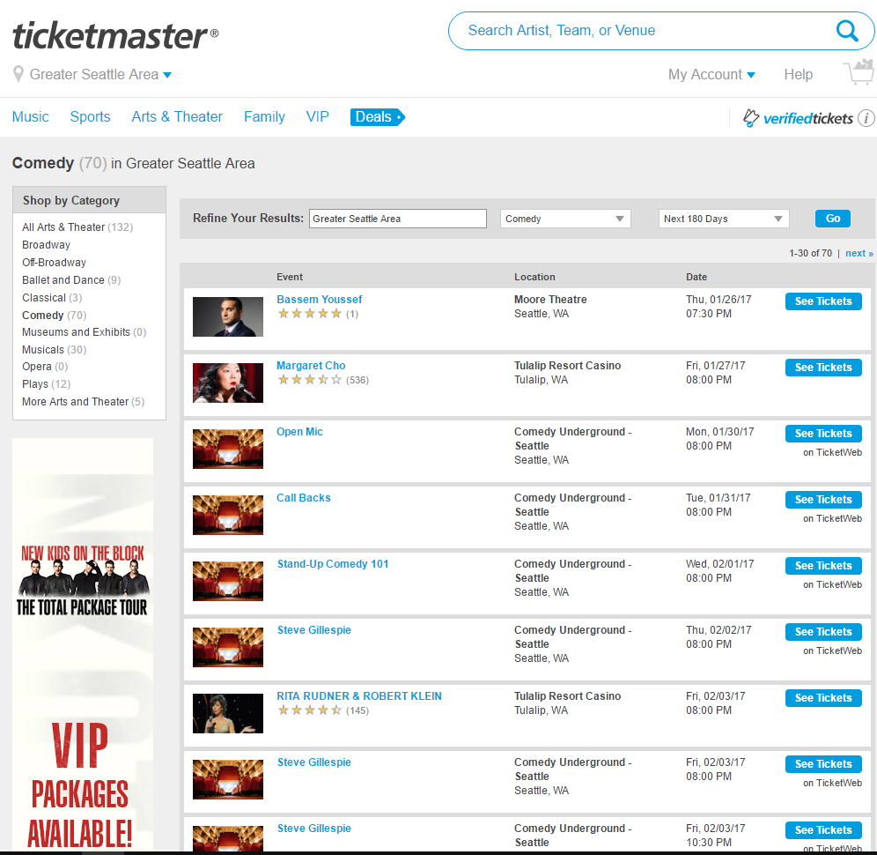

#### Page where you get an answer

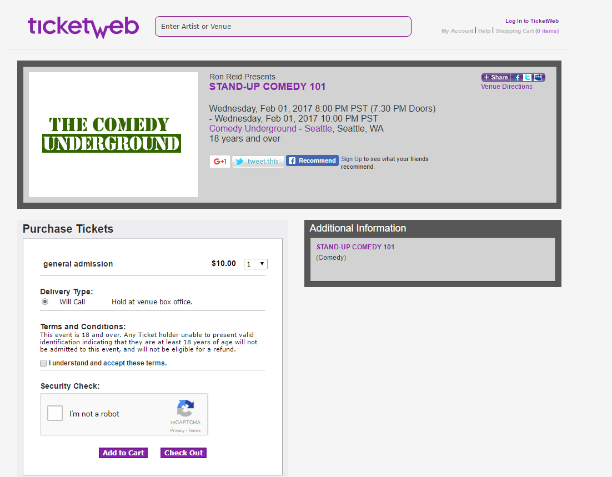

## Step 2: Sketch One Competitor Flow

### Favorite Competitor: Page Flow Sketch

Pages sketched as boxes for the flow between pages (or screens) where you ask “What should I do tonight?”, look for the answer, and get an answer. Arrows drawn between the boxes show how the pages are connected by clicks. Inside the page boxes details include:

* Where you ask the question
* Where the navigation is that allows you to find things to do
* Where the details of the “things to do” are displayed
* Where you click to move from page to page

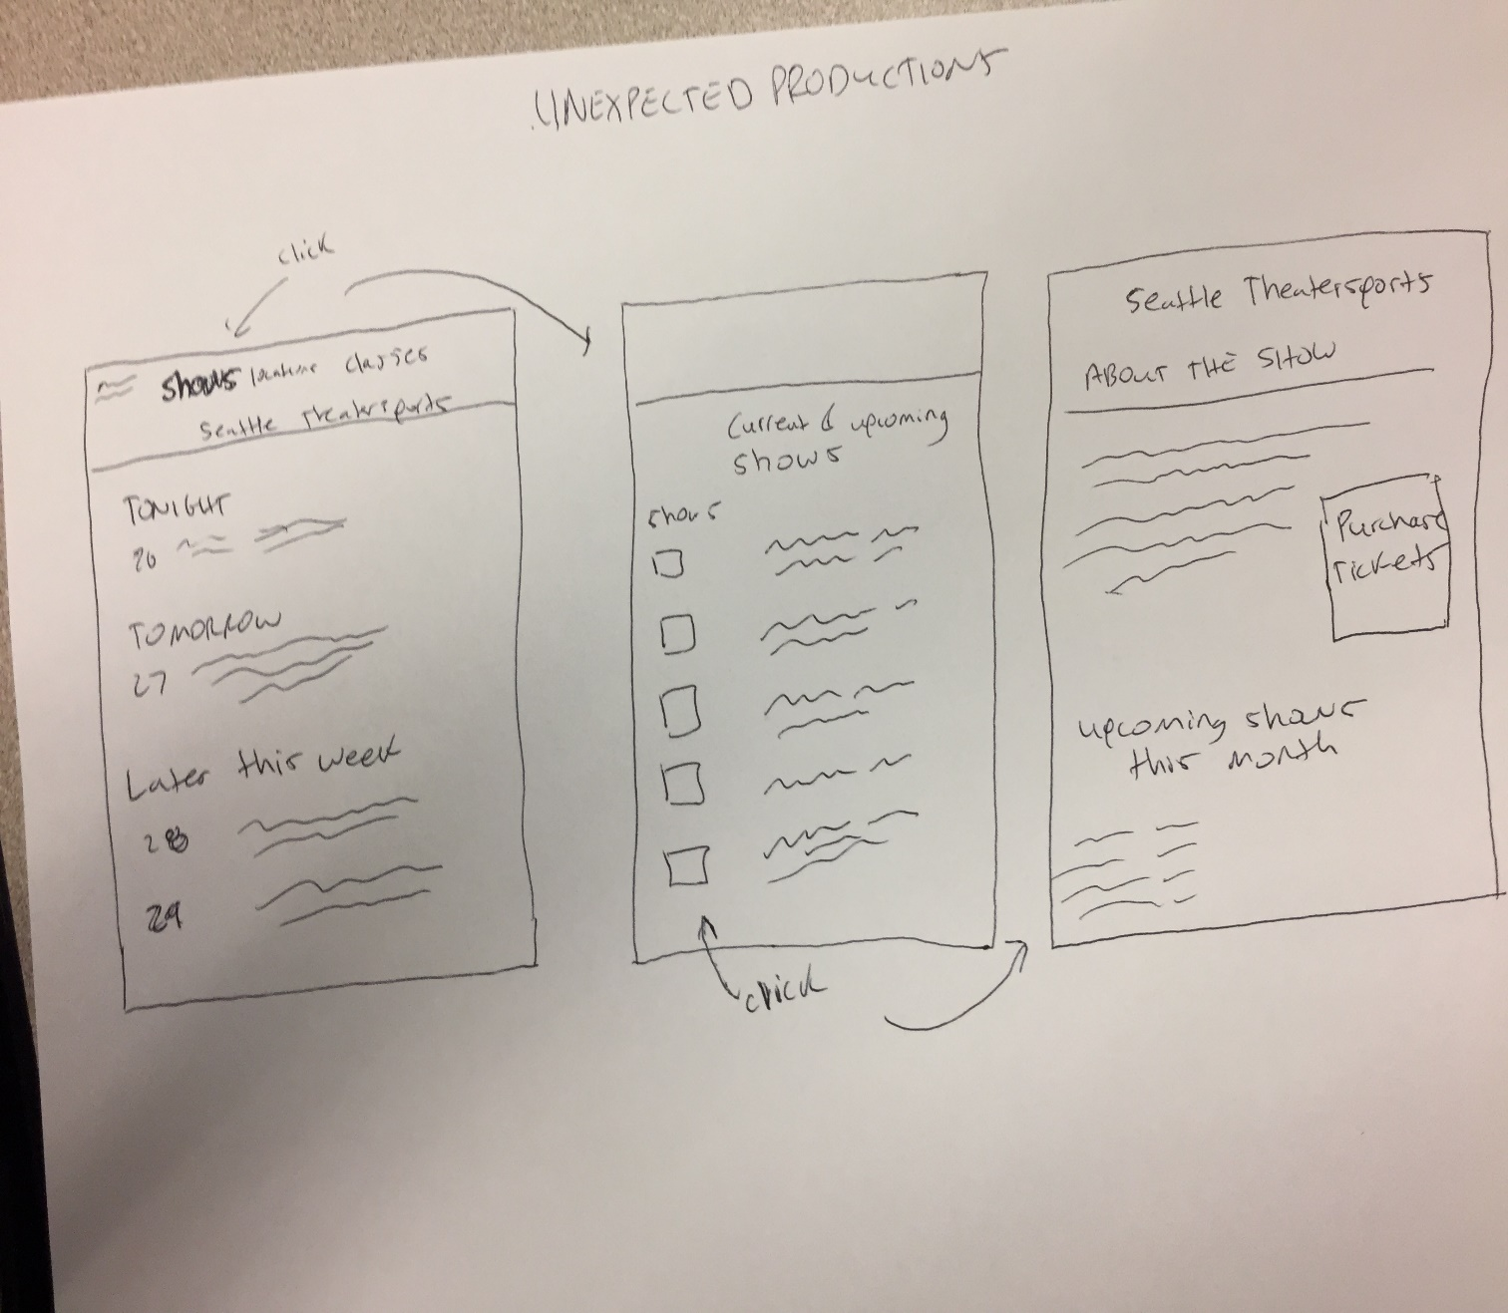

## Step 3: Sketch YOUR Flow

Seattle Comedy Productions

#### Sketch of My Page Flow

Pages sketched as boxes for the flow between pages (or screens) where you ask “What should I do tonight?”, look for the answer, and get an answer. Arrows drawn between the boxes show how the pages are connected by clicks. Inside the page boxes details include:

* Where you ask the question
* Where the navigation is that allows you to find things to do
* Where the details of the “things to do” are displayed
* Where you click to move from page to page

