As a developer, your classmate requests for a Python program integrating a CGPA calculator and a basic calculator. The CGPA calculator computes the CGPA based on marks from four courses attempted in a semester. The calculate_cgpa function should take in a list of marks, grades represented as letters ('A', 'B', 'C', 'D', 'E', 'F'), and a list of corresponding credit units for these four courses that are attempted in a particular semester to compute the CGPA. The basic_calculator function should perform arithmetic operations such as addition, subtraction, multiplication, division on numbers generated from a unique student number combination:
Student numbers: 1900717625, 2300717623, 2300707764, 2300713410, 207006808
Given the students numbers above to generate the numbers for which basic_calculator performs arithmetics, we add all the students numbers and get sum as below
Sum: 1900717625 + 2300717623 + 2300707764 + 2300713410 + 207006808 = 9009863230
The generated numbers represent the marks for each course mark. The generated numbers from the sum above would be:
Course 1: 00
Course 2: 98
Course 3: 63
Course 4: 23
Note that the first digit 9 is ignored and the marks generated from each following two digits. For the tasks, use these exact student numbers.
Also, Note that the exact course names are provided in a table below the writeup, and the grading system is also provided in a separate table.
Tasks:
a) Implement Python code using the functions calculate_cgpa and basic_calculator to generate the CGPA, and output the results to a Word document file.
b) Create Python classes for computing the CGPA and output the results to a word document file(creativity and inheritance are recommended)
c) Save the results from both (a) and (b) to an output Word document file using file write functions and the open() function to open the file for writing.
The courses that are to be used should be as follows and the formula to use for the CGPA is showcased below

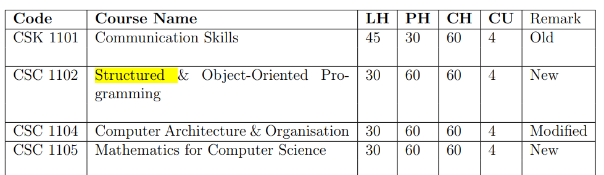
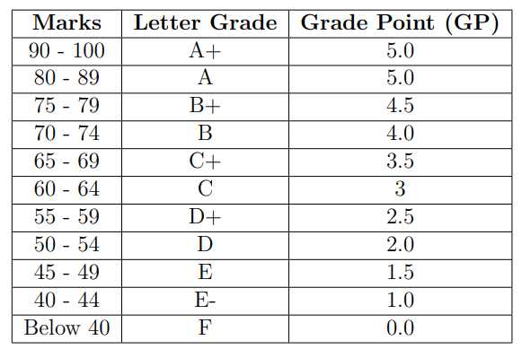

Use the following formula to calculate CGPA:
