Use HAB Linux
This document describes how to use HAB Linux.

Copy HAB Linux onto a USB memory stick
You will need:
- A broadband internet connection
- A memory stick of at least 8Gb in size, preferably USB 3
- A copy of the HAB Linux image file. This is available from the releases page, and should be called something like hablinux1404_1.img

Windows
- Plug USB stick in
- Download Win32 Disk Imager
- Install it (just follow the wizard, there are no questions to answer)
- Run it
- Have a look to see which drive letter your USB stick has been allocated. It will probably be E: if you have a CD-ROM drive, and D: otherwise.
- Set Device to the right drive letter
- Set Image File to the HAB Linux image you downloaded by clicking the blue folder button
- Click Write
- If you are prompted with Writing to a physical device can corrupt the device, click Yes.

Linux

- Plug USB stick in
- Start a terminal
- Run
sudo fdisk -l
Use the output to determine which of the disks is the USB stick. It will probably be /dev/sdb
- Change to the directory containing the image file
- Run
dd if=hablinux1404_1.img of=/dev/sdb
- Wait until this command returns (which could be a long time)

OS X
I don't have access to a copy of OS X. If you know how to write an image to a USB stick on OS X, please tell me.

Run HAB Linux

The goal is to get your computer to boot from the USB stick rather than from the hard disk (where your existing installation of Windows is installed). We’ll start by giving it a go and seeing if it just works.

With the stick still plugged in, power on your computer. You should see an unusual menu, headed with a blue bar titled UNetbootin like this:
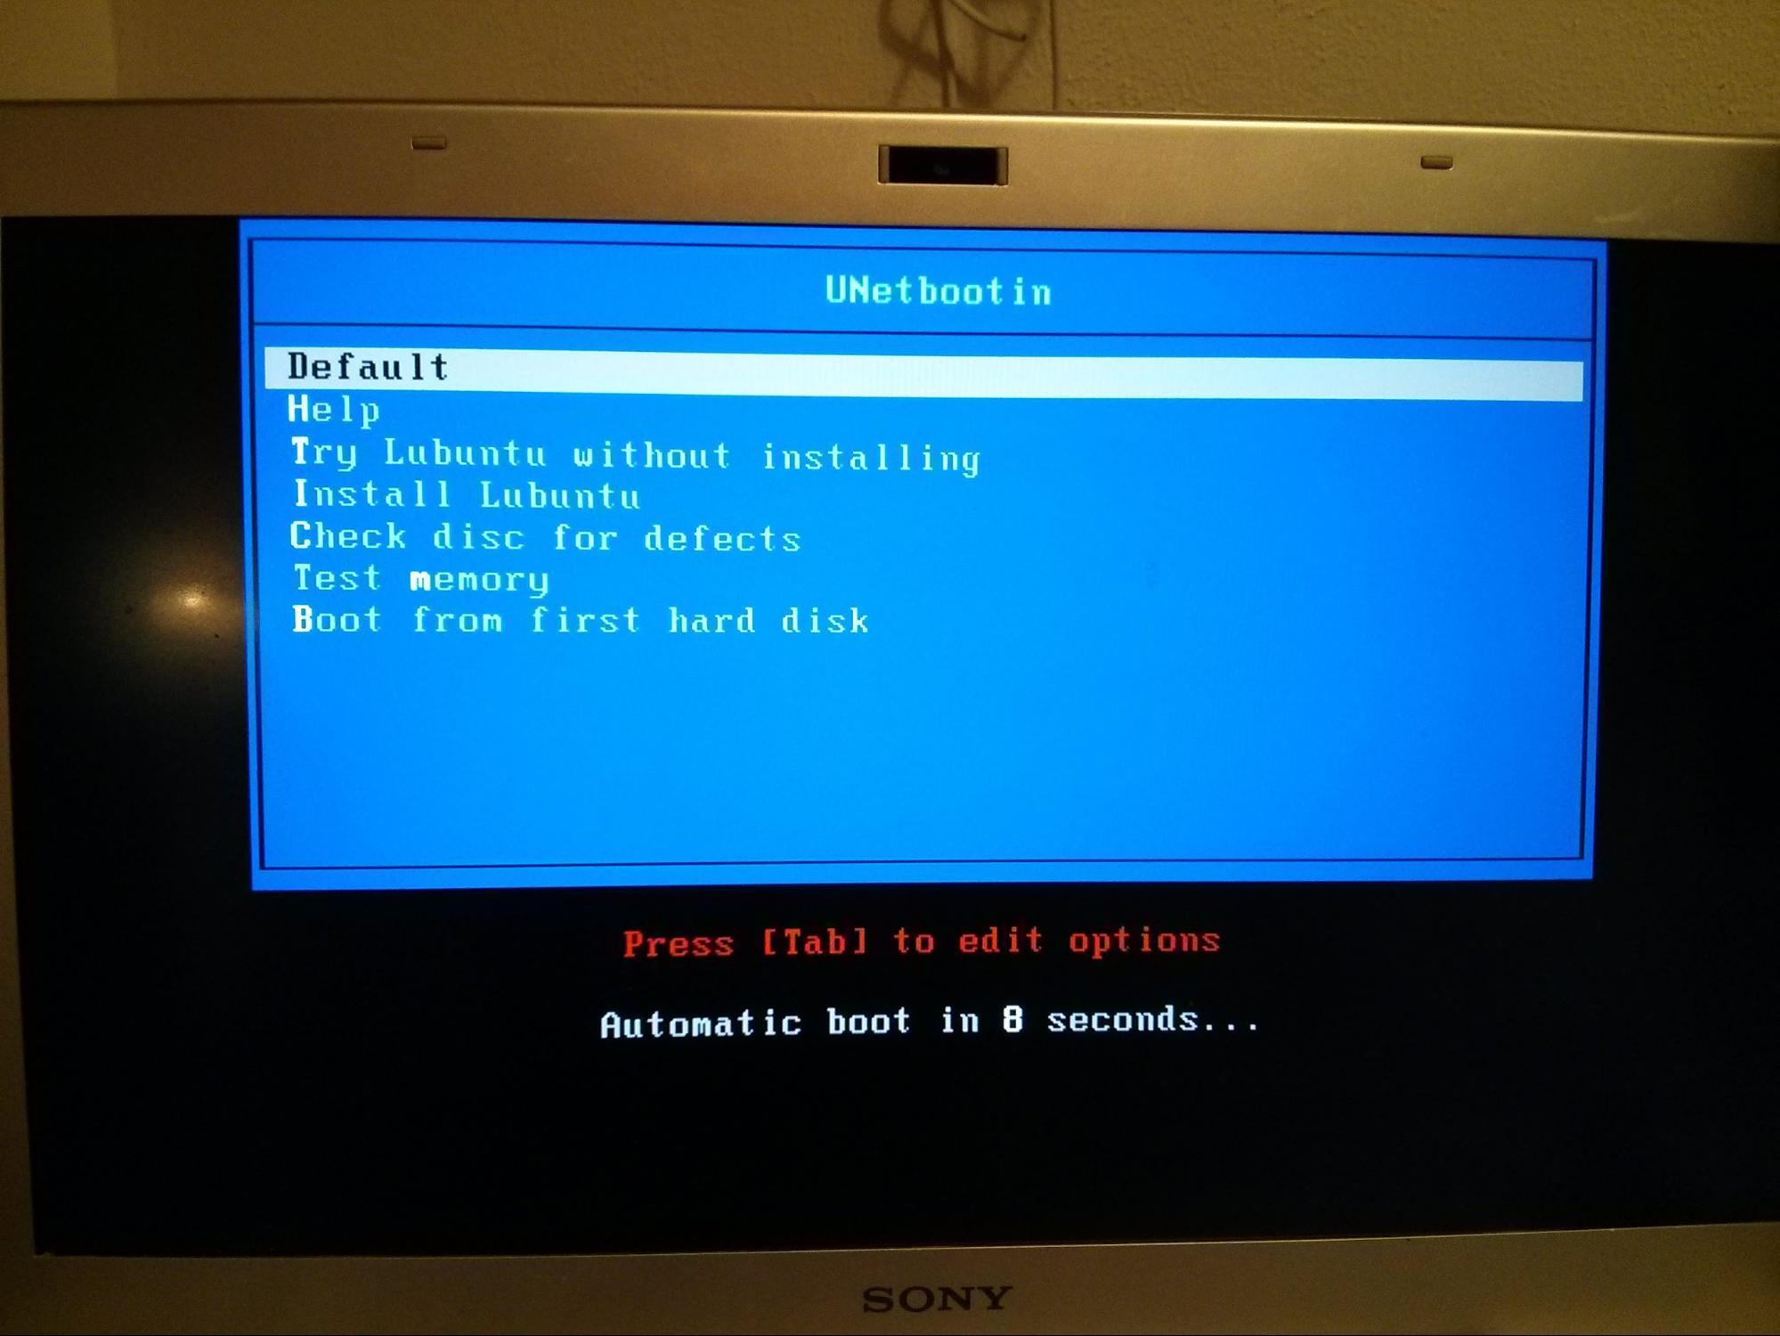
Don’t press anything. It will automatically boot into the right option. Once this screen goes away, it will boot to a desktop and you can start using it. How fast it boots to this desktop depends upon how fast your computer is and whether you are using USB2 or 3.

Troubleshooting
If you don’t see this screen (say it boots into Windows), then we need to fiddle with your computer a bit to tell it what to do. Unfortunately every computer does this slightly differently, so you’re going to need to use some ingenuity.

When you power your computer on, it runs the BIOS program. The BIOS is a very low level program (written in to a chip on the motherboard) that understands how to talk to your hard disk (where Windows (or your other OS) is stored), and how to start Windows from that hard disk. Once it has started the Windows boot process, it doesn’t do any more. Windows does the rest. The goal is to get the BIOS to launch Lubuntu from the USB stick rather than Windows from the hard disk. Windows won’t be running at all.

The difficulty is that not every computer has the same BIOS, so some experimentation may be required.

Boot from USB just this once
Most modern BIOSs include the ability to boot from a different device just this once, without changing any settings. If you want to do that, you need to find the key that does this and press it just as the computer switches on.
- Power your computer off
- Switch your monitor on
- Power your computer on
- Look at the first thing that comes on the screen. If you’re lucky, it will tell you which key you need to press. It will say something like Esc = Boot menu. F12 and Delete also commonly-used keys.
- If you don’t press the right key, the computer will continue booting from your hard disk just like it always does.
If you see the Windows logo, you have missed the BIOS screen. It’s possible your BIOS screen won’t show anything except a logo. If this is the case, you’ll just have try lots of keys until you find the right one, or Google it, such as “Dell Optiplex 360 BIOS key”. It’s most likely to be an F key, Delete or Esc.

Always boot from USB if it plugged in
Having to remember to hit the boot menu key as the computer starts can be annoying. Instead you can change the boot order of the BIOS, so that it tries boot from USB first, and then falls back to the hard disk. If you haven’t got the stick plugged in, it will boot as normal. Other users of the computer won’t even notice that you have changed anything. If you do have it plugged in, it will boot from the stick instead of from the hard disk. Easy.

In a similar manner to finding the boot menu key, you will have to find the BIOS setup key. Esc, Del, F2 and F10 are all common choices, but it could be any function key. All computers will have this option somewhere, so persevere.

Once you get in to the BIOS setup, it becomes even less standardised, so you’re pretty much on your own I’m afraid. Look for “boot order”, “boot device”, or “boot priority”. You might see a list of device types you can boot from:
- FDD - floppy drive
- HDD - hard drive
- USB - devices plugged in to the USB port
- CDROM - Any CD or DVD drives you might have
- LAN - the network card
Try not to mess with it too much, you just need to get USB in front of or above HDD. Use the keys shown in the on-screen instructions to change the order. You might also see a list of device names, such as “WDC84398420JT”, and “Samsung CD-R”. Hopefully they will be descriptive enough for you to work out which is which. If you need help, send in a screenshot.

