Build HAB Linux
This document describes how we built HAB Linux.

Lubuntu installation onto a USB memory stick
You will need:
- A computer with at least 512Mb RAM
- A CD burner
- A broadband internet connection
- A memory stick of at least 8Gb in size, preferably USB 3

The instructions should work on Windows and Linux. If you are running OS X, contact me for help.

- Put the memory stick in your computer
- Stick it in your computer, preferably in a USB 3 port (plastic tongue in the centre will be blue not black)
- Download/install unetbootin from http://unetbootin.sourceforge.net/
- Download Lubuntu 14.04 Desktop 32-bit from http://cdimage.ubuntu.com/lubuntu/releases/14.04/release/lubuntu-14.04.1-desktop-i386.iso
- Run unetbootin
- Select Diskimage, click … and select the ISO you have just downloaded
- Set Space used to preserve files across reboots (Ubuntu only): to 1 Mb
- Set drive to the drive the memory stick appears as
- Click OK
- The OS gets installed to the USB stick. At the end
- Open Windows Explorer, and go to the drive the USB stick appears as. In the root of the drive should be a file called casper-rw. Delete it.
- Linux users: read ahead the next few items. You can skip using System Rescue CD because you can just install gparted using your package manager.
- Download SystemRescueCD from http://sourceforge.net/projects/systemrescuecd/files/sysresccd-x86/4.0.0/systemrescuecd-x86-4.0.0.iso/download
- Burn it to a CD
- When the unetbootin has finished it might prompt you to reboot. Click Exit instead
- Boot from the SystemRescueCD disc, selecting the default option at the boot menu
- At the Load keymap prompt type 40
- Once it has started and you have a command prompt, type startx
- Plug in the USB stick
- Click on the third icon in from the left to launch gparted
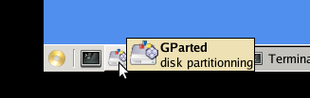
- In the top right-hand corner is a list of drives. Select the one that has the same size as your memory stick (or slightly smaller). It should have one big FAT32 partition. If it has an NTFS partition it’s the wrong drive.
- You will see a list of partitions. There will only be one there at the moment, with File System fat32 and Partition probably /dev/sdb1.
- Select the partition and clik Partition > Unmount. Select it again, then click Partition > Resize/Move; set New size to 780 Mb, click in to the Free space following box. The amount of free space following will be automatically calculated. Don’t change it. Click Resize/Move
- There should now be a lot of unallocated space. Select that space and click Partition > New. Set New size to 1000 Mb and File system to linux-swap, then click Add
- Select the remaining unallocated space and click Partition > New. Set New size to 5790 Mb (or leave it if already set to less), File system to ext4, and Label to casper-rw then click Add. [Note that this size is the maximum we could choose and still fit everything on an 8Gb stick. If you have a bigger stick and are not creating an image for distribution, you could make this last partition occupy all the unallocated space to allow more free space]
- Click Edit > Apply all operations and click Accept when warned that you will lose all the data on the drive.
- If you get asked Would you like to use FAT32?, say Yes
- You will see Applying pending operations, and when complete should see All operations successfully completed.
- Power off your computer, and remove the SystemRescueCD disc from your drive.
- Boot your computer from the USB stick. If you need help with this step, see Use HAB Linux.

Lubuntu customisation
Note that from this point onwards, all changes are saved to the casper-rw partition created above. If you want to remove all the customisations, you can put the stick in a computer running Linux and delete everything in that partition (apart from lost+found). Then you will have effectively returned to this point.

- If you use a wired network, you should see two arrows in the task bar, one pointing up and one down:
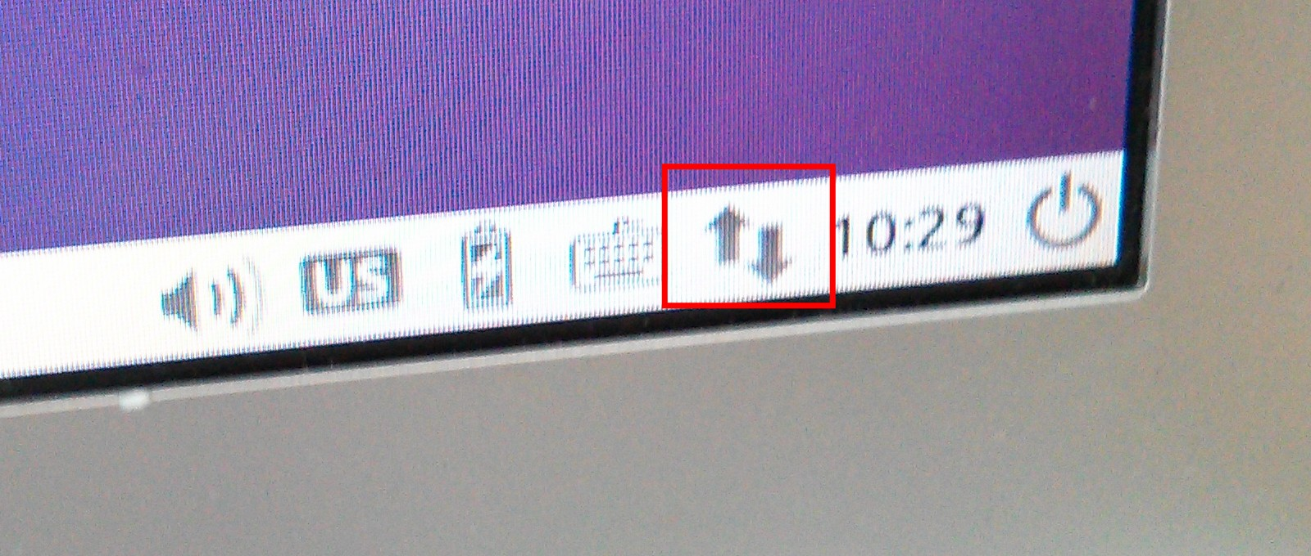
In this case you shouldn’t need to do anything more. If you use a wireless network, you will see an empty circle segment (looks like a pizza slice) or two computers with a cross.
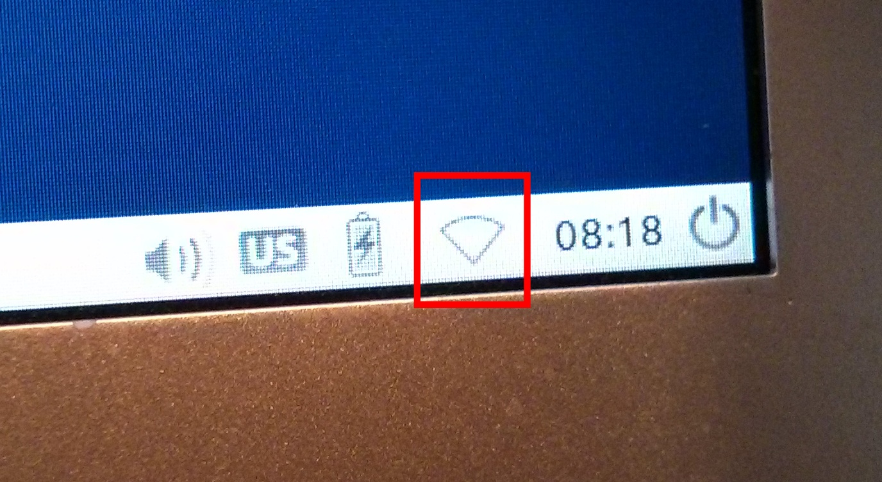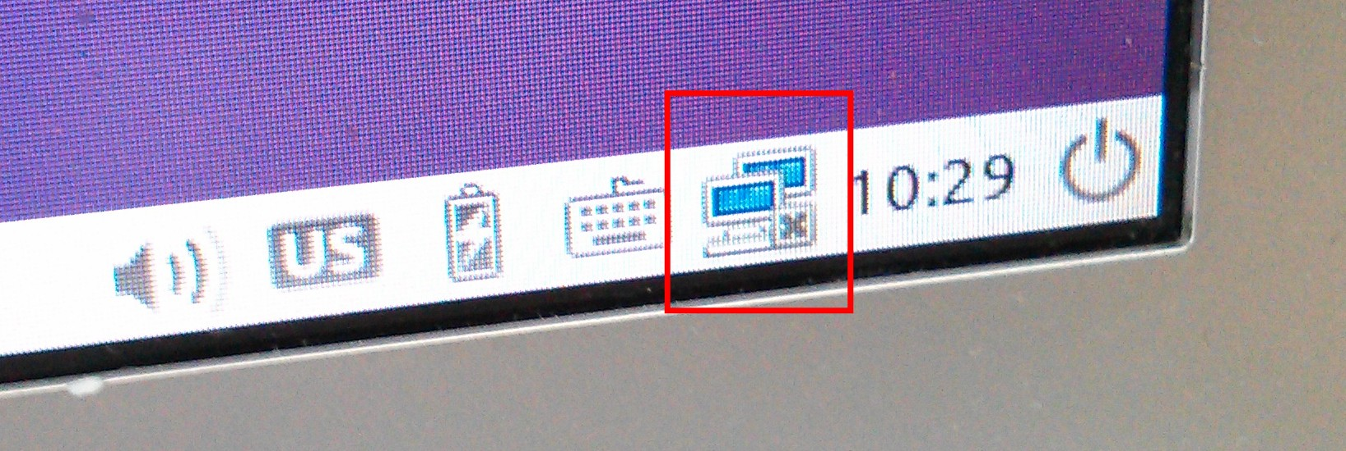
This represents the fact that you are not connected to a wireless network. Click on it to see available networks, then click on a network to join it.
- Start > Preferences > Language Support
- When prompted The language support is not installed completely, click Remind me later
or
- When prompted No language information available, click Cancel
- Click the Regional Formats tab and select English (United Kingdom). Then click Close
- Right-click on US in the system tray, then click “Keyboard Layout Handler” Settings
- Uncheck Keep system layouts
- Click Add and select English (UK)
- Select us and click Remove, and then Close
- Start > Preferences > Software & Updates
- Make sure all five boxes are checked - (main), (universe), (restricted), (multiverse) and Source code
- Click the drop-down next to Download from: and then click Other…
- Choose a server that is geographically close, and then click Choose Server
- Click Close, and then Close
- Start > System Tools > Software Updater
- If there are no updates available, you will see the message The software on this computer is up to date. Click OK. If there updates available, click Install now
- After the update completes, a message that An unhandlable error has occurred… may show up. It’s OK, the update has completed successfully. Click Close.
- You will very likely see a message saying that The computer needs to restart to finish installing updates. Click Restart Now...
- Continue to run the Software Updater and reboot as necessary until there are no more updates to apply.
- Start > Accessories > Terminal (you can also hit Ctrl + Alt + T)
- Edit > Preferences then click the Display tab, set Scrollback lines to 100000 and then click OK
- Make the window larger (drag the bottom right corner or click the + button in the top-right hand corner), then enter the following commands
- sudo bash
- add-apt-repository "deb http://archive.canonical.com/ $(lsb_release -sc) partner"
- apt-get update
- apt-get install firmware-b43-installer vim htop
- apt-get autoremove

Upgrade pulseaudio
Lubuntu 14.04 pulseaudio version 4 to provide audio services. This version has a known bug in it that prevents fldigi from decoding incoming packets properly. (http://cgit.freedesktop.org/pulseaudio/pulseaudio/commit/?id=2c14306507ce5049fb2bc883acea4f0d8c879876)

To work around this, we manually compile and install pulseaudio 5.
- apt-get build-dep pulseaudio
- apt-get install libpulse-dev
- Download http://freedesktop.org/software/pulseaudio/releases/pulseaudio-5.0.tar.gz and save the file
- cd Downloads
- tar xf pulseaudio-5.0.tar.gz
- cd pulseaudio-5.0
- export CFLAGS="-g -O2 -fstack-protector --param=ssp-buffer-size=4 -Wformat -Wformat-security -g -O2 -fstack-protector --param=ssp-buffer-size=4 -Wformat -Wformat-security -Werror=format-security -Wall" CXXFLAGS="-g -O2 -fstack-protector --param=ssp-buffer-size=4 -Wformat -Wformat-security -g -O2 -fstack-protector --param=ssp-buffer-size=4 -Wformat -Wformat-security -Werror=format-security -Wall"
- CPPFLAGS="-D_FORTIFY_SOURCE=2" LDFLAGS="-Wl,-Bsymbolic-functions -Wl,-z,relro -Wl,--no-as-needed -lxcb" ./configure --build=x86_64-linux-gnu --prefix=/usr --includedir="\${prefix}/include" --mandir="\${prefix}/share/man" --infodir="\${prefix}/share/info" --sysconfdir=/etc --localstatedir=/var --libexecdir="\${prefix}/lib/pulseaudio" --srcdir=. --disable-maintainer-mode --disable-dependency-tracking --disable-silent-rules --enable-x11 --disable-hal --libdir=\${prefix}/lib/x86_64-linux-gnu --with-module-dir=\${prefix}/lib/pulse-5.0/modules --disable-oss-wrapper
- make -j5
- apt-get remove pulseaudio
- make install
- Reboot.
- Start > Internet Firefox and then go to http://freemusicarchive.org/music/download/f3f803073a637bc710209e4564ee83bf4bfb5578
- You should be prompted to download an MP3 file. Click OK
- The file downloads, opens in GNOME Mplayer and starts playing.

Install collaboration tools
These handy tools are used by 1st Knaphill Scout Group for collaboration and interaction with the HAB community. You could skip them if you are not in the group.
- apt-get install skype xchat gitk shutter nautilus-dropbox
- When this finishes, you’ll prompted to start Dropbox. Ignore this.

Install rtl_sdr
This software contains the drivers for the USB receiver
- apt-get clean
- git clone https://github.com/realflash/rtl_sdr_kit
- cd rtl_sdr_kit
- export AUTO_REBOOT=y; ./rtl_sdr_kit.sh install
This step should take a couple of hours, and the computer will then reboot automatically.
- After the reboot, Start > Run and type lxshortcut -o ~/Desktop/GQRX
- Click on the gear icon and select a new icon, nm-signal-100
- Set Name to GQRX radio receiver
- Click the Desktop Entry tab, and set Command to gqrx and then click OK
- Plug in an RTL_SDR compatible dongle
- Double-click the new shortcut, and click OK
- The GQRX Configure I/O devices dialogue box should show, and Device should be set to the name of your dongle, such as Realtek RTL2838UHI. Click OK
- GQRX runs. On the right-hand side, click the Input Controls tab. Check the Hardware AGC box.
- Close GQRX

Clean up
- sudo bash
- rm -rf /home/lubuntu/rtl_sdr_kit
- apt-get clean

Install dl-fldigi
This software was written by the HAB community and decodes the transmitted data into readable text.
- apt-get install pavucontrol libcurl4-openssl-dev libjpeg62-dev autoconf libxmlrpc-c++8-dev
- git clone git://github.com/jamescoxon/dl-fldigi.git
- cd dl-fldigi
- git checkout DL3.1
- git submodule init
- git submodule update
- apt-get build-dep fldigi
- sed -i 's/^TESTS/#TESTS/' src/Makefile.am
- autoreconf -vfi
- ./configure --disable-flarq
- make -j4
- lxshortcut -o ~/Desktop/GQRX
- Click on the gear icon and select a new icon, credentials-preferences
- Set Name to dl-fldigi
- Click the Desktop Entry tab, and set Command to /home/lubuntu/dl-fldigi/src/dl-fldigi --hab and then click OK
- Double-click the new dl-fldigi icon on the desktop.
- Click Close on the Configuration Wizard. dl-fldigi starts
- Click Configure > Sound card
- Check the box PortAudio and then Close
- In the black area of the application, you’ll see lots of blue fuzz. This is sound being received from the microphone. You’ll see it change as you make noise
- Left-click on the volume/speaker icon in the task bar. Turn the volume up to about 90%.
- Right-click the same icon and click “Volume Control” Settings
- Click the Recording tab and set ALSA Capture from to Monitor of Built-in Audio Analog Stereo (or similar - Monitor of is the key). Close the Volume Control
- You should now see that the blue fuzz is gone.
- Click DL Client > Online. The tick should disappear from next to it, indicating your are offline.
- Op Mode > RTTY > RTTY 50
- Configure > Modems and then click the RTTY tab on the second row of tabs.
- Set these values:
  - Carrier shift: 425
  - Bits per character: 8
  - Stop bits: 2
- Configure > Save config
- Leave dl-fldigi open.
- Open Firefox again and download http://tenbus.co.uk/icaruscapture_30secs.mp3
- Start > Accessories > File Manager
- Go into the Downloads folder
- Double-click on the capture file to play it
- Click Edit > Loop Playlist (the capture is quite short)
- You should start to see data appear in dl-fldigi. Use the mouse to align the two yellow target marks with the two yellow bands of data on the screen. Left-click to set the target marks down.
- Wait. You should see at least one complete packet decoded, resulting in the Checksum box saying GOOD :-)

Install development tools
These things will help you when writing tracker software
- apt-get install idle arduino

Turn into image
- Download http://switch.dl.sourceforge.net/project/clonezilla/clonezilla_live_alternative/20140518-trusty/clonezilla-live-20140518-trusty-amd64.iso
- Burn it to a CD-R
- Boot from it

- Shut down the computer.
- Boot a Linux distribution, not from the USB stick
- Plug in the USB stick
- Open a terminal, and as root, run fdisk -l
- This will show you the hard disk structure of all hard disks on your computer. Look for the one that matches the size of your stick, and has a structure like this:

Disk /dev/sdg: 31.0 GB, 31009800192 bytes
64 heads, 32 sectors/track, 29573 cylinders, total 60566016 sectors
Units = sectors of 1 * 512 = 512 bytes
Sector size (logical/physical): 512 bytes / 512 bytes
I/O size (minimum/optimal): 512 bytes / 512 bytes
Disk identifier: 0x000b6ba4

Device Boot Start End Blocks Id System
/dev/sdg1 * 2048 1599487 798720 b W95 FAT32
/dev/sdg2 1599488 3647487 1024000 82 Linux swap / Solaris
/dev/sdg3 3647488 15935487 6144000 83 Linux

Yours might be /dev/sdb, c, d etc. Assuming you have used the numbers above, your block sizes should match. Add up the number of blocks in each partition (which will be the number of Kb) and convert to Mb.
798720
+ 1024000
+ 5938176
= 7760896 (Kb)
/1024 (Kilobytes in a Megabyte)
= 7570Mb
Thus we know the partitions we have created occupy the first 7761920 blocks of the USB stick. If we take a copy of those blocks in an image file and then write them to another stick, that stick should be a copy. The total needs to be less than the capacity of the stick you will write the image to: so to fit on an 8Gb stick, it needs b1gto be less than 8000Mb, a 16Gb stick less than 16,000Mb (because the lying bastards who make these things don’t follow the same 1024 Mb in a Gb as everyone else). However experience shows that the actual will be less than that even - 7948Mb on mine. Best off making it considerably smaller, and then you can use tools to expand it to reclaim the last few megabytes if you want to.
- Decide where you want to put the image. You’ll need 8Gb of free space (duh).
- Use dd to copy those blocks to an image file:
sudo dd if=/dev/sdg of=hablinux.img count=7761920 bs=1024
If you want to put the output file in the a specific directory rather than the current directory,
prefix the output filename with a path:
sudo dd if=/dev/sdg of=/home/user/hablinux.img count=7761920
On my relatively new low-end computer this took 7min. If you want to monitor progress, watch the size of the output file.
- Now zip the file:
zip -9 hablinux.zip hablinux.img
If zip isn’t installed you can add it with your software manager.

