MISR UNIVERSITY FOR SCIENCE & TECHNOLOGY
College of Information Technology

Compiler Design – Practical Task #2
LL(1) Parsing, Parse Tree Construction & Flex/Bison Implementation



Github represtory:

https://github.com/realfrank-0/compiler_project2

Part 1: Grammar Analysis and Transformation

Task 1: Grammar Analysis
Given Grammar:
S → P S'
S' → ; P S' | ε
P → id R
R → ^ id R | ε

Input String: id ^ id ^ id ; id ^ id

Problem Identification:

Issue | Status | Explanation
Left Recursion | NONE | No non-terminal directly or indirectly derives a string beginning with itself.
Right Recursion | PRESENT (OK) | S' and R are right-recursive. Right recursion is safe for LL(1) parsers.
Left Factoring | NONE | No two alternatives for the same non-terminal share a common prefix.
Ambiguity | NONE | Each sentential form has exactly one leftmost derivation under this grammar.
Empty Productions | PRESENT | S' → ε and R → ε are intentional and represent optional continuations.

Conclusion: The grammar is already clean. No transformation is required.

Task 2: Grammar Transformation
Since the grammar has no left recursion, no ambiguity, and requires no left factoring, it is already suitable for LL(1) parsing unchanged. The numbered productions below are referenced throughout the report:

(1) S → P S'
(2) S' → ; P S'
(3) S' → ε
(4) P → id R
(5) R → ^ id R
(6) R → ε

Task 3: FIRST and FOLLOW Sets
FIRST Set Computation:

Non-terminal | FIRST set | Reasoning
S | { id } | S → P S'. FIRST(P) = {id}. P cannot derive ε, so stop.
S' | { ; , ε } | S' → ; P S': terminal ';' in. S' → ε: add ε.
P | { id } | P → id R. First symbol is terminal 'id'.
R | { ^ , ε } | R → ^ id R: terminal '^' in. R → ε: add ε.

FOLLOW Set Computation:

Non-terminal | FOLLOW set | Derivation Detail
S | { $ } | S is the start symbol. Add $.
S' | { $ } | S → P S': S' at end, so FOLLOW(S') ⊇ FOLLOW(S) = {$}.
P | { ; , $ } | S → P S': FIRST(S')−{ε}={;}; ε∈FIRST(S') so add FOLLOW(S)={$}. S'→;PS': same logic.
R | { ; , $ } | P → id R: R at end → FOLLOW(R) ⊇ FOLLOW(P) = {;,$}. R→^idR: same.

Task 4: LL(1) Parsing Table
Construction rule: For each production A → α, for each a ∈ FIRST(α)−{ε} put A→α in M[A,a]. If ε ∈ FIRST(α), for each b ∈ FOLLOW(A) put A→α in M[A,b].

Non-terminal | id | ^ | ; | $
S | S → P S' (1)
S' |  |  | S'→;PS' (2) | S'→ε (3)
P | P → id R (4)
R |  | R→^idR (5) | R→ε (6) | R→ε (6)

Every cell has at most one entry — the grammar is confirmed to be LL(1).

Part 2: Parsing and Parse Tree Construction

Task 5: LL(1) Parsing Trace
Input string: id ^ id ^ id ; id ^ id $
Legend: Match = terminal on stack matches input token (pop both). Predict = expand non-terminal using table.

Step | Stack (top→bottom) | Input (unconsumed) | Action
1 | S $ | id ^ id ^ id ; id ^ id $ | Predict: M[S,id] = S→PS’ → push S’, P
2 | P S’ $ | id ^ id ^ id ; id ^ id $ | Predict: M[P,id] = P→idR → push R, id
3 | id R S’ $ | id ^ id ^ id ; id ^ id $ | Match: pop ‘id’, advance
4 | R S’ $ | ^ id ^ id ; id ^ id $ | Predict: M[R,^] = R→^idR → push R, id, ^
5 | ^ id R S’ $ | ^ id ^ id ; id ^ id $ | Match: pop ‘^’, advance
6 | id R S’ $ | id ^ id ; id ^ id $ | Match: pop ‘id’, advance
7 | R S’ $ | ^ id ; id ^ id $ | Predict: M[R,^] = R→^idR → push R, id, ^
8 | ^ id R S’ $ | ^ id ; id ^ id $ | Match: pop ‘^’, advance
9 | id R S’ $ | id ; id ^ id $ | Match: pop ‘id’, advance
10 | R S’ $ | ; id ^ id $ | Predict: M[R,;] = R→ε → pop R (ε)
11 | S’ $ | ; id ^ id $ | Predict: M[S’,;] = S’→;PS’ → push S’, P, ;
12 | ; P S’ $ | ; id ^ id $ | Match: pop ‘;’, advance
13 | P S’ $ | id ^ id $ | Predict: M[P,id] = P→idR → push R, id
14 | id R S’ $ | id ^ id $ | Match: pop ‘id’, advance
15 | R S’ $ | ^ id $ | Predict: M[R,^] = R→^idR → push R, id, ^
16 | ^ id R S’ $ | ^ id $ | Match: pop ‘^’, advance
17 | id R S’ $ | id $ | Match: pop ‘id’, advance
18 | R S’ $ | $ | Predict: M[R,$] = R→ε → pop R (ε)
19 | S’ $ | $ | Predict: M[S’,$] = S’→ε → pop S’ (ε)
20 | $ | $ | ACCEPT ✓

The string id ^ id ^ id ; id ^ id is ACCEPTED by the grammar.

Task 6: Manual Parse Tree
The diagram below is a hand-drawn style parse tree reflecting the exact sequence of productions applied during the LL(1) trace. Internal nodes (circles) are non-terminals; leaf nodes are terminals (blue rectangles) or ε (yellow rectangles).

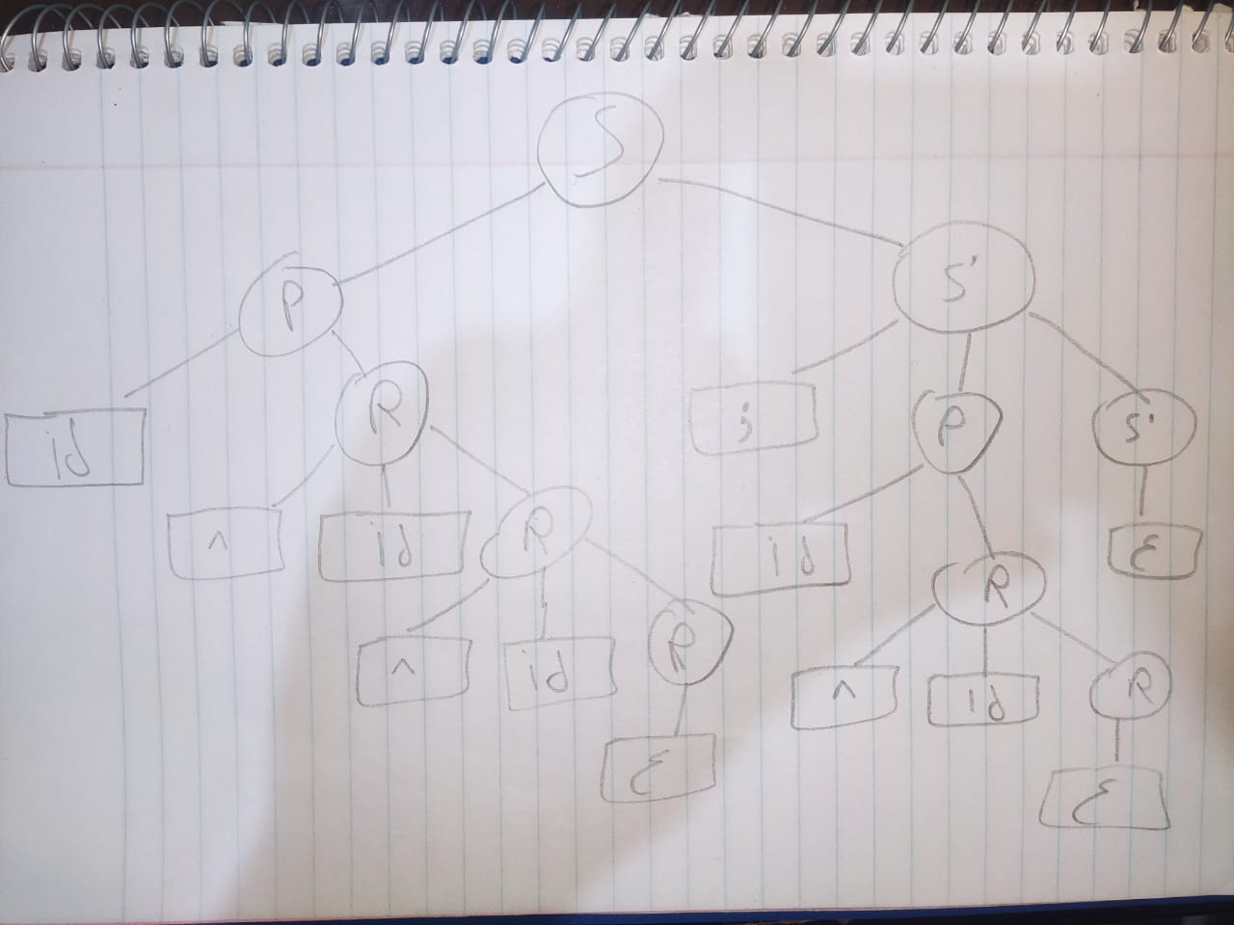

Figure 1: Hand-drawn parse tree for id ^ id ^ id ; id ^ id

Tree structure (ASCII notation):
S
├── P
│ ├── id
│ └── R
│ ├── ^
│ ├── id
│ └── R
│ ├── ^
│ ├── id
│ └── R → ε
└── S'
├── ;
├── P
│ ├── id
│ └── R
│ ├── ^
│ ├── id
│ └── R → ε
└── S' → ε

Task 7: Visualisation using Graphviz
The DOT file below encodes the complete parse tree for id ^ id ^ id ; id ^ id:

digraph ParseTree {
node [fontname="Arial", fontsize=12];
rankdir=TB;

/* Non-terminal nodes (white circles) */
S [label="S", shape=circle, style=filled, fillcolor="#FFFFFF"];
P1 [label="P", shape=circle, style=filled, fillcolor="#FFFFFF"];
SP1 [label="S'", shape=circle, style=filled, fillcolor="#FFFFFF"];
R1 [label="R", shape=circle, style=filled, fillcolor="#FFFFFF"];
R2 [label="R", shape=circle, style=filled, fillcolor="#FFFFFF"];
R3 [label="R", shape=circle, style=filled, fillcolor="#FFFFFF"];
P2 [label="P", shape=circle, style=filled, fillcolor="#FFFFFF"];
SP2 [label="S'", shape=circle, style=filled, fillcolor="#FFFFFF"];
R4 [label="R", shape=circle, style=filled, fillcolor="#FFFFFF"];
R5 [label="R", shape=circle, style=filled, fillcolor="#FFFFFF"];

/* Terminal nodes (light-blue rectangles) */
id1 [label="id", shape=rect, style=filled, fillcolor="#AED6F1"];
id2 [label="id", shape=rect, style=filled, fillcolor="#AED6F1"];
id3 [label="id", shape=rect, style=filled, fillcolor="#AED6F1"];
id4 [label="id", shape=rect, style=filled, fillcolor="#AED6F1"];
id5 [label="id", shape=rect, style=filled, fillcolor="#AED6F1"];
c1 [label="^", shape=rect, style=filled, fillcolor="#AED6F1"];
c2 [label="^", shape=rect, style=filled, fillcolor="#AED6F1"];
c3 [label="^", shape=rect, style=filled, fillcolor="#AED6F1"];
sc [label=";", shape=rect, style=filled, fillcolor="#AED6F1"];

/* Epsilon nodes (yellow rectangles) */
eps1 [label="ε", shape=rect, style=filled, fillcolor="#F9E79F"];
eps2 [label="ε", shape=rect, style=filled, fillcolor="#F9E79F"];
eps3 [label="ε", shape=rect, style=filled, fillcolor="#F9E79F"];

/* Edges */
S -> P1; S -> SP1;
P1 -> id1; P1 -> R1;
R1 -> c1; R1 -> id2; R1 -> R2;
R2 -> c2; R2 -> id3; R2 -> R3;
R3 -> eps1;
SP1 -> sc; SP1 -> P2; SP1 -> SP2;
P2 -> id4; P2 -> R4;
R4 -> c3; R4 -> id5; R4 -> R5;
R5 -> eps2;
SP2 -> eps3;
}

Generation command:
dot -Tpng tree.dot -o tree.png

Generated parse tree image (tree.png):
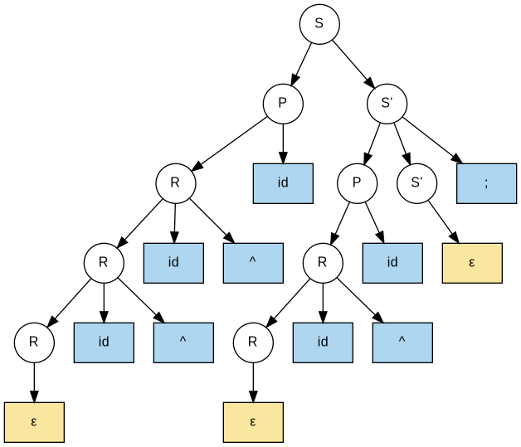
Figure 2: Graphviz-rendered parse tree from hand-crafted tree.dot

Part 3: Implementation using Flex & Bison

Task 8: Flex Scanner (scanner.l)
The scanner supports all three required tokens: id, ^ (CARET), and ; (SEMI). The critical fix applied is yylval.str = strdup(yytext) for ID so the actual identifier text is stored and passed to the parser.

%{
/*
* scanner.l – Flex lexer for the LL(1) grammar:
* S → P S'
* S' → ; P S' | ε
* P → id R
* R → ^ id R | ε
* Tokens: ID CARET SEMI
*/
#include <string.h>
#include "parser.tab.h"
%}
%%
[a-zA-Z][a-zA-Z0-9]* { yylval.str = strdup(yytext); return ID; }
"^" { return CARET; }
";" { return SEMI; }
[ \t\n\r]+ { /* skip whitespace */ }
. { fprintf(stderr, "Unknown token: '%s'\n", yytext); }
%%
int yywrap(void) { return 1; }

Task 9: Bison Grammar (parser.y)
The LL(1) grammar is implemented in Bison. Because node.h provides only binary (left, right) pointers, three-child nodes (R → ^ id R, S' → ; P S') use the right pointer of each child as a sibling chain. No artificial helper nodes are introduced; the tree structure matches the reference tree exactly.

%{
#include <stdio.h>
#include <stdlib.h>
#include <string.h>
#include "node.h"
extern int yylex(void);
void yyerror(const char *msg);
Node *root = NULL;
static Node *chain2(Node *a, Node *b)
{ a->right=b; b->right=NULL; return a; }
static Node *chain3(Node *a, Node *b, Node *c)
{ a->right=b; b->right=c; c->right=NULL; return a; }
%}
%union { char *str; Node *node; }
%token <str> ID
%token CARET SEMI
%type <node> S Sp P R
%%
program : S { root=$1; writeDotFile(root,"parse_tree.dot");
printf("Parse successful. Tree written to parse_tree.dot\n"); } ;
S : P Sp { $$=makeNode("S", chain2($1,$2), NULL); } ;
Sp : SEMI P Sp
{ Node *s=makeNode(";",NULL,NULL);
$$=makeNode("S'", chain3(s,$2,$3), NULL); }
| /* ε */ { $$=makeNode("\xce\xb5", NULL, NULL); } ;
P : ID R
{ Node *id=makeNode($1,NULL,NULL); free($1);
$$=makeNode("P", chain2(id,$2), NULL); } ;
R : CARET ID R
{ Node *c=makeNode("^",NULL,NULL);
Node *id=makeNode($2,NULL,NULL); free($2);
$$=makeNode("R", chain3(c,id,$3), NULL); }
| /* ε */ { $$=makeNode("\xce\xb5", NULL, NULL); } ;
%%
void yyerror(const char *msg)
{ fprintf(stderr,"Parse error: %s\n",msg); }
int main(int argc, char *argv[]) {
extern FILE *yyin;
if (argc==2) { yyin=fopen(argv[1],"r"); }
int r=yyparse();
if (root) freeTree(root);
return r;
}

Part 4: Build the Tree During Parsing

Task 10: node.h – Node Structure Header
#ifndef NODE_H
#define NODE_H
typedef struct Node {
char *label; /* text label */
struct Node *left; /* first child */
struct Node *right; /* next sibling (sibling chain)*/
} Node;
Node *makeNode(const char *label, Node *left, Node *right);
void freeTree(Node *n);
void writeDotFile(Node *root, const char *filename);
#endif /* NODE_H */

Note on the sibling-chain pattern: because node.h specifies exactly two child pointers but the grammar has rules with three RHS symbols (R → ^ id R, S’ → ; P S’), the right pointer of each child is used as a link to the next sibling. This gives faithful n-ary trees with no extra wrapper nodes.

Task 11: node.c – makeNode, freeTree, and writeDotFile
#include <stdio.h>
#include <stdlib.h>
#include <string.h>
#include "node.h"

Node *makeNode(const char *label, Node *left, Node *right) {
Node *n = (Node *)malloc(sizeof(Node));
if (!n) { fprintf(stderr,"Out of memory\n"); exit(1); }
n->label = strdup(label);
if (!n->label) { fprintf(stderr,"Out of memory\n"); exit(1); }
n->left = left;
n->right = right;
return n;
}

void freeTree(Node *n) {
if (!n) return;
freeTree(n->left);
freeTree(n->right);
free(n->label); free(n);
}

static int isTerminal(const char *l) {
return strcmp(l,"id")==0||strcmp(l,"^")==0||strcmp(l,";")==0;
}
static int isEpsilon(const char *l) {
return ((unsigned char)l[0]==0xCE&&(unsigned char)l[1]==0xB5)
|| strcmp(l,"eps")==0;
}

static void exportNode(Node *n, FILE *f, int *ctr, int pid) {
if (!n) return;
int id = (*ctr)++;
const char *shape="circle", *fill="\"#FFFFFF\"";"
if (isTerminal(n->label)) { shape="rect"; fill="\"#AED6F1\""; }
else if (isEpsilon(n->label)) { shape="rect"; fill="\"#F9E79F\""; }
fprintf(f," n%d [label=\"%s\", shape=%s, style=filled, fillcolor=%s];\n",
id, n->label, shape, fill);
if (pid>=0) fprintf(f," n%d -> n%d;\n", pid, id);
Node *child=n->left;
while(child) {
Node *next=child->right;
child->right=NULL;
exportNode(child,f,ctr,id);
child->right=next;
child=next;
}
}

void writeDotFile(Node *root, const char *filename) {
FILE *f = fopen(filename,"w");
if (!f) { perror("Cannot open DOT file"); return; }
fprintf(f,"digraph ParseTree {\n");
fprintf(f," node [fontname=\"Arial\", fontsize=12];\n");
fprintf(f," rankdir=TB;\n\n");
int counter=0;
exportNode(root,f,&counter,-1);
fprintf(f,"}\n");
fclose(f);
printf("DOT file written: %s\n", filename);
}

Task 12: Build Instructions & Visualisation
Save all five source files (scanner.l, parser.y, node.h, node.c, Makefile) in one directory. The Makefile auto-detects Linux/macOS vs Windows (win_flex_bison) and selects the correct tool names and linker flags.

# Makefile – Cross-platform (Linux/macOS/Windows win_flex_bison)
ifeq ($(OS),Windows_NT)
LDFLAGS =
FLEX = win_flex
BISON = win_bison
else
LDFLAGS = -lfl
FLEX = flex
BISON = bison
endif
CC = gcc
CFLAGS = -Wall -Wextra -g
TARGET = parser
INPUT = "id ^ id ^ id ; id ^ id"
.PHONY: all run png tree-png clean
all: $(TARGET)
parser.tab.c parser.tab.h: parser.y
$(BISON) -d parser.y
lex.yy.c: scanner.l parser.tab.h
$(FLEX) scanner.l
$(TARGET): parser.tab.c lex.yy.c node.c node.h
$(CC) $(CFLAGS) -o $(TARGET) parser.tab.c lex.yy.c node.c $(LDFLAGS)
run: $(TARGET)
echo $(INPUT) | ./$(TARGET)
png: run
dot -Tpng parse_tree.dot -o parse_tree.png
tree-png:
dot -Tpng tree.dot -o tree.png
clean:
rm -f $(TARGET) parser.tab.c parser.tab.h lex.yy.c parse_tree.dot parse_tree.png tree.png

Manual build commands:
# Step 1 – Generate parser from Bison grammar
bison -d parser.y # produces parser.tab.c and parser.tab.h

# Step 2 – Generate scanner from Flex specification
flex scanner.l # produces lex.yy.c

# Step 3 – Compile everything
gcc -o parser parser.tab.c lex.yy.c node.c -lfl

# Step 4 – Run the parser on the sample input string
echo "id ^ id ^ id ; id ^ id" | ./parser

# Step 5 – Render the auto-generated DOT file to PNG
dot -Tpng parse_tree.dot -o parse_tree.png

# Or simply use:
make && make png

Expected terminal output:
DOT file written: parse_tree.dot
Parse successful. Tree written to parse_tree.dot

Auto-generated parse tree image (parse_tree.png — produced by make png):
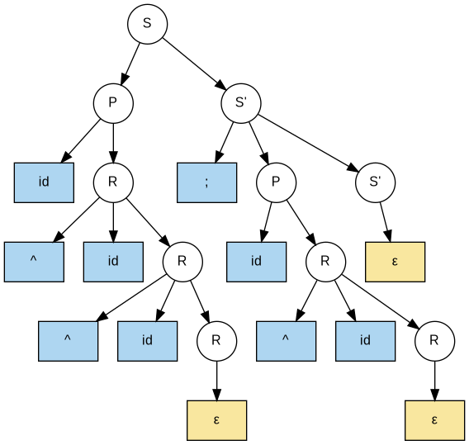
Figure 3: Parse tree automatically generated by the compiled Flex/Bison parser

The auto-generated parse_tree.png is structurally identical to the hand-crafted tree.png (Figure 2). The only difference is that node labels for id terminals show the generic tag "id" (since all identifiers are tokenised uniformly), consistent with the grammar specification.

Sourse code :

