Hierarchical Models
Day 2 Computer Lab

Activities
- Random intercept model
- Mark-recapture model (Lincoln-Peterson)
- State-space model

Activity 2.1: Random intercept model
Model description
A linear regression with a random intercept can be written as:
$$y_{i} \sim Normal\left(μ_{i}, σ\right) \\ μ_{i}=α_{g}+ \sum_{k=1}^{K}{β_{k}x_{k, i}}$$
$$α_{g} \sim Normal\left(μ^{α}, σ^{α}\right)$$
Notice that this is a hierarchical model because there are two models (denoted by ~) that are linked by a common parameter $α_{g}$ that appears on the right side of one model (i.e. the model for $y_{i}$) and on the left side of another model (i.e. the model for the intercept).
The following priors may be appropriate for this model:
$$μ^{α} \sim Normal\left( 0, 10\right) \\ σ^{α} \sim HalfCauchy(0, 5)$$
$$β_{k} \sim Normal\left(0, 10\right) \\ σ \sim HalfCauchy\left(0, 5\right)$$
This model is the same as our linear regression from day 1, except this model estimates a different intercept $α$ for each group $g$ in the data. The key concept is that the group-level intercepts $α_{g}$ may differ among groups, but they are not independent of one another. They are drawn from a common distribution with a shared mean $μ^{α}$ and standard deviation $σ^{α}$.
Note: The superscripts on $μ^{α}$ and $σ^{α}$ do not indicate that these parameters are raised to the power of $α$. This notation is used here to remind us that, for example, $μ^{α}$ represents the mean of the group-level $α$ values. However, I would generally not recommend ambiguous notation that requires an explanation like this one!

The DAG for this model could be written as:
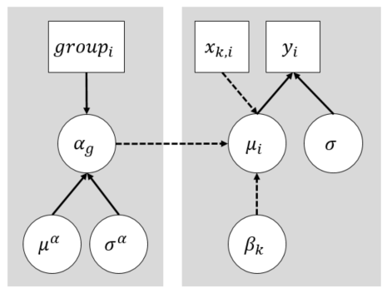

Activity 2.2: Mark-recapture model
We will use a Lincoln-Peterson mark-recapture model to estimate the total population size for a population that includes “unobservable” people who are not available to be counted. This is not a hierarchical model, but we will link it with a population process model in the next activity to make it hierarchical. We thought it might first be nice to see how this model works on its own.
In a simple mark-recapture survey, a population is surveyed in two successive rounds with randomly selected individuals being recorded with individual identifiers in each round. This method was originally developed for estimating animal populations for which a census is impossible, and it has been applied to estimate inaccessible human populations (e.g. homeless). The mark-recapture methodology allows us to estimate the total population size, including all of the unobservable individuals.
The total number of individuals “marked” $M$ (i.e. recorded with an individual identifier) in the first round is compared to the total number of individuals “captured” $C$ in the second round and the count of those who were “recaptured” $R$ (detected in both rounds) to estimate the total population size $N$.
$$R \sim Binomial(C,\frac{M}{N})$$
Q: What do the two parameters of the binomial distribution mean? What are their ranges of support and data types? What type of data is the outcome?

Q: What are a few assumptions that are associated with using this binomial distribution for the likelihood? Hint: Can you rewrite the probability parameter (i.e. $\frac{M}{N}$) in terms of R and C?

An appropriate prior for the unobserved latent parameter $N$ might be:
$$N \sim Uniform(C-R+M, 1e6)$$
Notice that the lower bound on this uniform prior is the total number of unique individuals observed across both rounds of the mark-recapture survey. In other words, there is zero probability of the population size being less than the number of individuals that we observed in the survey.
Q: Can you draw the DAG for this model?
Hint: The answer is in ./DAGS.pptx

Activity 2.3: State-space model
A state-space model is a hierarchical model that allows us to make inferences about a process that we cannot directly observe. The model has two levels: (1) a process model describing how a “state” changes through time dependent on the previous state, and (2) an observation model with imperfect observations (i.e. data) that are dependent on the state. The generic form of this model can be written as:
$$\left[ z_{t} \right| z_{t-1}, ϵ^{p} ] \\ \left[ y_{t} \right| z_{t},ϵ^{O} ]$$
where $z_{t}$ is the “state” that we are interested in for time step $t$, and $y_{t}$ is our observation that is dependent on that state. Each model contains a stochastic error term $ϵ$ that quantifies process error and observation error.
In this activity, we will build a state-space model with these levels:
- A process model describing how population size (i.e. the state of the population) changes through time, and
- An observation model describing how mark-recapture survey results relate to the true population size in each time step.
Our process model estimates population sizes $N_{t}$ each year $t$ and the relationship of population growth rates $λ_{t}$ with year-specific covariates. In this model, the population size $N_{t}$ is an unobserved “latent” parameter—i.e. it is not provided to the model as data.
$$N_{t} \sim LogNormal\left(\log\left(λ_{t}N_{t-1}\right),σ\right) \\ \log\left(λ_{t}\right)=α+\sum_{k=1}^{K}{β_{k}x_{k, t}}$$
where the population growth rate $λ_{t}$ quantifies annual changes in population size and the unexplained variance in the population process is captured by $σ$.
Q: Do you think a LogNormal distribution is appropriate for this process model? Why or why not?

So far, our model does not contain any data! We will link this population time series to our mark-recapture model from the previous activity so that we can integrate data from an annual mark-recapture survey to help estimate our parameters.
$$R_{t} \sim Binomial(C_{t},\frac{M_{t}}{N_{t}})$$
Remember that our mark-recapture surveys record the following data: The total number of individuals “marked” $M$ (i.e. recorded with an individual identifier) in the first round of the survey, the total number of individuals “captured” $C_{i}$ in the second round, and the count of those who were “recaptured” $R_{i}$ (detected in both rounds).
Q: Is there a variance parameter in the Binomial distribution to quantify observation error? If not, how is variance represented by this distribution?

The DAG for this model could be written as:
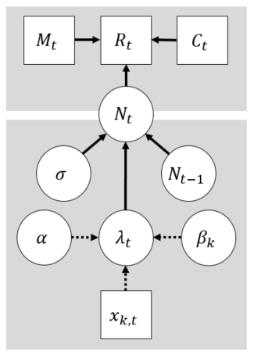
Q: Can you design appropriate priors for the model? Hint: Every parameter node without an arrow pointing into it requires a prior.
After you have designed your priors, compare them to the example in the Stan model code: ./Day_1/Lab_1/models/2c_state_space.stan

