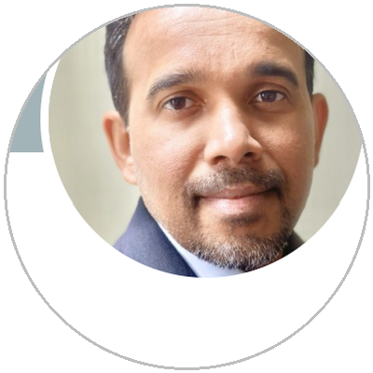  PRADEEP  KOLAKKAMPADATH  CONTACT  kolakkampadath@gmail.com  Greater St. Louis, MO  LinkedIn: valsa-kolakkampadath  realgradientdescent.tech  SUMMARY  Software Engineering Director with 20+ years of progressive IT leadership, currently managing a 56-person engineering excellence organization at Evernorth. Uniquely positioned at the intersection of enterprise engineering rigor and AI enablement—pioneering GenAI adoption in SDLC, building AI-powered developer tools, and architecting multi-agent AI systems. Proven track record driving platform modernization, resilience engineering, and large-scale organizational transformation while maintaining rigorous financial discipline and security standards.  CORE SKILLS  - AI/ML Engineering  - Multi-Agent Systems  - Platform Engineering  - Reliability Engineering  - CI/CD & DevOps  - Security & Compliance  - Healthcare IT  - Agile/SAFe  - P&L Management ($7.5M+)  - Team Building (56+ org)  - Cross-Functional Leadership  - Strategic Planning  CERTIFICATIONS  PMP (since 2008)  PMI-ACP  PAHM  EDUCATION  B.Tech, Biomedical Engineering  Cochin Univ. of Science & Tech.  MicroMasters, Cybersecurity  Rochester Institute of Technology  AI: Business Strategy  MIT Sloan Executive Ed. (2026) | WORK HISTORY  Director of Software Engineering | Evernorth Health Services  Aug 2024 – Present  - Leads 56-person engineering excellence org (24 employees, 32 contractors) across US and India with $7.5M annual budget  - Drove GenAI adoption in SDLC through test data mining MVPs, developer assist solutions, and AI fluency frameworks  - Transformed engineering enablement from support function into strategic enterprise-scale platform  - Replaced legacy tools with NeoLoad, launched Performance Testing front end as scalable enterprise standard  - Drove enterprise-wide Dependabot adoption and vulnerability dashboards, improving security remediation outcomes  - Led TCO optimization and portfolio budget analysis, strengthening funding alignment  Senior Manager, Software Engineering | Evernorth Health Services  Jul 2022 – Jul 2024  - Managed 22-person team across Stability Engineering, Performance Testing, and DoD QA  - Led Environment Simplification, exceeding targets for retiring legacy applications  - Piloted Endeavor GitHub Bridge enabling CI/CD in mainframe environments  Senior Delivery Manager | Evernorth Health Services  Dec 2017 – Jun 2022  - Led Engineering Stability Transformation and IT security controls improvement  - Drove process optimizations for IT Infrastructure Operations  Associate Director | Cognizant Technology Solutions  Jul 2016 – Dec 2017  - Led healthcare IT delivery for Express Scripts, managing cross-functional onsite/offshore teams  Senior Manager | Cognizant Technology Solutions  Dec 2012 – Jun 2016  - Delivered technology transformation initiatives and architectural optimizations for healthcare platforms  Service Delivery Manager | CGI Inc.  Apr 2009 – Dec 2012  - Managed $6M multi-site engagement (US/Canada/India), 70+ person team  - Achieved 40% revenue pipeline growth; improved delivery quality 20%+  - Led Claims IT through 5010, ICD-10, PPACA regulatory implementations  Earlier: Project Manager, Mahindra Satyam (2006-09) | Project Lead, Capgemini (2003-06) | Module Lead, UST Global (2002-03)  KEY ACCOMPLISHMENTS  - Transformed performance testing and stability engineering into enterprise-wide platforms serving all Evernorth application teams  - Positioned teams as strategic partners for AI adoption, moving GenAI from experimentation into governed, scalable workflows  - Built award-recognized teams with strong retention, continuous improvement culture, and automation-first mindset  - Delivered cost transparency through TCO optimization and service rationalization across high-cost applications  - Achieved top-tier CMDB certification results through measurable data quality standards and executive dashboards  NOTABLE PROJECTS  OpenClaw — Multi-agent AI system with 4 specialized agents (orchestration, coding, research, memory). Self-hosted on personal infrastructure. [realgradientdescent.tech]  Employee Communication Simulator — AI-powered simulation with 60 personas across 450-person org model, 3 communication modes, 4 interaction surfaces

