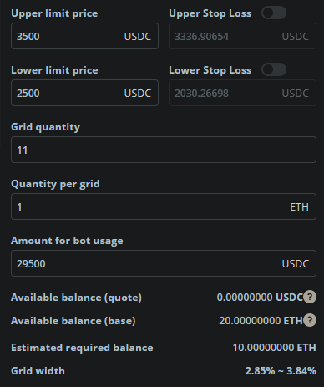

**Upper limit price**: If the price rises up more than upper limit price, the bot does not trade.

**Lower limit price**: If the price falls down less than lower limit price, the bot does not trade.

**Grid quantity**: It means the total count of grid. In the above case, grid quantity is 11(6 Buy Grid + 5 Sell Grid)

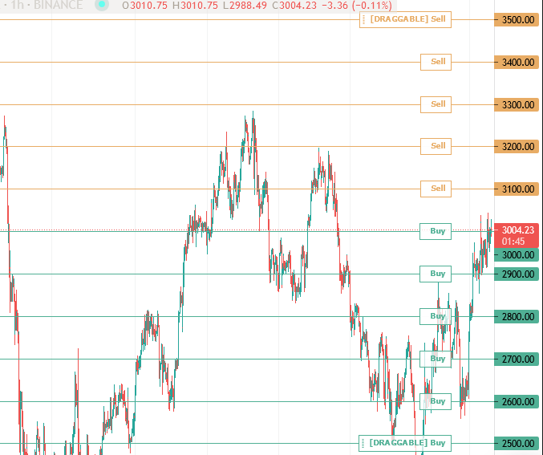

**Quantity per Grid**: It is the amount of which bot could trade in one grid (sell or buy)

**Amount for bot usage**: It is the total amount that the bot needs to trade. It is calculated from other parameters.

In the above example,

grid width = (upper limit price – lower limit price) / (grid quantity - 1) = (3500 – 2500) / 10 = 100

So, all of grid are placed in every 100. (2500, 2600, 2700, …, 3500)

amount for bot usage = 2500 + 2600 + … + 2900 = 29500 (upper limit price is not involved)

**Available balance(quote)**: it is the balance of usdc.

**Available balance(base)**: it is the balance of eth.

**Estimated Required balance:** it is the required balance of eth to trade. in the above example, there are 10 grids from 25 to 34 (except for upper limit price) and 1 eth is need in each grid, so Estimated Required Balance = 1 * 10 = 10 eth

**Grid width:** In the above example, grid width is 100,

2.85% ~ 3.84% is the percent of tradable uppest grid, lowest grid.

ie.

for uppest grid, grid width = (100 / 3500) * 100 = 2.857

for lowest grid, grid width = (100 / 2600) * 100 = 3.846

I fully understood the grid strategy and project purpose.

Please trust me.

And if something is wrong, let me know asap.

Thanks again.