**OLAP**

Teori

Operasi OLAP:

* Roll up (drill-up): menyimpulkan data (aggregate)

SELECT …

GROUP BY ROLLUP (…);

Contoh:

SELECT time, location, product, SUM (revenue) AS profit

FROM sales

GROUP BY ROLLUP (time, location, product);

* Drill down (roll down): kebalikan rollup (mendetailkan simpulan rollup)

SELECT …

GROUP BY ROLLDOWN (…);

Contoh:

SELECT time, location, product, SUM (revenue) AS profit

FROM sales

GROUP BY ROLLDOWN (time, location, product);

* Slice and dice: menunjukkan sebagian data cube

Contoh: What colors of Golf are not doing so well?

SELECT color, sum (price)

FROM sales

WHERE model = ‘Golf’ 🡪 Slicing

GROUP BY color 🡪 Dicing

* Pivot (rotate): mengubah orientasi data cube
* Other operations
  + drill across: *involving (across) more than one fact table*
  + drill through: *through the bottom level of the cube to its back-end relational tables (using SQL)*

Latihan Soal

This schema provides a simple "star schema" containing information about students, instructors, classes, and students taking classes from instructors.

Student ( studID, name, major )   // dimension table, studID is key

Instructor ( instID, dept );   // dimension table, instID is key

Class ( classID, univ, region, country );   // dimension table, classID is key

Took ( studID, instID, classID, score );   // fact table, foreign key references to dimension tables

**Questions:**

1. Find average scores grouped by student and instructor for courses taught in Quebec.
2. "Roll up" your result from problem 1 so it's grouping by the instructor only.
3. Find average scores grouped by student major.
4. "Drill down" on your result from problem 3 so it's grouping by instructor's department as well as student's major.
5. Use "WITH ROLLUP" on attributes of table Class to get average scores for all geographical granularities: by country, region, and university, as well as the overall average.

**Answers:**

1. Rata-rata nilai dikelompokkan berdasarkan murid dan instruktur untuk pelajaran yang diajar di Quebec.

SELECT studID, instID, ROUND(AVG(score),2) AS AverageScore

FROM Took

WHERE classID in

(SELECT classID FROM class WHERE region like 'Quebec')

GROUP BY studID, instID

ORDER BY studID

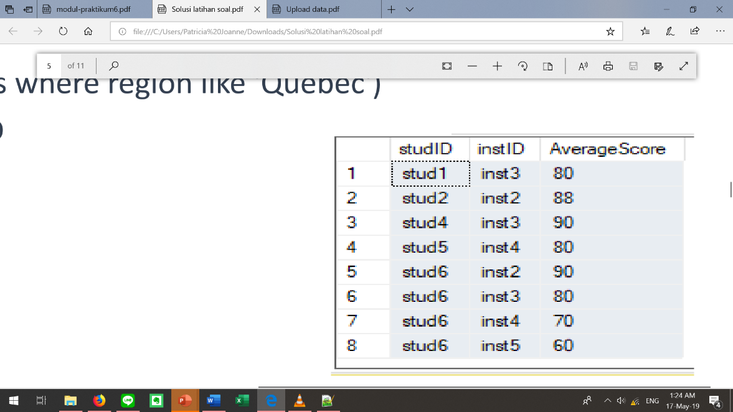

1. Rollup jawaban no. 1 sehingga kelompok hanya berdasarkan instruktur saja.

SELECT instID, ROUND(AVG(score),2) AS AverageScore

FROM Took

WHERE classID in

(SELECT classID FROM class WHERE region LIKE 'Quebec')

GROUP BY instID

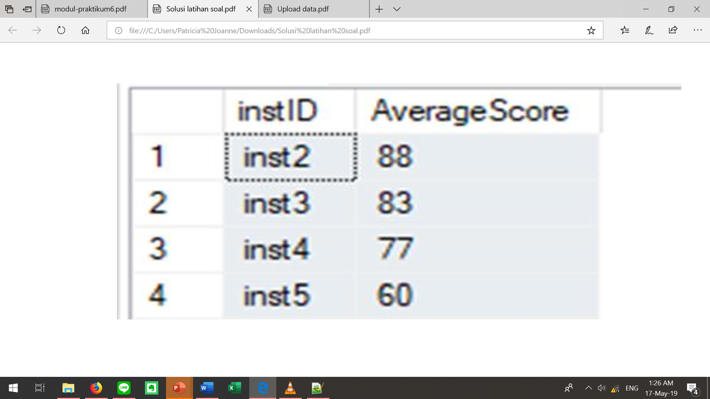

SELECT instID, ROUND(AVG(score),2) AS AverageScore

FROM Took

WHERE classID IN (SELECT classID from class where region like 'Quebec')

GROUP BY **ROLLUP** (instID)

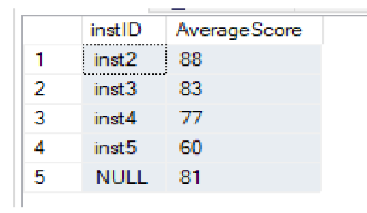

1. Rata-rata nilai dikelompokkan berdasarkan jurusan murid.

SELECT CAST (Student.major AS VARCHAR(10)) AS major,

AVG(Took.score) AS AvgScore

FROM Took LEFT JOIN Student

ON Took.studID=Student.studID

GROUP BY CAST(Student.major AS VARCHAR(10))

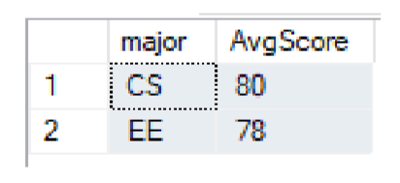

1. Drilldown jawaban no. 3 sehingga dikelompokkan berdasarkan departemen instruktur.

SELECT CAST (Student.major AS VARCHAR(10)) AS major,

**CAST(Instructor.dept AS VARCHAR(10)) AS dept,**

AVG(Took.score)AS AvgScore

FROM Took LEFT JOIN Student

ON Took.studID=Student.studID

**LEFT JOIN Instructor**

**ON Took.instID=Instructor.instID**

GROUP BY **ROLLDOWN** (CAST(Student.major AS VARCHAR(10)),

**CAST(Instructor.dept AS VARCHAR(10)))**

ORDER BY CAST(Student.major AS VARCHAR(10))

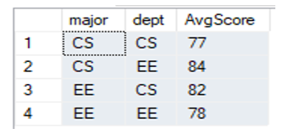

1. Gunakan ROLLUP untuk atribut tabel Class sehingga didapat rata-rata nilai untuk semua granularitas geografis: country, region, university.

SELECT CAST(Class.country AS VARCHAR(10)) AS country,

CAST(Class.region AS VARCHAR(10)) AS region,

CAST(Class.univ AS VARCHAR(10)) AS univ,

AVG(score) AS AvgScore

FROM Took LEFT JOIN Class

ON Took.classID=Class.classID

GROUP BY ROLLUP (CAST(Class.country AS VARCHAR(10)),

CAST(Class.region AS VARCHAR(10)),

CAST(Class.univ AS VARCHAR(10))

