**Tugas 1**

Nama : Patricia Joanne

NPM : 140810160065

**29 April 2019**

Tugas Pertemuan 9

**Soal:**

1. Gunakan Backpropagation dengan sebuah layar tersembunyi (dengan 3 unit) untuk mengenali fungsi logika XOR dengan 2 masukan x1 dan x2. Buatlah iterasi untuk menghitung bobot jaringan untuk pola pertama (x1 = 1, x2 = 1 dan l = 0). Gunakan laju pemahaman α = 0.15.

HINT: Langkah-langkah penyelesaian dapat anda pelajari di buku yang dilampirkan pada halaman 105-108.

1. Perhatikan kembali iterasi pola pertama fungsi logika XOR dengan BP pada soal no.1. Lakukan iterasi untuk pola kedua (x1 = 1, x2 = 0, l = 1) dengan menggunakan suku momentum (µ = 0,4).

HINT: Langkah-langkah penyelesaian dapat anda pelajari di buku yang dilampirkan pada halaman 114-118.

**Jawaban:**

1. Diketahui:

Masukan x1 dan x2

Pola pertama x1 = 1, x2 = 1, l = 0

α = 0.15

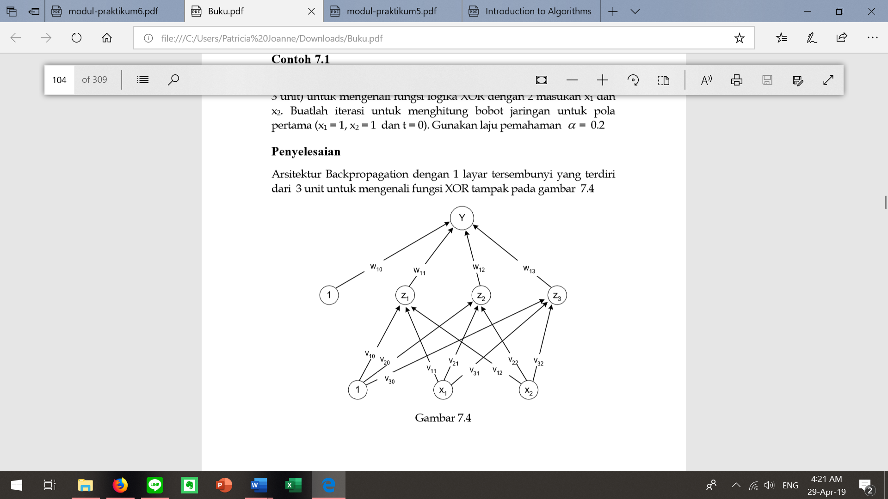

* Mula-mula bobot diberi nilai acak yang kecil (range [-1, 1]). Misal didapat bobot seperti tabel 1 (bobot dari layar masukan ke layar tersembunyi = vji) dan tabel 2 (bobot dari layar masukan ke layar tersembunyi = wkj)

|  |  |  |  |
| --- | --- | --- | --- |
|  | z1 | z2 | z3 |
| x1 | 0.5 | 0.3 | 0.4 |
| x2 | 0.1 | -0.1 | 0.2 |
| l | -0.3 | 0.3 | 0.3 |

|  |  |
| --- | --- |
|  | y |
| z1 | 0.8 |
| z2 | 0.4 |
| z3 | 0.6 |
| l | -0.2 |

* Hitung keluaran unit tersembunyi (zj)

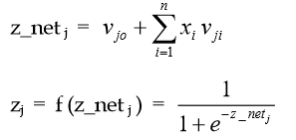

z_netj

|  |  |  |
| --- | --- | --- |
| Z |  | z_net |
| 1 | ν10 + (x1. ν11 + x2. ν12) | -0.3 + 1 (0.5) + 1 (0.1) = 0.3 |
| 2 | ν20 + (x1. ν21 + x2. ν22) | 0.3 + 1 (0.3) + 1 (-0.1) = 0.5 |
| 3 | ν30 + (x1. ν31 + x2. ν32) | 0.3 + 1 (0.4) + 1 (0.2) = 0.9 |

zj

|  |  |  |
| --- | --- | --- |
| Z |  | Zj |
| 1 |  | 0.57 |
| 2 |  | 0.62 |
| 3 |  | 0.71 |

* Hitung keluaran unit yk

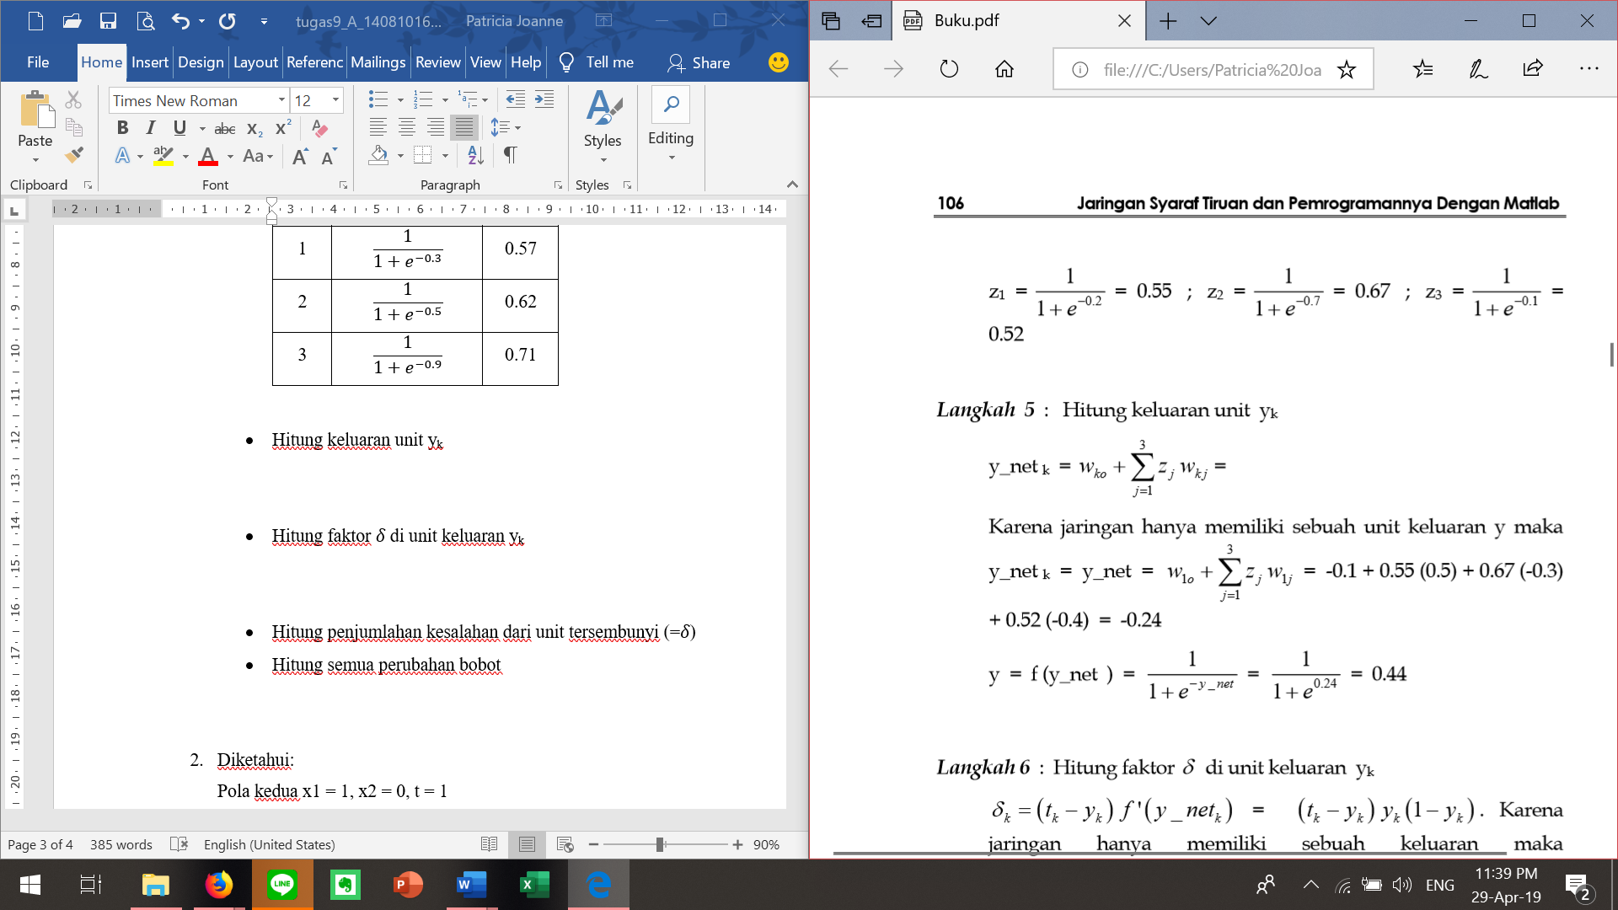



-0.2 + 0.57 (0.8) + 0.62 (0.4) + 0.71 (0.6) = 0.93

Y = f (y_net) = = = 0.72

* Hitung faktor 𝛿 di unit keluaran yk



𝛿1 = (0-0.72) 0.72 (1-0.72) = -0.15



Δwkj dengan α = 0.15 dan 𝛿k = -0.15

|  |  |  |  |
| --- | --- | --- | --- |
| k | J | α 𝛿k zj |  |
| 1 | 0 | 0.15*(-0.15)*1 | -0.0225 = -0.02 |
| 1 | 1 | 0.15*(-0.15)*0.57 | -0.012825 = -0.01 |
| 1 | 2 | 0.15*(-0.15)*0.62 | -0.01395 = -0.01 |
| 1 | 3 | 0.15*(-0.15)*0.71 | -0.015975 = 0.02 |

* Hitung penjumlahan kesalahan dari unit tersembunyi (=𝛿)

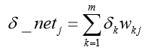





δ_netj

|  |  |  |
| --- | --- | --- |
| j |  | δ_netj |
| 1 | δ1.w11 | -0.15 * 0.8 = -0.12 |
| 2 | δ1.w12 | -0.15 * 0.4 = -0.06 |
| 3 | δ1.w13 | -0.15 * 0.6 = -0.09 |

δj

|  |  |  |
| --- | --- | --- |
| j | δ_netj zj (1-zj) | δj |
| 1 | -0.12 * 0.57 * (1-0.57) | -0.03 |
| 2 | -0.06 * 0.62 * (1-0.62) | -0.01 |
| 3 | -0.09 * 0.71 * (1-0.71) | -0.02 |

Δvji

|  |  |  |  |
| --- | --- | --- | --- |
| j\i | 0 | 1 | 2 |
| 1 | 0.15*(-0.03)*1 = -0.0045 | 0.15*(-0.01)*1 = -0.0015 | 0.15*(-0.02)*1 = -0.003 |
| 2 | 0.15*(-0.03)*1 = -0.0045 | 0.15*(-0.01)*1 = -0.0015 | 0.15*(-0.02)*1 = -0.003 |
| 3 | 0.15*(-0.03)*1 = -0.0045 | 0.15*(-0.01)*1 = -0.0015 | 0.15*(-0.02)*1 = -0.003 |

* Hitung semua perubahan bobot



w11 (baru) = 0.8 – 0.01 = 0.79

w12 (baru) = 0.4 – 0.01 = 0.39

w13 (baru) = 0.6 – 0.02 = 0.58

w10 (baru) = -0.2 – 0.02 = -0.22



|  |  |  |  |
| --- | --- | --- | --- |
|  | z1 | z2 | z3 |
| x1 | v11 (baru) = 0.5 -0.0045 = 0.4955 | v21 (baru) = 0.3 -0.0015 = 0.2985 | v31 (baru) = 0.4 -0.003 = 0.397 |
| x2 | v12 (baru) = 0.1 -0.0045 = 0.0955 | v22 (baru) = -0.1 -0.0015 = -0.1015 | v32 (baru) = 0.2 -0.003 = 0.197 |
| l | v10 (baru) = -0.3 -0.0045 = -0.3045 | v20 (baru) = 0.3 -0.0015 = 0.2985 | v30 (baru) = 0.3 -0.003 = 0.297 |

1. Diketahui:

Pola kedua x1 = 1, x2 = 0, t = 1

µ = 0,4

* Iterasi pola kedua sebenarnya sama dengan soal no. 1 hanya saja perhitungan bobot baru pada langkah terakhir dilakukan dengan menambahkan momentum (bobot pada waktu t-1 = bobot awal).
* Hasil iterasi dari pola pertama:

|  |  |  |  |
| --- | --- | --- | --- |
|  | z1 | z2 | z3 |
| x1 | 0.4955 | 0.2985 | 0.397 |
| x2 | 0.0955 | -0.1015 | 0.197 |
| l | -0.3045 | 0.2985 | 0.297 |

|  |  |
| --- | --- |
|  | y |
| z1 | 0.79 |
| z2 | 0.39 |
| z3 | 0.58 |
| l | -0.22 |

* Hitung keluaran unit tersembunyi (zj)



z_netj

|  |  |  |
| --- | --- | --- |
| Z |  | z_net |
| 1 | ν10 + (x1. ν11 + x2. ν12) | -0.3045 + 1 (0.4955) + 1 (0.0955) = 0.2865 |
| 2 | v20 + (x1. ν21 + x2. ν22) | 0.2985 + 1 (0.2985) + 1 (-0.1015) = 0.4955 |
| 3 | ν30 + (x1. ν31 + x2. ν32) | 0.297 + 1 (0.397) + 1 (0.197) = 0.891 |

zj

|  |  |  |
| --- | --- | --- |
| Z |  | Zj |
| 1 |  | 0.5711 |
| 2 |  | 0.6214 |
| 3 |  | 0.7090 |

* Hitung keluaran unit yk





-0.22 + 0.5711 (0.79) + 0.6214 (0.39) + 0.7090 (0.58) = 0.884735

Y = f (y_net) = = = 0.707

* Hitung faktor 𝛿 di unit keluaran yk



𝛿1 = (0-0.707) 0.707 (1-0.707) = -0.1464



Δwkj dengan α = 0.15 dan 𝛿k = -0.1464

|  |  |  |  |
| --- | --- | --- | --- |
| k | J | α 𝛿k zj |  |
| 1 | 0 | 0.15*(-0.1464)*1 | -0.02196 |
| 1 | 1 | 0.15*(-0.1464)*0.5711 | -0.01254 |
| 1 | 2 | 0.15*(-0.1464)*0.6214 | -0.01365 |
| 1 | 3 | 0.15*(-0.1464)*0.7090 | -0.01557 |

* Hitung penjumlahan kesalahan dari unit tersembunyi (=𝛿)







δ_netj

|  |  |  |
| --- | --- | --- |
| j |  | δ_netj |
| 1 | δ1.w11 | -0.15 * 0.79 = -0.1185 |
| 2 | δ1.w12 | -0.15 * 0.39 = -0.0585 |
| 3 | δ1.w13 | -0.15 * 0.58 = -0.087 |

δj

|  |  |  |
| --- | --- | --- |
| j | δ_netj zj (1-zj) | δj |
| 1 | -0.1185 * 0.5711 * (1-0.5711) | -0.029 |
| 2 | -0.0585 * 0.6214 * (1-0.6214) | -0.014 |
| 3 | -0.087 * 0.7090 * (1-0.7090) | -0.018 |

Δvji

|  |  |  |  |
| --- | --- | --- | --- |
| j\i | 0 | 1 | 2 |
| 1 | 0.15*(-0.029)*1 = -0.00435 | 0.15*(-0.014)*1 = -0.0021 | 0.15*(-0.018)*1 = -0.0027 |
| 2 | 0.15*(-0.029)*1 = -0.00435 | 0.15*(-0.014)*1 = -0.0021 | 0.15*(-0.018)*1 = -0.0027 |
| 3 | 0.15*(-0.029)*1 = -0.00435 | 0.15*(-0.014)*1 = -0.0021 | 0.15*(-0.018)*1 = -0.0027 |

* Hitung semua perubahan bobot

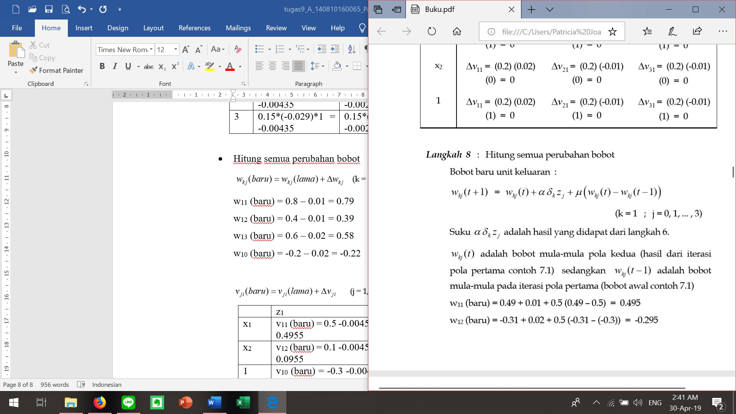

w11 (baru) = 0.79 + (-0.01254) + 0.4*(0.79-0.8) = 0.77346

w12 (baru) = 0.39 + (-0.01365) + 0.4*(0.39-0.4) = 0.37235

w13 (baru) = 0.58 + (-0.01557) + 0.4*(0.58-0.6) = 0.55643

w10 (baru) = -0.22 + (-0.02196) + 0.4*(-0.22+0.2) = -0.24996

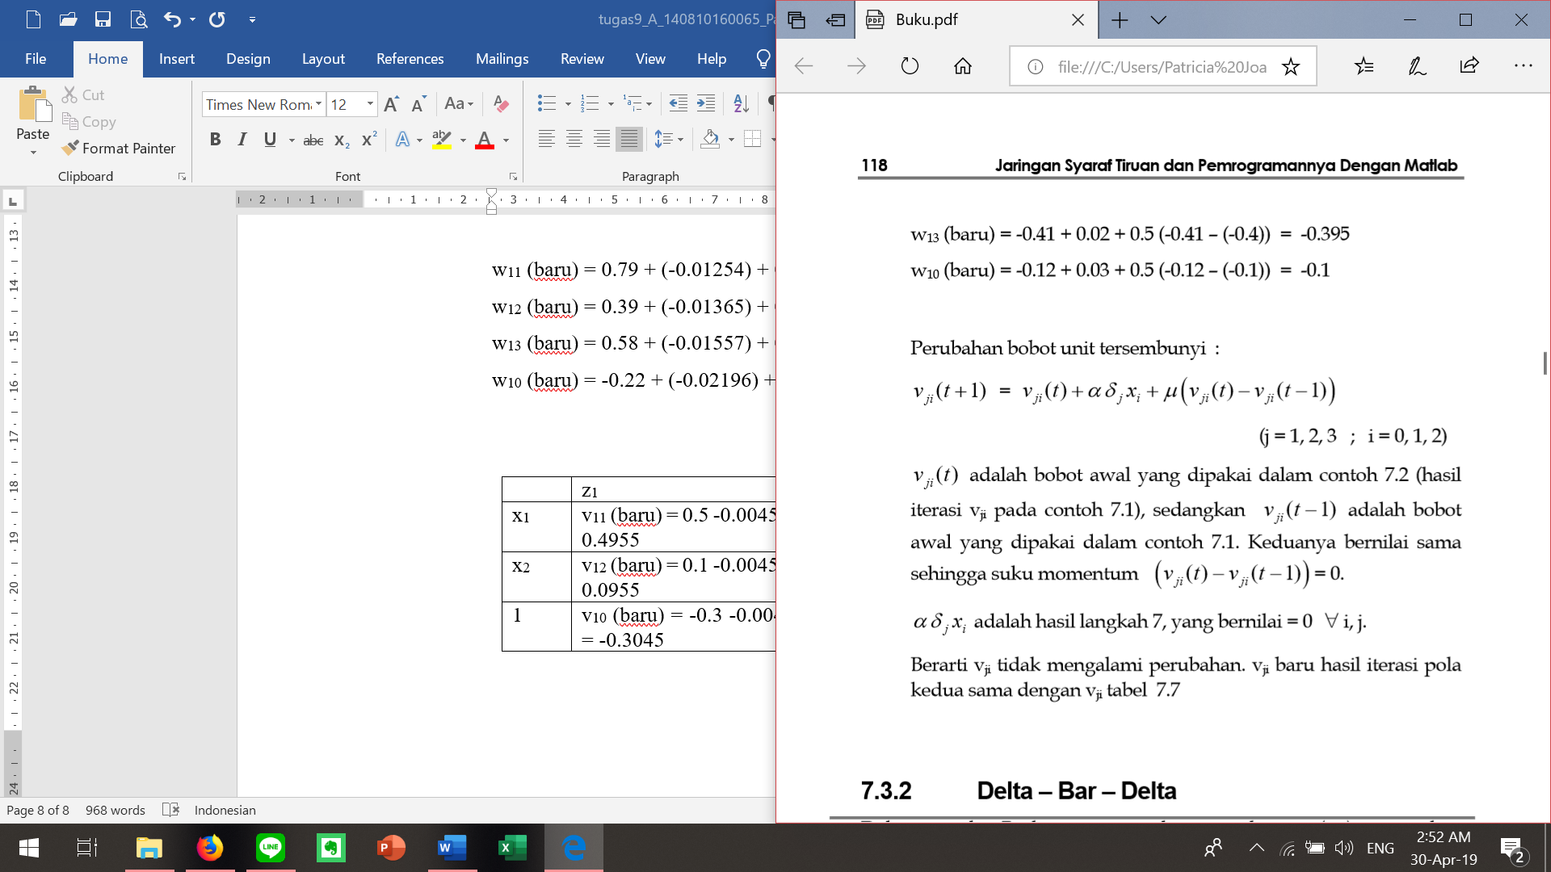

vji (t+1) dan vji (t) bernilai sama sehingga suku momentumnya = 0 berarti vji tidak mengalami perubahan atau vji baru sama dengan vji soal no. 1.