CLINICOS: DESIGNING DOCUMENTATION FOR THE TWO-MINUTE CONSULTATION
A Design Thinking Report on a Consultation-Documentation Assistant for Clinics, Hospitals and Health Systems
Team Name
Group 11
Member Details
Sl. No. | Name | SIN
1 | Ishaan Seal | 26-001-08-32-0059
2 | Debarjune Gangopadhyay | 26-001-08-32-0071
3 | Saptajit Datta | 26-001-08-32-0067
4 | Sadique Tanvee | 26-001-08-32-0022
5 | Sarad Gupta | 26-001-08-32-0073
6 | Saatvik Jaiswal | 26-001-08-32-0054
7 | Nishan Bhattacharjee | 26-001-08-32-0055

Topic
ClinicOS – a local-first assistant that records, transcribes and drafts the clinical note, so the doctor only reviews and signs
Subject
Design Thinking
October 2026
CONTENTS
INTRODUCTION 3
1. EMPATHIZE 4
1.1 The Setting: The Outpatient Consultation 4
1.2 How We Set Out to Listen 4
1.3 What the Evidence Says 5
1.4 What We Still Have to Hear Ourselves 5
1.5 The Assumptions That Broke 5
1.6 Who We Are Designing For: Personas 6
1.7 Empathy Map (Hypotheses) 7
1.8 Journey Map: The Consultation as It Happens Today 7
2. DEFINE 8
2.1 Four Problems, Not One 8
2.2 Problem Statement 8
2.3 Point of View 8
2.4 How Might We… 8
2.5 The Boundaries We Designed Inside 9
2.6 Success Criteria, Set Before Testing 9
3. IDEATE 10
3.1 Brainstorming: A Wide Field of Ideas 10
3.2 Four Directions Compared 11
3.3 Selection Criteria 11
3.4 Four Design Principles 11
3.5 What We Chose Not to Build 12
4. PROTOTYPE AND TEST 13
4.1 What Was Built: Working Software, Not a Mock-up 13
4.2 How It Is Built 13
4.3 Design Decisions Traced Back to the Field 14
4.4 How the Prototype Was Tested 14
4.5 Refining the Solution from Feedback 15
5. IMPLEMENT 16
5.1 From Prototype to Product 16
5.2 Where It Runs 16
5.3 Safeguards Enforced in Code 17
5.4 The Scaling Path 17
5.5 Next Steps 18
6. PROTOTYPE SCREENSHOTS 19
6.1 Getting In 19
6.2 The Doctor's Consultation 20
6.3 The Front Desk 26
6.4 Clinic Admin 28
7. CONCLUSION AND LEARNINGS 30
8. REFERENCES 31

INTRODUCTION
ClinicOS is a consultation-documentation assistant for clinics and medical institutions of every size. The plan from the start has been one product that grows with the institution using it: single-doctor and small clinics first, then multi-doctor clinics, hospitals and health systems, and finally an internationally scalable product. In a busy outpatient consultation the doctor has a few minutes for each patient — roughly two in India — and in that time must greet, take a history, examine, explain, prescribe and record. The record is the part that gets dropped.
ClinicOS does not ask the doctor to type. It records the consultation that was already happening, transcribes it on the clinic's own computer, drafts a structured clinical note, and asks the doctor only to read, correct and sign. A branded prescription prints from the signed note. The doctor stays the only person who makes clinical decisions; the software carries the record, it does not judge it.
This report follows the five stages of design thinking shown in our course material — Empathize, Define, Ideate, Prototype and test, and Implement — and explains what each stage produced for ClinicOS. Section 6 contains screenshots of the working prototype.
Stage | Question it answers | What it produced for ClinicOS
1. Empathize | Who are we designing for, and what is their day really like? | Research on consultation time and documentation load; a discovery interview script; a persona, an empathy map and a journey map
2. Define | What exactly is the problem? | Four problem clusters, one problem statement, a point of view and six How-Might-We questions
3. Ideate | What could solve it? | A backlog of 37 ideas, four directions compared, one chosen, and four design principles
4. Prototype and test | Does the idea work, and how will we know? | Working software, automated test suites, speed measurements and pass/fail gates set in advance
5. Implement | How does the prototype become a product? | Roles, front desk, billing, follow-up, a patient portal and an online service, with safeguards enforced in code

1. EMPATHIZE
Conduct research to understand users' problems and needs.

1.1 The Setting: The Outpatient Consultation
Outpatient care everywhere runs under time pressure, and in India it is extreme. As of 31 March 2023 the public network alone had 31,882 Primary Health Centres staffed by 40,583 doctors — roughly 1.3 doctors per centre (Health Dynamics of India 2022–23, Ministry of Health and Family Welfare) — and far more patients are seen in private practice: solo chambers, multi-doctor clinics and the outpatient departments of hospitals.
The unit this project studies is the outpatient consultation itself, wherever it happens. It starts with the single-doctor clinic, where the doctor is at once the receptionist, the diagnostician, the writer of instructions for the pharmacist and the record-keeper, so the problem is easiest to see. The same consultation repeats — at larger scale, with more people and systems around it — in multi-doctor clinics, hospital outpatient departments and health systems, and in other countries. ClinicOS is designed to grow into each of them.

1.2 How We Set Out to Listen
We chose methods that reveal what doctors actually do rather than what they say they would do:
- Secondary research. Published studies on consultation length, physician time use and internet access, used to understand the shape of the problem before going into the field.
- Discovery interviews with 20 doctors. A 20-minute script that never mentions software in its first half and asks only about the past — what the doctor did yesterday — because a doctor asked "would you use an AI scribe?" will politely say yes, while a doctor asked "what took the longest yesterday?" will tell the truth.
- Observation in the room. Watching consultations end to end and timing what really happens, rather than asking a doctor to recall it afterwards.
- Co-designing the consent line. Writing, in Bengali and English, the sentence a doctor will say aloud to a patient before recording, together with the people who will have to say it in front of a queue.
The interview script follows five rules: do not open the laptop for the first fifteen minutes; never ask "would you use this?" or "would you pay for this?"; ask about the past, not the future; write notes after the conversation, not during it; and ask for two further introductions at the end of every interview.
Honest status of this stage. At the time of writing the secondary research is complete and the interview script is ready, but the twenty discovery interviews and the observation sessions have not yet been carried out. They are the first task of the next phase (Section 5.5). Every finding in Section 1.3 is therefore from published evidence and is labelled with its source; the persona and empathy map in Sections 1.6 and 1.7 are hypotheses to be checked against the interviews, not interview results.

1.3 What the Evidence Says
Finding | Figure | Source
Average primary-care consultation in India | about 2 minutes (22.5 minutes in Sweden) | Irving et al., BMJ Open, 2017 (67 countries)
Countries where patients get 5 minutes or less | 18 countries, about half the world's population | Irving et al., 2017
Physician office time spent on records and desk work | 49.2%, against 27.0% with the patient | Sinsky et al., Annals of Internal Medicine, 2016
Documentation after clinic hours | a further 1–2 hours a day | Sinsky et al., 2016
Households with internet access in India | a large majority | NSS 80th Round, Telecom, Jan–Mar 2025

Two minutes must contain the greeting, the history, the examination, the explanation, the prescription and the record. What survives in practice is a line in a register or a carbon copy of the prescription — enough to hand the patient, but not enough to reconstruct the visit six months later.

1.4 What We Still Have to Hear Ourselves
Published evidence gives the shape of the problem; it cannot give one clinic's version of it. These are the questions the interviews are designed to answer:
- What actually took the longest in your clinic yesterday?
- When a patient you saw six months ago walks back in, how do you find out what you gave them last time?
- What happens to the register when it is full?
- Have you ever used software in the clinic? If you stopped, what made you stop?
- Of the patients you ask to come back, how many do?
- What would make you stop using something on day three?

1.5 The Assumptions That Broke
Two of our starting assumptions did not survive the research, and changing them changed the design:
We assumed | The evidence said | So we reframed
Clinics are offline; connectivity is the binding constraint. | Internet access now reaches a large majority of Indian households — the gap is far smaller than we assumed. | The constraint is not the absence of a connection but what a dropped one costs mid-consultation. The target became "never loses a consultation, for any reason."
Give the clinic an electronic record and the paperwork problem goes away. | Physicians spend 49.2% of office time on records and desk work against 27.0% with the patient. | Software that asks a doctor to type during a two-minute visit does not return time; it takes it. The remedy must cost less attention than paper.

1.6 Who We Are Designing For: Personas
The persona below is a composite built from the published evidence. Dr. Roy is not a real individual; the interviews will confirm or correct him.
Persona | Dr. A. Roy, 46 — practitioner running his own clinic
Practice | 40–60 patients on a working day; no receptionist or assistant; one laptop and one paper register
Languages | Speaks Bengali with patients; writes prescriptions in English
What he needs | To finish each visit with a usable written record without spending the visit producing it
What frustrates him | Recalling a patient he last saw eight months ago from one line in a register — or not recalling them at all
What he will not tolerate | Anything that adds a step in front of a waiting patient, or that loses a consultation even once

Because ClinicOS is meant to grow beyond the single clinic, we also sketched the person who decides for a larger institution:
Persona | Ms. S. Banerjee, 41 — outpatient operations head at a multi-specialty hospital
Practice | Several doctors per shift, a front desk, billing staff and an IT team; hundreds of outpatient visits a day
What she needs | Complete, consistent consultation records across doctors, with clear roles and an audit trail
What frustrates her | Doctors who stop using the hospital system because it slows them down, leaving records incomplete
What she will not accept | Patient data leaving the institution's control, or a system the hospital cannot export from

1.7 Empathy Map (Hypotheses)
Says | Thinks
"I don't have time to write everything."  "The patient never brings the old prescription."  "Computers slow me down." | Every second spent writing is taken from the patient.  If the laptop dies, years of records go with it.  Software is made for big hospitals, not for a clinic like mine.
Does | Feels
Talks, examines and prescribes in about two minutes.  Writes only the prescription; the rest stays in his head.  Relies on the patient to remember earlier visits. | Rushed by the queue outside.  Uneasy when a returning patient's history is unknown.  Wary of any tool that has failed him before.

1.8 Journey Map: The Consultation as It Happens Today
Step | What happens | What is recorded | Pain point
1. Patient arrives | Name called from the queue | Sometimes a line in the register | No history in front of the doctor
2. History taken | Patient describes the complaint in Bengali | Nothing | Details exist only in the doctor's memory
3. Examination | Doctor examines and notes findings mentally | Nothing | Findings are lost after the visit
4. Explanation | Doctor explains the condition and the plan | Nothing | Patient forgets instructions
5. Prescription | Doctor writes medicines by hand | The prescription, for the pharmacist | Often illegible; not written for the next visit
6. Patient leaves | Next patient called | — | The next visit starts from nothing

The breakdown point. Everything the doctor learns between steps 2 and 4 exists only in his head and in the two minutes he has. By step 6 it is gone, and only the prescription reliably becomes a record — and it is written for the pharmacist, not for the next visit.

2. DEFINE
Analyze insights to define core user problems.

2.1 Four Problems, Not One
Clustering what we found produced four distinct problems. Solving only the first is how most clinical software fails.
# | Problem | Why it matters
1 | Time is the scarcest resource | Two minutes must hold the greeting, the history, the examination, the explanation and the record.
2 | The record is sacrificed first | It is the only part of the visit with no one in the room speaking up for it.
3 | Continuity dies with the register | A patient's history is only as durable as one notebook and one laptop.
4 | Consent is unwritten | Nobody in this workflow has ever been asked to record permission, and data-protection law now requires it.

2.2 Problem Statement
In busy outpatient practice — starting with the single-doctor clinic — a consultation lasting roughly two minutes must produce both care and a record, and the record is routinely the part that is sacrificed. Existing clinical software addresses this by asking the doctor to type structured data during the consultation, which measurably consumes more of the doctor's attention than paper does and is consequently abandoned. Clinics are left with no usable patient history, unsystematic follow-up, and years of records resting on a single register or a single laptop — while any acceptable remedy must also avoid clinical judgements it is not permitted to make, and must protect consultation content that is legally sensitive personal data.

2.3 Point of View
Dr. Roy, a practitioner seeing 40–60 patients a day, needs a way to end each consultation with a usable written record without spending consultation time producing it — because the two minutes he has belong to the patient, and every second the record takes is taken from care.

2.4 How Might We…
- How might we let a record write itself from what is already being said in the room?
- How might we make recording feel like less work than the paper it replaces?
- How might we guarantee that no consultation is ever lost, whatever fails — the browser tab, the laptop, the power or the network?
- How might we ask a patient for meaningful consent in under fifteen seconds, in their own language?
- How might we keep a clinic's history portable enough that the clinic never feels captured by us?
- How might we stop short of clinical judgement while still being genuinely useful?

2.5 The Boundaries We Designed Inside
Two legal boundaries shape the solution rather than merely decorating it:
- CDSCO — Software as a Medical Device. Software limited to storing, formatting and communicating data sits outside medical-device regulation in India. Software that quantifies a physiological parameter to drive a clinical decision does not. A system that generated diagnoses, risk scores or triage badges would change what the project legally is.
- Digital Personal Data Protection Act, 2023 (and the DPDP Rules, 2025). Consultation content is personal data of the most sensitive kind. Informed consent, purpose limitation and deletion rights apply to a student prototype exactly as they apply to an established company.
Both point in the same direction: the system should carry the record, not judge it.

2.6 Success Criteria, Set Before Testing
Criterion | Measure | Threshold
The problem is real | Doctors naming documentation, unprompted, in their top three frustrations | at least 6 of 20
It is adopted, not endured | Pilot clinics still using it unattended on day 21 | at least 2 of 3
It returns attention | Doctor-reported time per consultation against the baseline | not worse
The record is trustworthy | Doctor edits needed per AI-drafted note | trending down
Nothing is ever lost | Consultations lost to a crash, power cut or network failure | 0

3. IDEATE
Brainstorm innovative solutions to the core problems.

3.1 Brainstorming: A Wide Field of Ideas
Brainstorming against the six How-Might-We questions produced 37 ideas, which we grouped into tiers by how much each depends on the others and how much risk it carries. A selection:
Tier | Example ideas | Why it matters
0 — Foundation | Crash and offline recovery; one-tap backup and restore; a speed pass; an activity log | A doctor who loses one consultation in front of a waiting patient stops using the system that afternoon
1 — Daily use | A token queue for the front desk; search by phone number; a Bengali medicine-timing card; WhatsApp follow-up reminders | Keeps the clinic using it even on days the doctor is too busy to record
2 — Value to the owner | Billing and receipts; a day-end summary; the follow-up list valued at the clinic's own fee | Gives the clinic owner a reason to pay that they can verify themselves
3 — Speed in the room | The doctor's own favourite prescriptions; repeat last visit's medicines; a quick visit without recording; search from any screen | Saves seconds on every one of 40–60 visits
4 — Records depth | Household linking by phone; the last visit at a glance; the clinic's logo on the prescription | Makes the second visit better than the first
5 — Chronic care (risky) | Trends of readings; doctor-set flags | Marked risky: anything computed into a risk badge crosses into regulated medical-device territory

3.2 Four Directions Compared
Direction | What it is | Verdict
Faster paper | Printed templates and tick-boxes | Rejected: still costs attention during the visit, and produces a record nobody can search
A conventional clinic EMR | Typed, structured fields on screen | Rejected: the measured failure mode — documentation time goes up and the software is abandoned within weeks
A scribe locked to one cloud | Audio always sent to one vendor's remote service | Rejected: gives the clinic no say over where its most sensitive audio goes, and stops when the link drops
An ambient scribe the clinic controls | Listens to the consultation already happening, drafts the note on the clinic's computer or a hosted service it chooses, asks the doctor only to review and sign | Chosen

Three of the four directions were rejected on evidence gathered in the Empathize stage, not on preference.

3.3 Selection Criteria
Criterion | Faster paper | Clinic EMR | Locked-cloud scribe | Clinic-controlled scribe
No typing during the visit | No | No | Yes | Yes
Works when the internet drops | Yes | Partly | No | Yes
Audio stays where the clinic chose | Yes | Yes | No | Yes
Searchable history | No | Yes | Yes | Yes
Runs on an ordinary laptop at low cost | Yes | Yes | Partly | Yes

3.4 Four Design Principles
Each principle answers one How-Might-We question, and each has cost us a feature we might otherwise have built:
- Listen, don't ask. The record is drafted from the conversation that was going to happen anyway. The doctor is never asked to enter data mid-visit.
- Never lose a consultation. Audio is written to disk continuously, not at the end. Work in progress survives a crash, a closed laptop or a power cut.
- Carry, don't judge. The system transcribes, structures and prints. It does not diagnose, score or advise — that boundary is deliberate.
- Leave the door open. Every record can be exported in an open format at any moment. A clinic that wants to leave should find it easy.

3.5 What We Chose Not to Build
Not built | Why
Diagnosis suggestions, risk scores, "high attention" flags | Clinical judgement belongs to the doctor, and it would make ClinicOS a regulated medical device
Keeping the audio after signing | Patients are promised the recording is deleted the moment the doctor signs
Training AI models on patient audio | A settled decision; only de-identified data, with an opt-out, may ever be used
Pre-written treatment templates | A shipped "viral fever" template would be clinical advice; each doctor saves only their own favourites
Lock-in | A full export in an open format must always work, even for a paused clinic

4. PROTOTYPE AND TEST
Build prototypes, test often, and refine solutions based on feedback.

4.1 What Was Built: Working Software, Not a Mock-up
The prototype is a working application that runs online as a service, or on a clinic's own computer — where it keeps working even without internet. A consultation moves through four steps:
Step | What the doctor does | What ClinicOS does
1. Record | Presses Start recording and talks to the patient as usual, in Bengali, Hindi, English or a mix | Saves the audio to disk in 5-second pieces, so an interruption loses seconds, not the visit
2. Transcribe | Nothing — transcription starts by itself when recording stops | Converts speech to text — on the clinic's own computer (faster-whisper) or through a hosted service
3. Draft | Nothing | Drafts a structured note — complaint, history, examination, diagnosis, medicines, tests, advice — using a language model — locally (Qwen 2.5, 7B, through Ollama) or hosted
4. Review and sign | Reads the draft, corrects anything wrong, adds a follow-up date or warning signs, and signs | Files the note, deletes the recording, logs every correction, and prints a branded prescription

If the patient says no to recording, or the visit is trivial, the doctor writes the note by hand on the same screen; nothing is recorded.

4.2 How It Is Built
- Application: Next.js 15, React 19 and TypeScript, with a hand-written design system and plain-language screens.
- Data: SQLite on the clinic's own computer; PostgreSQL for the online version. Hand-written SQL, no ORM.
- AI behind small interfaces: speech-to-text and note drafting each sit behind a provider interface, so a hosted service can replace the local one through settings alone.
- Recovery: the note autosaves to the server and to the browser's own storage; unfinished consultations reappear on the Today screen with the reason they stopped.
- Backup: a daily automatic snapshot (14 kept) taken with SQLite's online backup API — never a plain file copy, which can silently miss recent consultations — and a restore guarded by typing RESTORE.

4.3 Design Decisions Traced Back to the Field
What we learned | What we built
"A consultation must survive anything." | Audio streamed to disk every 5 seconds; the note saved in two independent places; interrupted visits shown with the words "nothing here has been lost".
"Consent has to fit in the room." | A short spoken explanation in Bengali and English on the recorder screen, and a server that refuses to record until the clinic has accepted ClinicOS's terms.
"One laptop is one point of failure." | A verified daily snapshot of the whole clinic, restorable in one step, and a plain-file export that works without ClinicOS at all.
"The doctor must stay in charge." | The AI draft is stored unchanged; the doctor's edits are stored separately; the difference at signing is the accuracy measure; signing is labelled as the clinical act.
"Doctors disbelieve inflated numbers." | Time saved is counted at a deliberately conservative 4 minutes per AI-drafted note, and never for notes written by hand.

4.4 How the Prototype Was Tested
Automated end-to-end tests. The test suites build the real application against a throwaway database, start it, and exercise it over real HTTP — every page and every route, with each role, and with another clinic's record ids to prove that one clinic can never reach another's data. On 20 September 2026 all 539 checks passed on PostgreSQL and 357 on SQLite.
Test suite | Checks
Upgrade safety and the permission matrix | 144
The day's list and search by phone | 50
The doctor's speed features | 55
Prescription extras | 18
Billing and follow-ups | 70
Password reset and restoring an old backup | 14
Many clinics in one database (online only) | 73
Clinic computer sync (online only) | 71
The patient portal (online only) | 44

Speed as a clinic grows. A benchmark builds a throwaway clinic of 5,000 patients and about 10,000 visits and times each screen. Measured on a Windows laptop: Today 154 ms, Patients 50 ms, a patient's record 32 ms, Bills 33 ms, Follow-ups 79 ms, Clinic admin 225 ms, and exporting the whole clinic 800 ms for 35 MB.
Testing with users. The tests that decide whether ClinicOS continues are the gates in Section 2.6, which were set before any testing so that they cannot be bent to fit the results. Failing any gate stops the project at that gate. To make the field test measurable, the prototype itself records the edits the doctor makes to each AI draft and how long each step of a consultation takes (Figure 17).

4.5 Refining the Solution from Feedback
Reviewing each working build inside the team led to these refinements. Feedback from doctors will come through the interviews and pilots.
- No consent screen on every visit. A doctor will not tap through a screen for each patient. The clinic now accepts ClinicOS's terms once — undertaking to tell every patient and to record no one who says no — and the server still refuses to record until it has.
- A path for "no". A patient who declines recording is not sent back to paper: the doctor writes the note by hand on the same screen.
- Safety fixes. An empty note can no longer be signed, and a signed visit refuses to be transcribed or drafted again, which could have overwritten the draft it was signed against.
- Honest measures. Step times are shown as the middle value and the longest, never an average, because one visit left open over lunch would distort an average.
- Lighter software. Six animation libraries were removed from the clinic app (177 MB less on every clinic computer), and the public website was rebuilt as a light page instead of a heavy scroll-driven film.

5. IMPLEMENT
Turn prototypes into functioning products.

5.1 From Prototype to Product
The single-doctor prototype was extended into a product that a whole clinic can run on. Each addition traces back to a backlog idea from the Ideate stage:
- Accounts, roles and an activity log. Doctor, front desk and clinic admin, each checked by the server on every page and request — hiding a button is never the control.
- A front desk that runs the day. Find a patient by name or phone, register them onto today's numbered list, and see who is waiting; the doctor sees "Waiting now" with Start visit.
- Speed features for the doctor. Repeat the last visit's medicines in one tap, the doctor's own favourite prescriptions, a quick visit without recording, and Ctrl+K search from any screen.
- Prescription extras. The clinic's logo, a "come back at once if…" box in the doctor's own words, and a medicine-timing card in Bengali, Hindi or English that only re-reads what the doctor wrote.
- Billing and follow-up. Bills, payment by cash, UPI or card, printed receipts with nothing clinical on them, and a follow-up list with a WhatsApp reminder that a person sends — ClinicOS sends nothing itself.
- A patient portal. After signing, the doctor can share the prescription with the patient, who opens it on their phone in English, Bengali or Hindi with a printed code and a PIN.
- An online service. Many clinics in one database, each seeing only its own records, with an optional paid add-on that keeps the clinic's own computer in step with its online copy.
Capability | Doctor | Front desk | Clinic admin
Clinical: transcripts, notes, signing, prescriptions | Yes | No | No
Front desk: register, find patients, today's list, follow-ups | Yes | Yes | No
Admin: people, clinic details, backups, export, deletion | If owner | No | Yes
Billing: bills, payments, receipts | Yes | Yes | Yes

5.2 Where It Runs
One codebase runs two ways. On the clinic's own computer it uses SQLite, needs no internet and sends nothing anywhere. Online, at vxclinicos.vercel.app/app, it runs on Vercel with its database in Supabase's Mumbai region. The online copy is still a prototype: it says so on every screen and is for made-up patients only, until the patient consent script covers online processing. A public website describes the product and takes enquiries.

5.3 Safeguards Enforced in Code
- No clinical judgement: no diagnosis generation, risk scores or triage badges.
- Identifiable data goes only where the clinic chose to keep it; one clinic's records are never shown to another, and Varaxis's own console shows counts only.
- Audio is deleted when the doctor signs.
- Patient audio is never used to train AI.
- Recording is allowed only on a basis the server checks.
- The AI's original draft is never overwritten, so its accuracy can be measured honestly.
- Backups use SQLite's online backup API, never a file copy.
- No lock-in: a full export in an open format always works.

5.4 The Scaling Path
The implementation is staged so that each step builds on the one before it, rather than being rebuilt for a bigger customer:
Stage | Who it serves | What it needs (and what is already built)
1. Clinics | Single-doctor and small practices | The consultation flow, records, front desk, billing, follow-up and prescriptions — built
2. Larger institutions | Multi-doctor clinics, polyclinics, hospital outpatient departments, health systems | Roles and permissions, many clinics in one account, an activity log, sync between a site's own computer and the cloud, full export — foundations built; integrations with hospital systems to come
3. International | Healthcare providers outside India | More languages, data stored in each region, and each market's privacy and medical-device rules — planned

5.5 Next Steps
Building further features before the interviews is the project's main risk, so the next step is to listen — to doctors and institutions of every size:
When | Step | Gate
Weeks 1–4 | Carry out the 20 discovery interviews, across practice sizes, with the script in Section 1.2 | At least 6 of 20 doctors name documentation unprompted
Weeks 5–8 | Pilot in 3 clinics, unattended after setup | At least 2 of 3 still using it on day 21
Weeks 9–16 | Convert pilots to paying clinics; finish the consent script and agreements for online use | At least 5 clinics paying
Throughout | Watch for any lost consultation | Zero, always

6. PROTOTYPE SCREENSHOTS
The screenshots below were taken from a sandbox copy of the working prototype on 12 October 2026. The sandbox is filled with made-up patients; no real patient's data appears. The sandbox was not running a speech model, so the transcript and AI draft in Figures 6 and 7 are sample text entered for illustration; the screens around them are exactly as the software shows them.

6.1 Getting In
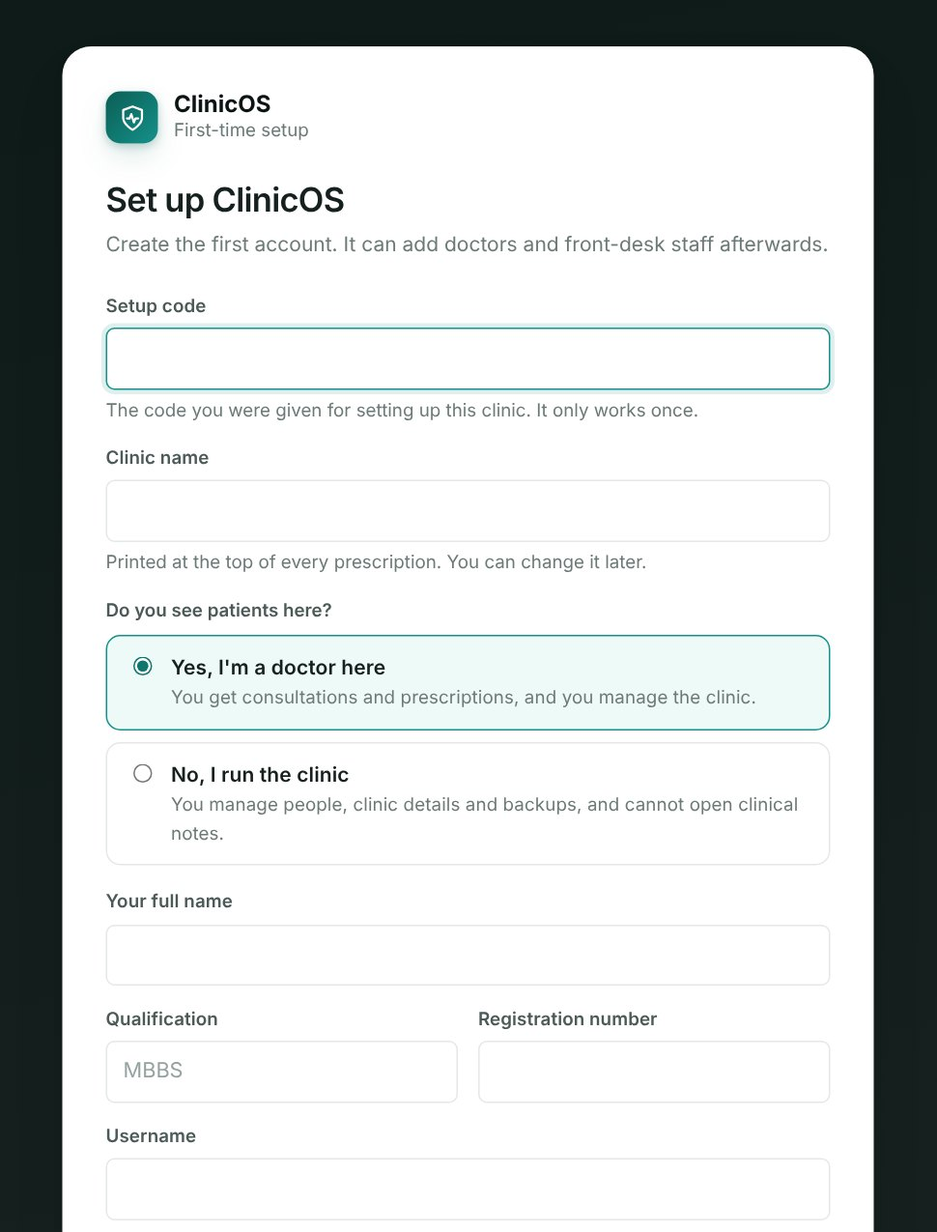
Figure 1: First-run setup. The first account is created with a one-time setup code, and setup then refuses forever.
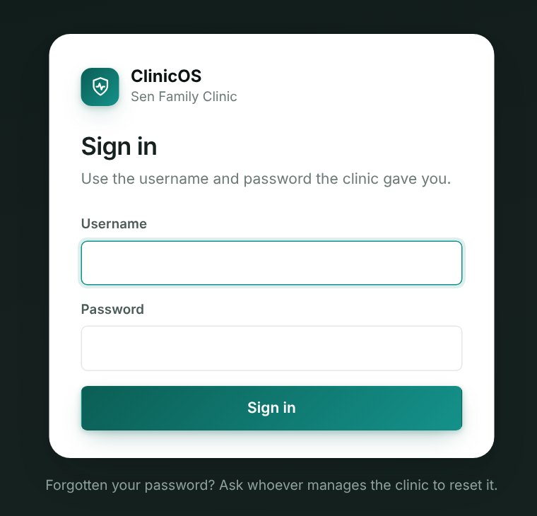
Figure 2: Sign-in. Each person has their own account; there is no shared clinic password.

6.2 The Doctor's Consultation
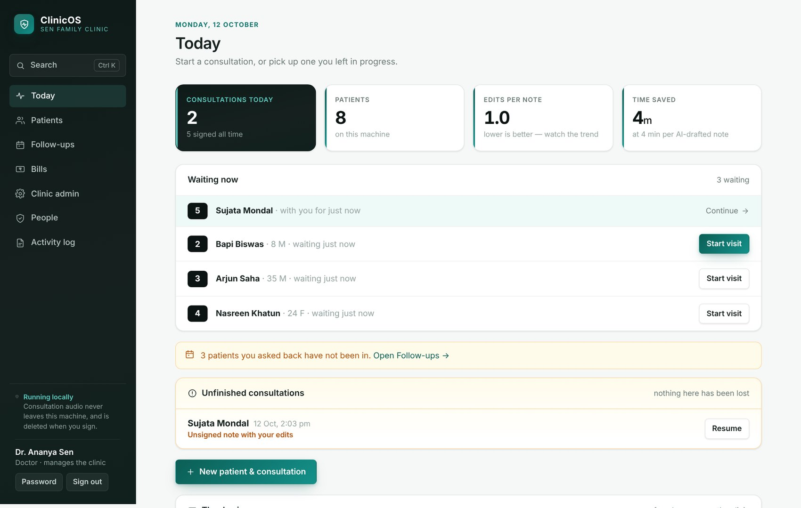
Figure 3: The doctor's Today screen: honest numbers at the top (including edits per note), patients waiting, a follow-up reminder, and unfinished consultations marked "nothing here has been lost".
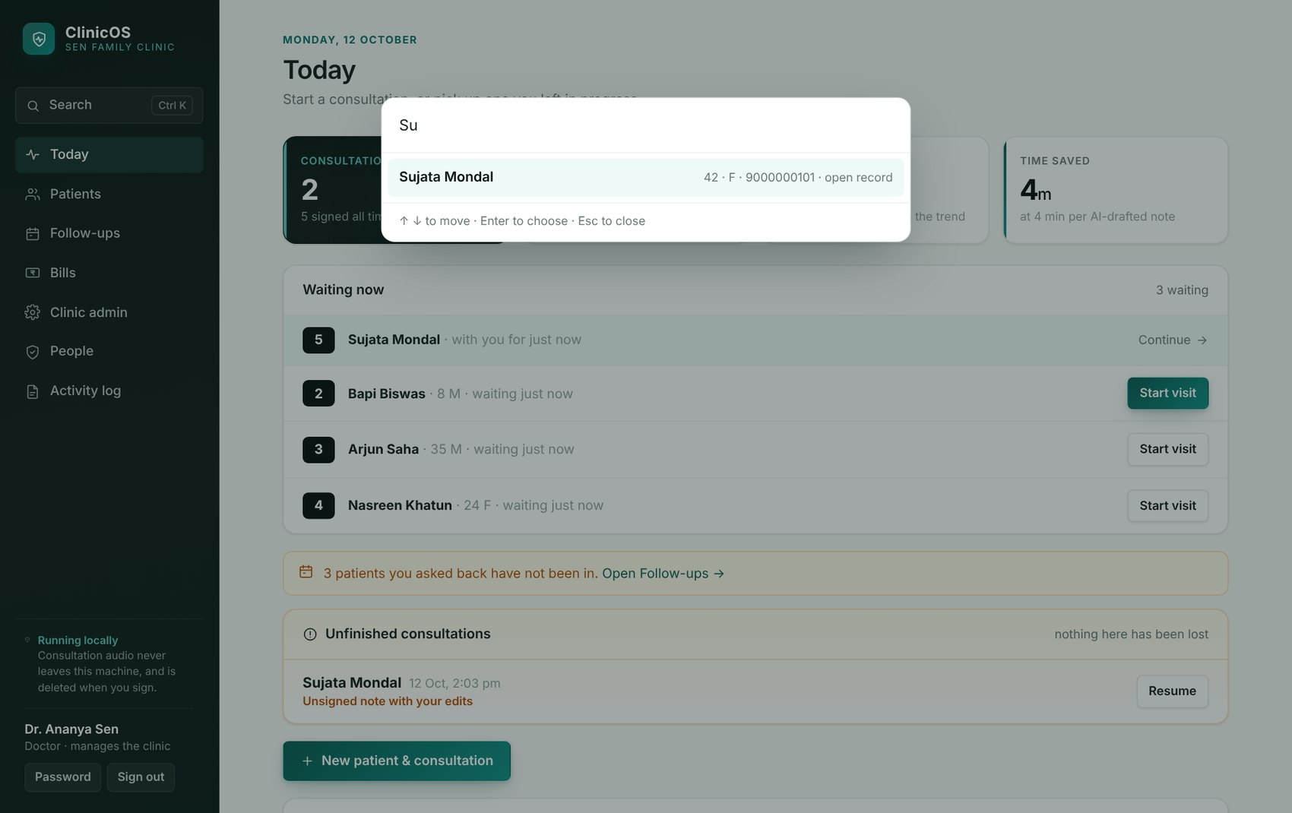
Figure 4: Ctrl+K search from any screen finds a patient by name or phone number.
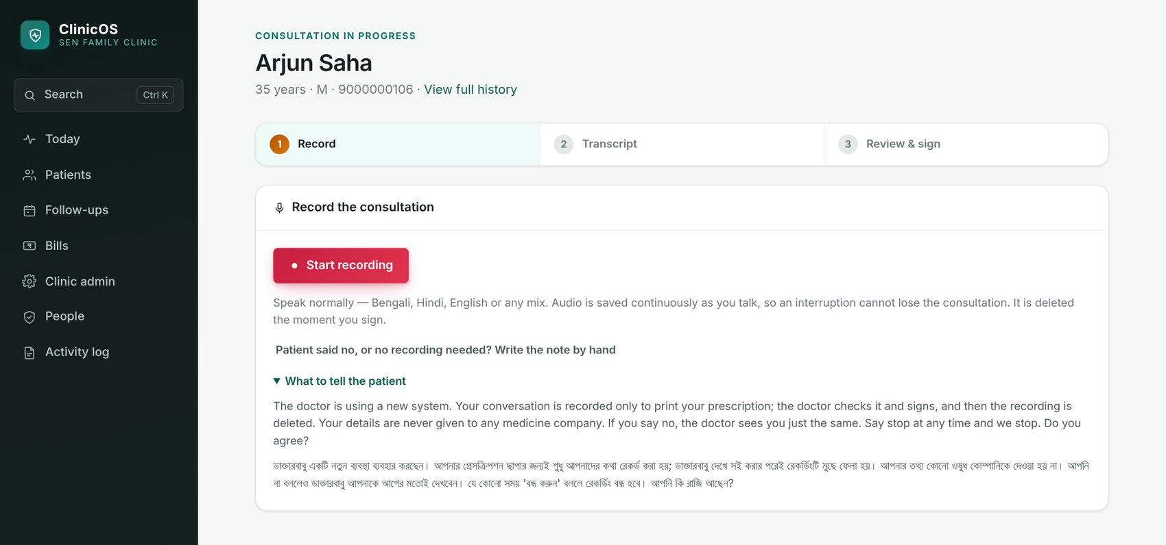
Figure 5: Step 1, Record. The spoken explanation for the patient is shown in English and Bengali; a patient who says no gets a note written by hand instead.
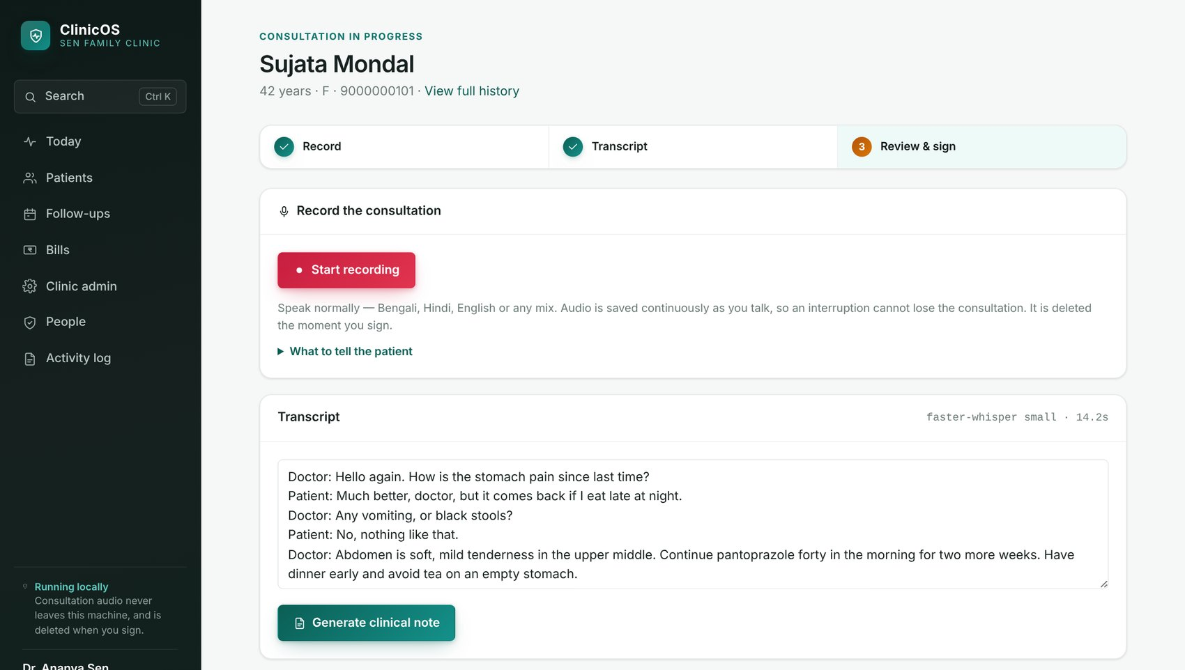
Figure 6: Steps 1–3 in progress: the recording, its transcript (sample text), and the button that drafts the clinical note.
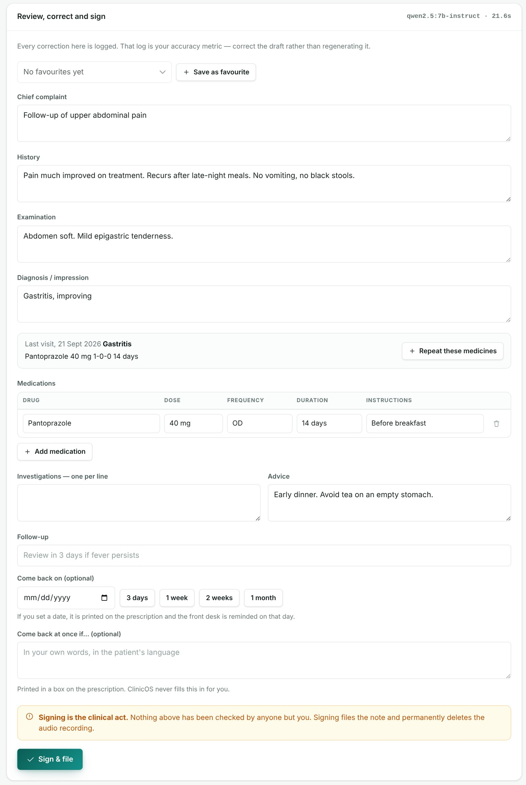
Figure 7: Review, correct and sign. The AI draft is editable; the patient's last visit is shown with one-tap repeat of its medicines; the follow-up date and warning signs are written only by the doctor; signing is labelled as the clinical act.
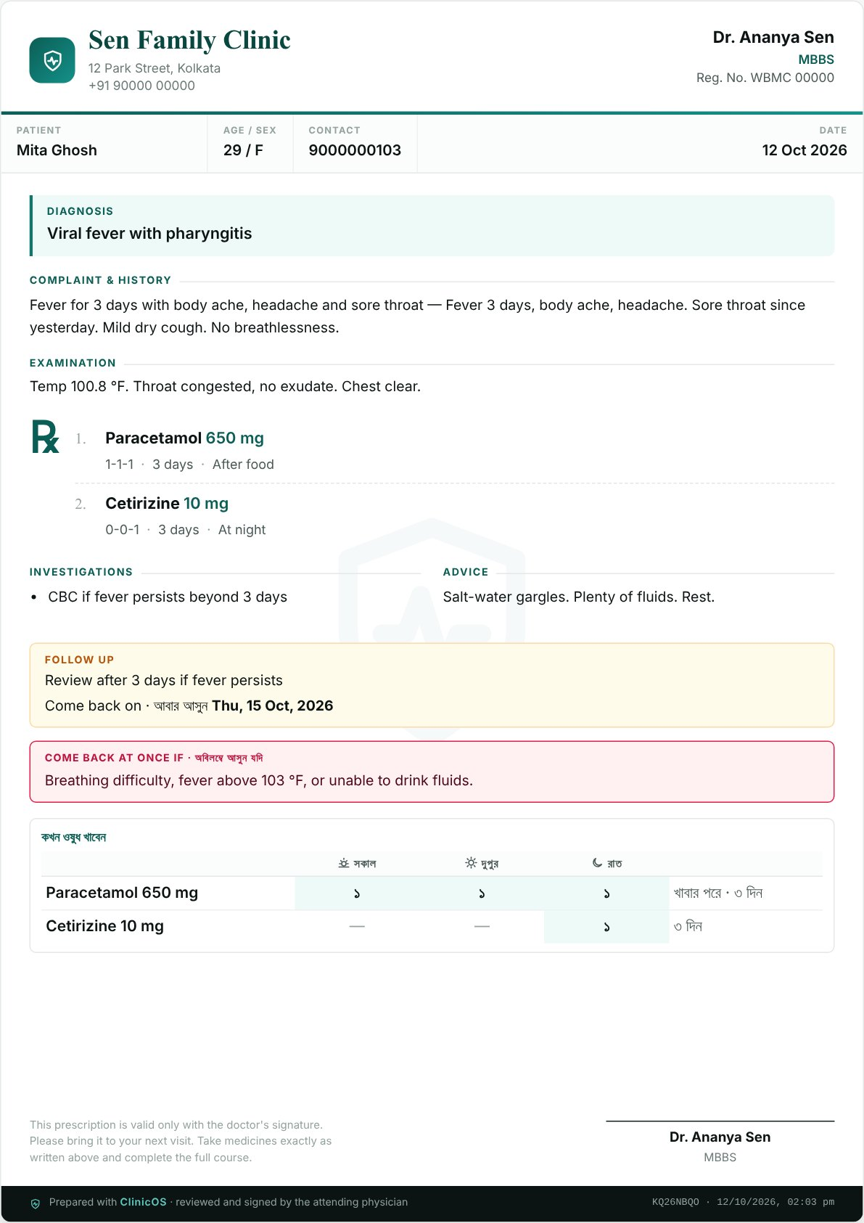
Figure 8: The printed prescription generated from the signed note, with the come-back date, the "come back at once if…" box and the medicine-timing card in Bengali.
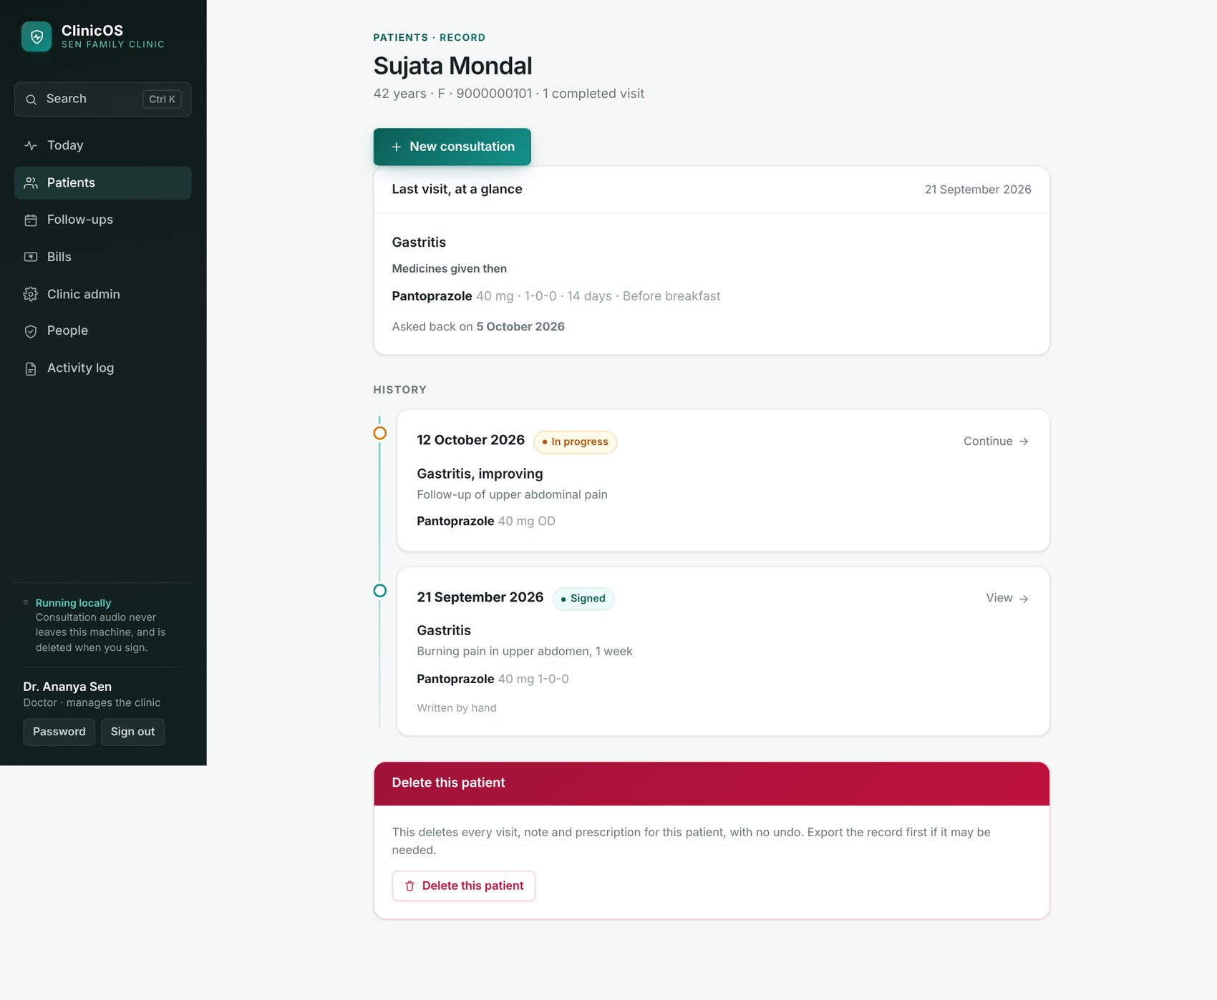
Figure 9: A patient's record: the last visit at a glance and the full history. Deleting a patient needs their name typed to confirm.

6.3 The Front Desk
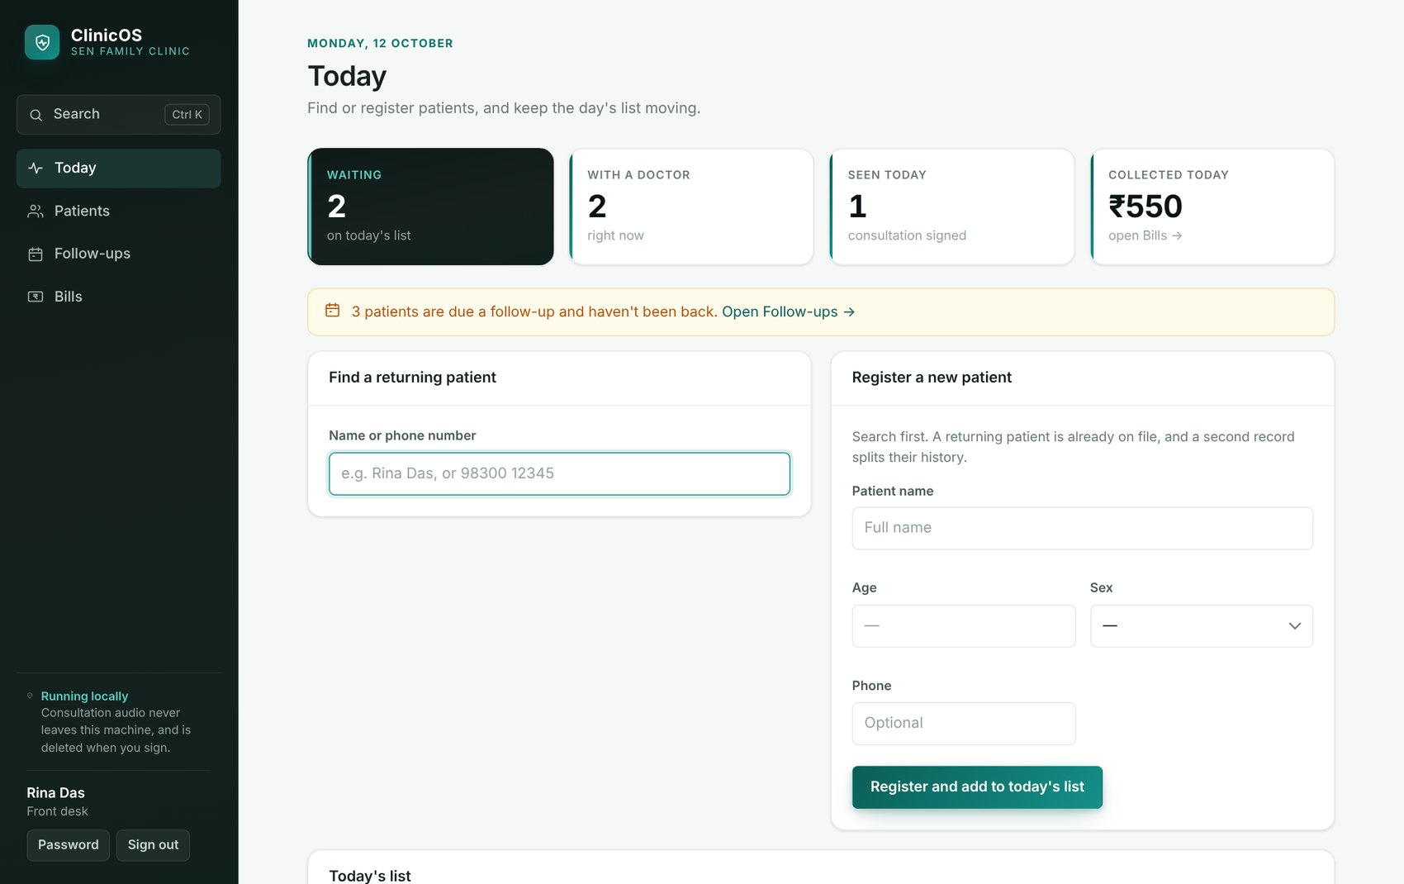
Figure 10: The front desk's Today: find or register a patient, the day's numbered list, and money collected today. Nothing clinical reaches this screen.
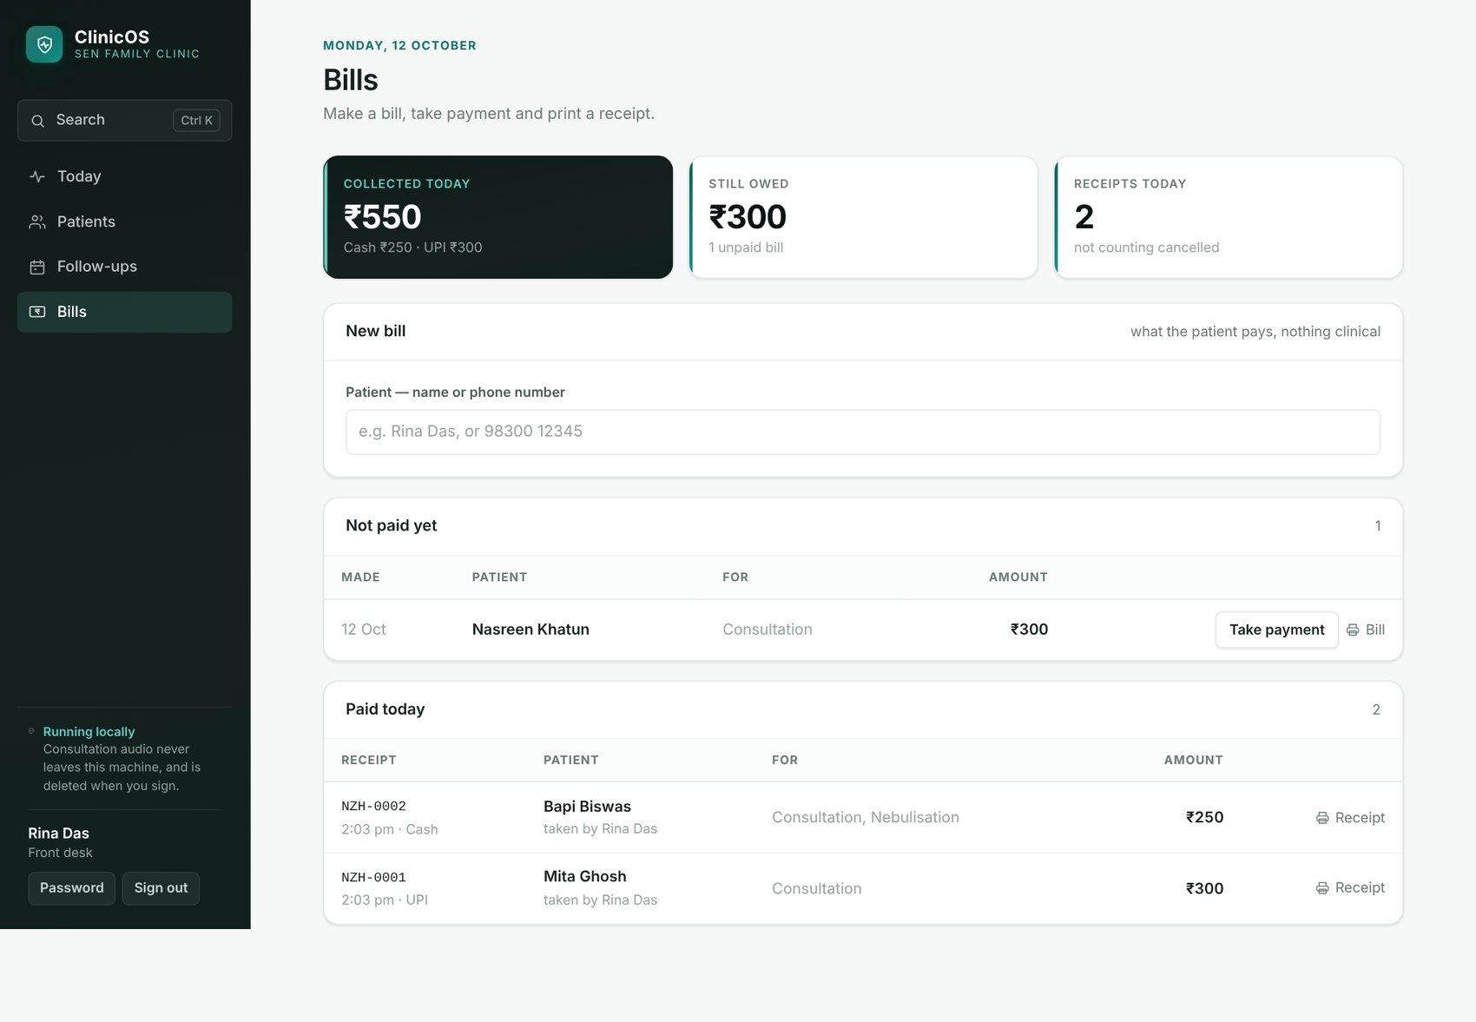
Figure 11: Bills: collected today by method, what is still owed, and today's receipts.
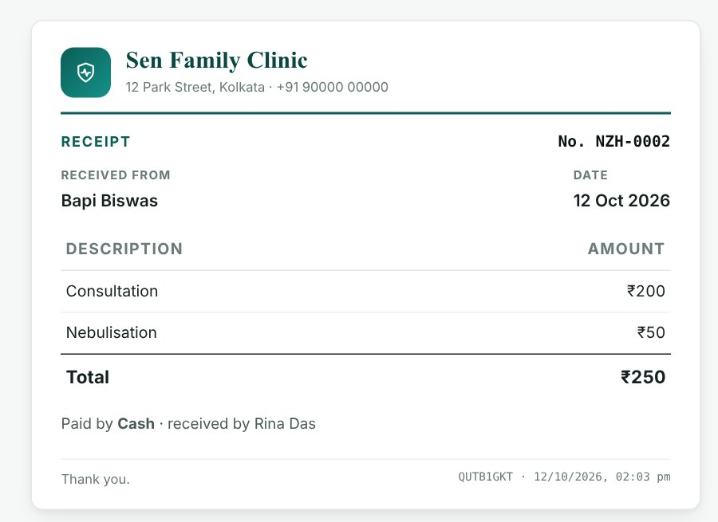
Figure 12: A printed receipt — the clinic, the receipt number, the lines and the total. Nothing clinical is printed on it.
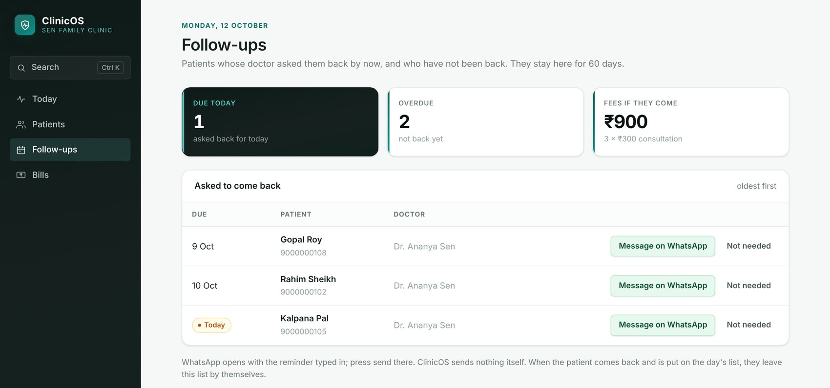
Figure 13: Follow-ups: patients asked back who have not returned. Message on WhatsApp opens WhatsApp with the reminder typed in; a person presses send.

6.4 Clinic Admin
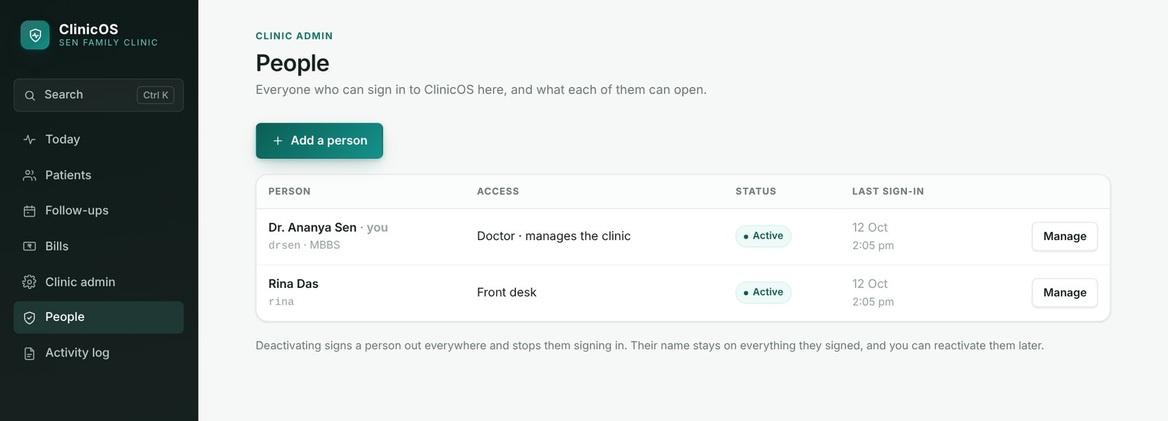
Figure 14: People: each account and what it can open.
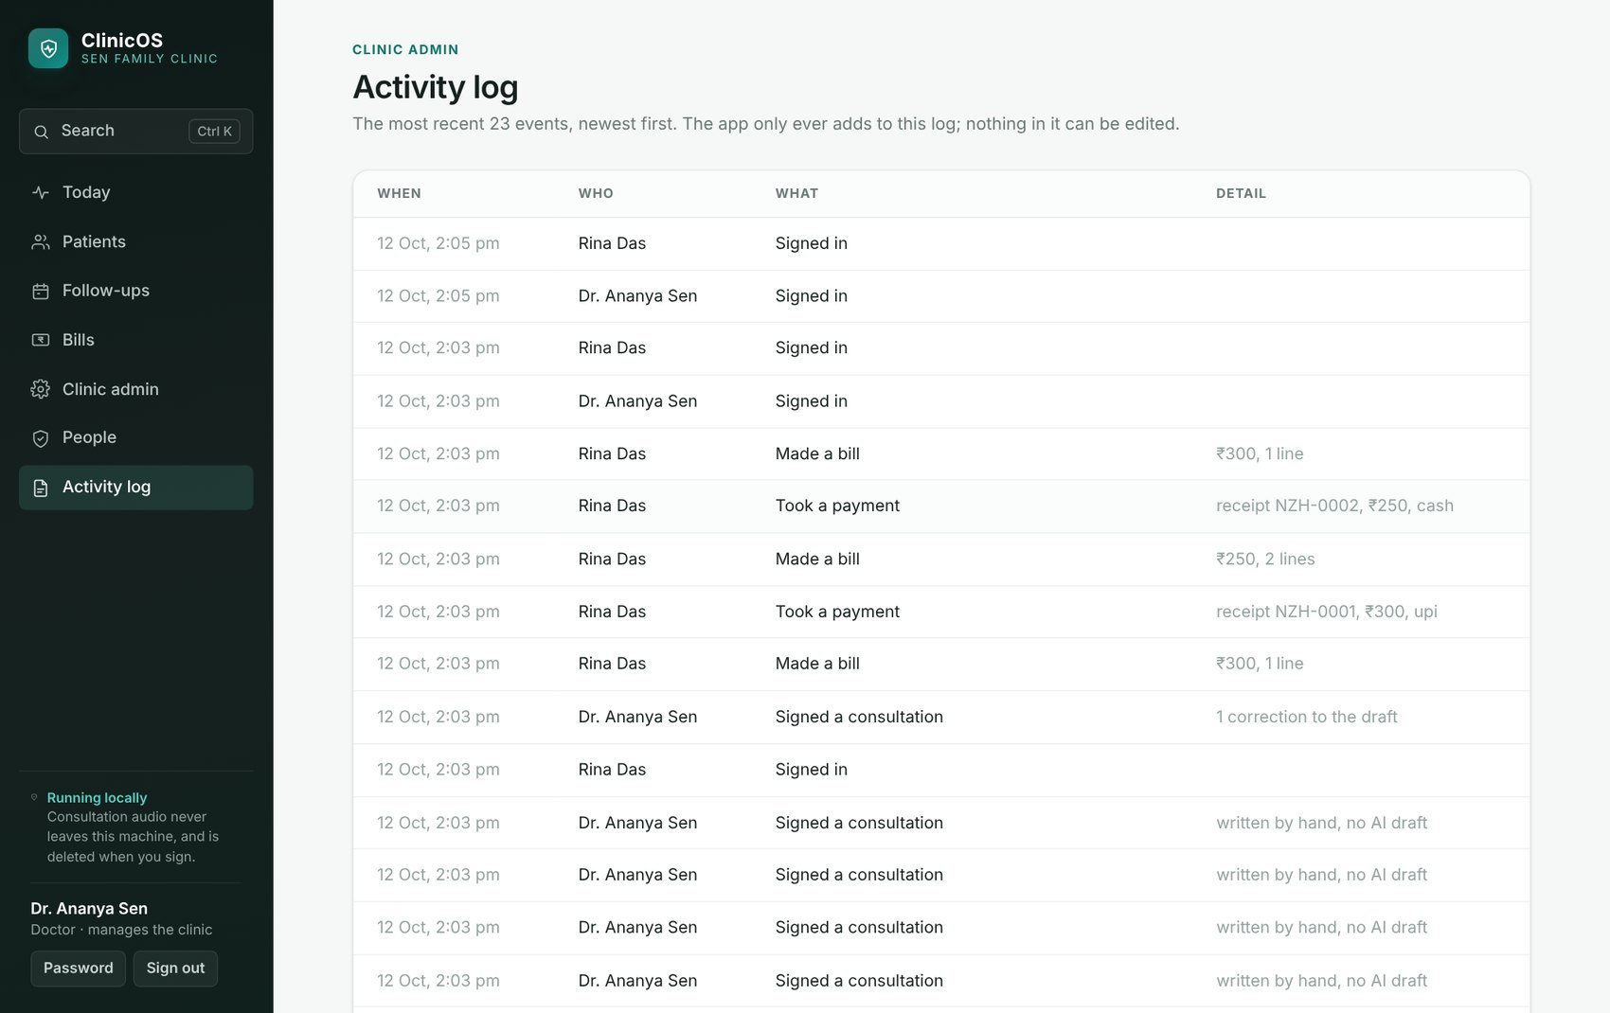
Figure 15: The activity log records who did what and when. It never contains a patient's name.
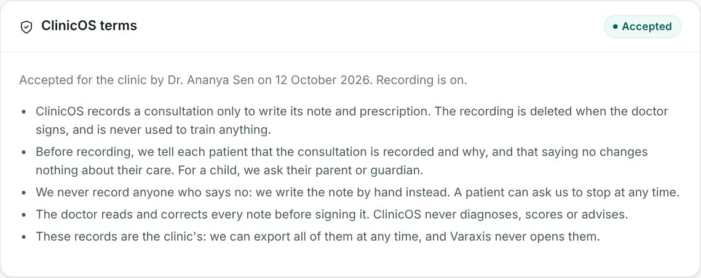
Figure 16: ClinicOS terms, accepted once by the clinic. Until they are accepted the server refuses to record.
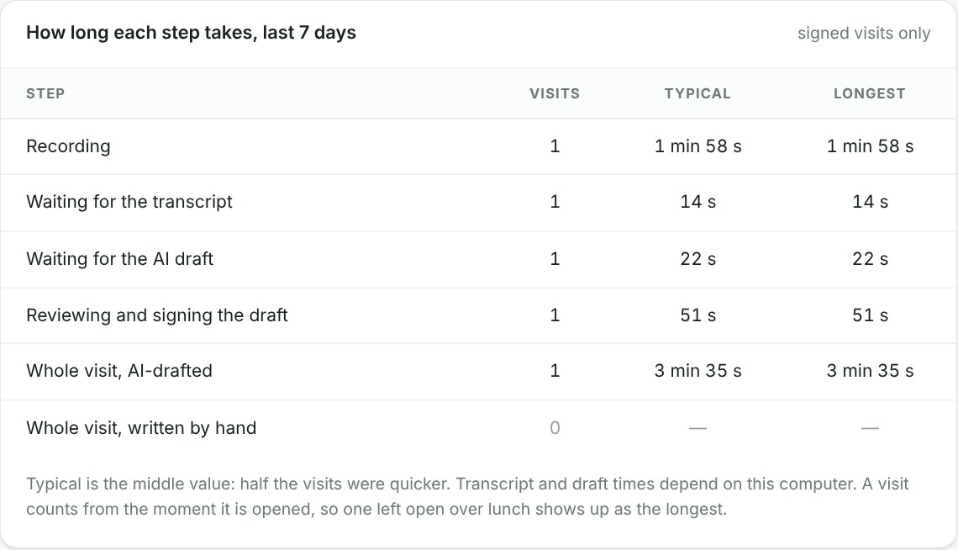
Figure 17: How long each step of a consultation takes — the middle value and the longest, never an average (sandbox sample data, not a field measurement).
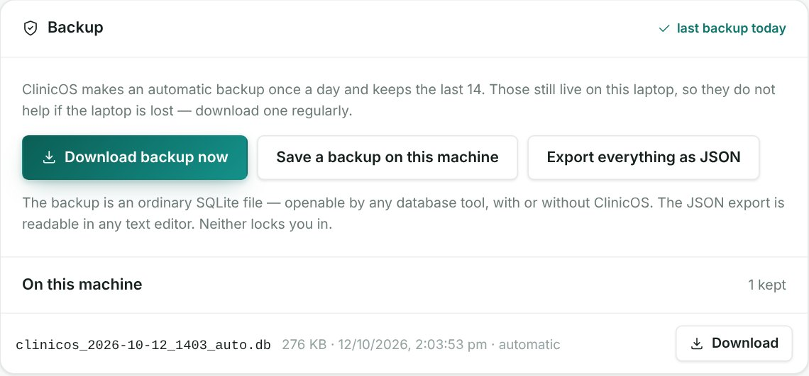
Figure 18: Backup: a daily automatic snapshot, a one-tap download, and a full export as JSON.

7. CONCLUSION AND LEARNINGS
Design thinking changed what ClinicOS is. We started by assuming that clinics were offline and that an electronic record would fix the paperwork. The Empathize stage broke both assumptions: the real constraint is what a dropped connection costs mid-consultation, and software that makes a doctor type takes time instead of returning it. The Define stage turned that into one problem statement and a point of view centred on the doctor's two minutes. The Ideate stage produced 37 ideas and rejected three of four directions on evidence. The Prototype stage produced working software tested by hundreds of automated checks, and the Implement stage turned it into a product a whole clinic can run — with its ethical limits enforced in code rather than in a policy document.
Our main learnings were:
- Constraints shape good design. The legal line between carrying a record and judging it decided what we built and, just as importantly, what we refused to build.
- Ask about the past, not the future. Evidence comes from what a doctor did yesterday, not from what they say they would do.
- Set the pass mark before the test. Gates written in advance keep a team honest about whether the idea is working.
- Honest numbers earn trust. A conservative figure a doctor believes is worth more than an impressive one they doubt.
The most important step is still ahead: the twenty doctor interviews. They will tell us whether the problem we defined is the one doctors actually feel — and the design is built to change if it is not.

8. REFERENCES
- Ministry of Health and Family Welfare, Government of India. Health Dynamics of India (Infrastructure and Human Resources) 2022–23. 2024.
- Irving, G. et al. "International variations in primary care physician consultation time: a systematic review of 67 countries." BMJ Open 7(10), 2017.
- Sinsky, C. et al. "Allocation of Physician Time in Ambulatory Practice: A Time and Motion Study in 4 Specialties." Annals of Internal Medicine 165(11), 2016.
- National Sample Survey Office, MoSPI. Comprehensive Modular Survey: Telecom, 80th Round (January–March 2025).
- Ministry of Electronics and Information Technology. The Digital Personal Data Protection Act, 2023 (No. 22 of 2023), and the Digital Personal Data Protection Rules, 2025.
- Central Drugs Standard Control Organisation. Medical Devices Rules, 2017, and guidance on software as a medical device.
- Hasso Plattner Institute of Design at Stanford (d.school). An Introduction to Design Thinking: Process Guide.

