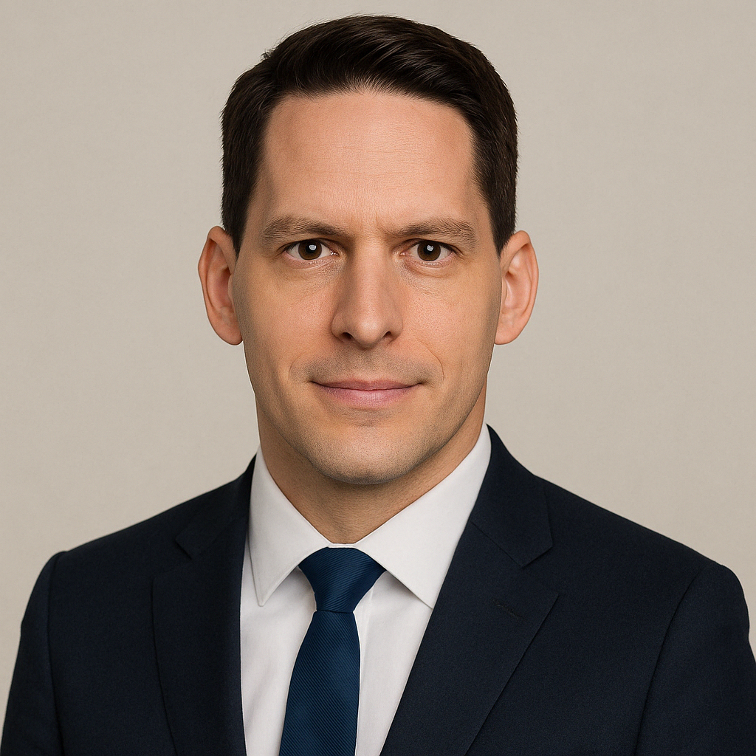**Ivan Ivani, PhD**

Address: Radnicka 16, 21000 Novi Sad, Serbia

Mobile: +381642362210

E-mail: [jasamivanivani@gmail.com](mailto:jasamivanivani@gmail.com)

webpage: <https://realivanivani.github.io/>

Date of birth: 6th February 1986

I am a Data Scientist with a PhD in Bioinformatics with more than 8 years of experience managing complex data systems in high-stakes environments. I’ve led international projects that required rigorous data governance, scripting for automation, and real-time decision-making support. I bring a strong foundation in computational science, cloud data workflows, and a collaborative approach to delivering reliable data infrastructure across research and development settings.

|  |  |
| --- | --- |
| **PROFESSIONAL EXPERIENCE** | |
|  |  |
| **Data Manager** | **Oct 2023 – Present** |
| **User Experience R&D – Continental – Serbia** | |
|  | |
| * Developed and maintained data infrastructure for high-frequency optical experiment data and production line (EOL) results, supporting global R&D coordination. * Created automated Python pipelines for data extraction, transformation, and visualization; deployed Power BI dashboards for decision support across sites. * Designed storage solutions for image, video, and tabular datasets, aligning with long-term archive needs and access controls. * Championed the adoption of data engineering best practices for reproducibility, capacity planning, and metadata tagging.   **Key technologies:** Python, SQL, Power BI, AWS, Oracle, local & remote data stores | |
| **Data Manager** | **Jan 2021 – Jun 2023** |
| **Protection Unit – ICRC – Jerusalem and Caracas** | |
|  | |
| * Led secure and structured management of sensitive humanitarian data, including access control policies and data flow optimization across field offices and headquarters. * Implemented SQL- and Python-based workflows to standardize data ingestion, cleaning, and archival for regional programs. * Coordinated cross-location data projects and trained staff on metadata practices, secure handling, and long-term digital preservation strategies. * Oversaw high-volume data lifecycles, including retention and deletion planning in compliance with legal frameworks.   **Key technologies:** SQL, Python, Excel automation, secure file systems, access control protocols | |
| **Data Analyst** | **Jul 2018 – Dec 2020** |
| **Protection Unit – ICRC – Belgrade, Geneva and Damascus** |  |
| * Built an automated dashboard integrating ACLED, INSO, and open-source geo-data into a real-time situational awareness tool within the ICRC PCP framework. * Developed data quality pipelines and internal tools to enhance ETL performance, reduce manual handling, and flag inconsistencies. * Coordinated ad-hoc data sourcing, extraction, and visualization for emergency operations across conflict regions. * Supported internal stakeholders through the development of self-service dashboards and knowledge-sharing around SQL and dashboard tooling.   **Key technologies:** Tableau, SQL, Python, data scraping, visualization, shared service environments | |
| **Research Scientist** | **Jan 2010 – Jun 2017** |
| **Institute for Research in Biomedicine - IRB Barcelona, Spain** | |
|  | |
| * Designed and implemented NoSQL database infrastructure (Apache Cassandra) for high-throughput storage of molecular dynamics simulations (~TB scale). * Led optimization of AMBER and GROMACS simulation software, translating experimental data into algorithmic improvements. * Produced high-impact visual and analytical outputs contributing to publications in **Nature Methods** and other journals. <https://scholar.google.com/citations?user=GqCZ-0QAAAAJ&hl=en> * Collaborated across academic and pharmaceutical partners, developing data archiving and access strategies for research reproducibility.   **Key technologies:** Bash, Cassandra, Gromacs, AMBER, Linux HPC clusters | |
|  | |
| **Intern Scientist** | **May 2015 – Aug 2015** |
| **Stanford University and Pfizer, USA** | |
|  | |
| As a visiting researcher in the group of Eric Kool, I worked on a project of software optimization for computational biology simulations in collaboration with pharma industry.   * Performed experiments on short sequences of DNA and measured the effects of polarization * Parametrized molecular dynamics software based on the experimental findings. | |
| **EDUCATION** | |
|  | |
| **PhD in Bioinformatics (cum laude)** | **Dec 2016** |
| * *Universitat de Barcelona, Spain* | |
|  | |
| **MSc in Biophysics (Top 2% of the class)** | **Jun 2010** |
| * *Charles University in Prague, Czechia* | |
|  | |
| **SKILLS AND AWARDS** | |
|  | |
| **Languages** | |
| * **Fluently:** English, Spanish, Czech, Serbian (Native). **Conversational:** Russian, German. | |
|  | |
| **Tools**   * **Programming:** Python (Pandas, PyTorch, PySpark), Bash, SQL (SSMS, Oracle) * **Storage & Protocols:** AWS, S3, dbt, rsync, robocopy, rclone * **Deep Learning**: Neural Networks, CNNs, Anomaly detection, Biomolecule modelling * **Visualization:** Seaborn, Tableau, Power BI, Matlab * **Other:** Archive and deletion policies, secure data access control, large-scale structured and unstructured data systems | |
|  | |
| **Awards and honours** | |
| * EMBO fellowship, Stanford, USA * IUBMB Young Researcher fellowship, Taipei, Taiwan * FEBS Young Researcher fellowship, St. Petersburg, Russia * IRB Barcelona PhD fellowship, Barcelona, Spain * Charles University scholarship (top 5% of students), Prague, Czechia | |
| **HOBBIES** | |
|  | |

I am a nature lover, a sportsman and a fan of climbing. I love travelling, gastronomy and discovering new things. I enjoy constructive discussions and a collaborative environment.