Elena A. Realisan May 06, 2025

IT26A Fundamentals of Database Systems

# IT26 DML Activity: SQL Practice Task

**INSERT**

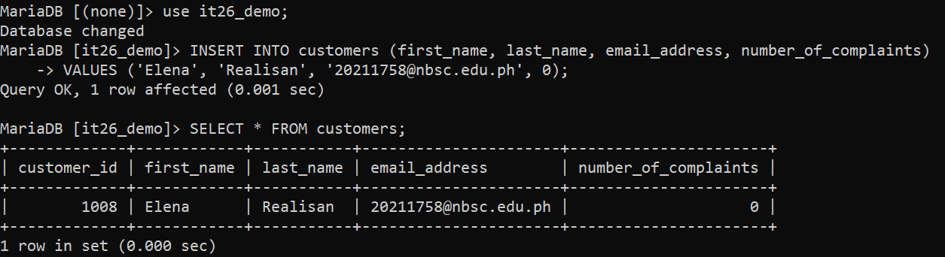

**SELECT**

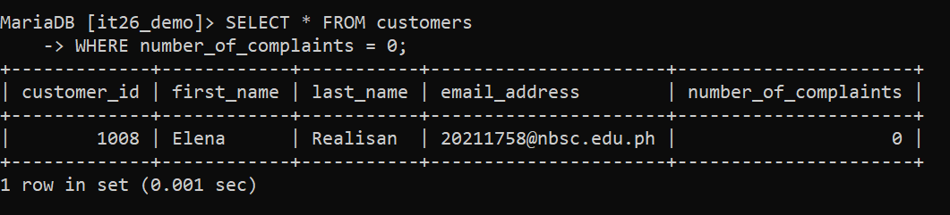

**UPDATE**

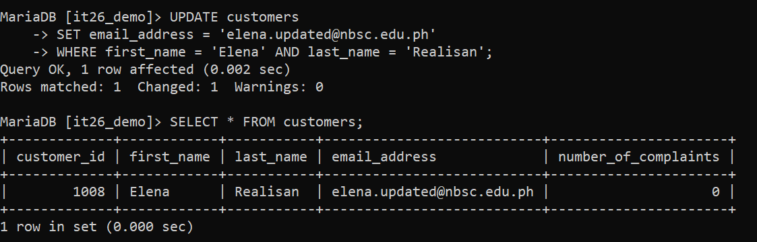

**DELETE**

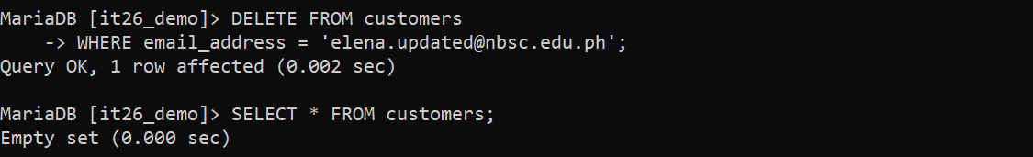

**CASCADING (ON DELETE CASCADE)**

