Xi’an Jiaotong University

课 程 实 验 报 告

实验名称： 机器学习实验2

姓名: 林圣翔
学号: 2223312202
专业班级: 计试2201
指导教师: 鲍军鹏教授
报告日期: 2025.4.20



一、实验目的
1、学习LSTM和GRU时序预测模型，探究不同网络结构和超参数对单步/多步预测性能的影响。
2、研究优化算法、学习率和时间窗口大小等参数在时序数据预测中的作用机制。
3、学习ResNet和VGG等图像分类模型，分析网络深度对分类准确率的影响。
4、探究不同优化策略和batch大小等训练参数对图像分类模型性能的影响。

二、实验内容
1、时序数据预测
对UCR的ECG数据集或者其它时序数据集，用两种深度学习模型进行多步预测，对比预测结果。
单步预测是用[tk-m,…,tk-2,tk-1,tk]预测tk+1。
多步预测是用[tk-m,…,tk-2,tk-1,tk]预测[tk+1,tk+2,tk+3,…,tk+p]。
在示例代码基础上进行修改，并调整每个模型的训练参数，包括优化方法、学习率、时间步大小等等，观察这些参数对模型训练和测试结果的影响。
2、图像分类
对Cifar10数据集或者其它图像数据集，用两种深度学习模型进行分类，对比分类结果。在示例代码基础上增加层数，调整每个模型的训练参数，包括优化方法、学习率、batch大小等等，观察这些参数对模型训练和测试结果的影响。

实验主要步骤
- 下载相关数据集和lstmPredictor.py、vggClassifier.py和resnetClassifier.py等文件。
- 将py文件转为ipynb的形式导入kaggle，借助 Kaggle 提供的 GPU 资源，提升实验的运行效率。
- 在lstmPredictor.py现有单步预测基础上实现多步预测，支持更长时间序列的推理任务。
- 对LSTM的单步及多步预测模块修改参数，例如窗口大小（10,20,30）、batch_size（64,128）、num_layers（1,2,3）、学习率（50,100）、时间步大小（1,3,5,7）等，观察这些参数对模型训练和测试结果的影响。
- 实现GRU单步及多步预测模块，并改变相关参数，并与LSTM进行对比实验。
- 在现有VGG模型的基础上调整每个模型的训练参数，例如优化方法（Adam，Sgd）、学习率（0.1，0.01，0.0001,0.00001）、batch大小等，绘制训练过程曲线以及测试结果混淆矩阵，之后增加VGG模型的网络深度（增加两层：self.layer4 = self._make_layer(512, 3, stride=2) ，self.layer5 = self._make_layer(1024, 3, stride=2)），并调整相关训练参数。
- 现有ResNet模型的基础上调整每个模型的训练参数，例如优化方法（Adam，Sgd）、学习率（1e-5,1e-4）、batch大小（64,128），weight_decay（5e-4，5e-5）等，绘制测试结果混淆矩阵，之后增加ResNet模型的网络深度（在self.features增加两个模块，结合原先的三个，共五个模块），并调整相关训练参数。

实验结果
1、时序数据预测运行截图
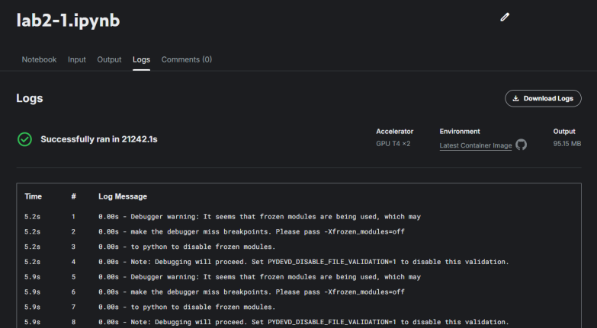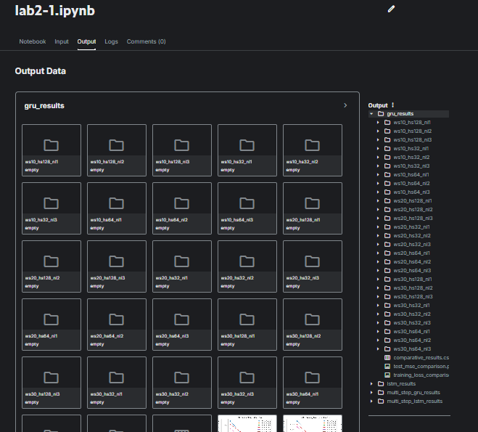
1.1、LSTM单步预测实验（学习率lr=0.0001）
window_size | hidden_size | num_layers | final_train_loss | final_test_mse
10 | 32 | 1 | 0.007707774132652004 | 1.2529569
10 | 32 | 2 | 0.005379964524586174 | 0.8665652
10 | 32 | 3 | 0.004976165158551317 | 0.7833335
10 | 64 | 1 | 0.006153517622052033 | 0.95199084
10 | 64 | 2 | 0.004459512255668481 | 0.73357284
10 | 64 | 3 | 0.0037879765363092103 | 0.7064333
10 | 128 | 1 | 0.005355515917117151 | 0.9315307
10 | 128 | 2 | 0.003736378037457343 | 0.74689007
10 | 128 | 3 | 0.003481493479140648 | 0.73251265
20 | 32 | 1 | 0.008015550591907656 | 1.2600279
20 | 32 | 2 | 0.005307482114514597 | 0.838277
20 | 32 | 3 | 0.004477425509809642 | 0.7203658
20 | 64 | 1 | 0.005648594548735518 | 0.9780909
20 | 64 | 2 | 0.004091832760622776 | 0.7290819
20 | 64 | 3 | 0.0035109520316970104 | 0.6194534
20 | 128 | 1 | 0.004824112799169819 | 0.9169979
20 | 128 | 2 | 0.0033651373942564355 | 0.646319
20 | 128 | 3 | 0.003081853457133104 | 0.58753717
30 | 32 | 1 | 0.006961578679116295 | 1.0962178
30 | 32 | 2 | 0.005407491405515806 | 0.8139169
30 | 32 | 3 | 0.00468611579080749 | 0.7594909
30 | 64 | 1 | 0.004558826998041562 | 0.80404127
30 | 64 | 2 | 0.0036307746505793524 | 0.69958985
30 | 64 | 3 | 0.0031332088970308044 | 0.5479919
30 | 128 | 1 | 0.0038294649085600678 | 0.6908275
30 | 128 | 2 | 0.0030339403602716274 | 0.6254047
30 | 128 | 3 | 0.002751998668206464 | 0.5930734
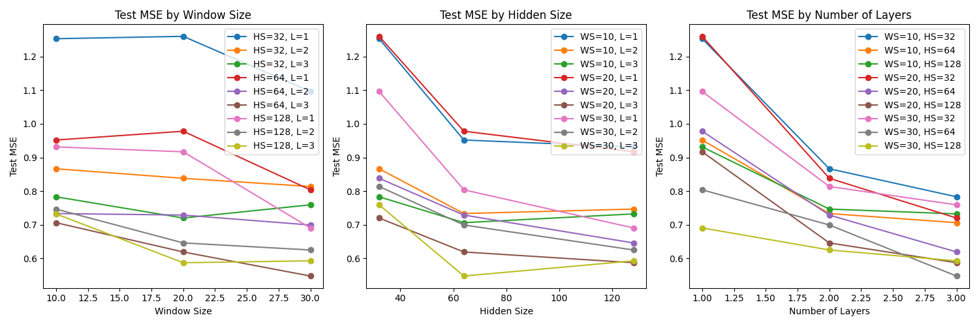
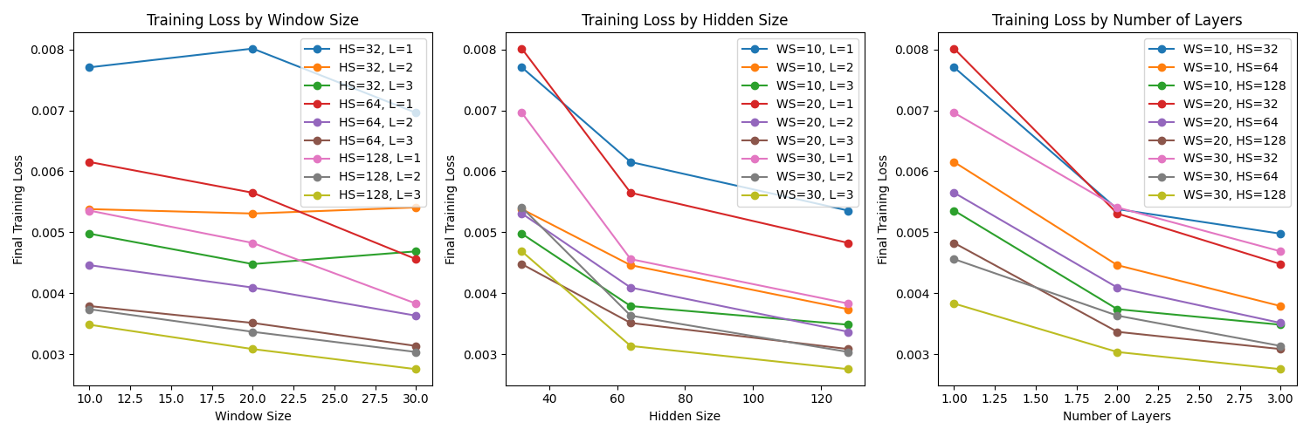
基于实验结果，选取 window_size=30、hidden_size=64、num_layers=3 作为参数组合进行展示，该配置在测试集上取得了较低的 MSE（0.548），表明模型具备较强的时序预测能力。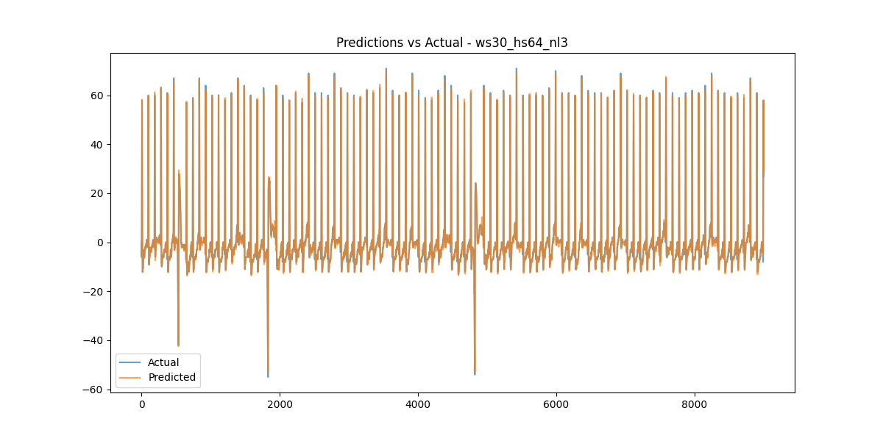
1.2、LSTM多步预测实验（学习率lr=0.0001）
window_size | hidden_size | num_layers | forecast_steps | final_train_loss | final_test_mse
20 | 64 | 2 | 1 | 0.003964234215279093 | 0.71019053
20 | 64 | 2 | 3 | 0.01143180064164193 | 2.4214747
20 | 64 | 2 | 5 | 0.04693974877023365 | 9.884016
20 | 64 | 2 | 7 | 0.10745870916771975 | 24.012205
20 | 64 | 3 | 1 | 0.0034481411310081037 | 0.7169994
20 | 64 | 3 | 3 | 0.008929238456270158 | 2.3215263
20 | 64 | 3 | 5 | 0.038815437158762775 | 9.212697
20 | 64 | 3 | 7 | 0.09332725989686257 | 24.425219
20 | 128 | 2 | 1 | 0.0035088674660251054 | 0.62577796
20 | 128 | 2 | 3 | 0.008597092021884193 | 2.4220679
20 | 128 | 2 | 5 | 0.033750590617362436 | 9.535341
20 | 128 | 2 | 7 | 0.08276734955356138 | 24.488827
20 | 128 | 3 | 1 | 0.003009269292794293 | 0.5921403
20 | 128 | 3 | 3 | 0.00829728931279444 | 2.007128
20 | 128 | 3 | 5 | 0.028313785250136832 | 10.851501
20 | 128 | 3 | 7 | 0.06771893186136944 | 25.38124
30 | 64 | 2 | 1 | 0.0035485133376801613 | 0.61697155
30 | 64 | 2 | 3 | 0.00941009462027379 | 1.9165355
30 | 64 | 2 | 5 | 0.020196376770178263 | 7.7727127
30 | 64 | 2 | 7 | 0.037381135442978476 | 11.458516
30 | 64 | 3 | 1 | 0.0031903832837642545 | 0.51289713
30 | 64 | 3 | 3 | 0.007420230529799194 | 1.7110882
30 | 64 | 3 | 5 | 0.013533280507190062 | 6.232508
30 | 64 | 3 | 7 | 0.02109812854763643 | 11.471396
30 | 128 | 2 | 1 | 0.0028918955119989712 | 0.53170455
30 | 128 | 2 | 3 | 0.005389960511820391 | 2.2628078
30 | 128 | 2 | 5 | 0.010949479349641834 | 5.6027136
30 | 128 | 2 | 7 | 0.017737259686904643 | 8.303173
30 | 128 | 3 | 1 | 0.0024961024853216323 | 0.6365015
30 | 128 | 3 | 3 | 0.005683308341625578 | 1.7139772
30 | 128 | 3 | 5 | 0.008469624525942647 | 3.5969174
30 | 128 | 3 | 7 | 0.011954372633736944 | 7.1130137
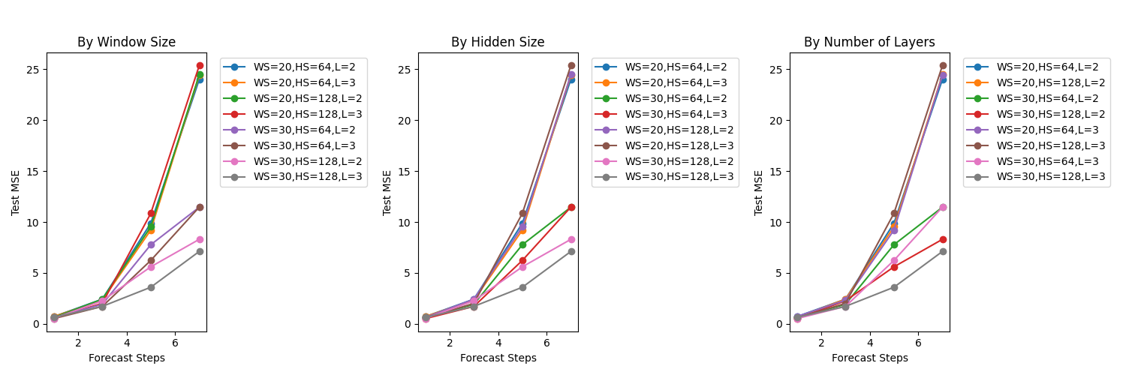
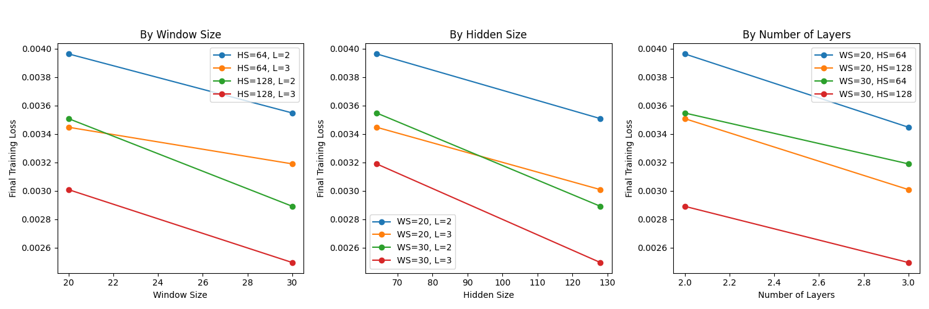
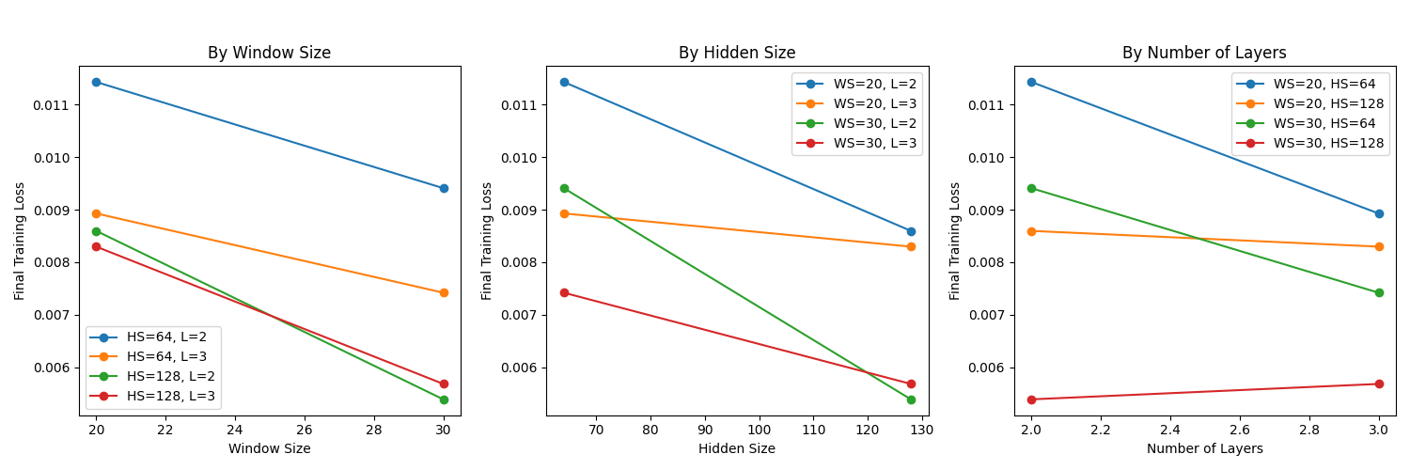
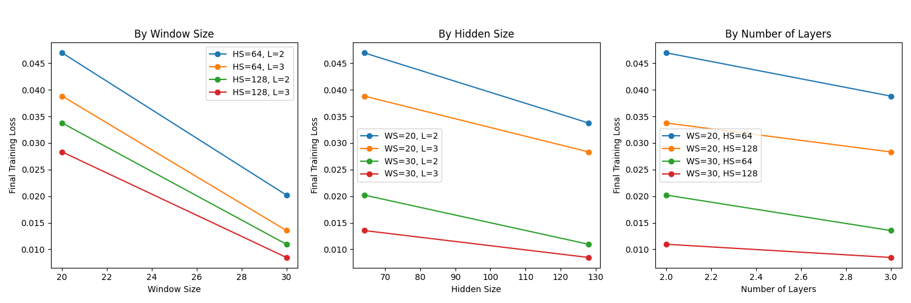
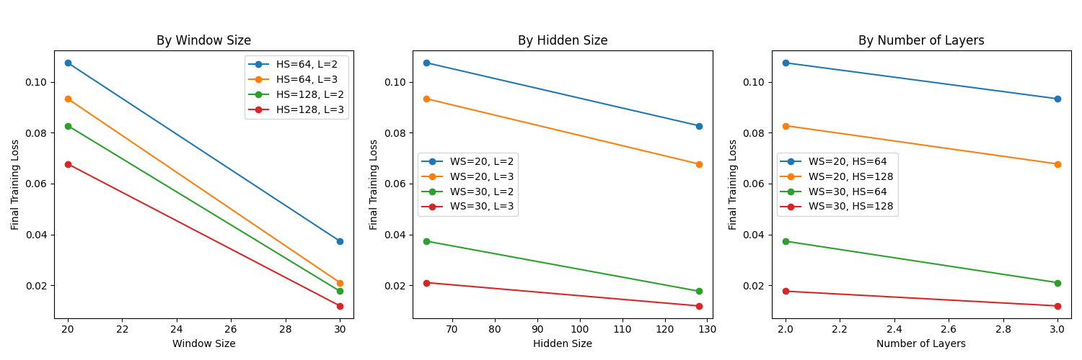
基于实验结果，选取window_size=30, hidden_size=64, num_layers=3, forecast_steps=3作为参数组合进行展示，该配置在测试集上取得了较低的 MSE（1.7110882），表明模型具备较强的时序预测能力。

1.3、GRU单步预测实验（学习率lr=0.0001）
window_size | hidden_size | num_layers | final_train_loss | final_test_mse
10 | 32 | 1 | 0.0095869618329211 | 1.5236424
10 | 32 | 2 | 0.005990396442850796 | 0.9055214
10 | 32 | 3 | 0.005225326228998999 | 0.831679
10 | 64 | 1 | 0.00718020880257671 | 1.1289014
10 | 64 | 2 | 0.004401235199155763 | 0.75936365
10 | 64 | 3 | 0.0040925095897209095 | 0.7610609
10 | 128 | 1 | 0.005639281926538921 | 0.9409897
10 | 128 | 2 | 0.0038168821033096032 | 0.6422729
10 | 128 | 3 | 0.0034815958243576105 | 0.6608178
20 | 32 | 1 | 0.008953549622674473 | 1.4324688
20 | 32 | 2 | 0.006897266409196607 | 1.0491923
20 | 32 | 3 | 0.005150059901253127 | 0.77967393
20 | 64 | 1 | 0.007012867931668397 | 1.1764086
20 | 64 | 2 | 0.004308687023095866 | 0.6990818
20 | 64 | 3 | 0.004073934036302778 | 0.77051413
20 | 128 | 1 | 0.005192067619291044 | 0.85455304
20 | 128 | 2 | 0.003604141774636313 | 0.65598327
20 | 128 | 3 | 0.00313797486657078 | 0.6030148
30 | 32 | 1 | 0.0085234464032266 | 1.3174373
30 | 32 | 2 | 0.005368552556408359 | 0.82362765
30 | 32 | 3 | 0.005215044231324389 | 0.8240869
30 | 64 | 1 | 0.0064578222708205875 | 1.0419819
30 | 64 | 2 | 0.004171034890754438 | 0.6560204
30 | 64 | 3 | 0.004131828495013817 | 0.69654864
30 | 128 | 1 | 0.004413870668408557 | 0.7667051
30 | 128 | 2 | 0.0032224129055266086 | 0.6572297
30 | 128 | 3 | 0.0027060009687840825 | 0.50841933
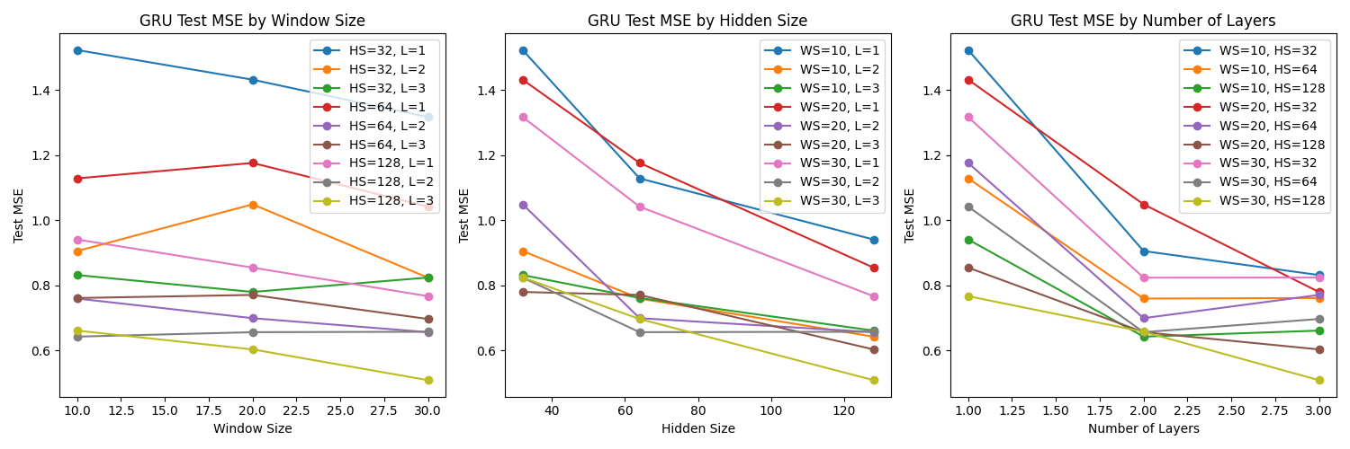
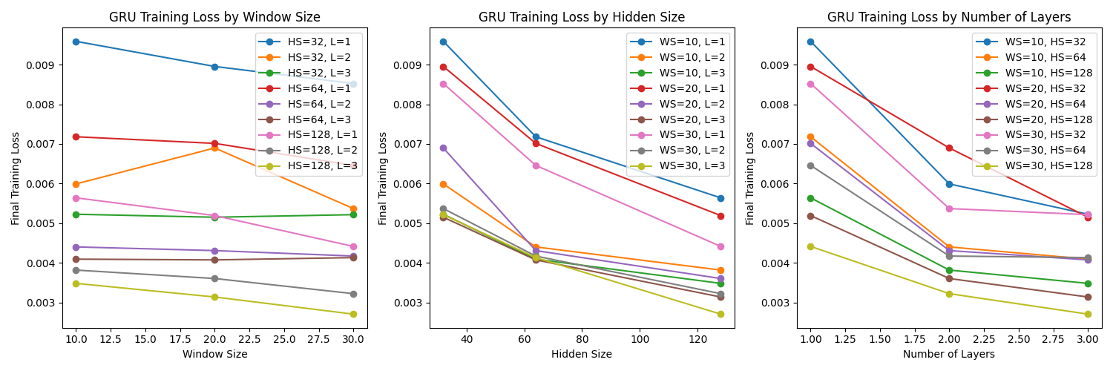
基于实验结果，选取 window_size=30、hidden_size=64、num_layers=3 作为参数组合进行展示，该配置在测试集上取得了较低的 MSE（0.69654864），表明模型具备较强的时序预测能力。
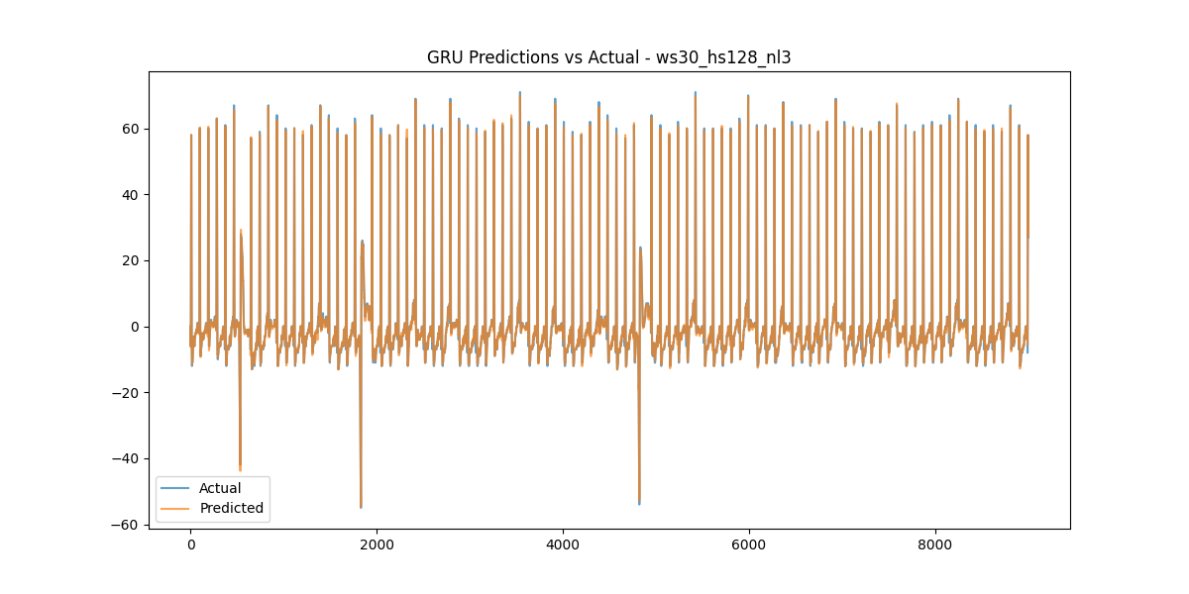
1.4、GRU多步预测实验（学习率lr=0.0001）
window_size | hidden_size | num_layers | forecast_steps | final_train_loss | final_test_mse
20 | 64 | 2 | 1 | 0.004091629556081365 | 0.63897026
20 | 64 | 2 | 3 | 0.013201079774639433 | 2.2808535
20 | 64 | 2 | 5 | 0.05487516681129885 | 9.824806
20 | 64 | 2 | 7 | 0.12238583484062607 | 26.853075
20 | 64 | 3 | 1 | 0.003957201863646865 | 0.62333256
20 | 64 | 3 | 3 | 0.010579194728052244 | 1.8572788
20 | 64 | 3 | 5 | 0.0402678830897657 | 8.342415
20 | 64 | 3 | 7 | 0.10673875303047414 | 21.958834
20 | 128 | 2 | 1 | 0.0035257666972827837 | 0.6491845
20 | 128 | 2 | 3 | 0.012031577346156487 | 2.4297864
20 | 128 | 2 | 5 | 0.03839976569494267 | 8.293244
20 | 128 | 2 | 7 | 0.10273458897604652 | 26.5051
20 | 128 | 3 | 1 | 0.003327749254334244 | 0.58445376
20 | 128 | 3 | 3 | 0.007439813366168315 | 1.9377961
20 | 128 | 3 | 5 | 0.030438209282981073 | 8.5310335
20 | 128 | 3 | 7 | 0.08928267009309265 | 26.642864
30 | 64 | 2 | 1 | 0.004262919210615531 | 0.6822434
30 | 64 | 2 | 3 | 0.011278467551697181 | 2.3499148
30 | 64 | 2 | 5 | 0.023378321257130266 | 4.633693
30 | 64 | 2 | 7 | 0.041764110808044944 | 9.745718
30 | 64 | 3 | 1 | 0.0036321609397596257 | 0.6344489
30 | 64 | 3 | 3 | 0.007735355435969967 | 1.5494717
30 | 64 | 3 | 5 | 0.01795153637386847 | 3.6555588
30 | 64 | 3 | 7 | 0.03155761349111477 | 8.433235
30 | 128 | 2 | 1 | 0.0031156441108600476 | 0.5685777
30 | 128 | 2 | 3 | 0.009661332614508333 | 1.7183431
30 | 128 | 2 | 5 | 0.016418927516674668 | 3.9387398
30 | 128 | 2 | 7 | 0.026728255104943657 | 7.3607903
30 | 128 | 3 | 1 | 0.002800110994363289 | 0.53995776
30 | 128 | 3 | 3 | 0.005245960264135913 | 1.5741116
30 | 128 | 3 | 5 | 0.010806400100303041 | 3.6496959
30 | 128 | 3 | 7 | 0.017471915436766634 | 6.0563684
final_train_loss
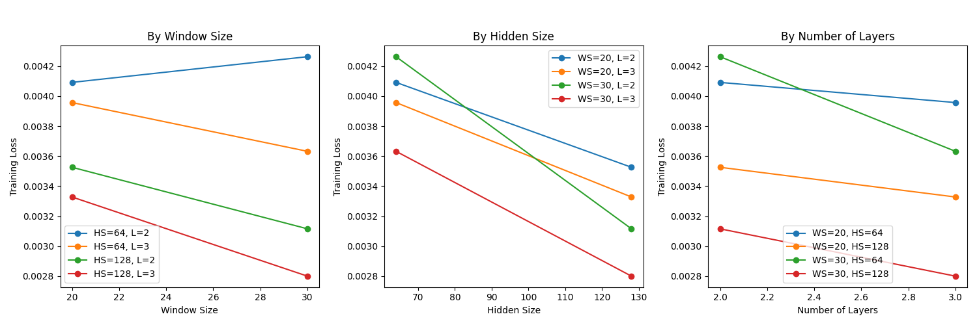
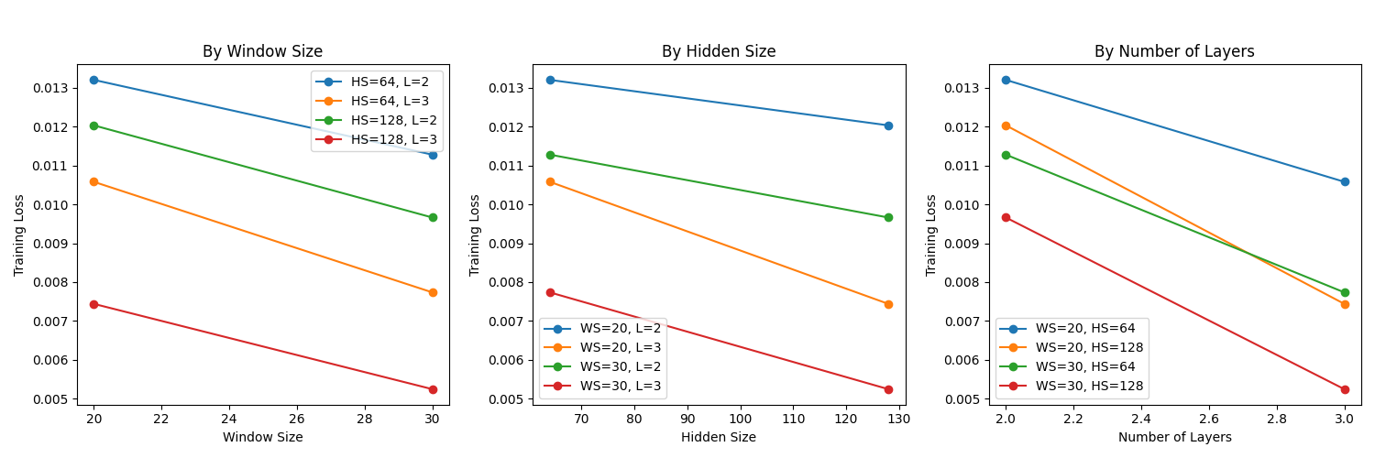
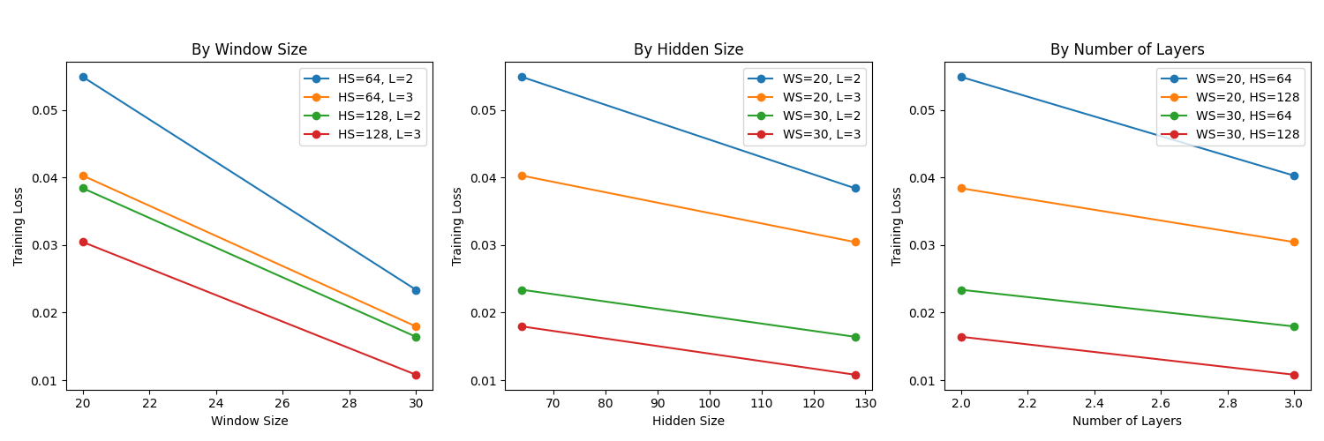
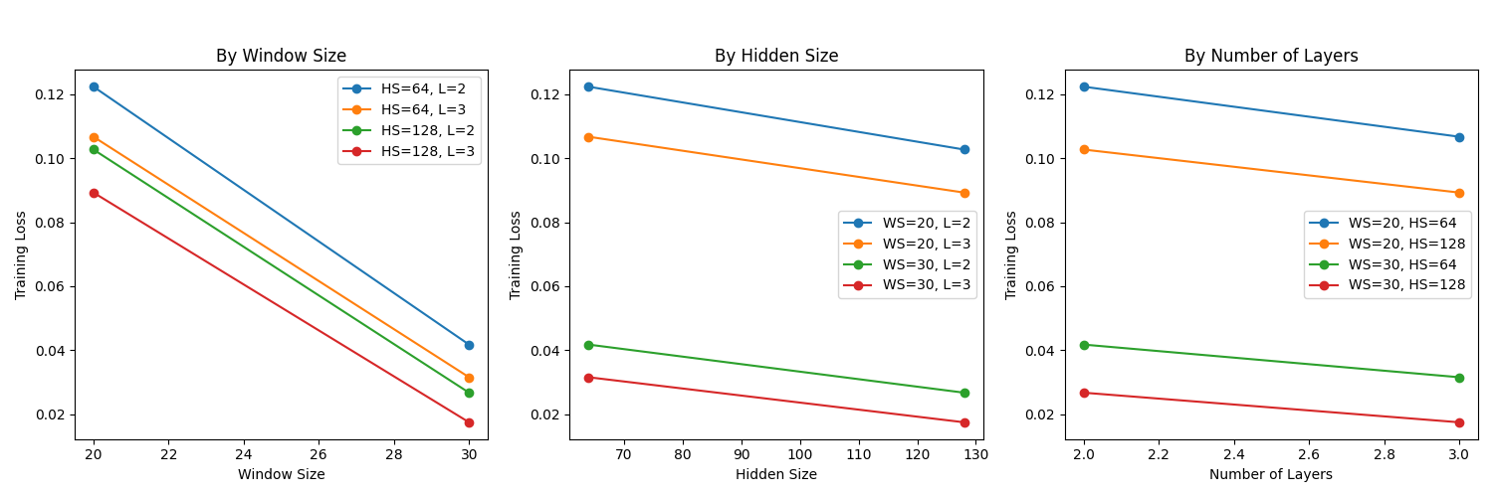
final_test_mse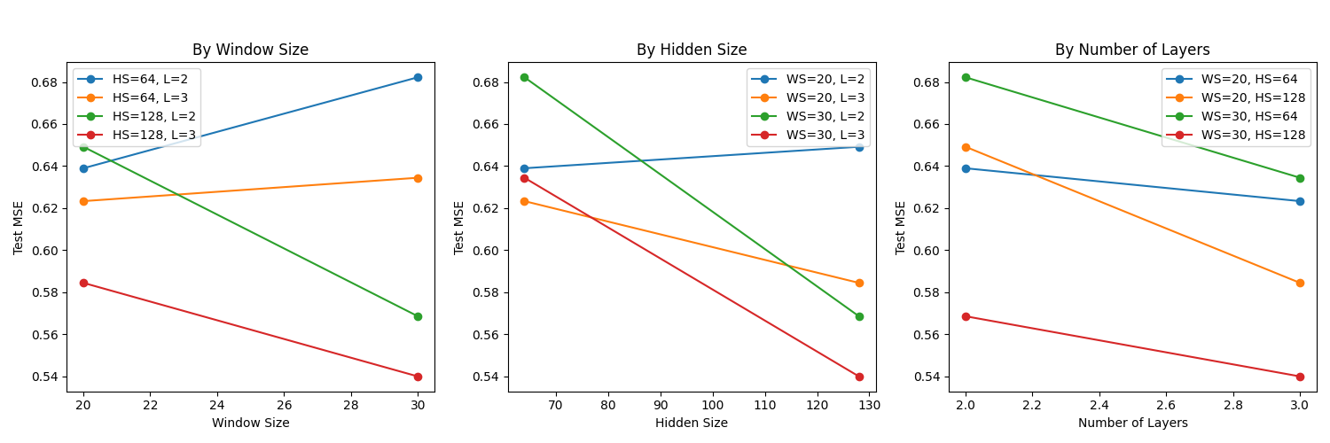
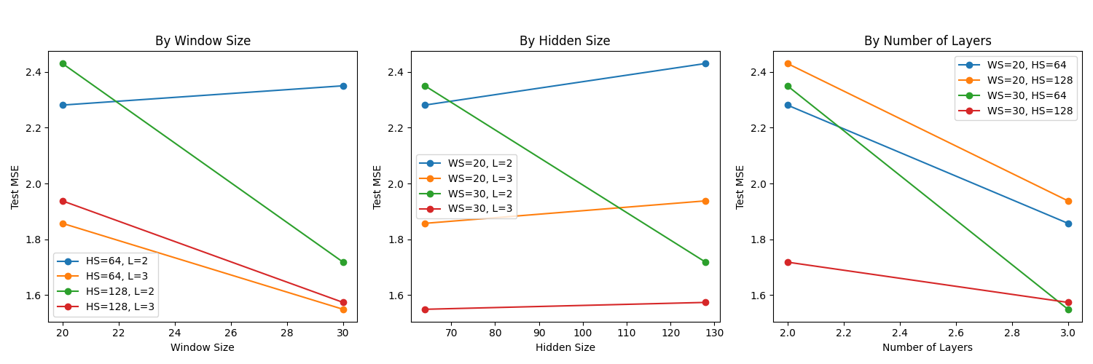
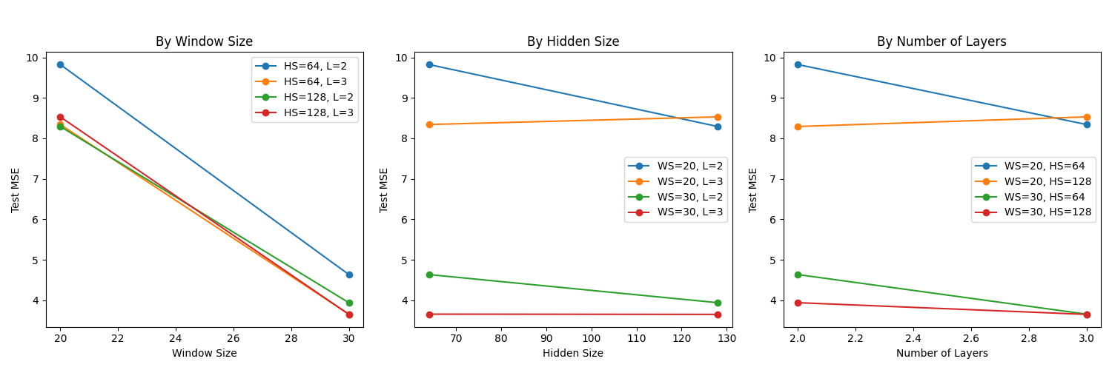
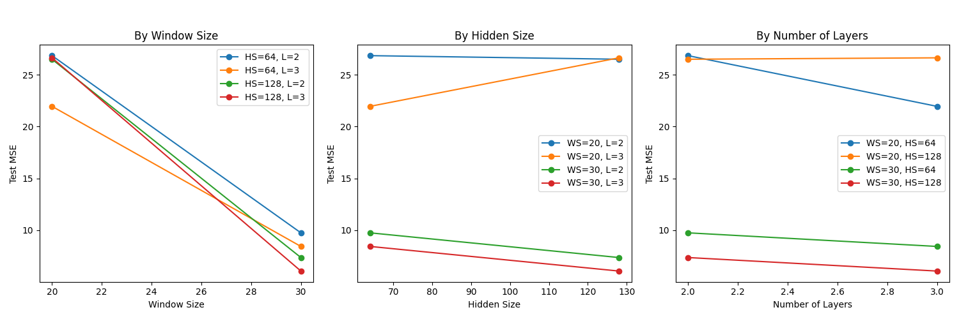
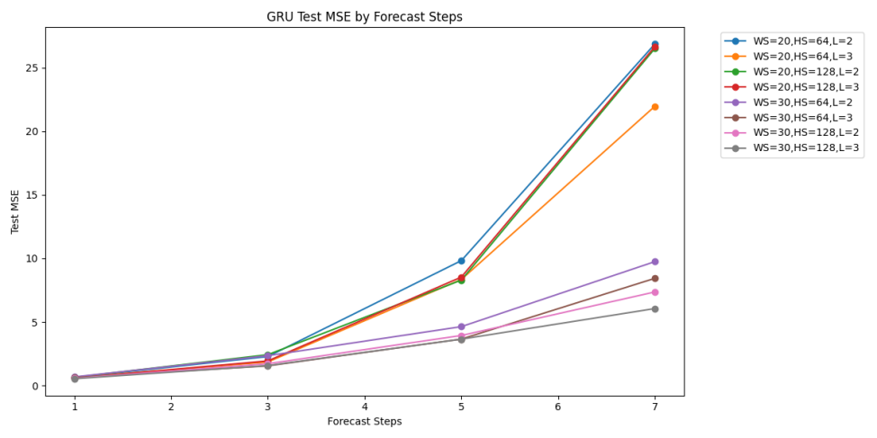
基于实验结果，选取 window_size=30、hidden_size=64、num_layers=3、forecast_steps=3作为参数组合进行展示，该配置在测试集上取得了较低的 MSE（1.5494717），表明模型具备较强的时序预测能力。
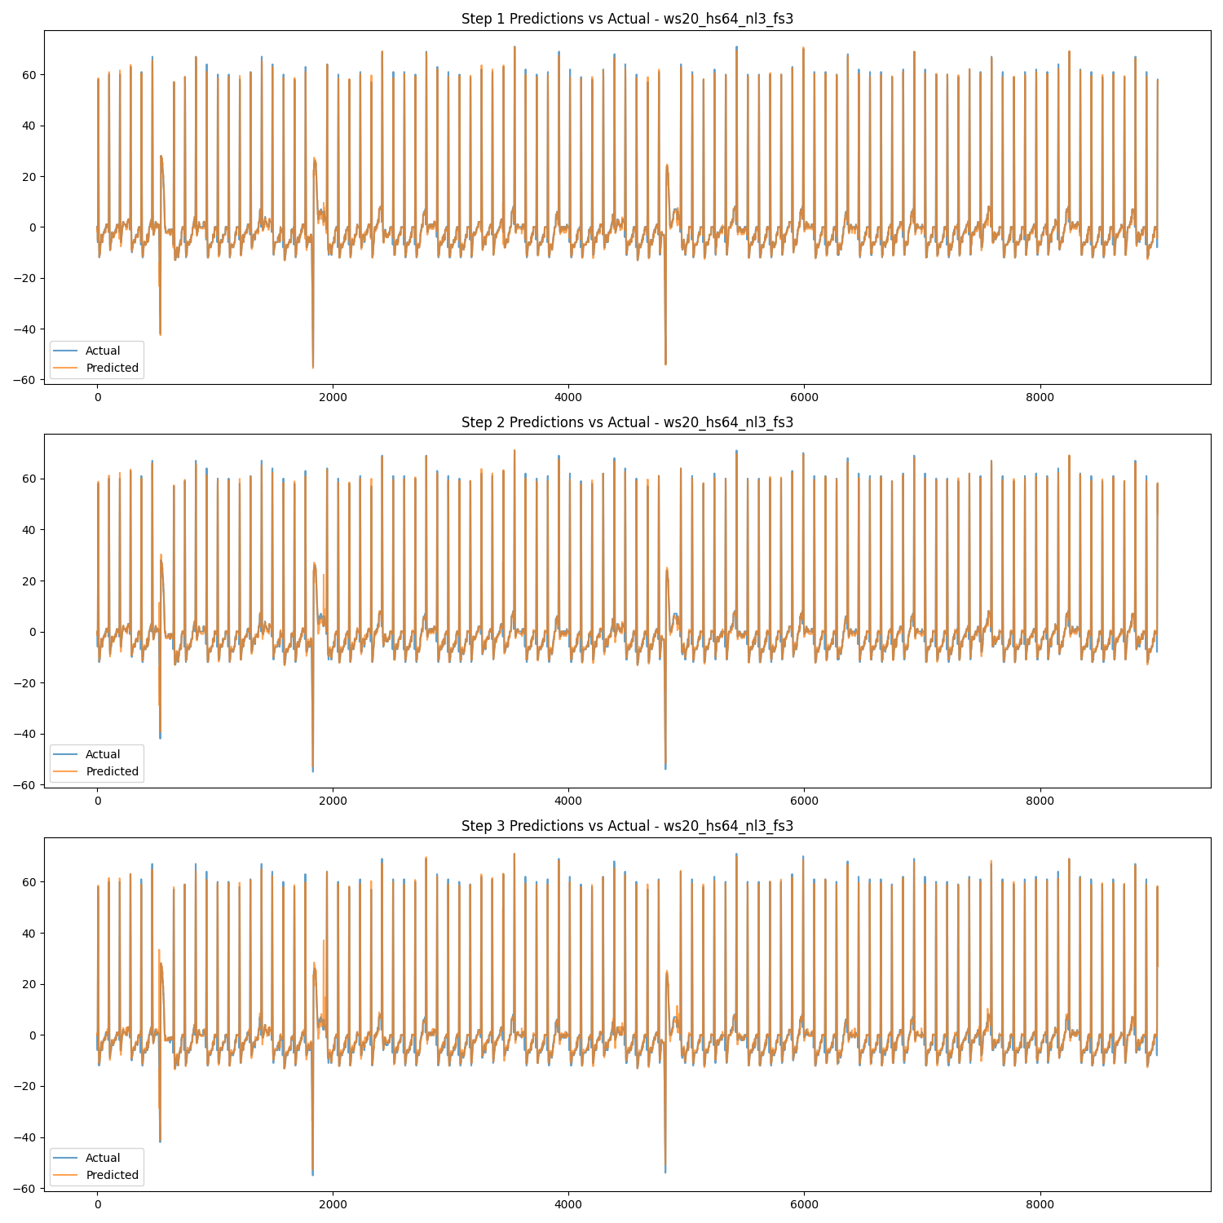
结果分析
1、窗口大小（Window Size）的影响：窗口增大（单步预测：10→20→30，多步预测：20→30），训练损失和测试MSE显著降低，说明更大的历史窗口能有效提升模型对长期时序模式的捕捉能力，尤其对多步预测改善更为明显。
2、隐层维度（Hidden Size）的影响：隐层扩大（单步预测：32→64→128，多步预测：64→128），单步预测和多步预测性能均匀提升，说明增加隐层容量优化了特征提取能力。
3、网络深度（Num Layers）的影响：层数增加（单步预测：1→2→3，多步预测：2→3），单步预测MSE降低，多步预测误差累积速度减缓，表明更深的网络能更好地建模复杂时序依赖关系。
4、预测步长（Forecast Steps）的影响：步长增加（单步预测：1→3→5→7，多步预测：1→3→5→7），测试MSE增长10-50倍，说明多步预测存在显著的误差累积效应，长期预测准确性下降较快。
5、学习率（lr）和训练轮次（epochs）的影响：上述实验结果陷于篇幅仅展示lr=0.0001和epochs=100的情景，实际实验通过对比不同学习率（0.01、0.001、0.0001）和训练轮次（50、100）的组合效果，发现学习率设为0.0001配合100个训练轮次能够取得最佳平衡：该配置既能有效避免高学习率（0.01）导致的训练震荡问题，同时，100个训练轮次确保模型充分收敛，相比50轮次显著提升了模型性能，具体学习率和训练轮次对模型训练的影响在图像分类的实验中有详细展示，此处不再重复。
6、模型类型对比：在优化参数配置后，LSTM和GRU模型均能实现较小的训练损失和测试MSE，预测效果良好。其中，LSTM凭借其更复杂的门控机制（输入门、遗忘门、输出门）和独立记忆单元展现出更优的预测精度，而GRU则因其简化的双门结构（更新门和重置门）和更少的参数量，在相同参数条件下实现了更快的训练收敛速度。
2、图像分类实验
2.1、ResNet图像分类实验
2.1.1、基础ResNet图像分类实验
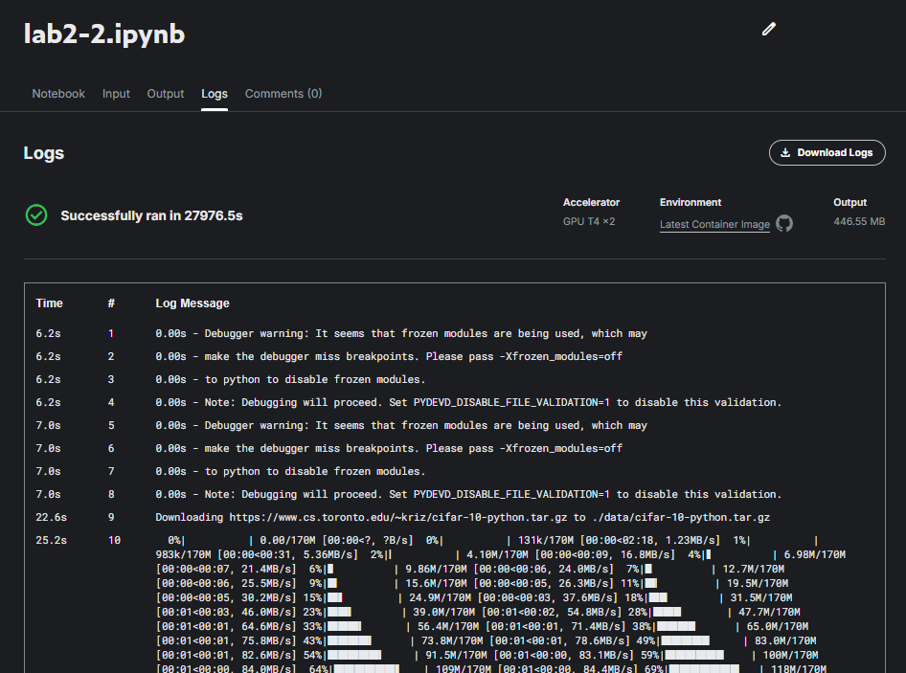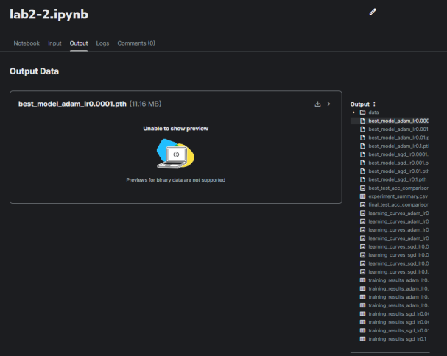
Optimizer | Epoches | Learning Rate | Weight Decay | Best Test Acc | Final Train Acc | Final Test Acc
ADAM | 100 | 0.1 | 0.0005 | 76.94 | 77.61 | 76.84
ADAM | 100 | 0.01 | 0.0005 | 83.64 | 86.034 | 83.53
ADAM | 100 | 0.001 | 0.0005 | 92.16 | 99.728 | 92.12
ADAM | 100 | 0.0001 | 0.0005 | 91.34 | 99.772 | 91.19
SGD | 100 | 0.1 | 0.0005 | 94.38 | 99.984 | 94.32
SGD | 100 | 0.01 | 0.0005 | 93.25 | 99.866 | 93.11
SGD | 100 | 0.001 | 0.0005 | 89.67 | 97.094 | 89.46
SGD | 100 | 0.0001 | 0.0005 | 72.81 | 74.378 | 72.61

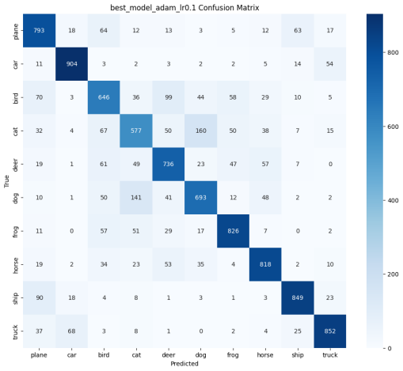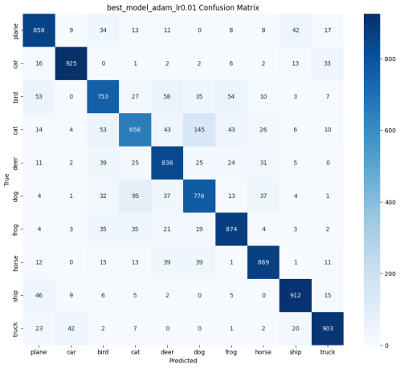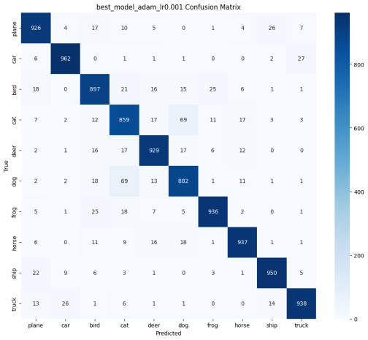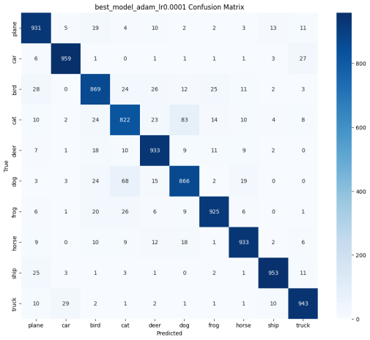
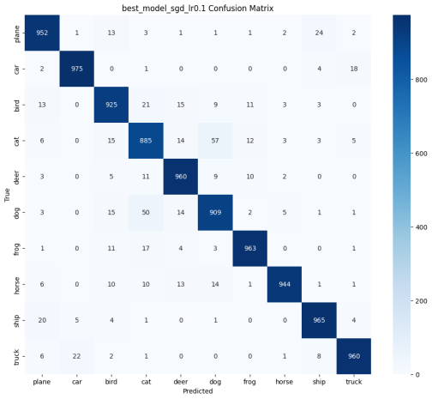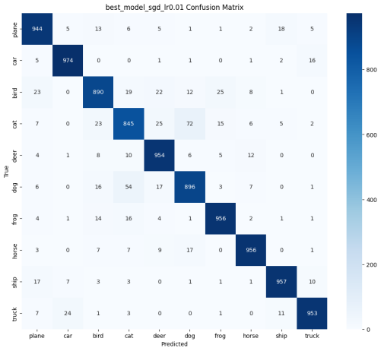
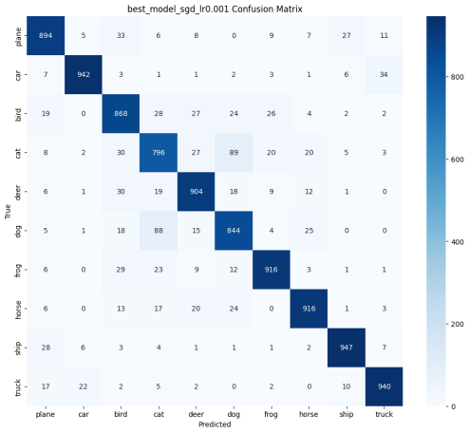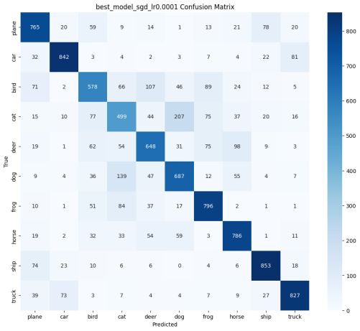
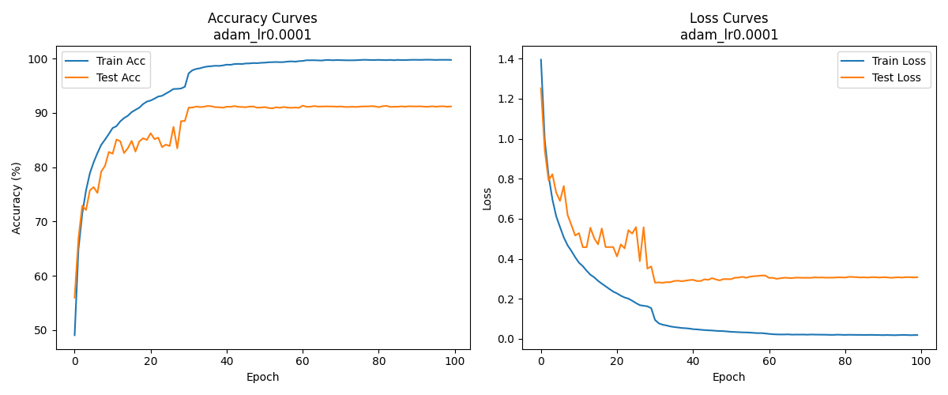
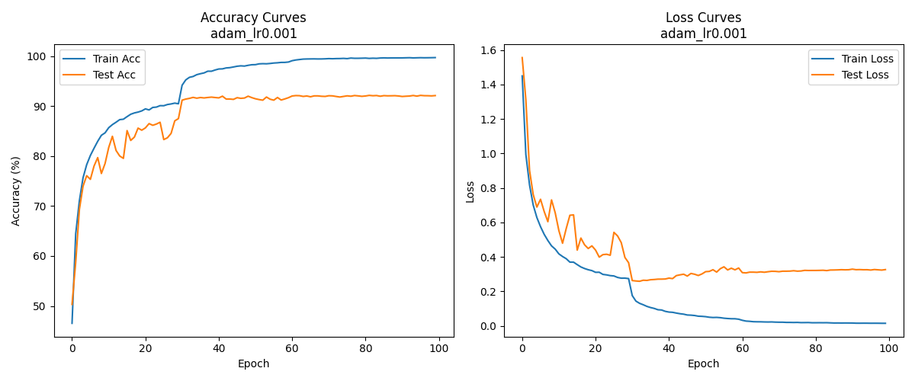
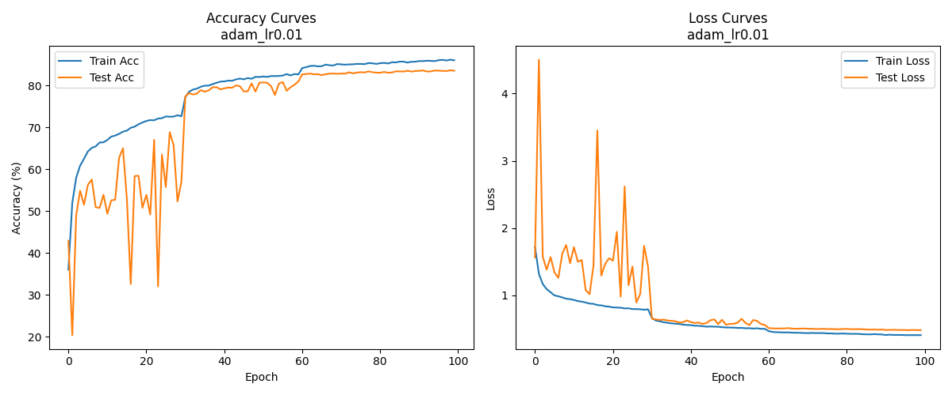
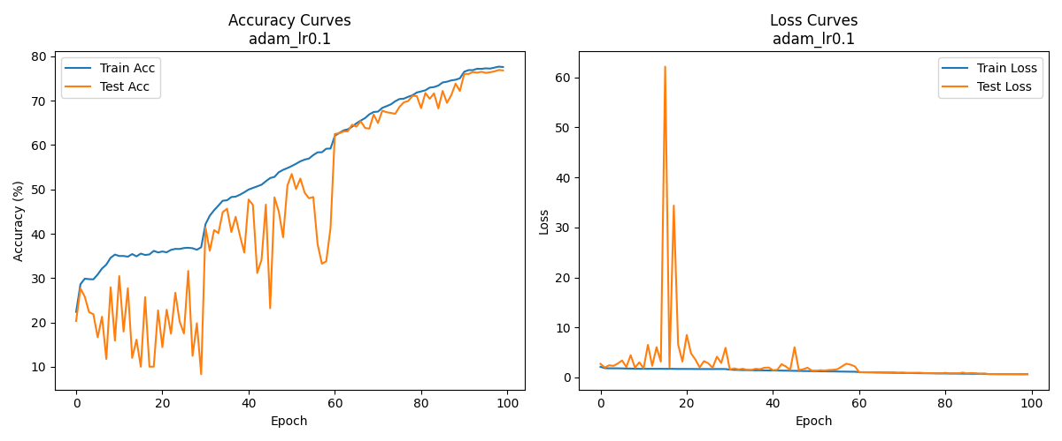
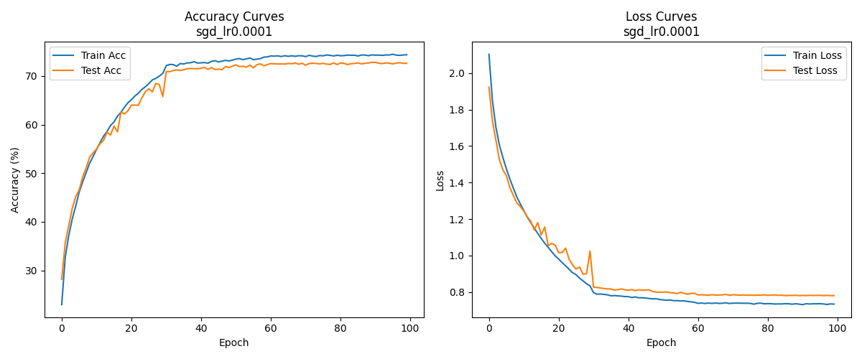
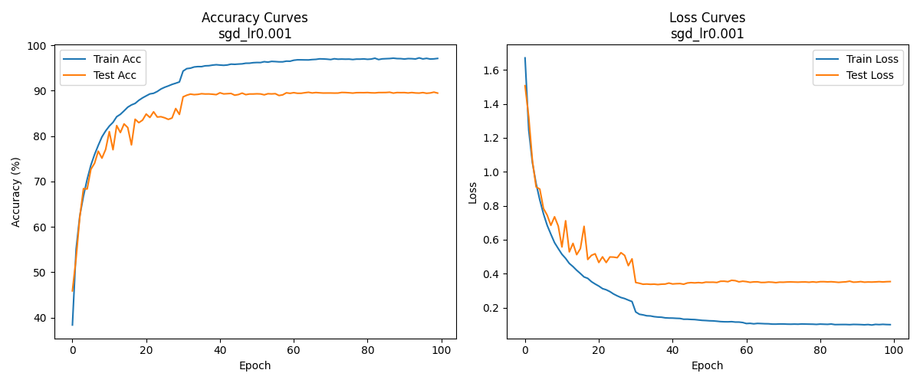
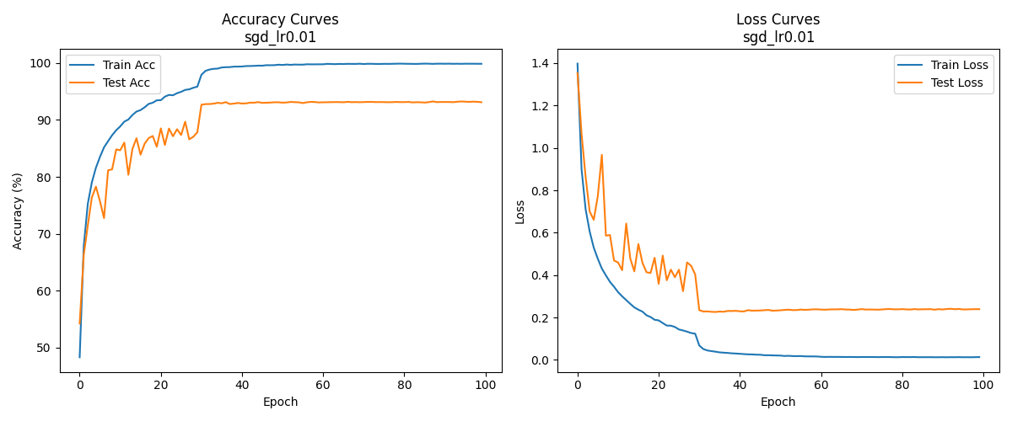
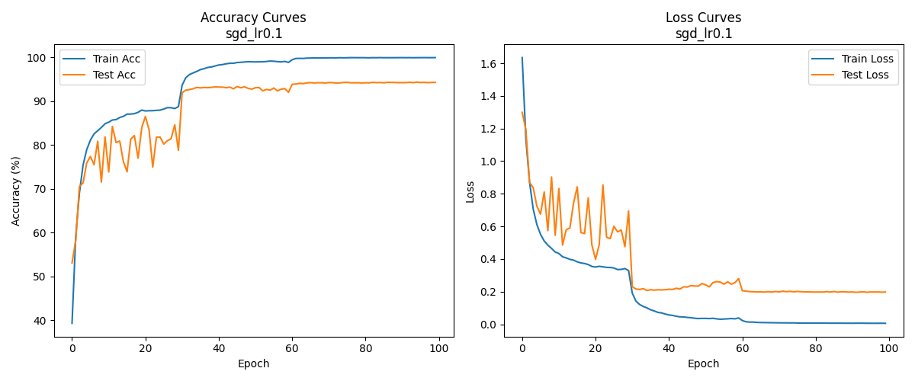
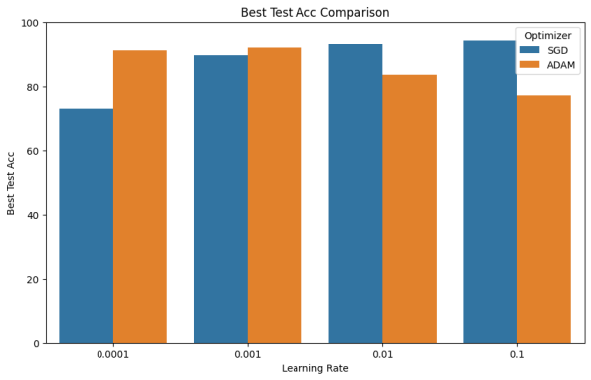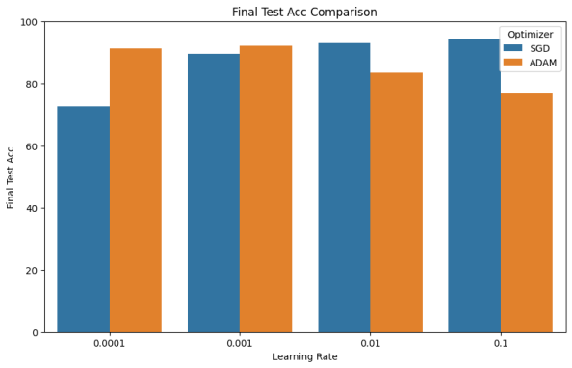
2.1.2、加深模型深度后的ResNet图像分类实验
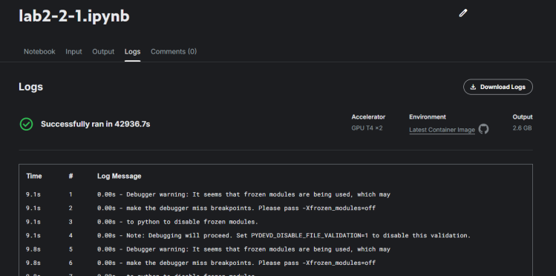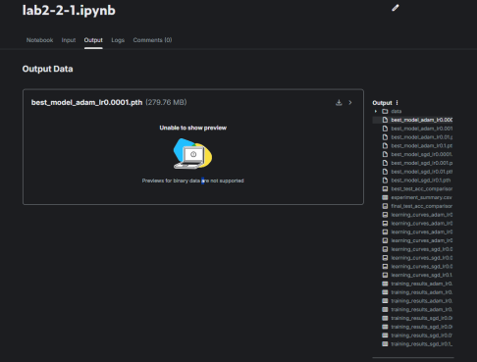

Optimizer | Epoches | Learning Rate | Weight Decay | Best Test Acc | Final Train Acc | Final Test Acc
ADAM | 50 | 0.1 | 0.0005 | 41.93 | 52.116% | 27.63%
ADAM | 50 | 0.01 | 0.0005 | 80.19 | 80.964% | 80.09%
ADAM | 50 | 0.001 | 0.0005 | 92.4 | 97.968% | 92.00%
ADAM | 50 | 0.0001 | 0.0005 | 92.15 | 99.448% | 92.04%
SGD | 50 | 0.1 | 0.0005 | 92.32 | 97.834% | 92.05%
SGD | 50 | 0.01 | 0.0005 | 93.21 | 99.598% | 93.07%
SGD | 50 | 0.001 | 0.0005 | 90.33 | 98.496% | 90.09%
SGD | 50 | 0.0001 | 0.0005 | 78.99 | 82.434% | 78.93%
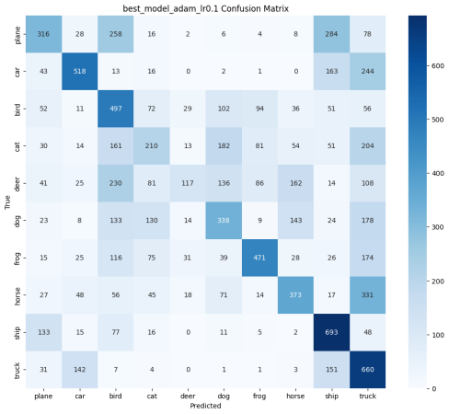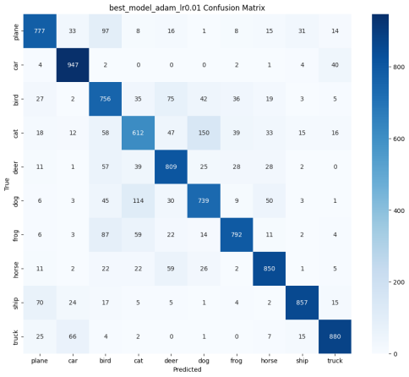
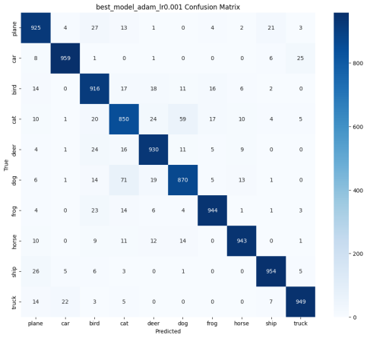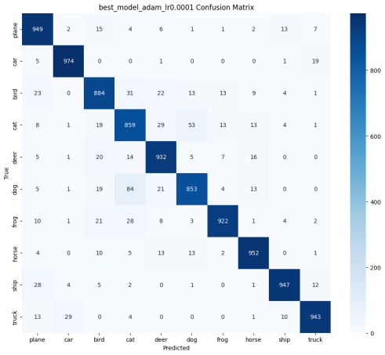
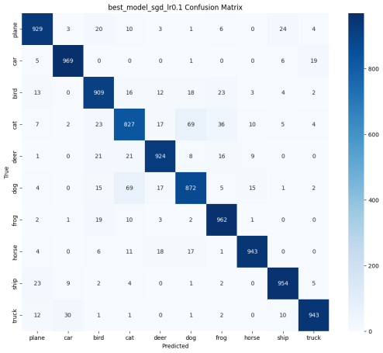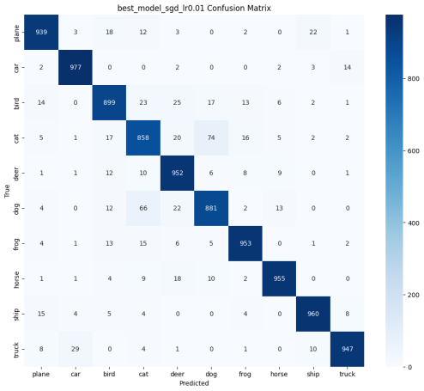
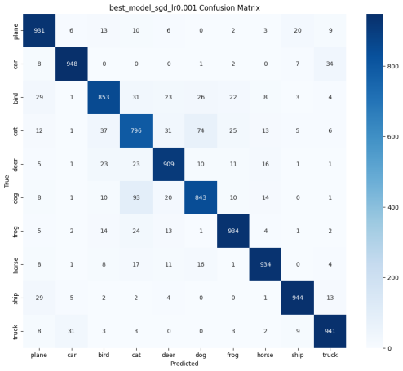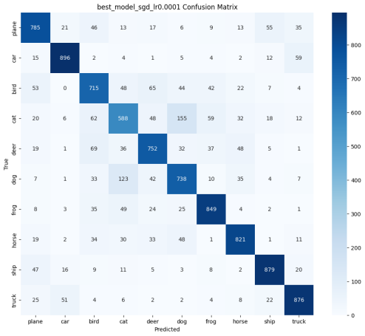
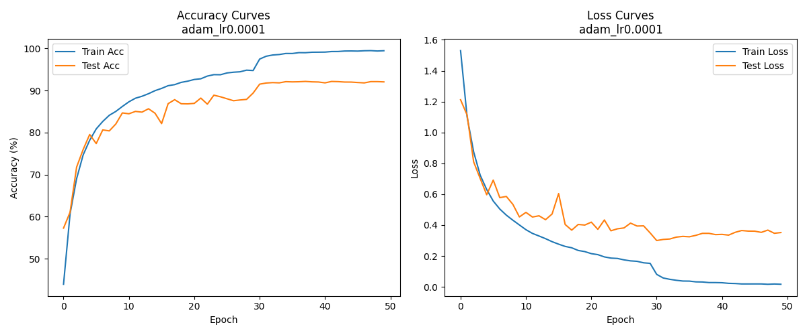
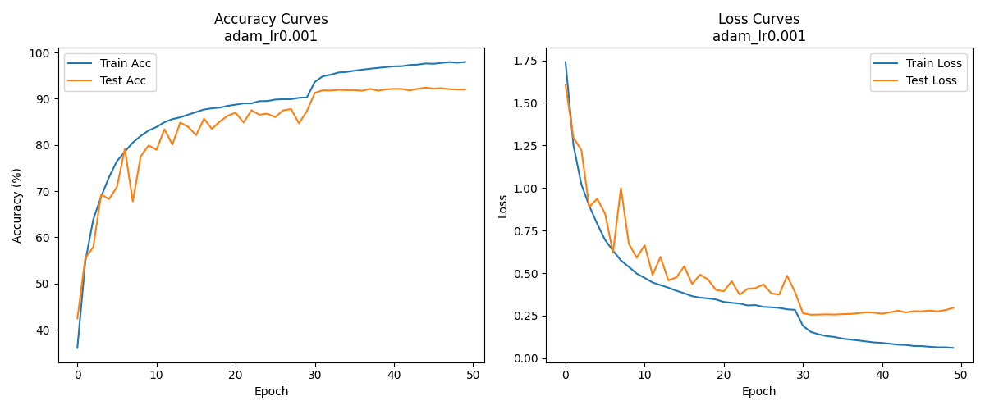
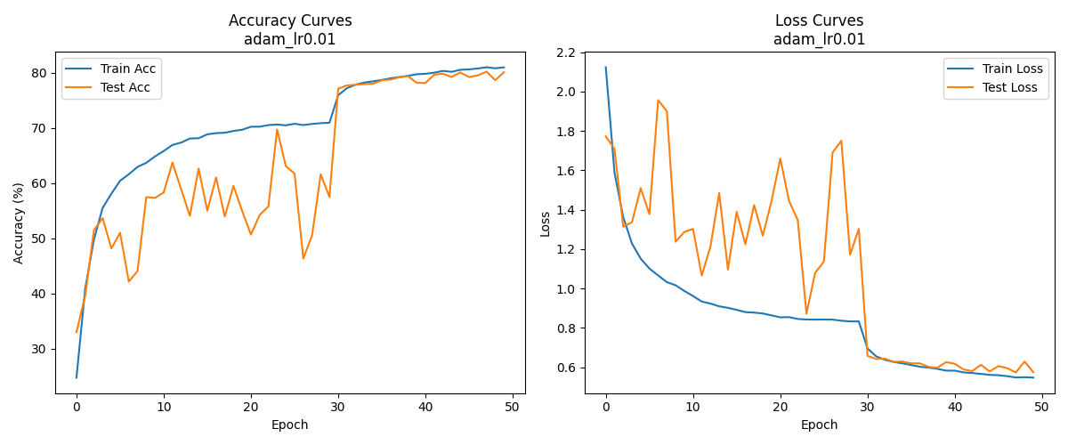
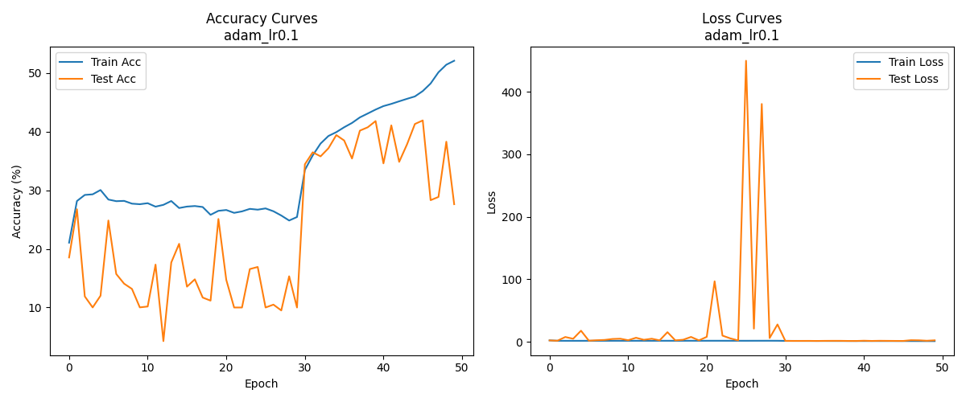
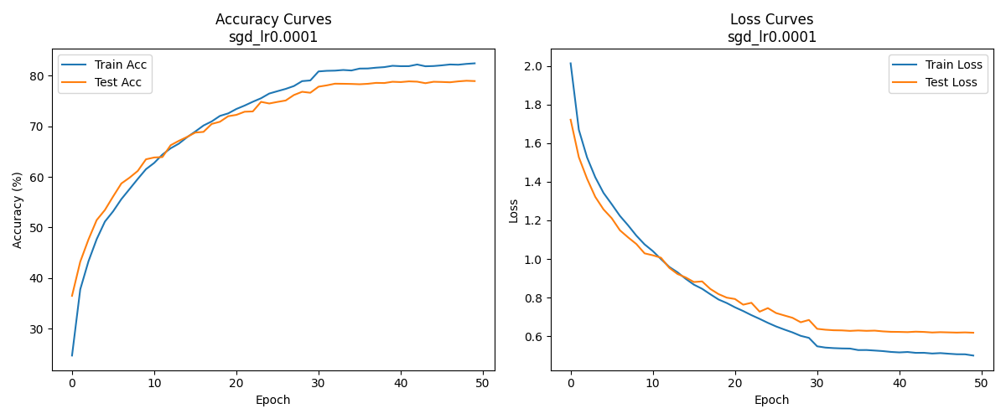
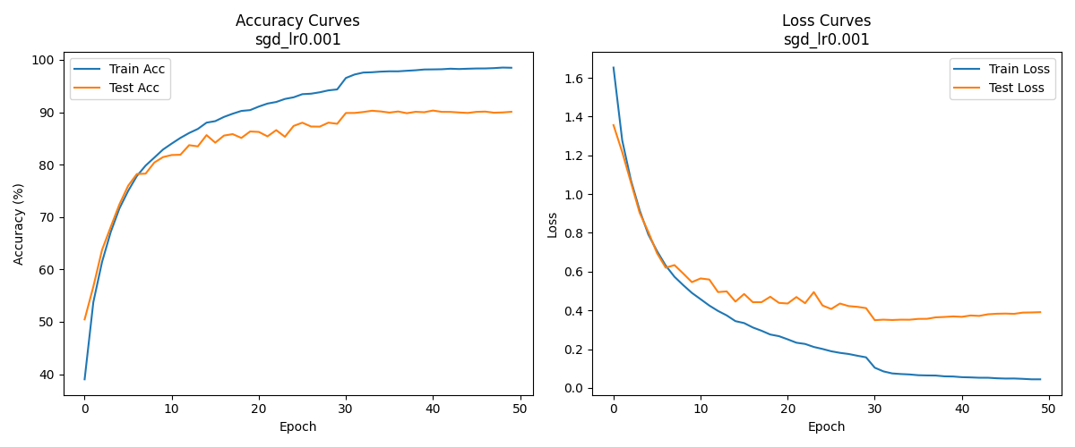
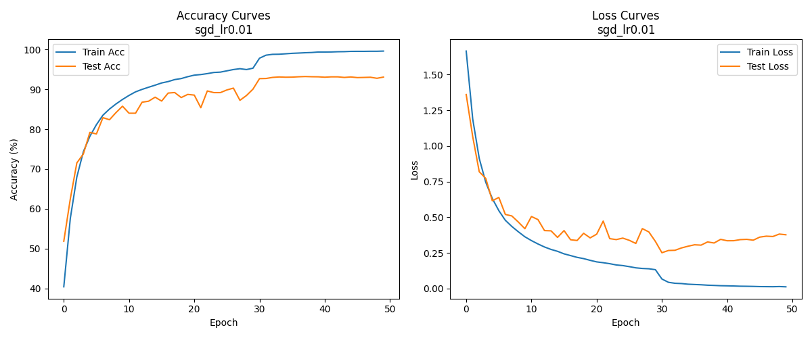
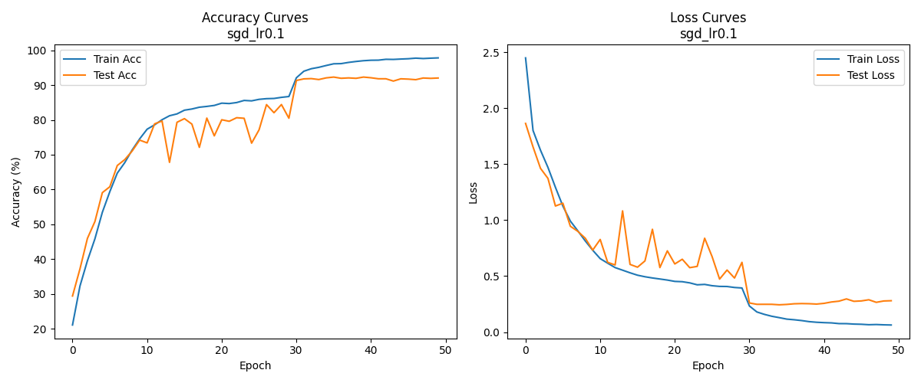
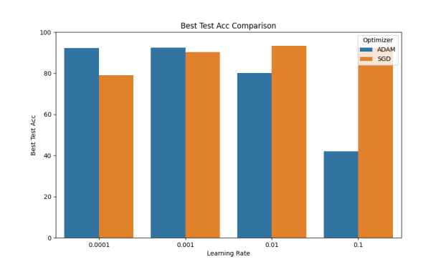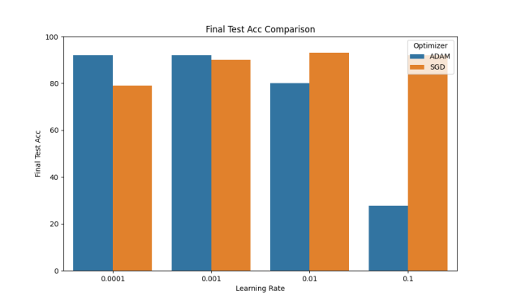
结果分析
- 优化器选择的影响：在基础VGG和深层VGG上，SGD优化器较大学习率（0.01）时表现最优（测试准确率94.32%），而Adam优化器在小学习率（0.001）时取得较好效果（92.04%），说明SGD更适合ResNet架构的训练，具有更强的稳定性和容错性。
- 学习率设置的影响：学习率与优化器的适配性对模型性能具有关键影响。实验表明，当学习率设置过高（如0.1）时，Adam优化器会出现性能崩溃，导致模型无法有效拟合；而学习率过低虽能使训练曲线更加平滑，但会显著减缓损失函数的下降速度。
- 训练轮次的影响：实验结果表明，随着训练轮次（epoch）的增加，模型整体呈现性能提升的趋势，表现为准确率上升和损失值下降，尽管训练过程中存在一定的波动性。值得注意的是，模型性能的提升速率会随epoch增大而逐渐减缓，且大多数参数组合在epoch=30附近会出现显著的性能提升拐点。
- 模型深度的影响：增加网络深度会显著延长训练时间。为优化GPU资源利用率，深度ResNet模型仅训练50个epoch（基础模型的50%训练轮次）。然而，在相同参数配置下，深层模型在Final Train Acc和Final Test Acc等关键指标上已达到或超越基础模型表现，证实了增加网络深度对提升模型准确率的有效性。值得注意的是，随着网络深度增加，模型对参数设置的敏感性也随之增强，当遇到不合适的参数组合时，训练过程的波动明显增大。

2.2、使用VGG进行图像分类
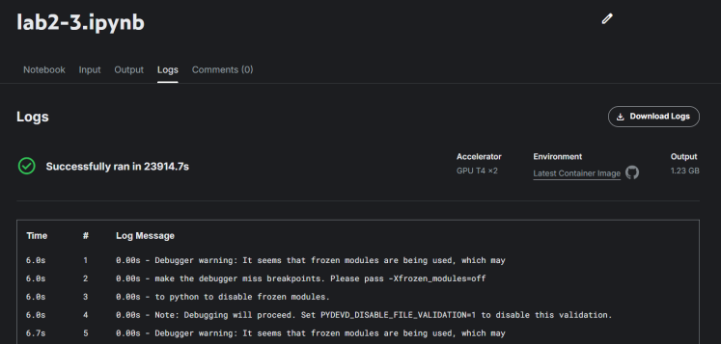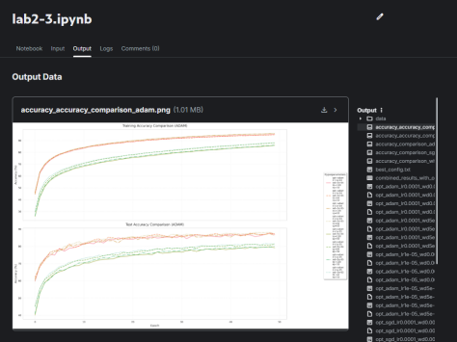
2.2.1、基础VGG图像分类实验
Epochs | Optimer | batch_size | weight_decay | lr | Final Train Accuracy | Final Test Accuracy
50 | sgd | 64 | 0.0005 | 1e-05 | 29.03% | 36.33%
50 | adam | 128 | 5e-05 | 1e-05 | 71.63% | 73.34%
50 | sgd | 64 | 0.0005 | 0.0001 | 67.54% | 70.2%
50 | adam | 64 | 0.0005 | 0.0001 | 93.24% | 87.34%
50 | sgd | 128 | 5e-05 | 0.0001 | 56.3% | 61.51%
50 | sgd | 128 | 0.0005 | 1e-05 | 21.26% | 24.53%
50 | adam | 64 | 0.0005 | 1e-05 | 75.84% | 76.84%
50 | sgd | 128 | 0.0005 | 0.0001 | 54.66% | 59.65%

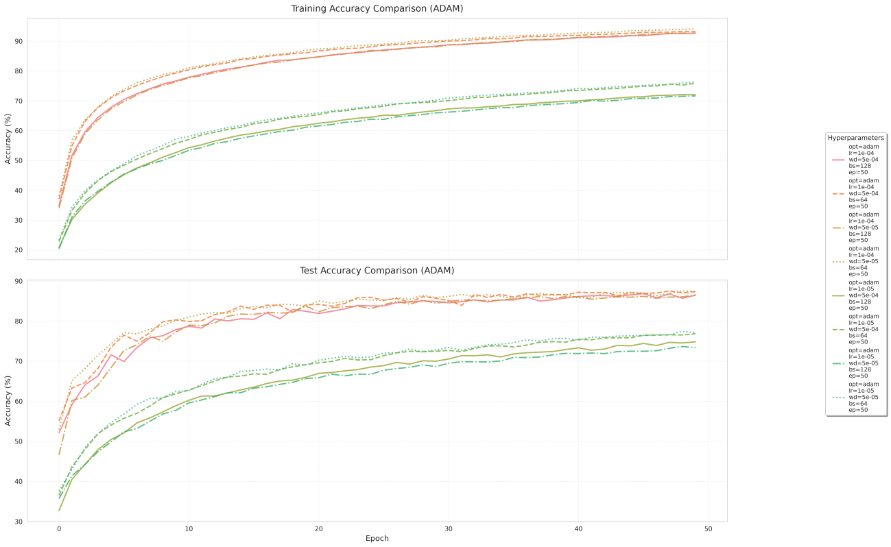
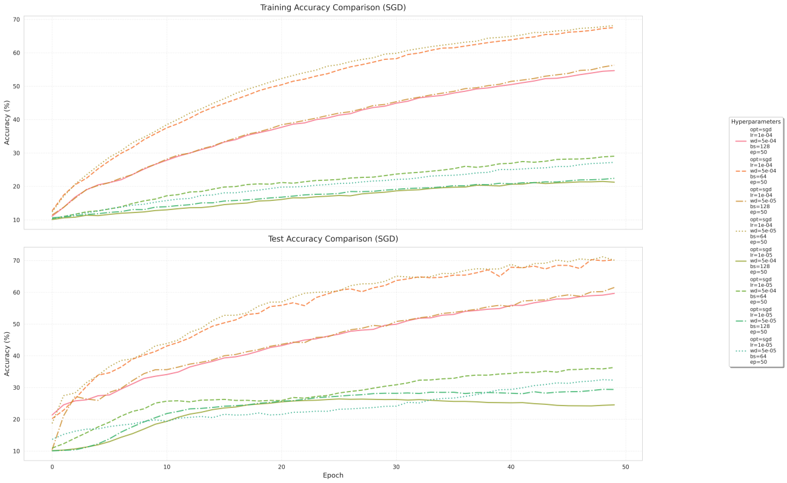
2.2.2、加深模型深度后的VGG图像分类实验
Epochs | Optimer | batch_size | weight_decay | lr | Final Train Accuracy | Final Test Accuracy
50 | sgd | 64 | 0.0005 | 1e-05 | 76.25% | 77.08%
50 | adam | 128 | 5e-05 | 1e-05 | 92.69% | 86.44%
50 | sgd | 64 | 0.0005 | 0.0001 | 22.42% | 29.38%
50 | adam | 64 | 0.0005 | 0.0001 | 72.01% | 74.82%
50 | sgd | 128 | 5e-05 | 0.0001 | 68.16% | 70.07%
50 | sgd | 128 | 0.0005 | 1e-05 | 27.19% | 32.33%
50 | adam | 64 | 0.0005 | 1e-05 | 94.1% | 87.36%
50 | sgd | 128 | 0.0005 | 0.0001 | 92.69% | 86.53%
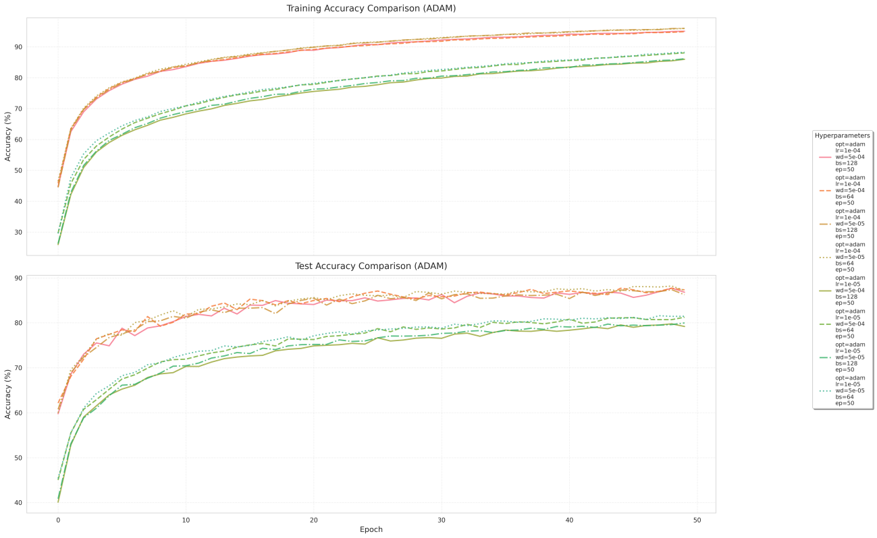
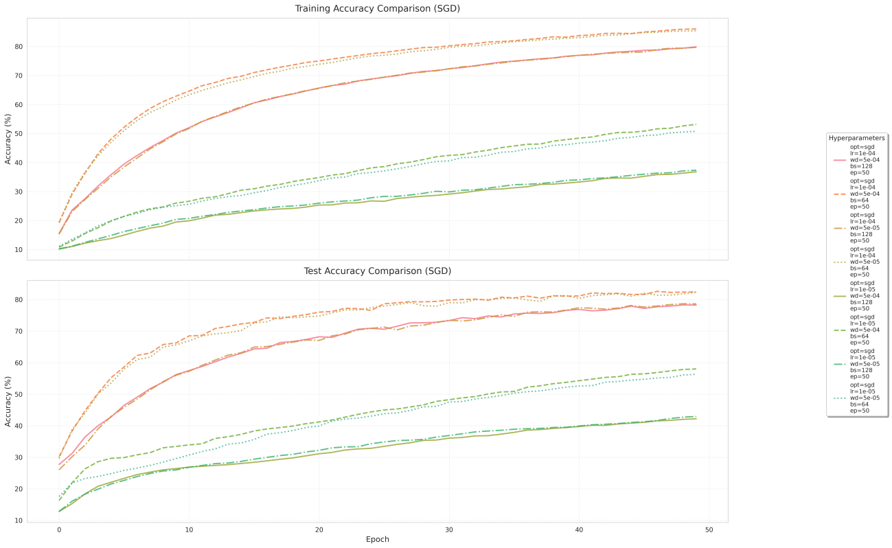

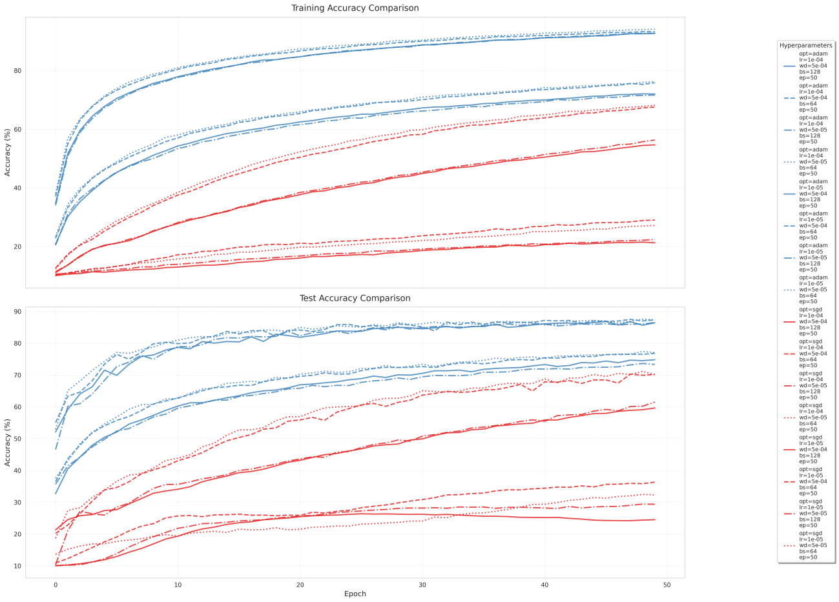
此处仅展示基础VGG（adam，batch_size=128，weight_decay=5e-05，1r=e-05）和深层VGG（sgd，batch_size=128，weight_decay=0.0005,lr=0.0001）的混淆矩阵结果，两者分别是基础VGG和深层VGG的最优训练参数组合，可见深层VGG对模型预测性能有所提升。
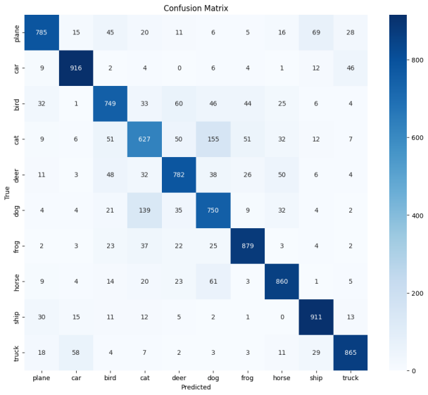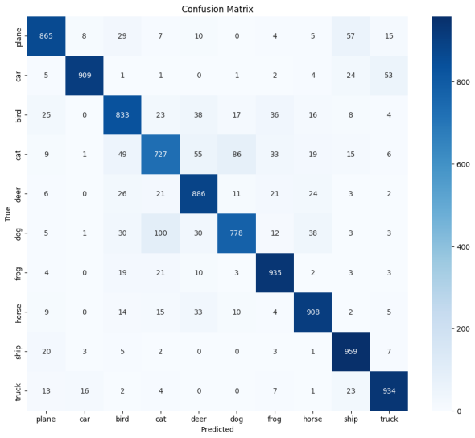
结果分析
1、优化器选择的影响：在基础VGG模型中，Adam优化器在大多数情况下表现优于SGD，尤其是在学习率为0.0001时，Adam取得了93.24%的训练准确率和87.34%的测试准确率，而SGD在相同学习率下仅为67.54%和70.2%。这表明Adam在初始训练阶段更高效，可能得益于其自适应学习率特性。然而，在加深模型后，SGD在某些配置下（如batch_size=128、weight_decay=0.0005、lr=0.0001）也能达到92.69%的训练准确率，接近Adam的表现，说明深度增加后SGD的潜力可能被进一步挖掘。
2、学习率设置的影响：无论是基础模型还是加深模型，过小的学习率（如1e-5）会导致训练缓慢，准确率偏低（如基础模型中SGD仅29.03%的训练准确率）。而学习率稍大（0.0001）时，性能显著提升，但需注意过大的学习率可能导致训练不稳定，例如加深模型中SGD在lr=0.0001时训练准确率骤降至22.42%，可能是由于模型深度增加后梯度更新更加敏感。
3、batch_size的影响：在基础VGG模型中，较大的batch size（如128）通常导致性能下降，可能因梯度更新过于平均化；而在加深后的模型中，较大的batch size配合SGD优化器反而能取得优异表现（如92.69%准确率），说明深层网络可能受益于更稳定的批量梯度计算。不过这种提升并非绝对，仍需结合合适的学习率和权重衰减才能发挥效果，例如相同batch size下不当的学习率仍会导致性能骤降。这表明batch size的最佳选择需要与模型深度、优化策略协同考虑。
4、权重衰减的影响：权重衰减的调整对过拟合有一定抑制作用，但在实验数据中表现不是很明显。
5、模型深度的影响：模型深度的增加总体上提升了性能，但需要更谨慎的超参数调优。加深后的模型在部分配置下测试准确率大幅提升，说明深度增加增强了特征提取能力。然而，某些配置下性能反而下降，表明深度增加可能加剧优化难度，需进一步调整学习率或引入梯度裁剪等策略。

五、实验小结
本次实验围绕时序预测和图像分类两大任务展开深入研究。在时序预测方面，通过对比LSTM和GRU模型的实验表明，适当增大输入窗口尺寸、隐层维度和网络深度能显著提升预测性能，其中GRU展现出更高的训练效率，而LSTM则在长期预测任务中表现出更优的稳定性，同时单步预测的结果显著优于多步预测的结果。图像分类实验表明，不同网络架构对优化器的适应性存在显著差异，甚至统一网络框架不同深度的模型对优化器的适应也有所不同。实验还发现，增加网络深度会改变最优超参数组合，并普遍加剧过拟合现象。这些发现为实际应用中模型选择和参数调优提供了重要参考。通过本次实验，我不仅深入掌握了深度学习模型的参数调优策略，更通过混淆矩阵、损失曲线等多种可视化手段，深化了对模型工作机制的理解，提升了实验结果的分析与呈现能力。

附录：
实验源代码
lab2-1-0.ipynb 时序数据预测实验代码（含不同学习率和训练轮次等对比）
lab2-1.ipynb 时序数据预测实验代码（含不同窗口大小、隐层维度、网络深度等对比）
lab2-2.ipynb 基础ResNet图像分类实验代码
lab2-2-1.ipynb 加深模型深度后的ResNet图像分类实验代码
lab2-3.ipynb 基础VGG和加深模型深度后的VGGt图像分类实验代码
lab2-1-0.ipynb
001  002  003  004  005  006  007  008  009  010  011  012  013  014  015  016  017  018  019  020  021  022  023  024  025  026  027  028  029  030  031  032  033  034  035  036  037  038  039  040  041  042  043  044  045  046  047  048  049  050  051  052  053  054  055  056  057  058  059  060  061  062  063  064  065  066  067  068  069  070  071  072  073  074  075  076  077  078  079  080  081  082  083  084  085  086  087  088  089  090  091  092  093  094  095  096  097  098  099  100  101  102  103  104  105  106  107  108  109  110  111  112  113  114  115  116  117  118  119  120  121  122  123  124  125  126  127  128  129  130  131  132  133  134  135  136  137  138  139  140 | import torch  import torch.nn as nn  import torch.optim as optim  from torch.utils.data import Dataset, DataLoader  import pandas as pd  import numpy as np  import argparse  import matplotlib.pyplot as plt  class TimeSeriesDataset(Dataset):  def __init__(self, X, y):  self.X = X  self.y = y  def __len__(self):  return len(self.X)  def __getitem__(self, idx):  return self.X[idx], self.y[idx]  class LSTMForecaster:  def __init__(self, data_path, window_size, hidden_size, num_layers, epochs, batch_size, lr):  self.data_path = data_path  self.window_size = window_size  self.hidden_size = hidden_size  self.num_layers = num_layers  self.epochs = epochs  self.batch_size = batch_size  self.lr = lr  self.device = torch.device('cuda' if torch.cuda.is_available() else 'cpu')  self.mean = 0  self.std = 1  self.X_train = None  self.y_train = None  self.X_test = None  self.y_test = None  self.model = None  self.criterion = nn.MSELoss()  self.optimizer = None  class LSTMModel(nn.Module):  def __init__(self, input_size, hidden_size, num_layers):  super().__init__()  self.lstm = nn.LSTM(input_size, hidden_size, num_layers, batch_first=True)  self.fc = nn.Linear(hidden_size, 1)  def forward(self, x):  out, _ = self.lstm(x)  out = out[:, -1, :]  out = self.fc(out)  return out  def prepare_data(self):  data = pd.read_csv(self.data_path).values.astype(np.float32)  train_size = int(len(data) * 0.7)  train_data = data[:train_size]  test_data = data[train_size - self.window_size:]  self.mean = train_data.mean()  self.std = train_data.std()  train_data = (train_data - self.mean) / self.std  test_data = (test_data - self.mean) / self.std  def create_samples(dataset):  X, y = [], []  for i in range(len(dataset)-self.window_size):  X.append(dataset[i:i+self.window_size])  y.append(dataset[i+self.window_size])  return np.array(X), np.array(y)  X_train, y_train = create_samples(train_data)  X_test, y_test = create_samples(test_data)  self.X_train = torch.from_numpy(X_train).float().view(-1, self.window_size, 1)  self.y_train = torch.from_numpy(y_train).float().view(-1, 1)  self.X_test = torch.from_numpy(X_test).float().view(-1, self.window_size, 1)  self.y_test = torch.from_numpy(y_test).float().view(-1, 1)  def build_model(self):  self.model = self.LSTMModel(1, self.hidden_size, self.num_layers).to(self.device)  self.optimizer = optim.Adam(self.model.parameters(), lr=self.lr)  def train(self):  train_dataset = TimeSeriesDataset(self.X_train, self.y_train)  train_loader = DataLoader(train_dataset, batch_size=self.batch_size, shuffle=True)  loss_filename = f"{self.window_size}-{self.hidden_size}-{self.num_layers}-{self.epochs}-{self.batch_size}-{self.lr}-loss_results.txt"  self.model.train()  with open(loss_filename, 'w') as f:  f.write("Epoch, Loss\n")  for epoch in range(self.epochs):  total_loss = 0  for X_batch, y_batch in train_loader:  X_batch, y_batch = X_batch.to(self.device), y_batch.to(self.device)  self.optimizer.zero_grad()  outputs = self.model(X_batch)  loss = self.criterion(outputs, y_batch)  loss.backward()  self.optimizer.step()  total_loss += loss.item()  avg_loss = total_loss / len(train_loader)  if (epoch+1)%10==0:  print(f'Epoch [{epoch+1}/{self.epochs}], Loss: {avg_loss:.4f}')  f.write(f"{epoch+1}, {avg_loss:.4f}\n")  torch.save(self.model.state_dict(), 'lstm_model.pth')  print(f"Loss results saved to: {loss_filename}")  def test(self):  test_dataset = TimeSeriesDataset(self.X_test, self.y_test)  test_loader = DataLoader(test_dataset, batch_size=self.batch_size, shuffle=False)  self.model.load_state_dict(torch.load('lstm_model.pth'))  self.model.eval()  predictions = []  actuals = []  with torch.no_grad():  for X_batch, y_batch in test_loader:  X_batch = X_batch.to(self.device)  pred = self.model(X_batch).cpu().numpy()  predictions.extend(pred)  actuals.extend(y_batch.numpy())  predictions = np.array(predictions) * self.std + self.mean  actuals = np.array(actuals) * self.std + self.mean  mse = np.mean((predictions - actuals) ** 2)  print(f'Test MSE: {mse:.4f}')  return actuals, predictions  def plot_results(self, actuals, predictions):  plt.figure(figsize=(12, 6))  plt.plot(actuals, label='Actual')  plt.plot(predictions, label='Predicted')  plt.legend()  plt.title('Time Series Prediction Results')  filename = f"{self.window_size}-{self.hidden_size}-{self.num_layers}-{self.epochs}-{self.batch_size}-{self.lr}-prediction_results.png"  #plt.show()  plt.savefig(filename)  plt.close()
01  02  03  04  05  06  07  08  09  10  11  12  13  14  15  16  17  18  19  20  21  22  23  24  25  26  27  28  29  30  31  32  33  34  35  36  37  38  39  40  41  42  43  44  45  46  47  48  49  50  51  52  53  54  55  56  57  58  59  60  61  62  63 | window_sizes = [5, 10, 15]  hidden_sizes = [100, 200]  num_layerss = [1, 3, 5]  epochs = 50  batch_size = 32  lr = 0.001  results = []  best_metrics = {'mse': float('inf')}  best_params = {}  for ws in window_sizes:  for hs in hidden_sizes:  for nl in num_layerss:  print(f"\nTraining model with WS={ws}, HS={hs}, Layers={nl}")  forecaster = LSTMForecaster(  data_path='/kaggle/input/ucr-ecg/UCR_ECG1_10000_11800_12100.txt',  window_size=ws,  hidden_size=hs,  num_layers=nl,  epochs=epochs,  batch_size=batch_size,  lr=lr  )  forecaster.prepare_data()  forecaster.build_model()  forecaster.train()  actuals, predictions = forecaster.test()  mse = ((actuals - predictions) ** 2).mean()  current_result = {  'window_size': ws,  'hidden_size': hs,  'num_layers': nl,  'mse': mse,  'actuals': actuals,  'predictions': predictions  }  results.append(current_result)  if mse < best_metrics['mse']:  best_metrics['mse'] = mse  best_params = {  'window_size': ws,  'hidden_size': hs,  'num_layers': nl  }  print(f"New best model! MSE: {mse:.4f}")  forecaster.plot_results(actuals, predictions)  print("\nHyperparameter search complete!")  print(f"Best parameters: {best_params}")  print(f"Best MSE: {best_metrics['mse']:.4f}")  best_result = next(r for r in results if (r['window_size'] == best_params['window_size'] and  r['hidden_size'] == best_params['hidden_size'] and  r['num_layers'] == best_params['num_layers']))  print("\nPlotting best model results...")  forecaster.plot_results(best_result['actuals'], best_result['predictions'])
01  02  03  04  05  06  07  08  09  10  11  12  13  14  15  16  17  18  19  20  21  22  23  24  25  26  27  28  29  30  31  32  33  34  35  36  37  38  39  40  41 | import glob  import matplotlib.pyplot as plt  import pandas as pd  loss_files = glob.glob("/kaggle/working/*-loss_results.txt")  plt.figure(figsize=(12, 6))  line_styles = ['-', '--', '-.', ':']  colors = ['b', 'g', 'r', 'c', 'm', 'y', 'k']  for i, loss_file in enumerate(loss_files):  try:  params = loss_file.split('/')[-1].split('-loss_results.txt')[0]  data = pd.read_csv(loss_file, header=0, names=['Epoch', 'Loss'], delimiter=',')  if not data.empty:  style_idx = i % len(line_styles)  color_idx = i % len(colors)  plt.plot(data['Epoch'], data['Loss'],  label=params,  linestyle=line_styles[style_idx],  color=colors[color_idx])  except Exception as e:  print(f"Error processing {loss_file}: {str(e)}")  plt.xlabel('Epoch')  plt.ylabel('Loss')  plt.title('Training Loss Comparison')  plt.legend(bbox_to_anchor=(1.05, 1), loc='upper left')  plt.grid(True)  plt.tight_layout()  comparison_filename = "loss_comparison.png"  plt.savefig(comparison_filename, bbox_inches='tight')  plt.show()  print(f"Comparison plot saved to: {comparison_filename}")
001  002  003  004  005  006  007  008  009  010  011  012  013  014  015  016  017  018  019  020  021  022  023  024  025  026  027  028  029  030  031  032  033  034  035  036  037  038  039  040  041  042  043  044  045  046  047  048  049  050  051  052  053  054  055  056  057  058  059  060  061  062  063  064  065  066  067  068  069  070  071  072  073  074  075  076  077  078  079  080  081  082  083  084  085  086  087  088  089  090  091  092  093  094  095  096  097  098  099  100  101  102  103  104  105  106  107  108  109  110  111  112  113  114  115  116  117  118  119  120  121  122  123  124  125  126  127  128  129  130  131  132  133  134  135  136  137  138  139  140  141  142  143  144 | import torch  import torch.nn as nn  import torch.optim as optim  from torch.utils.data import Dataset, DataLoader  import pandas as pd  import numpy as np  import argparse  import matplotlib.pyplot as plt  class TimeSeriesDataset(Dataset):  def __init__(self, X, y):  self.X = X  self.y = y  def __len__(self):  return len(self.X)  def __getitem__(self, idx):  return self.X[idx], self.y[idx]  class LSTMForecaster:  def __init__(self, data_path, window_size, forecast_horizon, hidden_size, num_layers, epochs, batch_size, lr):  self.data_path = data_path  self.window_size = window_size  self.forecast_horizon = forecast_horizon  self.hidden_size = hidden_size  self.num_layers = num_layers  self.epochs = epochs  self.batch_size = batch_size  self.lr = lr  self.device = torch.device('cuda' if torch.cuda.is_available() else 'cpu')  self.mean = 0  self.std = 1  self.X_train = None  self.y_train = None  self.X_test = None  self.y_test = None  self.model = None  self.criterion = nn.MSELoss()  self.optimizer = None  class LSTMModel(nn.Module):  def __init__(self, input_size, hidden_size, num_layers, forecast_horizon):  super().__init__()  self.lstm = nn.LSTM(input_size, hidden_size, num_layers, batch_first=True)  self.fc = nn.Linear(hidden_size, forecast_horizon)  def forward(self, x):  out, _ = self.lstm(x)  out = out[:, -1, :]  out = self.fc(out)  return out  def prepare_data(self):  data = pd.read_csv(self.data_path).values.astype(np.float32)  train_size = int(len(data) * 0.7)  train_data = data[:train_size]  test_data = data[train_size - self.window_size:]  self.mean = train_data.mean()  self.std = train_data.std()  train_data = (train_data - self.mean) / self.std  test_data = (test_data - self.mean) / self.std  def create_samples(dataset):  X, y = [], []  for i in range(len(dataset)-self.window_size-self.forecast_horizon+1):  X.append(dataset[i:i+self.window_size])  y.append(dataset[i+self.window_size:i+self.window_size+self.forecast_horizon])  return np.array(X), np.array(y)  X_train, y_train = create_samples(train_data)  X_test, y_test = create_samples(test_data)  self.X_train = torch.from_numpy(X_train).float().view(-1, self.window_size, 1)  self.y_train = torch.from_numpy(y_train).float().view(-1, self.forecast_horizon)  self.X_test = torch.from_numpy(X_test).float().view(-1, self.window_size, 1)  self.y_test = torch.from_numpy(y_test).float().view(-1, self.forecast_horizon)  def build_model(self):  self.model = self.LSTMModel(1, self.hidden_size, self.num_layers, self.forecast_horizon).to(self.device)  self.optimizer = optim.Adam(self.model.parameters(), lr=self.lr)  def train(self):  train_dataset = TimeSeriesDataset(self.X_train, self.y_train)  train_loader = DataLoader(train_dataset, batch_size=self.batch_size, shuffle=True)  loss_filename = f"{self.window_size}-{self.forecast_horizon}-{self.hidden_size}-{self.num_layers}-{self.epochs}-{self.batch_size}-{self.lr}-loss_results.txt"  self.model.train()  with open(loss_filename, 'w') as f:  f.write("Epoch, Loss\n")  for epoch in range(self.epochs):  total_loss = 0  for X_batch, y_batch in train_loader:  X_batch, y_batch = X_batch.to(self.device), y_batch.to(self.device)  self.optimizer.zero_grad()  outputs = self.model(X_batch)  loss = self.criterion(outputs, y_batch)  loss.backward()  self.optimizer.step()  total_loss += loss.item()  avg_loss = total_loss / len(train_loader)  print(f'Epoch [{epoch+1}/{self.epochs}], Loss: {avg_loss:.4f}')  f.write(f"{epoch+1}, {avg_loss:.4f}\n")  torch.save(self.model.state_dict(), 'lstm_model.pth')  print(f"Loss results saved to: {loss_filename}")  def test(self):  test_dataset = TimeSeriesDataset(self.X_test, self.y_test)  test_loader = DataLoader(test_dataset, batch_size=self.batch_size, shuffle=False)  self.model.load_state_dict(torch.load('lstm_model.pth'))  self.model.eval()  predictions = []  actuals = []  with torch.no_grad():  for X_batch, y_batch in test_loader:  X_batch = X_batch.to(self.device)  pred = self.model(X_batch).cpu().numpy()  predictions.extend(pred)  actuals.extend(y_batch.numpy())  predictions = np.array(predictions) * self.std + self.mean  actuals = np.array(actuals) * self.std + self.mean  mse = np.mean((predictions - actuals) ** 2)  print(f'Test MSE: {mse:.4f}')  return actuals, predictions  def plot_results(self, actuals, predictions):  plt.figure(figsize=(12, 6))  plt.plot(actuals[:, 0], label='Actual (first step)')  plt.plot(predictions[:, 0], label='Predicted (first step)')  plt.legend()  plt.title(f'Time Series Prediction Results ({self.forecast_horizon}-step forecast)')  filename = f"{self.window_size}-{self.forecast_horizon}-{self.hidden_size}-{self.num_layers}-{self.epochs}-{self.batch_size}-{self.lr}-prediction_results.png"  plt.savefig(filename)  plt.close()
01  02  03  04  05  06  07  08  09  10  11  12  13  14  15  16  17 | forecaster = LSTMForecaster(  data_path='/kaggle/input/ucr-ecg/UCR_ECG1_10000_11800_12100.txt',  window_size=10,  forecast_horizon=3,  hidden_size=50,  num_layers=1,  epochs=50,  batch_size=32,  lr=0.001  )  forecaster.prepare_data()  forecaster.build_model()  forecaster.train()  actuals, predictions = forecaster.test()  forecaster.plot_results(actuals, predictions)
01  02  03  04  05  06  07  08  09  10  11  12  13  14  15  16  17  18  19  20  21  22  23  24  25  26  27  28  29  30  31  32  33  34  35  36  37  38  39  40  41 | import glob  import matplotlib.pyplot as plt  import pandas as pd  loss_files = glob.glob("/kaggle/working/*-loss_results.txt")  plt.figure(figsize=(12, 6))  line_styles = ['-', '--', '-.', ':']  colors = ['b', 'g', 'r', 'c', 'm', 'y', 'k']  for i, loss_file in enumerate(loss_files):  try:  params = loss_file.split('/')[-1].split('-loss_results.txt')[0]  data = pd.read_csv(loss_file, header=0, names=['Epoch', 'Loss'], delimiter=',')  if not data.empty:  style_idx = i % len(line_styles)  color_idx = i % len(colors)  plt.plot(data['Epoch'], data['Loss'],  label=params,  linestyle=line_styles[style_idx],  color=colors[color_idx])  except Exception as e:  print(f"Error processing {loss_file}: {str(e)}")  plt.xlabel('Epoch')  plt.ylabel('Loss')  plt.title('Training Loss Comparison')  plt.legend(bbox_to_anchor=(1.05, 1), loc='upper left')  plt.grid(True)  plt.tight_layout()  comparison_filename = "loss_comparison.png"  plt.savefig(comparison_filename, bbox_inches='tight')  plt.show()  print(f"Comparison plot saved to: {comparison_filename}")
001  002  003  004  005  006  007  008  009  010  011  012  013  014  015  016  017  018  019  020  021  022  023  024  025  026  027  028  029  030  031  032  033  034  035  036  037  038  039  040  041  042  043  044  045  046  047  048  049  050  051  052  053  054  055  056  057  058  059  060  061  062  063  064  065  066  067  068  069  070  071  072  073  074  075  076  077  078  079  080  081  082  083  084  085  086  087  088  089  090  091  092  093  094  095  096  097  098  099  100  101  102  103  104  105  106  107  108  109  110  111  112  113  114  115  116  117  118  119  120  121  122  123  124  125  126  127  128  129  130  131  132  133  134  135  136  137  138  139  140  141  142  143  144  145  146  147  148  149  150  151  152  153  154  155  156  157  158  159 | import torch  import torch.nn as nn  import torch.optim as optim  from torch.utils.data import Dataset, DataLoader  import pandas as pd  import numpy as np  import matplotlib.pyplot as plt  class TimeSeriesDataset(Dataset):  def __init__(self, X, y):  self.X = X  self.y = y  def __len__(self):  return len(self.X)  def __getitem__(self, idx):  return self.X[idx], self.y[idx]  class GRUForecaster:  def __init__(self, data_path, window_size, hidden_size, num_layers, epochs, batch_size, lr):  self.data_path = data_path  self.window_size = window_size  self.hidden_size = hidden_size  self.num_layers = num_layers  self.epochs = epochs  self.batch_size = batch_size  self.lr = lr  self.device = torch.device('cuda' if torch.cuda.is_available() else 'cpu')  self.mean = 0  self.std = 1  self.model = None  self.criterion = nn.MSELoss()  self.optimizer = None  class GRUModel(nn.Module):  def __init__(self, input_size, hidden_size, num_layers):  super().__init__()  self.gru = nn.GRU(  input_size=input_size,  hidden_size=hidden_size,  num_layers=num_layers,  batch_first=True  )  self.fc = nn.Linear(hidden_size, 1)  def forward(self, x):  out, _ = self.gru(x)  out = out[:, -1, :]  out = self.fc(out)  return out  def prepare_data(self):  # 读取数据  data = pd.read_csv(self.data_path).values.astype(np.float32)  # 划分训练测试集 (70%训练，30%测试)  train_size = int(len(data) * 0.7)  train_data = data[:train_size]  test_data = data[train_size - self.window_size:] # 保持窗口连续性  # 标准化数据  self.mean = train_data.mean()  self.std = train_data.std()  train_data = (train_data - self.mean) / self.std  test_data = (test_data - self.mean) / self.std  def create_samples(dataset):  X, y = [], []  for i in range(len(dataset) - self.window_size):  X.append(dataset[i:i + self.window_size])  y.append(dataset[i + self.window_size])  return np.array(X), np.array(y)  X_train, y_train = create_samples(train_data)  X_test, y_test = create_samples(test_data)  self.X_train = torch.from_numpy(X_train).float().view(-1, self.window_size, 1)  self.y_train = torch.from_numpy(y_train).float().view(-1, 1)  self.X_test = torch.from_numpy(X_test).float().view(-1, self.window_size, 1)  self.y_test = torch.from_numpy(y_test).float().view(-1, 1)  def build_model(self):  self.model = self.GRUModel(  input_size=1, # 单变量时间序列  hidden_size=self.hidden_size,  num_layers=self.num_layers  ).to(self.device)  self.optimizer = optim.Adam(self.model.parameters(), lr=self.lr)  def train(self):  train_dataset = TimeSeriesDataset(self.X_train, self.y_train)  train_loader = DataLoader(train_dataset, batch_size=self.batch_size, shuffle=True)  self.model.train()  for epoch in range(self.epochs):  total_loss = 0  for X_batch, y_batch in train_loader:  X_batch, y_batch = X_batch.to(self.device), y_batch.to(self.device)  self.optimizer.zero_grad()  outputs = self.model(X_batch)  loss = self.criterion(outputs, y_batch)  loss.backward()  self.optimizer.step()  total_loss += loss.item()  avg_loss = total_loss / len(train_loader)  print(f'Epoch [{epoch+1}/{self.epochs}], Loss: {avg_loss:.6f}')  torch.save(self.model.state_dict(), 'gru_model.pth')  print("Training completed. Model saved as 'gru_model.pth'")  def test(self):  test_dataset = TimeSeriesDataset(self.X_test, self.y_test)  test_loader = DataLoader(test_dataset, batch_size=self.batch_size, shuffle=False)  self.model.load_state_dict(torch.load('gru_model.pth'))  self.model.eval()  predictions = []  actuals = []  with torch.no_grad():  for X_batch, y_batch in test_loader:  X_batch = X_batch.to(self.device)  pred = self.model(X_batch).cpu().numpy()  predictions.extend(pred)  actuals.extend(y_batch.numpy())  predictions = np.array(predictions).flatten() * self.std + self.mean  actuals = np.array(actuals).flatten() * self.std + self.mean  mse = np.mean((predictions - actuals) ** 2)  print(f'Test MSE: {mse:.6f}')  return actuals, predictions  def plot_results(self, actuals, predictions):  plt.figure(figsize=(15, 6))  plt.plot(actuals, label='Actual Values', color='blue', alpha=0.6)  plt.plot(predictions, label='GRU Predictions', color='red', alpha=0.8, linestyle='--')  plt.title('Time Series Forecasting with GRU')  plt.xlabel('Time Steps')  plt.ylabel('Value')  plt.legend()  plt.grid(True)  plt.savefig('gru_forecasting_results.png')  plt.close()
001  002  003  004  005  006  007  008  009  010  011  012  013  014  015  016  017  018  019  020  021  022  023  024  025  026  027  028  029  030  031  032  033  034  035  036  037  038  039  040  041  042  043  044  045  046  047  048  049  050  051  052  053  054  055  056  057  058  059  060  061  062  063  064  065  066  067  068  069  070  071  072  073  074  075  076  077  078  079  080  081  082  083  084  085  086  087  088  089  090  091  092  093  094  095  096  097  098  099  100  101  102  103  104  105  106  107  108  109  110  111  112  113  114  115  116  117  118  119  120  121  122  123  124  125  126  127  128  129  130  131  132  133  134  135  136  137  138  139  140  141  142  143  144  145  146  147  148  149  150  151  152  153  154  155  156  157  158  159  160  161  162  163  164  165  166  167  168  169  170  171  172  173  174  175  176  177  178  179  180 | import torch  import torch.nn as nn  import torch.optim as optim  from torch.utils.data import Dataset, DataLoader  import pandas as pd  import numpy as np  import matplotlib.pyplot as plt  class TimeSeriesDataset(Dataset):  def __init__(self, X, y):  self.X = X  self.y = y  def __len__(self):  return len(self.X)  def __getitem__(self, idx):  return self.X[idx], self.y[idx]  class GRUForecaster:  def __init__(self, data_path, window_size, hidden_size, num_layers, epochs, batch_size, lr, forecast_steps=5):  self.data_path = data_path  self.window_size = window_size  self.hidden_size = hidden_size  self.num_layers = num_layers  self.epochs = epochs  self.batch_size = batch_size  self.lr = lr  self.forecast_steps = forecast_steps # 新增：预测步数  self.device = torch.device('cuda' if torch.cuda.is_available() else 'cpu')  # 数据标准化参数  self.mean = 0  self.std = 1  # 模型组件  self.model = None  self.criterion = nn.MSELoss()  self.optimizer = None  class GRUModel(nn.Module):  def __init__(self, input_size, hidden_size, num_layers, forecast_steps):  super().__init__()  self.forecast_steps = forecast_steps  self.gru = nn.GRU(  input_size=input_size,  hidden_size=hidden_size,  num_layers=num_layers,  batch_first=True  )  self.fc = nn.Linear(hidden_size, forecast_steps) # 输出维度改为forecast_steps  def forward(self, x):  out, _ = self.gru(x)  out = out[:, -1, :] # 取最后一个时间步的隐藏状态  out = self.fc(out)  return out  def prepare_data(self):  # 读取数据  data = pd.read_csv(self.data_path).values.astype(np.float32)  # 划分训练测试集 (70%训练，30%测试)  train_size = int(len(data) * 0.7)  train_data = data[:train_size]  test_data = data[train_size - self.window_size:] # 保持窗口连续性  # 标准化数据  self.mean = train_data.mean()  self.std = train_data.std()  train_data = (train_data - self.mean) / self.std  test_data = (test_data - self.mean) / self.std  def create_samples(dataset):  X, y = [], []  # 修改：y现在包含未来forecast_steps个时间点的值  for i in range(len(dataset) - self.window_size - self.forecast_steps + 1):  X.append(dataset[i:i + self.window_size])  y.append(dataset[i + self.window_size:i + self.window_size + self.forecast_steps])  return np.array(X), np.array(y)  X_train, y_train = create_samples(train_data)  X_test, y_test = create_samples(test_data)  self.X_train = torch.from_numpy(X_train).float().view(-1, self.window_size, 1)  self.y_train = torch.from_numpy(y_train).float().view(-1, self.forecast_steps)  self.X_test = torch.from_numpy(X_test).float().view(-1, self.window_size, 1)  self.y_test = torch.from_numpy(y_test).float().view(-1, self.forecast_steps)  def build_model(self):  self.model = self.GRUModel(  input_size=1, # 单变量时间序列  hidden_size=self.hidden_size,  num_layers=self.num_layers,  forecast_steps=self.forecast_steps  ).to(self.device)  self.optimizer = optim.Adam(self.model.parameters(), lr=self.lr)  def train(self):  train_dataset = TimeSeriesDataset(self.X_train, self.y_train)  train_loader = DataLoader(train_dataset, batch_size=self.batch_size, shuffle=True)  self.model.train()  for epoch in range(self.epochs):  total_loss = 0  for X_batch, y_batch in train_loader:  X_batch, y_batch = X_batch.to(self.device), y_batch.to(self.device)  self.optimizer.zero_grad()  outputs = self.model(X_batch)  loss = self.criterion(outputs, y_batch)  loss.backward()  self.optimizer.step()  total_loss += loss.item()  avg_loss = total_loss / len(train_loader)  print(f'Epoch [{epoch+1}/{self.epochs}], Loss: {avg_loss:.6f}')  torch.save(self.model.state_dict(), 'gru_model.pth')  print("Training completed. Model saved as 'gru_model.pth'")  def test(self):  test_dataset = TimeSeriesDataset(self.X_test, self.y_test)  test_loader = DataLoader(test_dataset, batch_size=self.batch_size, shuffle=False)  self.model.load_state_dict(torch.load('gru_model.pth'))  self.model.eval()  predictions = []  actuals = []  with torch.no_grad():  for X_batch, y_batch in test_loader:  X_batch = X_batch.to(self.device)  pred = self.model(X_batch).cpu().numpy()  predictions.extend(pred)  actuals.extend(y_batch.numpy())  # 反标准化  predictions = np.array(predictions) * self.std + self.mean  actuals = np.array(actuals) * self.std + self.mean  # 计算每一步的MSE  for step in range(self.forecast_steps):  mse = np.mean((predictions[:, step] - actuals[:, step]) ** 2)  print(f'Test MSE (step {step+1}): {mse:.6f}')  # 为了保持图像不变，只返回第一步的预测结果  return actuals[:, 0], predictions[:, 0]  def plot_results(self, actuals, predictions):  plt.figure(figsize=(15, 6))  plt.plot(actuals, label='Actual Values', color='blue', alpha=0.6)  plt.plot(predictions, label='GRU Predictions', color='red', alpha=0.8, linestyle='--')  plt.title('Time Series Forecasting with GRU (First Step Only)')  plt.xlabel('Time Steps')  plt.ylabel('Value')  plt.legend()  plt.grid(True)  plt.savefig('gru_multi_forecasting_results.png')  plt.close()  if __name__ == "__main__":  forecaster = GRUForecaster(  data_path='/kaggle/input/ucr-ecg/UCR_ECG1_10000_11800_12100.txt',  window_size=10,  hidden_size=64,  num_layers=2,  epochs=50,  batch_size=32,  lr=0.001,  forecast_steps=5 # 设置预测步数  )  forecaster.prepare_data()  forecaster.build_model()  forecaster.train()  actuals, predictions = forecaster.test()  forecaster.plot_results(actuals, predictions)

lab2-1.ipynb
001  002  003  004  005  006  007  008  009  010  011  012  013  014  015  016  017  018  019  020  021  022  023  024  025  026  027  028  029  030  031  032  033  034  035  036  037  038  039  040  041  042  043  044  045  046  047  048  049  050  051  052  053  054  055  056  057  058  059  060  061  062  063  064  065  066  067  068  069  070  071  072  073  074  075  076  077  078  079  080  081  082  083  084  085  086  087  088  089  090  091  092  093  094  095  096  097  098  099  100  101  102  103  104  105  106  107  108  109  110  111  112  113  114  115  116  117  118  119  120  121  122  123  124  125  126  127  128  129  130  131  132  133  134  135  136  137  138  139  140  141  142  143  144  145  146  147  148  149  150  151  152  153  154  155  156  157  158  159  160  161  162  163  164  165  166  167  168  169  170  171  172  173  174  175  176  177  178  179  180  181  182  183  184  185  186  187  188  189  190  191  192  193  194  195  196  197  198  199  200  201  202  203  204  205  206  207  208  209  210  211  212  213  214  215  216  217  218  219  220  221  222  223  224  225  226  227  228  229  230  231  232  233  234  235  236  237  238  239  240  241  242  243  244  245  246  247  248  249  250  251  252  253  254  255  256  257  258  259  260  261  262  263  264  265  266  267  268  269  270  271  272  273  274  275  276  277  278  279  280  281  282  283  284  285  286  287  288  289  290  291  292  293  294  295  296  297  298  299  300  301  302  303  304  305  306  307  308  309  310  311  312  313  314  315  316  317  318  319  320  321  322  323  324  325  326  327  328  329  330  331 | import torch  import torch.nn as nn  import torch.optim as optim  from torch.utils.data import Dataset, DataLoader  import pandas as pd  import numpy as np  import matplotlib.pyplot as plt  import os  from tqdm import tqdm  class TimeSeriesDataset(Dataset):  def __init__(self, X, y):  self.X = X  self.y = y  def __len__(self):  return len(self.X)  def __getitem__(self, idx):  return self.X[idx], self.y[idx]  class LSTMForecaster:  def __init__(self, data_path, window_sizes=[10, 20, 30], hidden_sizes=[32, 64, 128],  num_layers_list=[1, 2, 3], epochs=100, batch_size=32, lr=0.001,  results_dir='results'):  self.data_path = data_path  self.window_sizes = window_sizes  self.hidden_sizes = hidden_sizes  self.num_layers_list = num_layers_list  self.epochs = epochs  self.batch_size = batch_size  self.lr = lr  self.device = torch.device('cuda' if torch.cuda.is_available() else 'cpu')  self.results_dir = results_dir  os.makedirs(self.results_dir, exist_ok=True)  self.load_and_normalize_data()  class LSTMModel(nn.Module):  def __init__(self, input_size, hidden_size, num_layers):  super().__init__()  self.lstm = nn.LSTM(input_size, hidden_size, num_layers, batch_first=True)  self.fc = nn.Linear(hidden_size, 1)  def forward(self, x):  out, _ = self.lstm(x)  out = out[:, -1, :]  out = self.fc(out)  return out  def load_and_normalize_data(self):  data = pd.read_csv(self.data_path).values.astype(np.float32)  train_size = int(len(data) * 0.7)  self.train_data = data[:train_size]  self.test_data = data[train_size:]  self.global_mean = self.train_data.mean()  self.global_std = self.train_data.std()  def prepare_data(self, window_size):  train_data = (self.train_data - self.global_mean) / self.global_std  test_data = (self.test_data - self.global_mean) / self.global_std  extended_test_data = np.concatenate([  train_data[-(window_size-1):],  test_data  ])  def create_samples(dataset):  X, y = [], []  for i in range(len(dataset)-window_size):  X.append(dataset[i:i+window_size])  y.append(dataset[i+window_size])  return np.array(X), np.array(y)  X_train, y_train = create_samples(train_data)  X_test, y_test = create_samples(extended_test_data)  return (  torch.from_numpy(X_train).float().view(-1, window_size, 1),  torch.from_numpy(y_train).float().view(-1, 1),  torch.from_numpy(X_test).float().view(-1, window_size, 1),  torch.from_numpy(y_test).float().view(-1, 1)  )  def train_model(self, window_size, hidden_size, num_layers):  X_train, y_train, X_test, y_test = self.prepare_data(window_size)  model = self.LSTMModel(1, hidden_size, num_layers).to(self.device)  optimizer = optim.Adam(model.parameters(), lr=self.lr)  criterion = nn.MSELoss()  train_dataset = TimeSeriesDataset(X_train, y_train)  train_loader = DataLoader(train_dataset, batch_size=self.batch_size, shuffle=True)  config_str = f"ws{window_size}_hs{hidden_size}_nl{num_layers}"  train_losses = []  test_mses = []  model.train()  for epoch in tqdm(range(self.epochs), desc=f"WS{window_size} HS{hidden_size} L{num_layers}"):  epoch_loss = 0  model.train()  for X_batch, y_batch in train_loader:  X_batch, y_batch = X_batch.to(self.device), y_batch.to(self.device)  optimizer.zero_grad()  outputs = model(X_batch)  loss = criterion(outputs, y_batch)  loss.backward()  optimizer.step()  epoch_loss += loss.item()  avg_loss = epoch_loss / len(train_loader)  train_losses.append(avg_loss)  if (epoch + 1) % 10 == 0 or epoch == self.epochs - 1:  model.eval()  with torch.no_grad():  test_mse = self.evaluate_model(model, X_test, y_test)  test_mses.append(test_mse)  model.train()  self.save_results(config_str, model, train_losses, test_mses, X_test, y_test)  return train_losses, test_mses[-1]  def evaluate_model(self, model, X_test, y_test):  test_dataset = TimeSeriesDataset(X_test, y_test)  test_loader = DataLoader(test_dataset, batch_size=self.batch_size, shuffle=False)  model.eval()  predictions = []  actuals = []  with torch.no_grad():  for X_batch, y_batch in test_loader:  X_batch = X_batch.to(self.device)  pred = model(X_batch).cpu().numpy()  predictions.extend(pred)  actuals.extend(y_batch.numpy())  predictions = np.array(predictions) * self.global_std + self.global_mean  actuals = np.array(actuals) * self.global_std + self.global_mean  return np.mean((predictions - actuals) ** 2)  def save_results(self, config_str, model, train_losses, test_mses, X_test, y_test):  config_dir = os.path.join(self.results_dir, config_str)  os.makedirs(config_dir, exist_ok=True)  loss_file = os.path.join(config_dir, 'training_losses.csv')  pd.DataFrame({  'epoch': range(1, len(train_losses)+1),  'loss': train_losses  }).to_csv(loss_file, index=False)  test_mse_file = os.path.join(config_dir, 'test_mses.csv')  pd.DataFrame({  'epoch': [10*(i+1) for i in range(len(test_mses))],  'test_mse': test_mses  }).to_csv(test_mse_file, index=False)  model_file = os.path.join(config_dir, 'model.pth')  torch.save(model.state_dict(), model_file)  self.generate_prediction_plot(model, X_test, y_test, config_str, config_dir)  with open(os.path.join(config_dir, 'config_summary.txt'), 'w') as f:  f.write(f"Window Size: {config_str.split('_')[0][2:]}\n")  f.write(f"Hidden Size: {config_str.split('_')[1][2:]}\n")  f.write(f"Num Layers: {config_str.split('_')[2][2:]}\n")  f.write(f"Final Training Loss: {train_losses[-1]:.4f}\n")  f.write(f"Final Test MSE: {test_mses[-1]:.4f}\n")  def generate_prediction_plot(self, model, X_test, y_test, config_str, config_dir):  test_dataset = TimeSeriesDataset(X_test, y_test)  test_loader = DataLoader(test_dataset, batch_size=self.batch_size, shuffle=False)  model.eval()  predictions = []  actuals = []  with torch.no_grad():  for X_batch, y_batch in test_loader:  X_batch = X_batch.to(self.device)  pred = model(X_batch).cpu().numpy()  predictions.extend(pred)  actuals.extend(y_batch.numpy())  predictions = np.array(predictions) * self.global_std + self.global_mean  actuals = np.array(actuals) * self.global_std + self.global_mean  plt.figure(figsize=(12, 6))  plt.plot(actuals, label='Actual', alpha=0.7)  plt.plot(predictions, label='Predicted', alpha=0.7)  plt.title(f'Predictions vs Actual - {config_str}')  plt.legend()  plot_file = os.path.join(config_dir, 'predictions_vs_actual.png')  plt.savefig(plot_file)  plt.close()  def run_experiments(self):  results = []  for ws in self.window_sizes:  for hs in self.hidden_sizes:  for nl in self.num_layers_list:  print(f"\nTraining model with WS={ws}, HS={hs}, Layers={nl}")  config_str = f"ws{ws}_hs{hs}_nl{nl}"  try:  final_loss, final_mse = self.train_model(ws, hs, nl)  results.append({  'window_size': ws,  'hidden_size': hs,  'num_layers': nl,  'final_train_loss': final_loss[-1],  'final_test_mse': final_mse  })  except Exception as e:  print(f"Failed to train {config_str}: {str(e)}")  continue  results_df = pd.DataFrame(results)  results_file = os.path.join(self.results_dir, 'comparative_results.csv')  results_df.to_csv(results_file, index=False)  self.generate_comparison_plots(results_df)  return results_df  def generate_comparison_plots(self, results_df):  plt.figure(figsize=(15, 5))  plt.subplot(1, 3, 1)  for hs in self.hidden_sizes:  for nl in self.num_layers_list:  subset = results_df[  (results_df['hidden_size'] == hs) &  (results_df['num_layers'] == nl)  ]  if not subset.empty:  plt.plot(subset['window_size'], subset['final_train_loss'],  'o-', label=f'HS={hs}, L={nl}')  plt.xlabel('Window Size')  plt.ylabel('Final Training Loss')  plt.title('Training Loss by Window Size')  plt.legend()  plt.subplot(1, 3, 2)  for ws in self.window_sizes:  for nl in self.num_layers_list:  subset = results_df[  (results_df['window_size'] == ws) &  (results_df['num_layers'] == nl)  ]  if not subset.empty:  plt.plot(subset['hidden_size'], subset['final_train_loss'],  'o-', label=f'WS={ws}, L={nl}')  plt.xlabel('Hidden Size')  plt.ylabel('Final Training Loss')  plt.title('Training Loss by Hidden Size')  plt.legend()  plt.subplot(1, 3, 3)  for ws in self.window_sizes:  for hs in self.hidden_sizes:  subset = results_df[  (results_df['window_size'] == ws) &  (results_df['hidden_size'] == hs)  ]  if not subset.empty:  plt.plot(subset['num_layers'], subset['final_train_loss'],  'o-', label=f'WS={ws}, HS={hs}')  plt.xlabel('Number of Layers')  plt.ylabel('Final Training Loss')  plt.title('Training Loss by Number of Layers')  plt.legend()  plt.tight_layout()  plt.savefig(os.path.join(self.results_dir, 'training_loss_comparison.png'))  plt.show()  plt.close()  plt.figure(figsize=(15, 5))  plt.subplot(1, 3, 1)  for hs in self.hidden_sizes:  for nl in self.num_layers_list:  subset = results_df[  (results_df['hidden_size'] == hs) &  (results_df['num_layers'] == nl)  ]  if not subset.empty:  plt.plot(subset['window_size'], subset['final_test_mse'],  'o-', label=f'HS={hs}, L={nl}')  plt.xlabel('Window Size')  plt.ylabel('Test MSE')  plt.title('Test MSE by Window Size')  plt.legend()  plt.subplot(1, 3, 2)  for ws in self.window_sizes:  for nl in self.num_layers_list:  subset = results_df[  (results_df['window_size'] == ws) &  (results_df['num_layers'] == nl)  ]  if not subset.empty:  plt.plot(subset['hidden_size'], subset['final_test_mse'],  'o-', label=f'WS={ws}, L={nl}')  plt.xlabel('Hidden Size')  plt.ylabel('Test MSE')  plt.title('Test MSE by Hidden Size')  plt.legend()  plt.subplot(1, 3, 3)  for ws in self.window_sizes:  for hs in self.hidden_sizes:  subset = results_df[  (results_df['window_size'] == ws) &  (results_df['hidden_size'] == hs)  ]  if not subset.empty:  plt.plot(subset['num_layers'], subset['final_test_mse'],  'o-', label=f'WS={ws}, HS={hs}')  plt.xlabel('Number of Layers')  plt.ylabel('Test MSE')  plt.title('Test MSE by Number of Layers')  plt.legend()  plt.tight_layout()  plt.savefig(os.path.join(self.results_dir, 'test_mse_comparison.png'))  plt.show()  plt.close()
01  02  03  04  05  06  07  08  09  10  11  12  13  14  15  16  17  18 | if __name__ == '__main__':  data_path = "/kaggle/input/ucr-ecg/UCR_ECG1_10000_11800_12100.txt"  forecaster = LSTMForecaster(  data_path=data_path,  window_sizes=[10, 20, 30],  hidden_sizes=[32, 64, 128],  num_layers_list=[1, 2, 3],  epochs=100,  batch_size=32,  lr=0.0001,  results_dir='lstm_results'  )  results = forecaster.run_experiments()  print("\nComparative Results:")  print(results.to_string(index=False))
001  002  003  004  005  006  007  008  009  010  011  012  013  014  015  016  017  018  019  020  021  022  023  024  025  026  027  028  029  030  031  032  033  034  035  036  037  038  039  040  041  042  043  044  045  046  047  048  049  050  051  052  053  054  055  056  057  058  059  060  061  062  063  064  065  066  067  068  069  070  071  072  073  074  075  076  077  078  079  080  081  082  083  084  085  086  087  088  089  090  091  092  093  094  095  096  097  098  099  100  101  102  103  104  105  106  107  108  109  110  111  112  113  114  115  116  117  118  119  120  121  122  123  124  125  126  127  128  129  130  131  132  133  134  135  136  137  138  139  140  141  142  143  144  145  146  147  148  149  150  151  152  153  154  155  156  157  158  159  160  161  162  163  164  165  166  167  168  169  170  171  172  173  174  175  176  177  178  179  180  181  182  183  184  185  186  187  188  189  190  191  192  193  194  195  196  197  198  199  200  201  202  203  204  205  206  207  208  209  210  211  212  213  214  215  216  217  218  219  220  221  222  223  224  225  226  227  228  229  230  231  232  233  234  235  236  237  238  239  240  241  242  243  244  245  246  247  248  249  250  251  252  253  254  255  256  257  258  259  260  261  262  263  264  265  266  267  268  269  270  271  272  273  274  275  276  277  278  279  280  281  282  283  284  285  286  287  288  289  290  291  292  293  294  295  296  297  298  299  300  301  302  303  304  305  306  307  308  309  310  311  312  313  314  315  316  317  318  319  320  321  322  323  324  325  326  327  328  329  330  331  332  333  334  335  336  337  338  339  340  341  342  343  344  345  346  347  348  349  350  351  352  353  354  355  356  357  358  359  360 | import torch  import torch.nn as nn  import torch.optim as optim  from torch.utils.data import Dataset, DataLoader  import pandas as pd  import numpy as np  import matplotlib.pyplot as plt  import os  from tqdm import tqdm  from sklearn.metrics import mean_squared_error  class TimeSeriesDataset(Dataset):  def __init__(self, X, y):  self.X = X  self.y = y  def __len__(self):  return len(self.X)  def __getitem__(self, idx):  return self.X[idx], self.y[idx]  class MultiStepLSTMForecaster:  def __init__(self, data_path, window_sizes=[10, 20, 30], hidden_sizes=[32, 64, 128],  num_layers_list=[1, 2, 3], forecast_steps=[1, 3, 5], epochs=100,  batch_size=32, lr=0.001, results_dir='multi_step_results'):  self.data_path = data_path  self.window_sizes = window_sizes  self.hidden_sizes = hidden_sizes  self.num_layers_list = num_layers_list  self.forecast_steps = forecast_steps  self.epochs = epochs  self.batch_size = batch_size  self.lr = lr  self.device = torch.device('cuda' if torch.cuda.is_available() else 'cpu')  self.results_dir = results_dir  os.makedirs(self.results_dir, exist_ok=True)  self.load_and_normalize_data()  class LSTMModel(nn.Module):  def __init__(self, input_size, hidden_size, num_layers, output_steps=1):  super().__init__()  self.output_steps = output_steps  self.lstm = nn.LSTM(input_size, hidden_size, num_layers, batch_first=True)  self.fc = nn.Linear(hidden_size, output_steps)  def forward(self, x):  out, _ = self.lstm(x)  out = out[:, -1, :]  out = self.fc(out)  return out.view(-1, self.output_steps)  def load_and_normalize_data(self):  data = pd.read_csv(self.data_path).values.astype(np.float32)  train_size = int(len(data) * 0.7)  self.train_data = data[:train_size]  self.test_data = data[train_size:]  self.global_mean = self.train_data.mean()  self.global_std = self.train_data.std()  def prepare_data(self, window_size, forecast_steps):  train_data = (self.train_data - self.global_mean) / self.global_std  test_data = (self.test_data - self.global_mean) / self.global_std  extended_test_data = np.concatenate([  train_data[-(window_size + forecast_steps - 1):],  test_data  ])  def create_samples(dataset):  X, y = [], []  for i in range(len(dataset)-window_size-forecast_steps+1):  X.append(dataset[i:i+window_size])  y.append(dataset[i+window_size:i+window_size+forecast_steps])  return np.array(X), np.array(y)  X_train, y_train = create_samples(train_data)  X_test, y_test = create_samples(extended_test_data)  return (  torch.from_numpy(X_train).float().view(-1, window_size, 1),  torch.from_numpy(y_train).float().view(-1, forecast_steps),  torch.from_numpy(X_test).float().view(-1, window_size, 1),  torch.from_numpy(y_test).float().view(-1, forecast_steps)  )  def train_model(self, window_size, hidden_size, num_layers, forecast_steps):  X_train, y_train, X_test, y_test = self.prepare_data(window_size, forecast_steps)  model = self.LSTMModel(1, hidden_size, num_layers, forecast_steps).to(self.device)  optimizer = optim.Adam(model.parameters(), lr=self.lr)  criterion = nn.MSELoss()  train_dataset = TimeSeriesDataset(X_train, y_train)  train_loader = DataLoader(train_dataset, batch_size=self.batch_size, shuffle=True)  config_str = f"ws{window_size}_hs{hidden_size}_nl{num_layers}_fs{forecast_steps}"  train_losses = []  test_mses = []  model.train()  for epoch in tqdm(range(self.epochs), desc=f"WS{window_size} HS{hidden_size} L{num_layers} FS{forecast_steps}"):  epoch_loss = 0  for X_batch, y_batch in train_loader:  X_batch, y_batch = X_batch.to(self.device), y_batch.to(self.device)  optimizer.zero_grad()  outputs = model(X_batch)  loss = criterion(outputs, y_batch)  loss.backward()  optimizer.step()  epoch_loss += loss.item()  avg_loss = epoch_loss / len(train_loader)  train_losses.append(avg_loss)  if (epoch + 1) % 10 == 0 or epoch == self.epochs - 1:  model.eval()  with torch.no_grad():  test_mse = self.evaluate_model(model, X_test, y_test, forecast_steps)  test_mses.append(test_mse)  model.train()  self.save_results(config_str, model, train_losses, test_mses, X_test, y_test, forecast_steps)  return train_losses, test_mses[-1]  def evaluate_model(self, model, X_test, y_test, forecast_steps):  test_dataset = TimeSeriesDataset(X_test, y_test)  test_loader = DataLoader(test_dataset, batch_size=self.batch_size, shuffle=False)  model.eval()  predictions = []  actuals = []  with torch.no_grad():  for X_batch, y_batch in test_loader:  X_batch = X_batch.to(self.device)  pred = model(X_batch).cpu().numpy()  predictions.extend(pred)  actuals.extend(y_batch.numpy())  predictions = np.array(predictions) * self.global_std + self.global_mean  actuals = np.array(actuals) * self.global_std + self.global_mean  step_mses = [mean_squared_error(actuals[:, i], predictions[:, i])  for i in range(forecast_steps)]  return np.mean(step_mses)  def save_results(self, config_str, model, train_losses, test_mses, X_test, y_test, forecast_steps):  config_dir = os.path.join(self.results_dir, config_str)  os.makedirs(config_dir, exist_ok=True)  loss_file = os.path.join(config_dir, 'training_losses.csv')  pd.DataFrame({  'epoch': range(1, len(train_losses)+1),  'loss': train_losses  }).to_csv(loss_file, index=False)  test_mse_file = os.path.join(config_dir, 'test_mses.csv')  pd.DataFrame({  'epoch': [10*(i+1) for i in range(len(test_mses))],  'test_mse': test_mses  }).to_csv(test_mse_file, index=False)  model_file = os.path.join(config_dir, 'model.pth')  torch.save(model.state_dict(), model_file)  self.generate_prediction_plot(model, X_test, y_test, config_str, config_dir, forecast_steps)  with open(os.path.join(config_dir, 'config_summary.txt'), 'w') as f:  f.write(f"Window Size: {config_str.split('_')[0][2:]}\n")  f.write(f"Hidden Size: {config_str.split('_')[1][2:]}\n")  f.write(f"Num Layers: {config_str.split('_')[2][2:]}\n")  f.write(f"Forecast Steps: {config_str.split('_')[3][2:]}\n")  f.write(f"Final Training Loss: {train_losses[-1]:.4f}\n")  f.write(f"Final Test MSE: {test_mses[-1]:.4f}\n")  def generate_prediction_plot(self, model, X_test, y_test, config_str, config_dir, forecast_steps):  test_dataset = TimeSeriesDataset(X_test, y_test)  test_loader = DataLoader(test_dataset, batch_size=self.batch_size, shuffle=False)  model.eval()  predictions = []  actuals = []  with torch.no_grad():  for X_batch, y_batch in test_loader:  X_batch = X_batch.to(self.device)  pred = model(X_batch).cpu().numpy()  predictions.extend(pred)  actuals.extend(y_batch.numpy())  predictions = np.array(predictions) * self.global_std + self.global_mean  actuals = np.array(actuals) * self.global_std + self.global_mean  plt.figure(figsize=(15, 5*forecast_steps))  for step in range(forecast_steps):  plt.subplot(forecast_steps, 1, step+1)  plt.plot(actuals[:, step], label='Actual', alpha=0.7)  plt.plot(predictions[:, step], label='Predicted', alpha=0.7)  plt.title(f'Step {step+1} Predictions vs Actual - {config_str}')  plt.legend()  plt.tight_layout()  plot_file = os.path.join(config_dir, 'predictions_vs_actual.png')  plt.savefig(plot_file)  plt.close()  def run_experiments(self):  results = []  for ws in self.window_sizes:  for hs in self.hidden_sizes:  for nl in self.num_layers_list:  for fs in self.forecast_steps:  print(f"\nTraining model with WS={ws}, HS={hs}, Layers={nl}, FS={fs}")  config_str = f"ws{ws}_hs{hs}_nl{nl}_fs{fs}"  try:  final_loss, final_mse = self.train_model(ws, hs, nl, fs)  results.append({  'window_size': ws,  'hidden_size': hs,  'num_layers': nl,  'forecast_steps': fs,  'final_train_loss': final_loss[-1],  'final_test_mse': final_mse  })  except Exception as e:  print(f"Failed to train {config_str}: {str(e)}")  continue  results_df = pd.DataFrame(results)  results_file = os.path.join(self.results_dir, 'comparative_results.csv')  results_df.to_csv(results_file, index=False)  self.generate_comparison_plots(results_df)  return results_df  def generate_comparison_plots(self, results_df):  for fs in self.forecast_steps:  plt.figure(figsize=(15, 5))  plt.suptitle(f'Training Loss Comparison (Forecast Steps={fs})', y=1.05)  plt.subplot(1, 3, 1)  for hs in self.hidden_sizes:  for nl in self.num_layers_list:  subset = results_df[  (results_df['hidden_size'] == hs) &  (results_df['num_layers'] == nl) &  (results_df['forecast_steps'] == fs)  ]  if not subset.empty:  plt.plot(subset['window_size'], subset['final_train_loss'],  'o-', label=f'HS={hs}, L={nl}')  plt.xlabel('Window Size')  plt.ylabel('Final Training Loss')  plt.title('By Window Size')  plt.legend()  plt.subplot(1, 3, 2)  for ws in self.window_sizes:  for nl in self.num_layers_list:  subset = results_df[  (results_df['window_size'] == ws) &  (results_df['num_layers'] == nl) &  (results_df['forecast_steps'] == fs)  ]  if not subset.empty:  plt.plot(subset['hidden_size'], subset['final_train_loss'],  'o-', label=f'WS={ws}, L={nl}')  plt.xlabel('Hidden Size')  plt.ylabel('Final Training Loss')  plt.title('By Hidden Size')  plt.legend()  plt.subplot(1, 3, 3)  for ws in self.window_sizes:  for hs in self.hidden_sizes:  subset = results_df[  (results_df['window_size'] == ws) &  (results_df['hidden_size'] == hs) &  (results_df['forecast_steps'] == fs)  ]  if not subset.empty:  plt.plot(subset['num_layers'], subset['final_train_loss'],  'o-', label=f'WS={ws}, HS={hs}')  plt.xlabel('Number of Layers')  plt.ylabel('Final Training Loss')  plt.title('By Number of Layers')  plt.legend()  plt.tight_layout()  plt.savefig(os.path.join(self.results_dir, f'training_loss_comparison_fs{fs}.png'))  plt.show()  plt.close()  plt.figure(figsize=(15, 5))  plt.suptitle('Test MSE by Forecast Steps', y=1.05)  plt.subplot(1, 3, 1)  for ws in self.window_sizes:  subset = results_df[results_df['window_size'] == ws]  if not subset.empty:  for hs in self.hidden_sizes:  for nl in self.num_layers_list:  config_subset = subset[  (subset['hidden_size'] == hs) &  (subset['num_layers'] == nl)  ]  if not config_subset.empty:  plt.plot(config_subset['forecast_steps'], config_subset['final_test_mse'],  'o-', label=f'WS={ws},HS={hs},L={nl}')  plt.xlabel('Forecast Steps')  plt.ylabel('Test MSE')  plt.title('By Window Size')  plt.legend(bbox_to_anchor=(1.05, 1), loc='upper left')  plt.subplot(1, 3, 2)  for hs in self.hidden_sizes:  subset = results_df[results_df['hidden_size'] == hs]  if not subset.empty:  for ws in self.window_sizes:  for nl in self.num_layers_list:  config_subset = subset[  (subset['window_size'] == ws) &  (subset['num_layers'] == nl)  ]  if not config_subset.empty:  plt.plot(config_subset['forecast_steps'], config_subset['final_test_mse'],  'o-', label=f'WS={ws},HS={hs},L={nl}')  plt.xlabel('Forecast Steps')  plt.ylabel('Test MSE')  plt.title('By Hidden Size')  plt.legend(bbox_to_anchor=(1.05, 1), loc='upper left')  plt.subplot(1, 3, 3)  for nl in self.num_layers_list:  subset = results_df[results_df['num_layers'] == nl]  if not subset.empty:  for ws in self.window_sizes:  for hs in self.hidden_sizes:  config_subset = subset[  (subset['window_size'] == ws) &  (subset['hidden_size'] == hs)  ]  if not config_subset.empty:  plt.plot(config_subset['forecast_steps'], config_subset['final_test_mse'],  'o-', label=f'WS={ws},HS={hs},L={nl}')  plt.xlabel('Forecast Steps')  plt.ylabel('Test MSE')  plt.title('By Number of Layers')  plt.legend(bbox_to_anchor=(1.05, 1), loc='upper left')  plt.tight_layout()  plt.savefig(os.path.join(self.results_dir, 'test_mse_vs_forecast_steps.png'))  plt.show()  plt.close()
01  02  03  04  05  06  07  08  09  10  11  12  13  14  15  16  17  18  19 | if __name__ == '__main__':  data_path = "/kaggle/input/ucr-ecg/UCR_ECG1_10000_11800_12100.txt"  forecaster = MultiStepLSTMForecaster(  data_path=data_path,  window_sizes=[20, 30],  hidden_sizes=[64, 128],  num_layers_list=[2, 3],  forecast_steps=[1, 3, 5, 7],  epochs=100,  batch_size=32,  lr=0.0001,  results_dir='multi_step_lstm_results'  )  results = forecaster.run_experiments()  print("\nComparative Results:")  print(results.to_string(index=False))
001  002  003  004  005  006  007  008  009  010  011  012  013  014  015  016  017  018  019  020  021  022  023  024  025  026  027  028  029  030  031  032  033  034  035  036  037  038  039  040  041  042  043  044  045  046  047  048  049  050  051  052  053  054  055  056  057  058  059  060  061  062  063  064  065  066  067  068  069  070  071  072  073  074  075  076  077  078  079  080  081  082  083  084  085  086  087  088  089  090  091  092  093  094  095  096  097  098  099  100  101  102  103  104  105  106  107  108  109  110  111  112  113  114  115  116  117  118  119  120  121  122  123  124  125  126  127  128  129  130  131  132  133  134  135  136  137  138  139  140  141  142  143  144  145  146  147  148  149  150  151  152  153  154  155  156  157  158  159  160  161  162  163  164  165  166  167  168  169  170  171  172  173  174  175  176  177  178  179  180  181  182  183  184  185  186  187  188  189  190  191  192  193  194  195  196  197  198  199  200  201  202  203  204  205  206  207  208  209  210  211  212  213  214  215  216  217  218  219  220  221  222  223  224  225  226  227  228  229  230  231  232  233  234  235  236  237  238  239  240  241  242  243  244  245  246  247  248  249  250  251  252  253  254  255  256  257  258  259  260  261  262  263  264  265  266  267  268  269  270  271  272  273  274  275  276  277  278  279  280  281  282  283  284  285  286  287  288  289  290  291  292  293  294  295  296  297  298  299  300  301  302  303  304  305  306  307  308  309  310  311  312  313  314  315  316  317  318  319  320  321  322  323  324  325  326  327  328  329  330  331 | import torch  import torch.nn as nn  import torch.optim as optim  from torch.utils.data import Dataset, DataLoader  import pandas as pd  import numpy as np  import matplotlib.pyplot as plt  import os  from tqdm import tqdm  class TimeSeriesDataset(Dataset):  def __init__(self, X, y):  self.X = X  self.y = y  def __len__(self):  return len(self.X)  def __getitem__(self, idx):  return self.X[idx], self.y[idx]  class GRUForecaster:  def __init__(self, data_path, window_sizes=[10, 20, 30], hidden_sizes=[32, 64, 128],  num_layers_list=[1, 2, 3], epochs=100, batch_size=32, lr=0.001,  results_dir='gru_results'):  self.data_path = data_path  self.window_sizes = window_sizes  self.hidden_sizes = hidden_sizes  self.num_layers_list = num_layers_list  self.epochs = epochs  self.batch_size = batch_size  self.lr = lr  self.device = torch.device('cuda' if torch.cuda.is_available() else 'cpu')  self.results_dir = results_dir  os.makedirs(self.results_dir, exist_ok=True)  self.load_and_normalize_data()  class GRUModel(nn.Module):  def __init__(self, input_size, hidden_size, num_layers):  super().__init__()  self.gru = nn.GRU(input_size, hidden_size, num_layers, batch_first=True)  self.fc = nn.Linear(hidden_size, 1)  def forward(self, x):  out, _ = self.gru(x)  out = out[:, -1, :]  out = self.fc(out)  return out  def load_and_normalize_data(self):  data = pd.read_csv(self.data_path).values.astype(np.float32)  train_size = int(len(data) * 0.7)  self.train_data = data[:train_size]  self.test_data = data[train_size:]  self.global_mean = self.train_data.mean()  self.global_std = self.train_data.std()  def prepare_data(self, window_size):  train_data = (self.train_data - self.global_mean) / self.global_std  test_data = (self.test_data - self.global_mean) / self.global_std  extended_test_data = np.concatenate([  train_data[-(window_size-1):],  test_data  ])  def create_samples(dataset):  X, y = [], []  for i in range(len(dataset)-window_size):  X.append(dataset[i:i+window_size])  y.append(dataset[i+window_size])  return np.array(X), np.array(y)  X_train, y_train = create_samples(train_data)  X_test, y_test = create_samples(extended_test_data)  return (  torch.from_numpy(X_train).float().view(-1, window_size, 1),  torch.from_numpy(y_train).float().view(-1, 1),  torch.from_numpy(X_test).float().view(-1, window_size, 1),  torch.from_numpy(y_test).float().view(-1, 1)  )  def train_model(self, window_size, hidden_size, num_layers):  X_train, y_train, X_test, y_test = self.prepare_data(window_size)  model = self.GRUModel(1, hidden_size, num_layers).to(self.device)  optimizer = optim.Adam(model.parameters(), lr=self.lr)  criterion = nn.MSELoss()  train_dataset = TimeSeriesDataset(X_train, y_train)  train_loader = DataLoader(train_dataset, batch_size=self.batch_size, shuffle=True)  config_str = f"ws{window_size}_hs{hidden_size}_nl{num_layers}"  train_losses = []  test_mses = []  model.train()  for epoch in tqdm(range(self.epochs), desc=f"WS{window_size} HS{hidden_size} L{num_layers}"):  epoch_loss = 0  model.train()  for X_batch, y_batch in train_loader:  X_batch, y_batch = X_batch.to(self.device), y_batch.to(self.device)  optimizer.zero_grad()  outputs = model(X_batch)  loss = criterion(outputs, y_batch)  loss.backward()  optimizer.step()  epoch_loss += loss.item()  avg_loss = epoch_loss / len(train_loader)  train_losses.append(avg_loss)  if (epoch + 1) % 10 == 0 or epoch == self.epochs - 1:  model.eval()  with torch.no_grad():  test_mse = self.evaluate_model(model, X_test, y_test)  test_mses.append(test_mse)  model.train()  self.save_results(config_str, model, train_losses, test_mses, X_test, y_test)  return train_losses, test_mses[-1]  def evaluate_model(self, model, X_test, y_test):  test_dataset = TimeSeriesDataset(X_test, y_test)  test_loader = DataLoader(test_dataset, batch_size=self.batch_size, shuffle=False)  model.eval()  predictions = []  actuals = []  with torch.no_grad():  for X_batch, y_batch in test_loader:  X_batch = X_batch.to(self.device)  pred = model(X_batch).cpu().numpy()  predictions.extend(pred)  actuals.extend(y_batch.numpy())  predictions = np.array(predictions) * self.global_std + self.global_mean  actuals = np.array(actuals) * self.global_std + self.global_mean  return np.mean((predictions - actuals) ** 2)  def save_results(self, config_str, model, train_losses, test_mses, X_test, y_test):  config_dir = os.path.join(self.results_dir, config_str)  os.makedirs(config_dir, exist_ok=True)  loss_file = os.path.join(config_dir, 'training_losses.csv')  pd.DataFrame({  'epoch': range(1, len(train_losses)+1),  'loss': train_losses  }).to_csv(loss_file, index=False)  test_mse_file = os.path.join(config_dir, 'test_mses.csv')  pd.DataFrame({  'epoch': [10*(i+1) for i in range(len(test_mses))],  'test_mse': test_mses  }).to_csv(test_mse_file, index=False)  model_file = os.path.join(config_dir, 'model.pth')  torch.save(model.state_dict(), model_file)  self.generate_prediction_plot(model, X_test, y_test, config_str, config_dir)  with open(os.path.join(config_dir, 'config_summary.txt'), 'w') as f:  f.write(f"Window Size: {config_str.split('_')[0][2:]}\n")  f.write(f"Hidden Size: {config_str.split('_')[1][2:]}\n")  f.write(f"Num Layers: {config_str.split('_')[2][2:]}\n")  f.write(f"Final Training Loss: {train_losses[-1]:.4f}\n")  f.write(f"Final Test MSE: {test_mses[-1]:.4f}\n")  def generate_prediction_plot(self, model, X_test, y_test, config_str, config_dir):  test_dataset = TimeSeriesDataset(X_test, y_test)  test_loader = DataLoader(test_dataset, batch_size=self.batch_size, shuffle=False)  model.eval()  predictions = []  actuals = []  with torch.no_grad():  for X_batch, y_batch in test_loader:  X_batch = X_batch.to(self.device)  pred = model(X_batch).cpu().numpy()  predictions.extend(pred)  actuals.extend(y_batch.numpy())  predictions = np.array(predictions) * self.global_std + self.global_mean  actuals = np.array(actuals) * self.global_std + self.global_mean  plt.figure(figsize=(12, 6))  plt.plot(actuals, label='Actual', alpha=0.7)  plt.plot(predictions, label='Predicted', alpha=0.7)  plt.title(f'GRU Predictions vs Actual - {config_str}')  plt.legend()  plot_file = os.path.join(config_dir, 'predictions_vs_actual.png')  plt.savefig(plot_file)  plt.close()  def run_experiments(self):  results = []  for ws in self.window_sizes:  for hs in self.hidden_sizes:  for nl in self.num_layers_list:  print(f"\nTraining GRU model with WS={ws}, HS={hs}, Layers={nl}")  config_str = f"ws{ws}_hs{hs}_nl{nl}"  try:  final_loss, final_mse = self.train_model(ws, hs, nl)  results.append({  'window_size': ws,  'hidden_size': hs,  'num_layers': nl,  'final_train_loss': final_loss[-1],  'final_test_mse': final_mse  })  except Exception as e:  print(f"Failed to train {config_str}: {str(e)}")  continue  results_df = pd.DataFrame(results)  results_file = os.path.join(self.results_dir, 'comparative_results.csv')  results_df.to_csv(results_file, index=False)  self.generate_comparison_plots(results_df)  return results_df  def generate_comparison_plots(self, results_df):  plt.figure(figsize=(15, 5))  plt.subplot(1, 3, 1)  for hs in self.hidden_sizes:  for nl in self.num_layers_list:  subset = results_df[  (results_df['hidden_size'] == hs) &  (results_df['num_layers'] == nl)  ]  if not subset.empty:  plt.plot(subset['window_size'], subset['final_train_loss'],  'o-', label=f'HS={hs}, L={nl}')  plt.xlabel('Window Size')  plt.ylabel('Final Training Loss')  plt.title('GRU Training Loss by Window Size')  plt.legend()  plt.subplot(1, 3, 2)  for ws in self.window_sizes:  for nl in self.num_layers_list:  subset = results_df[  (results_df['window_size'] == ws) &  (results_df['num_layers'] == nl)  ]  if not subset.empty:  plt.plot(subset['hidden_size'], subset['final_train_loss'],  'o-', label=f'WS={ws}, L={nl}')  plt.xlabel('Hidden Size')  plt.ylabel('Final Training Loss')  plt.title('GRU Training Loss by Hidden Size')  plt.legend()  plt.subplot(1, 3, 3)  for ws in self.window_sizes:  for hs in self.hidden_sizes:  subset = results_df[  (results_df['window_size'] == ws) &  (results_df['hidden_size'] == hs)  ]  if not subset.empty:  plt.plot(subset['num_layers'], subset['final_train_loss'],  'o-', label=f'WS={ws}, HS={hs}')  plt.xlabel('Number of Layers')  plt.ylabel('Final Training Loss')  plt.title('GRU Training Loss by Number of Layers')  plt.legend()  plt.tight_layout()  plt.savefig(os.path.join(self.results_dir, 'training_loss_comparison.png'))  plt.show()  plt.close()  plt.figure(figsize=(15, 5))  plt.subplot(1, 3, 1)  for hs in self.hidden_sizes:  for nl in self.num_layers_list:  subset = results_df[  (results_df['hidden_size'] == hs) &  (results_df['num_layers'] == nl)  ]  if not subset.empty:  plt.plot(subset['window_size'], subset['final_test_mse'],  'o-', label=f'HS={hs}, L={nl}')  plt.xlabel('Window Size')  plt.ylabel('Test MSE')  plt.title('GRU Test MSE by Window Size')  plt.legend()  plt.subplot(1, 3, 2)  for ws in self.window_sizes:  for nl in self.num_layers_list:  subset = results_df[  (results_df['window_size'] == ws) &  (results_df['num_layers'] == nl)  ]  if not subset.empty:  plt.plot(subset['hidden_size'], subset['final_test_mse'],  'o-', label=f'WS={ws}, L={nl}')  plt.xlabel('Hidden Size')  plt.ylabel('Test MSE')  plt.title('GRU Test MSE by Hidden Size')  plt.legend()  plt.subplot(1, 3, 3)  for ws in self.window_sizes:  for hs in self.hidden_sizes:  subset = results_df[  (results_df['window_size'] == ws) &  (results_df['hidden_size'] == hs)  ]  if not subset.empty:  plt.plot(subset['num_layers'], subset['final_test_mse'],  'o-', label=f'WS={ws}, HS={hs}')  plt.xlabel('Number of Layers')  plt.ylabel('Test MSE')  plt.title('GRU Test MSE by Number of Layers')  plt.legend()  plt.tight_layout()  plt.savefig(os.path.join(self.results_dir, 'test_mse_comparison.png'))  plt.show()  plt.close()
01  02  03  04  05  06  07  08  09  10  11  12  13  14  15  16  17 | if __name__ == '__main__':  data_path = "/kaggle/input/ucr-ecg/UCR_ECG1_10000_11800_12100.txt"  forecaster = GRUForecaster(  data_path=data_path,  window_sizes=[10, 20, 30],  hidden_sizes=[32, 64, 128],  num_layers_list=[1, 2, 3],  epochs=100,  batch_size=32,  lr=0.0001,  results_dir='gru_results'  )  results = forecaster.run_experiments()  print("\nComparative Results:")  print(results.to_string(index=False))
001  002  003  004  005  006  007  008  009  010  011  012  013  014  015  016  017  018  019  020  021  022  023  024  025  026  027  028  029  030  031  032  033  034  035  036  037  038  039  040  041  042  043  044  045  046  047  048  049  050  051  052  053  054  055  056  057  058  059  060  061  062  063  064  065  066  067  068  069  070  071  072  073  074  075  076  077  078  079  080  081  082  083  084  085  086  087  088  089  090  091  092  093  094  095  096  097  098  099  100  101  102  103  104  105  106  107  108  109  110  111  112  113  114  115  116  117  118  119  120  121  122  123  124  125  126  127  128  129  130  131  132  133  134  135  136  137  138  139  140  141  142  143  144  145  146  147  148  149  150  151  152  153  154  155  156  157  158  159  160  161  162  163  164  165  166  167  168  169  170  171  172  173  174  175  176  177  178  179  180  181  182  183  184  185  186  187  188  189  190  191  192  193  194  195  196  197  198  199  200  201  202  203  204  205  206  207  208  209  210  211  212  213  214  215  216  217  218  219  220  221  222  223  224  225  226  227  228  229  230  231  232  233  234  235  236  237  238  239  240  241  242  243  244  245  246  247  248  249  250  251  252  253  254  255  256  257  258  259  260  261  262  263  264  265  266  267  268  269  270  271  272  273  274  275  276  277  278  279  280  281  282  283  284  285  286  287  288  289  290  291  292  293  294  295  296  297  298  299  300  301  302  303  304  305  306  307  308  309  310  311  312  313  314  315  316  317  318  319  320  321  322  323  324  325  326  327  328  329  330  331  332  333  334  335  336 | import torch  import torch.nn as nn  import torch.optim as optim  from torch.utils.data import Dataset, DataLoader  import pandas as pd  import numpy as np  import matplotlib.pyplot as plt  import os  from tqdm import tqdm  from sklearn.metrics import mean_squared_error  class TimeSeriesDataset(Dataset):  def __init__(self, X, y):  self.X = X  self.y = y  def __len__(self):  return len(self.X)  def __getitem__(self, idx):  return self.X[idx], self.y[idx]  class MultiStepGRUForecaster:  def __init__(self, data_path, window_sizes=[10, 20, 30], hidden_sizes=[32, 64, 128],  num_layers_list=[1, 2, 3], forecast_steps=[1, 3, 5], epochs=100,  batch_size=32, lr=0.001, results_dir='multi_step_gru_results'):  self.data_path = data_path  self.window_sizes = window_sizes  self.hidden_sizes = hidden_sizes  self.num_layers_list = num_layers_list  self.forecast_steps = forecast_steps  self.epochs = epochs  self.batch_size = batch_size  self.lr = lr  self.device = torch.device('cuda' if torch.cuda.is_available() else 'cpu')  self.results_dir = results_dir  os.makedirs(self.results_dir, exist_ok=True)  self.load_and_normalize_data()  class GRUModel(nn.Module):  def __init__(self, input_size, hidden_size, num_layers, output_steps=1):  super().__init__()  self.output_steps = output_steps  self.gru = nn.GRU(input_size, hidden_size, num_layers, batch_first=True)  self.fc = nn.Linear(hidden_size, output_steps)  def forward(self, x):  out, _ = self.gru(x)  out = out[:, -1, :]  out = self.fc(out)  return out.view(-1, self.output_steps)  def load_and_normalize_data(self):  data = pd.read_csv(self.data_path).values.astype(np.float32)  train_size = int(len(data) * 0.7)  self.train_data = data[:train_size]  self.test_data = data[train_size:]  self.global_mean = self.train_data.mean()  self.global_std = self.train_data.std()  def prepare_data(self, window_size, forecast_steps):  train_data = (self.train_data - self.global_mean) / self.global_std  test_data = (self.test_data - self.global_mean) / self.global_std  extended_test_data = np.concatenate([  train_data[-(window_size + forecast_steps - 1):],  test_data  ])  def create_samples(dataset):  X, y = [], []  for i in range(len(dataset)-window_size-forecast_steps+1):  X.append(dataset[i:i+window_size])  y.append(dataset[i+window_size:i+window_size+forecast_steps])  return np.array(X), np.array(y)  X_train, y_train = create_samples(train_data)  X_test, y_test = create_samples(extended_test_data)  return (  torch.from_numpy(X_train).float().view(-1, window_size, 1),  torch.from_numpy(y_train).float().view(-1, forecast_steps),  torch.from_numpy(X_test).float().view(-1, window_size, 1),  torch.from_numpy(y_test).float().view(-1, forecast_steps)  )  def train_model(self, window_size, hidden_size, num_layers, forecast_steps):  X_train, y_train, X_test, y_test = self.prepare_data(window_size, forecast_steps)  model = self.GRUModel(1, hidden_size, num_layers, forecast_steps).to(self.device)  optimizer = optim.Adam(model.parameters(), lr=self.lr)  criterion = nn.MSELoss()  train_dataset = TimeSeriesDataset(X_train, y_train)  train_loader = DataLoader(train_dataset, batch_size=self.batch_size, shuffle=True)  config_str = f"ws{window_size}_hs{hidden_size}_nl{num_layers}_fs{forecast_steps}"  train_losses = []  test_mses = []  model.train()  for epoch in tqdm(range(self.epochs), desc=f"WS{window_size} HS{hidden_size} L{num_layers} FS{forecast_steps}"):  epoch_loss = 0  for X_batch, y_batch in train_loader:  X_batch, y_batch = X_batch.to(self.device), y_batch.to(self.device)  optimizer.zero_grad()  outputs = model(X_batch)  loss = criterion(outputs, y_batch)  loss.backward()  optimizer.step()  epoch_loss += loss.item()  avg_loss = epoch_loss / len(train_loader)  train_losses.append(avg_loss)  if (epoch + 1) % 10 == 0 or epoch == self.epochs - 1:  model.eval()  with torch.no_grad():  test_mse = self.evaluate_model(model, X_test, y_test, forecast_steps)  test_mses.append(test_mse)  model.train()  self.save_results(config_str, model, train_losses, test_mses, X_test, y_test, forecast_steps)  return train_losses, test_mses[-1]  def evaluate_model(self, model, X_test, y_test, forecast_steps):  test_dataset = TimeSeriesDataset(X_test, y_test)  test_loader = DataLoader(test_dataset, batch_size=self.batch_size, shuffle=False)  model.eval()  predictions = []  actuals = []  with torch.no_grad():  for X_batch, y_batch in test_loader:  X_batch = X_batch.to(self.device)  pred = model(X_batch).cpu().numpy()  predictions.extend(pred)  actuals.extend(y_batch.numpy())  predictions = np.array(predictions) * self.global_std + self.global_mean  actuals = np.array(actuals) * self.global_std + self.global_mean  step_mses = [mean_squared_error(actuals[:, i], predictions[:, i])  for i in range(forecast_steps)]  return np.mean(step_mses)  def save_results(self, config_str, model, train_losses, test_mses, X_test, y_test, forecast_steps):  config_dir = os.path.join(self.results_dir, config_str)  os.makedirs(config_dir, exist_ok=True)  parts = config_str.split('_')  ws = int(parts[0][2:])  hs = int(parts[1][2:])  nl = int(parts[2][2:])  fs = int(parts[3][2:])  pd.DataFrame({  'epoch': range(1, len(train_losses)+1),  'loss': train_losses  }).to_csv(os.path.join(config_dir, 'training_losses.csv'), index=False)  pd.DataFrame({  'epoch': [10*(i+1) for i in range(len(test_mses))],  'test_mse': test_mses  }).to_csv(os.path.join(config_dir, 'test_mses.csv'), index=False)  torch.save(model.state_dict(), os.path.join(config_dir, 'model.pth'))  self.generate_prediction_plots(model, X_test, y_test, config_str, config_dir, forecast_steps)  with open(os.path.join(config_dir, 'config_summary.txt'), 'w') as f:  f.write(f"Window Size: {ws}\n")  f.write(f"Hidden Size: {hs}\n")  f.write(f"Num Layers: {nl}\n")  f.write(f"Forecast Steps: {fs}\n")  f.write(f"Final Training Loss: {train_losses[-1]:.4f}\n")  f.write(f"Final Test MSE: {test_mses[-1]:.4f}\n")  def generate_prediction_plots(self, model, X_test, y_test, config_str, config_dir, forecast_steps):  test_dataset = TimeSeriesDataset(X_test, y_test)  test_loader = DataLoader(test_dataset, batch_size=self.batch_size, shuffle=False)  model.eval()  predictions = []  actuals = []  with torch.no_grad():  for X_batch, y_batch in test_loader:  X_batch = X_batch.to(self.device)  pred = model(X_batch).cpu().numpy()  predictions.extend(pred)  actuals.extend(y_batch.numpy())  predictions = np.array(predictions) * self.global_std + self.global_mean  actuals = np.array(actuals) * self.global_std + self.global_mean  plt.figure(figsize=(15, 5*forecast_steps))  for step in range(forecast_steps):  plt.subplot(forecast_steps, 1, step+1)  plt.plot(actuals[:, step], label='Actual', alpha=0.7)  plt.plot(predictions[:, step], label='Predicted', alpha=0.7)  plt.title(f'Step {step+1} Predictions vs Actual - {config_str}')  plt.legend()  plt.tight_layout()  plt.savefig(os.path.join(config_dir, 'predictions_vs_actual.png'))  plt.close()  def run_experiments(self):  results = []  for ws in self.window_sizes:  for hs in self.hidden_sizes:  for nl in self.num_layers_list:  for fs in self.forecast_steps:  print(f"\nTraining GRU model with WS={ws}, HS={hs}, Layers={nl}, FS={fs}")  config_str = f"ws{ws}_hs{hs}_nl{nl}_fs{fs}"  try:  final_loss, final_mse = self.train_model(ws, hs, nl, fs)  results.append({  'window_size': ws,  'hidden_size': hs,  'num_layers': nl,  'forecast_steps': fs,  'final_train_loss': final_loss[-1],  'final_test_mse': final_mse  })  except Exception as e:  print(f"Failed to train {config_str}: {str(e)}")  continue  results_df = pd.DataFrame(results)  print("Results DataFrame columns:", results_df.columns)  print("Results DataFrame content:\n", results_df)  results_file = os.path.join(self.results_dir, 'comparative_results.csv')  results_df.to_csv(results_file, index=False)  if not results_df.empty:  self.generate_comparison_plots(results_df)  return results_df  def generate_comparison_plots(self, results_df):  self._generate_hyperparam_plots(results_df, 'final_train_loss', 'Training Loss')  self._generate_hyperparam_plots(results_df, 'final_test_mse', 'Test MSE')  plt.figure(figsize=(12, 6))  for ws in self.window_sizes:  for hs in self.hidden_sizes:  for nl in self.num_layers_list:  subset = results_df[  (results_df['window_size'] == ws) &  (results_df['hidden_size'] == hs) &  (results_df['num_layers'] == nl)  ]  if not subset.empty:  plt.plot(subset['forecast_steps'], subset['final_test_mse'],  'o-', label=f'WS={ws},HS={hs},L={nl}')  plt.xlabel('Forecast Steps')  plt.ylabel('Test MSE')  plt.title('GRU Test MSE by Forecast Steps')  plt.legend(bbox_to_anchor=(1.05, 1), loc='upper left')  plt.tight_layout()  plt.savefig(os.path.join(self.results_dir, 'test_mse_vs_forecast_steps.png'))  plt.show()  plt.close()  def _generate_hyperparam_plots(self, results_df, metric, title):  required_columns = ['window_size', 'hidden_size', 'num_layers', 'forecast_steps', metric]  if not all(col in results_df.columns for col in required_columns):  print(f"Warning: Missing required columns in results DataFrame. Available columns: {results_df.columns}")  return  for fs in self.forecast_steps:  plt.figure(figsize=(15, 5))  plt.suptitle(f'GRU {title} Comparison (Forecast Steps={fs})', y=1.05)  plt.subplot(1, 3, 1)  for hs in self.hidden_sizes:  for nl in self.num_layers_list:  subset = results_df[  (results_df['hidden_size'] == hs) &  (results_df['num_layers'] == nl) &  (results_df['forecast_steps'] == fs)  ]  if not subset.empty:  plt.plot(subset['window_size'], subset[metric],  'o-', label=f'HS={hs}, L={nl}')  plt.xlabel('Window Size')  plt.ylabel(title)  plt.title('By Window Size')  plt.legend()  plt.subplot(1, 3, 2)  for ws in self.window_sizes:  for nl in self.num_layers_list:  subset = results_df[  (results_df['window_size'] == ws) &  (results_df['num_layers'] == nl) &  (results_df['forecast_steps'] == fs)  ]  if not subset.empty:  plt.plot(subset['hidden_size'], subset[metric],  'o-', label=f'WS={ws}, L={nl}')  plt.xlabel('Hidden Size')  plt.ylabel(title)  plt.title('By Hidden Size')  plt.legend()  plt.subplot(1, 3, 3)  for ws in self.window_sizes:  for hs in self.hidden_sizes:  subset = results_df[  (results_df['window_size'] == ws) &  (results_df['hidden_size'] == hs) &  (results_df['forecast_steps'] == fs)  ]  if not subset.empty:  plt.plot(subset['num_layers'], subset[metric],  'o-', label=f'WS={ws}, HS={hs}')  plt.xlabel('Number of Layers')  plt.ylabel(title)  plt.title('By Number of Layers')  plt.legend()  plt.tight_layout()  plt.savefig(os.path.join(self.results_dir, f'{metric.lower()}_comparison_fs{fs}.png'))  plt.show()  plt.close()
01  02  03  04  05  06  07  08  09  10  11  12  13  14  15  16  17  18  19 | if __name__ == '__main__':  data_path = "/kaggle/input/ucr-ecg/UCR_ECG1_10000_11800_12100.txt"  forecaster = MultiStepGRUForecaster(  data_path=data_path,  window_sizes=[20, 30],  hidden_sizes=[64, 128],  num_layers_list=[2, 3],  forecast_steps=[1, 3, 5, 7],  epochs=100,  batch_size=32,  lr=0.0001,  results_dir='multi_step_gru_results'  )  results = forecaster.run_experiments()  print("\nComparative Results:")  print(results.to_string(index=False))

lab2-2.ipynb
001  002  003  004  005  006  007  008  009  010  011  012  013  014  015  016  017  018  019  020  021  022  023  024  025  026  027  028  029  030  031  032  033  034  035  036  037  038  039  040  041  042  043  044  045  046  047  048  049  050  051  052  053  054  055  056  057  058  059  060  061  062  063  064  065  066  067  068  069  070  071  072  073  074  075  076  077  078  079  080  081  082  083  084  085  086  087  088  089  090  091  092  093  094  095  096  097  098  099  100  101  102  103  104  105  106  107  108  109  110  111  112  113  114  115  116  117  118  119  120  121  122  123  124  125  126  127  128  129  130  131  132  133  134  135  136  137  138  139  140  141  142  143  144  145  146  147  148  149  150  151  152  153  154  155  156  157  158  159  160  161  162  163  164  165  166  167  168  169  170  171  172  173  174  175  176  177  178  179  180  181  182  183  184  185  186  187  188  189  190  191  192  193  194  195  196  197  198 | import argparse  import torch  import torch.nn as nn  import torch.nn.functional as F  import torch.optim as optim  import torchvision  import torchvision.transforms as transforms  from torch.utils.data import DataLoader  import matplotlib.pyplot as plt  import numpy as np  from sklearn.metrics import confusion_matrix, accuracy_score  import seaborn as sns  class BasicBlock(nn.Module):  def __init__(self, in_channels, out_channels, stride=1):  super().__init__()  self.conv1 = nn.Conv2d(  in_channels, out_channels, kernel_size=3, stride=stride, padding=1, bias=False)  self.bn1 = nn.BatchNorm2d(out_channels)  self.conv2 = nn.Conv2d(  out_channels, out_channels, kernel_size=3, stride=1, padding=1, bias=False)  self.bn2 = nn.BatchNorm2d(out_channels)  self.shortcut = nn.Sequential()  if stride != 1 or in_channels != out_channels:  self.shortcut = nn.Sequential(  nn.Conv2d(in_channels, out_channels, kernel_size=1,  stride=stride, bias=False),  nn.BatchNorm2d(out_channels)  )  def forward(self, x):  out = F.relu(self.bn1(self.conv1(x)))  out = self.bn2(self.conv2(out))  out += self.shortcut(x)  out = F.relu(out)  return out  class ResNet(nn.Module):  def __init__(self, num_classes=10):  super().__init__()  self.in_channels = 64  self.conv1 = nn.Conv2d(3, 64, kernel_size=3,  stride=1, padding=1, bias=False)  self.bn1 = nn.BatchNorm2d(64)  self.layer1 = self._make_layer(64, 2, stride=1)  self.layer2 = self._make_layer(128, 2, stride=2)  self.layer3 = self._make_layer(256, 2, stride=2)  self.avgpool = nn.AdaptiveAvgPool2d((1, 1))  self.fc = nn.Linear(256, num_classes)  def _make_layer(self, out_channels, num_blocks, stride):  layers = []  layers.append(BasicBlock(self.in_channels, out_channels, stride))  self.in_channels = out_channels  for _ in range(1, num_blocks):  layers.append(BasicBlock(out_channels, out_channels, stride=1))  return nn.Sequential(*layers)  def forward(self, x):  x = F.relu(self.bn1(self.conv1(x)))  x = self.layer1(x)  x = self.layer2(x)  x = self.layer3(x)  x = self.avgpool(x)  x = x.view(x.size(0), -1)  x = self.fc(x)  return x  class CIFAR10DataLoader:  def __init__(self, batch_size=128):  self.batch_size = batch_size  self.transform_train = transforms.Compose([  transforms.RandomCrop(32, padding=4),  transforms.RandomHorizontalFlip(),  transforms.ToTensor(),  transforms.Normalize((0.4914, 0.4822, 0.4465), (0.2023, 0.1994, 0.2010)),  ])  self.transform_test = transforms.Compose([  transforms.ToTensor(),  transforms.Normalize((0.4914, 0.4822, 0.4465), (0.2023, 0.1994, 0.2010)),  ])  def get_loaders(self):  trainset = torchvision.datasets.CIFAR10(  root='./data', train=True, download=True, transform=self.transform_train)  testset = torchvision.datasets.CIFAR10(  root='./data', train=False, download=True, transform=self.transform_test)  trainloader = DataLoader(  trainset, batch_size=self.batch_size, shuffle=True, num_workers=2)  testloader = DataLoader(  testset, batch_size=self.batch_size, shuffle=False, num_workers=2)  return trainloader, testloader  class Trainer:  def __init__(self, model, train_loader, test_loader, device, optimizer_type='sgd',  epochs=100, lr=0.1, weight_decay=5e-4):  self.model = model.to(device)  self.train_loader = train_loader  self.test_loader = test_loader  self.device = device  self.epochs = epochs  self.criterion = nn.CrossEntropyLoss()  if optimizer_type.lower() == 'adam':  self.optimizer = optim.Adam(model.parameters(), lr=lr, weight_decay=weight_decay)  else:  self.optimizer = optim.SGD(model.parameters(), lr=lr, momentum=0.9, weight_decay=weight_decay)  self.scheduler = optim.lr_scheduler.StepLR(self.optimizer, step_size=30, gamma=0.1)  self.best_acc = 0.0  self.train_acc_history = []  self.test_acc_history = []  self.train_loss_history = []  self.test_loss_history = []  self.config = {  'optimizer': optimizer_type,  'lr': lr,  'weight_decay': weight_decay  }  def train_epoch(self):  self.model.train()  total_loss = 0.0  correct = 0  total = 0  for inputs, labels in self.train_loader:  inputs, labels = inputs.to(self.device), labels.to(self.device)  self.optimizer.zero_grad()  outputs = self.model(inputs)  loss = self.criterion(outputs, labels)  loss.backward()  self.optimizer.step()  total_loss += loss.item()  _, predicted = outputs.max(1)  total += labels.size(0)  correct += predicted.eq(labels).sum().item()  return total_loss/len(self.train_loader), 100.*correct/total  def evaluate(self):  self.model.eval()  total_loss = 0.0  correct = 0  total = 0  with torch.no_grad():  for inputs, labels in self.test_loader:  inputs, labels = inputs.to(self.device), labels.to(self.device)  outputs = self.model(inputs)  loss = self.criterion(outputs, labels)  total_loss += loss.item()  _, predicted = outputs.max(1)  total += labels.size(0)  correct += predicted.eq(labels).sum().item()  return total_loss/len(self.test_loader), 100.*correct/total  def train(self):  print(f"Training with config: {self.config}")  for epoch in range(self.epochs):  train_loss, train_acc = self.train_epoch()  test_loss, test_acc = self.evaluate()  self.scheduler.step()  self.train_acc_history.append(train_acc)  self.test_acc_history.append(test_acc)  self.train_loss_history.append(train_loss)  self.test_loss_history.append(test_loss)  print(f"Epoch {epoch+1}/{self.epochs}")  print(f"Train Loss: {train_loss:.4f} | Acc: {train_acc:.2f}%")  print(f"Test Loss: {test_loss:.4f} | Acc: {test_acc:.2f}%")  if test_acc > self.best_acc:  self.best_acc = test_acc  torch.save(self.model.state_dict(), f"best_model_{self.config['optimizer']}_lr{self.config['lr']}.pth")  print(f"Best Test Accuracy: {self.best_acc:.2f}%")  self.save_results()  def save_results(self):  import pandas as pd  results = {  'epoch': list(range(1, self.epochs+1)),  'train_acc': self.train_acc_history,  'test_acc': self.test_acc_history,  'train_loss': self.train_loss_history,  'test_loss': self.test_loss_history  }  df = pd.DataFrame(results)  config_str = f"{self.config['optimizer']}_lr{self.config['lr']}_wd{self.config['weight_decay']}"  filename = f"training_results_{config_str}.csv"  df.to_csv(filename, index=False)  print(f"Results saved to {filename}")
01  02  03  04  05  06  07  08  09  10  11  12  13  14  15  16  17  18  19  20  21  22  23  24  25  26  27  28  29  30  31  32  33  34  35  36  37  38  39  40  41  42  43  44  45 | def run_experiments():  device = torch.device("cuda" if torch.cuda.is_available() else "cpu")  batch_size = 128  lr_list = [0.1, 0.01, 0.001, 0.0001]  optimizers = ['sgd', 'adam']  data_loader = CIFAR10DataLoader(batch_size)  train_loader, test_loader = data_loader.get_loaders()  for optimizer_type in optimizers:  for lr in lr_list:  print(f"\n=== Starting experiment: {optimizer_type.upper()} with LR={lr} ===")  model = ResNet()  trainer = Trainer(model, train_loader, test_loader, device,  optimizer_type=optimizer_type, lr=lr)  trainer.train()  plot_learning_curves(trainer, f"{optimizer_type}_lr{lr}")  def plot_learning_curves(trainer, config_str):  plt.figure(figsize=(12, 5))  plt.subplot(1, 2, 1)  plt.plot(trainer.train_acc_history, label='Train Acc')  plt.plot(trainer.test_acc_history, label='Test Acc')  plt.xlabel('Epoch')  plt.ylabel('Accuracy (%)')  plt.title(f'Accuracy Curves\n{config_str}')  plt.legend()  plt.subplot(1, 2, 2)  plt.plot(trainer.train_loss_history, label='Train Loss')  plt.plot(trainer.test_loss_history, label='Test Loss')  plt.xlabel('Epoch')  plt.ylabel('Loss')  plt.title(f'Loss Curves\n{config_str}')  plt.legend()  plt.tight_layout()  plt.savefig(f"learning_curves_{config_str}.png")  plt.close()  if __name__ == "__main__":  run_experiments()
01  02  03  04  05  06  07  08  09  10  11  12  13  14  15  16  17  18  19  20  21  22  23  24  25  26  27  28  29  30  31  32  33 | import pandas as pd  import glob  def summarize_results():  files = glob.glob("training_results_*.csv")  summary = []  for f in files:  config = f.replace("training_results_", "").replace(".csv", "")  optimizer, lr, wd = config.split("_")  lr_value = float(lr.replace("lr", ""))  wd_value = float(wd.replace("wd", ""))  df = pd.read_csv(f)  best_test_acc = df['test_acc'].max()  final_test_acc = df['test_acc'].iloc[-1]  final_train_acc = df['train_acc'].iloc[-1]  summary.append({  'Optimizer': optimizer.upper(),  'Learning Rate': lr_value,  'Weight Decay': wd_value,  'Best Test Acc': best_test_acc,  'Final Test Acc': final_test_acc,  'Final Train Acc': final_train_acc  })  summary_df = pd.DataFrame(summary)  summary_df.to_csv("experiment_summary.csv", index=False)  print(summary_df.sort_values(by='Best Test Acc', ascending=False))  return summary_df  summary_df = summarize_results()
01  02  03  04  05  06  07  08  09  10 | def visualize_comparison(summary_df):  for metric in ['Best Test Acc', 'Final Test Acc']:  plt.figure(figsize=(10, 6))  sns.barplot(data=summary_df, x='Learning Rate', y=metric, hue='Optimizer')  plt.title(f'{metric} Comparison')  plt.ylim(0, 100)  plt.savefig(f"{metric.lower().replace(' ', '_')}_comparison.png")  plt.show()  visualize_comparison(summary_df)

lab2-2-1.ipynb
001  002  003  004  005  006  007  008  009  010  011  012  013  014  015  016  017  018  019  020  021  022  023  024  025  026  027  028  029  030  031  032  033  034  035  036  037  038  039  040  041  042  043  044  045  046  047  048  049  050  051  052  053  054  055  056  057  058  059  060  061  062  063  064  065  066  067  068  069  070  071  072  073  074  075  076  077  078  079  080  081  082  083  084  085  086  087  088  089  090  091  092  093  094  095  096  097  098  099  100  101  102  103  104  105  106  107  108  109  110  111  112  113  114  115  116  117  118  119  120  121  122  123  124  125  126  127  128  129  130  131  132  133  134  135  136  137  138  139  140  141  142  143  144  145  146  147  148  149  150  151  152  153  154  155  156  157  158  159  160  161  162  163  164  165  166  167  168  169  170  171  172  173  174  175  176  177  178  179  180  181  182  183  184  185  186  187  188  189  190  191  192  193  194  195  196  197  198  199  200  201  202 | import argparse  import torch  import torch.nn as nn  import torch.nn.functional as F  import torch.optim as optim  import torchvision  import torchvision.transforms as transforms  from torch.utils.data import DataLoader  import matplotlib.pyplot as plt  import numpy as np  from sklearn.metrics import confusion_matrix, accuracy_score  import seaborn as sns  class BasicBlock(nn.Module):  def __init__(self, in_channels, out_channels, stride=1):  super().__init__()  self.conv1 = nn.Conv2d(  in_channels, out_channels, kernel_size=3, stride=stride, padding=1, bias=False)  self.bn1 = nn.BatchNorm2d(out_channels)  self.conv2 = nn.Conv2d(  out_channels, out_channels, kernel_size=3, stride=1, padding=1, bias=False)  self.bn2 = nn.BatchNorm2d(out_channels)  self.shortcut = nn.Sequential()  if stride != 1 or in_channels != out_channels:  self.shortcut = nn.Sequential(  nn.Conv2d(in_channels, out_channels, kernel_size=1,  stride=stride, bias=False),  nn.BatchNorm2d(out_channels)  )  def forward(self, x):  out = F.relu(self.bn1(self.conv1(x)))  out = self.bn2(self.conv2(out))  out += self.shortcut(x)  out = F.relu(out)  return out  class ResNet(nn.Module):  def __init__(self, num_classes=10):  super().__init__()  self.in_channels = 64  self.conv1 = nn.Conv2d(3, 64, kernel_size=3, stride=1, padding=1, bias=False)  self.bn1 = nn.BatchNorm2d(64)  self.layer1 = self._make_layer(64, 3, stride=1)  self.layer2 = self._make_layer(128, 3, stride=2)  self.layer3 = self._make_layer(256, 3, stride=2)  self.layer4 = self._make_layer(512, 3, stride=2)  self.layer5 = self._make_layer(1024, 3, stride=2)  self.avgpool = nn.AdaptiveAvgPool2d((1, 1))  self.fc = nn.Linear(1024, num_classes)  def _make_layer(self, out_channels, num_blocks, stride):  layers = []  layers.append(BasicBlock(self.in_channels, out_channels, stride))  self.in_channels = out_channels  for _ in range(1, num_blocks):  layers.append(BasicBlock(out_channels, out_channels, stride=1))  return nn.Sequential(*layers)  def forward(self, x):  x = F.relu(self.bn1(self.conv1(x)))  x = self.layer1(x)  x = self.layer2(x)  x = self.layer3(x)  x = self.layer4(x)  x = self.layer5(x)  x = self.avgpool(x)  x = x.view(x.size(0), -1)  x = self.fc(x)  return x  class CIFAR10DataLoader:  def __init__(self, batch_size=128):  self.batch_size = batch_size  self.transform_train = transforms.Compose([  transforms.RandomCrop(32, padding=4),  transforms.RandomHorizontalFlip(),  transforms.ToTensor(),  transforms.Normalize((0.4914, 0.4822, 0.4465), (0.2023, 0.1994, 0.2010)),  ])  self.transform_test = transforms.Compose([  transforms.ToTensor(),  transforms.Normalize((0.4914, 0.4822, 0.4465), (0.2023, 0.1994, 0.2010)),  ])  def get_loaders(self):  trainset = torchvision.datasets.CIFAR10(  root='./data', train=True, download=True, transform=self.transform_train)  testset = torchvision.datasets.CIFAR10(  root='./data', train=False, download=True, transform=self.transform_test)  trainloader = DataLoader(  trainset, batch_size=self.batch_size, shuffle=True, num_workers=2)  testloader = DataLoader(  testset, batch_size=self.batch_size, shuffle=False, num_workers=2)  return trainloader, testloader  class Trainer:  def __init__(self, model, train_loader, test_loader, device, optimizer_type='sgd',  epochs=50, lr=0.1, weight_decay=5e-4):  self.model = model.to(device)  self.train_loader = train_loader  self.test_loader = test_loader  self.device = device  self.epochs = epochs  self.criterion = nn.CrossEntropyLoss()  if optimizer_type.lower() == 'adam':  self.optimizer = optim.Adam(model.parameters(), lr=lr, weight_decay=weight_decay)  else:  self.optimizer = optim.SGD(model.parameters(), lr=lr, momentum=0.9, weight_decay=weight_decay)  self.scheduler = optim.lr_scheduler.StepLR(self.optimizer, step_size=30, gamma=0.1)  self.best_acc = 0.0  self.train_acc_history = []  self.test_acc_history = []  self.train_loss_history = []  self.test_loss_history = []  self.config = {  'optimizer': optimizer_type,  'lr': lr,  'weight_decay': weight_decay  }  def train_epoch(self):  self.model.train()  total_loss = 0.0  correct = 0  total = 0  for inputs, labels in self.train_loader:  inputs, labels = inputs.to(self.device), labels.to(self.device)  self.optimizer.zero_grad()  outputs = self.model(inputs)  loss = self.criterion(outputs, labels)  loss.backward()  self.optimizer.step()  total_loss += loss.item()  _, predicted = outputs.max(1)  total += labels.size(0)  correct += predicted.eq(labels).sum().item()  return total_loss/len(self.train_loader), 100.*correct/total  def evaluate(self):  self.model.eval()  total_loss = 0.0  correct = 0  total = 0  with torch.no_grad():  for inputs, labels in self.test_loader:  inputs, labels = inputs.to(self.device), labels.to(self.device)  outputs = self.model(inputs)  loss = self.criterion(outputs, labels)  total_loss += loss.item()  _, predicted = outputs.max(1)  total += labels.size(0)  correct += predicted.eq(labels).sum().item()  return total_loss/len(self.test_loader), 100.*correct/total  def train(self):  print(f"Training with config: {self.config}")  for epoch in range(self.epochs):  train_loss, train_acc = self.train_epoch()  test_loss, test_acc = self.evaluate()  self.scheduler.step()  self.train_acc_history.append(train_acc)  self.test_acc_history.append(test_acc)  self.train_loss_history.append(train_loss)  self.test_loss_history.append(test_loss)  print(f"Epoch {epoch+1}/{self.epochs}")  print(f"Train Loss: {train_loss:.4f} | Acc: {train_acc:.2f}%")  print(f"Test Loss: {test_loss:.4f} | Acc: {test_acc:.2f}%")  if test_acc > self.best_acc:  self.best_acc = test_acc  torch.save(self.model.state_dict(), f"best_model_{self.config['optimizer']}_lr{self.config['lr']}.pth")  print(f"Best Test Accuracy: {self.best_acc:.2f}%")  self.save_results()  def save_results(self):  import pandas as pd  results = {  'epoch': list(range(1, self.epochs+1)),  'train_acc': self.train_acc_history,  'test_acc': self.test_acc_history,  'train_loss': self.train_loss_history,  'test_loss': self.test_loss_history  }  df = pd.DataFrame(results)  config_str = f"{self.config['optimizer']}_lr{self.config['lr']}_wd{self.config['weight_decay']}"  filename = f"training_results_{config_str}.csv"  df.to_csv(filename, index=False)  print(f"Results saved to {filename}")
01  02  03  04  05  06  07  08  09  10  11  12  13  14  15  16  17  18  19  20  21  22  23  24  25  26  27  28  29  30  31  32  33  34  35  36  37  38  39  40  41  42  43  44  45 | def run_experiments():  device = torch.device("cuda" if torch.cuda.is_available() else "cpu")  batch_size = 128  lr_list = [0.1, 0.01, 0.001, 0.0001]  optimizers = ['sgd', 'adam']  data_loader = CIFAR10DataLoader(batch_size)  train_loader, test_loader = data_loader.get_loaders()  for optimizer_type in optimizers:  for lr in lr_list:  print(f"\n=== Starting experiment: {optimizer_type.upper()} with LR={lr} ===")  model = ResNet()  trainer = Trainer(model, train_loader, test_loader, device,  optimizer_type=optimizer_type, lr=lr)  trainer.train()  plot_learning_curves(trainer, f"{optimizer_type}_lr{lr}")  def plot_learning_curves(trainer, config_str):  plt.figure(figsize=(12, 5))  plt.subplot(1, 2, 1)  plt.plot(trainer.train_acc_history, label='Train Acc')  plt.plot(trainer.test_acc_history, label='Test Acc')  plt.xlabel('Epoch')  plt.ylabel('Accuracy (%)')  plt.title(f'Accuracy Curves\n{config_str}')  plt.legend()  plt.subplot(1, 2, 2)  plt.plot(trainer.train_loss_history, label='Train Loss')  plt.plot(trainer.test_loss_history, label='Test Loss')  plt.xlabel('Epoch')  plt.ylabel('Loss')  plt.title(f'Loss Curves\n{config_str}')  plt.legend()  plt.tight_layout()  plt.savefig(f"learning_curves_{config_str}.png")  plt.close()  if __name__ == "__main__":  run_experiments()
01  02  03  04  05  06  07  08  09  10  11  12  13  14  15  16  17  18  19  20  21  22  23  24  25  26  27  28  29  30  31  32  33 | import pandas as pd  import glob  def summarize_results():  files = glob.glob("training_results_*.csv")  summary = []  for f in files:  config = f.replace("training_results_", "").replace(".csv", "")  optimizer, lr, wd = config.split("_")  lr_value = float(lr.replace("lr", ""))  wd_value = float(wd.replace("wd", ""))  df = pd.read_csv(f)  best_test_acc = df['test_acc'].max()  final_test_acc = df['test_acc'].iloc[-1]  final_train_acc = df['train_acc'].iloc[-1]  summary.append({  'Optimizer': optimizer.upper(),  'Learning Rate': lr_value,  'Weight Decay': wd_value,  'Best Test Acc': best_test_acc,  'Final Test Acc': final_test_acc,  'Final Train Acc': final_train_acc  })  summary_df = pd.DataFrame(summary)  summary_df.to_csv("experiment_summary.csv", index=False)  print(summary_df.sort_values(by='Best Test Acc', ascending=False))  return summary_df  summary_df = summarize_results()
01  02  03  04  05  06  07  08  09  10 | def visualize_comparison(summary_df):  for metric in ['Best Test Acc', 'Final Test Acc']:  plt.figure(figsize=(10, 6))  sns.barplot(data=summary_df, x='Learning Rate', y=metric, hue='Optimizer')  plt.title(f'{metric} Comparison')  plt.ylim(0, 100)  plt.savefig(f"{metric.lower().replace(' ', '_')}_comparison.png")  plt.show()  visualize_comparison(summary_df)

lab2-3.ipynb
001  002  003  004  005  006  007  008  009  010  011  012  013  014  015  016  017  018  019  020  021  022  023  024  025  026  027  028  029  030  031  032  033  034  035  036  037  038  039  040  041  042  043  044  045  046  047  048  049  050  051  052  053  054  055  056  057  058  059  060  061  062  063  064  065  066  067  068  069  070  071  072  073  074  075  076  077  078  079  080  081  082  083  084  085  086  087  088  089  090  091  092  093  094  095  096  097  098  099  100  101  102  103  104  105  106  107  108  109  110  111  112  113  114  115  116  117  118  119  120  121  122  123  124  125  126  127  128  129  130  131  132  133  134  135  136  137  138  139  140  141  142  143  144  145  146  147  148  149  150  151  152  153  154  155  156  157  158  159  160  161  162  163  164  165  166  167  168  169  170  171  172  173  174  175  176  177  178  179 | import torch  import torch.nn as nn  import torch.optim as optim  import torchvision  import torchvision.transforms as transforms  from torch.utils.data import DataLoader  import numpy as np  import matplotlib.pyplot as plt  import seaborn as sns  from sklearn.metrics import confusion_matrix  import argparse  class VGG7(nn.Module):  def __init__(self):  super(VGG7, self).__init__()  self.features = nn.Sequential(  nn.Conv2d(3, 64, kernel_size=3, padding=1),  nn.BatchNorm2d(64),  nn.ReLU(inplace=True),  nn.MaxPool2d(kernel_size=2, stride=2),  nn.Conv2d(64, 128, kernel_size=3, padding=1),  nn.BatchNorm2d(128),  nn.ReLU(inplace=True),  nn.MaxPool2d(kernel_size=2, stride=2),  nn.Conv2d(128, 256, kernel_size=3, padding=1),  nn.BatchNorm2d(256),  nn.ReLU(inplace=True),  nn.Conv2d(256, 256, kernel_size=3, padding=1),  nn.ReLU(inplace=True),  nn.MaxPool2d(kernel_size=2, stride=2),  )  self.classifier = nn.Sequential(  nn.Linear(256*4*4, 512),  nn.ReLU(inplace=True),  nn.Dropout(0.5),  nn.Linear(512, 256),  nn.ReLU(inplace=True),  nn.Dropout(0.5),  nn.Linear(256, 10),  )  def forward(self, x):  x = self.features(x)  x = x.view(x.size(0), -1)  x = self.classifier(x)  return x  class CIFAR10Classifier:  def __init__(self, args):  self.args = args  self.device = torch.device("cuda" if torch.cuda.is_available() else "cpu")  self.classes = ('plane', 'car', 'bird', 'cat', 'deer',  'dog', 'frog', 'horse', 'ship', 'truck')  self.model = VGG7().to(self.device)  self.criterion = nn.CrossEntropyLoss()  if args.optimizer.lower() == 'adam':  self.optimizer = optim.Adam(self.model.parameters(),  lr=args.lr,  weight_decay=args.weight_decay)  elif args.optimizer.lower() == 'sgd':  self.optimizer = optim.SGD(self.model.parameters(),  lr=args.lr,  momentum=0.9,  weight_decay=args.weight_decay)  else:  raise ValueError(f"Unsupported optimizer: {args.optimizer}")  self._load_data()  def _load_data(self):  transform_train = transforms.Compose([  transforms.RandomHorizontalFlip(),  transforms.RandomCrop(32, padding=4),  transforms.ToTensor(),  transforms.Normalize((0.4914, 0.4822, 0.4465), (0.2023, 0.1994, 0.2010)),  ])  transform_test = transforms.Compose([  transforms.ToTensor(),  transforms.Normalize((0.4914, 0.4822, 0.4465), (0.2023, 0.1994, 0.2010)),  ])  trainset = torchvision.datasets.CIFAR10(  root='./data', train=True, download=True, transform=transform_train)  self.trainloader = DataLoader(trainset, batch_size=self.args.batch_size,  shuffle=True, num_workers=2)  testset = torchvision.datasets.CIFAR10(  root='./data', train=False, download=True, transform=transform_test)  self.testloader = DataLoader(testset, batch_size=self.args.batch_size,  shuffle=False, num_workers=2)  def train(self):  print(f"\nStarting training with {self.args.epochs} epochs...")  filename = f"opt_{self.args.optimizer}_lr{self.args.lr}_wd{self.args.weight_decay}_bs{self.args.batch_size}_ep{self.args.epochs}-acc.txt"  with open(filename, 'w') as f:  f.write("Epoch, Train_acc, Test_acc\n")  for epoch in range(self.args.epochs):  self.model.train()  total = 0  correct = 0  for inputs, targets in self.trainloader:  inputs, targets = inputs.to(self.device), targets.to(self.device)  self.optimizer.zero_grad()  outputs = self.model(inputs)  loss = self.criterion(outputs, targets)  loss.backward()  self.optimizer.step()  _, predicted = outputs.max(1)  total += targets.size(0)  correct += predicted.eq(targets).sum().item()  train_acc = 100 * correct / total  test_acc = self.test()  f.write(f"{epoch}, {train_acc:.2f}, {test_acc:.2f}\n")  if (epoch+1) % 10 == 0:  print(f"Epoch [{epoch+1}/{self.args.epochs}] | "  f"Train Acc: {train_acc:.2f}% | "  f"Test Acc: {test_acc:.2f}%")  model_save_name = f"opt_{self.args.optimizer}_lr{self.args.lr}_wd{self.args.weight_decay}_bs{self.args.batch_size}_ep{self.args.epochs}.pth"  torch.save(self.model.state_dict(), model_save_name)  print(f"Model saved to {model_save_name}")  def test(self):  self.model.eval()  all_targets = []  all_preds = []  with torch.no_grad():  for inputs, targets in self.testloader:  inputs, targets = inputs.to(self.device), targets.to(self.device)  outputs = self.model(inputs)  _, predicted = outputs.max(1)  all_targets.extend(targets.cpu().numpy())  all_preds.extend(predicted.cpu().numpy())  accuracy = 100 * np.sum(np.array(all_preds) == np.array(all_targets)) / len(all_targets)  return accuracy  def plot_confusion_matrix(self):  self.model.eval()  all_targets = []  all_preds = []  with torch.no_grad():  for inputs, targets in self.testloader:  inputs, targets = inputs.to(self.device), targets.to(self.device)  outputs = self.model(inputs)  _, predicted = outputs.max(1)  all_targets.extend(targets.cpu().numpy())  all_preds.extend(predicted.cpu().numpy())  cm = confusion_matrix(all_targets, all_preds)  plt.figure(figsize=(12, 10))  sns.heatmap(cm, annot=True, fmt='d', cmap='Blues',  xticklabels=self.classes,  yticklabels=self.classes)  plt.title('Confusion Matrix')  plt.xlabel('Predicted')  plt.ylabel('True')  filename = f"confusion_matrix_opt_{self.args.optimizer}_lr{self.args.lr}_wd{self.args.weight_decay}_bs{self.args.batch_size}_ep{self.args.epochs}.png"  plt.savefig(filename)  plt.close()  print(f"Confusion matrix saved to {filename}")
01  02  03  04  05  06  07  08  09  10  11  12  13  14  15  16  17  18  19  20  21  22  23  24  25  26  27  28  29  30  31  32  33  34  35  36  37  38  39  40  41  42  43  44  45  46  47  48  49  50  51  52  53  54  55  56  57  58  59  60  61  62  63  64  65 | from types import SimpleNamespace  param_grid = {  'batch_size': [64, 128],  'lr': [ 0.0001, 0.00001],  'weight_decay': [5e-4, 5e-5],  'optimizer': ['sgd', 'adam']  }  base_args = {  'train': True,  'test': True,  'plot': True,  'epochs': 50,  'save_path': None,  'load_path': None  }  results = []  for batch_size in param_grid['batch_size']:  for lr in param_grid['lr']:  for weight_decay in param_grid['weight_decay']:  for optimizer in param_grid['optimizer']:  print(f"\n=== Testing config: batch_size={batch_size}, lr={lr}, "  f"weight_decay={weight_decay}, optimizer={optimizer} ===")  current_args = base_args.copy()  current_args.update({  'batch_size': batch_size,  'lr': lr,  'weight_decay': weight_decay,  'optimizer': optimizer,  'save_path': f"model_bs{batch_size}_lr{lr}_wd{weight_decay}_{optimizer}.pth"  })  args = SimpleNamespace(**current_args)  classifier = CIFAR10Classifier(args)  if args.train:  classifier.train()  if args.test:  accuracy = classifier.test()  results.append({  'batch_size': batch_size,  'lr': lr,  'weight_decay': weight_decay,  'optimizer': optimizer,  'accuracy': accuracy  })  print(f"Test Accuracy: {accuracy:.2f}%")  if results:  best_result = max(results, key=lambda x: x['accuracy'])  print("\n=== Best Configuration ===")  print(f"Batch Size: {best_result['batch_size']}")  print(f"Learning Rate: {best_result['lr']}")  print(f"Weight Decay: {best_result['weight_decay']}")  print(f"Optimizer: {best_result['optimizer']}")  print(f"Accuracy: {best_result['accuracy']:.2f}%")  with open('best_config.txt', 'w') as f:  f.write(str(best_result))
001  002  003  004  005  006  007  008  009  010  011  012  013  014  015  016  017  018  019  020  021  022  023  024  025  026  027  028  029  030  031  032  033  034  035  036  037  038  039  040  041  042  043  044  045  046  047  048  049  050  051  052  053  054  055  056  057  058  059  060  061  062  063  064  065  066  067  068  069  070  071  072  073  074  075  076  077  078  079  080  081  082  083  084  085  086  087  088  089  090  091  092  093  094  095  096  097  098  099  100  101  102  103  104  105  106  107  108  109  110  111  112  113  114  115  116  117  118  119  120  121  122  123  124  125  126  127  128  129  130  131  132  133  134  135  136  137  138  139  140  141  142  143  144  145  146  147  148  149  150  151  152  153  154  155  156  157  158  159  160  161  162  163  164  165  166  167  168  169  170  171  172  173  174  175  176  177  178  179  180  181  182  183  184  185  186  187  188  189 | import glob  import matplotlib.pyplot as plt  import pandas as pd  import numpy as np  import seaborn as sns  import os  import re  sns.set_style("whitegrid")  plt.figure(figsize=(12, 8))  files = glob.glob("opt_*_lr*_wd*_bs*_ep*-acc.txt")  files = [f for f in files if not f.startswith("confusion_matrix_")]  line_styles = ['-', '--', '-.', ':']  colors = sns.color_palette("husl", n_colors=len(files))  all_data = []  def parse_filename(filename):  filename = os.path.basename(filename)  params_str = filename.replace('-acc.txt', '')  pattern = r"opt_([a-zA-Z]+)_lr([\d.e+-]+)_wd([\d.e+-]+)_bs(\d+)_ep(\d+)"  match = re.match(pattern, params_str)  if match:  try:  return {  'optimizer': match.group(1).lower(),  'lr': float(match.group(2)),  'wd': float(match.group(3)),  'bs': int(match.group(4)),  'ep': int(match.group(5)),  'params_str': params_str  }  except ValueError as e:  raise ValueError(f"Failed to convert parameters: {str(e)}")  raise ValueError("Filename pattern not matched")  for i, file in enumerate(files):  try:  params = parse_filename(file)  if params is None:  raise ValueError(f"Could not parse parameters from filename: {file}")  data = pd.read_csv(file)  data.columns = data.columns.str.strip().str.lower().str.replace(' ', '_')  required_cols = {'epoch', 'train_acc', 'test_acc'}  if not required_cols.issubset(set(data.columns)):  raise ValueError(f"Missing required columns in {file}")  for key, value in params.items():  data[key] = value  all_data.append(data)  print(f"Successfully processed: {file}")  except Exception as e:  print(f"Error processing {file}: {str(e)}")  if all_data:  combined_data = pd.concat(all_data)  def create_label(row):  return (f"opt={row['optimizer']}\n"  f"lr={row['lr']:.0e}\n"  f"wd={row['wd']:.0e}\n"  f"bs={row['bs']}\n"  f"ep={row['ep']}")  combined_data['label'] = combined_data.apply(create_label, axis=1)  fig, (ax1, ax2) = plt.subplots(2, 1, figsize=(16, 14), sharex=True)  optimizers = combined_data['optimizer'].unique()  opt_colors = sns.color_palette("Set1", n_colors=len(optimizers))  color_map = {opt: color for opt, color in zip(optimizers, opt_colors)}  for i, (label, group) in enumerate(combined_data.groupby('label')):  opt = group['optimizer'].iloc[0]  ax1.plot(group['epoch'], group['train_acc'],  label=label,  linestyle=line_styles[i % len(line_styles)],  color=color_map[opt],  linewidth=2,  alpha=0.8)  ax2.plot(group['epoch'], group['test_acc'],  label=label,  linestyle=line_styles[i % len(line_styles)],  color=color_map[opt],  linewidth=2,  alpha=0.8)  ax1.set_title('Training Accuracy Comparison', fontsize=14, pad=10)  ax1.set_ylabel('Accuracy (%)', fontsize=12)  ax1.grid(True, alpha=0.3, linestyle='--')  ax2.set_title('Test Accuracy Comparison', fontsize=14, pad=10)  ax2.set_xlabel('Epoch', fontsize=12)  ax2.set_ylabel('Accuracy (%)', fontsize=12)  ax2.grid(True, alpha=0.3, linestyle='--')  handles, labels = ax1.get_legend_handles_labels()  fig.legend(handles, labels,  bbox_to_anchor=(1.12, 0.5),  loc='center left',  frameon=True,  shadow=True,  fontsize=9,  title='Hyperparameters',  title_fontsize=10)  plt.tight_layout()  comparison_filename = "accuracy_comparison_with_optimizer.png"  plt.savefig(comparison_filename, bbox_inches='tight', dpi=300)  plt.close()  print(f"\nSuccessfully compared {len(all_data)} configurations")  print(f"Comparison plot saved to: {comparison_filename}")  combined_data.to_csv("combined_results_with_optimizer.csv", index=False)  print("Combined results saved to: combined_results_with_optimizer.csv")  for opt in optimizers:  opt_data = combined_data[combined_data['optimizer'] == opt]  if len(opt_data) > 0:  fig, (ax1, ax2) = plt.subplots(2, 1, figsize=(16, 12), sharex=True)  for i, (label, group) in enumerate(opt_data.groupby('label')):  ax1.plot(group['epoch'], group['train_acc'],  label=label,  linestyle=line_styles[i % len(line_styles)],  color=colors[i],  linewidth=2,  alpha=0.8)  ax2.plot(group['epoch'], group['test_acc'],  label=label,  linestyle=line_styles[i % len(line_styles)],  color=colors[i],  linewidth=2,  alpha=0.8)  ax1.set_title(f'Training Accuracy Comparison ({opt.upper()})', fontsize=14, pad=10)  ax1.set_ylabel('Accuracy (%)', fontsize=12)  ax1.grid(True, alpha=0.3, linestyle='--')  ax2.set_title(f'Test Accuracy Comparison ({opt.upper()})', fontsize=14, pad=10)  ax2.set_xlabel('Epoch', fontsize=12)  ax2.set_ylabel('Accuracy (%)', fontsize=12)  ax2.grid(True, alpha=0.3, linestyle='--')  handles, labels = ax1.get_legend_handles_labels()  fig.legend(handles, labels,  bbox_to_anchor=(1.12, 0.5),  loc='center left',  frameon=True,  shadow=True,  fontsize=9,  title='Hyperparameters',  title_fontsize=10)  plt.tight_layout()  opt_filename = f"accuracy_comparison_{opt}.png"  plt.savefig(opt_filename, bbox_inches='tight', dpi=300)  plt.close()  print(f"Optimizer-specific plot saved to: {opt_filename}")  else:  print("\nNo valid data files found for comparison")  if files:  print("\nFound files (but couldn't process):")  for f in files:  print(f" - {f}")  print("\nSample file content:")  try:  with open(files[0], 'r') as f:  print(f.read())  except:  print("Could not read file content")
001  002  003  004  005  006  007  008  009  010  011  012  013  014  015  016  017  018  019  020  021  022  023  024  025  026  027  028  029  030  031  032  033  034  035  036  037  038  039  040  041  042  043  044  045  046  047  048  049  050  051  052  053  054  055  056  057  058  059  060  061  062  063  064  065  066  067  068  069  070  071  072  073  074  075  076  077  078  079  080  081  082  083  084  085  086  087  088  089  090  091  092  093  094  095  096  097  098  099  100  101  102  103  104  105  106  107  108  109  110  111  112  113  114  115  116  117  118  119  120  121  122  123  124  125  126  127  128  129  130  131  132  133  134  135  136  137  138  139  140  141  142  143  144  145  146  147  148  149  150  151  152  153  154  155  156  157  158  159  160  161  162  163  164  165  166  167  168  169  170  171  172  173  174  175  176  177  178  179  180  181  182  183  184  185  186  187  188  189  190  191  192  193  194  195  196 | import torch  import torch.nn as nn  import torch.optim as optim  import torchvision  import torchvision.transforms as transforms  from torch.utils.data import DataLoader  import numpy as np  import matplotlib.pyplot as plt  import seaborn as sns  from sklearn.metrics import confusion_matrix  import argparse  class VGG11(nn.Module):  def __init__(self):  super(VGG11, self).__init__()  self.features = nn.Sequential(  nn.Conv2d(3, 64, kernel_size=3, padding=1),  nn.BatchNorm2d(64),  nn.ReLU(inplace=True),  nn.MaxPool2d(kernel_size=2, stride=2),  nn.Conv2d(64, 128, kernel_size=3, padding=1),  nn.BatchNorm2d(128),  nn.ReLU(inplace=True),  nn.MaxPool2d(kernel_size=2, stride=2),  nn.Conv2d(128, 256, kernel_size=3, padding=1),  nn.BatchNorm2d(256),  nn.ReLU(inplace=True),  nn.Conv2d(256, 256, kernel_size=3, padding=1),  nn.BatchNorm2d(256),  nn.ReLU(inplace=True),  nn.MaxPool2d(kernel_size=2, stride=2),  nn.Conv2d(256, 512, kernel_size=3, padding=1),  nn.BatchNorm2d(512),  nn.ReLU(inplace=True),  nn.Conv2d(512, 512, kernel_size=3, padding=1),  nn.BatchNorm2d(512),  nn.ReLU(inplace=True),  nn.MaxPool2d(kernel_size=2, stride=2),  nn.Conv2d(512, 512, kernel_size=3, padding=1),  nn.BatchNorm2d(512),  nn.ReLU(inplace=True),  nn.Conv2d(512, 512, kernel_size=3, padding=1),  nn.BatchNorm2d(512),  nn.ReLU(inplace=True),  nn.MaxPool2d(kernel_size=2, stride=2),  )  self.classifier = nn.Sequential(  nn.Linear(512*1*1, 1024),  nn.ReLU(inplace=True),  nn.Dropout(0.5),  nn.Linear(1024, 512),  nn.ReLU(inplace=True),  nn.Dropout(0.5),  nn.Linear(512, 10),  )  def forward(self, x):  x = self.features(x)  x = x.view(x.size(0), -1)  x = self.classifier(x)  return x  class CIFAR10Classifier:  def __init__(self, args):  self.args = args  self.device = torch.device("cuda" if torch.cuda.is_available() else "cpu")  self.classes = ('plane', 'car', 'bird', 'cat', 'deer',  'dog', 'frog', 'horse', 'ship', 'truck')  self.model = VGG11().to(self.device)  self.criterion = nn.CrossEntropyLoss()  if args.optimizer.lower() == 'adam':  self.optimizer = optim.Adam(self.model.parameters(),  lr=args.lr,  weight_decay=args.weight_decay)  elif args.optimizer.lower() == 'sgd':  self.optimizer = optim.SGD(self.model.parameters(),  lr=args.lr,  momentum=0.9,  weight_decay=args.weight_decay)  else:  raise ValueError(f"Unsupported optimizer: {args.optimizer}")  self._load_data()  def _load_data(self):  transform_train = transforms.Compose([  transforms.RandomHorizontalFlip(),  transforms.RandomCrop(32, padding=4),  transforms.ToTensor(),  transforms.Normalize((0.4914, 0.4822, 0.4465), (0.2023, 0.1994, 0.2010)),  ])  transform_test = transforms.Compose([  transforms.ToTensor(),  transforms.Normalize((0.4914, 0.4822, 0.4465), (0.2023, 0.1994, 0.2010)),  ])  trainset = torchvision.datasets.CIFAR10(  root='./data', train=True, download=True, transform=transform_train)  self.trainloader = DataLoader(trainset, batch_size=self.args.batch_size,  shuffle=True, num_workers=2)  testset = torchvision.datasets.CIFAR10(  root='./data', train=False, download=True, transform=transform_test)  self.testloader = DataLoader(testset, batch_size=self.args.batch_size,  shuffle=False, num_workers=2)  def train(self):  print(f"\nStarting training with {self.args.epochs} epochs...")  filename = f"optimized_opt_{self.args.optimizer}_lr{self.args.lr}_wd{self.args.weight_decay}_bs{self.args.batch_size}_ep{self.args.epochs}-acc.txt"  with open(filename, 'w') as f:  f.write("Epoch, Train_acc, Test_acc\n")  for epoch in range(self.args.epochs):  self.model.train()  total = 0  correct = 0  for inputs, targets in self.trainloader:  inputs, targets = inputs.to(self.device), targets.to(self.device)  self.optimizer.zero_grad()  outputs = self.model(inputs)  loss = self.criterion(outputs, targets)  loss.backward()  self.optimizer.step()  _, predicted = outputs.max(1)  total += targets.size(0)  correct += predicted.eq(targets).sum().item()  train_acc = 100 * correct / total  test_acc = self.test()  f.write(f"{epoch}, {train_acc:.2f}, {test_acc:.2f}\n")  if (epoch+1) % 10 == 0:  print(f"Epoch [{epoch+1}/{self.args.epochs}] | "  f"Train Acc: {train_acc:.2f}% | "  f"Test Acc: {test_acc:.2f}%")  model_save_name = f"optimized_opt_{self.args.optimizer}_lr{self.args.lr}_wd{self.args.weight_decay}_bs{self.args.batch_size}_ep{self.args.epochs}.pth"  torch.save(self.model.state_dict(), model_save_name)  print(f"Model saved to {model_save_name}")  def test(self):  self.model.eval()  all_targets = []  all_preds = []  with torch.no_grad():  for inputs, targets in self.testloader:  inputs, targets = inputs.to(self.device), targets.to(self.device)  outputs = self.model(inputs)  _, predicted = outputs.max(1)  all_targets.extend(targets.cpu().numpy())  all_preds.extend(predicted.cpu().numpy())  accuracy = 100 * np.sum(np.array(all_preds) == np.array(all_targets)) / len(all_targets)  return accuracy  def plot_confusion_matrix(self):  self.model.eval()  all_targets = []  all_preds = []  with torch.no_grad():  for inputs, targets in self.testloader:  inputs, targets = inputs.to(self.device), targets.to(self.device)  outputs = self.model(inputs)  _, predicted = outputs.max(1)  all_targets.extend(targets.cpu().numpy())  all_preds.extend(predicted.cpu().numpy())  cm = confusion_matrix(all_targets, all_preds)  plt.figure(figsize=(12, 10))  sns.heatmap(cm, annot=True, fmt='d', cmap='Blues',  xticklabels=self.classes,  yticklabels=self.classes)  plt.title('Confusion Matrix')  plt.xlabel('Predicted')  plt.ylabel('True')  filename = f"optimized_confusion_matrix_opt_{self.args.optimizer}_lr{self.args.lr}_wd{self.args.weight_decay}_bs{self.args.batch_size}_ep{self.args.epochs}.png"  plt.savefig(filename)  plt.close()  print(f"Confusion matrix saved to {filename}")
01  02  03  04  05  06  07  08  09  10  11  12  13  14  15  16  17  18  19  20  21  22  23  24  25  26  27  28  29  30  31  32  33  34  35  36  37  38  39  40  41  42  43  44  45  46  47  48  49  50  51  52  53  54  55  56  57  58  59  60  61  62  63  64  65 | from types import SimpleNamespace  param_grid = {  'batch_size': [64, 128],  'lr': [ 0.0001, 0.00001],  'weight_decay': [5e-4, 5e-5],  'optimizer': ['sgd', 'adam']  }  base_args = {  'train': True,  'test': True,  'plot': True,  'epochs': 50,  'save_path': None,  'load_path': None  }  results = []  for batch_size in param_grid['batch_size']:  for lr in param_grid['lr']:  for weight_decay in param_grid['weight_decay']:  for optimizer in param_grid['optimizer']:  print(f"\n=== Testing config: batch_size={batch_size}, lr={lr}, "  f"weight_decay={weight_decay}, optimizer={optimizer} ===")  current_args = base_args.copy()  current_args.update({  'batch_size': batch_size,  'lr': lr,  'weight_decay': weight_decay,  'optimizer': optimizer,  'save_path': f"model_bs{batch_size}_lr{lr}_wd{weight_decay}_{optimizer}.pth"  })  args = SimpleNamespace(**current_args)  classifier = CIFAR10Classifier(args)  if args.train:  classifier.train()  if args.test:  accuracy = classifier.test()  results.append({  'batch_size': batch_size,  'lr': lr,  'weight_decay': weight_decay,  'optimizer': optimizer,  'accuracy': accuracy  })  print(f"Test Accuracy: {accuracy:.2f}%")  if results:  best_result = max(results, key=lambda x: x['accuracy'])  print("\n=== Best Configuration ===")  print(f"Batch Size: {best_result['batch_size']}")  print(f"Learning Rate: {best_result['lr']}")  print(f"Weight Decay: {best_result['weight_decay']}")  print(f"Optimizer: {best_result['optimizer']}")  print(f"Accuracy: {best_result['accuracy']:.2f}%")  with open('best_config.txt', 'w') as f:  f.write(str(best_result))
001  002  003  004  005  006  007  008  009  010  011  012  013  014  015  016  017  018  019  020  021  022  023  024  025  026  027  028  029  030  031  032  033  034  035  036  037  038  039  040  041  042  043  044  045  046  047  048  049  050  051  052  053  054  055  056  057  058  059  060  061  062  063  064  065  066  067  068  069  070  071  072  073  074  075  076  077  078  079  080  081  082  083  084  085  086  087  088  089  090  091  092  093  094  095  096  097  098  099  100  101  102  103  104  105  106  107  108  109  110  111  112  113  114  115  116  117  118  119  120  121  122  123  124  125  126  127  128  129  130  131  132  133  134  135  136  137  138  139  140  141  142  143  144  145  146  147  148  149  150  151  152  153  154  155  156  157  158  159  160  161  162  163  164  165  166  167  168  169  170  171  172  173  174  175  176  177  178  179  180  181  182  183  184  185  186  187  188  189 | import glob  import matplotlib.pyplot as plt  import pandas as pd  import numpy as np  import seaborn as sns  import os  import re  sns.set_style("whitegrid")  plt.figure(figsize=(12, 8))  files = glob.glob("optimized_opt_*_lr*_wd*_bs*_ep*-acc.txt")  files = [f for f in files if not f.startswith("optimized_confusion_matrix_")]  line_styles = ['-', '--', '-.', ':']  colors = sns.color_palette("husl", n_colors=len(files))  all_data = []  def parse_filename(filename):  filename = os.path.basename(filename)  params_str = filename.replace('-acc.txt', '')  pattern = r"optimized_opt_([a-zA-Z]+)_lr([\d.e+-]+)_wd([\d.e+-]+)_bs(\d+)_ep(\d+)"  match = re.match(pattern, params_str)  if match:  try:  return {  'optimizer': match.group(1).lower(),  'lr': float(match.group(2)),  'wd': float(match.group(3)),  'bs': int(match.group(4)),  'ep': int(match.group(5)),  'params_str': params_str  }  except ValueError as e:  raise ValueError(f"Failed to convert parameters: {str(e)}")  raise ValueError("Filename pattern not matched")  for i, file in enumerate(files):  try:  params = parse_filename(file)  if params is None:  raise ValueError(f"Could not parse parameters from filename: {file}")  data = pd.read_csv(file)  data.columns = data.columns.str.strip().str.lower().str.replace(' ', '_')  required_cols = {'epoch', 'train_acc', 'test_acc'}  if not required_cols.issubset(set(data.columns)):  raise ValueError(f"Missing required columns in {file}")  for key, value in params.items():  data[key] = value  all_data.append(data)  print(f"Successfully processed: {file}")  except Exception as e:  print(f"Error processing {file}: {str(e)}")  if all_data:  combined_data = pd.concat(all_data)  def create_label(row):  return (f"opt={row['optimizer']}\n"  f"lr={row['lr']:.0e}\n"  f"wd={row['wd']:.0e}\n"  f"bs={row['bs']}\n"  f"ep={row['ep']}")  combined_data['label'] = combined_data.apply(create_label, axis=1)  fig, (ax1, ax2) = plt.subplots(2, 1, figsize=(16, 14), sharex=True)  optimizers = combined_data['optimizer'].unique()  opt_colors = sns.color_palette("Set1", n_colors=len(optimizers))  color_map = {opt: color for opt, color in zip(optimizers, opt_colors)}  for i, (label, group) in enumerate(combined_data.groupby('label')):  opt = group['optimizer'].iloc[0]  ax1.plot(group['epoch'], group['train_acc'],  label=label,  linestyle=line_styles[i % len(line_styles)],  color=color_map[opt],  linewidth=2,  alpha=0.8)  ax2.plot(group['epoch'], group['test_acc'],  label=label,  linestyle=line_styles[i % len(line_styles)],  color=color_map[opt],  linewidth=2,  alpha=0.8)  ax1.set_title('Training Accuracy Comparison', fontsize=14, pad=10)  ax1.set_ylabel('Accuracy (%)', fontsize=12)  ax1.grid(True, alpha=0.3, linestyle='--')  ax2.set_title('Test Accuracy Comparison', fontsize=14, pad=10)  ax2.set_xlabel('Epoch', fontsize=12)  ax2.set_ylabel('Accuracy (%)', fontsize=12)  ax2.grid(True, alpha=0.3, linestyle='--')  handles, labels = ax1.get_legend_handles_labels()  fig.legend(handles, labels,  bbox_to_anchor=(1.12, 0.5),  loc='center left',  frameon=True,  shadow=True,  fontsize=9,  title='Hyperparameters',  title_fontsize=10)  plt.tight_layout()  comparison_filename = "optimized_accuracy_comparison_with_optimizer.png"  plt.savefig(comparison_filename, bbox_inches='tight', dpi=300)  plt.close()  print(f"\nSuccessfully compared {len(all_data)} configurations")  print(f"Comparison plot saved to: {comparison_filename}")  combined_data.to_csv("optimized_ombined_results_with_optimizer.csv", index=False)  print("Combined results saved to: optimized_combined_results_with_optimizer.csv")  for opt in optimizers:  opt_data = combined_data[combined_data['optimizer'] == opt]  if len(opt_data) > 0:  fig, (ax1, ax2) = plt.subplots(2, 1, figsize=(16, 12), sharex=True)  for i, (label, group) in enumerate(opt_data.groupby('label')):  ax1.plot(group['epoch'], group['train_acc'],  label=label,  linestyle=line_styles[i % len(line_styles)],  color=colors[i],  linewidth=2,  alpha=0.8)  ax2.plot(group['epoch'], group['test_acc'],  label=label,  linestyle=line_styles[i % len(line_styles)],  color=colors[i],  linewidth=2,  alpha=0.8)  ax1.set_title(f'Training Accuracy Comparison ({opt.upper()})', fontsize=14, pad=10)  ax1.set_ylabel('Accuracy (%)', fontsize=12)  ax1.grid(True, alpha=0.3, linestyle='--')  ax2.set_title(f'Test Accuracy Comparison ({opt.upper()})', fontsize=14, pad=10)  ax2.set_xlabel('Epoch', fontsize=12)  ax2.set_ylabel('Accuracy (%)', fontsize=12)  ax2.grid(True, alpha=0.3, linestyle='--')  handles, labels = ax1.get_legend_handles_labels()  fig.legend(handles, labels,  bbox_to_anchor=(1.12, 0.5),  loc='center left',  frameon=True,  shadow=True,  fontsize=9,  title='Hyperparameters',  title_fontsize=10)  plt.tight_layout()  opt_filename = f"accuracy_accuracy_comparison_{opt}.png"  plt.savefig(opt_filename, bbox_inches='tight', dpi=300)  plt.close()  print(f"Optimizer-specific plot saved to: {opt_filename}")  else:  print("\nNo valid data files found for comparison")  if files:  print("\nFound files (but couldn't process):")  for f in files:  print(f" - {f}")  print("\nSample file content:")  try:  with open(files[0], 'r') as f:  print(f.read())  except:  print("Could not read file content")

