Xi’an Jiaotong University

课 程 实 验 报 告

实验名称： 机器学习实验3

姓名: 林圣翔
学号: 2223312202
专业班级: 计试2201
指导教师: 鲍军鹏教授
报告日期: 2025.4.25



一、实验目的
1、掌握Transformer的核心原理与架构，深入理解自注意力机制等关键组件，并学习如何将其应用于语言模型任务中。
2、采用基于位置和通过端到端的两种不同方式，实现问答模型。
3、对比分析不同问答建模方式的性能。

二、实验内容
1、实现采用基于位置的问答方式的模型，输入包括待回答的问题与相关上下文内容，模型通过预测答案在上下文中的起始位置（start）与结束位置（end）来提取最终答案。
2、实现通过端到端的方式直接生成答案的模型。模型输入同样为问题及其相关上下文，输出为直接预测得到的答案文本。
3、通过输入测试样例，直观展示并对比两种模型（基于位置预测和端到端生成）的预测结果，分析不同方法在答案准确性、语义连贯性等方面的表现差异。

实验主要步骤
- 下载train-1.1.json、dev-1.1.json、SQuAD-dev-v2.0.json和SQuAD-train-v2.0.json数据集以及transformerRaw.py、transformerQA1.py和transformerQA2.py基本代码。
- 将py文件转为ipynb的形式导入kaggle，借助 Kaggle 提供的 GPU 资源，提升实验的运行效率。
- 通过系统性的代码审查与调试，解决模型实现中的编译错误和运行时问题，确保基于位置预测和端到端生成两种模型均能顺利完成训练和测试流程。
- 基于训练完成的模型，实现实时问答演示功能，直观展示两种模型（基于位置预测与端到端生成）的表现差异与特点。

实验结果
基于位置的问答方式的模型在SQuAD 1.1上实验结果
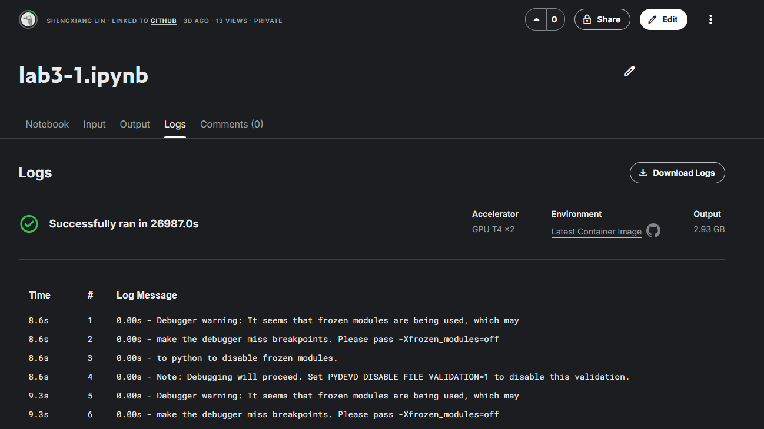
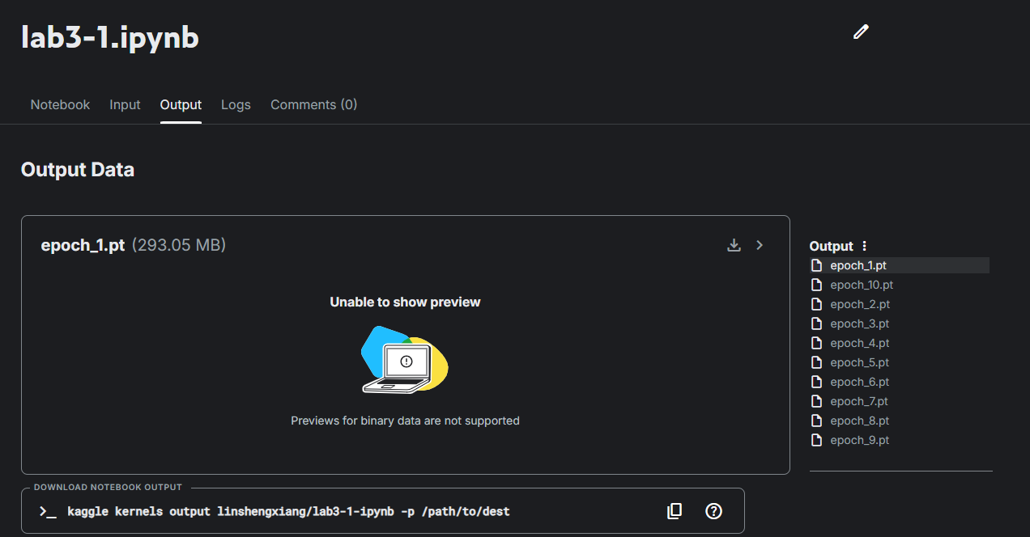
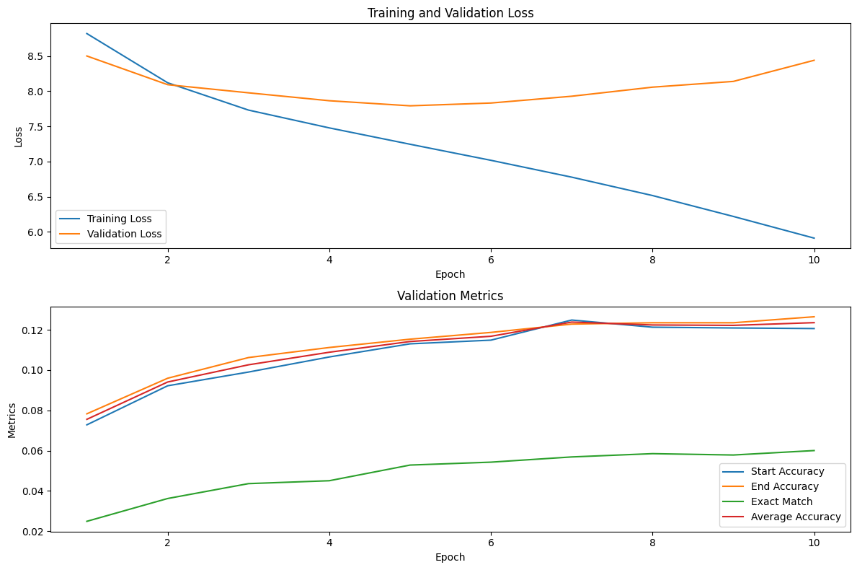
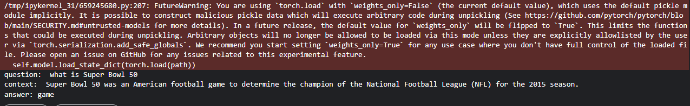
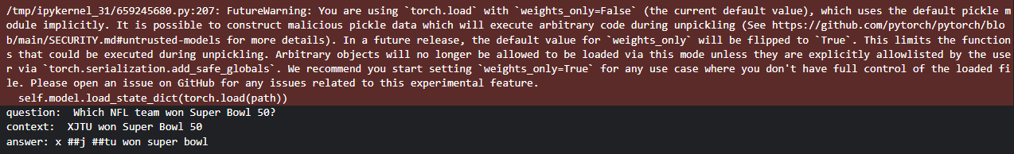
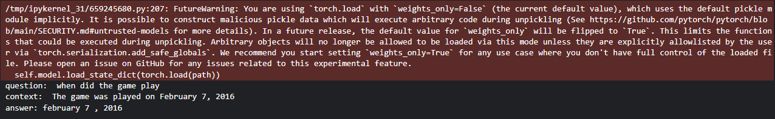
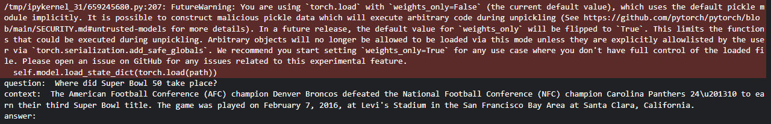
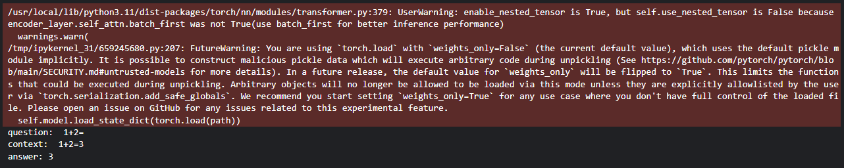
基于位置的问答方式的模型在SQuAD 1.1上实验结果，无论是训练集内还是训练集外的输入语句，在简单问题和简短上下文场景下，模型能够生成较为准确的简短答案，虽然输出中偶现冗余符号，但整体语法结构基本正确。然而，当面对复杂问题或长上下文）时，模型表现显著下降，常出现无输出或输出不完整的情况。这种性能差异可能源于模型对长距离语义依赖关系的捕捉能力不足。

基于端到端生成方式的模型在SQuAD 2.0数据集上实验结果
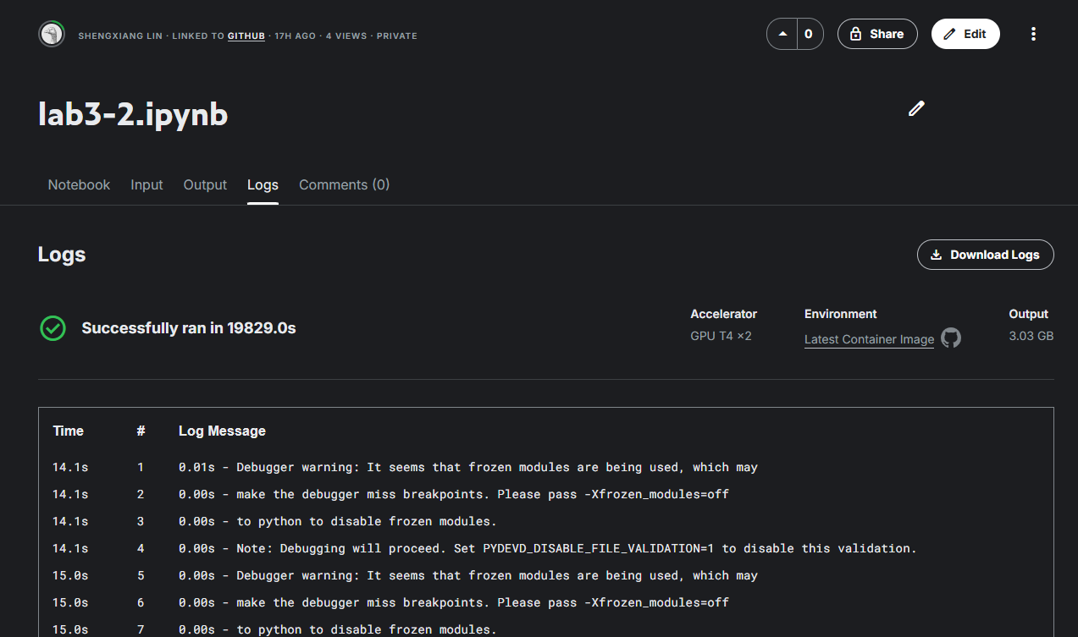
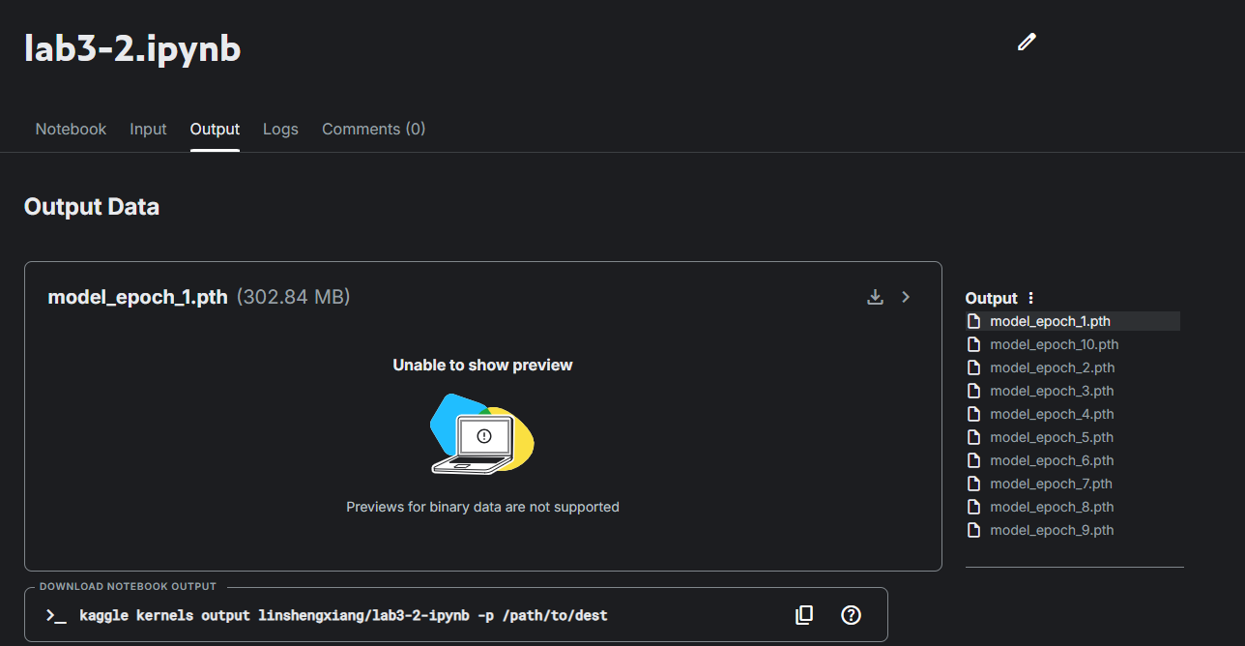

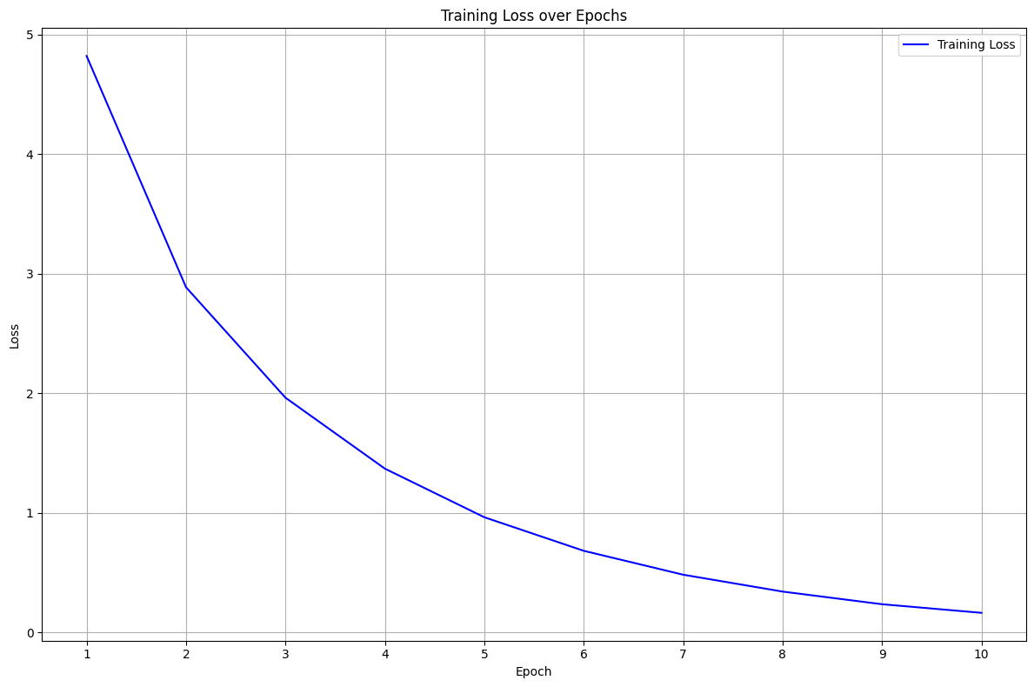
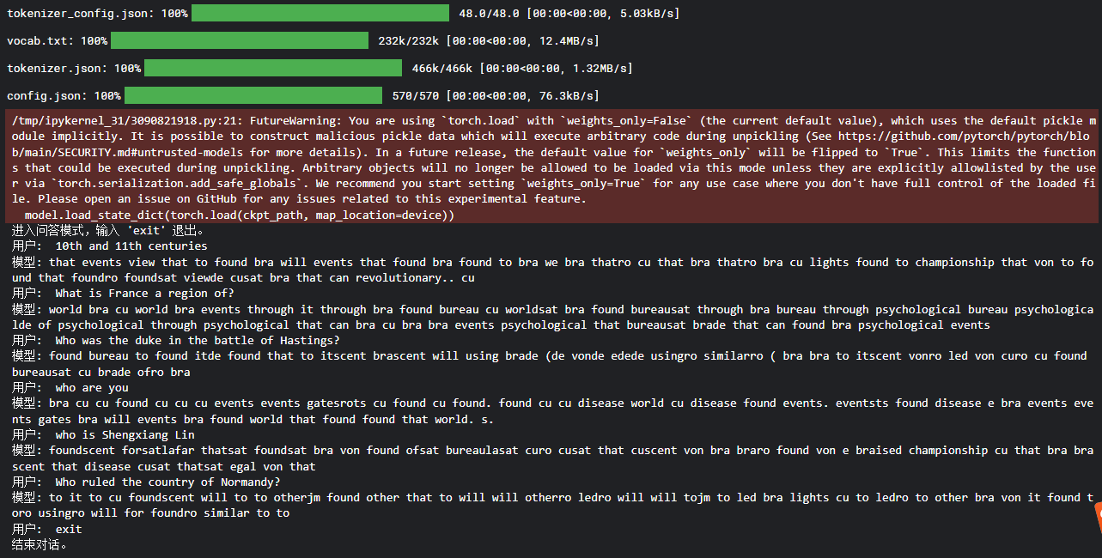
本次实验发现，基于端到端生成方式的模型在SQuAD 2.0数据集上的表现欠佳。无论是训练集内还是训练集外的输入语句，模型生成的答案质量均不理想，主要表现为：①生成的单词序列缺乏语义连贯性，相邻词汇之间几乎不存在合理的语法或语义关联；②输出语句的流畅性较差，难以形成完整的语义表达。这种现象可能由以下原因导致：①模型训练轮次（10个epoch）可能不足，未能充分学习语言生成的复杂模式；②由于训练时间限制，训练数据规模限制；③生成式模型架构的设计可能存在优化空间，特别是在处理开放域问答时的泛化能力；④损失函数的设计或超参数配置可能也需要进一步调整以提升生成质量。

实验小结
通过本次实验，我深入理解了Transformer架构的核心原理及其自注意力机制的关键作用，并成功实现了基于位置预测和端到端生成两种不同原理的问答模型。实验过程中，我不仅掌握了模型构建的关键技术，还通过实践认识到两种方法在各自数据集上表现性能的差异。在本次实验里，基于位置的问答方式的模型能够实现简单的问答，端到端的方式直接生成答案的模型在生成语句的语法以及准确率上表现均较差。同时，通过本次实验，我在模型优化方面积累了宝贵经验，包括数据集处理技巧、参数调优方法等，有效提升了模型的训练效率。这些收获为我后续开展更复杂的自然语言处理任务奠定了坚实的理论与实践基础。

附录：
实验源代码
lab3-1.ipynb 在数据集SQuAD 1.1上基于位置的问答方式的模型代码
lab3-2.ipynb 在数据集SQuAD 2.0上基于端到端生成方式的模型代码

lab3-1.ipynb
- import math
- import torch
- import torch.nn as nn
- import torch.nn.functional as F

- class MultiHeadAttention(nn.Module):
- """多头注意力机制"""
- def __init__(self, d_model, nhead, dropout=0.1):
- super().__init__()
- self.d_model = d_model
- self.nhead = nhead
- self.d_k = d_model // nhead

- self.q_linear = nn.Linear(d_model, d_model)
- self.k_linear = nn.Linear(d_model, d_model)
- self.v_linear = nn.Linear(d_model, d_model)
- self.dropout = nn.Dropout(dropout)
- self.out_linear = nn.Linear(d_model, d_model)

- def forward(self, q, k, v, mask=None):
- batch_size = q.size(0)

- # 线性变换并分头
- q = self.q_linear(q).view(batch_size, -1, self.nhead, self.d_k).transpose(1,2)
- k = self.k_linear(k).view(batch_size, -1, self.nhead, self.d_k).transpose(1,2)
- v = self.v_linear(v).view(batch_size, -1, self.nhead, self.d_k).transpose(1,2)

- # 计算注意力
- scores = torch.matmul(q, k.transpose(-2, -1)) / math.sqrt(self.d_k)
- if mask is not None:
- scores = scores.masked_fill(mask == 0, -1e9)

- attn = F.softmax(scores, dim=-1)
- attn = self.dropout(attn)

- # 合并多头
- output = torch.matmul(attn, v)
- output = output.transpose(1, 2).contiguous().view(batch_size, -1, self.d_model)
- return self.out_linear(output)

- class FeedForward(nn.Module):
- """前馈网络"""
- def __init__(self, d_model, dim_feedforward=2048, dropout=0.1):
- super().__init__()
- self.linear1 = nn.Linear(d_model, dim_feedforward)
- self.dropout = nn.Dropout(dropout)
- self.linear2 = nn.Linear(dim_feedforward, d_model)

- def forward(self, x):
- x = F.relu(self.linear1(x))
- x = self.dropout(x)
- return self.linear2(x)

- class EncoderLayer(nn.Module):
- """编码器层"""
- def __init__(self, d_model, nhead, dim_feedforward, dropout=0.1):
- super().__init__()
- self.self_attn = MultiHeadAttention(d_model, nhead, dropout)
- self.ffn = FeedForward(d_model, dim_feedforward, dropout)
- self.norm1 = nn.LayerNorm(d_model)
- self.norm2 = nn.LayerNorm(d_model)
- self.dropout1 = nn.Dropout(dropout)
- self.dropout2 = nn.Dropout(dropout)

- def forward(self, src, src_mask=None):
- # 自注意力
- src2 = self.self_attn(src, src, src, src_mask)
- src = src + self.dropout1(src2)
- src = self.norm1(src)

- # 前馈网络
- src2 = self.ffn(src)
- src = src + self.dropout2(src2)
- return self.norm2(src)

- class DecoderLayer(nn.Module):
- """解码器层"""
- def __init__(self, d_model, nhead, dim_feedforward, dropout=0.1):
- super().__init__()
- self.self_attn = MultiHeadAttention(d_model, nhead, dropout)
- self.cross_attn = MultiHeadAttention(d_model, nhead, dropout)
- self.ffn = FeedForward(d_model, dim_feedforward, dropout)
- self.norm1 = nn.LayerNorm(d_model)
- self.norm2 = nn.LayerNorm(d_model)
- self.norm3 = nn.LayerNorm(d_model)
- self.dropout1 = nn.Dropout(dropout)
- self.dropout2 = nn.Dropout(dropout)
- self.dropout3 = nn.Dropout(dropout)

- def forward(self, tgt, memory, tgt_mask=None, memory_mask=None):
- # 自注意力（带掩码）
- tgt2 = self.self_attn(tgt, tgt, tgt, tgt_mask)
- tgt = tgt + self.dropout1(tgt2)
- tgt = self.norm1(tgt)

- # 交叉注意力（编码器输出作为k,v）
- tgt2 = self.cross_attn(tgt, memory, memory, memory_mask)
- tgt = tgt + self.dropout2(tgt2)
- tgt = self.norm2(tgt)

- # 前馈网络
- tgt2 = self.ffn(tgt)
- tgt = tgt + self.dropout3(tgt2)
- return self.norm3(tgt)

- class TransformerEncoder(nn.Module):
- """完整编码器"""
- def __init__(self, num_layers, d_model, nhead, dim_feedforward, dropout=0.1):
- super().__init__()
- self.layers = nn.ModuleList([
- EncoderLayer(d_model, nhead, dim_feedforward, dropout)
- for _ in range(num_layers)
- ])

- def forward(self, src, src_mask=None):
- for layer in self.layers:
- src = layer(src, src_mask)
- return src

- class TransformerDecoder(nn.Module):
- """完整解码器"""
- def __init__(self, num_layers, d_model, nhead, dim_feedforward, dropout=0.1):
- super().__init__()
- self.layers = nn.ModuleList([
- DecoderLayer(d_model, nhead, dim_feedforward, dropout)
- for _ in range(num_layers)
- ])

- def forward(self, tgt, memory, tgt_mask=None, memory_mask=None):
- for layer in self.layers:
- tgt = layer(tgt, memory, tgt_mask, memory_mask)
- return tgt
- import json
- import torch
- import torch.nn as nn
- from torch.utils.data import Dataset, DataLoader
- from torch.optim import AdamW
- import argparse
- import os
- from tqdm import tqdm
- from transformers import BertTokenizerFast

- class Config:
- def __init__(self):
- self.batch_size = 32
- self.learning_rate = 3e-5
- self.epochs = 10
- self.max_length = 256
- self.model_dir = "/kaggle/working"
- self.train_path = "/kaggle/input/v1-1-json/train-v1.1.json"
- self.dev_path = "/kaggle/input/v1-1-json/dev-v1.1.json"
- self.device = torch.device("cuda" if torch.cuda.is_available() else "cpu")
- self.d_model = 768
- self.nhead = 12
- self.dim_feedforward = 3072
- self.dropout = 0.1
- self.num_layers = 7

- class SQuADProcessor:
- def __init__(self, config):
- self.config = config
- self.tokenizer = BertTokenizerFast.from_pretrained('bert-base-uncased')

- def load_data(self, path):
- with open(path, 'r') as f:
- return json.load(f)['data']

- def process(self, data):
- examples = []
- for article in data:
- for para in article['paragraphs']:
- context = para['context']
- for qa in para['qas']:
- example = {
- 'context': context,
- 'question': qa['question'],
- 'answer': qa['answers'][0]
- }
- examples.append(example)
- return examples

- def create_features(self, examples):
- input_ids, masks = [], []
- start_pos, end_pos = [], []

- for ex in examples:
- encoding = self.tokenizer(
- ex['question'],
- ex['context'],
- max_length=self.config.max_length,
- truncation=True,
- padding='max_length',
- return_offsets_mapping=True
- )

- ans_start = ex['answer']['answer_start']
- ans_end = ans_start + len(ex['answer']['text'])

- start_char = ans_start
- end_char = ans_end
- sequence_ids = encoding.sequence_ids()

- # Find token positions
- start_token, end_token = -1, -1
- for i, (idx, (s, e)) in enumerate(zip(sequence_ids, encoding.offset_mapping)):
- if idx != 1: continue # Only look at context tokens
- if s <= start_char < e: start_token = i
- if s < end_char <= e: end_token = i

- if start_token != -1 and end_token != -1:
- input_ids.append(encoding['input_ids'])
- masks.append(encoding['attention_mask'])
- start_pos.append(start_token)
- end_pos.append(end_token)

- return {
- 'input_ids': torch.tensor(input_ids),
- 'attention_mask': torch.tensor(masks),
- 'start_pos': torch.tensor(start_pos),
- 'end_pos': torch.tensor(end_pos)
- }

- class SQuADDataset(Dataset):
- def __init__(self, features):
- self.features = features

- def __len__(self):
- return len(self.features['input_ids'])

- def __getitem__(self, idx):
- return {k: v[idx] for k, v in self.features.items()}

- class TransformerQA(nn.Module):
- def __init__(self, config, tokenizer):
- super().__init__()
- self.tokenizer = tokenizer
- self.embedding = nn.Embedding(self.tokenizer.vocab_size, config.d_model)
- self.pos_encoder = nn.Parameter(torch.zeros(config.max_length, config.d_model))
- encoder_layer = nn.TransformerEncoderLayer(
- d_model=config.d_model,
- nhead=config.nhead,
- dim_feedforward=config.dim_feedforward,
- dropout=config.dropout
- )
- self.encoder = nn.TransformerEncoder(encoder_layer, config.num_layers)
- self.start_fc = nn.Linear(config.d_model, 1)
- self.end_fc = nn.Linear(config.d_model, 1)
- self.dropout = nn.Dropout(config.dropout)

- def forward(self, input_ids, attention_mask):
- x = self.embedding(input_ids) + self.pos_encoder[:input_ids.size(1)]
- x = self.dropout(x)
- x = x.permute(1, 0, 2) # [seq_len, bs, dim]

- output = self.encoder(x, src_key_padding_mask=~attention_mask.bool())
- output = output.permute(1, 0, 2) # [bs, seq_len, dim]

- start_logits = self.start_fc(output).squeeze(-1)
- end_logits = self.end_fc(output).squeeze(-1)
- return start_logits, end_logits

- class QATrainer:
- def __init__(self, config, model, train_loader, dev_loader=None):
- self.config = config
- self.model = model.to(config.device)
- self.train_loader = train_loader
- self.dev_loader = dev_loader
- self.optimizer = AdamW(model.parameters(), lr=config.learning_rate)

- def train_epoch(self):
- self.model.train()
- total_loss = 0
- for batch in tqdm(self.train_loader, desc="Training"):
- input_ids = batch['input_ids'].to(self.config.device)
- mask = batch['attention_mask'].to(self.config.device)
- start = batch['start_pos'].to(self.config.device)
- end = batch['end_pos'].to(self.config.device)

- self.optimizer.zero_grad()
- s_logits, e_logits = self.model(input_ids, mask)

- loss = nn.CrossEntropyLoss()(s_logits, start) + \
- nn.CrossEntropyLoss()(e_logits, end)

- loss.backward()
- self.optimizer.step()
- total_loss += loss.item()
- return total_loss / len(self.train_loader)

- def evaluate(self):
- self.model.eval()
- # 请补全evaluate过程
- total_loss = 0
- start_correct = 0
- end_correct = 0
- exact_match = 0
- total_samples = 0

- with torch.no_grad():
- for batch in tqdm(self.dev_loader, desc="Evaluating"):
- input_ids = batch['input_ids'].to(self.config.device)
- mask = batch['attention_mask'].to(self.config.device)
- start_pos = batch['start_pos'].to(self.config.device)
- end_pos = batch['end_pos'].to(self.config.device)

- # 获取模型预测
- s_logits, e_logits = self.model(input_ids, mask)

- # 计算损失
- loss = nn.CrossEntropyLoss()(s_logits, start_pos) + \
- nn.CrossEntropyLoss()(e_logits, end_pos)
- total_loss += loss.item()

- # 获取预测位置
- pred_start = torch.argmax(s_logits, dim=1)
- pred_end = torch.argmax(e_logits, dim=1)

- # 计算指标
- start_correct += (pred_start == start_pos).sum().item()
- end_correct += (pred_end == end_pos).sum().item()
- exact_match += ((pred_start == start_pos) & (pred_end == end_pos)).sum().item()
- total_samples += len(input_ids)

- # 计算各项指标
- metrics = {
- 'loss': total_loss / len(self.dev_loader),
- 'start_acc': start_correct / total_samples,
- 'end_acc': end_correct / total_samples,
- 'exact_match': exact_match / total_samples,
- 'avg_acc': (start_correct + end_correct) / (2 * total_samples)
- }

- return metrics

- def save_model(self, path):
- torch.save(self.model.state_dict(), path)

- def load_model(self, path):
- self.model.load_state_dict(torch.load(path))
- def run_full_process(model_save_path="/kaggle/working/model.pt"):
- # 初始化配置和处理器
- config = Config()
- processor = SQuADProcessor(config)

- # 训练流程
- print("Starting training process...")
- train_data = processor.load_data(config.train_path)
- train_examples = processor.process(train_data)
- train_features = processor.create_features(train_examples)
- train_dataset = SQuADDataset(train_features)
- train_loader = DataLoader(train_dataset, batch_size=config.batch_size, shuffle=True)

- dev_data = processor.load_data(config.dev_path)
- dev_examples = processor.process(dev_data)
- dev_features = processor.create_features(dev_examples)
- dev_loader = DataLoader(SQuADDataset(dev_features), batch_size=config.batch_size)
- tokenizer = BertTokenizerFast.from_pretrained('bert-base-uncased')
- model = TransformerQA(config, tokenizer) # 传入tokenizer
- #model = TransformerQA(config)
- trainer = QATrainer(config, model, train_loader, dev_loader)

- for epoch in range(config.epochs):
- avg_loss = trainer.train_epoch()
- print(f"Epoch {epoch+1} Loss: {avg_loss}")
- metrics = trainer.evaluate()
- print(f"Epoch {epoch+1} Validation Metrics: {metrics}")
- trainer.save_model(f"{config.model_dir}/epoch_{epoch+1}.pt")

- # 测试流程（使用最后保存的模型）
- print("\nStarting testing process with the trained model...")
- final_model_path = f"{config.model_dir}/epoch_{config.epochs}.pt"

- test_data = processor.load_data(config.dev_path) # 假设使用dev集作为测试
- test_examples = processor.process(test_data)
- test_features = processor.create_features(test_examples)
- test_loader = DataLoader(SQuADDataset(test_features), batch_size=config.batch_size)
- tokenizer = BertTokenizerFast.from_pretrained('bert-base-uncased')
- test_model = TransformerQA(config, tokenizer)
- test_trainer = QATrainer(config, test_model, None, test_loader)
- test_trainer.load_model(final_model_path)
- test_metrics = test_trainer.evaluate()
- print(f"\nFinal Test Results - {test_metrics}")

- # 在Jupyter中直接运行
- run_full_process()
- config = Config()

- # 初始化tokenizer和模型
- tokenizer = BertTokenizerFast.from_pretrained('bert-base-uncased')
- model = TransformerQA(config, tokenizer)
- model.to(config.device)
- model_path = os.path.join("/kaggle/input/epoch_10/pytorch/default/1/", "epoch_10.pt")
- trainer = QATrainer(config, model, None)
- trainer.load_model(model_path)

- input_question = input("question: ")
- input_context = input("context: ")

- encoding = tokenizer(
- input_question,
- input_context,
- max_length=config.max_length,
- truncation=True,
- padding='max_length',
- return_tensors="pt"
- ).to(config.device)

- input_ids = encoding['input_ids']
- attention_mask = encoding['attention_mask']

- with torch.no_grad():
- start_logits, end_logits = model(input_ids, attention_mask)
- pred_start = torch.argmax(start_logits, dim=1).item()
- pred_end = torch.argmax(end_logits, dim=1).item()

- tokens = tokenizer.convert_ids_to_tokens(input_ids.squeeze())
- prediction = " ".join(tokens[pred_start:pred_end+1])

- print("answer:", prediction)

lab3-2.ipynb
- import math
- import torch
- import torch.nn as nn
- import torch.nn.functional as F

- class MultiHeadAttention(nn.Module):
- """多头注意力机制"""
- def __init__(self, d_model, nhead, dropout=0.1):
- super().__init__()
- self.d_model = d_model
- self.nhead = nhead
- self.d_k = d_model // nhead

- self.q_linear = nn.Linear(d_model, d_model)
- self.k_linear = nn.Linear(d_model, d_model)
- self.v_linear = nn.Linear(d_model, d_model)
- self.dropout = nn.Dropout(dropout)
- self.out_linear = nn.Linear(d_model, d_model)

- def forward(self, q, k, v, mask=None):
- batch_size = q.size(0)

- # 线性变换并分头
- q = self.q_linear(q).view(batch_size, -1, self.nhead, self.d_k).transpose(1,2)
- k = self.k_linear(k).view(batch_size, -1, self.nhead, self.d_k).transpose(1,2)
- v = self.v_linear(v).view(batch_size, -1, self.nhead, self.d_k).transpose(1,2)

- # 计算注意力
- scores = torch.matmul(q, k.transpose(-2, -1)) / math.sqrt(self.d_k)
- if mask is not None:
- scores = scores.masked_fill(mask == 0, -1e9)

- attn = F.softmax(scores, dim=-1)
- attn = self.dropout(attn)

- # 合并多头
- output = torch.matmul(attn, v)
- output = output.transpose(1, 2).contiguous().view(batch_size, -1, self.d_model)
- return self.out_linear(output)

- class FeedForward(nn.Module):
- """前馈网络"""
- def __init__(self, d_model, dim_feedforward=2048, dropout=0.1):
- super().__init__()
- self.linear1 = nn.Linear(d_model, dim_feedforward)
- self.dropout = nn.Dropout(dropout)
- self.linear2 = nn.Linear(dim_feedforward, d_model)

- def forward(self, x):
- x = F.relu(self.linear1(x))
- x = self.dropout(x)
- return self.linear2(x)

- class EncoderLayer(nn.Module):
- """编码器层"""
- def __init__(self, d_model, nhead, dim_feedforward, dropout=0.1):
- super().__init__()
- self.self_attn = MultiHeadAttention(d_model, nhead, dropout)
- self.ffn = FeedForward(d_model, dim_feedforward, dropout)
- self.norm1 = nn.LayerNorm(d_model)
- self.norm2 = nn.LayerNorm(d_model)
- self.dropout1 = nn.Dropout(dropout)
- self.dropout2 = nn.Dropout(dropout)

- def forward(self, src, src_mask=None):
- # 自注意力
- src2 = self.self_attn(src, src, src, src_mask)
- src = src + self.dropout1(src2)
- src = self.norm1(src)

- # 前馈网络
- src2 = self.ffn(src)
- src = src + self.dropout2(src2)
- return self.norm2(src)

- class DecoderLayer(nn.Module):
- """解码器层"""
- def __init__(self, d_model, nhead, dim_feedforward, dropout=0.1):
- super().__init__()
- self.self_attn = MultiHeadAttention(d_model, nhead, dropout)
- self.cross_attn = MultiHeadAttention(d_model, nhead, dropout)
- self.ffn = FeedForward(d_model, dim_feedforward, dropout)
- self.norm1 = nn.LayerNorm(d_model)
- self.norm2 = nn.LayerNorm(d_model)
- self.norm3 = nn.LayerNorm(d_model)
- self.dropout1 = nn.Dropout(dropout)
- self.dropout2 = nn.Dropout(dropout)
- self.dropout3 = nn.Dropout(dropout)

- def forward(self, tgt, memory, tgt_mask=None, memory_mask=None):
- # 自注意力（带掩码）
- tgt2 = self.self_attn(tgt, tgt, tgt, tgt_mask)
- tgt = tgt + self.dropout1(tgt2)
- tgt = self.norm1(tgt)

- # 交叉注意力（编码器输出作为k,v）
- tgt2 = self.cross_attn(tgt, memory, memory, memory_mask)
- tgt = tgt + self.dropout2(tgt2)
- tgt = self.norm2(tgt)

- # 前馈网络
- tgt2 = self.ffn(tgt)
- tgt = tgt + self.dropout3(tgt2)
- return self.norm3(tgt)

- class TransformerEncoder(nn.Module):
- """完整编码器"""
- def __init__(self, num_layers, d_model, nhead, dim_feedforward, dropout=0.1):
- super().__init__()
- self.layers = nn.ModuleList([
- EncoderLayer(d_model, nhead, dim_feedforward, dropout)
- for _ in range(num_layers)
- ])

- def forward(self, src, src_mask=None):
- for layer in self.layers:
- src = layer(src, src_mask)
- return src

- class TransformerDecoder(nn.Module):
- """完整解码器"""
- def __init__(self, num_layers, d_model, nhead, dim_feedforward, dropout=0.1):
- super().__init__()
- self.layers = nn.ModuleList([
- DecoderLayer(d_model, nhead, dim_feedforward, dropout)
- for _ in range(num_layers)
- ])

- def forward(self, tgt, memory, tgt_mask=None, memory_mask=None):
- for layer in self.layers:
- tgt = layer(tgt, memory, tgt_mask, memory_mask)
- return tgt
- import torch
- import torch.nn as nn
- import json
- from torch.utils.data import Dataset, DataLoader
- from transformers import BertTokenizer
- import math
- import os

- class QADataset(Dataset):
- """处理 SQuAD 格式数据为模型输入格式"""
- def __init__(self, file_path, tokenizer, max_length=256):
- self.data = []
- with open(file_path, 'r') as f:
- squad = json.load(f)

- for article in squad['data'][:200]:
- for para in article['paragraphs']:
- context = para['context']
- for qa in para['qas']:
- question = qa['question']
- answer = qa['answers'][0]['text'] if qa['answers'] else ""
- input_text = f"{question} context: {context}"
- output_text = answer

- inputs = tokenizer(input_text, max_length=max_length, padding='max_length', truncation=True, return_tensors="pt")
- targets = tokenizer(output_text, max_length=max_length, padding='max_length', truncation=True, return_tensors="pt")

- self.data.append({
- 'input_ids': inputs['input_ids'].squeeze(0),
- 'attention_mask': inputs['attention_mask'].squeeze(0),
- 'labels': targets['input_ids'].squeeze(0)
- })

- self.data = self.data[:1] # 可根据需求调节数据量

- def __len__(self):
- return len(self.data)

- def __getitem__(self, idx):
- return self.data[idx]

- # ------------------ 位置编码 ------------------ #
- class PositionalEncoding(nn.Module):
- """正弦位置编码"""
- def __init__(self, d_model, max_len=512, dropout=0.1):
- super().__init__()
- self.dropout = nn.Dropout(p=dropout)

- pos = torch.arange(max_len).unsqueeze(1)
- div_term = torch.exp(torch.arange(0, d_model, 2) * (-math.log(10000.0) / d_model))
- pe = torch.zeros(max_len, d_model)
- pe[:, 0::2] = torch.sin(pos * div_term)
- pe[:, 1::2] = torch.cos(pos * div_term)

- self.register_buffer('pe', pe)

- def forward(self, x):
- x = x + self.pe[:x.size(1)]
- return self.dropout(x)

- # ------------------ 问答Transformer模型 ------------------ #
- class TransformerQA(nn.Module):
- def __init__(self, vocab_size, d_model=512, nhead=8, num_encoder_layers=6, num_decoder_layers=6, dim_feedforward=2048, dropout=0.1):
- super().__init__()
- self.embedding = nn.Embedding(vocab_size, d_model)
- self.pos_encoder = PositionalEncoding(d_model, dropout=dropout)
- self.encoder = TransformerEncoder(num_encoder_layers, d_model, nhead, dim_feedforward, dropout)
- self.decoder = TransformerDecoder(num_decoder_layers, d_model, nhead, dim_feedforward, dropout)
- self.fc_out = nn.Linear(d_model, vocab_size)
- self.d_model = d_model

- def forward(self, src, tgt, src_mask=None, tgt_mask=None):
- src = self.pos_encoder(self.embedding(src) * math.sqrt(self.d_model))
- memory = self.encoder(src, src_mask)

- tgt = self.pos_encoder(self.embedding(tgt) * math.sqrt(self.d_model))
- output = self.decoder(tgt, memory, tgt_mask)

- return self.fc_out(output)

- def generate_mask(self, src, tgt):
- src_pad_mask = (src == 0).unsqueeze(1).unsqueeze(2) # [B, 1, 1, S]
- tgt_pad_mask = (tgt == 0).unsqueeze(1).unsqueeze(2)
- seq_len = tgt.size(1)
- tgt_sub_mask = torch.triu(torch.ones(seq_len, seq_len), diagonal=1).bool().to(src.device)
- tgt_mask = tgt_pad_mask | tgt_sub_mask
- return src_pad_mask, tgt_mask

- def generate_answer(self, src_ids, tokenizer, max_len=50):
- """自回归生成答案"""
- self.eval()
- device = src_ids.device

- src_mask = (src_ids == tokenizer.pad_token_id).unsqueeze(1).unsqueeze(2)
- memory = self.encoder(self.pos_encoder(self.embedding(src_ids) * math.sqrt(self.d_model)), src_mask)

- outputs = torch.LongTensor([[tokenizer.cls_token_id]]).to(device)

- for _ in range(max_len):
- _, tgt_mask = self.generate_mask(src_ids, outputs)
- tgt_emb = self.pos_encoder(self.embedding(outputs) * math.sqrt(self.d_model))
- dec_out = self.decoder(tgt_emb, memory, tgt_mask)
- logits = self.fc_out(dec_out)[:, -1, :]

- # 温度采样 + Top-k策略
- logits /= 10
- topk_vals, topk_idx = logits.topk(10)
- probs = torch.softmax(topk_vals, dim=-1)
- next_token = topk_idx.gather(-1, torch.multinomial(probs, num_samples=1))

- outputs = torch.cat([outputs, next_token], dim=1)
- if next_token.item() == tokenizer.sep_token_id:
- break

- return tokenizer.decode(outputs.squeeze(0), skip_special_tokens=True)
- from tqdm import tqdm
- import torch

- tokenizer = BertTokenizer.from_pretrained('bert-base-uncased')
- train_dataset = QADataset('/kaggle/input/squad-v2-0/SQuAD-train-v2.0.json', tokenizer)
- #train_dataset = train_dataset[:100000]
- train_loader = DataLoader(train_dataset, batch_size=16, shuffle=True)
- model = TransformerQA(vocab_size=tokenizer.vocab_size)
- device = torch.device("cuda" if torch.cuda.is_available() else "cpu")
- trainer = QATrainer(model, tokenizer, device)
- optimizer = torch.optim.Adam(model.parameters(), lr=3e-5)
- num_epochs = 10

- for epoch in range(num_epochs):
- print(f"\nEpoch {epoch + 1}/{num_epochs}")

- # 使用tqdm包装train_loader
- train_loader_tqdm = tqdm(train_loader, desc=f"Training Epoch {epoch + 1}", leave=True)

- train_loss = trainer.train_epoch(train_loader_tqdm, optimizer)

- print(f"\nTrain Loss: {train_loss:.4f}")
- model_save_path = f'/kaggle/working/model_epoch_{epoch + 1}.pth'
- torch.save(trainer.model.state_dict(), model_save_path)
- def chat(model, tokenizer, device, max_len=50):
- model.eval()
- print("进入问答模式，输入 'exit' 退出。")
- while True:
- question = input("用户: ")
- if question.strip().lower() == 'exit':
- print("结束对话。")
- break
- inputs = tokenizer(question, max_length=256, padding='max_length', truncation=True, return_tensors="pt")
- src = inputs['input_ids'].to(device)
- answer = model.generate_answer(src, tokenizer, max_len)
- print(f"模型: {answer}")

- tokenizer = BertTokenizer.from_pretrained('bert-base-uncased')
- device = torch.device("cuda" if torch.cuda.is_available() else "cpu")

- model = TransformerQA(vocab_size=tokenizer.vocab_size)
- ckpt_path = '/kaggle/input/model_epoch_9/pytorch/default/1/model_epoch_9.pth'
- model.load_state_dict(torch.load(ckpt_path, map_location=device))
- model.to(device)

- chat(model, tokenizer, device)

