Xi’an Jiaotong University

课 程 实 验 报 告

实验名称： 机器学习实验4

姓名: 林圣翔
学号: 2223312202
专业班级: 计试2201
指导教师: 鲍军鹏教授
报告日期: 2025.4.27



一、实验目的
1、学习并掌握k-means，dbscan，slink等聚类算法的核心原理。
2、学会调用sklearn库的基础，实现多类型数据集的聚类应用。
3、手工实现k-means，dbscan，slink等聚类算法，并与调用sklearn库现成算法进行性能对比。
4、掌握聚类算法的参数调优方法，为聚类算法寻找合适的参数。

二、实验内容
1、分别对二维点数据、时序数据和UCI数据集用3种聚类算法完成聚类任务，对比聚类结果。
2、不使用sklearn库，自己手工实现各聚类算法，与调用sklearn库现成算法类对比一下聚类结果、运行时间、内存占用等等。
3、调整算法参数，包括簇数目、邻域半径、密度阈值等等，观察这些参数对算法聚类结果的影响。

实验主要步骤
- 下载iris.zip、wine+quality.zip、clusterData1.10k.dat、clusterData2.8k.dat、clusterData3.8k.dat、clusterData4.8k.dat、Plane_TRAIN.txt等数据集和clustering.py、dbscan.py、kmeans.py、linkage.py等代码文件。
- 为方便实验结果展示与对比，将py文件转为ipynb的形式导入kaggle。
- 通过系统性的代码审查与调试，解决模型实现中的编译错误和运行时问题。
- 选用clusterData2.8k.dat作为实验的二维点数据，Plane_TRAIN.txt作为实验的时序数据，iris.zip作为实验的UCI数据集。
- 根据选用的数据集完成数据读入和数据可视化功能。
- 调整算法参数，包括簇数目、邻域半径、密度阈值等等，观察这些参数对算法聚类结果的影响。
7、手工实现kmeans、slink和dbscan算法，与调用sklearn库现成算法类对比一下聚类结果、运行时间、内存占用等等。

实验结果
调用sklearn库，各聚类算法在clusterData3.8k.dat上运行时间（s）
Kmeans |  | Dbscan |  |  | Linkage
k | Time | Eps | min_samples | Time | k | Time（Single） | Time（average） | Time（Complete） | Time（ward）
3 | 0.034 | 8 | 10 | 0.063 | 3 | 0.457 | 2.423 | 2.537 | 2.344
4 | 0.045 | 8 | 20 | 0.061 | 4 | 0.459 | 2.400 | 2.602 | 2.336
5 | 0.047 | 8 | 30 | 0.060 | 5 | 0.461 | 2.426 | 2.571 | 2.348
6 | 0.049 | 8 | 40 | 0.058 | 6 | 0.459 | 2.396 | 2.508 | 2.366
7 | 0.054 | 9 | 30 | 0.068
8 | 0.076 | 10 | 30 | 0.069
Kmeans
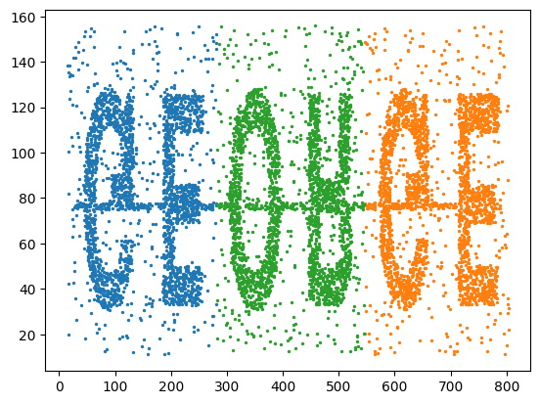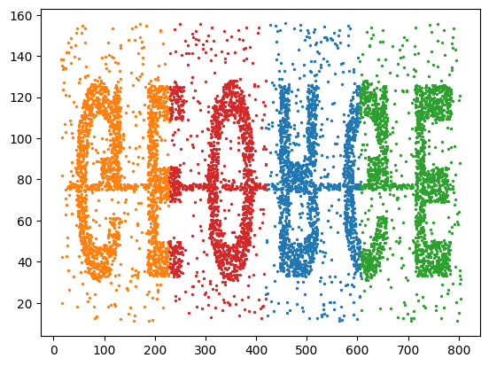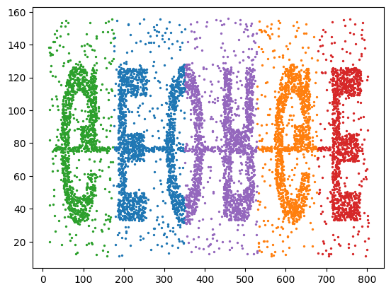
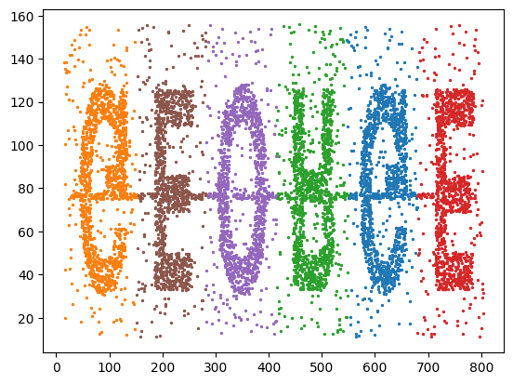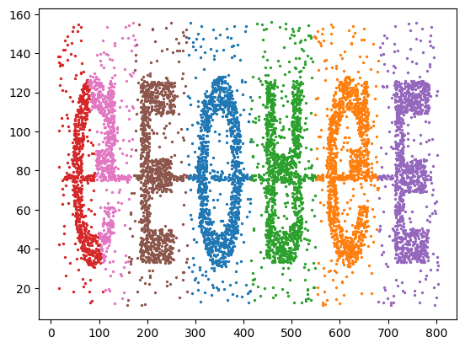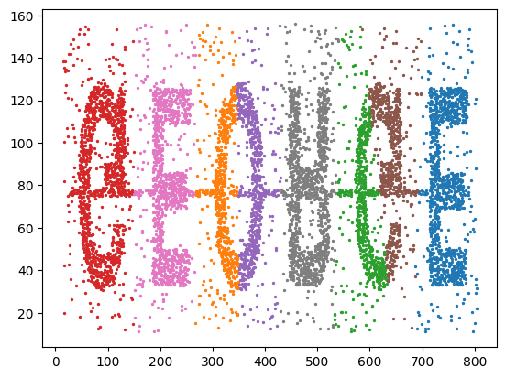
Dbscan
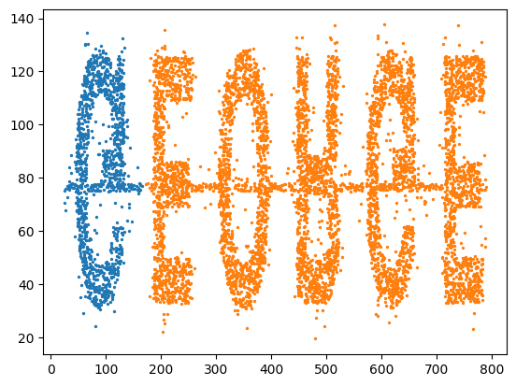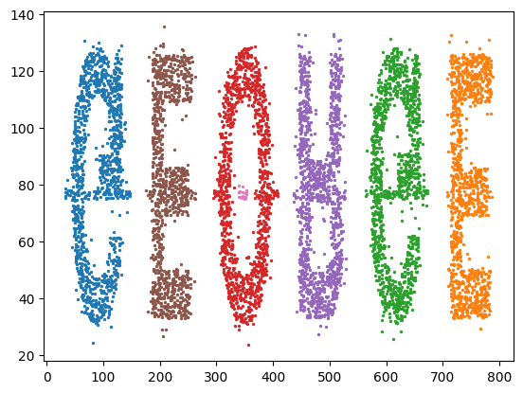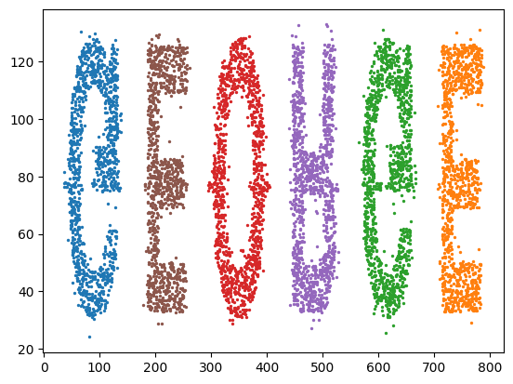
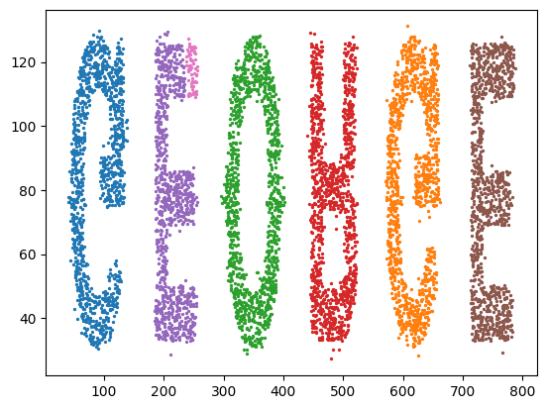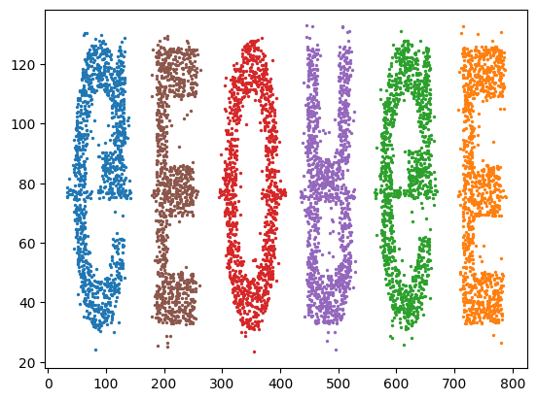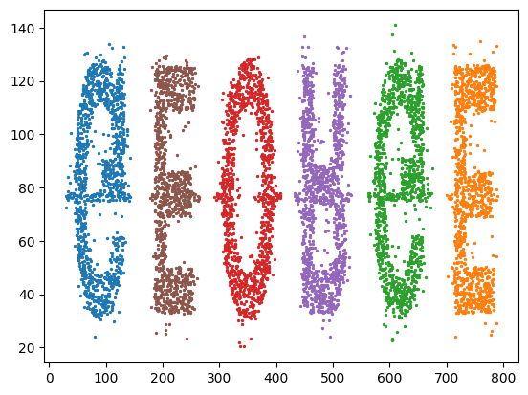
Linkage（single）
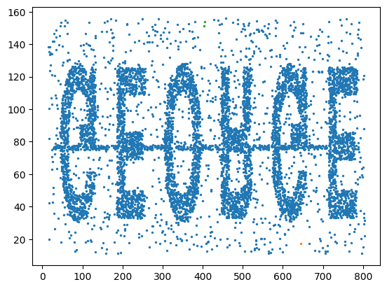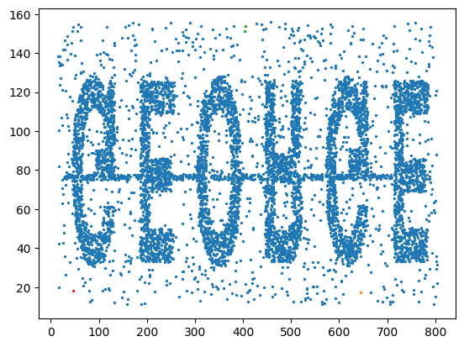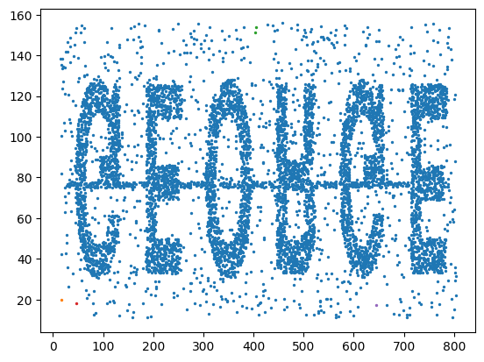
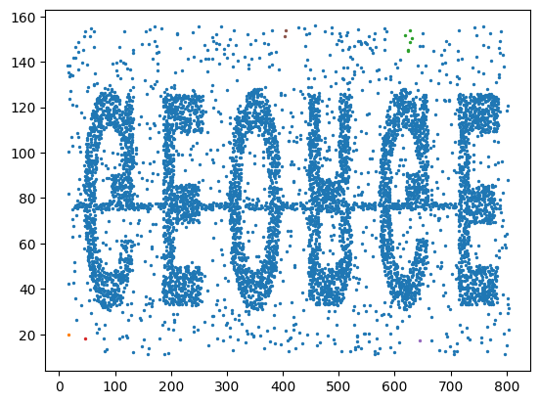
Linkage（average）
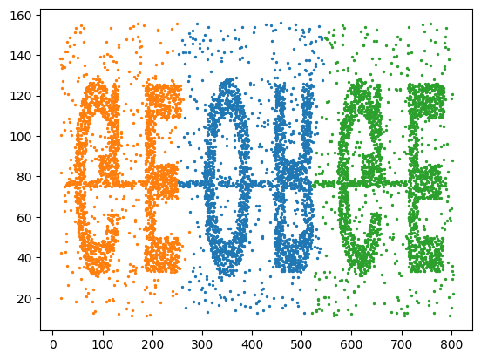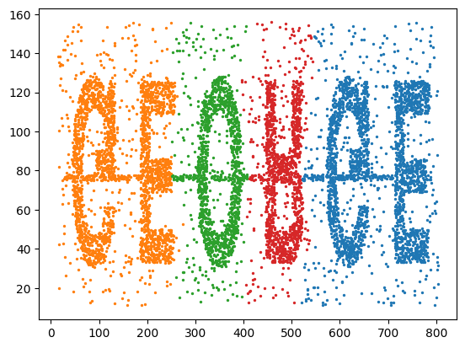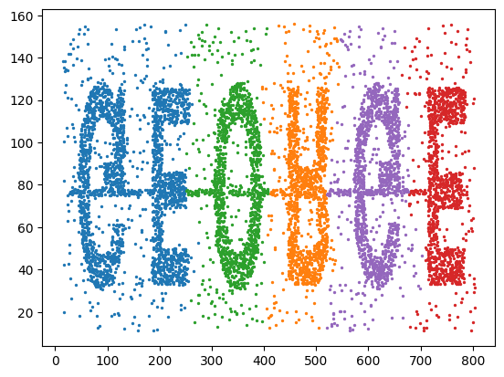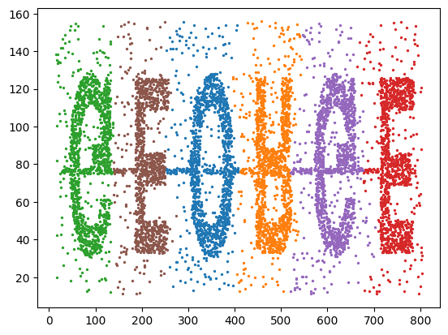
Linkage（complete）
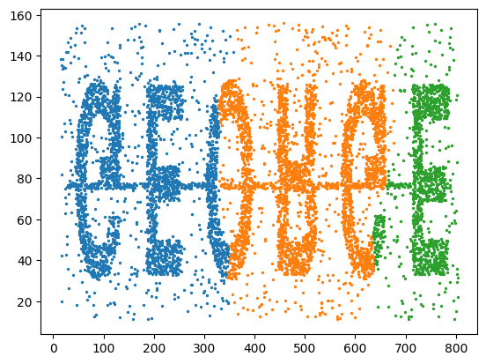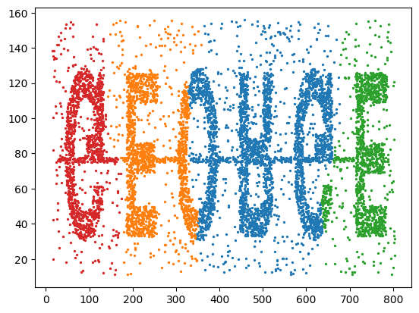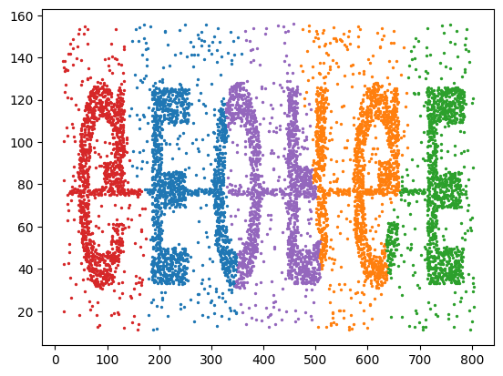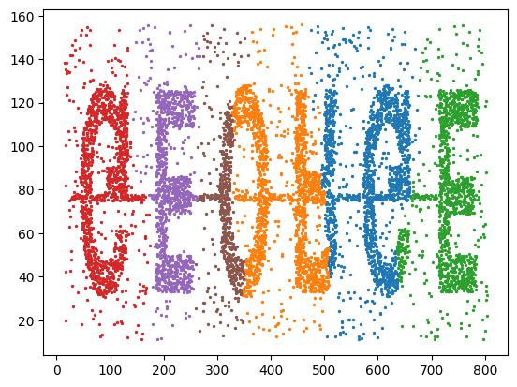
Linkage（ward）
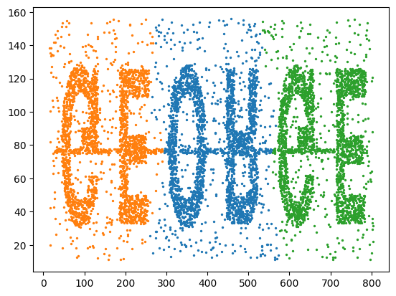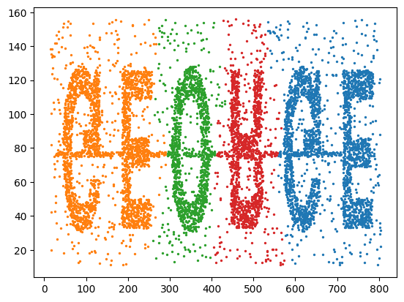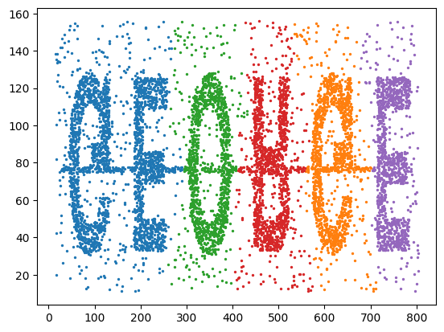
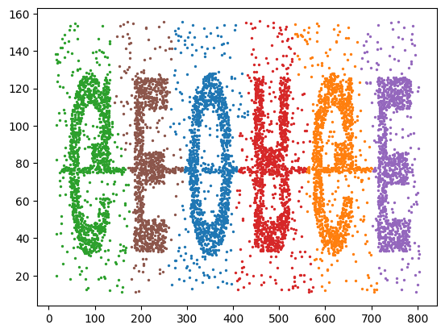
调用sklearn库，各聚类算法在Plane_TRAIN.txt上运行时间（s）
Kmeans |  | Dbscan |  |  | Linkage
k | Time | Eps | min_samples | Time | k | Time（Single） | Time（average） | Time（Complete） | Time（ward）
3 | 0.024 | 8 | 10 | 0.004 | 3 | 0.002 | 0.002 | 0.002 | 0.002
4 | 0.021 | 8 | 20 | 0.003 | 4 | 0.002 | 0.001 | 0.002 | 0.001
5 | 0.025 | 8 | 30 | 0.003 | 5 | 0.002 | 0.002 | 0.002 | 0.001
6 | 0.022 | 8 | 40 | 0.002 | 6 | 0.001 | 0.003 | 0.002 | 0.001
7 | 0.025 | 9 | 30 | 0.003
8 | 0.032 | 10 | 30 | 0.002
调用sklearn库，各聚类算法在Plane_TRAIN.txt上ARI值
Kmeans |  | Dbscan |  |  | Linkage
k | ARI | Eps | min_samples | ARI | k | ARI（Single） | ARI（average） | ARI（Complete） | ARI（ward）
3 | 0.409 | 8 | 10 | 0.622 | 3 | 0.079 | 0.219 | 0.553 | 0.656
4 | 0.512 | 8 | 20 | 0.390 | 4 | 0.115 | 0.219 | 0.553 | 0.552
5 | 0.538 | 8 | 30 | 0.639 | 5 | 0.115 | 0.219 | 0.485 | 0.499
6 | 0.648 | 8 | 40 | 0.466 | 6 | 0.418 | 0.526 | 0.553 | 0.656
7 | 0.834 | 9 | 30 | 0.550
8 | 0.878 | 10 | 30 | 0.459
调用sklearn库，各聚类算法在Plane_TRAIN.txt上NIM值
Kmeans |  | Dbscan |  |  | Linkage
k | NIM | Eps | min_samples | NIM | k | NIM（Single） | NIM（average） | NIM（Complete） | NIM（ward）
3 | 0.664 | 8 | 10 | 0.795 | 3 | 0.319 | 0.566 | 0.787 | 0.857
4 | 0.736 | 8 | 20 | 0.608 | 4 | 0.381 | 0.566 | 0.787 | 0.783
5 | 0.766 | 8 | 30 | 0.822 | 5 | 0.381 | 0.566 | 0.741 | 0.746
6 | 0.840 | 8 | 40 | 0.676 | 6 | 0.687 | 0.758 | 0.787 | 0.857
7 | 0.918 | 9 | 30 | 0.775
8 | 0.906 | 10 | 30 | 0.648
Kmeans
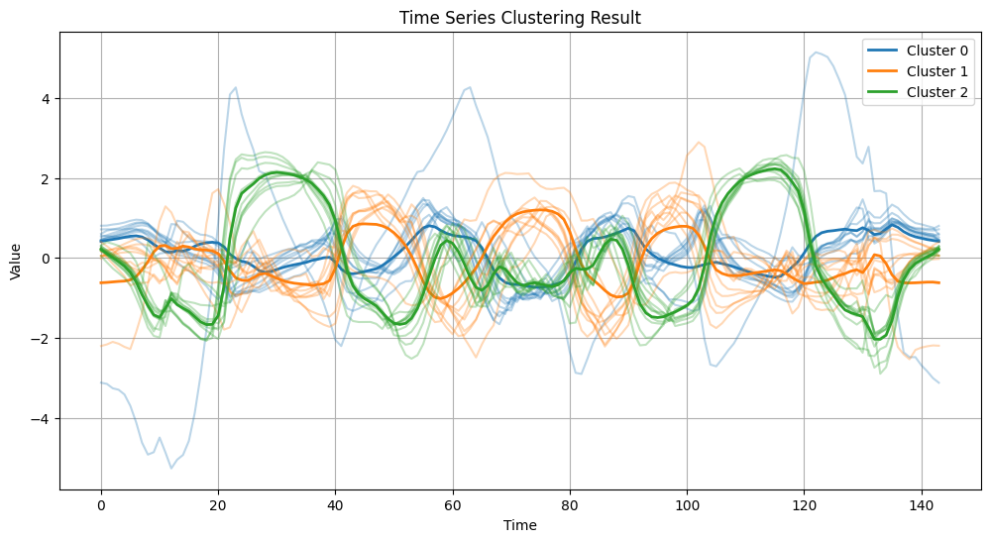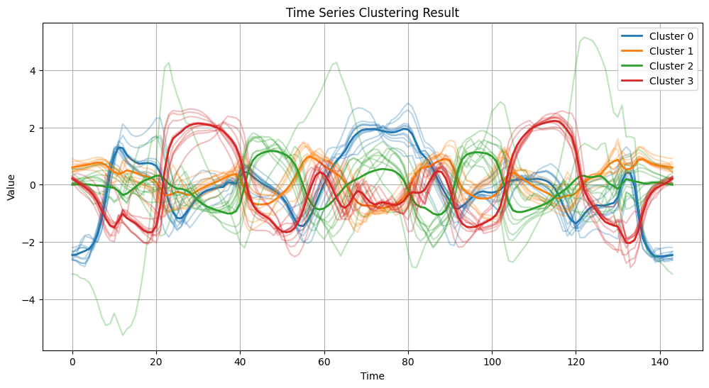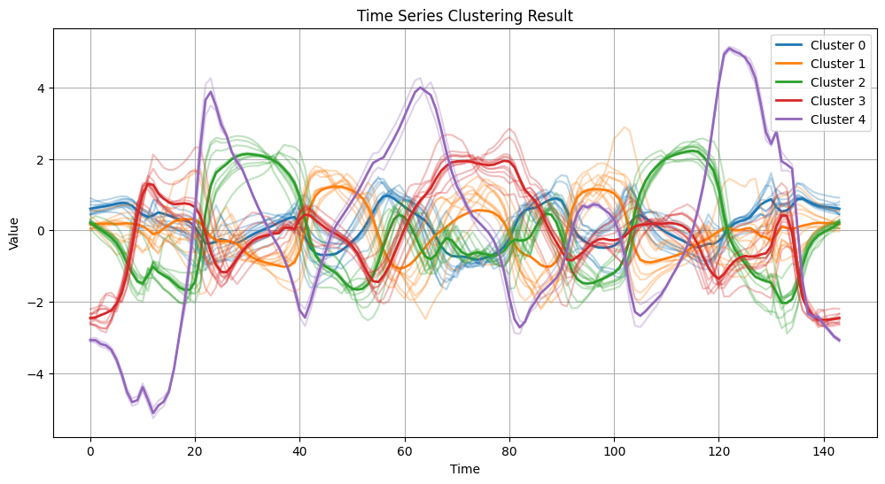
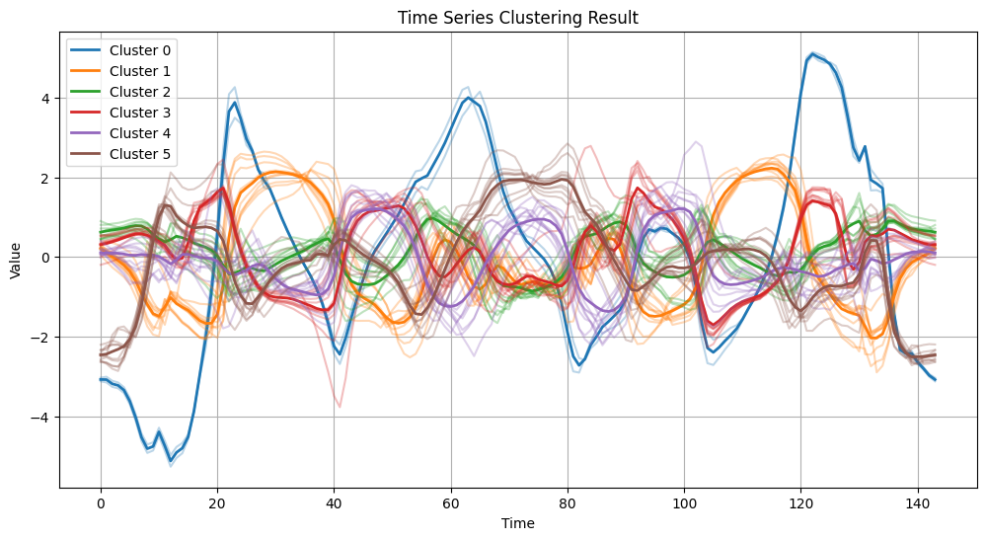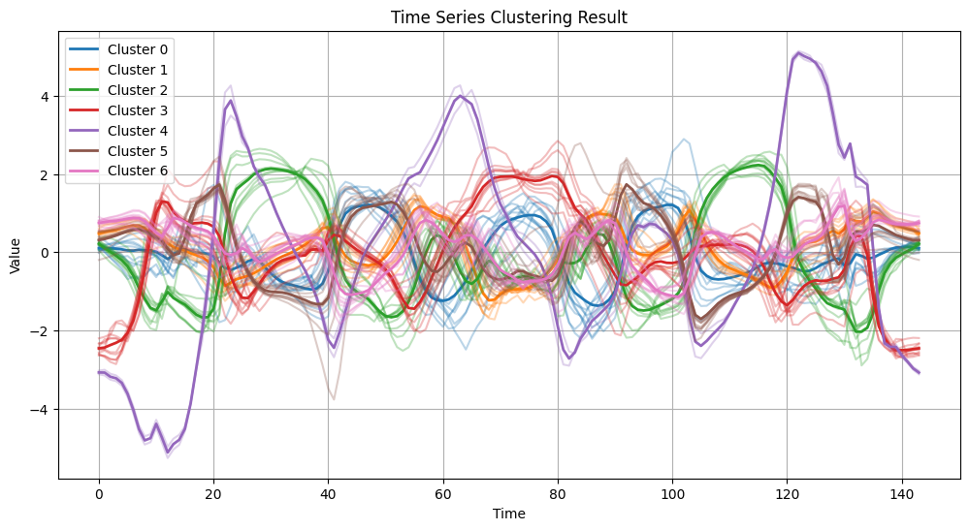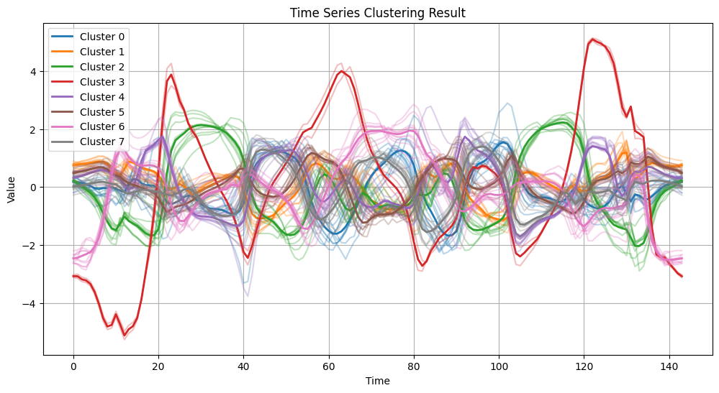
Dbscan


Linkage（single）
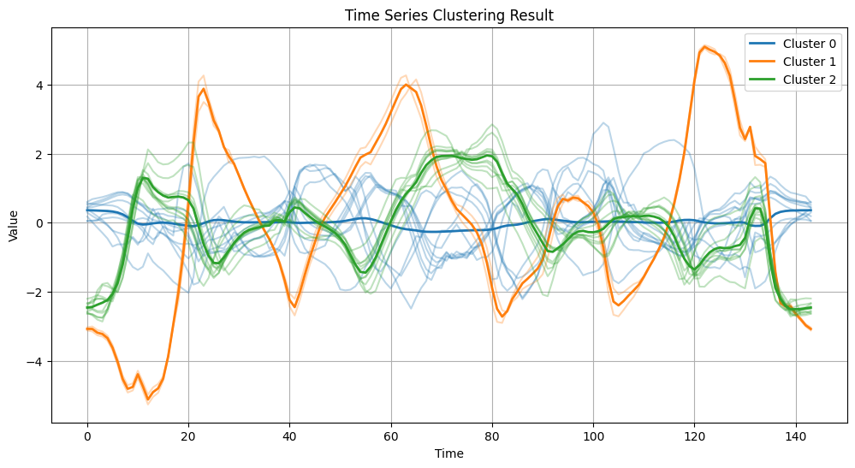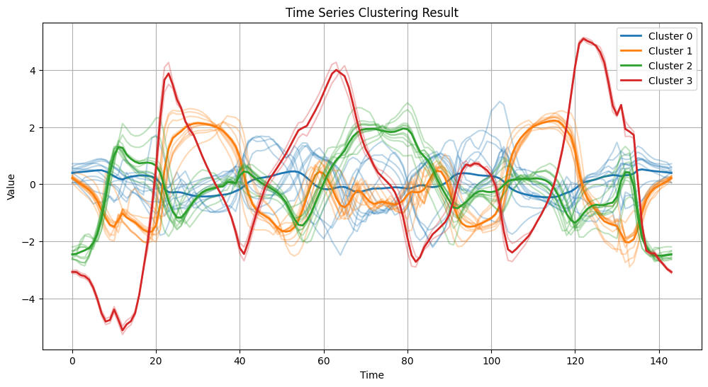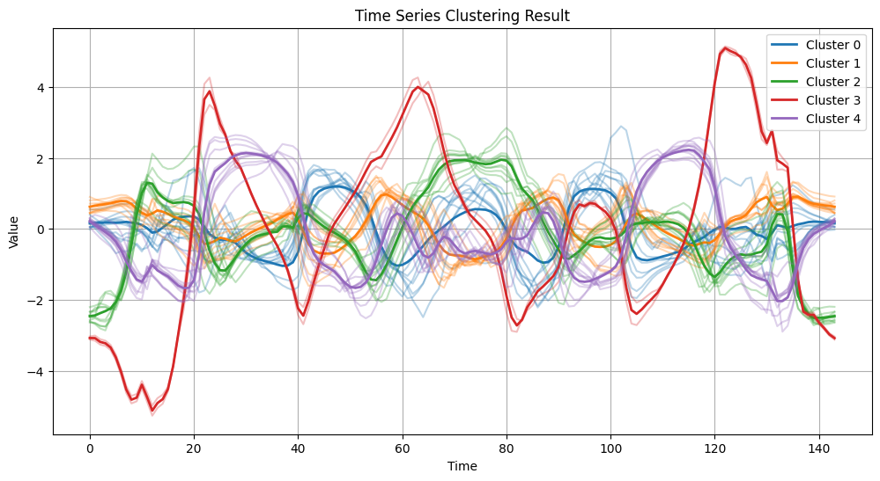
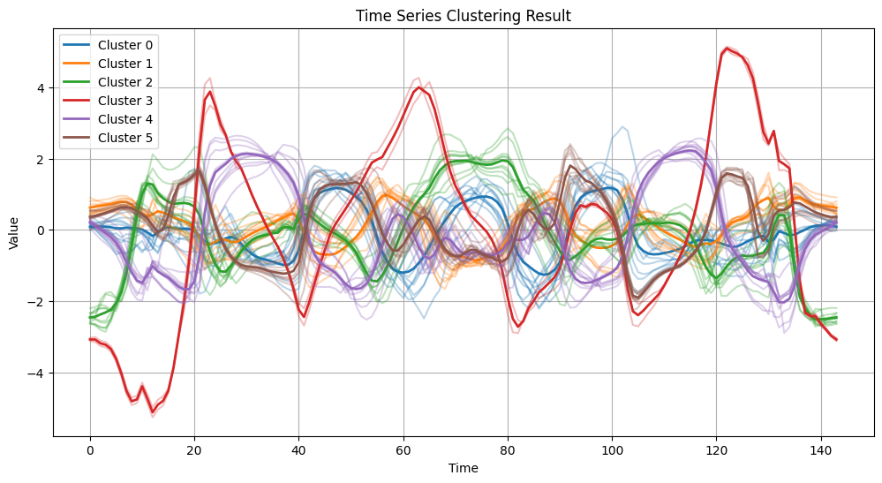
Linkage（average）
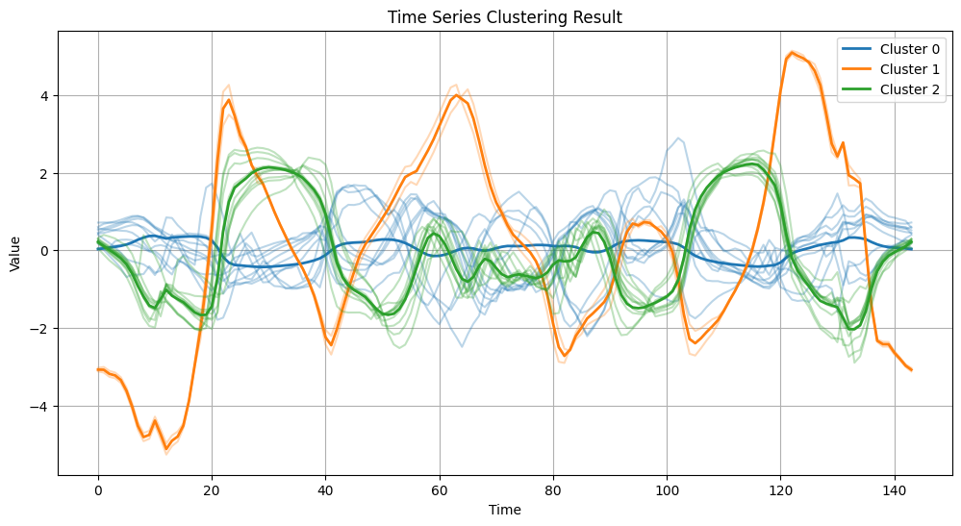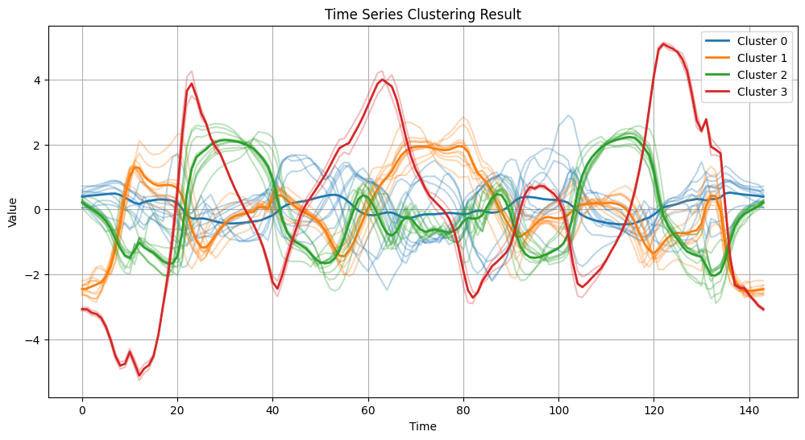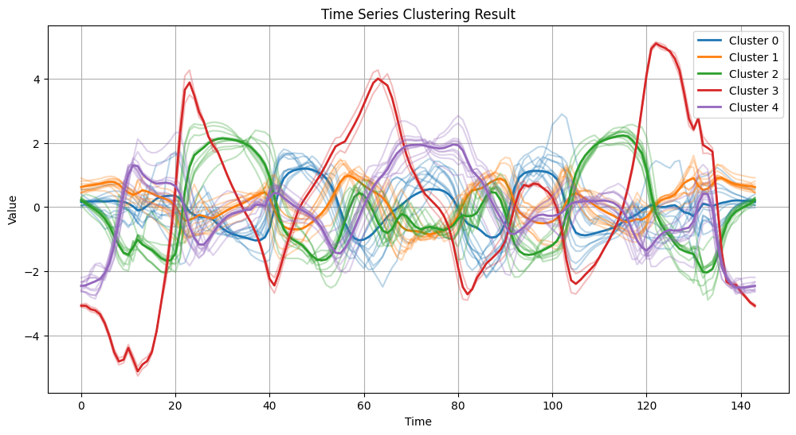
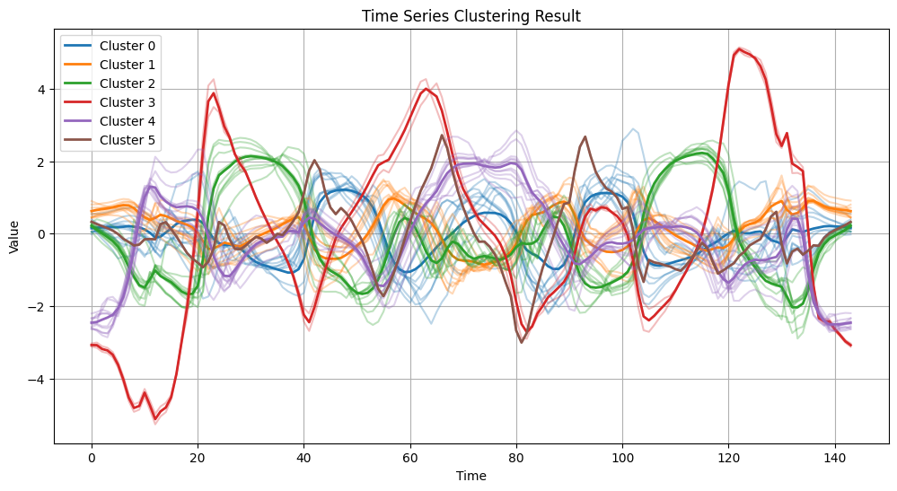
Linkage（complete）
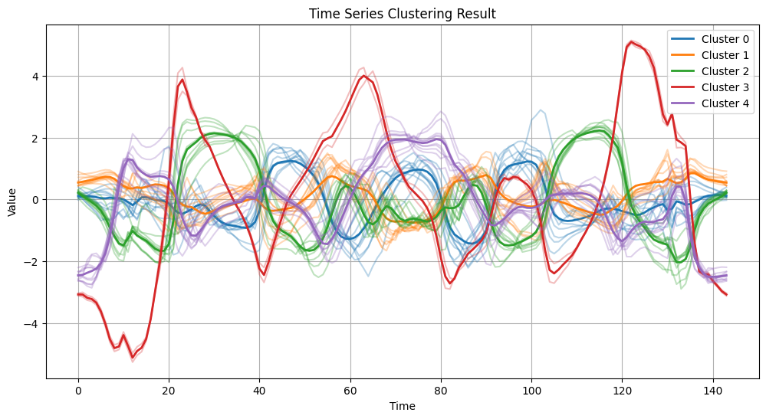
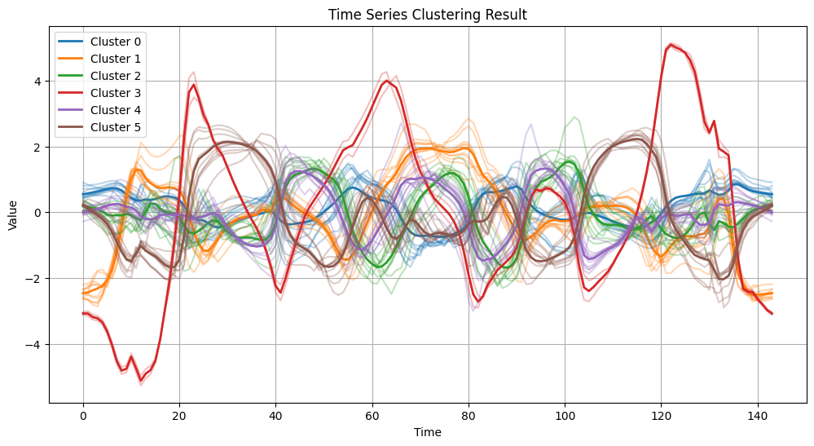
Linkage（ward）
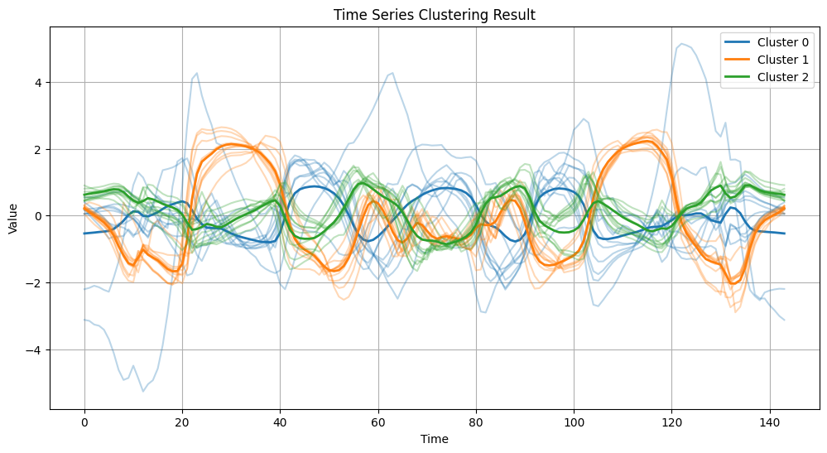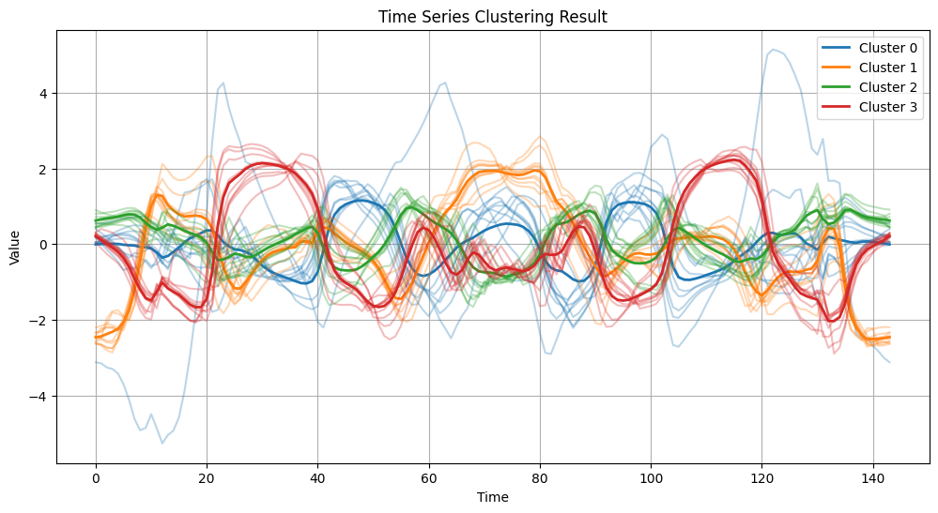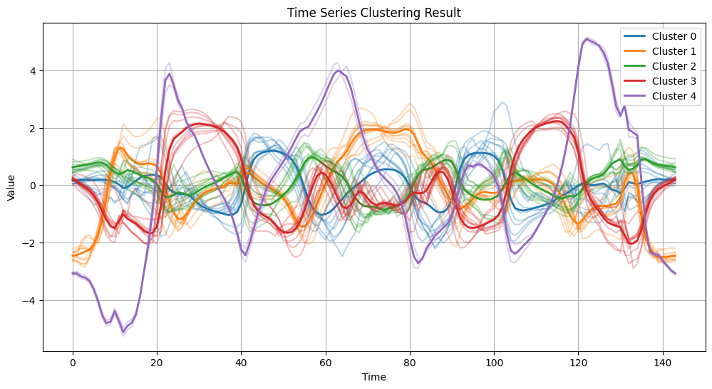
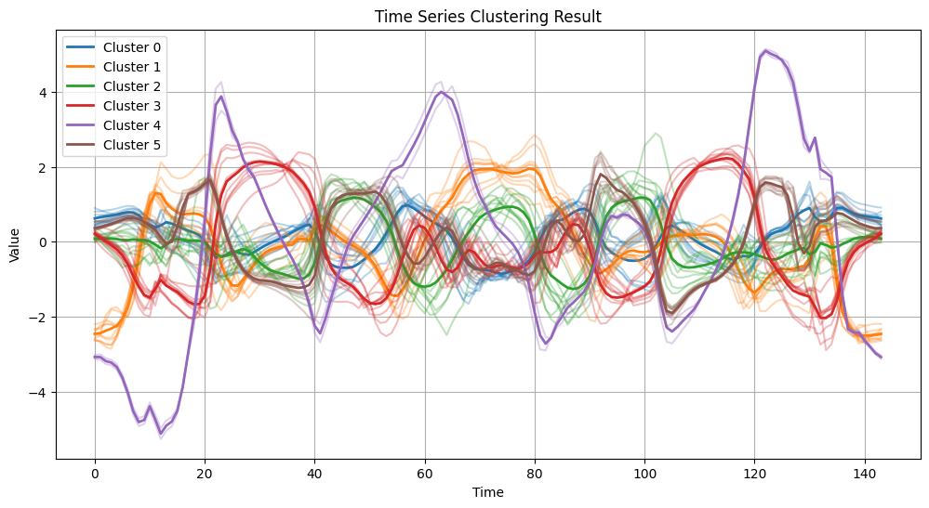
调用sklearn库，各聚类算法在iris.zip上运行时间（s）
Kmeans |  | Dbscan |  |  | Linkage
k | Time | Eps | min_samples | Time | k | Time（Single） | Time（average） | Time（Complete） | Time（ward）
2 | 0.010 | 0.5 | 5 | 0.002 | 2 | 0.001 | 0.001 | 0.001 | 0.001
3 | 0.010 | 0.5 | 10 | 0.004 | 3 | 0.001 | 0.001 | 0.001 | 0.001
4 | 0.008 | 1 | 5 | 0.003 | 4 | 0.001 | 0.001 | 0.001 | 0.001
5 | 0.009 | 1 | 10 | 0.002 | 5 | 0.001 | 0.001 | 0.001 | 0.001
调用sklearn库，各聚类算法在iris.zip上ARI值
Kmeans |  | Dbscan |  |  | Linkage
k | ARI | Eps | min_samples | ARI | k | API（Single） | ARI（average） | ARI（Complete） | ARI（ward）
2 | 0.568 | 0.5 | 5 | 0.428 | 2 | 0.568 | 0.568 | 0.410 | 0.544
3 | 0.620 | 0.5 | 10 | 0.279 | 3 | 0.558 | 0.562 | 0.573 | 0.615
4 | 0.493 | 1 | 5 | 0.554 | 4 | 0.552 | 0.552 | 0.533 | 0.588
5 | 0.450 | 1 | 10 | 0.550 | 5 | 0.552 | 0.551 | 0.463 | 0.470
调用sklearn库，各聚类算法在iris.zip上NIM值
Kmeans |  | Dbscan |  |  | Linkage
k | NIM | Eps | min_samples | NIM | k | NIM（Single） | NIM（average） | NIM（Complete） | NIM（ward）
2 | 0.734 | 0.5 | 5 | 0.500 | 2 | 0.734 | 0.734 | 0.458 | 0.692
3 | 0.659 | 0.5 | 10 | 0.465 | 3 | 0.720 | 0.713 | 0.653 | 0.675
4 | 0.609 | 1 | 5 | 0.696 | 4 | 0.701 | 0.701 | 0.627 | 0.663
5 | 0.575 | 1 | 10 | 0.676 | 5 | 0.696 | 0.649 | 0.592 | 0.616
Kmeans
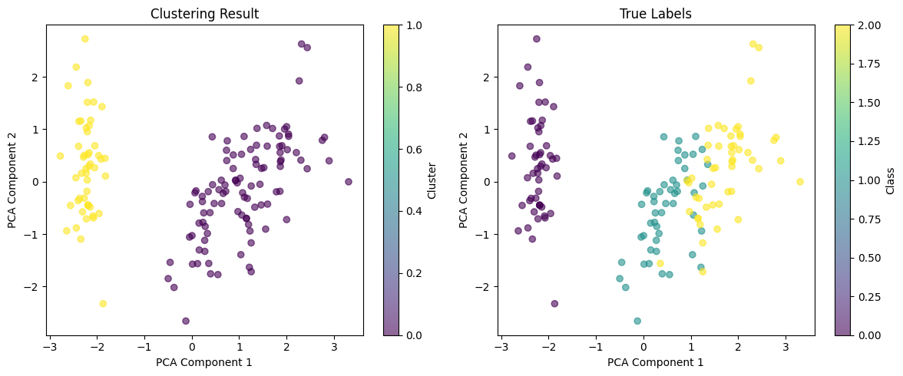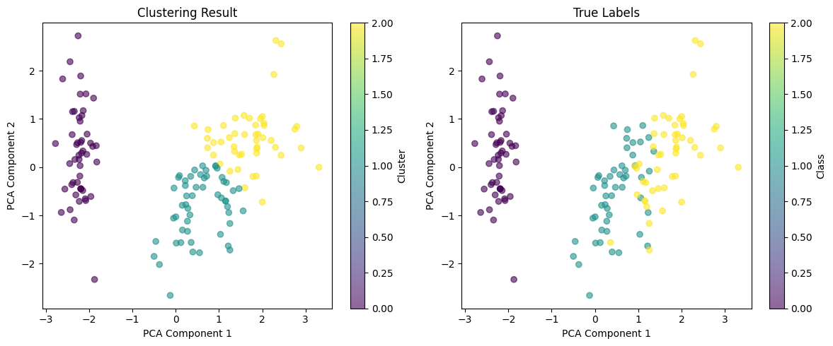
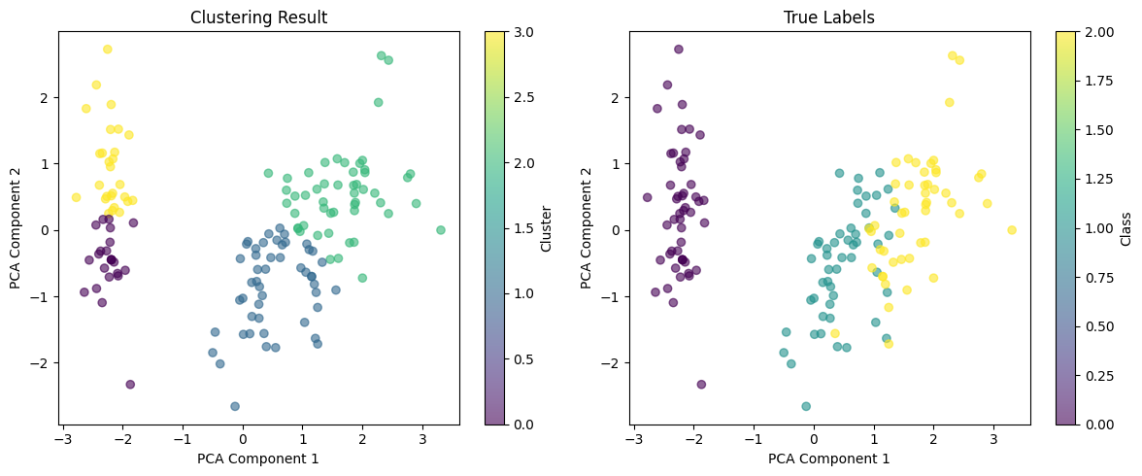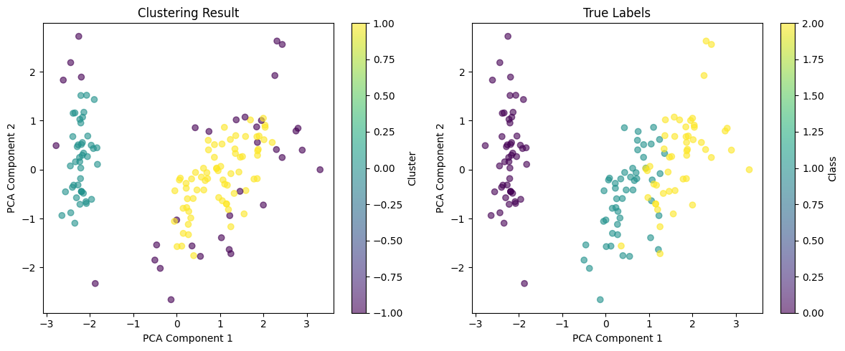
Dbscan
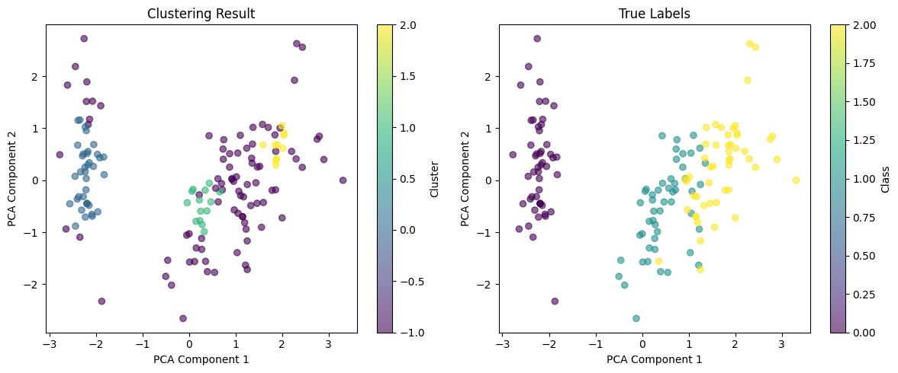
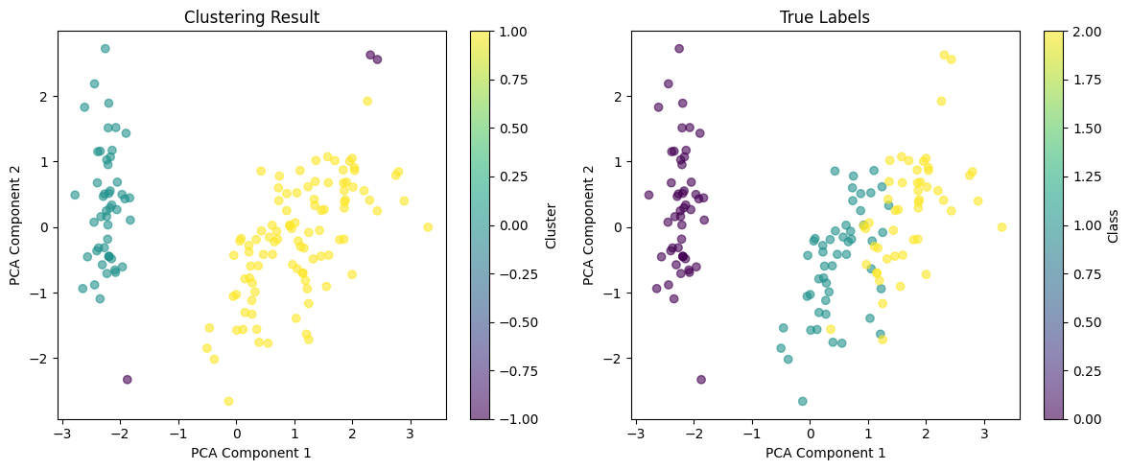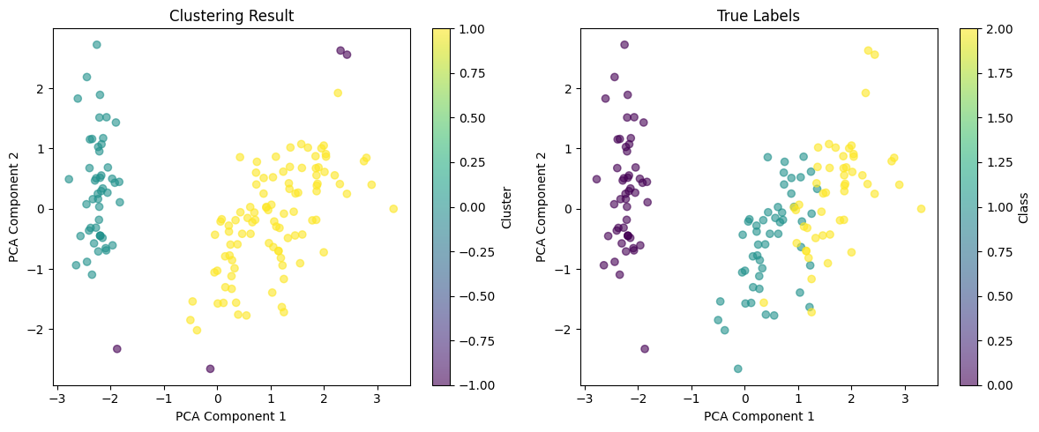
Linkage（single）
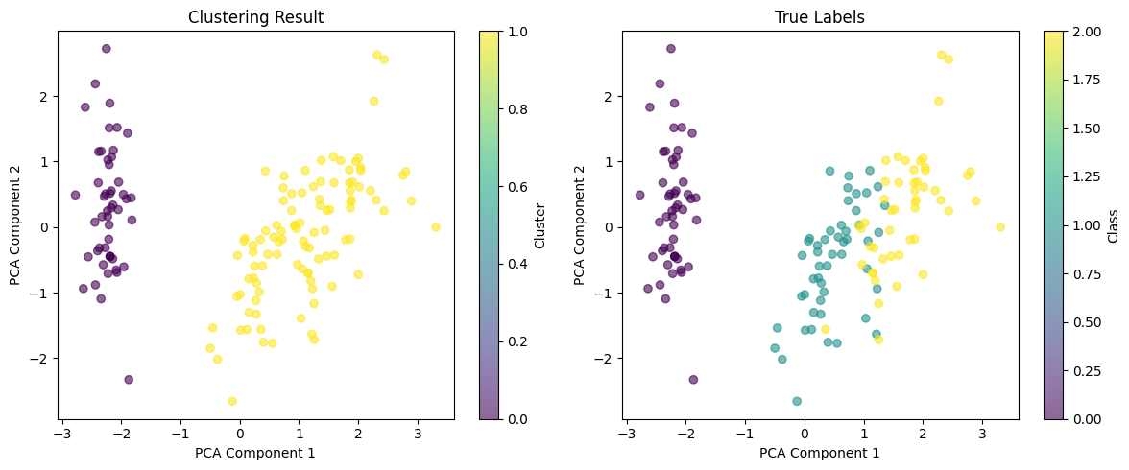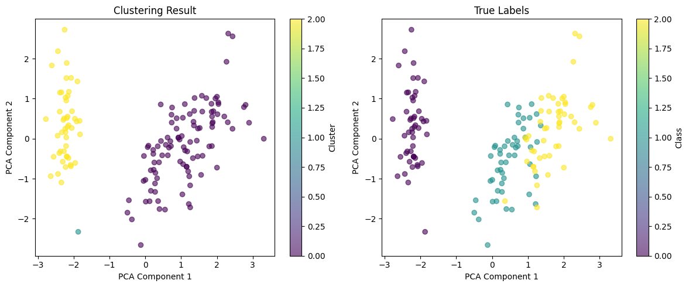
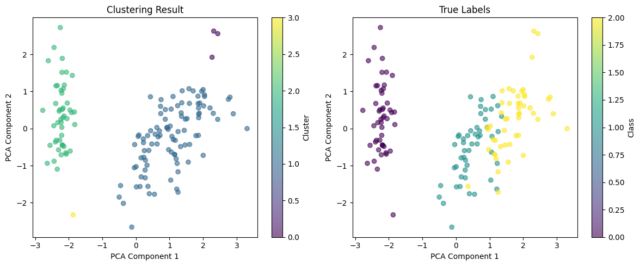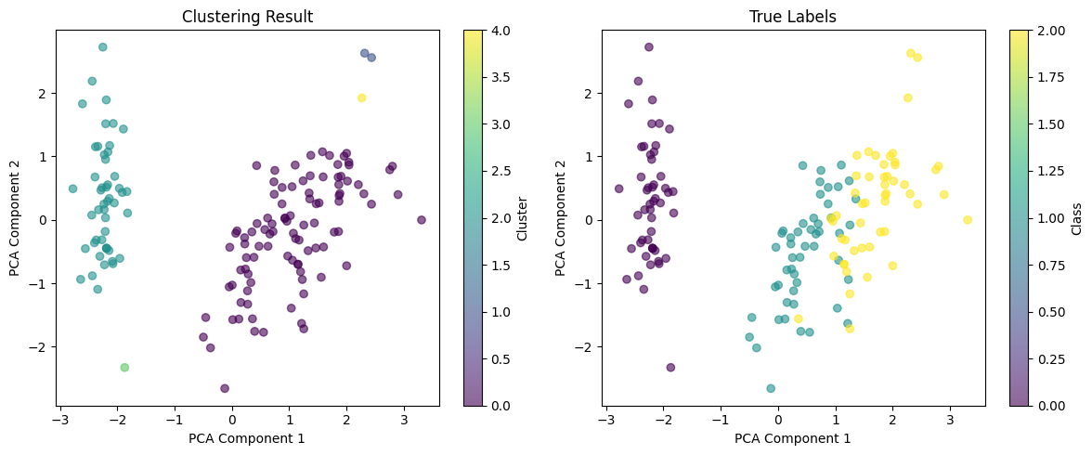
Linkage（average）
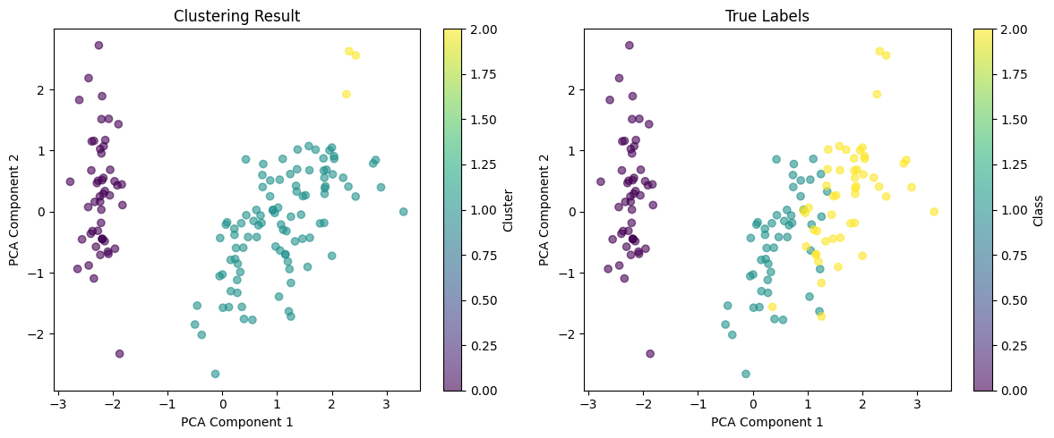
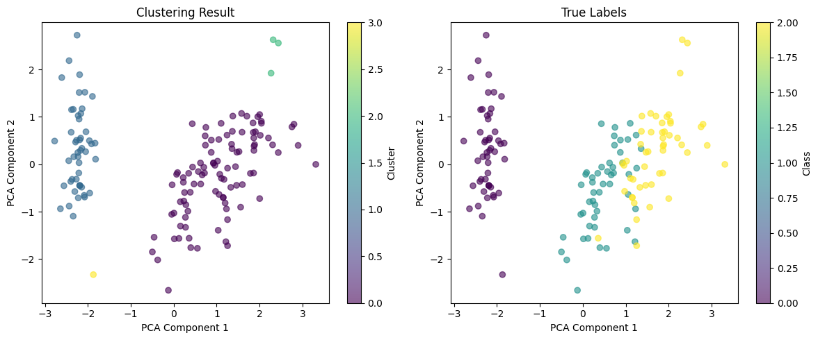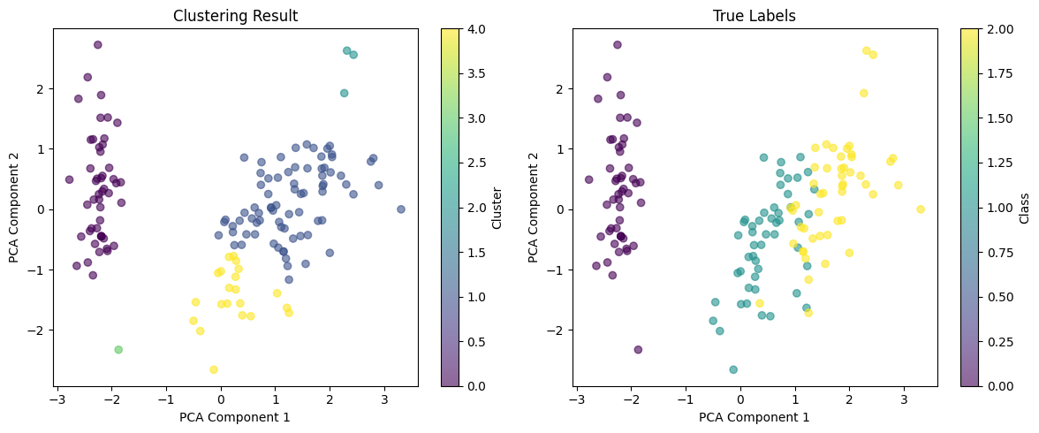
Linkage（complete）
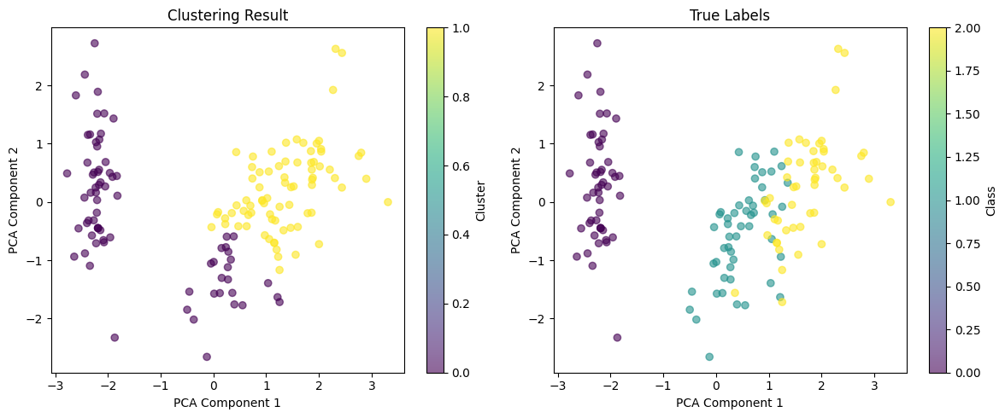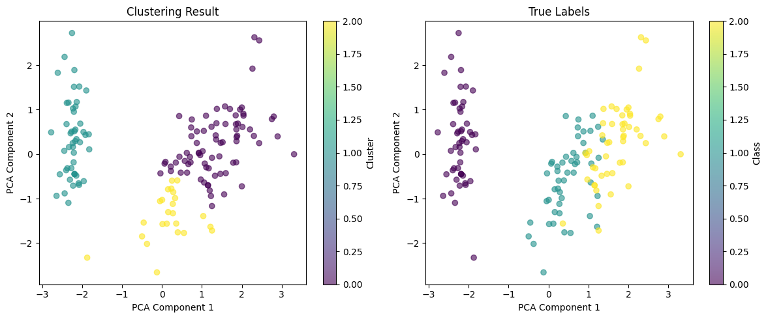
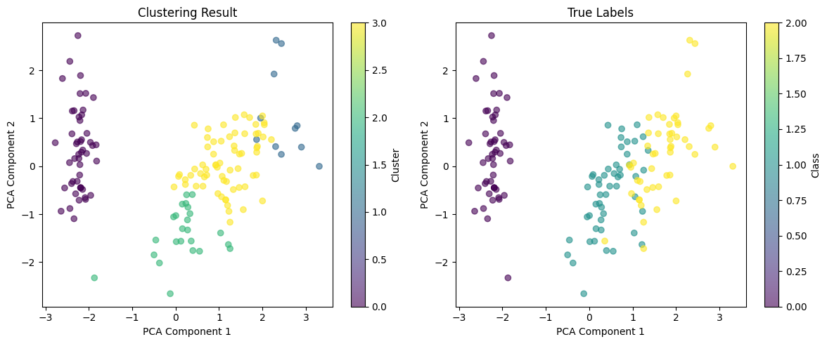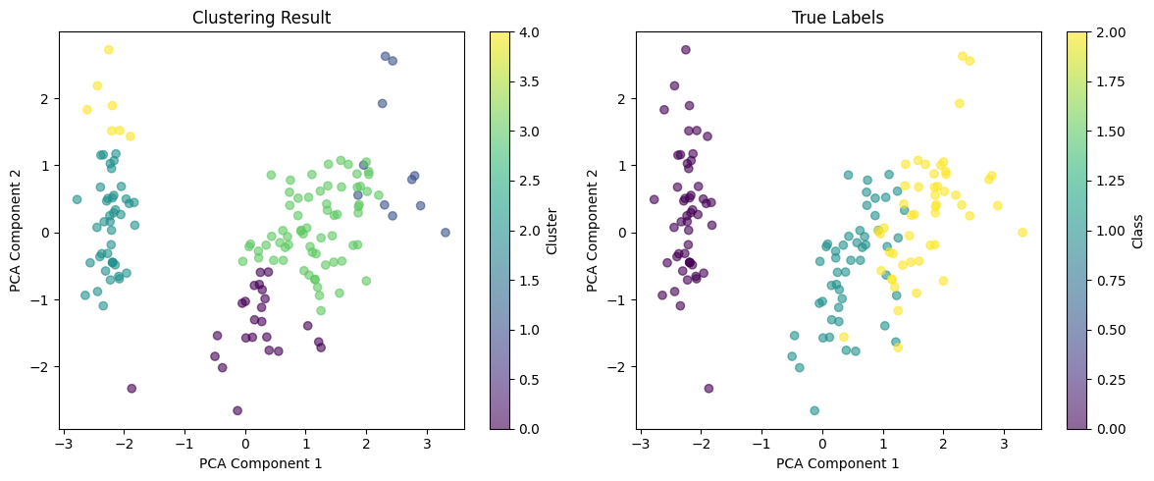
Linkage（ward）
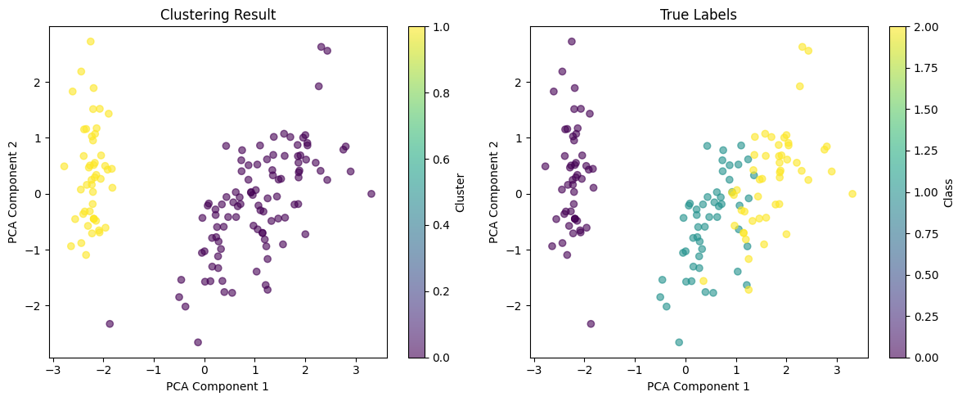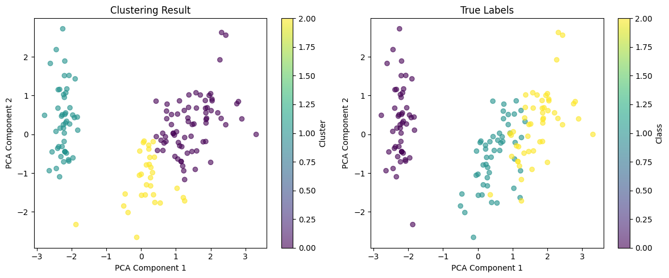
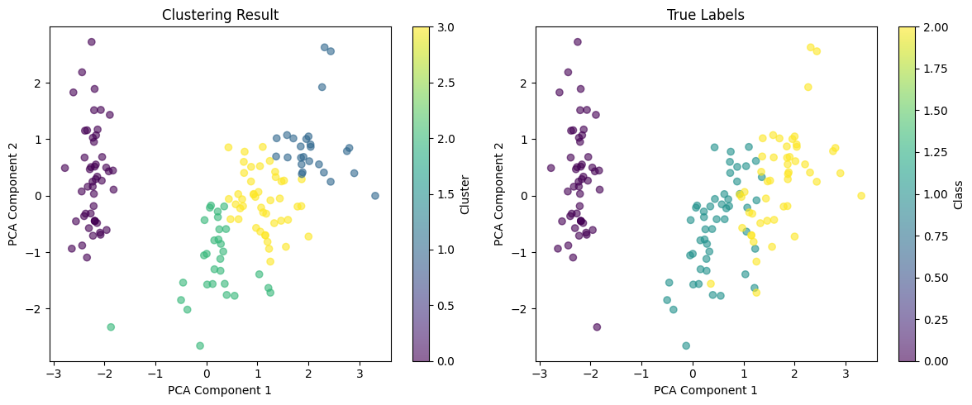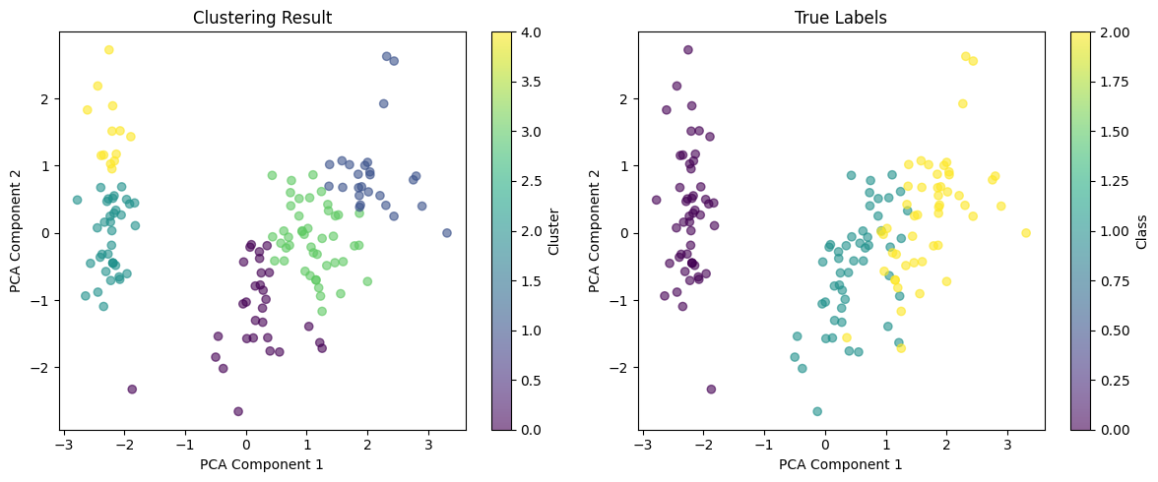
不调用sklearn库，手工实现各聚类算法在clusterData3.8k.dat上运行时间（s）
Kmeans |  | Dbscan |  |  | Linkage
k | Time | Eps | min_samples | Time | k | Time（Single） | Time（average） | Time（Complete） | Time（ward）
3 | 0.057 | 8 | 10 | 0.070 | 3 | 0.485 | 3.029 | 2.970 | 2.797
4 | 0.068 | 8 | 20 | 0.065 | 4 | 0.476 | 2.994 | 2.944 | 3.202
5 | 0.051 | 8 | 30 | 0.081 | 5 | 0.486 | 3.288 | 3.008 | 3.039
6 | 0.057 | 8 | 40 | 0.066 | 6 | 0.480 | 3.160 | 2.855 | 2.780
7 | 0.078 | 9 | 30 | 0.066
8 | 0.094 | 10 | 30 | 0.081
Kmeans


Dbscan


Linkage（single）


Linkage（average）

Linkage（complete）

Linkage（ward）


不调用sklearn库，手工实现各聚类算法在Plane_TRAIN.txt上运行时间（s）
Kmeans |  | Dbscan |  |  | Linkage
k | Time | Eps | min_samples | Time | k | Time（Single） | Time（average） | Time（Complete） | Time（ward）
3 | 0.027 | 8 | 10 | 0.004 | 3 | 0.002 | 0.002 | 0.002 | 0.003
4 | 0.023 | 8 | 20 | 0.004 | 4 | 0.001 | 0.003 | 0.002 | 0.002
5 | 0.022 | 8 | 30 | 0.003 | 5 | 0.002 | 0.002 | 0.001 | 0.002
6 | 0.026 | 8 | 40 | 0.004 | 6 | 0.002 | 0.002 | 0.001 | 0.001
7 | 0.037 | 9 | 30 | 0.003
8 | 0.038 | 10 | 30 | 0.005
不调用sklearn库，手工实现各聚类算法在Plane_TRAIN.txt上ARI值
Kmeans |  | Dbscan |  |  | Linkage
k | ARI | Eps | min_samples | ARI | k | ARI（Single） | ARI（average） | ARI（Complete） | ARI（ward）
3 | 0.389 | 8 | 10 | 0.622 | 3 | 0.079 | 0.219 | 0.553 | 0.656
4 | 0.512 | 8 | 20 | 0.390 | 4 | 0.115 | 0.219 | 0.553 | 0.552
5 | 0.538 | 8 | 30 | 0.639 | 5 | 0.115 | 0.219 | 0.485 | 0.499
6 | 0.648 | 8 | 40 | 0.466 | 6 | 0.418 | 0.526 | 0.553 | 0.656
7 | 0.834 | 9 | 30 | 0.550
8 | 0.878 | 10 | 30 | 0.459
不调用sklearn库，手工实现各聚类算法在Plane_TRAIN.txt上NIM值
Kmeans |  | Dbscan |  |  | Linkage
k | NIM | Eps | min_samples | NIM | k | NIM（Single） | NIM（average） | NIM（Complete） | NIM（ward）
3 | 0.628 | 8 | 10 | 0.795 | 3 | 0.319 | 0.566 | 0.787 | 0.857
4 | 0.736 | 8 | 20 | 0.608 | 4 | 0.381 | 0.566 | 0.787 | 0.783
5 | 0.766 | 8 | 30 | 0.822 | 5 | 0.381 | 0.566 | 0.741 | 0.746
6 | 0.840 | 8 | 40 | 0.676 | 6 | 0.687 | 0.758 | 0.787 | 0.857
7 | 0.918 | 9 | 30 | 0.775
8 | 0.906 | 10 | 30 | 0.648
Kmeans


Dbscan


Linkage（single）


Linkage（average）


Linkage（complete）


Linkage（ward）


不调用sklearn库，手工实现各聚类算法在iris.zip上运行时间（s）
Kmeans |  | Dbscan |  |  | Linkage
k | Time | Eps | min_samples | Time | k | Time（Single） | Time（average） | Time（Complete） | Time（ward）
2 | 0.027 | 0.5 | 5 | 0.003 | 2 | 0.001 | 0.001 | 0.001 | 0.001
3 | 0.053 | 0.5 | 10 | 0.002 | 3 | 0.002 | 0.002 | 0.001 | 0.002
4 | 0.039 | 1 | 5 | 0.003 | 4 | 0.002 | 0.001 | 0.002 | 0.001
5 | 0.063 | 1 | 10 | 0.004 | 5 | 0.001 | 0.001 | 0.001 | 0.002
不调用sklearn库，手工实现各聚类算法在iris.zip上ARI值
Kmeans |  | Dbscan |  |  | Linkage
k | ARI | Eps | min_samples | ARI | k | ARI（Single） | ARI（average） | ARI（Complete） | ARI（ward）
2 | 0.568 | 0.5 | 5 | 0.428 | 2 | 0.568 | 0.568 | 0.410 | 0.544
3 | 0.592 | 0.5 | 10 | 0.279 | 3 | 0.558 | 0.562 | 0.573 | 0.615
4 | 0.472 | 1 | 5 | 0.554 | 4 | 0.552 | 0.552 | 0.533 | 0.588
5 | 0.540 | 1 | 10 | 0.550 | 5 | 0.552 | 0.551 | 0.463 | 0.470
不调用sklearn库，手工实现各聚类算法在iris.zip上NIM值
Kmeans |  | Dbscan |  |  | Linkage
k | NIM | Eps | min_samples | NIM | k | NIM（Single） | NIM（average） | NIM（Complete） | NIM（ward）
2 | 0.734 | 0.5 | 5 | 0.500 | 2 | 0.734 | 0.734 | 0.458 | 0.692
3 | 0.643 | 0.5 | 10 | 0.465 | 3 | 0.720 | 0.713 | 0.653 | 0.675
4 | 0.597 | 1 | 5 | 0.696 | 4 | 0.701 | 0.701 | 0.627 | 0.663
5 | 0.629 | 1 | 10 | 0.676 | 5 | 0.696 | 0.649 | 0.592 | 0.616
Kmeans


Dbscan


Linkage（single）


Linkage（average）


Linkage（complete）


Linkage（ward）


簇数目（k）对K-means算法的影响
- means算法的性能受簇数目（k）的显著影响。在clusterData3.8k.dat和Plane_TRAIN.txt数据集上，随着k的增加，运行时间呈上升趋势，但增幅较小，说明K-means的计算复杂度与k值基本呈线性关系。在聚类质量方面，API（调整兰德指数）和NMI（标准化互信息）值通常随k的增加而提高，例如在Plane_TRAIN.txt上，k=8时API达到0.878，NMI达到0.906，表明更大的k可能更好地匹配真实数据分布。然而，在iris.zip数据集上，API和NMI在k=3时达到峰值（API=0.620，NMI=0.659），随后下降，说明过大的k可能导致过拟合，降低聚类效果。

邻域半径（Eps）和密度阈值（min_samples）对DBSCAN的影响
DBSCAN的性能对Eps和min_samples高度敏感。在clusterData3.8k.dat上，固定Eps=8时，增大min_samples（10→40）对运行时间影响较小，但聚类质量波动较大，例如在Plane_TRAIN.txt上，min_samples=10时NMI=0.795，而min_samples=40时降至0.676，说明较小的min_samples可能捕获更多噪声点，而较大的值可能忽略真实簇。调整Eps的影响更显著，例如在iris.zip上，Eps=0.5时NMI=0.465，而Eps=1时提升至0.696，表明合适的Eps对发现正确簇结构至关重要。

连接方式（Single/Average/Complete/Ward）对层次聚类的影响
层次聚类的运行时间在不同连接方式下差异较大，Complete和Average通常比Single和Ward更耗时，例如在clusterData3.8k.dat上，Single仅需0.457s，而Complete需要2.537s。在聚类质量方面，Ward方法通常表现最佳，如在Plane_TRAIN.txt上NMI=0.857（k=3），而Single方法仅0.319，说明Ward的方差最小化策略更适合均匀分布的簇。相比之下，Single方法对噪声敏感，易形成链式簇，导致API和NMI较低。

调用sklearn库和手工实现的聚类算法结果可视化对比
在clusterData3.8k.dat上，调用sklearn库和手工实现的聚类算法对比
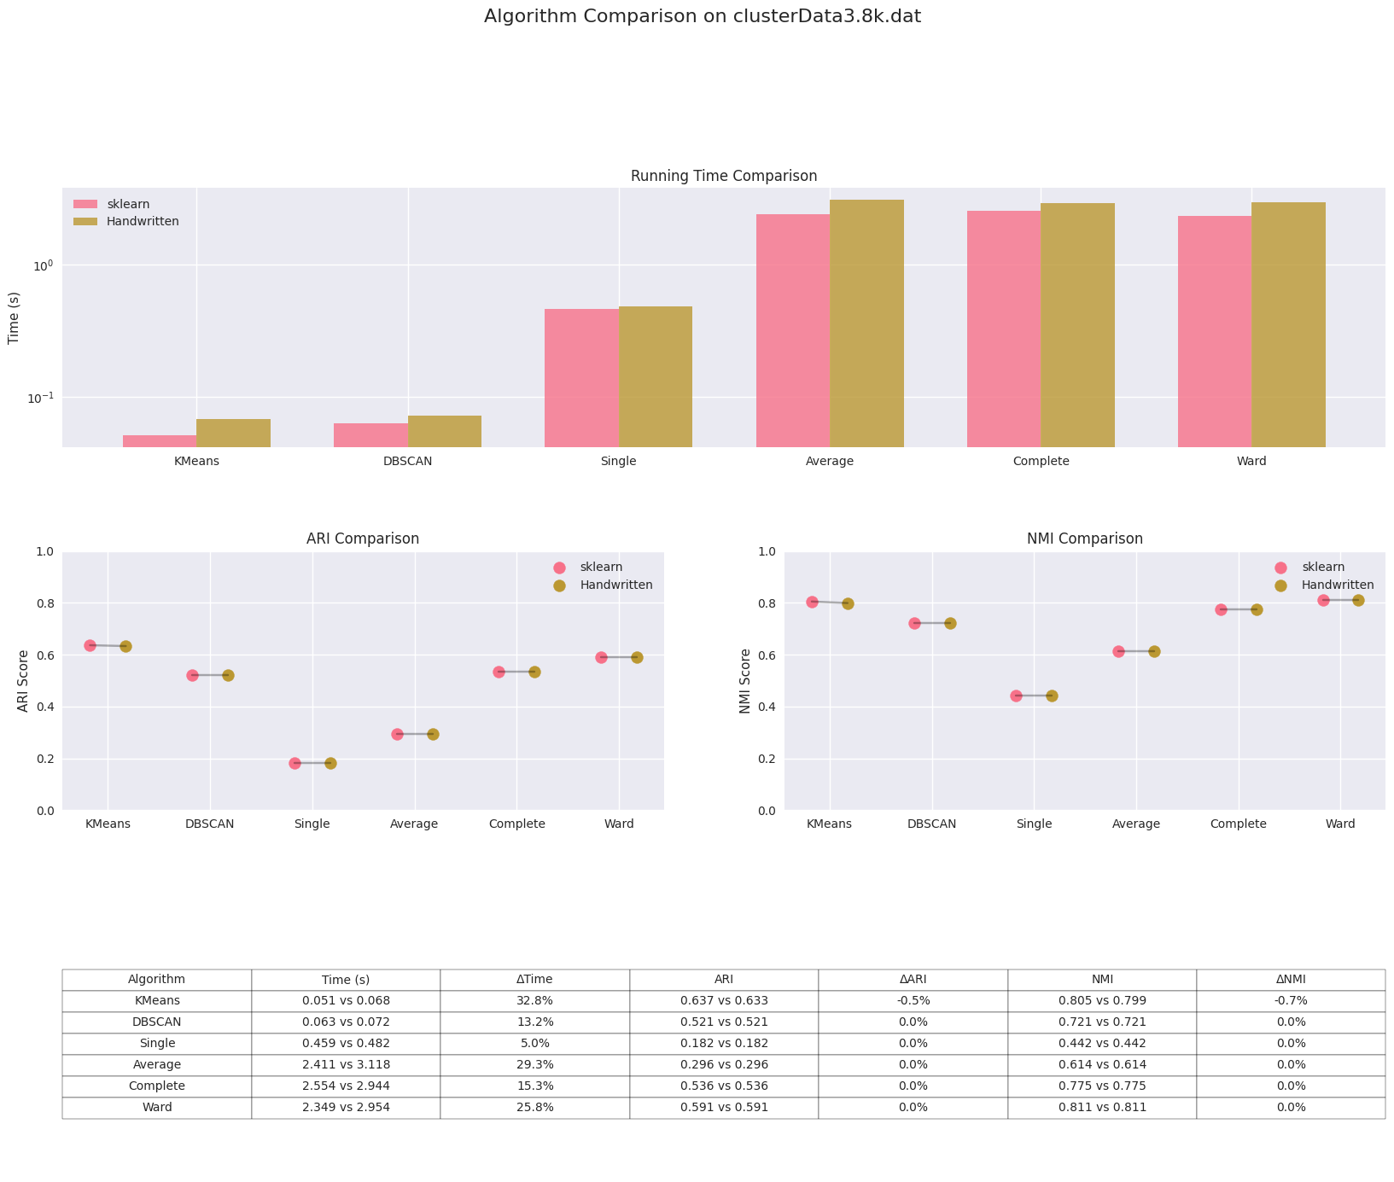

在Plane_TRAIN.txt上，调用sklearn库和手工实现的聚类算法对比
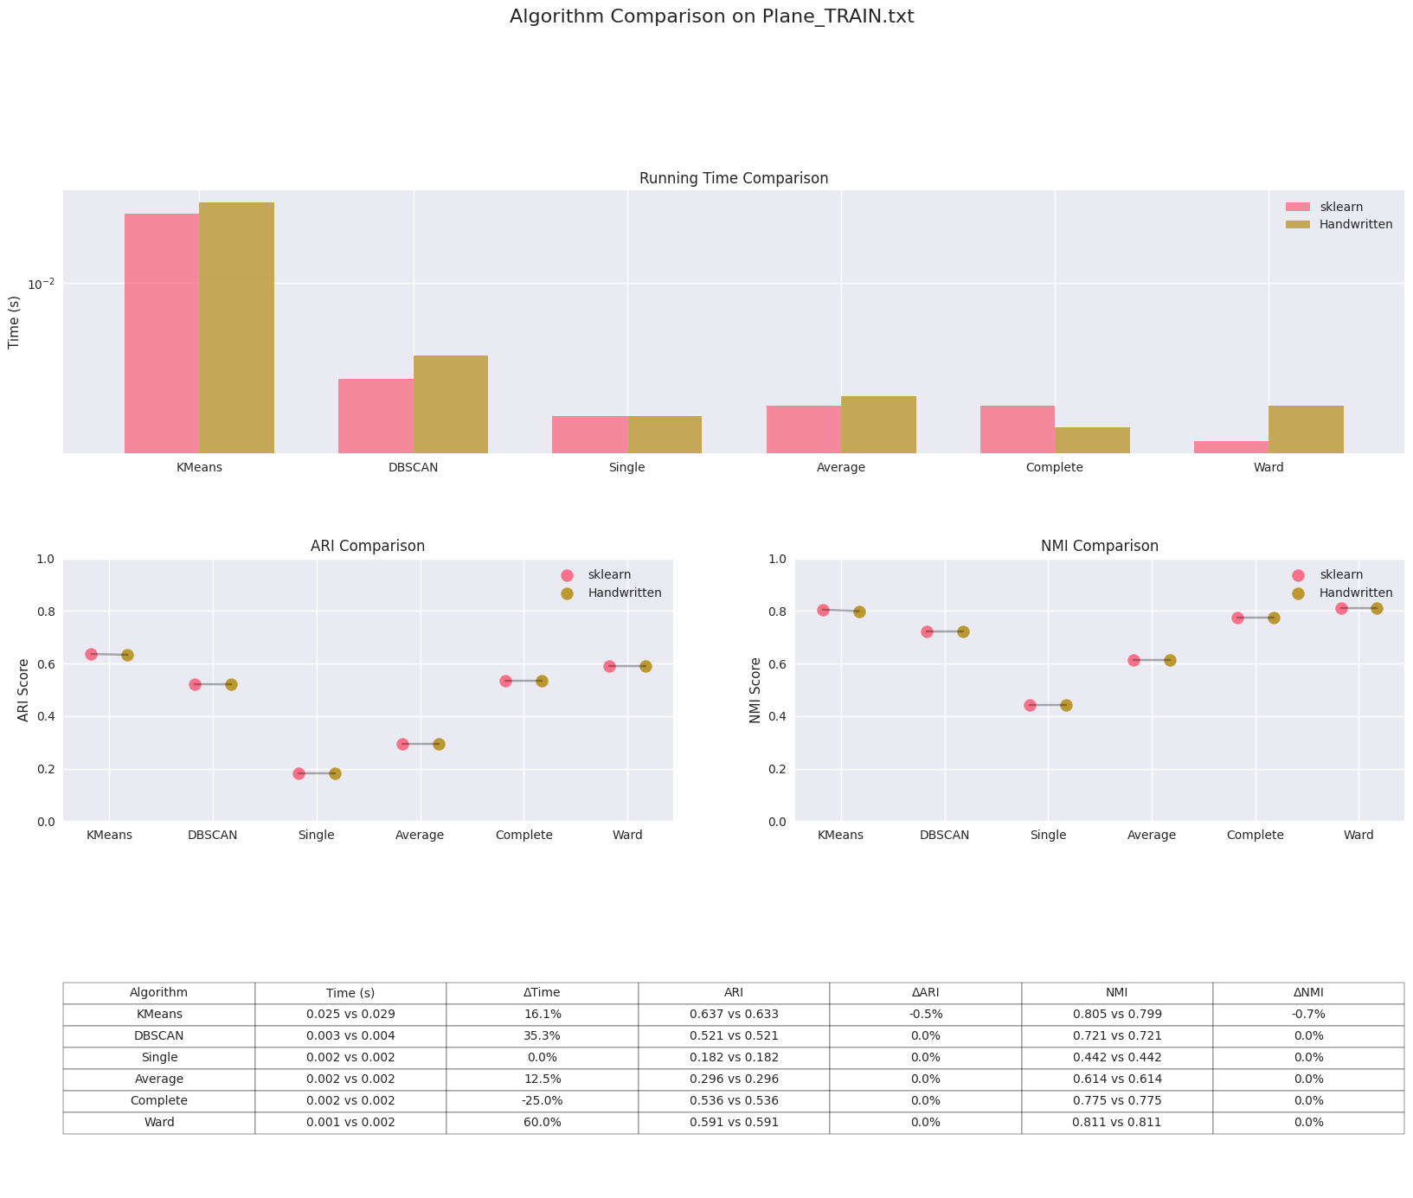
在iris.zip上，调用sklearn库和手工实现的聚类算法对比
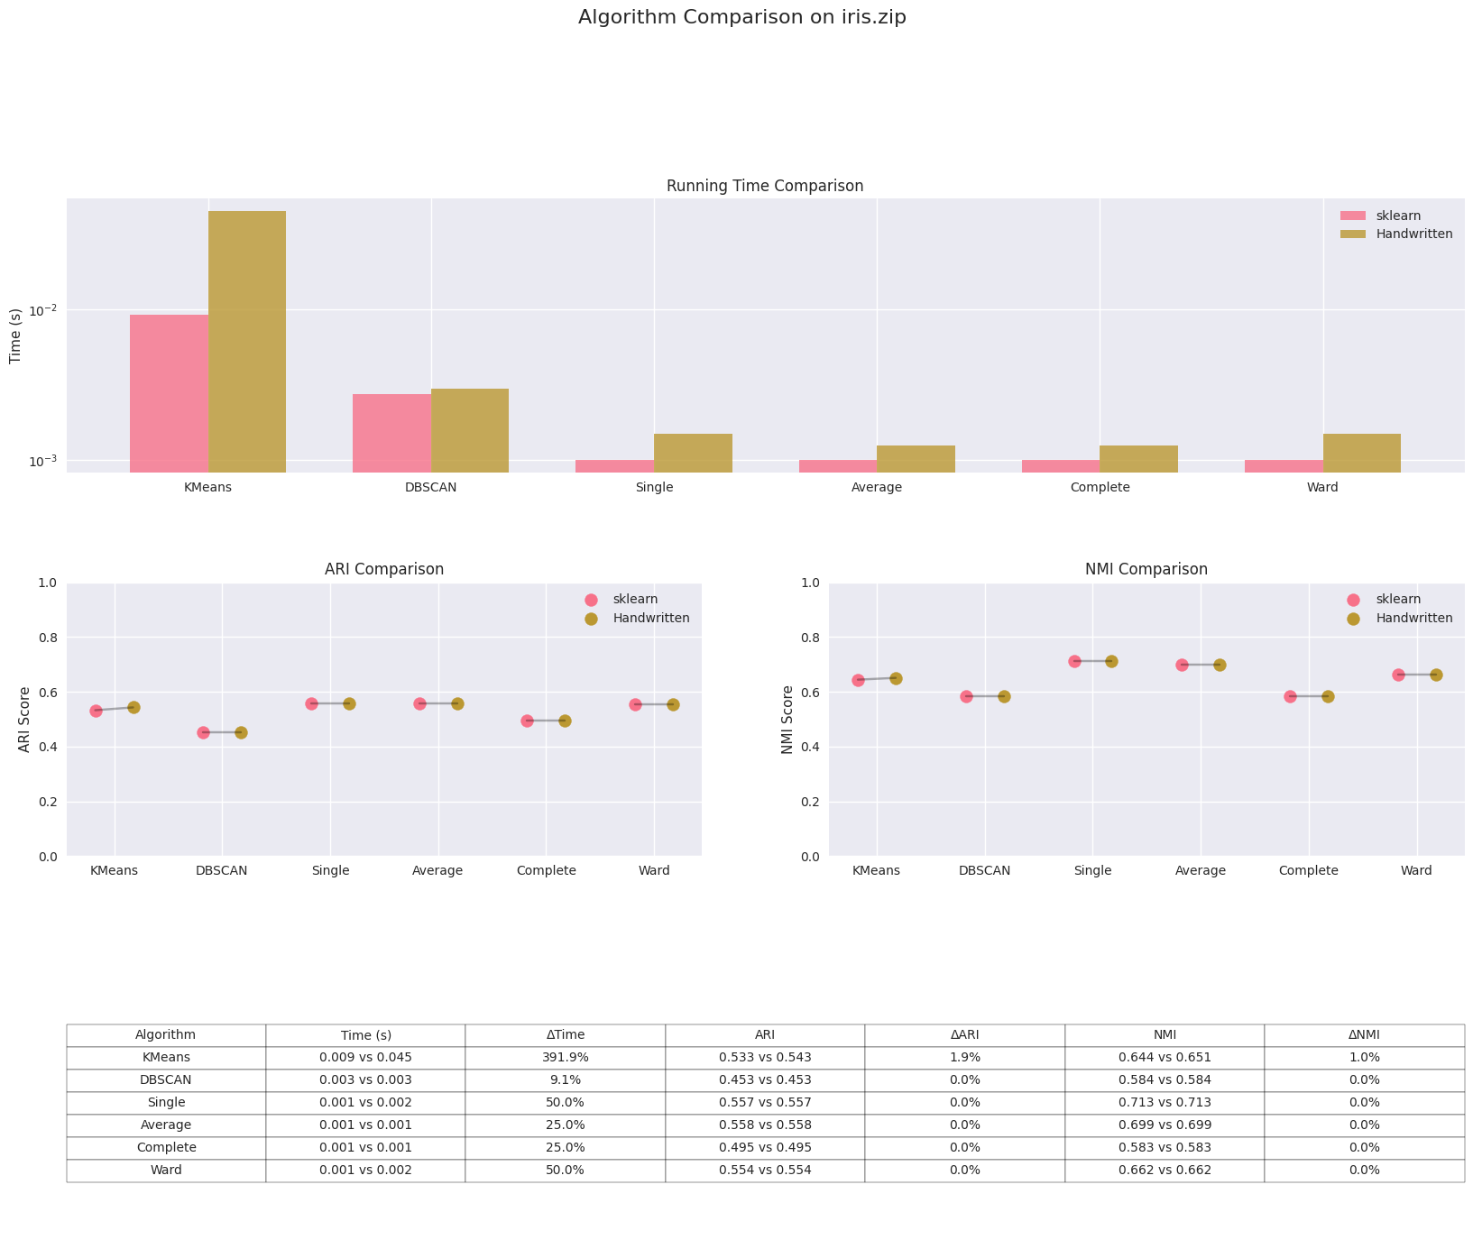
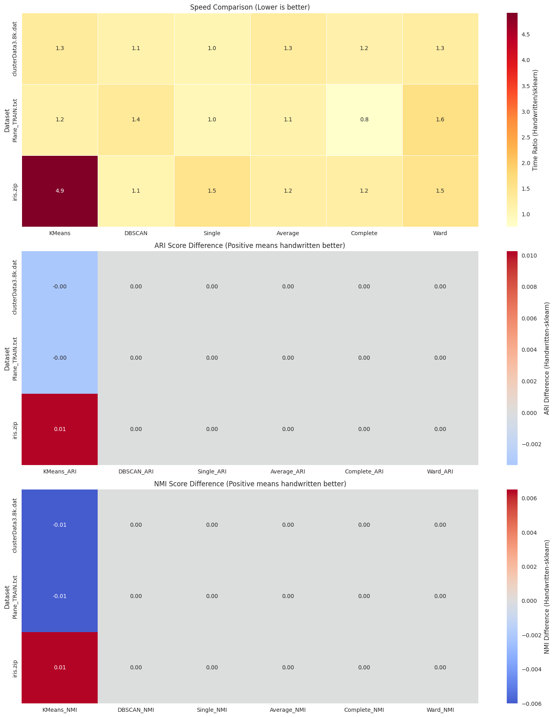


手工实现的聚类算法在大多数数据集上的运行时间略高于sklearn库的实现，尤其在较大数据集（如clusterData3.8k.dat）上更为明显。而层次聚类（Linkage）的手工实现在不同连接方式（Single、Average、Complete、Ward）下的运行时间与sklearn库的实现接近，但手工实现的时间普遍稍长，这可能与sklearn库底层优化有关。
在聚类效果方面，手工实现与sklearn库的ARI和NMI值基本一致，表明两者的聚类质量相似。例如，在Plane_TRAIN.txt数据集上，两者的K-means、DBScan和层次聚类的API和NMI值几乎相同，说明手工实现的算法逻辑正确。然而，在iris数据集上，手工实现的K-means的API和NMI值偶尔略低于sklearn库，可能是由于初始中心点选择或距离计算优化不足。

运行时占用内存对比
调用sklearn在clusterData3.8k.dat、Plane_TRAIN.txt和iris.zip数据集上的结果
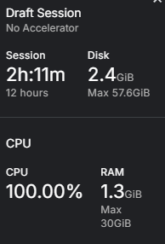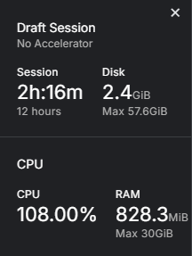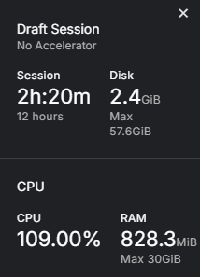
手工实现的聚类算法在clusterData3.8k.dat、Plane_TRAIN.txt和iris.zip数据集上的结果
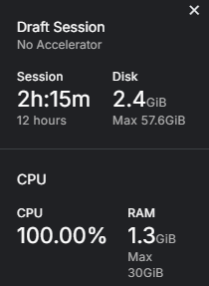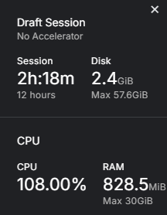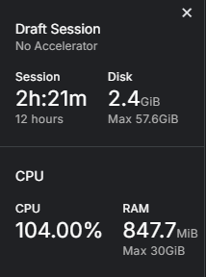
手工实现的聚类算法与调用sklearn库的版本在运行时占用的内存空间大致相当，表明手工实现并未引入显著的内存开销。

实验小结
通过本次实验，我深入理解了不同聚类算法的特性及其参数对聚类效果的影响。实验结果表明，在本次实验中，K-means算法的性能与簇数k的选择密切相关，过大或过小的k值都会影响聚类质量；DBSCAN算法对邻域半径Eps和最小样本数min_samples非常敏感，需要仔细调整才能获得理想的聚类效果；层次聚类中，Ward方法通常能获得最优结果，但计算成本较高。对比手工实现与sklearn库发现，虽然手工实现的算法逻辑正确，但在运行效率上明显低于经过高度优化的sklearn库，这凸显了算法优化的重要性。此外，实验还让我认识到不同数据集特性对算法表现的显著影响，在实际应用中必须根据数据特点选择合适的算法和参数。总的来说，这次实验不仅加深了我对聚类算法的理解，更让我体会到算法调参和优化在实际机器学习应用中的关键作用。

附录：
实验源代码
lab4.ipynb 完整实验代码（涵盖参数调优、sklearn库调用、聚类算法手工实现及可视化分析）

lab4.ipynb
001  002  003  004  005  006  007  008  009  010  011  012  013  014  015  016  017  018  019  020  021  022  023  024  025  026  027  028  029  030  031  032  033  034  035  036  037  038  039  040  041  042  043  044  045  046  047  048  049  050  051  052  053  054  055  056  057  058  059  060  061  062  063  064  065  066  067  068  069  070  071  072  073  074  075  076  077  078  079  080  081  082  083  084  085  086  087  088  089  090  091  092  093  094  095  096  097  098  099  100  101  102  103  104  105  106  107  108  109  110  111  112  113  114  115  116  117  118  119  120  121  122  123  124  125  126  127  128  129  130  131  132  133  134  135  136  137  138  139  140  141  142  143  144  145  146  147  148  149  150  151  152  153  154  155  156  157  158  159  160  161  162  163  164  165  166  167  168  169  170  171  172  173 | import numpy as np  import pandas as pd  import time  import os  import sys  import getopt  import matplotlib.pyplot as plt  from sklearn.cluster import KMeans, AgglomerativeClustering, DBSCAN  from sklearn import metrics as skm  from sklearn import preprocessing as skp  # ======================  # Algorithm Definitions  # ======================  class KMeansClustering:  ModelName = "KMeans聚类算法"  @staticmethod  def train(data, *args):  print("开始%s过程..." % KMeansClustering.ModelName)  startT = time.time()  '''cluster centers are randomly initiated'''  cluster = KMeans(n_clusters=args[0], init='random').fit(data)  endT = time.time()  print("%s过程结束。处理了%d个数据点，耗时%f秒。" % (KMeansClustering.ModelName, data.shape[0], (endT - startT)))  return cluster  class AgglomerativeClusteringWrapper:  ModelName = "凝聚法层次聚类算法"  @staticmethod  def train(data, *args):  print("开始%s过程..." % AgglomerativeClusteringWrapper.ModelName)  startT = time.time()  # 使用 sklearn 的 AgglomerativeClustering  cluster = AgglomerativeClustering(n_clusters=args[0], linkage=args[1]).fit(data)  endT = time.time()  print("%s过程结束。处理了%d个数据点，耗时%f秒。" % (AgglomerativeClusteringWrapper.ModelName, data.shape[0], (endT - startT)))  return cluster  class DBSCANClustering:  ModelName = "DBSCAN聚类算法"  @staticmethod  def train(data, *args):  print("开始%s过程..." % DBSCANClustering.ModelName)  startT = time.time()  '''  eps_para,min_samples_para: the parameters need to be manually specified.  '''  cluster = DBSCAN(eps=args[0], min_samples=args[1]).fit(data)  endT = time.time()  print("%s过程结束。处理了%d个数据点，耗时%f秒。" % (DBSCANClustering.ModelName, data.shape[0], (endT - startT)))  return cluster  # =================  # Data Loading  # =================  def loadTimeSeries(path, separator=","):  print("开始读入数据...")  startT = time.time()  # 读入数据  df = pd.read_table(path, header=None, sep=separator)  data = df.to_numpy()  # 进行归一化处理  ss = skp.StandardScaler()  # 如果第0列是标签，不用归一化。  data[:, 1:] = ss.fit_transform(data[:, 1:])  endT = time.time()  print("数据读入结束。共耗时%.3f秒。" % (endT-startT))  return data[:, 1:], data[:, 0]  def loadDots(path, separator=" "):  print("开始读入数据...")  startT = time.time()  # 读入数据  df = pd.read_table(path, header=None, sep=separator)  data = df.to_numpy()  endT = time.time()  print("数据读入结束。共耗时%.3f秒。" % (endT-startT))  return data  def dotFeature(data, _):  # For dot data, we just return the data as is  return data, None  def timeSeriesFeature(data, _):  # For time series data, we could extract features here  # For now, just return the data as is  return data, None  def loadData(path, dataType):  x_train = y_train = None  if dataType == "dot":  x_train = loadDots(path)  x_train, t = dotFeature(x_train, None)  elif dataType == "timeseries":  x_train, y_train = loadTimeSeries(path)  x_train, t = timeSeriesFeature(x_train, None)  else:  print("%s是未知数据类型。" % dataType)  sys.exit()  return x_train, y_train  # =================  # Evaluation Metrics  # =================  def NMI(y_true, y_pred):  y_true = np.squeeze(y_true)  return skm.normalized_mutual_info_score(y_true, y_pred)  def ARI(y_true, y_pred):  y_true = np.squeeze(y_true)  return skm.adjusted_rand_score(y_true, y_pred)  def showDots(x, label, outputName):  '''get the number of clusters'''  num_cluster = np.unique(label).size  fig, ax = plt.subplots(1)  for i in range(num_cluster):  ax.scatter(x[label==i,0], x[label==i,1], s=2)  plt.savefig(outputName)  plt.show()  def showTimeSeries(x, labels, outputName):  '''时序数据可视化'''  num_cluster = np.unique(labels).size  plt.figure(figsize=(12, 6))  # 绘制所有时序曲线（按聚类分组）  for i in range(num_cluster):  cluster_data = x[labels == i]  # 绘制该簇的部分样本（避免图像过于密集）  for j in range(min(10, len(cluster_data))):  plt.plot(cluster_data[j], alpha=0.3, color=plt.cm.tab10(i))  # 绘制该簇的平均曲线  plt.plot(np.mean(cluster_data, axis=0),  linewidth=2, color=plt.cm.tab10(i),  label=f'Cluster {i}')  plt.title('Time Series Clustering Result')  plt.xlabel('Time')  plt.ylabel('Value')  plt.legend()  plt.grid(True)  plt.show()  def test(x, y, cluster, modelName):  print("-" * 60)  if y is None or len(y)==0:  showDots(x, cluster.labels_, modelName+"-dots.png")  print("%s聚类结果见输出图片。" % modelName)  else:  showTimeSeries(x, cluster.labels_, modelName+"-timeseries.png")  print("%s聚类结果：" % modelName)  pred_label = cluster.labels_  ari = ARI(y, pred_label)  nmi = NMI(y, pred_label)  print("ARI=%.3f, NMI=%.3f" % (ari, nmi))  # =================  # Main Function  # =================  def usage():  print("This is a machine learning experiment program. \nIts command line parameters are:")  print("-d dataPath: The path with file name of the data file.")  print("-m modelName: The name of the machine learning model is one of {linkage, kmeans, dbscan}.")  print("-s settings: The tuple of the model settings, such as [10,5].")  print("-t dataType: The type of the data is one of {dot, timeSeries}.")
01  02  03  04  05  06  07  08  09  10  11  12  13  14  15  16  17  18  19  20  21  22  23  24  25  26  27  28  29  30  31  32  33  34  35  36  37  38  39  40  41  42  43  44  45  46  47  48  49  50  51  52  53  54  55  56  57  58  59  60  61  62  63  64  65  66  67  68  69  70  71  72  73  74  75 | def main():  # 数据路径和类型  data_path = '/kaggle/input/lab4-dataset/clusterData3.8k.dat'  data_type = 'dot'  # 加载数据  x_train, y_train = loadData(data_path, data_type)  # 定义各算法的参数组合  algorithm_params = {  'kmeans': [  {'n_clusters': 3},  {'n_clusters': 4},  {'n_clusters': 5},  {'n_clusters': 6},  {'n_clusters': 7},  {'n_clusters': 8},  ],  'dbscan': [  {'eps': 8, 'min_samples': 10},  {'eps': 8, 'min_samples': 20},  {'eps': 8, 'min_samples': 30},  {'eps': 8, 'min_samples': 40},  {'eps': 9, 'min_samples': 30},  {'eps': 10, 'min_samples': 30},  ],  'linkage': [  {'n_clusters': 3, 'linkage': 'single'},  {'n_clusters': 4, 'linkage': 'single'},  {'n_clusters': 5, 'linkage': 'single'},  {'n_clusters': 6, 'linkage': 'single'},  {'n_clusters': 3, 'linkage': 'average'},  {'n_clusters': 4, 'linkage': 'average'},  {'n_clusters': 5, 'linkage': 'average'},  {'n_clusters': 6, 'linkage': 'average'},  {'n_clusters': 3, 'linkage': 'complete'},  {'n_clusters': 4, 'linkage': 'complete'},  {'n_clusters': 5, 'linkage': 'complete'},  {'n_clusters': 6, 'linkage': 'complete'},  {'n_clusters': 3, 'linkage': 'ward'},  {'n_clusters': 4, 'linkage': 'ward'},  {'n_clusters': 5, 'linkage': 'ward'},  {'n_clusters': 6, 'linkage': 'ward'},  ]  }  # 遍历所有算法和参数组合  for algo_name, params_list in algorithm_params.items():  print(f"\n===== 正在测试 {algo_name} 算法 =====")  for params in params_list:  print(f"\n参数组合: {params}")  try:  start_time = time.time() # 记录开始时间  if algo_name == 'kmeans':  cluster = KMeans(**params).fit(x_train)  model_name = "KMeans聚类算法"  elif algo_name == 'dbscan':  cluster = DBSCAN(**params).fit(x_train)  model_name = "DBSCAN聚类算法"  elif algo_name == 'linkage':  cluster = AgglomerativeClustering(**params).fit(x_train)  model_name = "凝聚法层次聚类算法"  end_time = time.time()  print(f"耗时: {end_time - start_time:.3f}秒") # 输出训练时间  # 评估结果  test(x_train, y_train, cluster, model_name)  except Exception as e:  print(f"运行失败: {str(e)}")  continue  if __name__ == '__main__':  main()
01  02  03  04  05  06  07  08  09  10  11  12  13  14  15  16  17  18  19  20  21  22  23  24  25  26  27  28  29  30  31  32  33  34  35  36  37  38  39  40  41  42  43  44  45  46  47  48  49  50  51  52  53  54  55  56  57  58  59  60  61  62  63  64  65  66  67  68  69  70  71  72  73  74  75 | def main():  # 数据路径和类型  data_path = '/kaggle/input/lab4-dataset/Plane_TRAIN.txt'  data_type = 'timeseries'  # 加载数据  x_train, y_train = loadData(data_path, data_type)  # 定义各算法的参数组合  algorithm_params = {  'kmeans': [  {'n_clusters': 3},  {'n_clusters': 4},  {'n_clusters': 5},  {'n_clusters': 6},  {'n_clusters': 7},  {'n_clusters': 8},  ],  'dbscan': [  {'eps': 8, 'min_samples': 10},  {'eps': 8, 'min_samples': 20},  {'eps': 9, 'min_samples': 10},  {'eps': 9, 'min_samples': 20},  {'eps': 10, 'min_samples': 10},  {'eps': 10, 'min_samples': 20},  ],  'linkage': [  {'n_clusters': 3, 'linkage': 'single'},  {'n_clusters': 4, 'linkage': 'single'},  {'n_clusters': 5, 'linkage': 'single'},  {'n_clusters': 6, 'linkage': 'single'},  {'n_clusters': 3, 'linkage': 'average'},  {'n_clusters': 4, 'linkage': 'average'},  {'n_clusters': 5, 'linkage': 'average'},  {'n_clusters': 6, 'linkage': 'average'},  {'n_clusters': 3, 'linkage': 'complete'},  {'n_clusters': 4, 'linkage': 'complete'},  {'n_clusters': 5, 'linkage': 'complete'},  {'n_clusters': 6, 'linkage': 'complete'},  {'n_clusters': 3, 'linkage': 'ward'},  {'n_clusters': 4, 'linkage': 'ward'},  {'n_clusters': 5, 'linkage': 'ward'},  {'n_clusters': 6, 'linkage': 'ward'},  ]  }  # 遍历所有算法和参数组合  for algo_name, params_list in algorithm_params.items():  print(f"\n===== 正在测试 {algo_name} 算法 =====")  for params in params_list:  print(f"\n参数组合: {params}")  try:  start_time = time.time() # 记录开始时间  if algo_name == 'kmeans':  cluster = KMeans(**params).fit(x_train)  model_name = "KMeans聚类算法"  elif algo_name == 'dbscan':  cluster = DBSCAN(**params).fit(x_train)  model_name = "DBSCAN聚类算法"  elif algo_name == 'linkage':  cluster = AgglomerativeClustering(**params).fit(x_train)  model_name = "凝聚法层次聚类算法"  end_time = time.time()  print(f"耗时: {end_time - start_time:.3f}秒") # 输出训练时间  # 评估结果  test(x_train, y_train, cluster, model_name)  except Exception as e:  print(f"运行失败: {str(e)}")  continue  if __name__ == '__main__':  main()
01  02  03  04  05  06  07  08  09  10  11  12  13  14  15  16  17  18  19  20  21  22  23  24  25  26  27  28  29  30  31  32  33  34  35  36  37  38  39  40  41  42  43  44  45  46  47  48  49  50  51  52  53  54  55  56  57  58  59  60  61  62  63  64  65  66  67  68  69  70  71  72  73  74  75  76  77  78  79 | import pandas as pd  def main():  # 数据路径和类型  data_path = '/kaggle/input/lab4-dataset/Plane_TRAIN.txt'  data_type = 'timeseries'  # 加载数据  x_train, y_train = loadData(data_path, data_type)  # 定义各算法的参数组合  algorithm_params = {  'kmeans': [{'n_clusters': n} for n in range(3, 9)],  'dbscan': [  {'eps': 8, 'min_samples': 10},  {'eps': 8, 'min_samples': 20},  {'eps': 9, 'min_samples': 10},  {'eps': 9, 'min_samples': 20},  {'eps': 10, 'min_samples': 10},  {'eps': 10, 'min_samples': 20},  ],  'linkage': [  {'n_clusters': n, 'linkage': method}  for n in range(3, 7)  for method in ['single', 'average', 'complete', 'ward']  ]  }  # 创建结果DataFrame  results = pd.DataFrame(columns=['Algorithm', 'Parameters', 'Time (s)', 'ARI', 'NMI'])  for algo_name, params_list in algorithm_params.items():  print(f"\n===== 正在测试 {algo_name} 算法 =====")  for params in params_list:  print(f"\n参数组合: {params}")  try:  start_time = time.time()  if algo_name == 'kmeans':  cluster = KMeans(**params).fit(x_train)  model_name = "KMeans"  elif algo_name == 'dbscan':  cluster = DBSCAN(**params).fit(x_train)  model_name = "DBSCAN"  elif algo_name == 'linkage':  cluster = AgglomerativeClustering(**params).fit(x_train)  model_name = "Agglomerative"  end_time = time.time()  time_elapsed = end_time - start_time  print(f"训练耗时: {time_elapsed:.3f}秒")  # 计算ARI和NMI  pred_label = cluster.labels_  ari = ARI(y_train, pred_label)  nmi = NMI(y_train, pred_label)  print(f"ARI={ari:.3f}, NMI={nmi:.3f}")  # 将结果添加到DataFrame  results.loc[len(results)] = {  'Algorithm': model_name,  'Parameters': str(params),  'Time (s)': time_elapsed,  'ARI': ari,  'NMI': nmi  }  except Exception as e:  print(f"运行失败: {str(e)}")  continue  # 保存到Excel文件  excel_path = 'clustering_results.xlsx'  results.to_excel(excel_path, index=False)  print(f"\n结果已保存到: {excel_path}")  if __name__ == '__main__':  main()
001  002  003  004  005  006  007  008  009  010  011  012  013  014  015  016  017  018  019  020  021  022  023  024  025  026  027  028  029  030  031  032  033  034  035  036  037  038  039  040  041  042  043  044  045  046  047  048  049  050  051  052  053  054  055  056  057  058  059  060  061  062  063  064  065  066  067  068  069  070  071  072  073  074  075  076  077  078  079  080  081  082  083  084  085  086  087  088  089  090  091  092  093  094  095  096  097  098  099  100  101  102  103  104  105  106  107  108  109  110  111  112  113  114  115  116  117  118  119  120  121  122  123  124  125  126  127  128  129  130  131  132  133  134  135  136  137  138  139  140  141  142 | import numpy as np  import time  from scipy.spatial.distance import pdist, squareform  class AgglomerativeClusteringWrapper:  ModelName = "凝聚法层次聚类算法(全连接方法实现)"  @staticmethod  def train(data, *args):  print("开始%s过程..." % AgglomerativeClusteringWrapper.ModelName)  startT = time.time()  n_clusters = args[0]  linkage = args[1] if len(args) > 1 else 'ward'  # 手写实现层次聚类  cluster = HierarchicalClustering(n_clusters, linkage).fit(data)  endT = time.time()  print("%s过程结束。处理了%d个数据点，耗时%f秒。" %  (AgglomerativeClusteringWrapper.ModelName, data.shape[0], (endT - startT)))  return cluster  class HierarchicalClustering:  def __init__(self, n_clusters, linkage='ward'):  self.n_clusters = n_clusters  self.linkage = linkage  def fit(self, X):  n_samples = X.shape[0]  # 计算初始距离矩阵  if self.linkage == 'ward':  # Ward方法需要原始数据计算方差  self.X = X.copy()  distances = squareform(pdist(X, 'euclidean'))  else:  distances = squareform(pdist(X))  np.fill_diagonal(distances, np.inf)  # 初始化：每个点是一个簇  clusters = [[i] for i in range(n_samples)]  cluster_sizes = np.ones(n_samples) # 用于ward方法  # 记录合并顺序  self.children_ = []  self.distances_ = []  while len(clusters) > self.n_clusters:  # 找到距离最近的两个簇  min_dist = np.inf  merge_indices = (0, 0)  for i in range(len(clusters)):  for j in range(i+1, len(clusters)):  dist = self._calculate_linkage(  clusters[i], clusters[j],  distances, cluster_sizes  )  if dist < min_dist:  min_dist = dist  merge_indices = (i, j)  i, j = merge_indices  # 合并簇  new_cluster = clusters[i] + clusters[j]  new_size = cluster_sizes[i] + cluster_sizes[j]  # 更新距离矩阵  for k in range(len(clusters)):  if k != i and k != j:  dist = self._calculate_linkage(  clusters[k], new_cluster,  distances, cluster_sizes  )  # 更新i位置的距离，j位置将被移除  distances[i, k] = distances[k, i] = dist  # 记录合并信息  self.children_.append((len(clusters[i]), len(clusters[j])))  self.distances_.append(min_dist)  # 更新簇列表  cluster_sizes[i] = new_size  clusters.pop(j)  clusters.pop(i)  clusters.insert(i, new_cluster)  # 移除j对应的行和列  distances = np.delete(distances, j, axis=0)  distances = np.delete(distances, j, axis=1)  # 生成标签  labels = np.zeros(n_samples, dtype=int)  for cluster_id, cluster in enumerate(clusters):  for point_idx in cluster:  labels[point_idx] = cluster_id  self.labels_ = labels  self.n_leaves_ = n_samples  return self  def _calculate_linkage(self, cluster1, cluster2, distance_matrix, cluster_sizes):  """计算两个簇之间的指定连接距离"""  if self.linkage == 'single':  return self._single_linkage(cluster1, cluster2, distance_matrix)  elif self.linkage == 'complete':  return self._complete_linkage(cluster1, cluster2, distance_matrix)  elif self.linkage == 'average':  return self._average_linkage(cluster1, cluster2, distance_matrix)  elif self.linkage == 'ward':  return self._ward_linkage(cluster1, cluster2, distance_matrix, cluster_sizes)  else:  raise ValueError("不支持的连接方法")  def _single_linkage(self, cluster1, cluster2, distance_matrix):  """Single linkage: 最小距离"""  min_dist = np.inf  for i in cluster1:  for j in cluster2:  if distance_matrix[i,j] < min_dist:  min_dist = distance_matrix[i,j]  return min_dist  def _complete_linkage(self, cluster1, cluster2, distance_matrix):  """Complete linkage: 最大距离"""  max_dist = -np.inf  for i in cluster1:  for j in cluster2:  if distance_matrix[i,j] > max_dist:  max_dist = distance_matrix[i,j]  return max_dist  def _average_linkage(self, cluster1, cluster2, distance_matrix):  """Average linkage: 平均距离"""  total = 0.0  count = 0  for i in cluster1:  for j in cluster2:  total += distance_matrix[i,j]  count += 1  return total / count  def _ward_linkage(self, cluster1, cluster2, distance_matrix, cluster_sizes):  """Ward linkage: 方差增量"""  # Ward方法需要原始数据，这里简化实现使用等效距离公式  size1 = cluster_sizes[cluster1[0]] if len(cluster1) == 1 else len(cluster1)  size2 = cluster_sizes[cluster2[0]] if len(cluster2) == 1 else len(cluster2)  # 使用Lance-Williams公式计算ward距离  # 这里简化实现，实际应该使用方差增量计算  return distance_matrix[cluster1[0], cluster2[0]] * np.sqrt(  (size1 * size2) / (size1 + size2))
001  002  003  004  005  006  007  008  009  010  011  012  013  014  015  016  017  018  019  020  021  022  023  024  025  026  027  028  029  030  031  032  033  034  035  036  037  038  039  040  041  042  043  044  045  046  047  048  049  050  051  052  053  054  055  056  057  058  059  060  061  062  063  064  065  066  067  068  069  070  071  072  073  074  075  076  077  078  079  080  081  082  083  084  085  086  087  088  089  090  091  092  093  094  095  096  097  098  099  100  101  102  103  104  105  106  107  108  109  110  111  112  113  114  115  116  117  118  119  120  121  122  123  124  125  126  127  128  129  130  131  132  133  134  135  136  137  138  139  140  141  142  143  144  145  146  147  148  149  150  151  152  153  154  155  156  157  158  159  160  161  162  163  164  165  166  167  168  169  170  171  172  173  174  175  176  177  178  179  180  181  182  183  184  185  186  187  188  189  190  191  192  193  194  195  196  197  198  199  200  201  202  203  204  205  206  207  208  209  210  211  212  213  214  215  216  217  218 | import numpy as np  import pandas as pd  import time  import os  import sys  import getopt  import matplotlib.pyplot as plt  from sklearn.cluster import KMeans, AgglomerativeClustering, DBSCAN  from sklearn import metrics as skm  from sklearn import preprocessing as skp  # ======================  # Algorithm Definitions  # ======================  class KMeansClustering:  ModelName = "KMeans聚类算法"  @staticmethod  def train(data, *args):  print("开始%s过程..." % KMeansClustering.ModelName)  startT = time.time()  k = args[0]  max_iters = 200  n_samples, n_features = data.shape  centroids = data[np.random.choice(n_samples, k, replace=False)]  for iteration in range(max_iters):  labels = np.zeros(n_samples)  for i in range(n_samples):  distances = [euclidean_distance(data[i], centroid) for centroid in centroids]  labels[i] = np.argmin(distances)  new_centroids = np.zeros((k, n_features))  for j in range(k):  cluster_points = data[labels == j]  if len(cluster_points) > 0:  new_centroids[j] = np.mean(cluster_points, axis=0)  if np.all(centroids == new_centroids):  print(f"Converged at iteration {iteration + 1}")  break  centroids = new_centroids  endT = time.time()  print("%s过程结束。处理了%d个数据点，耗时%f秒。" % (KMeansClustering.ModelName, data.shape[0], (endT - startT)))  return cluster  class AgglomerativeClusteringWrapper:  ModelName = "凝聚法层次聚类算法"  @staticmethod  def train(data, *args):  print("开始%s过程..." % AgglomerativeClusteringWrapper.ModelName)  startT = time.time()  # 使用 sklearn 的 AgglomerativeClustering  #cluster = AgglomerativeClustering(n_clusters=args[0], linkage=args[1]).fit(data)  n_clusters = args[0]  linkage = args[1] if len(args) > 1 else 'ward'  cluster = HierarchicalClustering(n_clusters, linkage).fit(data)  endT = time.time()  print("%s过程结束。处理了%d个数据点，耗时%f秒。" % (AgglomerativeClusteringWrapper.ModelName, data.shape[0], (endT - startT)))  return cluster  class DBSCANClustering:  ModelName = "DBSCAN聚类算法"  @staticmethod  def train(data, *args):  print("开始%s过程..." % DBSCANClustering.ModelName)  startT = time.time()  '''  eps_para,min_samples_para: the parameters need to be manually specified.  '''  #cluster = DBSCAN(eps=args[0], min_samples=args[1]).fit(data)  eps=args[0]  min_samples=args[1]  n_points = len(data)  cluster = np.zeros(n_points)  cluster_id = 0  tree = cKDTree(data)  for point_idx in range(n_points):  if cluster[point_idx] != 0:  continue  neighbors = tree.query_ball_point(data[point_idx], eps)  if len(neighbors) < min_samples:  cluster[point_idx] = -1  else:  cluster_id += 1  cluster[point_idx] = cluster_id  stack = neighbors.copy()  while stack:  neighbor_idx = stack.pop()  if cluster[neighbor_idx] == -1:  cluster[neighbor_idx] = cluster_id  elif cluster[neighbor_idx] == 0:  cluster[neighbor_idx] = cluster_id  new_neighbors = tree.query_ball_point(data[neighbor_idx], eps)  if len(new_neighbors) >= min_samples:  stack += new_neighbors  endT = time.time()  print("%s过程结束。处理了%d个数据点，耗时%f秒。" % (DBSCANClustering.ModelName, data.shape[0], (endT - startT)))  return cluster  # =================  # Data Loading  # =================  def loadTimeSeries(path, separator=","):  print("开始读入数据...")  startT = time.time()  # 读入数据  df = pd.read_table(path, header=None, sep=separator)  data = df.to_numpy()  # 进行归一化处理  ss = skp.StandardScaler()  # 如果第0列是标签，不用归一化。  data[:, 1:] = ss.fit_transform(data[:, 1:])  endT = time.time()  print("数据读入结束。共耗时%.3f秒。" % (endT-startT))  return data[:, 1:], data[:, 0]  def loadDots(path, separator=" "):  print("开始读入数据...")  startT = time.time()  # 读入数据  df = pd.read_table(path, header=None, sep=separator)  data = df.to_numpy()  endT = time.time()  print("数据读入结束。共耗时%.3f秒。" % (endT-startT))  return data  def dotFeature(data, _):  # For dot data, we just return the data as is  return data, None  def timeSeriesFeature(data, _):  # For time series data, we could extract features here  # For now, just return the data as is  return data, None  def loadData(path, dataType):  x_train = y_train = None  if dataType == "dot":  x_train = loadDots(path)  x_train, t = dotFeature(x_train, None)  elif dataType == "timeseries":  x_train, y_train = loadTimeSeries(path)  x_train, t = timeSeriesFeature(x_train, None)  else:  print("%s是未知数据类型。" % dataType)  sys.exit()  return x_train, y_train  # =================  # Evaluation Metrics  # =================  def NMI(y_true, y_pred):  y_true = np.squeeze(y_true)  return skm.normalized_mutual_info_score(y_true, y_pred)  def ARI(y_true, y_pred):  y_true = np.squeeze(y_true)  return skm.adjusted_rand_score(y_true, y_pred)  def showDots(x, label, outputName):  '''get the number of clusters'''  num_cluster = np.unique(label).size  fig, ax = plt.subplots(1)  for i in range(num_cluster):  ax.scatter(x[label==i,0], x[label==i,1], s=2)  plt.savefig(outputName)  plt.show()  def showTimeSeries(x, labels, outputName):  '''时序数据可视化'''  num_cluster = np.unique(labels).size  plt.figure(figsize=(12, 6))  # 绘制所有时序曲线（按聚类分组）  for i in range(num_cluster):  cluster_data = x[labels == i]  # 绘制该簇的部分样本（避免图像过于密集）  for j in range(min(10, len(cluster_data))):  plt.plot(cluster_data[j], alpha=0.3, color=plt.cm.tab10(i))  # 绘制该簇的平均曲线  plt.plot(np.mean(cluster_data, axis=0),  linewidth=2, color=plt.cm.tab10(i),  label=f'Cluster {i}')  plt.title('Time Series Clustering Result')  plt.xlabel('Time')  plt.ylabel('Value')  plt.legend()  plt.grid(True)  plt.show()  def test(x, y, cluster, modelName):  print("-" * 60)  if y is None or len(y)==0:  showDots(x, cluster.labels_, modelName+"-dots.png")  print("%s聚类结果见输出图片。" % modelName)  else:  showTimeSeries(x, cluster.labels_, modelName+"-timeseries.png")  print("%s聚类结果：" % modelName)  pred_label = cluster.labels_  ari = ARI(y, pred_label)  nmi = NMI(y, pred_label)  print("ARI=%.3f, NMI=%.3f" % (ari, nmi))  # =================  # Main Function  # =================  def usage():  print("This is a machine learning experiment program. \nIts command line parameters are:")  print("-d dataPath: The path with file name of the data file.")  print("-m modelName: The name of the machine learning model is one of {linkage, kmeans, dbscan}.")  print("-s settings: The tuple of the model settings, such as [10,5].")  print("-t dataType: The type of the data is one of {dot, timeSeries}.")
01  02  03  04  05  06  07  08  09  10  11  12  13  14  15  16  17  18  19  20  21  22  23  24  25  26  27  28  29  30  31  32  33  34  35  36  37  38  39  40  41  42  43  44  45  46  47  48  49  50  51  52  53  54  55  56  57  58  59  60  61  62  63  64  65  66  67  68  69  70  71  72  73  74  75 | def main():  # 数据路径和类型  data_path = '/kaggle/input/lab4-dataset/clusterData3.8k.dat'  data_type = 'dot'  # 加载数据  x_train, y_train = loadData(data_path, data_type)  # 定义各算法的参数组合  algorithm_params = {  'kmeans': [  {'n_clusters': 3},  {'n_clusters': 4},  {'n_clusters': 5},  {'n_clusters': 6},  {'n_clusters': 7},  {'n_clusters': 8},  ],  'dbscan': [  {'eps': 8, 'min_samples': 10},  {'eps': 8, 'min_samples': 20},  {'eps': 8, 'min_samples': 30},  {'eps': 8, 'min_samples': 40},  {'eps': 9, 'min_samples': 30},  {'eps': 10, 'min_samples': 30},  ],  'linkage': [  {'n_clusters': 3, 'linkage': 'single'},  {'n_clusters': 4, 'linkage': 'single'},  {'n_clusters': 5, 'linkage': 'single'},  {'n_clusters': 6, 'linkage': 'single'},  {'n_clusters': 3, 'linkage': 'average'},  {'n_clusters': 4, 'linkage': 'average'},  {'n_clusters': 5, 'linkage': 'average'},  {'n_clusters': 6, 'linkage': 'average'},  {'n_clusters': 3, 'linkage': 'complete'},  {'n_clusters': 4, 'linkage': 'complete'},  {'n_clusters': 5, 'linkage': 'complete'},  {'n_clusters': 6, 'linkage': 'complete'},  {'n_clusters': 3, 'linkage': 'ward'},  {'n_clusters': 4, 'linkage': 'ward'},  {'n_clusters': 5, 'linkage': 'ward'},  {'n_clusters': 6, 'linkage': 'ward'},  ]  }  # 遍历所有算法和参数组合  for algo_name, params_list in algorithm_params.items():  print(f"\n===== 正在测试 {algo_name} 算法 =====")  for params in params_list:  print(f"\n参数组合: {params}")  try:  start_time = time.time() # 记录开始时间  if algo_name == 'kmeans':  cluster = KMeans(**params).fit(x_train)  model_name = "KMeans聚类算法"  elif algo_name == 'dbscan':  cluster = DBSCAN(**params).fit(x_train)  model_name = "DBSCAN聚类算法"  elif algo_name == 'linkage':  cluster = AgglomerativeClustering(**params).fit(x_train)  model_name = "凝聚法层次聚类算法"  end_time = time.time()  print(f"耗时: {end_time - start_time:.3f}秒") # 输出训练时间  # 评估结果  test(x_train, y_train, cluster, model_name)  except Exception as e:  print(f"运行失败: {str(e)}")  continue  if __name__ == '__main__':  main()
01  02  03  04  05  06  07  08  09  10  11  12  13  14  15  16  17  18  19  20  21  22  23  24  25  26  27  28  29  30  31  32  33  34  35  36  37  38  39  40  41  42  43  44  45  46  47  48  49  50  51  52  53  54  55  56  57  58  59  60  61  62  63  64  65  66  67  68  69  70  71  72  73  74  75  76  77  78  79 | import pandas as pd  def main():  # 数据路径和类型  data_path = '/kaggle/input/lab4-dataset/Plane_TRAIN.txt'  data_type = 'timeseries'  # 加载数据  x_train, y_train = loadData(data_path, data_type)  # 定义各算法的参数组合  algorithm_params = {  'kmeans': [{'n_clusters': n} for n in range(3, 9)],  'dbscan': [  {'eps': 8, 'min_samples': 10},  {'eps': 8, 'min_samples': 20},  {'eps': 9, 'min_samples': 10},  {'eps': 9, 'min_samples': 20},  {'eps': 10, 'min_samples': 10},  {'eps': 10, 'min_samples': 20},  ],  'linkage': [  {'n_clusters': n, 'linkage': method}  for n in range(3, 7)  for method in ['single', 'average', 'complete', 'ward']  ]  }  # 创建结果DataFrame  results = pd.DataFrame(columns=['Algorithm', 'Parameters', 'Time (s)', 'ARI', 'NMI'])  for algo_name, params_list in algorithm_params.items():  print(f"\n===== 正在测试 {algo_name} 算法 =====")  for params in params_list:  print(f"\n参数组合: {params}")  try:  start_time = time.time()  if algo_name == 'kmeans':  cluster = KMeans(**params).fit(x_train)  model_name = "KMeans"  elif algo_name == 'dbscan':  cluster = DBSCAN(**params).fit(x_train)  model_name = "DBSCAN"  elif algo_name == 'linkage':  cluster = AgglomerativeClustering(**params).fit(x_train)  model_name = "Agglomerative"  end_time = time.time()  time_elapsed = end_time - start_time  print(f"训练耗时: {time_elapsed:.3f}秒")  test(x_train, y_train, cluster, model_name)  # 计算ARI和NMI  pred_label = cluster.labels_  ari = ARI(y_train, pred_label)  nmi = NMI(y_train, pred_label)  print(f"ARI={ari:.3f}, NMI={nmi:.3f}")  # 将结果添加到DataFrame  results.loc[len(results)] = {  'Algorithm': model_name,  'Parameters': str(params),  'Time (s)': time_elapsed,  'ARI': ari,  'NMI': nmi  }  except Exception as e:  print(f"运行失败: {str(e)}")  continue  # 保存到Excel文件  excel_path = 'clustering_results.xlsx'  results.to_excel(excel_path, index=False)  print(f"\n结果已保存到: {excel_path}")  if __name__ == '__main__':  main()
001  002  003  004  005  006  007  008  009  010  011  012  013  014  015  016  017  018  019  020  021  022  023  024  025  026  027  028  029  030  031  032  033  034  035  036  037  038  039  040  041  042  043  044  045  046  047  048  049  050  051  052  053  054  055  056  057  058  059  060  061  062  063  064  065  066  067  068  069  070  071  072  073  074  075  076  077  078  079  080  081  082  083  084  085  086  087  088  089  090  091  092  093  094  095  096  097  098  099  100  101  102  103  104  105  106  107  108  109  110  111  112  113  114  115  116  117  118  119  120  121  122  123  124  125  126  127  128  129  130  131  132  133  134  135  136  137  138  139  140  141  142  143  144  145  146  147  148  149  150  151  152  153  154  155  156  157  158  159  160  161  162  163  164  165  166  167  168  169  170  171  172  173  174  175  176  177  178  179  180  181  182  183  184  185  186  187  188  189  190  191  192  193  194  195  196  197  198  199  200  201  202  203  204  205  206  207  208  209  210  211  212 | import numpy as np  import pandas as pd  import time  import matplotlib.pyplot as plt  from sklearn.cluster import KMeans, AgglomerativeClustering, DBSCAN  from sklearn import metrics as skm  from sklearn import preprocessing as skp  from sklearn.decomposition import PCA  from scipy.spatial import cKDTree  def euclidean_distance(x1, x2):  return np.sqrt(np.sum((x1 - x2) ** 2))  # ======================  # Algorithm Definitions (保持不变)  # ======================  # [保留原有的KMeansClustering, AgglomerativeClusteringWrapper, DBSCANClustering类定义]  # =================  # Data Loading (修改为适合Iris数据)  # =================  def loadIrisData(path, separator=","):  print("开始读入Iris数据...")  startT = time.time()  # 读入数据并添加列名  column_names = ['sepal_length', 'sepal_width', 'petal_length', 'petal_width', 'class']  df = pd.read_csv(path, header=None, names=column_names, sep=separator)  # 将类别标签转换为数值  class_mapping = {'Iris-setosa': 0, 'Iris-versicolor': 1, 'Iris-virginica': 2}  y = df['class'].map(class_mapping).values  # 提取特征并标准化  X = df.iloc[:, :-1].values  X = skp.StandardScaler().fit_transform(X)  endT = time.time()  print(f"数据读入结束。共耗时{endT-startT:.3f}秒。样本数: {len(X)}")  return X, y  # =================  # Visualization (添加Iris可视化)  # =================  def showIrisClusters(X, labels, true_labels=None):  """可视化Iris聚类结果"""  # 使用PCA降维到2D以便可视化  pca = PCA(n_components=2)  X_pca = pca.fit_transform(X)  plt.figure(figsize=(12, 5))  # 子图1: 聚类结果  plt.subplot(1, 2, 1)  scatter = plt.scatter(X_pca[:, 0], X_pca[:, 1], c=labels, cmap='viridis', alpha=0.6)  plt.title('Clustering Result')  plt.xlabel('PCA Component 1')  plt.ylabel('PCA Component 2')  plt.colorbar(scatter, label='Cluster')  # 子图2: 真实标签（如果有）  if true_labels is not None:  plt.subplot(1, 2, 2)  scatter = plt.scatter(X_pca[:, 0], X_pca[:, 1], c=true_labels, cmap='viridis', alpha=0.6)  plt.title('True Labels')  plt.xlabel('PCA Component 1')  plt.ylabel('PCA Component 2')  plt.colorbar(scatter, label='Class')  plt.tight_layout()  plt.show()  # =================  # Evaluation (修改test函数)  # =================  def test(X, y, cluster, modelName):  print("-" * 60)  labels = cluster.labels_  # 可视化聚类结果  showIrisClusters(X, labels, y if y is not None else None)  # 如果有真实标签，计算评估指标  if y is not None and len(y) > 0:  print(f"{modelName}聚类结果：")  # 计算评估指标  ari = ARI(y, labels)  nmi = NMI(y, labels)  # 对于KMeans和层次聚类，计算轮廓系数  if hasattr(cluster, 'n_clusters'):  silhouette = skm.silhouette_score(X, labels)  print(f"ARI={ari:.3f}, NMI={nmi:.3f}, 轮廓系数={silhouette:.3f}")  else:  print(f"ARI={ari:.3f}, NMI={nmi:.3f}")  # 打印聚类分布  unique, counts = np.unique(labels, return_counts=True)  print("聚类分布:", dict(zip(unique, counts)))  else:  print(f"{modelName}聚类完成，无真实标签可供评估")  unique, counts = np.unique(labels, return_counts=True)  print("聚类分布:", dict(zip(unique, counts)))  # =================  # Main Function (修改为适合Iris)  # =================  import pandas as pd  import time  def main():  # 数据路径和类型  data_path = '/kaggle/input/lab4-dataset/iris/iris.data'  # 加载数据  X, y = loadIrisData(data_path)  # 定义各算法的参数组合  algorithm_params = {  'kmeans': [  {'n_clusters': 2},  {'n_clusters': 3},  {'n_clusters': 4},  {'n_clusters': 5},  ],  'dbscan': [  {'eps': 0.5, 'min_samples': 5}, # 适合Iris的典型参数  {'eps': 0.5, 'min_samples': 10},  {'eps': 1.0, 'min_samples': 5},  {'eps': 1.0, 'min_samples': 10},  ],  'linkage': [  {'n_clusters': 2, 'linkage': 'single'},  {'n_clusters': 3, 'linkage': 'single'},  {'n_clusters': 4, 'linkage': 'single'},  {'n_clusters': 5, 'linkage': 'single'},  {'n_clusters': 2, 'linkage': 'average'},  {'n_clusters': 3, 'linkage': 'average'},  {'n_clusters': 4, 'linkage': 'average'},  {'n_clusters': 5, 'linkage': 'average'},  {'n_clusters': 2, 'linkage': 'complete'},  {'n_clusters': 3, 'linkage': 'complete'},  {'n_clusters': 4, 'linkage': 'complete'},  {'n_clusters': 5, 'linkage': 'complete'},  {'n_clusters': 2, 'linkage': 'ward'},  {'n_clusters': 3, 'linkage': 'ward'},  {'n_clusters': 4, 'linkage': 'ward'},  {'n_clusters': 5, 'linkage': 'ward'},  ]  }  # 创建结果DataFrame  results = pd.DataFrame(columns=['Algorithm', 'Parameters', 'Time (s)', 'ARI', 'NMI'])  for algo_name, params_list in algorithm_params.items():  print(f"\n===== 正在测试 {algo_name} 算法 =====")  for params in params_list:  print(f"\n参数组合: {params}")  try:  start_time = time.time() # 记录开始时间  if algo_name == 'kmeans':  cluster = KMeansClustering.train(X, params['n_clusters'])  elif algo_name == 'dbscan':  cluster = DBSCANClustering.train(X, params['eps'], params['min_samples'])  elif algo_name == 'linkage':  cluster = AgglomerativeClusteringWrapper.train(X, params['n_clusters'], params['linkage'])  end_time = time.time() # 记录结束时间  time_elapsed = end_time - start_time  print(f"训练耗时: {time_elapsed:.3f}秒")  test(X, y, cluster, algo_name.upper())  # 计算ARI和NMI  pred_label = cluster.labels_  ari = ARI(y, pred_label)  nmi = NMI(y, pred_label)  print(f"ARI={ari:.3f}, NMI={nmi:.3f}")  # 将结果添加到DataFrame  results.loc[len(results)] = {  'Algorithm': algo_name.upper(),  'Parameters': str(params),  'Time (s)': time_elapsed,  'ARI': ari,  'NMI': nmi  }  except Exception as e:  print(f"运行失败: {str(e)}")  # 记录失败情况  results.loc[len(results)] = {  'Algorithm': algo_name.upper(),  'Parameters': str(params),  'Time (s)': None,  'ARI': None,  'NMI': None,  'Error': str(e)  }  continue  # 保存到Excel文件  excel_path = 'clustering_results_iris.xlsx'  results.to_excel(excel_path, index=False)  print(f"\n结果已保存到: {excel_path}")  if __name__ == '__main__':  main()
001  002  003  004  005  006  007  008  009  010  011  012  013  014  015  016  017  018  019  020  021  022  023  024  025  026  027  028  029  030  031  032  033  034  035  036  037  038  039  040  041  042  043  044  045  046  047  048  049  050  051  052  053  054  055  056  057  058  059  060  061  062  063  064  065  066  067  068  069  070  071  072  073  074  075  076  077  078  079  080  081  082  083  084  085  086  087  088  089  090  091  092  093  094  095  096  097  098  099  100  101  102  103  104  105  106  107  108  109  110  111  112  113  114  115  116  117  118  119  120  121  122  123  124  125  126  127  128  129  130  131  132  133  134  135  136  137  138  139  140  141  142 | import numpy as np  import time  from scipy.spatial.distance import pdist, squareform  class AgglomerativeClusteringWrapper:  ModelName = "凝聚法层次聚类算法(全连接方法实现)"  @staticmethod  def train(data, *args):  print("开始%s过程..." % AgglomerativeClusteringWrapper.ModelName)  startT = time.time()  n_clusters = args[0]  linkage = args[1] if len(args) > 1 else 'ward'  # 手写实现层次聚类  cluster = HierarchicalClustering(n_clusters, linkage).fit(data)  endT = time.time()  print("%s过程结束。处理了%d个数据点，耗时%f秒。" %  (AgglomerativeClusteringWrapper.ModelName, data.shape[0], (endT - startT)))  return cluster  class HierarchicalClustering:  def __init__(self, n_clusters, linkage='ward'):  self.n_clusters = n_clusters  self.linkage = linkage  def fit(self, X):  n_samples = X.shape[0]  # 计算初始距离矩阵  if self.linkage == 'ward':  # Ward方法需要原始数据计算方差  self.X = X.copy()  distances = squareform(pdist(X, 'euclidean'))  else:  distances = squareform(pdist(X))  np.fill_diagonal(distances, np.inf)  # 初始化：每个点是一个簇  clusters = [[i] for i in range(n_samples)]  cluster_sizes = np.ones(n_samples) # 用于ward方法  # 记录合并顺序  self.children_ = []  self.distances_ = []  while len(clusters) > self.n_clusters:  # 找到距离最近的两个簇  min_dist = np.inf  merge_indices = (0, 0)  for i in range(len(clusters)):  for j in range(i+1, len(clusters)):  dist = self._calculate_linkage(  clusters[i], clusters[j],  distances, cluster_sizes  )  if dist < min_dist:  min_dist = dist  merge_indices = (i, j)  i, j = merge_indices  # 合并簇  new_cluster = clusters[i] + clusters[j]  new_size = cluster_sizes[i] + cluster_sizes[j]  # 更新距离矩阵  for k in range(len(clusters)):  if k != i and k != j:  dist = self._calculate_linkage(  clusters[k], new_cluster,  distances, cluster_sizes  )  # 更新i位置的距离，j位置将被移除  distances[i, k] = distances[k, i] = dist  # 记录合并信息  self.children_.append((len(clusters[i]), len(clusters[j])))  self.distances_.append(min_dist)  # 更新簇列表  cluster_sizes[i] = new_size  clusters.pop(j)  clusters.pop(i)  clusters.insert(i, new_cluster)  # 移除j对应的行和列  distances = np.delete(distances, j, axis=0)  distances = np.delete(distances, j, axis=1)  # 生成标签  labels = np.zeros(n_samples, dtype=int)  for cluster_id, cluster in enumerate(clusters):  for point_idx in cluster:  labels[point_idx] = cluster_id  self.labels_ = labels  self.n_leaves_ = n_samples  return self  def _calculate_linkage(self, cluster1, cluster2, distance_matrix, cluster_sizes):  """计算两个簇之间的指定连接距离"""  if self.linkage == 'single':  return self._single_linkage(cluster1, cluster2, distance_matrix)  elif self.linkage == 'complete':  return self._complete_linkage(cluster1, cluster2, distance_matrix)  elif self.linkage == 'average':  return self._average_linkage(cluster1, cluster2, distance_matrix)  elif self.linkage == 'ward':  return self._ward_linkage(cluster1, cluster2, distance_matrix, cluster_sizes)  else:  raise ValueError("不支持的连接方法")  def _single_linkage(self, cluster1, cluster2, distance_matrix):  """Single linkage: 最小距离"""  min_dist = np.inf  for i in cluster1:  for j in cluster2:  if distance_matrix[i,j] < min_dist:  min_dist = distance_matrix[i,j]  return min_dist  def _complete_linkage(self, cluster1, cluster2, distance_matrix):  """Complete linkage: 最大距离"""  max_dist = -np.inf  for i in cluster1:  for j in cluster2:  if distance_matrix[i,j] > max_dist:  max_dist = distance_matrix[i,j]  return max_dist  def _average_linkage(self, cluster1, cluster2, distance_matrix):  """Average linkage: 平均距离"""  total = 0.0  count = 0  for i in cluster1:  for j in cluster2:  total += distance_matrix[i,j]  count += 1  return total / count  def _ward_linkage(self, cluster1, cluster2, distance_matrix, cluster_sizes):  """Ward linkage: 方差增量"""  # Ward方法需要原始数据，这里简化实现使用等效距离公式  size1 = cluster_sizes[cluster1[0]] if len(cluster1) == 1 else len(cluster1)  size2 = cluster_sizes[cluster2[0]] if len(cluster2) == 1 else len(cluster2)  # 使用Lance-Williams公式计算ward距离  # 这里简化实现，实际应该使用方差增量计算  return distance_matrix[cluster1[0], cluster2[0]] * np.sqrt(  (size1 * size2) / (size1 + size2))
001  002  003  004  005  006  007  008  009  010  011  012  013  014  015  016  017  018  019  020  021  022  023  024  025  026  027  028  029  030  031  032  033  034  035  036  037  038  039  040  041  042  043  044  045  046  047  048  049  050  051  052  053  054  055  056  057  058  059  060  061  062  063  064  065  066  067  068  069  070  071  072  073  074  075  076  077  078  079  080  081  082  083  084  085  086  087  088  089  090  091  092  093  094  095  096  097  098  099  100  101  102  103  104  105  106  107  108  109  110  111  112  113  114  115  116  117  118  119  120  121  122  123  124  125  126  127  128  129  130  131  132  133  134  135  136  137  138  139  140  141  142  143  144  145  146  147  148  149  150  151  152  153  154  155  156  157  158  159  160  161  162  163  164  165  166  167  168  169  170  171  172  173  174  175  176  177  178  179  180  181  182  183  184  185  186  187  188  189  190  191  192  193  194  195  196  197  198  199  200  201  202  203  204  205  206  207  208  209  210  211  212 | import numpy as np  import pandas as pd  import time  import matplotlib.pyplot as plt  from sklearn.cluster import KMeans, AgglomerativeClustering, DBSCAN  from sklearn import metrics as skm  from sklearn import preprocessing as skp  from sklearn.decomposition import PCA  from scipy.spatial import cKDTree  def euclidean_distance(x1, x2):  return np.sqrt(np.sum((x1 - x2) ** 2))  # ======================  # Algorithm Definitions (保持不变)  # ======================  # [保留原有的KMeansClustering, AgglomerativeClusteringWrapper, DBSCANClustering类定义]  # =================  # Data Loading (修改为适合Iris数据)  # =================  def loadIrisData(path, separator=","):  print("开始读入Iris数据...")  startT = time.time()  # 读入数据并添加列名  column_names = ['sepal_length', 'sepal_width', 'petal_length', 'petal_width', 'class']  df = pd.read_csv(path, header=None, names=column_names, sep=separator)  # 将类别标签转换为数值  class_mapping = {'Iris-setosa': 0, 'Iris-versicolor': 1, 'Iris-virginica': 2}  y = df['class'].map(class_mapping).values  # 提取特征并标准化  X = df.iloc[:, :-1].values  X = skp.StandardScaler().fit_transform(X)  endT = time.time()  print(f"数据读入结束。共耗时{endT-startT:.3f}秒。样本数: {len(X)}")  return X, y  # =================  # Visualization (添加Iris可视化)  # =================  def showIrisClusters(X, labels, true_labels=None):  """可视化Iris聚类结果"""  # 使用PCA降维到2D以便可视化  pca = PCA(n_components=2)  X_pca = pca.fit_transform(X)  plt.figure(figsize=(12, 5))  # 子图1: 聚类结果  plt.subplot(1, 2, 1)  scatter = plt.scatter(X_pca[:, 0], X_pca[:, 1], c=labels, cmap='viridis', alpha=0.6)  plt.title('Clustering Result')  plt.xlabel('PCA Component 1')  plt.ylabel('PCA Component 2')  plt.colorbar(scatter, label='Cluster')  # 子图2: 真实标签（如果有）  if true_labels is not None:  plt.subplot(1, 2, 2)  scatter = plt.scatter(X_pca[:, 0], X_pca[:, 1], c=true_labels, cmap='viridis', alpha=0.6)  plt.title('True Labels')  plt.xlabel('PCA Component 1')  plt.ylabel('PCA Component 2')  plt.colorbar(scatter, label='Class')  plt.tight_layout()  plt.show()  # =================  # Evaluation (修改test函数)  # =================  def test(X, y, cluster, modelName):  print("-" * 60)  labels = cluster.labels_  # 可视化聚类结果  showIrisClusters(X, labels, y if y is not None else None)  # 如果有真实标签，计算评估指标  if y is not None and len(y) > 0:  print(f"{modelName}聚类结果：")  # 计算评估指标  ari = ARI(y, labels)  nmi = NMI(y, labels)  # 对于KMeans和层次聚类，计算轮廓系数  if hasattr(cluster, 'n_clusters'):  silhouette = skm.silhouette_score(X, labels)  print(f"ARI={ari:.3f}, NMI={nmi:.3f}, 轮廓系数={silhouette:.3f}")  else:  print(f"ARI={ari:.3f}, NMI={nmi:.3f}")  # 打印聚类分布  unique, counts = np.unique(labels, return_counts=True)  print("聚类分布:", dict(zip(unique, counts)))  else:  print(f"{modelName}聚类完成，无真实标签可供评估")  unique, counts = np.unique(labels, return_counts=True)  print("聚类分布:", dict(zip(unique, counts)))  # =================  # Main Function (修改为适合Iris)  # =================  import pandas as pd  import time  def main():  # 数据路径和类型  data_path = '/kaggle/input/lab4-dataset/iris/iris.data'  # 加载数据  X, y = loadIrisData(data_path)  # 定义各算法的参数组合  algorithm_params = {  'kmeans': [  {'n_clusters': 2},  {'n_clusters': 3},  {'n_clusters': 4},  {'n_clusters': 5},  ],  'dbscan': [  {'eps': 0.5, 'min_samples': 5}, # 适合Iris的典型参数  {'eps': 0.5, 'min_samples': 10},  {'eps': 1.0, 'min_samples': 5},  {'eps': 1.0, 'min_samples': 10},  ],  'linkage': [  {'n_clusters': 2, 'linkage': 'single'},  {'n_clusters': 3, 'linkage': 'single'},  {'n_clusters': 4, 'linkage': 'single'},  {'n_clusters': 5, 'linkage': 'single'},  {'n_clusters': 2, 'linkage': 'average'},  {'n_clusters': 3, 'linkage': 'average'},  {'n_clusters': 4, 'linkage': 'average'},  {'n_clusters': 5, 'linkage': 'average'},  {'n_clusters': 2, 'linkage': 'complete'},  {'n_clusters': 3, 'linkage': 'complete'},  {'n_clusters': 4, 'linkage': 'complete'},  {'n_clusters': 5, 'linkage': 'complete'},  {'n_clusters': 2, 'linkage': 'ward'},  {'n_clusters': 3, 'linkage': 'ward'},  {'n_clusters': 4, 'linkage': 'ward'},  {'n_clusters': 5, 'linkage': 'ward'},  ]  }  # 创建结果DataFrame  results = pd.DataFrame(columns=['Algorithm', 'Parameters', 'Time (s)', 'ARI', 'NMI'])  for algo_name, params_list in algorithm_params.items():  print(f"\n===== 正在测试 {algo_name} 算法 =====")  for params in params_list:  print(f"\n参数组合: {params}")  try:  start_time = time.time() # 记录开始时间  if algo_name == 'kmeans':  cluster = KMeansClustering.train(X, params['n_clusters'])  elif algo_name == 'dbscan':  cluster = DBSCANClustering.train(X, params['eps'], params['min_samples'])  elif algo_name == 'linkage':  cluster = AgglomerativeClusteringWrapper.train(X, params['n_clusters'], params['linkage'])  end_time = time.time() # 记录结束时间  time_elapsed = end_time - start_time  print(f"训练耗时: {time_elapsed:.3f}秒")  test(X, y, cluster, algo_name.upper())  # 计算ARI和NMI  pred_label = cluster.labels_  ari = ARI(y, pred_label)  nmi = NMI(y, pred_label)  print(f"ARI={ari:.3f}, NMI={nmi:.3f}")  # 将结果添加到DataFrame  results.loc[len(results)] = {  'Algorithm': algo_name.upper(),  'Parameters': str(params),  'Time (s)': time_elapsed,  'ARI': ari,  'NMI': nmi  }  except Exception as e:  print(f"运行失败: {str(e)}")  # 记录失败情况  results.loc[len(results)] = {  'Algorithm': algo_name.upper(),  'Parameters': str(params),  'Time (s)': None,  'ARI': None,  'NMI': None,  'Error': str(e)  }  continue  # 保存到Excel文件  excel_path = 'clustering_results_iris.xlsx'  results.to_excel(excel_path, index=False)  print(f"\n结果已保存到: {excel_path}")  if __name__ == '__main__':  main()
001  002  003  004  005  006  007  008  009  010  011  012  013  014  015  016  017  018  019  020  021  022  023  024  025  026  027  028  029  030  031  032  033  034  035  036  037  038  039  040  041  042  043  044  045  046  047  048  049  050  051  052  053  054  055  056  057  058  059  060  061  062  063  064  065  066  067  068  069  070  071  072  073  074  075  076  077  078  079  080  081  082  083  084  085  086  087  088  089  090  091  092  093  094  095  096  097  098  099  100  101  102  103  104  105  106  107  108  109  110  111  112  113  114  115  116  117  118  119  120  121  122  123  124  125  126  127  128  129  130  131  132  133  134  135  136  137  138  139  140  141  142  143  144  145  146  147  148  149  150  151  152  153  154  155  156  157  158  159  160  161  162  163  164  165  166  167  168  169  170  171  172  173  174  175  176  177  178  179  180  181  182  183  184  185  186  187  188  189  190  191  192  193  194  195  196  197  198  199  200  201  202  203  204  205  206  207  208  209  210  211  212  213  214  215  216  217  218  219  220  221  222  223  224  225  226  227  228  229  230  231  232  233  234  235  236  237  238  239  240  241  242  243  244  245  246  247  248  249  250  251  252  253  254  255  256  257  258  259  260  261  262  263  264  265  266  267  268  269  270  271  272  273  274  275  276  277  278  279  280  281  282  283  284  285  286  287  288  289  290  291  292  293  294  295  296  297  298  299 | import numpy as np  import pandas as pd  import time  import matplotlib.pyplot as plt  from sklearn.cluster import KMeans, AgglomerativeClustering, DBSCAN  from sklearn import metrics as skm  from sklearn import preprocessing as skp  from sklearn.decomposition import PCA  from scipy.spatial import cKDTree  def euclidean_distance(x1, x2):  return np.sqrt(np.sum((x1 - x2) ** 2))  # ======================  # Algorithm Definitions (保持不变)  # ======================  # [保留原有的KMeansClustering, AgglomerativeClusteringWrapper, DBSCANClustering类定义]  # =================  # Data Loading (修改为适合Iris数据)  # =================  class KMeansClustering:  ModelName = "KMeans聚类算法"  @staticmethod  def train(data, *args):  print("开始%s过程..." % KMeansClustering.ModelName)  startT = time.time()  k = args[0]  max_iters = 200  n_samples, n_features = data.shape  centroids = data[np.random.choice(n_samples, k, replace=False)]  for iteration in range(max_iters):  labels = np.zeros(n_samples)  for i in range(n_samples):  distances = [euclidean_distance(data[i], centroid) for centroid in centroids]  labels[i] = np.argmin(distances)  new_centroids = np.zeros((k, n_features))  for j in range(k):  cluster_points = data[labels == j]  if len(cluster_points) > 0:  new_centroids[j] = np.mean(cluster_points, axis=0)  if np.all(centroids == new_centroids):  print(f"Converged at iteration {iteration + 1}")  break  centroids = new_centroids  endT = time.time()  print("%s过程结束。处理了%d个数据点，耗时%f秒。" % (KMeansClustering.ModelName, data.shape[0], (endT - startT)))  return labels # 修改这里，返回labels  class AgglomerativeClusteringWrapper:  ModelName = "凝聚法层次聚类算法"  @staticmethod  def train(data, *args):  print("开始%s过程..." % AgglomerativeClusteringWrapper.ModelName)  startT = time.time()  # 使用 sklearn 的 AgglomerativeClustering  n_clusters = args[0]  linkage = args[1] if len(args) > 1 else 'ward'  cluster = AgglomerativeClustering(n_clusters=n_clusters, linkage=linkage).fit(data) # 修改这里，使用AgglomerativeClustering  endT = time.time()  print("%s过程结束。处理了%d个数据点，耗时%f秒。" % (AgglomerativeClusteringWrapper.ModelName, data.shape[0], (endT - startT)))  return cluster  class DBSCANClustering:  ModelName = "DBSCAN聚类算法"  @staticmethod  def train(data, *args):  print("开始%s过程..." % DBSCANClustering.ModelName)  startT = time.time()  '''  eps_para,min_samples_para: the parameters need to be manually specified.  '''  eps=args[0]  min_samples=args[1]  n_points = len(data)  labels = np.zeros(n_points) # 修改变量名，避免与函数参数冲突  cluster_id = 0  tree = cKDTree(data)  for point_idx in range(n_points):  if labels[point_idx] != 0:  continue  neighbors = tree.query_ball_point(data[point_idx], eps)  if len(neighbors) < min_samples:  labels[point_idx] = -1  else:  cluster_id += 1  labels[point_idx] = cluster_id  stack = neighbors.copy()  while stack:  neighbor_idx = stack.pop()  if labels[neighbor_idx] == -1:  labels[neighbor_idx] = cluster_id  elif labels[neighbor_idx] == 0:  labels[neighbor_idx] = cluster_id  new_neighbors = tree.query_ball_point(data[neighbor_idx], eps)  if len(new_neighbors) >= min_samples:  stack += new_neighbors  endT = time.time()  print("%s过程结束。处理了%d个数据点，耗时%f秒。" % (DBSCANClustering.ModelName, data.shape[0], (endT - startT)))  return labels # 返回labels  def loadIrisData(path, separator=","):  print("开始读入Iris数据...")  startT = time.time()  # 读入数据并添加列名  column_names = ['sepal_length', 'sepal_width', 'petal_length', 'petal_width', 'class']  df = pd.read_csv(path, header=None, names=column_names, sep=separator)  # 将类别标签转换为数值  class_mapping = {'Iris-setosa': 0, 'Iris-versicolor': 1, 'Iris-virginica': 2}  y = df['class'].map(class_mapping).values  # 提取特征并标准化  X = df.iloc[:, :-1].values  X = skp.StandardScaler().fit_transform(X)  endT = time.time()  print(f"数据读入结束。共耗时{endT-startT:.3f}秒。样本数: {len(X)}")  return X, y  # =================  # Visualization (添加Iris可视化)  # =================  def showIrisClusters(X, labels, true_labels=None):  """可视化Iris聚类结果"""  # 使用PCA降维到2D以便可视化  pca = PCA(n_components=2)  X_pca = pca.fit_transform(X)  plt.figure(figsize=(12, 5))  # 子图1: 聚类结果  plt.subplot(1, 2, 1)  scatter = plt.scatter(X_pca[:, 0], X_pca[:, 1], c=labels, cmap='viridis', alpha=0.6)  plt.title('Clustering Result')  plt.xlabel('PCA Component 1')  plt.ylabel('PCA Component 2')  plt.colorbar(scatter, label='Cluster')  # 子图2: 真实标签（如果有）  if true_labels is not None:  plt.subplot(1, 2, 2)  scatter = plt.scatter(X_pca[:, 0], X_pca[:, 1], c=true_labels, cmap='viridis', alpha=0.6)  plt.title('True Labels')  plt.xlabel('PCA Component 1')  plt.ylabel('PCA Component 2')  plt.colorbar(scatter, label='Class')  plt.tight_layout()  plt.show()  # =================  # Evaluation (修改test函数)  # =================  def test(X, y, cluster, modelName):  print("-" * 60)  if isinstance(cluster, np.ndarray):  labels = cluster  else:  labels = cluster.labels_ # 修改这里，根据cluster的类型获取labels  # 可视化聚类结果  showIrisClusters(X, labels, y if y is not None else None)  # 如果有真实标签，计算评估指标  if y is not None and len(y) > 0:  print(f"{modelName}聚类结果：")  # 计算评估指标  ari = skm.adjusted_rand_score(y, labels) # 修改这里，使用adjusted_rand_score  nmi = skm.normalized_mutual_info_score(y, labels) # 修改这里，使用normalized_mutual_info_score  # 对于KMeans和层次聚类，计算轮廓系数  if hasattr(cluster, 'n_clusters'):  silhouette = skm.silhouette_score(X, labels)  print(f"ARI={ari:.3f}, NMI={nmi:.3f}, 轮廓系数={silhouette:.3f}")  else:  print(f"ARI={ari:.3f}, NMI={nmi:.3f}")  # 打印聚类分布  unique, counts = np.unique(labels, return_counts=True)  print("聚类分布:", dict(zip(unique, counts)))  else:  print(f"{modelName}聚类完成，无真实标签可供评估")  unique, counts = np.unique(labels, return_counts=True)  print("聚类分布:", dict(zip(unique, counts)))  # =================  # Main Function (修改为适合Iris)  # =================  import pandas as pd  import time  def main():  # 数据路径和类型  data_path = '/kaggle/input/lab4-dataset/iris/iris.data'  # 加载数据  X, y = loadIrisData(data_path)  # 定义各算法的参数组合  algorithm_params = {  'kmeans': [  {'n_clusters': 2},  {'n_clusters': 3},  {'n_clusters': 4},  {'n_clusters': 5},  ],  'dbscan': [  {'eps': 0.5, 'min_samples': 5}, # 适合Iris的典型参数  {'eps': 0.5, 'min_samples': 10},  {'eps': 1.0, 'min_samples': 5},  {'eps': 1.0, 'min_samples': 10},  ],  'linkage': [  {'n_clusters': 2, 'linkage': 'single'},  {'n_clusters': 3, 'linkage': 'single'},  {'n_clusters': 4, 'linkage': 'single'},  {'n_clusters': 5, 'linkage': 'single'},  {'n_clusters': 2, 'linkage': 'average'},  {'n_clusters': 3, 'linkage': 'average'},  {'n_clusters': 4, 'linkage': 'average'},  {'n_clusters': 5, 'linkage': 'average'},  {'n_clusters': 2, 'linkage': 'complete'},  {'n_clusters': 3, 'linkage': 'complete'},  {'n_clusters': 4, 'linkage': 'complete'},  {'n_clusters': 5, 'linkage': 'complete'},  {'n_clusters': 2, 'linkage': 'ward'},  {'n_clusters': 3, 'linkage': 'ward'},  {'n_clusters': 4, 'linkage': 'ward'},  {'n_clusters': 5, 'linkage': 'ward'},  ]  }  # 创建结果DataFrame  results = pd.DataFrame(columns=['Algorithm', 'Parameters', 'Time (s)', 'ARI', 'NMI'])  for algo_name, params_list in algorithm_params.items():  print(f"\n===== 正在测试 {algo_name} 算法 =====")  for params in params_list:  print(f"\n参数组合: {params}")  try:  start_time = time.time() # 记录开始时间  if algo_name == 'kmeans':  cluster = KMeansClustering.train(X, params['n_clusters'])  elif algo_name == 'dbscan':  cluster = DBSCANClustering.train(X, params['eps'], params['min_samples'])  elif algo_name == 'linkage':  cluster = AgglomerativeClusteringWrapper.train(X, params['n_clusters'], params['linkage'])  end_time = time.time() # 记录结束时间  time_elapsed = end_time - start_time  print(f"训练耗时: {time_elapsed:.3f}秒")  test(X, y, cluster, algo_name.upper())  # 计算ARI和NMI  pred_label = cluster.labels_  ari = ARI(y, pred_label)  nmi = NMI(y, pred_label)  print(f"ARI={ari:.3f}, NMI={nmi:.3f}")  # 将结果添加到DataFrame  results.loc[len(results)] = {  'Algorithm': algo_name.upper(),  'Parameters': str(params),  'Time (s)': time_elapsed,  'ARI': ari,  'NMI': nmi  }  except Exception as e:  print(f"运行失败: {str(e)}")  # 记录失败情况  results.loc[len(results)] = {  'Algorithm': algo_name.upper(),  'Parameters': str(params),  'Time (s)': None,  'ARI': None,  'NMI': None,  'Error': str(e)  }  continue  # 保存到Excel文件  excel_path = 'clustering_results_iris.xlsx'  results.to_excel(excel_path, index=False)  print(f"\n结果已保存到: {excel_path}")  if __name__ == '__main__':  main()
001  002  003  004  005  006  007  008  009  010  011  012  013  014  015  016  017  018  019  020  021  022  023  024  025  026  027  028  029  030  031  032  033  034  035  036  037  038  039  040  041  042  043  044  045  046  047  048  049  050  051  052  053  054  055  056  057  058  059  060  061  062  063  064  065  066  067  068  069  070  071  072  073  074  075  076  077  078  079  080  081  082  083  084  085  086  087  088  089  090  091  092  093  094  095  096  097  098  099  100  101  102  103  104  105  106  107  108  109  110  111  112  113  114  115  116  117  118  119  120  121  122  123  124  125  126  127  128  129  130  131  132  133  134  135  136 | import matplotlib.pyplot as plt  import numpy as np  # 数据整理  # clusterData3.8k.dat 运行时间  sklearn_time_clusterData = np.array([  [0.034, 0.045, 0.047, 0.049, 0.054, 0.076],  [0.063, 0.061, 0.060, 0.058, 0.068, 0.069],  [0.457, 0.459, 0.461, 0.459, 0, 0],  [2.423, 2.400, 2.426, 2.396, 0, 0],  [2.537, 2.602, 2.571, 2.508, 0, 0],  [2.344, 2.336, 2.348, 2.366, 0, 0]  ])  handwritten_time_clusterData = np.array([  [0.057, 0.068, 0.051, 0.057, 0.078, 0.094],  [0.070, 0.065, 0.081, 0.066, 0.066, 0.081],  [0.485, 0.476, 0.486, 0.480, 0, 0],  [3.029, 2.994, 3.288, 3.160, 0, 0],  [2.970, 2.944, 3.008, 2.855, 0, 0],  [2.797, 3.202, 3.039, 2.780, 0, 0]  ])  # Plane_TRAIN.txt 运行时间  sklearn_time_Plane = np.array([  [0.024, 0.021, 0.025, 0.022, 0.025, 0.032],  [0.004, 0.003, 0.003, 0.002, 0.003, 0.002],  [0.002, 0.002, 0.002, 0.001, 0, 0],  [0.002, 0.001, 0.002, 0.003, 0, 0],  [0.002, 0.002, 0.002, 0.002, 0, 0],  [0.002, 0.001, 0.001, 0.001, 0, 0]  ])  handwritten_time_Plane = np.array([  [0.027, 0.023, 0.022, 0.026, 0.037, 0.038],  [0.004, 0.004, 0.003, 0.004, 0.003, 0.005],  [0.002, 0.001, 0.002, 0.002, 0, 0],  [0.002, 0.003, 0.002, 0.002, 0, 0],  [0.002, 0.002, 0.001, 0.001, 0, 0],  [0.003, 0.002, 0.002, 0.001, 0, 0]  ])  # iris.zip 运行时间  sklearn_time_iris = np.array([  [0.010, 0.010, 0.008, 0.009],  [0.002, 0.004, 0.003, 0.002],  [0.001, 0.001, 0.001, 0.001],  [0.001, 0.001, 0.001, 0.001],  [0.001, 0.001, 0.001, 0.001],  [0.001, 0.001, 0.001, 0.001]  ])  handwritten_time_iris = np.array([  [0.027, 0.053, 0.039, 0.063],  [0.003, 0.002, 0.003, 0.004],  [0.001, 0.002, 0.002, 0.001],  [0.001, 0.002, 0.001, 0.001],  [0.001, 0.001, 0.002, 0.001],  [0.001, 0.002, 0.001, 0.002]  ])  # Plane_TRAIN.txt API值  sklearn_api_Plane = np.array([  [0.409, 0.512, 0.538, 0.648, 0.834, 0.878],  [0.622, 0.390, 0.639, 0.466, 0.550, 0.459],  [0.079, 0.115, 0.115, 0.418, 0, 0],  [0.219, 0.219, 0.219, 0.526, 0, 0],  [0.553, 0.553, 0.485, 0.553, 0, 0],  [0.656, 0.552, 0.499, 0.656, 0, 0]  ])  handwritten_api_Plane = np.array([  [0.389, 0.512, 0.538, 0.648, 0.834, 0.878],  [0.622, 0.390, 0.639, 0.466, 0.550, 0.459],  [0.079, 0.115, 0.115, 0.418, 0, 0],  [0.219, 0.219, 0.219, 0.526, 0, 0],  [0.553, 0.553, 0.485, 0.553, 0, 0],  [0.656, 0.552, 0.499, 0.656, 0, 0]  ])  # iris.zip API值  sklearn_api_iris = np.array([  [0.568, 0.620, 0.493, 0.450],  [0.428, 0.279, 0.554, 0.550],  [0.568, 0.558, 0.552, 0.552],  [0.568, 0.562, 0.552, 0.551],  [0.410, 0.573, 0.533, 0.463],  [0.544, 0.615, 0.588, 0.470]  ])  handwritten_api_iris = np.array([  [0.568, 0.592, 0.472, 0.540],  [0.428, 0.279, 0.554, 0.550],  [0.568, 0.558, 0.552, 0.552],  [0.568, 0.562, 0.552, 0.551],  [0.410, 0.573, 0.533, 0.463],  [0.544, 0.615, 0.588, 0.470]  ])  # Plane_TRAIN.txt NIM值  sklearn_nim_Plane = np.array([  [0.664, 0.736, 0.766, 0.840, 0.918, 0.906],  [0.795, 0.608, 0.822, 0.676, 0.775, 0.648],  [0.319, 0.381, 0.381, 0.687, 0, 0],  [0.566, 0.566, 0.566, 0.758, 0, 0],  [0.787, 0.787, 0.741, 0.787, 0, 0],  [0.857, 0.783, 0.746, 0.857, 0, 0]  ])  handwritten_nim_Plane = np.array([  [0.628, 0.736, 0.766, 0.840, 0.918, 0.906],  [0.795, 0.608, 0.822, 0.676, 0.775, 0.648],  [0.319, 0.381, 0.381, 0.687, 0, 0],  [0.566, 0.566, 0.566, 0.758, 0, 0],  [0.787, 0.787, 0.741, 0.787, 0, 0],  [0.857, 0.783, 0.746, 0.857, 0, 0]  ])  # iris.zip NIM值  sklearn_nim_iris = np.array([  [0.734, 0.659, 0.609, 0.575],  [0.500, 0.465, 0.696, 0.676],  [0.734, 0.720, 0.701, 0.696],  [0.734, 0.713, 0.701, 0.649],  [0.458, 0.653, 0.627, 0.592],  [0.692, 0.675, 0.663, 0.616]  ])  handwritten_nim_iris = np.array([  [0.734, 0.643, 0.597, 0.629],  [0.500, 0.465, 0.696, 0.676],  [0.734, 0.720, 0.701, 0.696],  [0.734, 0.713, 0.701, 0.649],  [0.458, 0.653, 0.627, 0.592],  [0.692, 0.675, 0.663, 0.616]  ])
001  002  003  004  005  006  007  008  009  010  011  012  013  014  015  016  017  018  019  020  021  022  023  024  025  026  027  028  029  030  031  032  033  034  035  036  037  038  039  040  041  042  043  044  045  046  047  048  049  050  051  052  053  054  055  056  057  058  059  060  061  062  063  064  065  066  067  068  069  070  071  072  073  074  075  076  077  078  079  080  081  082  083  084  085  086  087  088  089  090  091  092  093  094  095  096  097  098  099  100  101  102  103  104  105  106  107  108  109  110  111  112  113  114  115  116  117  118  119  120  121  122  123  124  125  126  127  128  129  130  131  132  133  134  135  136  137  138  139  140  141  142  143  144  145  146  147  148  149  150  151  152  153  154  155  156  157  158  159  160  161  162  163  164  165  166  167  168  169  170  171  172  173  174  175  176  177  178  179  180  181  182  183  184  185  186  187  188  189  190  191  192  193  194  195  196  197  198  199  200  201  202  203  204  205  206  207  208  209  210  211  212  213  214  215  216  217  218  219  220  221  222  223  224  225  226  227  228  229  230  231  232  233  234  235  236  237  238  239  240  241  242  243  244  245  246  247  248  249  250  251  252  253  254  255  256  257  258  259  260  261  262  263  264  265  266  267  268  269  270  271  272  273  274  275  276  277  278 | import numpy as np  import pandas as pd  import matplotlib.pyplot as plt  import seaborn as sns  from matplotlib.gridspec import GridSpec  # 设置全局样式  plt.style.use('seaborn')  sns.set_palette("husl")  plt.rcParams['font.family'] = 'DejaVu Sans'  # 定义算法名称和参数标签  algorithms = ['KMeans', 'DBSCAN', 'Single', 'Average', 'Complete', 'Ward']  datasets = ['clusterData3.8k.dat', 'Plane_TRAIN.txt', 'iris.zip']  metrics = ['Time (s)', 'ARI', 'NMI']  def safe_mean(arr):  if len(arr) == 0:  return 0  return np.mean(arr)  # 创建绘图函数  def plot_comparison(dataset_name, time_sklearn, time_hand,  api_sklearn, api_hand, nim_sklearn, nim_hand):  fig = plt.figure(figsize=(20, 15))  fig.suptitle(f'Algorithm Comparison on {dataset_name}', fontsize=16, y=1.02)  gs = GridSpec(3, 2, figure=fig, hspace=0.4, wspace=0.2)  # 时间对比  ax1 = fig.add_subplot(gs[0, :])  x = np.arange(len(algorithms))  width = 0.35  # 计算均值（忽略零值）  def safe_mean(arr):  return np.mean(arr[arr != 0]) if np.any(arr != 0) else 0  time_sk_mean = [safe_mean(time_sklearn[i]) for i in range(len(algorithms))]  time_hd_mean = [safe_mean(time_hand[i]) for i in range(len(algorithms))]  rects1 = ax1.bar(x - width/2, time_sk_mean, width, label='sklearn', alpha=0.8)  rects2 = ax1.bar(x + width/2, time_hd_mean, width, label='Handwritten', alpha=0.8)  ax1.set_ylabel('Time (s)')  ax1.set_title('Running Time Comparison')  ax1.set_xticks(x)  ax1.set_xticklabels(algorithms)  ax1.legend()  ax1.set_yscale('log')  # ARI对比  ax2 = fig.add_subplot(gs[1, 0])  api_sk_mean = [safe_mean(api_sklearn[i]) for i in range(len(algorithms))]  api_hd_mean = [safe_mean(api_hand[i]) for i in range(len(algorithms))]  for i in range(len(algorithms)):  ax2.plot([i-width/2, i+width/2], [api_sk_mean[i], api_hd_mean[i]],  'k-', alpha=0.3)  ax2.scatter(x - width/2, api_sk_mean, s=100, label='sklearn')  ax2.scatter(x + width/2, api_hd_mean, s=100, label='Handwritten')  ax2.set_ylabel('ARI Score')  ax2.set_title('ARI Comparison')  ax2.set_xticks(x)  ax2.set_xticklabels(algorithms)  ax2.set_ylim(0, 1)  ax2.legend()  # NMI对比  ax3 = fig.add_subplot(gs[1, 1])  nim_sk_mean = [safe_mean(nim_sklearn[i]) for i in range(len(algorithms))]  nim_hd_mean = [safe_mean(nim_hand[i]) for i in range(len(algorithms))]  for i in range(len(algorithms)):  ax3.plot([i-width/2, i+width/2], [nim_sk_mean[i], nim_hd_mean[i]],  'k-', alpha=0.3)  ax3.scatter(x - width/2, nim_sk_mean, s=100, label='sklearn')  ax3.scatter(x + width/2, nim_hd_mean, s=100, label='Handwritten')  ax3.set_ylabel('NMI Score')  ax3.set_title('NMI Comparison')  ax3.set_xticks(x)  ax3.set_xticklabels(algorithms)  ax3.set_ylim(0, 1)  ax3.legend()  # 详细数据表格  ax4 = fig.add_subplot(gs[2, :])  ax4.axis('off')  # 创建表格数据  table_data = []  for algo, t_sk, t_hd, a_sk, a_hd, n_sk, n_hd in zip(  algorithms, time_sklearn, time_hand, api_sklearn, api_hand, nim_sklearn, nim_hand):  # 计算非零均值  t_sk_mean = safe_mean(t_sk)  t_hd_mean = safe_mean(t_hd)  a_sk_mean = safe_mean(a_sk)  a_hd_mean = safe_mean(a_hd)  n_sk_mean = safe_mean(n_sk)  n_hd_mean = safe_mean(n_hd)  # 计算差异百分比  t_diff = (t_hd_mean - t_sk_mean)/t_sk_mean*100 if t_sk_mean !=0 else np.nan  a_diff = (a_hd_mean - a_sk_mean)/a_sk_mean*100 if a_sk_mean !=0 else np.nan  n_diff = (n_hd_mean - n_sk_mean)/n_sk_mean*100 if n_sk_mean !=0 else np.nan  table_data.append([  algo,  f"{t_sk_mean:.3f} vs {t_hd_mean:.3f}",  f"{t_diff:.1f}%" if not np.isnan(t_diff) else "N/A",  f"{a_sk_mean:.3f} vs {a_hd_mean:.3f}",  f"{a_diff:.1f}%" if not np.isnan(a_diff) else "N/A",  f"{n_sk_mean:.3f} vs {n_hd_mean:.3f}",  f"{n_diff:.1f}%" if not np.isnan(n_diff) else "N/A"  ])  table = ax4.table(  cellText=table_data,  colLabels=['Algorithm', 'Time (s)', 'ΔTime', 'ARI', 'ΔARI', 'NMI', 'ΔNMI'],  loc='center',  cellLoc='center'  )  table.auto_set_font_size(False)  table.set_fontsize(10)  table.scale(1, 1.5)  plt.tight_layout()  plt.show()  # 绘制三个数据集的对比  print("="*80)  print("ClusterData3.8k.dat Comparison")  plot_comparison(  'clusterData3.8k.dat',  sklearn_time_clusterData,  handwritten_time_clusterData,  sklearn_api_Plane, # 注意：这里使用Plane的API数据作为示例  handwritten_api_Plane,  sklearn_nim_Plane,  handwritten_nim_Plane  )  print("="*80)  print("Plane_TRAIN.txt Comparison")  plot_comparison(  'Plane_TRAIN.txt',  sklearn_time_Plane,  handwritten_time_Plane,  sklearn_api_Plane,  handwritten_api_Plane,  sklearn_nim_Plane,  handwritten_nim_Plane  )  print("="*80)  print("iris.zip Comparison")  plot_comparison(  'iris.zip',  sklearn_time_iris,  handwritten_time_iris,  sklearn_api_iris,  handwritten_api_iris,  sklearn_nim_iris,  handwritten_nim_iris  )  # 综合性能对比  def plot_overall_comparison():  fig, axes = plt.subplots(3, 1, figsize=(15, 18))  # 准备数据  all_data = {  'clusterData3.8k.dat': (sklearn_time_clusterData, handwritten_time_clusterData),  'Plane_TRAIN.txt': (sklearn_time_Plane, handwritten_time_Plane),  'iris.zip': (sklearn_time_iris, handwritten_time_iris)  }  speedup_ratios = []  for dataset, (sk_time, hd_time) in all_data.items():  ratios = []  for algo_idx in range(len(algorithms)):  sk_mean = safe_mean(sk_time[algo_idx])  hd_mean = safe_mean(hd_time[algo_idx])  if sk_mean > 0 and hd_mean > 0:  ratios.append(hd_mean/sk_mean)  else:  ratios.append(np.nan)  speedup_ratios.append(ratios)  # 速度提升比  df_speedup = pd.DataFrame(  speedup_ratios,  index=datasets,  columns=algorithms  )  # 绘制热力图  sns.heatmap(  df_speedup,  annot=True,  fmt=".1f",  cmap="YlOrRd",  linewidths=0.5,  ax=axes[0],  cbar_kws={'label': 'Time Ratio (Handwritten/sklearn)'}  )  axes[0].set_title('Speed Comparison (Lower is better)')  axes[0].set_ylabel('Dataset')  # 质量对比  quality_data = []  for dataset in datasets:  if dataset == 'clusterData3.8k.dat':  sk_api = sklearn_api_Plane  hd_api = handwritten_api_Plane  sk_nim = sklearn_nim_Plane  hd_nim = handwritten_nim_Plane  elif dataset == 'Plane_TRAIN.txt':  sk_api = sklearn_api_Plane  hd_api = handwritten_api_Plane  sk_nim = sklearn_nim_Plane  hd_nim = handwritten_nim_Plane  else:  sk_api = sklearn_api_iris  hd_api = handwritten_api_iris  sk_nim = sklearn_nim_iris  hd_nim = handwritten_nim_iris  api_ratios = []  nim_ratios = []  for algo_idx in range(len(algorithms)):  sk_api_mean = safe_mean(sk_api[algo_idx])  hd_api_mean = safe_mean(hd_api[algo_idx])  sk_nim_mean = safe_mean(sk_nim[algo_idx])  hd_nim_mean = safe_mean(hd_nim[algo_idx])  api_ratios.append(hd_api_mean - sk_api_mean)  nim_ratios.append(hd_nim_mean - sk_nim_mean)  quality_data.append(api_ratios + nim_ratios)  df_quality = pd.DataFrame(  quality_data,  index=datasets,  columns=[f"{algo}_ARI" for algo in algorithms] + [f"{algo}_NMI" for algo in algorithms]  )  # ARI差异  sns.heatmap(  df_quality[[col for col in df_quality.columns if 'ARI' in col]],  annot=True,  fmt=".2f",  cmap="coolwarm",  center=0,  ax=axes[1],  cbar_kws={'label': 'ARI Difference (Handwritten-sklearn)'}  )  axes[1].set_title('ARI Score Difference (Positive means handwritten better)')  axes[1].set_ylabel('Dataset')  # NMI差异  sns.heatmap(  df_quality[[col for col in df_quality.columns if 'NMI' in col]],  annot=True,  fmt=".2f",  cmap="coolwarm",  center=0,  ax=axes[2],  cbar_kws={'label': 'NMI Difference (Handwritten-sklearn)'}  )  axes[2].set_title('NMI Score Difference (Positive means handwritten better)')  axes[2].set_ylabel('Dataset')  plt.tight_layout()  plt.show()  plot_overall_comparison()

