Sam套lct

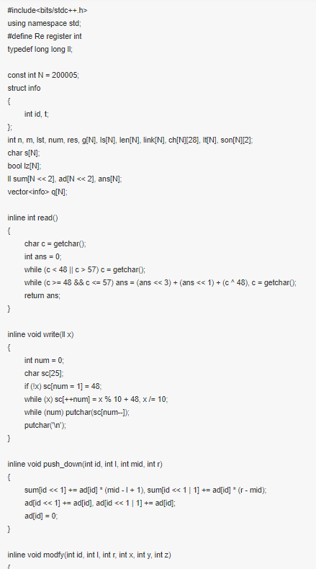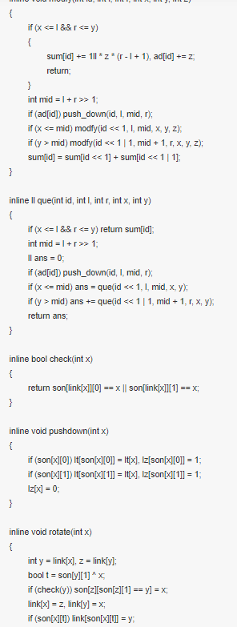
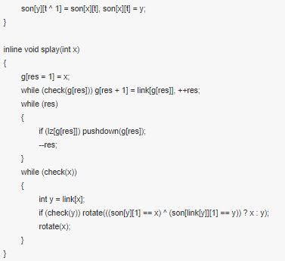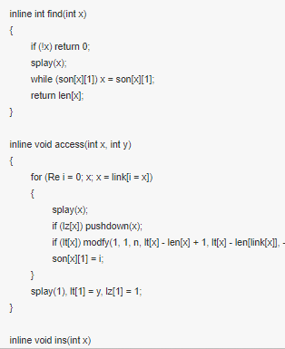

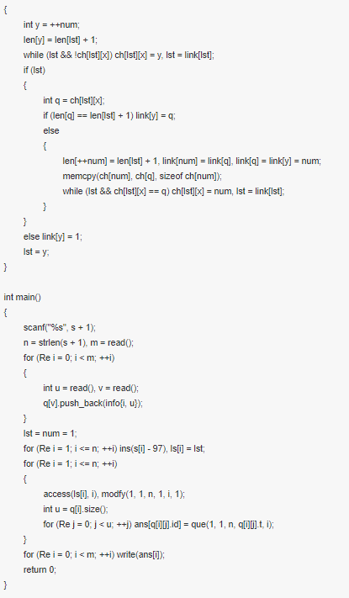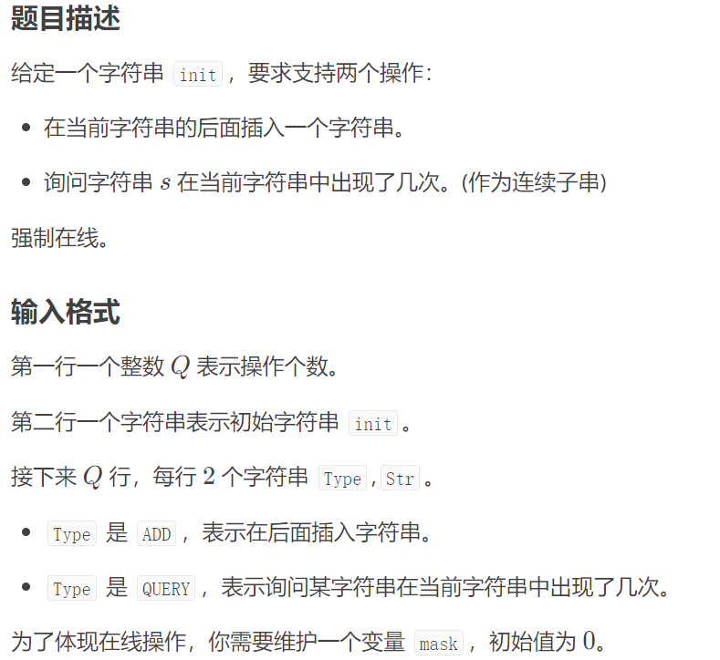
#include<bits/stdc++.h>
using namespace std;
#define ll long long
#define ull unsigned long long
#define debug(...) fprintf(stderr,__VA_ARGS__)
#define ok debug("OK\n")
inline ll read(){
ll x(0),f(1);char c=getchar();
while(!isdigit(c)){if(c=='-') f=-1;c=getchar();}
while(isdigit(c)){x=(x<<1)+(x<<3)+c-'0';c=getchar();}
return x*f;
}
const int N=3e6+100;
const int M=1e6+100;
const int mod=1e9;
int clo;

struct SAM;

struct LCT{
int tr[N][2],f[N],val[N],rev[N],add[N];
#define ls(o) tr[o][0]
#define rs(o) tr[o][1]
inline bool isroot(int x){
return ls(f[x])!=x&&rs(f[x])!=x;
}
inline bool which(int x){
return tr[f[x]][1]==x;
}
inline void Rev(int x){
if(x){
rev[x]^=1;swap(ls(x),rs(x));
}
return;
}
inline void Add(int x,int w){
if(x){
val[x]+=w;add[x]+=w;
}
return;
}
inline void pushdown(int x){
if(rev[x]){
rev[x]=0;
Rev(ls(x));Rev(rs(x));
}
if(add[x]){
int w=add[x];add[x]=0;
Add(ls(x),w);Add(rs(x),w);
}
return;
}
inline void rotate(int x){
int fa=f[x],gfa=f[fa];
int d=which(x),son=tr[x][d^1];
pushdown(gfa);pushdown(fa);pushdown(x);
f[x]=gfa;if(!isroot(fa)) tr[gfa][which(fa)]=x;
f[fa]=x;tr[x][d^1]=fa;
if(son){f[son]=fa;}tr[fa][d]=son;
}
int zhan[N];
inline void splay(int x){
int y=x,top=0;
zhan[++top]=y;
while(!isroot(y)) zhan[++top]=y=f[y];
while(top) pushdown(zhan[top--]);
for(int fa;fa=f[x],!isroot(x);rotate(x)){
if(!isroot(fa)) which(fa)==which(x)?rotate(fa):rotate(x);
}
return;
}
inline void access(int x){
for(int y(0);x;y=x,x=f[x]){
splay(x);
tr[x][1]=y;
if(y) f[y]=x;
}
return;
}
inline void makeroot(int x){
access(x);splay(x);Rev(x);
return;
}
inline int findroot(int x){
access(x);splay(x);
while(pushdown(x),tr[x][0]) x=tr[x][0];
return x;
}
inline void split(int x,int y){
makeroot(x);access(y);splay(y);
return;
}
inline void link(int x,int y){
//printf("link: %d - %d\n",x,y);
makeroot(x);makeroot(y);
if(findroot(x)==findroot(y)){
assert(0);
printf("!!\n");
return;
}
f[x]=y;
}
inline void cut(int x,int y){
//printf("cut: %d - %d\n",x,y);
split(x,y);
if(tr[y][0]!=x||tr[x][1]){
assert(0);
printf("??\n");
return;
}
tr[y][0]=0;f[x]=0;
return;
}
void newnode(int x,int f,int c=1){
link(x,f);
split(1,x);
Add(x,c);
return;
}
void print(int x){
if(!x) return;
printf("x=%d fa=%d ls=%d rs=%d val=%d rev=%d add=%d\n",
x,f[x],ls(x),rs(x),val[x],rev[x],add[x]);
print(ls(x));print(rs(x));
}
void Debug(){
printf("---debug:\n");
for(int i=1;i<=clo;i++){
if(isroot(i)) print(i);
}
putchar('\n');
}
}lct;

struct SAM{
int len[N],fa[N],tr[N][2],tot,lst;

SAM(){tot=lst=1;}

void ins(int c){
c-='A';
int cur=++tot,p=lst;lst=tot;
len[cur]=len[p]+1;
//printf("\n---ins: %d\n",c);
for(;p&&!tr[p][c];p=fa[p]) tr[p][c]=cur;
if(!tr[p][c]) fa[cur]=1;
else{
int q=tr[p][c];
if(len[q]==len[p]+1) fa[cur]=q;
else{
int nq=++tot;
len[nq]=len[p]+1;fa[nq]=fa[q];
for(int i=0;i<2;i++) tr[nq][i]=tr[q][i];

lct.splay(q);
lct.val[nq]=lct.val[q];
lct.cut(q,fa[q]);lct.link(nq,fa[q]);lct.link(q,nq);

fa[q]=fa[cur]=nq;
for(;p&&tr[p][c]==q;p=fa[p]) tr[p][c]=nq;
//printf(" clone(%d) = %d len=%d\n",q,nq,len[nq]);
}
}
clo=tot;
lct.newnode(cur,fa[cur]);
//lct.Debug();
return;
}
int work(char *s,int n){
int now=1;
for(int i=1;i<=n;i++){
int c=s[i]-'A';
//printf("now=%d c=%d tr=%d\n",now,c,tr[now][c]);
if(!tr[now][c]){
//printf("!");
return 0;
}
now=tr[now][c];
}
//printf("now=%d\n",now);
lct.splay(now);
return lct.val[now];
}
}sam;
int n,m;
char s[N],op[12],s0[N];
void get(int msk){
for(int i=0;i<n;i++) s0[i]=s[i+1];
for(int i=0;i<n;i++){
msk=(msk*131+i)%n;
swap(s0[i],s0[msk]);
//printf("i=%d msk=%d\n",i,msk);
}
for(int i=1;i<=n;i++) s[i]=s0[i-1];
return;
}
int msk;

signed main(){
#ifndef ONLINE_JUDGE
freopen("a.in","r",stdin);
freopen("a.out","w",stdout);
#endif
m=read();
scanf(" %s",s+1);n=strlen(s+1);
for(int i=1;i<=n;i++){
sam.ins(s[i]);
}
for(int i=1;i<=m;i++){
//debug("%d\n",i);
scanf(" %s %s",op+1,s+1);
n=strlen(s+1);
get(msk);
//printf("%s\n",s+1);
if(op[1]=='A'){
for(int j=1;j<=n;j++) sam.ins(s[j]);
}
else{
int res=sam.work(s,n);
printf("%d\n",res);
msk^=res;
}
}
return 0;
}

点分治 poj1741
#include <iostream>
#include <fstream>
#include <algorithm>
#include <cmath>
#include <ctime>
#include <cstdio>
#include <cstdlib>
#include <cstring>
using namespace std;
#define mmst(a, b) memset(a, b, sizeof(a))
#define mmcp(a, b) memcpy(a, b, sizeof(b))
typedef long long LL;
const int N=20005,oo=1e9+7;
void read(int &hy)
{
hy=0;
char cc=getchar();
while(cc<'0'||cc>'9')
cc=getchar();
while(cc>='0'&&cc<='9')
{
hy=(hy<<3)+(hy<<1)+cc-'0';
cc=getchar();
}
}
int n,L;
int to[N],nex[N],val[N],head[N],cnt;
int siz[N],d[N],vis[N],pre[N],root,sum;
int dep[N],a[N];
int ans;
void add(int u,int v,int w)
{
to[++cnt]=v;
val[cnt]=w;
nex[cnt]=head[u];
head[u]=cnt;
}
Void dfsRoot(int x,int fa)
{
pre[x]=fa;
siz[x]=1;
d[x]=0;
for(int h=head[x];h;h=nex[h])
if(!vis[to[h]]&&to[h]!=fa)
{
dfsRoot(to[h],x);
siz[x]+=siz[to[h]];
d[x]=max(d[x],siz[to[h]]);
}
d[x]=max(d[x],sum-siz[x]);
if(d[x]<d[root])
root=x;
}
void dfsDeep(int x,int fa)
{
a[++a[0]]=dep[x];
for(int h=head[x];h;h=nex[h])
if(!vis[to[h]]&&to[h]!=fa)
{
dep[to[h]]=dep[x]+val[h];
dfsDeep(to[h],x);
}
}
int cal(int x,int now)
{
dep[x]=now;
a[0]=0;
dfsDeep(x,0);
sort(a+1,a+1+a[0]);
int l=1,r=a[0],ans=0;
while(l<r)
{
if(a[l]+a[r]<=L)
ans+=r-l,l++;
else r--;
}
return ans;
}
void dfsSol(int x)
{
siz[pre[x]]=sum-siz[x];
vis[x]=1;
ans+=cal(x,0);
for(int h=head[x];h;h=nex[h])
if(!vis[to[h]])
{
ans-=cal(to[h],val[h]);
sum=siz[to[h]];
root=0;
dfsRoot(to[h],0);
dfsSol(root);
}
}
int main()
{
while(1)
{
cin>>n>>L;
if(n==0)
break;
cnt=0;
mmst(vis,0);
mmst(head,0);

ans=0;
for(int i=1;i<=n-1;i++)
{
int u,v,w;
read(u);
read(v);
read(w);
add(u,v,w);
add(v,u,w);
}
sum=n;
root=0;
d[0]=oo;
dfsRoot(1,0);
dfsSol(root);
printf("%d\n",ans);
}
}
Poj2114
#include <cstdio>
#include <cstring>
#include <algorithm>
#include <iostream>
#include <cmath>
using namespace std;
#define maxn 111111
#define maxm 211111
#define INF 11111111
#define size Size

struct node {
int from, to, next;
int w;
}edge[maxm];
int n, m, cnt, root;
long long ans, k;
int head[maxn];
bool vis[maxn];
int size[maxn], num[maxn]; //以i为根的子树的节点 i的子树中最多的节点
long long d[maxn], Min;

void add_edge (int from, int to, int w) {
edge[cnt].from = from, edge[cnt].to = to, edge[cnt].w = w, edge[cnt].next = head[from],
head[from] = cnt++;
}

void dfs_size (int u, int fa) {
size[u] = 1;
num[u] = 0;
for (int i = head[u]; i != -1; i = edge[i].next) {
int v = edge[i].to;
if (v == fa || vis[v])
continue;
dfs_size (v, u);
size[u] += size[v];
if (size[v] > num[u]) {
num[u] = size[v];
}
}
}

void find_root (int u, int fa, int pre) { //找到重心
long long cur = 0;
cur = max (num[u], size[pre]-size[u]);
if (cur < Min) {
Min = cur;
root = u;
}
for (int i = head[u]; i != -1; i = edge[i].next) {
int v = edge[i].to;
if (v == fa || vis[v])
continue;
find_root (v, u, pre);
}
}

int tmp[maxn], tot;
void get_dis (int u, int fa, int dis) { //得到每个点到当前根的距离
tmp[tot++] = dis;
for (int i = head[u]; i != -1; i = edge[i].next) {
int v = edge[i].to;
if (vis[v] || v == fa)
continue;
d[v] = dis+edge[i].w;
get_dis (v, u, d[v]);
}
}

int solve (int u, int d) {
long long ans = 0;
tot = 0;
get_dis (u, 0, d);
sort (tmp, tmp+tot);
int r = tot-1, l = 0;
while (r>l) {
for (; tmp[r]+tmp[l] > k && r > l; r--) {}
/*if (tmp[l]+tmp[r] == k) {
for (int i = r; i > l && tmp[l]+tmp[i] == k; i--)
ans++;
}*/
if (tmp[l]+tmp[r] == k) {
int cnt1 = 1, cnt2 = 1;
while (r > l && tmp[r-1] == tmp[r]) {
r--;
if (r > l) cnt2++;
else break;
}
while (r > l && tmp[l+1] == tmp[l]) {
l++;
if (r > l) cnt1++;
else break;
}
ans += cnt1*cnt2;
}
l++;
}
return ans;
}

void dfs (int u) {
Min = INF;
dfs_size (u, 0);
find_root (u, 0, u);
vis[root] = 1;
ans += solve (root, 0);
for (int i = head[root]; i != -1; i = edge[i].next) {
int v = edge[i].to;
if (vis[v])
continue;
ans -= solve (v, edge[i].w);
dfs (v);
}
}

int main () {
//freopen ("in", "r", stdin);
while (scanf ("%d", &n) == 1 && n) { //cout << n << endl;
cnt = 0;
int u, v;
long long w;
memset (head, -1, sizeof head);
for (u = 1; u <= n; u++) {
for (; ;) {
scanf ("%d", &v);
if (!v)
break;
scanf ("%lld", &w); //cout << u << " " << v << " " <<w << endl;
add_edge (u, v, w);
add_edge (v, u, w);
}
}
for (; ;) {
scanf ("%lld\n", &k);
if (k == 0)
break;
memset (vis, 0, sizeof vis);
ans = 0;
dfs (1);
if (ans) printf ("AYE\n");
else printf ("NAY\n");
}
printf (".\n");
//cout << k << endl;
}
//printf (".\n");
return 0;
}
题目：
给定一棵树， 带边权。现在有2种操作：1.修改第i条边的权值。2.询问u到其他一个任意点的最大距离是多少。
解法：边分治+线段树首先我们将所有的点修改和边修改都存在对应的边里面。然后接下来就是边分治的过程。对于边分治的一层来说，以这条边为界分割出来。设这条边为 x, y, w我们把这层图上所有的边修改， 点询问都拿出来， 按照修改时间排序一下。在切掉这条边的基础上。
然后以x为根， dfn建立一棵线段树， 记下边修改是修改在那个子树上的。然后以y为根， dfn建立一棵线段树， 记下边修改是修改在那个子树上的。然后对于一个修改操作来说， 就是相当于修改这颗子树的所有点的权值。对于一个询问操作来说， 就是询问这个点到这边根的距离 + 中间这条边 + 另一边的最大值。注意的是， 记得维护中间这条边的修改。为了排除虚点的影响， 我就把虚点的权值设为-inf了，但是感jio是可以不用这样搞的总复杂度分析：每个点只会出现在log个子图内， 每个修改和询问也最多是出现在这log个子图内。每幅图sort + 线段树操作1次。所以是 n * log + q * log * log。

#include<bits/stdc++.h>using namespace std;#define Fopen freopen("_in.txt","r",stdin); freopen("_out.txt","w",stdout);#define LL long long#define ULL unsigned LL#define fi first#define se second#define pb push_back#define lson l,m,rt<<1#define rson m+1,r,rt<<1|1#define lch(x) tr[x].son[0]#define rch(x) tr[x].son[1]#define max3(a,b,c) max(a,max(b,c))#define min3(a,b,c) min(a,min(b,c))
typedef pair<int,int> pll;const int inf = 0x3f3f3f3f;const LL INF = 0x3f3f3f3f3f3f3f3f;const LL mod = (int)1e9+7;const int N = 2e5 + 100;struct Node{
int head[N], to[N<<1], nt[N<<1], ct[N<<1], id[N<<1];
int tot;
void init(){
memset(head, -1, sizeof(head));
tot = 0;
}
void add(int u, int v, int cost, int fid){
ct[tot] = cost;
to[tot] = v;
nt[tot] = head[u];
id[tot] = fid;
head[u] = tot++;
}
}e[2];int n, maxn, m, white[N], cut[N<<1];void rebuild(int o, int u){
int ff = 0;
for(int i = e[0].head[u]; ~i; i = e[0].nt[i]){
int v = e[0].to[i];
if(o == v) continue;
if(!ff){
e[1].add(u, v, e[0].ct[i], e[0].id[i]);
e[1].add(v, u, e[0].ct[i], e[0].id[i]);
ff = u;
}
else {
++n;
e[1].add(ff, n, 0, 0); e[1].add(n, ff, 0, 0);
e[1].add(n, v, e[0].ct[i], e[0].id[i]); e[1].add(v, n, e[0].ct[i], e[0].id[i]);
ff = n;
}
rebuild(u, v);
}
}
int sz[N], minval, id;void get_edge(int o, int u, int num){
sz[u] = 1;
for(int i = e[1].head[u]; ~i; i = e[1].nt[i]){
int v = e[1].to[i];
if(v == o || cut[i>>1]) continue;
get_edge(u, v, num);
sz[u] += sz[v];
int tmp = max(sz[v], num - sz[v]);
if(tmp < minval){
minval = tmp;
id = i;
}
}
}int k = 0, op;int qtot = 0;
pll P[N<<2];int L[N];
vector<pll> edge[N];
vector<pll> Que[N];
LL ans[N];int col[N];int ecol[N];struct GG{
LL a[N];
LL seg[N<<2], lazy[N<<2];
int point[N];
int edis[N];
int tot = 0;
int dfn[N], out[N], fdfn[N];
void dfs(int o, int u, LL dis){
sz[u] = 1;
dfn[u] = ++tot;
fdfn[tot] = u;
col[u] = op;
if(u > maxn)
a[tot] = -INF;
else
a[tot] = dis;
for(pll & t : Que[u])
P[++qtot] = t;
for(int i = e[1].head[u]; ~i; i = e[1].nt[i]){
int v = e[1].to[i];
if(v == o || cut[i>>1]) continue;
ecol[e[1].id[i]] = op;
point[e[1].id[i]] = v;
edis[e[1].id[i]] = e[1].ct[i];
for(pll & t : edge[e[1].id[i]]){
P[++qtot] = t;
}
dfs(u, v, dis + e[1].ct[i]);
sz[u] += sz[v];
}
out[u] = tot;

}
void Build(int l, int r, int rt){
lazy[rt] = 0;
if(l == r){
seg[rt] = a[l];
return ;
}
int m = l+r >> 1;
Build(lson); Build(rson);
seg[rt] = max(seg[rt<<1], seg[rt<<1|1]);
}
void Tree_Build(){
Build(1, tot, 1);
}
void PushDown(int rt){
if(lazy[rt]){
lazy[rt<<1] += lazy[rt];
lazy[rt<<1|1] += lazy[rt];
seg[rt<<1] += lazy[rt];
seg[rt<<1|1] += lazy[rt];
lazy[rt] = 0;
}
}
void Update(int L, int R, int C, int l, int r, int rt){
if(L <= l && r <= R){
seg[rt] += C;
lazy[rt] += C;
return ;
}
int m = l+r >> 1;
PushDown(rt);
if(L <= m) Update(L, R, C, lson);
if(m < R) Update(L, R, C, rson);
seg[rt] = max(seg[rt<<1], seg[rt<<1|1]);
}
void Tree_Update(int id, int ct){
int u = point[id];
Update(dfn[u], out[u], ct-edis[id], 1, tot, 1);
edis[id] = ct;
}
LL Query(int L, int l, int r, int rt){
if(l == r) return seg[rt];
PushDown(rt);
int m = l+r >> 1;
if(L <= m) return Query(L, lson);
return Query(L, rson);
}
LL Tree_Query(int x){
return Query(dfn[x], 1, tot, 1);
}
void init(){
tot = 0;
}
}Seg[2];void solve(int u, int num){// cout << u << " " << num << endl;
if(num <= 1) return ;
minval = inf;
get_edge(0, u, num);
int nid = id;
cut[nid>>1] = 1;
qtot = 0;
op = 0;
Seg[0].init();
Seg[0].dfs(0, e[1].to[nid], 0);
Seg[0].Tree_Build();
op = 1;
Seg[1].init();
Seg[1].dfs(0, e[1].to[nid ^ 1], 0);
Seg[1].Tree_Build();
int gid = e[1].id[nid];
for(pll & t : edge[gid])
P[++qtot] = t;
sort(P+1, P+1+qtot);
for(int i = 1; i <= qtot; ++i){
if(P[i].se < 0){
int u = -P[i].se;
if(u == gid)
e[1].ct[nid] = L[P[i].fi];
else
Seg[ecol[u]].Tree_Update(u, L[P[i].fi]);
}
else {
int u = P[i].se;
int id = col[u];
ans[P[i].fi] = max(ans[P[i].fi], Seg[id].Tree_Query(u) + Seg[id^1].seg[1] + e[1].ct[nid]);
}
}
solve(e[1].to[nid], sz[e[1].to[nid]]);
solve(e[1].to[nid^1], sz[e[1].to[nid^1]]);
}int main(){
e[0].init(), e[1].init();
scanf("%d", &n);
maxn = n;
for(int i = 1, u, v, w; i < n; ++i){
scanf("%d%d%d", &u, &v, &w);
e[0].add(u, v, w, i);
e[0].add(v, u, w, i);
}
int q, u;
char s[4];
scanf("%d", &q);
for(int i = 1; i <= q; ++i){
ans[i] = -1;
scanf("%s", s);
if(s[0] == 'Q'){
scanf("%d", &u);
Que[u].pb(pll(i, u));
}
else {
scanf("%d%d", &u, &L[i]);
edge[u].pb(pll(i, -u));
}
}
rebuild(0, 1);// cout << n << endl;
solve(1, n);
for(int i = 1; i <= q; ++i){
if(~ans[i])
printf("%lld\n", ans[i]);
}
return 0;
}

