Fewer repeaters, Better benefit
Summary
The present paper is aiming at providing a solution, which is a method to settle the allocation of the repeaters to meet the condition accommodating users communicating synchronously. With different constraint and requests, the problem can be views as the mixture of a Topological Structure problem, a Coloring problem and an Irregular Changing problem.
First of all we propose two basic models to determine the type of repeater and the repeater arrangement-rules. By analyzing the conditions and requests given by the problem from the problem, we establish a reasonable model for single repeater and the design some arrangement rules for the communication with a repeat group.
Secondly we set a model to solve the problem (1). The essence of the problem is topological structure selection problem. In order to simplify the model, only three candidates of topological structure mode, namely triangle structure, square structure and honeycomb structure. We find out the relationship between the smallest number of covering-layer and the radius of single repeater and then, restore it to real condition by setting the scale. With the request of minimal number of covering-layer, the repeater group is relocated for minimizing the number of repeaters inside the given area.
Thirdly we set a color mode to settle the problem (2). The essence of the problem (2) is coloring problem under the communication constraints. Each repeater is labeled with a color according to its PL tone and wording frequency pair. Any point in the given area should not be covered by repeaters with the same color. Consider the constraints on the PL tone, wording frequency band and the properties of repeaters. Problem (2) is turning to a coloring problem with public section. After complex calculation, we discover that the original mode does not work for this problem. And searching for other optimal solution is necessary. We raise three kinds of changes including change the model of repeaters, the topological structure of repeaters arrangement and the minimum number of the circles covering a point and develop the original model to solve the problem(2).
Finally we establish a dynamic-radium model in which Mountain regions are described as block functions. The essence of the problem (3) is irregular changing problem. We can abstract mountain into an area of quadrilateral. The repeaters, established on the top of the mountain will extend their coverage radius. Because the geographical position of repeaters is mainly decided by their radius, the repeaters nearby the mountain area are accordingly shifted to adapt the original repeater map.
Based on above works, it is concluded that the honeycomb structure is the optimal arrangement for repeaters. Under the constraints on the maximal accommodation capability, some changes are necessary. Besides if the mountain is considered, some radius-enlarged repeaters should be relocated and the repeater map should be adapted accordingly.
Contents
1. Introduction................................................................................................................ 3
1.1 Problem statement: ............................................................................................. 3
1. 2 Background the technology of the CTCSS: ...........................................................3
1. 3 The usage of CTCSS: ......................................................................................... 3
2.Key Terminology: ...................................................................................................... 4
3. Analysis ....................................................................................................................... 4
4. Basic Assumption and Hypotheses ........................................................................... 5
5.The model of Repeaters ............................................................................................. 6
5.1The maximal number of repeaters in one area ................................................... . 6
5.2The volume of each repeater ................................................................................. 7
6. Topological Structure:............................................................................................... 7
6.1 Fading the area ................................................................................................... 7
6.2 Basic model structure (Take the triangle as an example) .......................................... 8
7 Solving problem (1)..................................................................................................... 9
7.1 Symbols: .......................................................................................................... 10
7.2 Dot map ........................................................................................................... 10
7.3 Locations of the repeaters. .................................................................................. 11
7.4 Result of triangle ............................................................................................... 12
7.5 Comparison among network structure (triangle, square), honeycomb structure ....... 12
7.6 Result of problem (1)(Referring Fig 11) ............................................................... 12
8. Solving problem (2).................................................................................................. 13
8.1 Analysis ........................................................................................................... 13
8.2 The temporary solution ...................................................................................... 13
8.3 How many kinds of repeater we need. ............................................................ 15
8.4 Limitations ....................................................................................................... 16
8.5 The changes ..................................................................................................... 16
8.5.1 Change the model of repeater ...................................................................... 16
8.5.2 Change the model of structure ..................................................................... 17
8.5.3 Change in the distance between repeaters. ..................................................... 17
9. The discussion of problem (3) ................................................................................. 17
9.1 Supplements of assumption: ............................................................................... 17
9.2 Solution: .......................................................................................................... 18
10 Model evaluation ..................................................................................................... 19
10.1.Advantages of the model................................................................................ 19
10.2 Limitations of the model ............................................................................... 20
11.Reference ................................................................................................................. 20
1. Introduction
1.1 Problem statement:
There’s a VHF radio spectrum involving line-of-sight transmission and reception. Thanks to a repeater by picking up weak signals, amplifying them, and retransmitting them on a different frequency. Due to the exclusion of the influence interfere including the geographical separation, more repeaters (and hence more users) can be accommodated in a particular area.
Question (1): Determine the minimum number of repeaters to accommodate 1,000 simultaneous users. Spectrum is 145 to 148 MHz, frequency difference 600 kHz, and 54 PL tones is available in the area of radius 40 miles?
Question (2): What’s the changes if there are 10,000 users?
Question (3): Discuss the case taking account of mountainous areas?

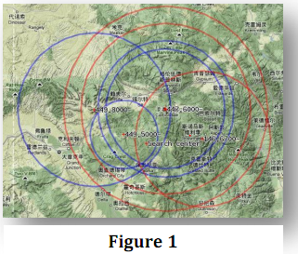
1.2 Background the technology of the CTCSS:
In the early 1950s some geniuses in Moto R&D developed a system which added a low frequency tone to the existing transmitter audio that was present as long as the transmitter was keyed. The receiver was modified by adding a tone detector circuit to the receiver and then the receiver squelch was modified so that it wouldn’t open unless the tone was there. The legal folks patented the idea and the technique then trademarked the term “Private Line”. Sales literature of the time compared the system to the receiver having a front door lock on it, and the transmitter having a key ring full of keys, and only the signal with the correct “key” could open the lock. (Referring to Figure 1)

- 3 The usage of CTCSS:

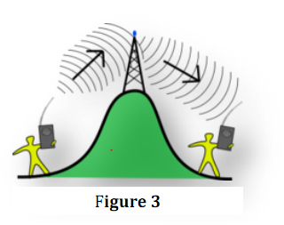
CTCSS don’t cure or prevent reference interference, it truly adds earplugs full of selection. The ability of a receiver to mute the audio until it detects a carrier with the correct CTCSS tone is called decoding. Receivers are equipped with features to allow the CTCSS "lock" to be disabled. To draw a conclusion, the 54 different PL tones are the key to determine the receivers. (Referring to Figure 3)

2.Key Terminology:
Covering-layers (CL): The circle represents a repeater influencing radium.

Color Bitmap (CB): The bitmap is full of colored circle.

Uplink frequency: refers to the transmitting station to the satellite on the signal transmission frequency used. The signal is launched from the ground up, so called uplink frequency.

Topological Structure: Topological spaces are mathematical structures that allow the formal definition of concepts such as convergence, connectedness, and continuity. They appear in every branch of modern mathematics and are a central unifying notion. The branch of mathematics that studies topological spaces in their own right is called topology.

Coloring Problem: The graph coloring is a classic NP-complete problem. Presently there is no effective method to solve this problem.

3. Analysis
The problem is a combination of Topological Structure problem , coloring problem and irregular Changing problem. Ideally, we try to search an approximate location structure. Regarding it as a special topological structure with many circles, we choose network structure (triangle, square), honeycomb structure as research objects, then choose a better optimum allocation .The position of the point’s intersection represents a repeater. Different structures gets different numbers .Our goal is to get the min one. Problem (2) is not only the problem of increasing users, but also the problem of Coloring Problem. It’s that even if the model of problem (1) can solve problem (2), there’s a limit, as well; because 54 different PL tones and 3 communications channels must be considered. As a result, the species of repeaters we can use is limited by 54 different PL tones and 3 communications channels. At the aim to solve the problem, we must check the answer, that is whether the population being surging to 10,000 or not. At first use the model (1) to make a optimum allocation. And then we must check, in this case, whether the number of colors we need is less than 162. It must appear two conditions. The first is the bingo condition. The limit is unnecessary. The second is mismatching. At that condition we must make changes. Problem (3) is the case considering the effect of mountainous areas. When repeaters are on the mountain, their covering radius aren’t the same value any more. In this case, the covering radius and the max number of users that a repeater can contain are varying, meanwhile, the structure allocation is also irregular .Then we should discuss the change trend of the structure.

4. Basic Assumption and Hypotheses

To ensure the range is separated by repeaters in 40 miles round, every point communication can accommodate 1,000 people at the same time. We make the following assumptions

- Repeaters are arranged in topologies structure. Only one kind of polygon will be able to piece together into a complete graphic graphics area. Take account of the covering repeatedly at least. Network structure (triangle, square), honeycomb structure is considered only.

- In ideal condition, if PL and numbers of frequency in spectrum satisfies, there’s no affection.

- According to the information from the website , “50Km” is the max radium of a ideal repeater.

- The impact-strength doesn’t turn off as the increasing radium.

- Ignore the user how to get connect with their repeaters. Meanwhile the signal from the user transmits to one repeater only.

- After calculating, central angle is 3.4 X 10-5 °. It’s too small comparing with the earth. Draw a conclusion, the area is similar to a flat plane.

- Assume repeaters operating in ideal conditions. Ignore the weather, radiation etc. influencing the work of repeater.

5.The maximal number of repeaters in our area

5.1 The species of repeaters
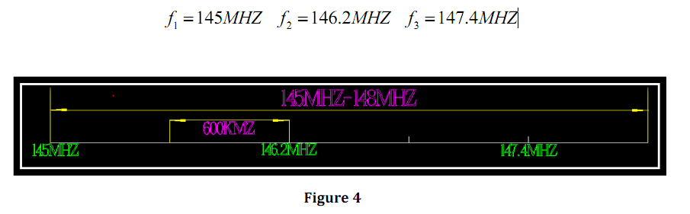
Check the problem “Assume that the spectrum available is 145 to 148 MHz, the transmitter frequency in a repeater is either 600 kHz above or 600 kHz below the receiver frequency.” At the aim of avoiding the interruptions from other frequency channel, we take frequency band in three parts. Draw a spectrum with CAX2009. “f1, f2, f 3” are three suitable starting points. (Referring to Figure 4)
Use different colors identifying different repeaters. . The spectrum available is 145 to 148 MHz .Only three communication-channels are available. Meanwhile there are 54 different PL tones available. The maximum types of repeaters are done.
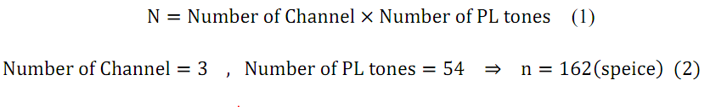
※Each kind represents a unique of color
5.2 The volume of each repeater
Refer to the article on the Internet. One person approximately occupy the spectrum with bandwidth 3.5 KHz. “max” is the most volume in one area ,which one repeater controls.
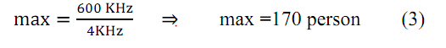

6．Topological Structure:

6.1 Fading the area

If we assume that the distribution of repeaters is uniform. So we use the triangle, square and hexagonal circular making area filled.
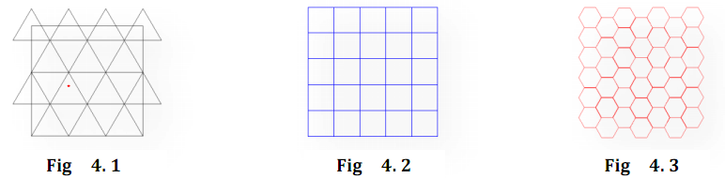
After referring to the map of repeaters in the USA, we regard the problem as a mixture of Graph Theory and Coloring Problem.(Referring Fig 4. 1,Fig 4. 2,Fig 4. 3)
If we find the trend of the increasing radius, it’s easy to know the relationship between CL and radius. Different colors mean different CLs. Besides we will get the most suitable radius and RC. Take consideration of the spectrum, frequency differences and PL tones .we will get the approximate volume of each repeaters. Finally compare all of them . The calculated number and location of the repeaters is mapped.
Use Matlab making different radius, while every different parts will has a unique color .Colors represent CLs. Find the relationship between CLs and radius.
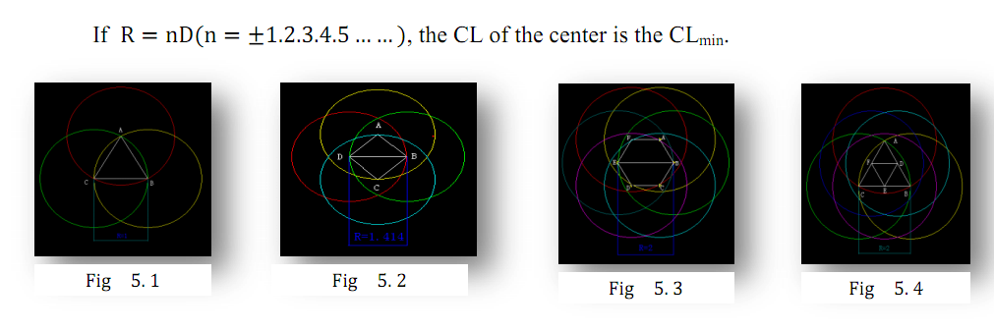
Take the use of Triangle as the basic parts of area fading the whole circular flat area of radius 40 miles radius. It’s easy to find the center of the polygon has the most CLs. Take the center as a detection.
We draw network with circles structure (triangle, square), honeycomb structure using CAXA 2009.Take one triangle as an example
The Fig shows an increasing trend .The longer the radius, the more CLs at a point. So there’s a relationship between the radius and the minimum of the CLs(Referring Fig 5. 1,Fig 5. 2,Fig 5. 3, Fig 5. 4)

6.2 Basic model structure (Take the triangle as an example)

Because of three methods of pulling the whole area, we just take the triangle as an example. The distance between two points is changing. Changing the pixels of the distance will lead different conclusion. If the distance is being large, the color of each area is changing .The optical color is filled mostly. The map in real must be drawn later.

The first step: Dot Matrix making
First make a matrix with a lot of points evenly distributed in the lattice of discrete random, in Matlab .Every point means a unique repeater. The circle will be added up later.

The second step: Adding the circle
Make numbers of circles instead of every bit. The center of every circle is at the locations of the bits. We take the “R=50 Pixel” representing “Radium=50km”. Scale bar between the Dot Matrix and the real is done.

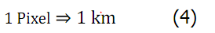

The third step: Make the Distance smalller
Try much distance as much as possible. The coloring bitmap is different. Our aim is to find the best course to make sure the expected conclusion.
.
The fourth step: Add the color
We check every area in the map. If it’s circled in Ncl times, we take a unique color to represent the area. We can differ the Ncl by color. Skim the flow process diagram .Different kind of color is in a mixture. It’s hard to detect without deal.

Obtain the correct region
Check every point .If the pigment of one area is higher than the standard’s, turn it into red. Else if change it into blue. After the handle-process, the final pigment map is appeared. It’s the final map to judge.(Referring Fig 6)
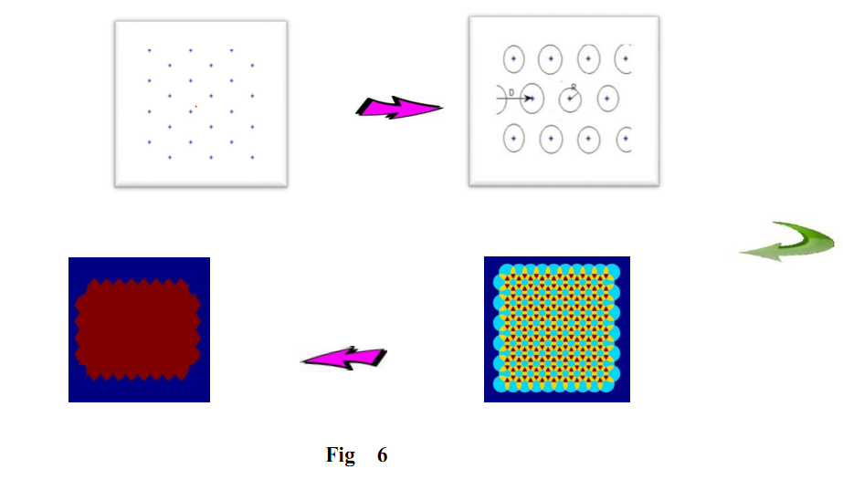
7 Solving problem (1)
We can judge the feasibility of the model by using the final coloring map, Next step, add constraint of the volume in the area of a repeater. The finale conclusion may be done regarding triangle as an example.
7.1 Symbols:
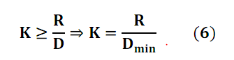
r is the radium of the 40 miles area
N is the different number which one repeater can obtain.
Ncl is the number of the circles covering a point
Num is the number of repeater.
M is the number of repeater specie
7.2 Dot map
Different pigments mean different numbers of layers covering. “max=150 person” is in one circle. So different color represent different number(Ncl). n is 1000 in problem(1)
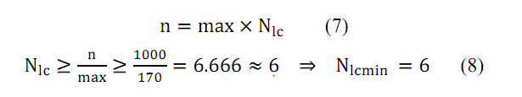
Different K can make different CB. If Ncl is more approximate to Nclmin ,the CB is more suitable. There is one unique CB.(Referring Fig. 7)
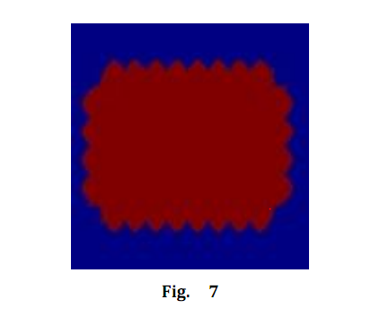
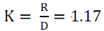
Calculate the CB by Mathlab. R=50pixel=50km
The radius of circular flat area is 40 miles. Refer the equation that “1 mile = 1.60931 km”. The radium(r) may get. “ 64.37 km”
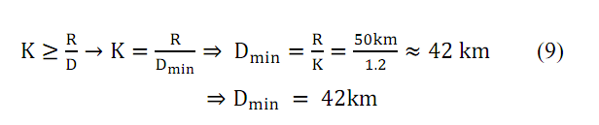
Draw the real map back .
The lower the repeater is , the better. Dmin means the appropriate distance .Draw back the real map.(Referring Fig. 8)
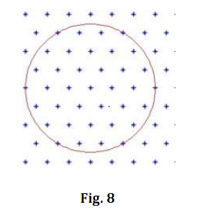
7.3 Locations of the repeaters.
It’s known that “ 64.37 km≈64 pixel”.
Add the circle with “r=64pixel” on the Matrix making. Shadow region represents the circular flat area of radius 40 miles radius. (Referring Fig 9)
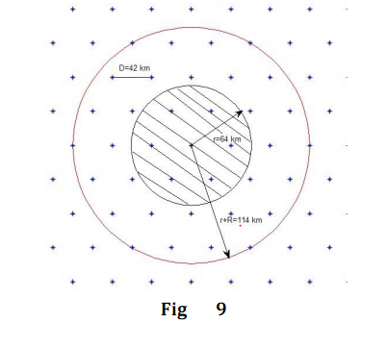
7.4 Result of triangle
“K, Num, Nclmax, Nclmin” is the decisive factors .If taking the triangle as an example. The “K, Num, Nclmax, Nclmin” must be sure.( Referring Chart 2)
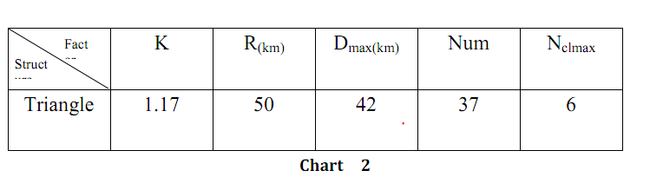
  - Comparison among network structure (triangle,
square), honeycomb structure
The triangle is an example below. Square and hexagonal take the same process. They are different programs. Try to get a reasonable program. Decisive factors are “K , Num, Nclmax, Nclmin”, ( Referring Chart 3).
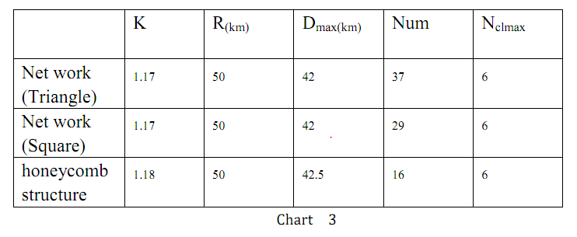
So we choose the hexagonal honeycomb structure.
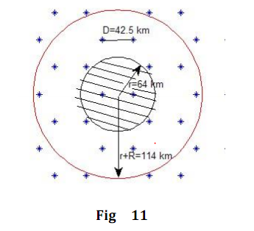
7.6 Result of problem (1)(Referring Fig 11)
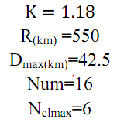

8. Solving problem (2)
8.1 Analysis
Obviously the different between them is the N. It’s 1,000 to 10,000. Refer the question (1). We may get solution. But there is a limit.. 54 different PL tones and 3 communications channels must be considered. Check the answer if the population is surging to 10,000. The problem is transformed to the coloring problem. More CLs is equal to containing more people. But the total number of repeaters is 162. The limitation is appearing. It must use 162 different color construct the bitmap. Besides no reusing is in the same CL. It’s two conditions. The first is the bingo condition. The limit is unnecessary. The second is mismatching. We must take the use of method exhaustion. The original model is useless.
8.2 The temporary solution
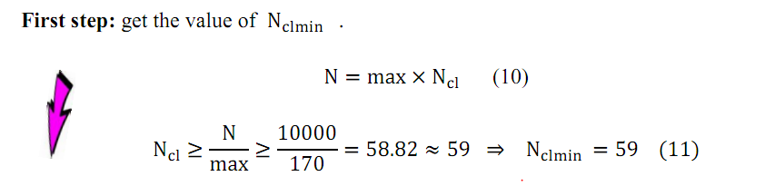
The same part between them are “max=150 person”“R=50pixel=50km” .Repeat the same process. We draw a conclusion that honeycomb structure is the most suitable structure.

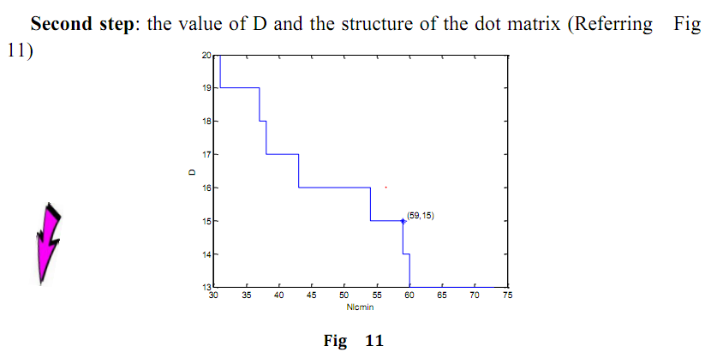
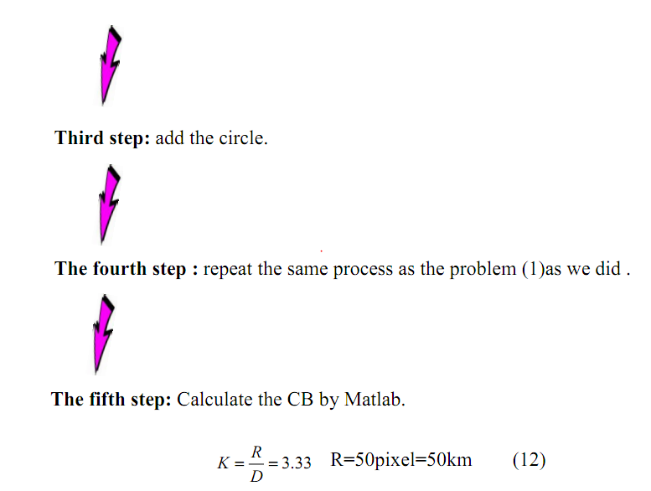
The radius of circular flat area is 40 miles. Refer the equation that “1 mile = 1.60931 km”. The radium(r) may get. “r=40mile=64.73Km ”.
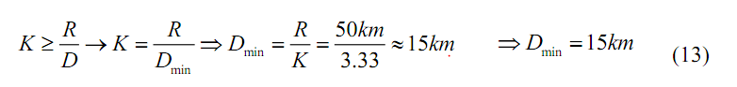
Then we get the following map by Matlab( Referring Fig 12)
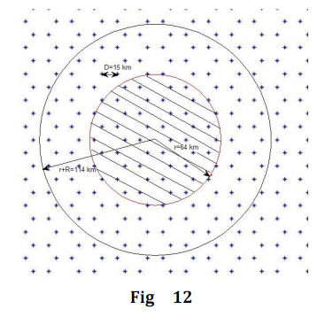
In this case, Nclmin=59 and Nclmax=68.However, is the repeater species we need less than 162?
8.3 How many kinds of repeater we need.

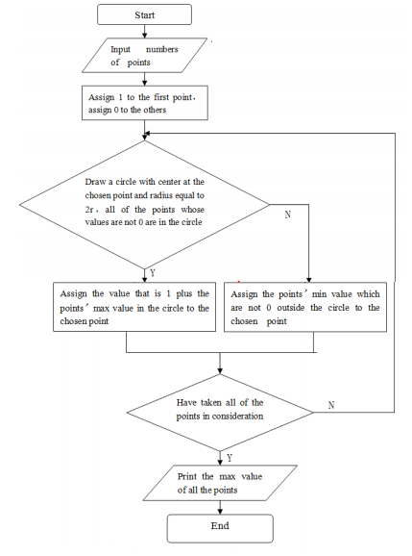
Let the computer generate a matrix of number .There’s not same point influencing circle of other point.

Using Matlab run the program, get the final M=177
8.4 Limitations
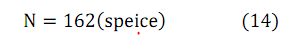
If 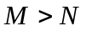the solution is mismatch
Else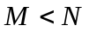 the solution is bingo
Our model can’t solve the problem (2). So we try some other Model Optimization as well as the changes of the Topological Structure.

8.5 The changes
From the discussion above, we draw a conclusion that we can change repeater species, structure and the min value of Ncl in order to solve the problem.
8.5.1 Change the model of repeater
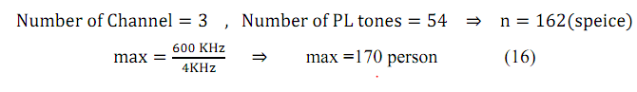
Referring the model of repeater, The species of repeaters, the Volume of each repeater are independent variable.
These parameters are in ideal conditions. Change one of them. A circular flat area of radius 40 miles radius could contain more people. Perhaps the problem (2) could be solved. It’ must be a combination of the variable value can take that, 10.000 people communicate at every dot in reality .
8.5.2 Change the model of structure
Just three structures: network structure (triangle, square), honeycomb structure are considered. If the model of repeater isn’t changed, change the structure such as Bus topology, Star topology, Ring topology, Tree topology, Meshed topology.

Choose other structures. Check them with the standard of maximum coloring .And chose a better one..
8.5.3 Change in the distance between repeaters.
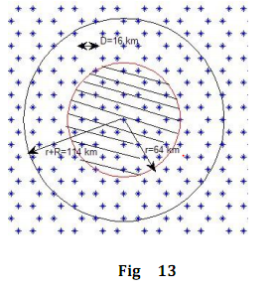
Change the min value of Ncl: We learn that when the Nclmin of Problem(2) is 59 , Nclmax=68 and M is 177>162,so the problem cannot be solved. Therefore we can decrease Nclmin in order to make M≦162.The more approximate to 162, the better it is. In this case, most of the points (repeaters) are necessary to accommodate 10000 users synchronously. Finally, we get the best value of Nclmin by Matlab. It is 54 and one point of the area can accommodate at least 9180 simultaneous users. Under the circumstances, 64.3 percentages of points can accommodate 10000 simultaneous users. (Referring Fig 13)
9. The discussion of the problem (3)
9.1 Supplements of assumption:

1. There can be many repeaters built on the top of the mountain.
2. When a repeater is built on the top of the mountain, repeater’s covering radius will increase. We assume it’ll add up to 75 km.
3. Assume affect region of mountains is a quadrangle with a length of d and a width of l.
4. Assume if repeaters are near to mountains, we build them on the top of mountains.

9.2 Solution:
When discussing the previous problems, we don’t consider the geographic location. Now we take it into consideration, for example, mountains can block signals. As a result, repeaters’ covering radius aren’t the same value any more. With covering radius changing, the structure changes as well.
Obviously, the sum of covering radius also changes, as the Chart 3.Based on it, we can see that a big circle can cover a small circle, two big circles can cover two small circles, three big circles can cover three small circles, four big circles can cover five small circles, five big circles can cover six small circles and so on.
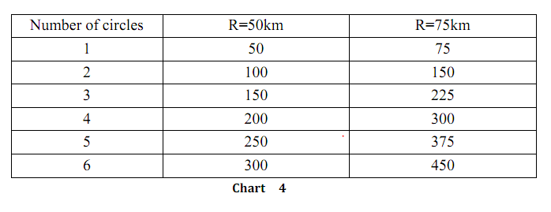
However, circles with the same covering radius can be covered by each other. As a result, the discipline can’t adapt to the case entirely. But if 80 or more than 80 percentages of a small circle can be covered by a big one, we can deem the small one being covered entirely. For instance, when repeaters in the area are necessary to accommodate 1,000 simultaneous users, that is R=50km,D=42.5km,the repeaters' honeycomb topologies structure is the one shown in Fig14.
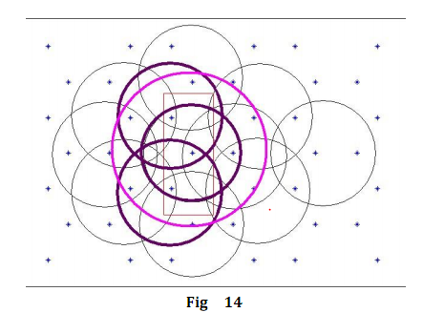
Obviously, when the repeater at the center of Fig14 is built on the top of the mountain, the percentage is 85%>80%.In this case, we can use a repeater on the top of the mountain to replace the two at the edge of the area. Then we can see the repeaters' honeycomb topologies structure turns to the one shown in Fig15.

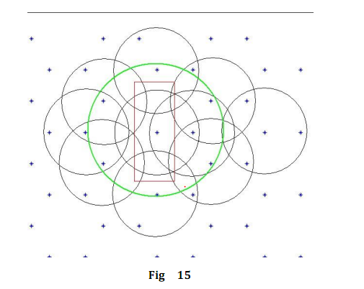
10 Model evaluation
10.1. Advantages of the model
1. Creative: The model transforms the complicated problem into the problem in a mixture of Topological Structure problem, Coloring problem and Irregular Changing problem, making programming easier to complete.

2. Strongly logical: In the process of building model, we choose three common topologies structure, compare them with each other and optimize them. Then we choose the honeycomb topologies structure. It makes the model more acceptable.

3. Flexible: We turn the coloring problem with public section, according to the problem, get a best number of PL we need by programming.(2)When taking the geographic location into consideration, we use “irregular changing problem” to analyze the effect on the structure of repeaters .Then we get the structure when repeaters are built on the top of mountains.

10.2 Limitations of model

1. In the process of solving problems, we ignore many factors which can effect repeater’s covering radius, such as weather, radiation, loss of signal. As a result, the result we get has difference with the real one.

2. As a result of the Coloring Problem being a NP-complete problem, when we calculate the min value of the colors we need, the value we get is just a locally optimal solution. It makes the result a little inaccurate, as well.
11. Reference
- Li Fang、Wenhua Dou.etc, After the minimum connected sensor cover set myself the problem solving algorithm, Journal of Software Vo1.17, No.2,Febrary 2006 .pp.175_184[in Chinese]
- Huasheng Cheng,Yuexn Zhang, Visual C++ Programming based ,Szhou
University Press, 2000[in Chinese]
- Zhixiong He,Pairs of permutations and combinations to explore coloring
problem，Dehong Teachers College (Department of Mathematics)
http://wenku.baidu.com/view/e200cc8da0116c175f0e48df.html [in Chinese]
- Qixiao Ye, Mathematical Contest in Modeling resource materials，Hunan
University Press, 1997 [in Chinese]
- Wei Zhang，Expanded coverage of digital MMDS measures，The state
broadcasting film and television administration (SARFT), 2008 15(9), pp.64-64,84，
- http://www.cqvip.com/qk/81884X/200809/28234665.html [in Chinese]
- Qiyi Liu,Amateur Radio Communications Technology，Posts & Telecom
Press，
- Gordon L.Stliber.etc Principles of Mobile Communication (Second Edition) ,
Publishing house of electronics industry ,[in Chinese]
- http://en.wikipedia.org/wiki/Topological_space

