|  |  |  |  |  |  |  |  |  |  |  |  |  |  |  |  |  |  |  |  |  |  |  |  |  |  |
| --- | --- | --- | --- | --- | --- | --- | --- | --- | --- | --- | --- | --- | --- | --- | --- | --- | --- | --- | --- | --- | --- | --- | --- | --- | --- |
| |  |  | | --- | --- | | For office use only | | | T1 | ________________ | | T2 | ________________ | | T3 | ________________ | | T4 | ________________ | | |  | | --- | | Team Control Number **46522** | |  | | Problem Chosen **A** | | |  |  | | --- | --- | | For office use only | | | F1 | ________________ | | F2 | ________________ | | F3 | ________________ | | F4 | ________________ | |

**2016   
MCM/ICM**

**A Hot Bath,A Best Strategy  
Summary**

**Contents**

Introduction 2

Assumptions 3

Model Parameters 3

Models 4

Model Overview 4

Model 1: Static Model 6

➢Model Analysis 6

➢Model Building 7

➢Model Testing 7

Model 2:Only Inflow Model 9

➢Model Analysis 9

➢Model Building 10

➢Model Testing 10

Model 3：Equal Flow Import and Export Model 12

➢Model Analysis 12

➢Model Building 12

➢Model Testing 13

Optimization Model 13

➢Model Analysis 14

➢Simulation Results 14

Sensitivity Analysis 15

Conclusion 19

Strengths and Weaknesses 20

Strengths 20

Weaknesses 21

References 21

**Introduction**

**Assumptions**

**Model Parameters**

**Table 1.**

|  |  |  |
| --- | --- | --- |
| Parameter | Meaning | Unit |
|  | temperature of water in the bathtub |  |
|  | temperature of adding hot water |  |
|  | temperature of wall surface of the bathtub |  |
|  | time of adding water |  |
|  | the moment of water began to overflow |  |
|  | heat dissipation coefficient of bathtub wall |  |
|  | the flow of hot water into the bathtub |  |
|  | Boltzmann constant | - |
|  | radiation coefficient of water |  |
|  | radiation coefficient of bathtub wall |  |

**Models**

**Model Overview**

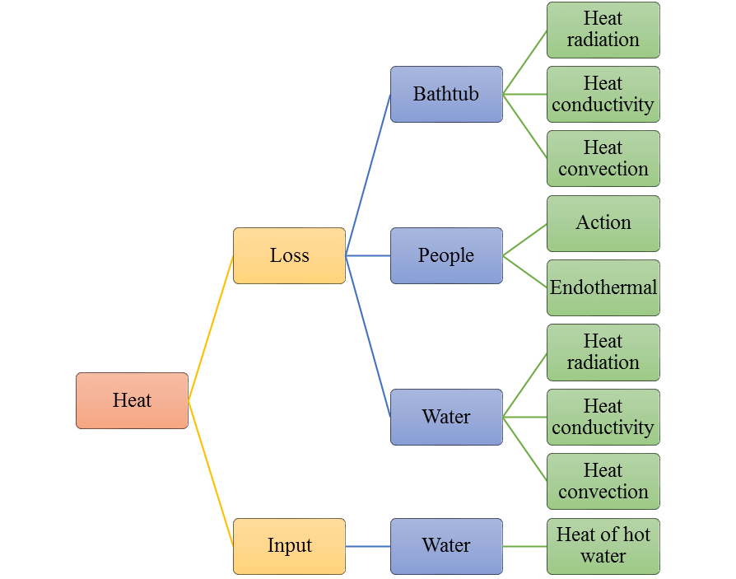

**Figure 1.**The total energy change of water in the bathtub.

Model Overview

We divide the bath process into three phases. They correspond to three models. Model 1:Static Model、Model 2:Only Inflow Model、Model 3：Equal flow imports and export Model.

* First, we consider the system in natural state thermal energy conversion. Energy losses including water circulated by heat and lead to sporadic bath heat and energy loss. The specific energy loss method is shown in Figure 1. On this basis, we build the Model 1.
* Temperature decrease gradually. When the man feels cold, he turns on the tap. Allows the water to flow into the bathtub of hot water. **But at the moment the bathtub water damage did not reach the overflow outlet.**Model 2. only need to add hot water inflow of heat can be on the foundation of the Model 1. Of course, we cannot ignore quality flow into the bathtub.
* Finally, when the water in the bathtub reaches the height of the overflow, a new energy change is created. That is the energy of the water flowing out. Our model three is based on the model two to account for the loss of energy.

Our three models can description of the whole process of bathing. We can also solve mission temperature as close as possible to the initial temperature of the strategy.

According to the survey, common materials for acrylic bathtub, we selected the common parameters are as follows:

**Table 2.**

Model Parameters

|  |  |  |
| --- | --- | --- |
| **Parameter** | **Meaning** | **Value** |
|  | initial temperature | 312 |
|  | ambient temperature | 289 |
|  | surface area of the bathtub’s upper surface | 0.66 |
|  | surface area of the all inner wall of the bathtub | 2.29 |
|  | thickness of bathtub wall | 0.02 |
|  | overflow height of bathtub | 0.48 |
|  | volume of the initial water in the bath tub | 0.21 |
|  | the average volume of thehuman body inthe bathtub | 0.06 |
|  | the average area of the human body into the bathtub | 1.45 |
|  | maximum capacity of bathtub | 0.3168 |
|  | the quality of initial water in the bathtub | 210 |
|  | the quality of water in bathtub when overflowing | 256.8 |
|  | heat dissipation coefficient of water | 300 |
|  | heat thermal conductivity of bathtub’s wall | 0.19 |
|  | density of water | 1000 |
|  | the temperature of feeling cold | 305 |
|  | specific heat capacity of water |  |

**Model 1: Static Model**

* **ModelAnalysis**
* **Model Building**
* **Model Testing**

**Parametric hypothesis**

**Model simulation and result**

**Result Analysis**

**Model 2:Only Inflow Model**

* **Model Analysis**
* **Model Building**
* **Model Testing**

**Parameter hypothesis**

* The temperature of feeling the cold is ;

**Model simulation and result**

**Result Analysis**

**Model 3：Equal Flow Import and Export Model**

* **Model Analysis**
* **Model Building**
* **Model Testing**

**Parameter hypothesis**

* The moment of water began to overflow: 
* The temperature of water began to overflow: 

**Model simulation and result**

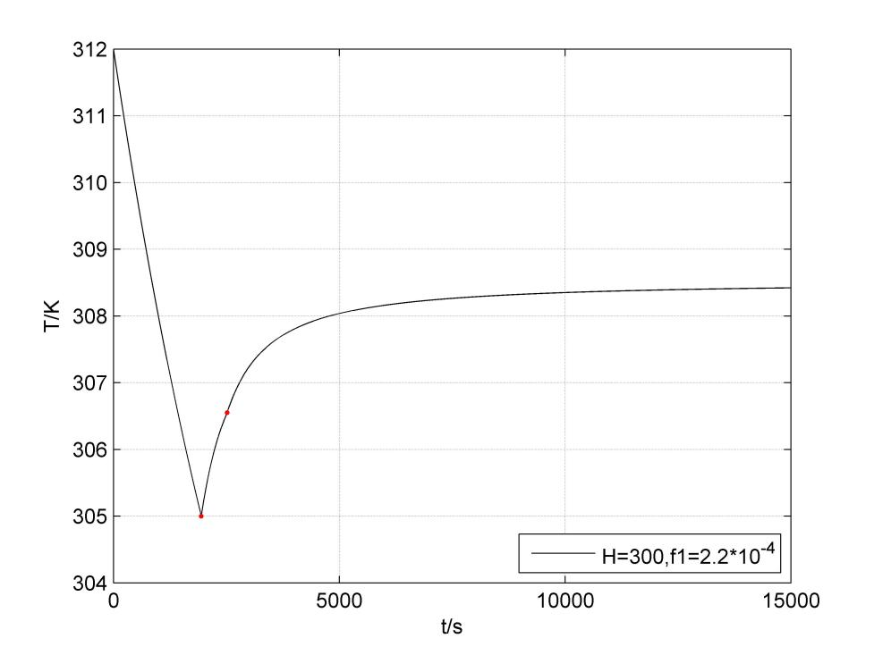

**Figure 9.** The simulation and result of Model 3

**Result Analysis**

From the **Figure 9.** we can found that the results are similar to Model 2. They are the first rapid heating, with the temperature rise temperature rise rate gradually slowed down.The final water temperature tends to be a lower than the value of the inflow temperature.We choose a large flow, the same as the initial temperature of the water to heat. Obviously, the result is not ideal. It not only has not reached the ideal temperature, but also the heating rate is very low. Therefore, we consider the next higher than the initial temperature of the water to heat.

**Optimization Model**

* **Model Analysis**
* **Simulation Results**
* **Optimization Strategy**

**Sensitivity Analysis**

* **Influence of the bathtub shape**
* **Influence of bath volume**
* **Influence of human volume**
* **Influence of human shape and temperature**
* **Influence of human motion on Strategy**
* **Analysis of the influence of soap bubbles**

**Conclusion**

**Strengths and Weaknesses**

**Strengths**

* Through this model, we can get a control object (water temperature at a certain time) making it maintains a strong degree of balance (i.e., the sensitivity of each variable is almost zero) of the better control strategy.

**Weaknesses**

* We don't have enough necessary data to validate the model.

**References**

**Appendix**