Palatino Linotype

字体

结构：

第一段：

近年来，xxx问题引起了广泛的关注。Xxxxxxx

In recent years, the issue of xxx has arose wide concerns.

因此，为了解决xxx，我们采取了如下行动。

Thus, with an attempt to mitigate xxx, we proceed as follows.

第二段：

第一，我们设计了xxx模型来模拟xxx，具体介绍模型思路。

devise a **xxx model**

**…**

**给一些结果**

Firstly, we develop AMS model which mainly uses ARIMA sequence to predict the

SST.

In addition,

When it comes to task two, we build…

In task three, we analyzed the crisis of small fishing companies in Scotland and

relocated them from an economic perspective.

**最后，我们对HSI模型进行了敏感性分析，因为**

**鱼类种群的分布将影响捕捞公司的最佳位置。 因素**

**可能会影响其结果，例如盐度，pH，自然灾害和迁徙**

**鱼类种群的性质，已予以考虑。 结果表明模型仍然可以保持**

**他们的高效率。 换句话说，我们的模型具有高稳定性，高容错性**

**率和广泛的适用性。**

Finally, we performed a sensitivity analysis on the HSI model, because the predicted

distribution of fish stocks would affect the optimal location of fishing companies. Factors

that might affect its results, such as salinity, pH, natural disasters, and the migratory

nature of fish stocks, were taken into account. The result shows that models can still keep

their high effectiveness. In other word, our models have high stability, high error-tolerant

rate and extensive applicability.

As for problem 1, it is referred that resistance to erosion reaches its maximum when the water-faced surface is smooth.[4] Thus,

Problem 3 is discussed in two cases:

Four advice is given in problem 4:

Finally, sensitivity analysis of coefficient of length cutting 𝜆𝜆𝑐𝑐, coefficient of saturated water absorption 𝜆𝜆𝑠𝑠, initial volume 𝑉𝑉0

We analyze the sensitivity of the linear prediction model, while we add 5% random

disturbance, the maximum relative error is 3.98%, the model can be considered stable. Finally, We write an article for Hook Line and Sinker Magazine.

**Keywords**

Optimizing Model;

**引用网图也要给网址**

Firstly, set the Seawater Temperature Prediction Model. We use historical data of seawater temperature to predict seawater temperature changes in the target sea area in the next 50 years. Secondly, set the Fish Migration Prediction Model. We describe the correlation between seawater temperature changes and fish migration directions, and then simulate fish migration directions based on seawater temperature changes in the target sea area over the next 50 years. Finally, set the Fishing Company Earnings Evaluation Model. We assess changes in the profitability of fishing companies based on the migration of fish in the next 50 years and discuss strategies to deal with such changes subject to some objective conditions.

In summary, the whole modeling process can be shown as follows:

* We formulate the problem as a network flow in which vertices are the locations of escorts and wheelchair passengers.
* **We divide the map into grids, and it is more convenient to study after discretization.**
* **We divide the model into three phases: Rasterization of Regions, Wildfire Frequency-Distance Weighted Model and Multi-objective Optimization Model.**
* The Poisson framework is simple and yet flexible enough to allow for a statistically sound modelization of the occurrence of forest fires. it has aclear probabilistic interpretation, which is a definite advantage in risk assessment.

The is divided into three(数字) phases, as shown in the figure:

三维图很好看

**好看的图**

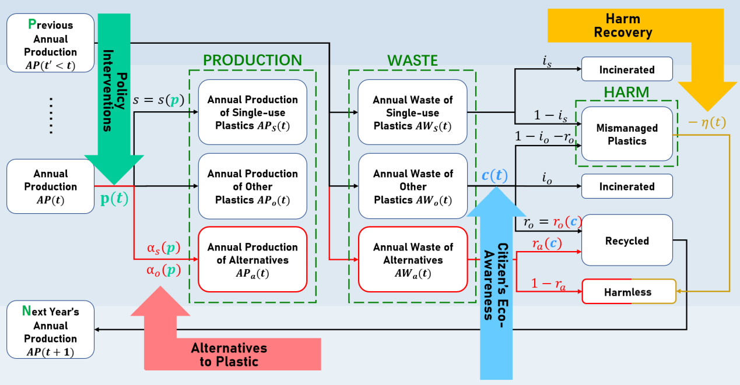

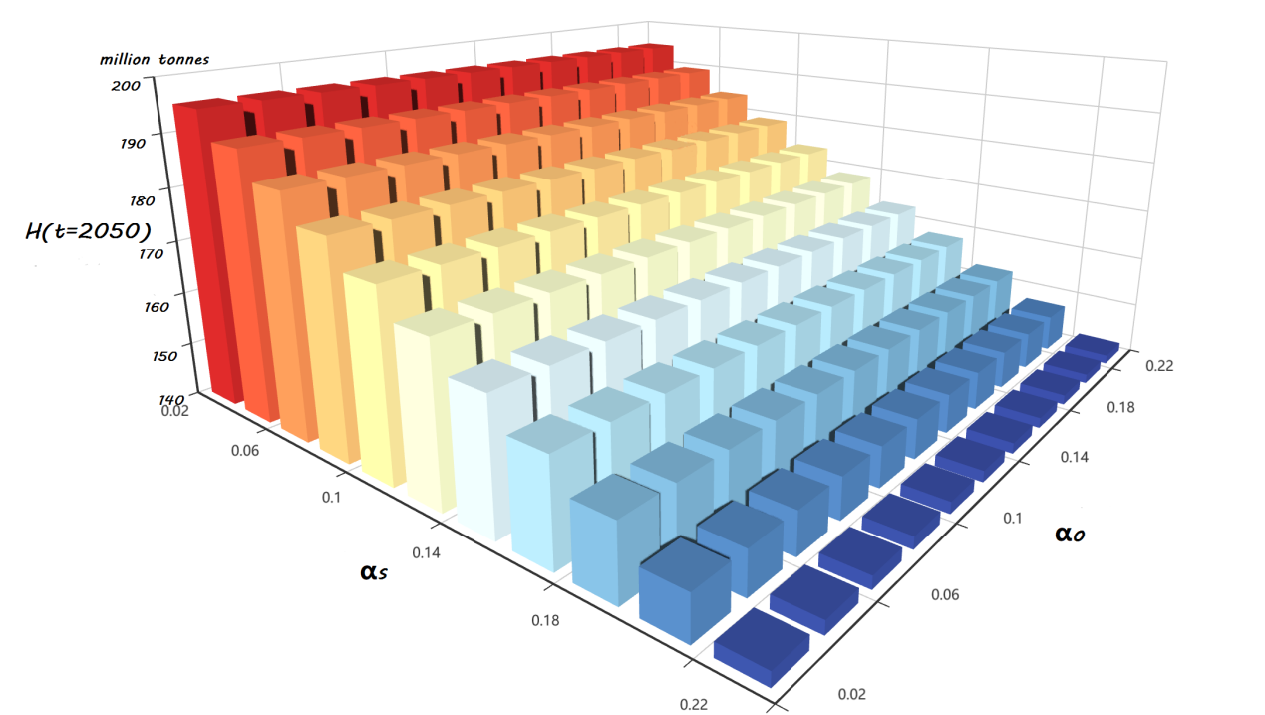

**两变量的灵敏度分析**

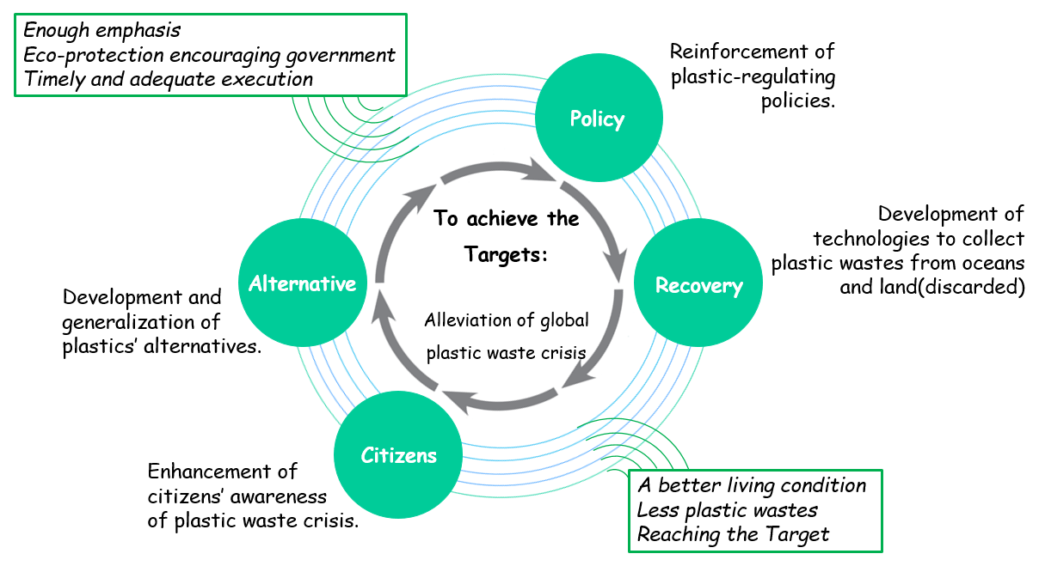

**Memo里**

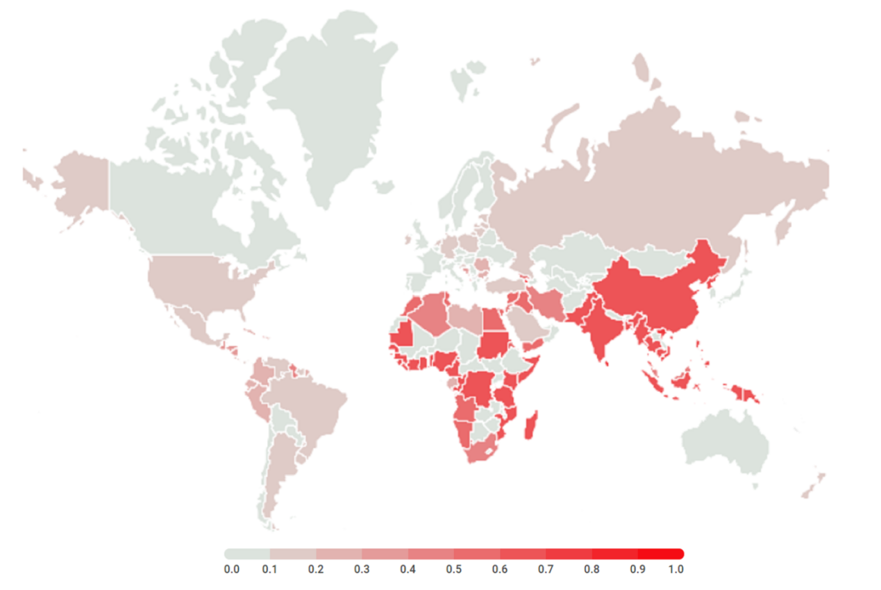

**地理热图常用**

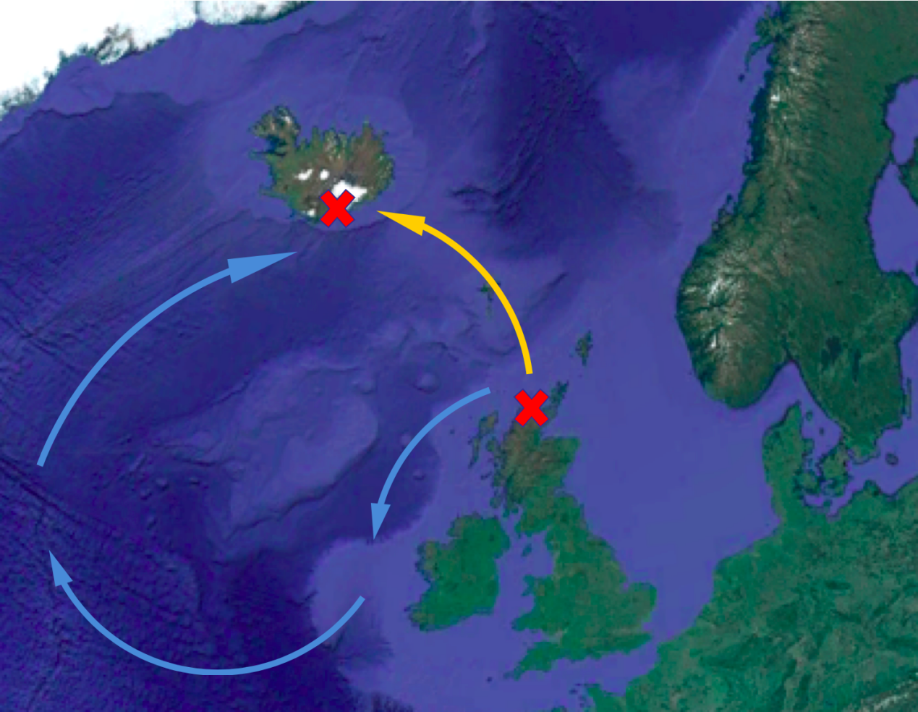

**要学会画箭头 打标记 图才好看**

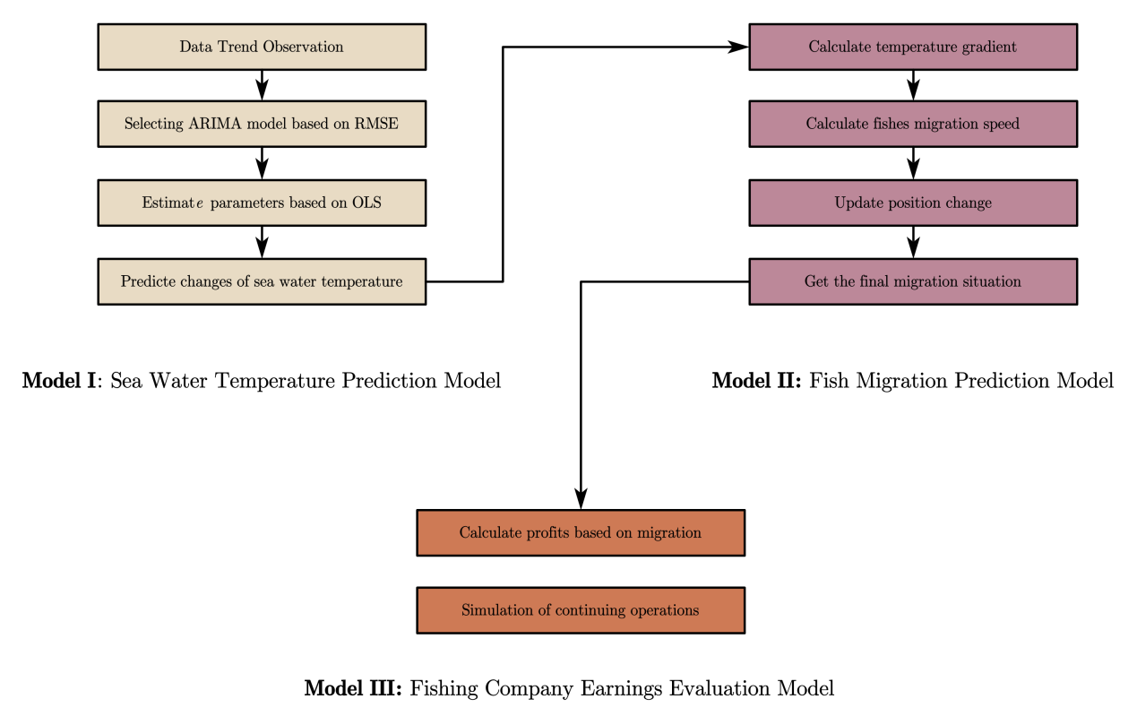

**模型概述 我很喜欢**

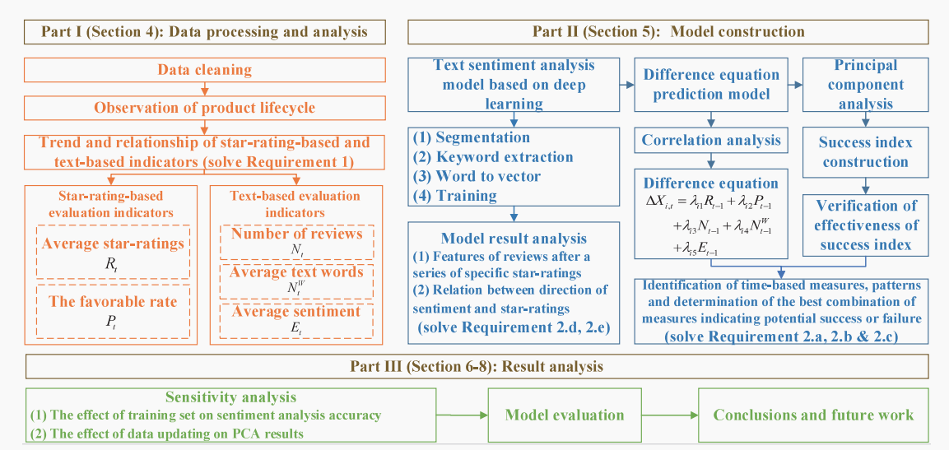

**这个画的太完整了 我们做完之后也要给这样大的概况**

|  |
| --- |
| **framework** |

**结构 框架**

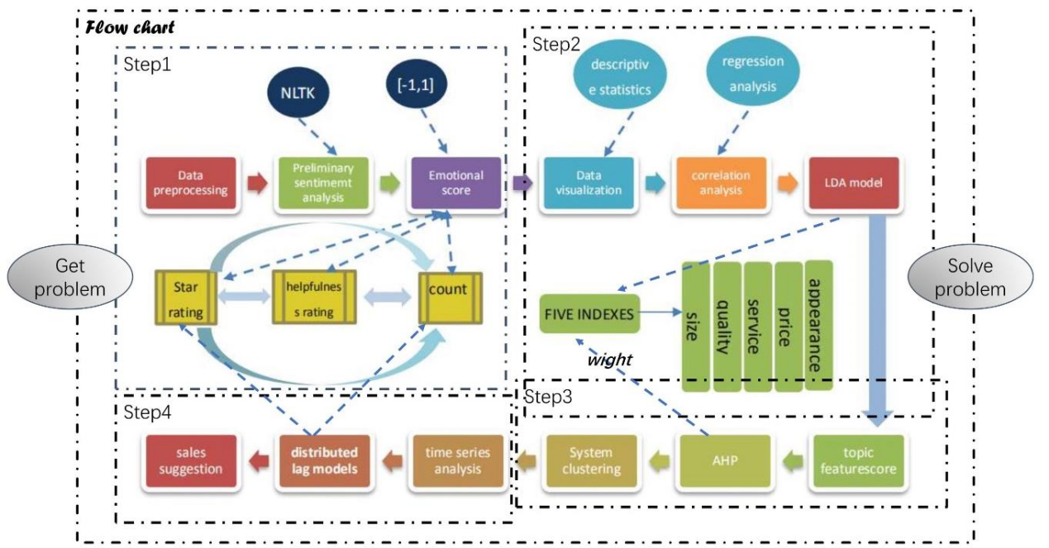

**全文的flow chart**

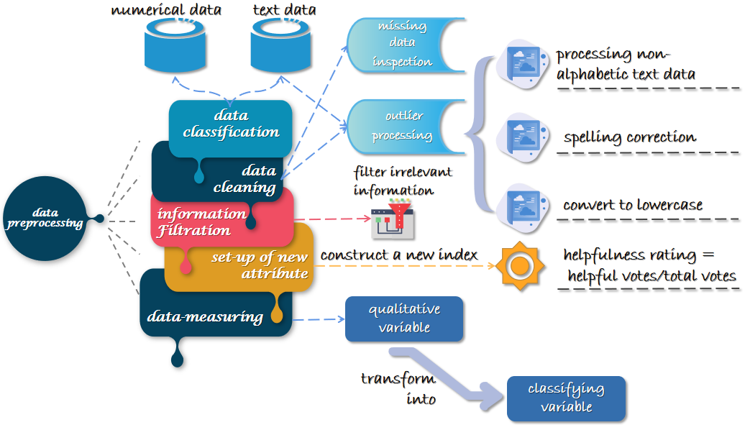

**数据处理的flow chart**

**来自2010638 C题 拿SPSS做的**

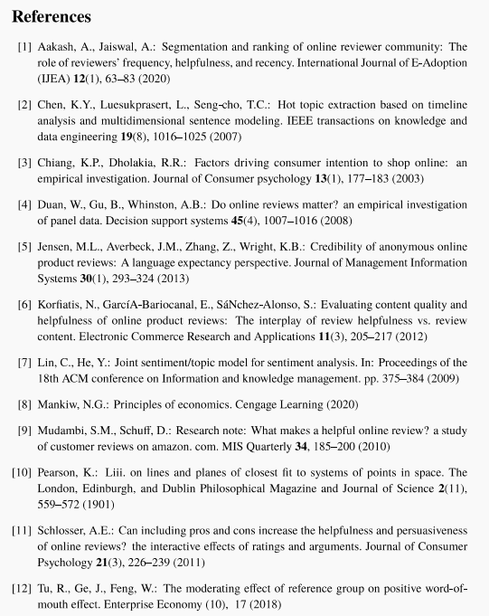

**参考文献的排版**

