ent2

A randomness testing suite for Makers.

Quality Control v 0.1
September 2022
Paul Uszak
www.reallyreallyrandom.com

Revisions.

0.1 10 September 2022. Initial draft.

Table of Contents
1. Revisions. 2
2. Objective. 4
3. The old `ent`:- 5
3.1. Output. 5
3.2. Current issues. 5
4. The new `ent2`. 7
4.1. Output 7
4.2. Justification 7
5. Test determination. 9
5.1. PASS/FAIL 9
5.2. Messages. 12
6. Encoding simulated CDFs 13
7. Test descriptions. 15
7.1. Min. entropy. 15
7.2. Chi square distribution. 16
7.3. Permuted compression ratio. 16
7.4. Pure compression. 17
7.5. Arithmetic mean. 18
7.6. Serial Correlation 19
7.7. Monte Carlo value for Pi 19
7.8. Excursion from mean 21
7.9. Runs. 22
8. Quality control/testing the tests. 23
9. Issues. 24

Objective.

gfdasgdsa

Reference test tests.

The following images are visual representations of binary and text files that were tested with `ent2`. They are 640 x 800 pixels x 8 bits grey level (512,000 bytes). Only Mersenne Twister.bin passes all nine tests.
The `ent2` output also serves as reference results for other users to compare with. This should identify any problems with changes in the Python compression and scientific libraries that underpin some of the individual tests.

Mersenne Twister.bin


Urandom + ?.bin

Randu.bin

Lena.bin

Shakespeare.zip


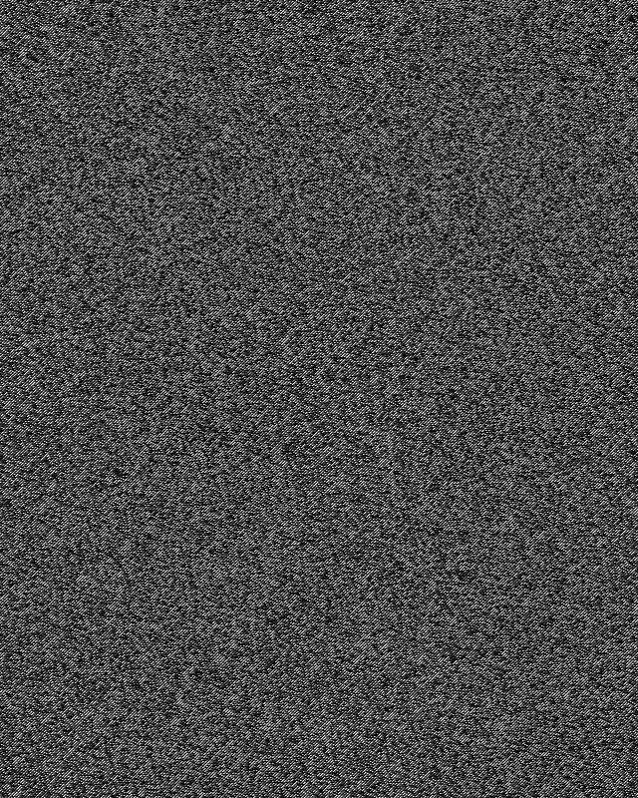


Shakespeare.txt

Expected test failure rate.

We expect 5% of the tests of a perfectly random sample set to fail (Type I error) if α = 0.05. This failure rate expectation will be checked by running `ent2` XXXX times against samples drawn from /dev/random. This procedure will also contribute to validating the individual tests.

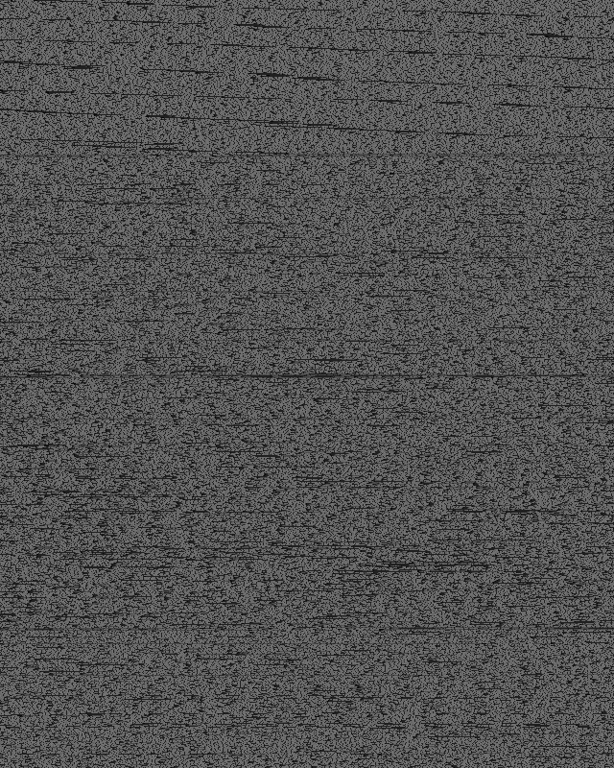Shakespeare in text.

