ent2

A randomness testing suite for Makers.

Specification 0.2
15 August 2022
Paul Uszak
www.reallyreallyrandom.com

Revisions.

0.1 10 August 2022. Initial draft.
0.2 15 August 2022. Minor corrections, additional questions and updated charts.

Table of Contents
1. Revisions. 2
2. Objective. 4
3. The old `ent`:- 5
3.1. Output. 5
3.2. Current issues. 5
4. The new `ent_v2`. 7
4.1. Output 7
4.2. Justification 7
5. PASS/FAIL determination. 9
6. Questions. 12
7. Test descriptions. 14
7.1. Min. entropy test. 14
7.2. Permuted compression ratio. 16
7.3. Pure compression. 18
7.4. Arithmetic mean. 19
7.5. Serial Correlation 20
7.6. Monte Carlo value for Pi 22
7.7. Excursion from mean 23

Objective.

Creation of a new accurate and easy to use randomness test suite tailored for TRNG Makers generating in the sub 1 MB space. It will be a derivative of the `ent` test suite @ https://www.fourmilab.ch/random/ incorporating PASS and FAIL statuses for individual tests, alleviating the need for interpretation of p values. The results of the tests will be followed by a final conclusive recommendation as to whether the sample set can be used for cryptographic purposes.

The old `ent`:-

Output.

From an arbitrary test run:-

Entropy = 6.028367 bits per byte.

Optimum compression would reduce the size
of this 3220 byte file by 24 percent.

Chi square distribution for 3220 samples is 9694.33, and randomly
would exceed this value less than 0.01 percent of the times.

Arithmetic mean value of data bytes is 83.3404 (127.5 = random).
Monte Carlo value for Pi is 4.000000000 (error 27.32 percent).
Serial correlation coefficient is 0.020502 (totally uncorrelated = 0.0).

Current issues.

- In “evaluating pseudorandom number generators for encryption”, the required entropy rate is 1 bit/bit or 8 bits/byte. Anything substantially less is useless for cryptography. There is no need to measure it as the only result concerning us is a pass/fail determination within agreed confidence bounds, à la the other standard randomness tests like `dieharder`. Yet there are no bounds and no determination of any p values for confidence other than for a bit/byte distribution χ².
- And it can’t be used for general entropy measurement in it’s default setting, as it reports the wrong type of entropy. Cryptography focuses on the most conservative min.entropy H∞, not Shannon entropy. `ent` reports Shannon entropy which is always higher for all sample distributions other than uniform. And uniform distributions are uncommon from most DIY entropy sources.
- “BUGS: Note that the ‘optimal compression’ shown for the file is computed from the byte- or bit-stream entropy and thus reflects compressibility based on a reading frame of the chosen width (8-bit bytes or individual bits if the -b option is specified). Algorithms which use a larger reading frame, such as the Lempel-Ziv [Lempel & Ziv] algorithm, may achieve greater compression if the file contains repeated sequences of multiple bytes.”
- A consequence of the above is that an 8-bit window presupposes IID data with a relaxation period not greater than 8 bits. It is common to see `ent` used (incorrectly) against non-IID data sets. In those cases the reported entropy would be much higher than the true rate.
In summary, there is no confidence in the `ent` metrics as to whether the sample data set is suitable for cryptography.

The new `ent_v2`.

Output

The v2 vision for an arbitrary test run. For 64 kB, 128 kB, 256 kB and 512 kB sample sizes. But for initial release, targeting 512 kB. Based on the author’s experience, it should be possible to generate such a sample set from a DIY TRNG given that there is no rush to do so.
The input file should be checked for complying with these sizes at ingestion and a message issued if necessary.

Permuted compression ratio, FAIL (?).
Runs, PASS (p = 0.4).
Serial correlation, FAIL (p = 0.00004).

SAMPLES ARE NOT IID.

Pure compression, PASS (?).
Chi square distribution, PASS (p = 0.5).
Arithmetic mean value, FAIL (p = 0.0008).
Monte Carlo value for Pi, PASS (p = 0.5).
Excursion from mean, FAIL (p = 0.99).

Min. entropy, FAIL (p = 0.002).
Min. entropy < 5.91 bits per byte.

SAMPLES UNSUITABLE FOR CRYPTOGRAPHY @ ALPHA = 0.05.

Reference https://sites.google.com/site/astudyofentropy/background-information/the-tests/dieharder-test-descriptions as a description of Dieharder tests/problems.

https://nvlpubs.nist.gov/nistpubs/SpecialPublications/NIST.SP.800-90B.pdf

Justification

- Creates an unambiguous test result per sample set. `ent2` will have PASS, FAIL and finally use or don’t use for cryptography messages.
- No statistics knowledge will be necessary to interpret the results.
- If any test statistics are output, they will always be +ve values, i.e. abs(test statistic) following the current `ent` output.
- Minimization of type II errors to err on the side of security.
- An α = 0.05 creates a test 5x stronger than in the NIST Randomness Test Suite, Special Publication 800-22 ((STS), https://nvlpubs.nist.gov/nistpubs/legacy/sp/nistspecialpublication800-22r1a.pdf) which uses α = 0.01. And 50x stronger than in the NIST Recommendation for the Entropy Sources Used for Random Bit Generation, Special Publication 800-90B (https://nvlpubs.nist.gov/nistpubs/SpecialPublications/NIST.SP.800-90B.pdf) uses α = 0.001.
- Target the 64 kB to 512 kB sample space as there is no current alternative (other than the original `ent`). FIPS140-2 is plainly useless. NIST’s STS requires a minimum of 1.25 MB of samples for 10 bitstreams.
- Maintains the majority of `ent` test types, but tightens the test bounds.
- Maintains a similar name for familiarity.
- Make calibration algorithms and resultant data available to instil confidence through the opportunity for independent validation.

PASS/FAIL determination.

It is suggested that α = 0.05 for the reasons in section 4.2.
The tests are either single or two tailed, and if single tailed, may be left or right handed. For example (single tailed, left handed):-

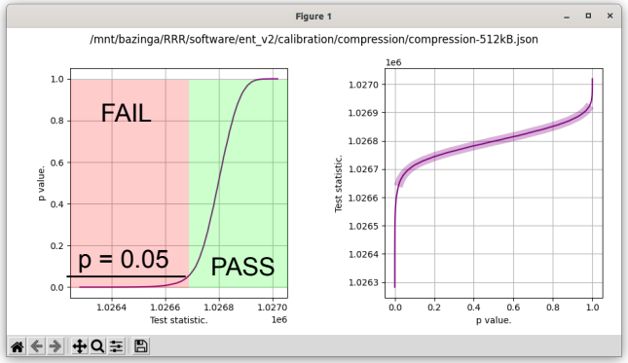Test statistics for the pure compression test on a 512 kB sample set. The purple highlight is the range 0.025 ≤ p ≤ 0.975.
With α = 0.05, criticals @ p = [0.025 0.05 0.95 0.975] = [1026653.74535627 1026684.09009091 1026896.62800875 1026912.85180169]. In this case PASS ≥ 1,026,684 bytes with a one tailed test. If the test statistic were 2 MB, although extremely unlikely, it must still logically be considered a PASS as the sample set did not compress.
And a two tailed test:-
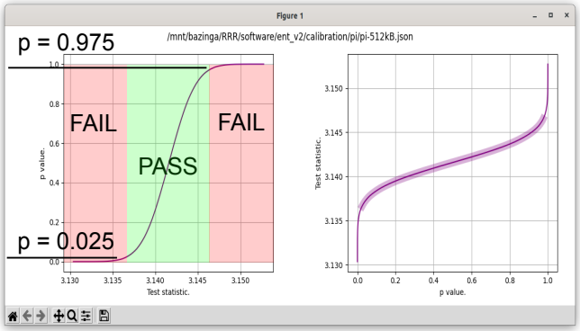Test statistics for the Monte Carlo value for pi test on a 512 kB sample set. The purple highlight is the range 0.025 ≤ p ≤ 0.975.
α = 0.05, criticals @ p = [0.025 0.05 0.95 0.975] = [3.13666963 3.13746903 3.14568527 3.14649241]. In this case 3.13666963 < PASS < 3.14649241 with a two tailed test.

100,000 trials for calibration simulations with 100 bins to construct the cumulative distribution functions. It may be possible to numerically fit normal distributions to some of the test statistics, e.g. permuted compression ratio.

Test | Test purpose | Calibration data | p value determination
Permuted compression ratio | IID | Simulated | CDF interpolation/From z score?
Runs | IID | Simulated | CDF interpolation
Serial correlation | IID | Simulated | CDF interpolation
Pure compression | 8 bit randomness | Simulated | CDF interpolation
Chi square distribution | 8 bit randomness | Algebraic | From z score
Arithmetic mean value | 8 bit randomness | Algebraic | From z score
Monte Carlo value for Pi | 8 bit randomness | Algebraic | From z score
Excursion from mean | 8 bit randomness | Simulated | CDF interpolation
Min. entropy | 8 bit randomness | Simulated | CDF interpolation

Questions.

These are the issues:-
- WHAT IS v2 FOR EXACTLY?
- For the Maker space unfamiliar with statistics. Trying to nullify all the crypto.SE questions about NIST, diehard and dieharder testing.
- Aim: minimisation of type II errors.
- 500 kB exact file size? Example value from ent home page.
- 8 bits/byte sample file? (Most tests fail for bits < 8).
- I like pi approximation as it uses 4 byte tuples. Plus sentimentality as it’s in `ent`.
- Does the 68–95–99.7 (±3δ) rule have any place here for PASS/FAIL?
- There is the 80/20 rule. α = 0.8? Too strong?
- From SP 800-22, “For the examples in this document, α has been chosen to be 0.01”.
- If we can’t assign a p value, can we use a range from simulation?
- What are the benefits of a p over a range? We can easily get both via simulation.
- Isn’t it a pain to have to install all of those libraries, e.g. numpy? Portability/dependencies? Showstopper?
- Might need to distribute calibration file(s) to prevent Python updates in compression altering our CDFs. See https://www.calculatorsoup.com/calculators/math/factors.php to get the right size from an image of something.
- Might have to include instructions for installing dependent Python libraries.
- Create GitHub space?
- How many trials for each test? Suggest a 5% significance -> 1% resolution -> 1/100th -> do 10,000 trial for debugging, but can do 100,000 for final simulations. Done.
- Is 32 random bits → 32 bit float randomly distributed on [0, 1]? No, but good enough? Total precision is 24 bits (equivalent to log10(224) ≈ 7.225 decimal digits), from https://en.wikipedia.org/wiki/Single-precision_floating-point_format#IEEE_754_standard:_binary32 .
- Does the KS test for uniformity (Pi replacement) work only on 8 bit samples, or less?
- I still like pi and we already have the calibration data.
- How do we exactly calculate the autocorrelation? How many lags? See https://www.statology.org/autocorrelation-python/ or the statsmodels from https://scicoding.com/4-ways-of-calculating-autocorrelation-in-python/. I think `ent` uses lag = 1.
- What license is best?
- Think up a better name.
- Do we want ± test statistics, or just magnitude (abs(T.S.))? `ent` shows abs(correlation), and NIST’s IID test statistics are all +ve.
- Include instructions about `truncate` to make sample file smaller (correct size) - Linux only. What about Windoze?
- Which serial correlation algo?
- Add in references below like excursion, permuted ratio etc.

Test descriptions.

Min. entropy test.

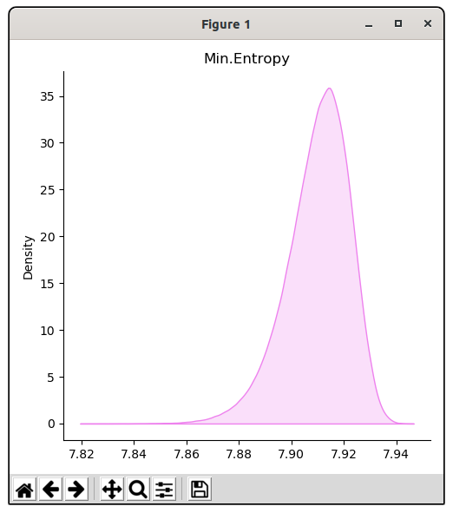

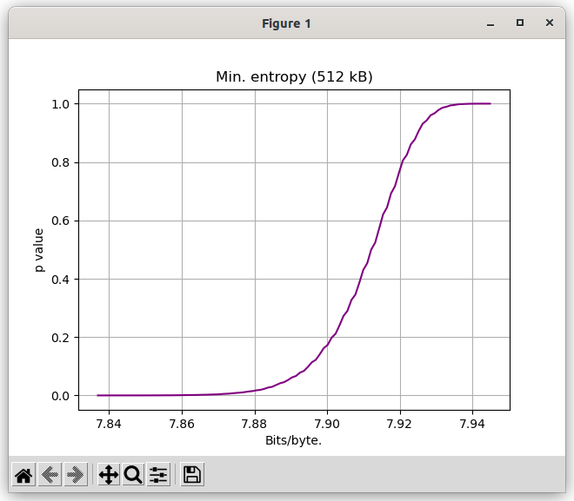

Permuted compression ratio.
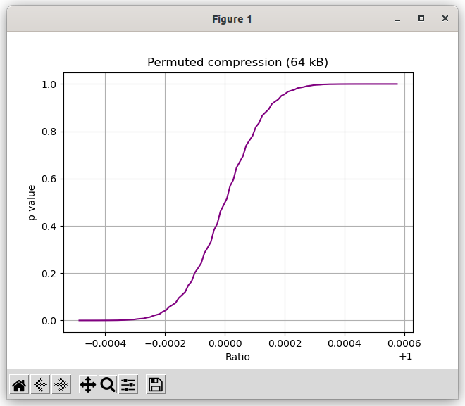

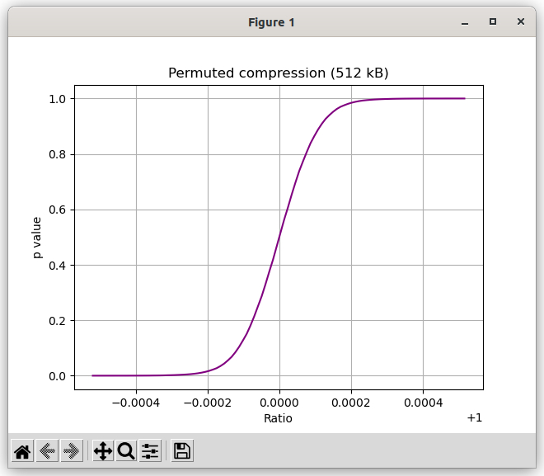

Pure compression.

The pure compression test simply attempts to compress the data sample. Perfectly random data is incompressible and compressing such results in a compressed file that is larger than the original data sample. The data sample is compressed with two compression algorithms, BZ2 and LZMA. Two algorithms stand a better chance at exploiting non randomness than a single one would. The two compressed sizes are then summed to form the test statistic as:-
|BZ2(data_samples)| + |LZMA(data_samples)|.
The test statistic is not normally distributed, as can be seen from the following cumulative distribution function:-
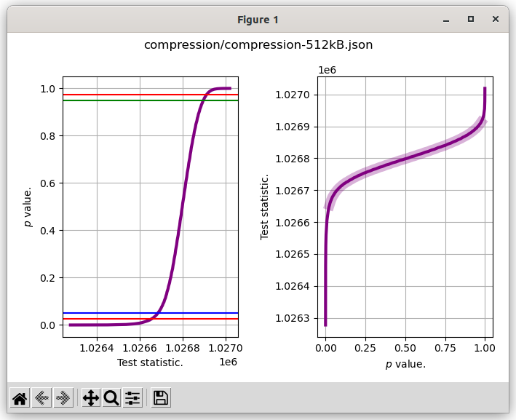
Criticals @ p = [0.025 0.05 0.95 0.975] = [1026653.51101735 1026684.53605086 1026896.16822881 1026912.16952706]

Arithmetic mean.

Arithmetic mean is simply the mean of the data sample. We expect it to be normally distributed at location μ = 127.5. Variance of a general discrete uniform distribution U(a, b) is
giving δ = 73.90027064 for random bytes distributed as U(0, 255). The standard deviation of the mean,. A z score and thus a p value can be determined in the usual way.and p is obtained via the Python function scipy.stats.norm.sf(z).

References: https://en.wikipedia.org/wiki/Standard_deviation#Standard_deviation_of_the_mean, https://vrcacademy.com/tutorials/discrete-uniform-distribution/.

Serial Correlation

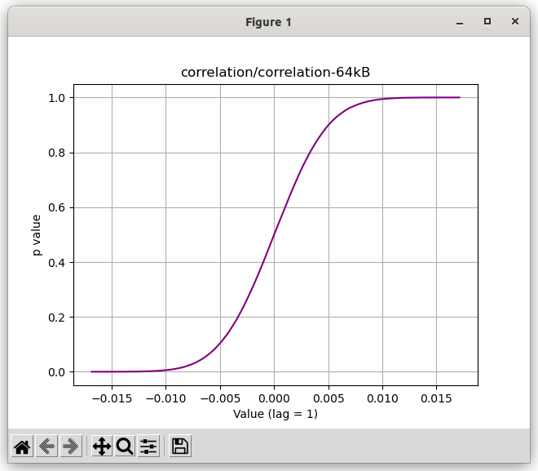

Monte Carlo value for Pi

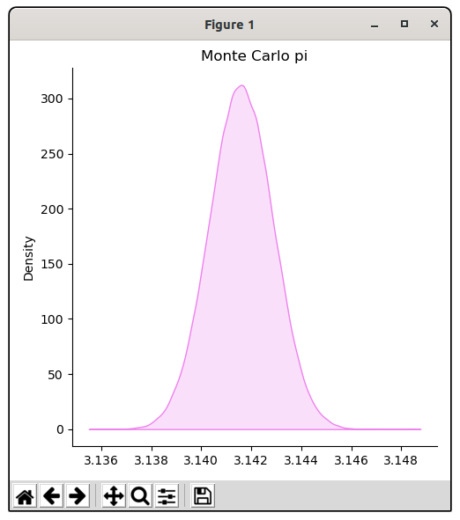

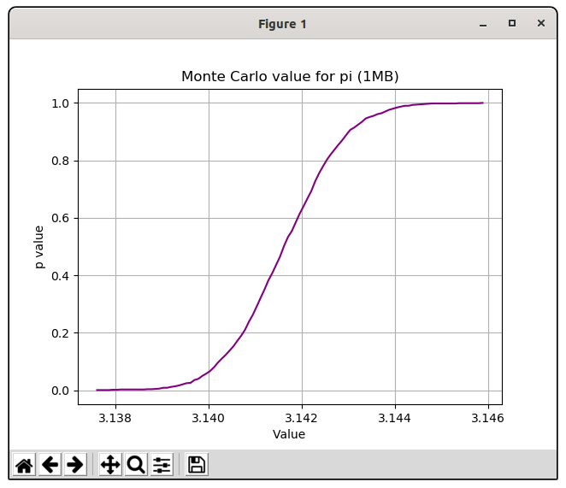

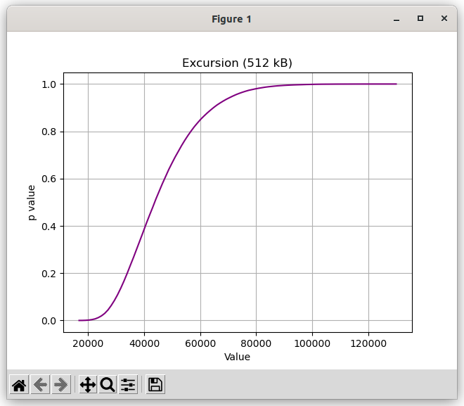
Excursion from mean

This is an excursion from the mean test, 100,000 trials. It’s from https://nvlpubs.nist.gov/nistpubs/SpecialPublications/NIST.SP.800-90B.pdf section 5.1.1.
Not sure if this is useable; look at the range (20 k – 120 k). But for context:-
shakspeare.txt is 5.4 MB in size.
max. excursion (shakespeare.txt) = 678,027.
max. excursion (5.4 MB file from MS Twister) = 178,876.

