ent2

A randomness testing suite for Makers.

Specification v 0.3
September 2022
Paul Uszak
www.reallyreallyrandom.com

Revisions.

0.1 10 August 2022. Initial draft.
0.2 15 August 2022. Major amendments, additional test information and updated charts.
0.3 6 September 2022. All tests selected. Significant re-organisation of sections.

Table of Contents
1. Revisions. 2
2. Objective. 4
3. The old `ent`:- 5
3.1. Output. 5
3.2. Current issues. 5
4. The new `ent2`. 7
4.1. Output 7
4.2. Justification 7
5. Test determination. 9
5.1. PASS/FAIL 9
5.2. Messages. 12
6. Test descriptions. 13
6.1. Min. entropy. 13
6.2. Chi square distribution. 14
6.3. Permuted compression ratio. 14
6.4. Pure compression. 15
6.5. Arithmetic mean. 16
6.6. Serial Correlation 17
6.7. Monte Carlo value for Pi 17
6.8. Excursion from mean 19
6.9. Runs. 20
7. Quality control/testing the tests. 21
8. Issues. 22

Objective.

Creation of a new accurate and easy to use randomness test suite tailored for TRNG Makers generating in the sub 1 MB space. It will be a derivative of the `ent` test suite @ https://www.fourmilab.ch/random/ incorporating PASS and FAIL statuses for individual tests, alleviating the need for interpretation of p values. The results of the tests will be followed by a final conclusive recommendation as to whether the sample set can be used for cryptographic purposes.

The old `ent`:-

Output.

From an arbitrary test run:-

Entropy = 6.028367 bits per byte.

Optimum compression would reduce the size
of this 3220 byte file by 24 percent.

Chi square distribution for 3220 samples is 9694.33, and randomly
would exceed this value less than 0.01 percent of the times.

Arithmetic mean value of data bytes is 83.3404 (127.5 = random).
Monte Carlo value for Pi is 4.000000000 (error 27.32 percent).
Serial correlation coefficient is 0.020502 (totally uncorrelated = 0.0).

Current issues.

- In “evaluating pseudorandom number generators for encryption”, the required entropy rate is 1 bit/bit or 8 bits/byte. Anything substantially less is useless for cryptography. There is no need to measure it as the only result concerning us is a pass/fail determination within agreed confidence bounds, à la the other standard randomness tests like `dieharder`. Yet there are no bounds and no determination of any p values for confidence other than for a bit/byte distribution χ².
- And it can’t be used for general entropy measurement in it’s default setting, as it reports the wrong type of entropy. Cryptography focuses on the most conservative min. entropy H∞, not Shannon entropy. `ent` reports Shannon entropy which is always higher for all sample distributions other than uniform. And uniform distributions are uncommon from most DIY entropy sources.
- From the `ent` website, “BUGS: Note that the ‘optimal compression’ shown for the file is computed from the byte- or bit-stream entropy and thus reflects compressibility based on a reading frame of the chosen width (8-bit bytes or individual bits if the -b option is specified). Algorithms which use a larger reading frame, such as the Lempel-Ziv [Lempel & Ziv] algorithm, may achieve greater compression if the file contains repeated sequences of multiple bytes.”
- A consequence of the above is that an 8-bit window presupposes IID data with a relaxation period not greater than 8 bits. It is common to see `ent` used (incorrectly) against non-IID data sets. In those cases the reported entropy would be much higher than the true rate.
In summary, there is no confidence in the `ent` metrics as to whether the sample data set is suitable for cryptography.

The new `ent2`.

Output

The v2 vision for an arbitrary test run. For 64 kB, 128 kB, 256 kB and 512 kB sample sizes. But for initial release, targeting 512 kB (512,000 bytes). Based on the author’s experience, it should be possible to generate such a sample set from a DIY TRNG given that there is no rush to do so.
The input file should be checked for complying with these sizes at ingestion and a message issued if necessary.
The output:-

Testing test-samples/filename.bin

Permuted compression ratio, (p = 0.9855), FAIL.
Runs, (p = 0.4000), PASS.
Serial correlation, (p = 0.0004), FAIL.

SAMPLES ARE NOT IID.

Pure compression, (p = 0.7897), PASS.
Chi square distribution, (p = 0.5000), PASS.
Arithmetic mean value, (p = 0.0008), FAIL.
Monte Carlo value for Pi, (p = 0.5071), PASS.
Excursion from mean, (p = 0.9998), FAIL.
Min. entropy, (p = 0.0002), FAIL.

Min. entropy < 5.9103 bits per byte.

SAMPLES UNSUITABLE FOR CRYPTOGRAPHY @ α = 0.0500.

Justification

- Create an unambiguous test result per sample set. `ent2` will have PASS, FAIL and finally use or don’t use for cryptography messages.
- No statistics knowledge will be necessary to interpret the results.
- Trying to nullify all those crypto.SE questions about NIST, diehard and dieharder testing and interpretation of p values, such as https://crypto.stackexchange.com/q/71911/23115.
- Minimization of type II errors to err on the side of caution as this is a cryptographic test suite. Tests will fail safe.
- An α = 0.05 creates a test 5x stronger than in the NIST Randomness Test Suite, Special Publication 800-22 ((STS), (https://nvlpubs.nist.gov/nistpubs/legacy/sp/nistspecialpublication800-22r1a.pdf) which uses α = 0.01. And 50x stronger than in the NIST Recommendation for the Entropy Sources Used for Random Bit Generation, Special Publication 800-90B (https://nvlpubs.nist.gov/nistpubs/SpecialPublications/NIST.SP.800-90B.pdf) which uses α = 0.001.
- α = 0.05 is commonly accepted in most sciences, other than particle physics.
- Target the 64 kB to 512 kB sample space as there is no current alternative (other than the original `ent`). FIPS140-2 is plainly useless. NIST’s STS requires a minimum of 1.25 MB of samples for 10 bitstreams.
- Maintains the majority of `ent` test types, but tightens the test bounds.
- Maintains a similar name for familiarity.
- Make calibration algorithms and resultant data available to instil confidence through the opportunity for independent validation.
- Use a range of 0.0 < p < 1.0. So p = 0.5 is the expectation, E(test).

Test determination.

PASS/FAIL

It is suggested that α = 0.05 for the reasons in section 4.2.
The tests are either single or two tailed, and if single tailed, may be left or right handed. For example (single tailed):-

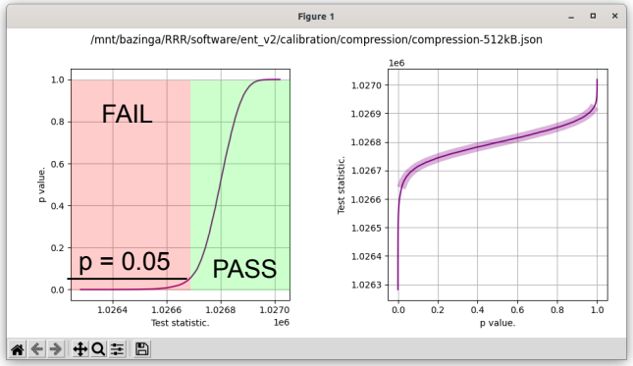Test statistics for the pure compression test on a 512 kB sample set. The purple highlight is the range 0.025 ≤ p ≤ 0.975. With α = 0.05, criticals @ p = [0.025 0.05 0.95 0.975] = [1026653.74535627 1026684.09009091 1026896.62800875 1026912.85180169].
In this case PASS ≥ 1,026,684 bytes with a one tailed test. If the test statistic were 2 MB, although extremely unlikely, it must still logically be considered a PASS as the sample set did not compress.
And a two tailed test:-
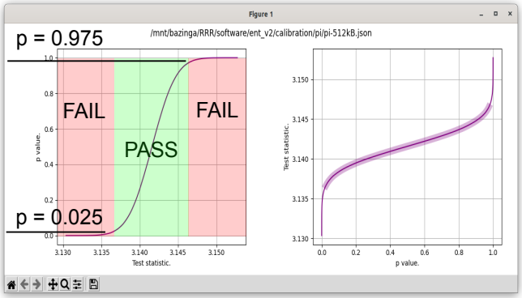Test statistics for the Monte Carlo value for pi test on a 512 kB sample set. The purple highlight is the range 0.025 ≤ p ≤ 0.975. α = 0.05, criticals @ p = [0.025 0.05 0.95 0.975] = [3.13666963 3.13746903 3.14568527 3.14649241]. In this case 3.13666963 < PASS < 3.14649241 with a two tailed test.
100,000 trials will be run for each test calibration simulation withbins to construct the cumulative distribution functions. It may be possible to numerically fit normal distributions to some of the test statistics, e.g. permuted compression ratio. That will then allow direct p value calculation via a z score.
The calibration samples are drawn from a PCG XSL RR 128/64 random number generator for Numpy array generation, as suggested at (https://numpy.org/doc/stable/reference/random/generator.html). Raw byte sequences will be generated by the Linux cryptographic generator as at (https://docs.python.org/3/library/os.html#os.urandom). Shuffling (as for the permuted compression ratio) will be also undertaken by a PCG XSL RR 128/64. The Mersenne Twister will not be used anywhere in the calibration of `ent2` for the reasons stated at (https://en.wikipedia.org/wiki/Mersenne_Twister#Disadvantages).
We use a maximum ofsamples for a full calibration run per test. The PCG generator has a period of 2¹²⁸, so less thansamples are drawn which is the recommendation from Jones, Good Practice in (Pseudo) Random Number Generation for Bioinformatics Applications, UCL Bioinformatics Group.
We suggest α = 0.05. The α boundaries are at:-
left_outer = α / 2
left_inner = α
right_inner = 1 - α
right_outer = 1 - (α / 2)
Test summary:-
Test | Test purpose | Calibration data | Test statistic distribution | p value determination | PASSing p value
Permuted compression ratio | IID | Simulated | Normal | From z score. | p < right_inner
Runs | IID | Algebraic | Invisible | From z score | left_outer < p < right_outer
Serial correlation | IID | Algebraic | Invisible | From z score | left_outer < p < right_outer
Pure compression | Randomness | Simulated | Not Normal | CDF interpolation | left_inner < p
Chi square distribution | Randomness | Algebraic | Invisible | From z score | left_outer < p < right_outer
Arithmetic mean value | Randomness | Algebraic | Normal | From z score | left_outer < p < right_outer
Monte Carlo value for Pi | Randomness | Simulated | Normal | From z score | left_outer < p < right_outer
Excursion from mean | Randomness | Simulated | Not Normal | CDF interpolation | left_outer < p < right_outer
Min. entropy | Randomness | Simulated | Not Normal | CDF interpolation | left_inner < p

CDF = Cumulative distribution function.
IID = Independent and identically distributed.
Reference:-
O'Neill, PCG: A Family of Simple Fast Space-Efficient Statistically Good Algorithms for Random Number Generation, Harvey Mudd College at (https://www.pcg-random.org/pdf/hmc-cs-2014-0905.pdf).

Messages.

- The message “SAMPLES ARE NOT IID” will be output if any one of the permuted compression ratio, runs or serial correlation tests fail at the critical α level.
- If the samples are IID, a message as “SAMPLES ARE IID” will be displayed.
- H∞ will be displayed based on a scan window of 8 bits as per `ent`. If any one of the permuted compression ratio, runs or serial correlation tests fail at the critical α level, H∞ will be displayed as “Min. Entropy < x bits/byte” as the sample data is autocorrelated and thus an accurate determination of the min. entropy cannot be reliably made. All that can be inferred is that H∞ must be less than that calculated from an 8 bit scan window.
- If the samples are IID, H∞ will be displayed as “Min. Entropy = x bits/byte” as the entropy calculation will be accurate.
- If all tests pass, a final message will be displayed: “SAMPLES SUITABLE FOR CRYPTOGRAPHY @ α = x”.
- If any of the tests fail, a final message will be displayed: “SAMPLES UNSUITABLE FOR CRYPTOGRAPHY @ α = x”.

Test descriptions.

Min. entropy.

Min. entropy (H∞) of a set is defined as −log₂(pmax) where pmax is the highest probability of occurrence of any individual element of the set.
We simply calculate this for the requisite number of trials. Notice that this is not a Normal distribution, so critical α interpolation from the CDF will be required.
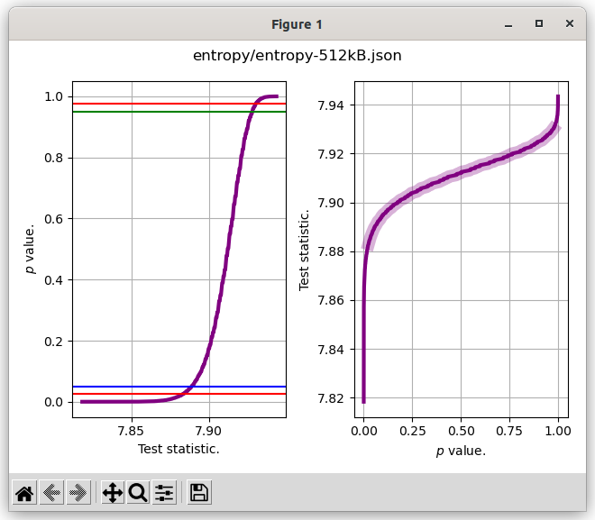Red lines: α = (0.025, 0.975). Blue line: α = 0.05. Green line: α = 0.95.

Chi square distribution.

Calculate a one-way chi-square test. The chi-square test tests the null hypothesis that the categorical data has the given frequencies from Python’s scipy.stats.chisquare function. If the resultant p value is to reflect the χ² value for 8 bit samples, and not n ≤ 8 bit samples, a reference array (f_exp) has to be supplied holding expected frequencies for 256 byte values. As scipy.stats.chisquare(f_obs, f_exp).
p values arise directly from the Python function.

Permuted compression ratio.

Is a means of determining whether a set has independently and identically (IID) distributed members. We define it aswhere the permuted samples are shuffled by a pseudo random number generator and C is a compression function. The expectation of the ratio is 1.0 for an IID set. Non IID sample sets cause ratios to tend upwards past 1.0.
The data sample is compressed with two compression algorithms, BZ2 and LZMA. Two algorithms stand a better chance at exploiting non randomness than a single one would. The two compressed sizes are then summed to form the length of the test statistic components.
Notice that this is a Normal distribution so p values will be determined via z scores. A z score and thus a p value can be determined in the usual way;. p is obtained via the Python function scipy.stats.norm.cdf(z).

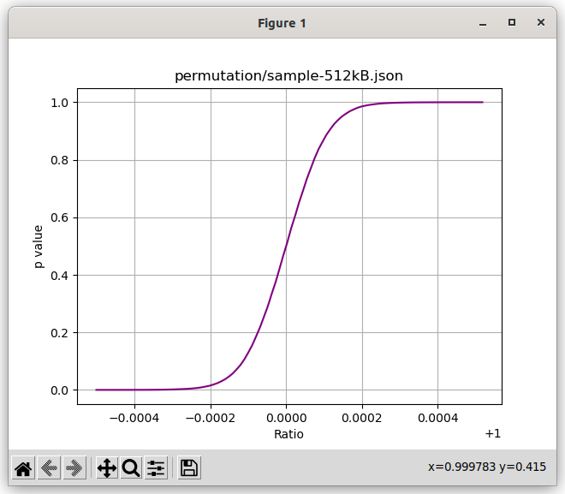

Pure compression.

The pure compression test simply attempts to compress the data sample. Perfectly random data is incompressible and compressing such results in a compressed file that is larger than the original data sample. The data sample is compressed with two compression algorithms, BZ2 and LZMA. Two algorithms stand a better chance at exploiting non randomness than a single one would. The two compressed sizes are then summed to form the test statistic (TS) as:-
TS = |BZ2(data_samples)| + |LZMA(data_samples)|.
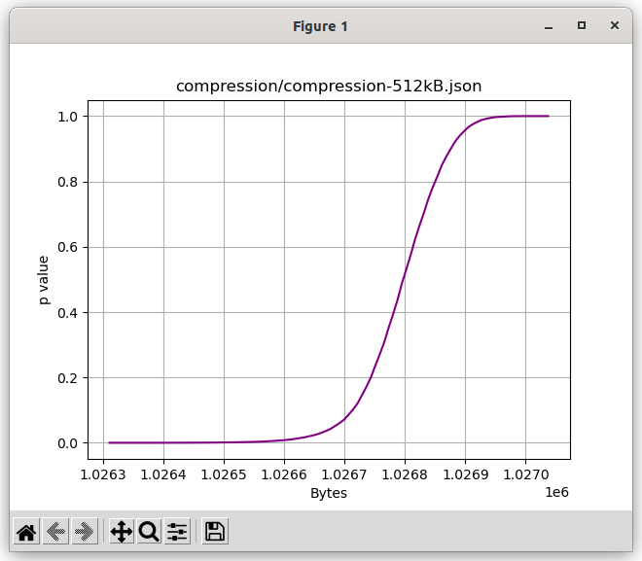
Notice that this is not a Normal distribution, so critical α interpolation from the CDF will be required.

Arithmetic mean.

Arithmetic mean is simply the mean of the data sample. We expect it to be normally distributed at location μ = 127.5. Variance of a general discrete uniform distribution U(a, b) is
giving δ = 73.90027064 for random bytes distributed as U(0, 255). The standard deviation of the mean,for a sample set of size N. A z score and thus a p value can be determined in the usual way;. p is obtained via the Python function scipy.stats.norm.cdf(z).

References:-
https://en.wikipedia.org/wiki/Standard_deviation#Standard_deviation_of_the_mean, https://vrcacademy.com/tutorials/discrete-uniform-distribution/.

Serial Correlation

We calculate the autocorrelation function via the statsmodels tsa.stattools.acf function. Lag = 1 to match the current lag implementation in `ent`.
p values arise directly from the Python function.

Monte Carlo value for Pi
The simulation creates a cumulative distribution function as:-

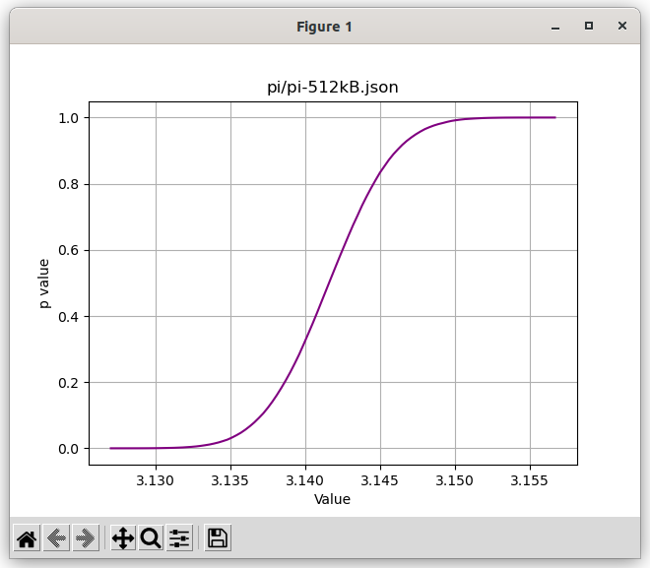
We use the average value method from:- https://blogs.sas.com/content/iml/2016/03/14/monte-carlo-estimates-of-pi.html as its resultant variance is much tighter than the area method. Byte data samples are firstly converted to 8 byte wide long integers, and then double floats using.
The mean of the calibration run was 3.14158338360124 which is accurate to four decimal places compared to the true expectation of 3.141592653589793238. That’s an error of 0.0003% (512 kB sample). The error is 0.0006% for 64 kB sample sets.
Notice that this is a Normal distribution so p values will be determined via z scores. A z score and thus a p value can be determined in the usual way;. p is obtained via the Python function scipy.stats.norm.cdf(z).

Excursion from mean

The excursion test statistic measures how far the running sum of sample values deviates from its average value at each point along the dataset. The test statistic is the largest deviation from the running average. It mirrors NIST’s (https://nvlpubs.nist.gov/nistpubs/SpecialPublications/NIST.SP.800-90B.pdf) § 5.1.1.
The test statistic is always positive as it’s effectively a distance or amplitude.
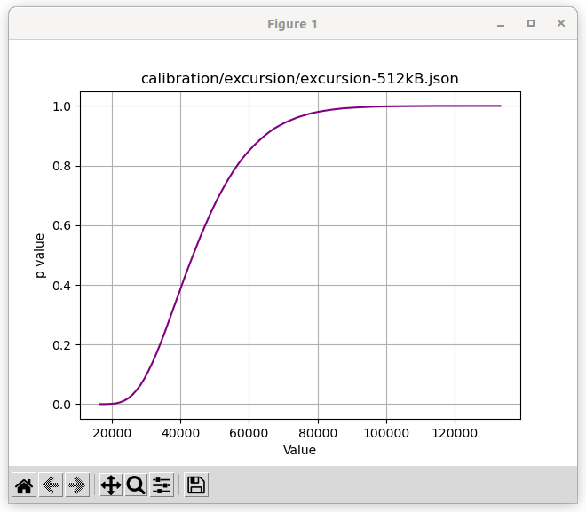
Notice that this is not a Normal distribution, so critical α interpolation from the CDF will be required.

Runs.

Runs test is a statistical test that is used to determine whether or not a dataset comes from a random process. We use the runstest_1samp() function from the Python statsmodels library.
p values arise directly from the Python function.

Quality control/testing the tests.

We expect 5% of the tests of a perfectly random sample set to fail (Type I error) if α = 0.05. This failure rate expectation will be checked by running `ent2` 20,000 times against samples drawn from /dev/random. This procedure will also contribute to validating the individual tests.

Issues.

These are several issues hosted on GitHub at https://github.com/reallyreallyrandom/ent2/issues .

