Process Definition Document

**Automation of Onboarding for New Joiners process**

Commissioned by Leading Business Improvement.

Development by Automation For You.

Date: Date of latest update

|  |
| --- |
| Statement of confidentiality  This document contains information that is proprietary and confidential to your company name, which shall not be disclosed, transmitted, duplicated, or used in whole or in part for any function other than its intended purpose. Any use or disclosure in whole or in part of this information without explicit written permission of your company name is prohibited.  © Copyright, your organization |

Table of Contents

1. Objective 3

1.1. Business Objectives and Benefits 3

2. Current Process 3

2.1. Process Overview 3

2.2. Standard of Metrics 4

2.3. Volume of data 4

3. Business Rules 5

4. Detailed Process Steps – AS IS 5

5. To-be Pre-process steps (Proposed solution) 6

6. In Scope 6

7. Out of Scope 7

8. Non-process requirements 7

8.1. Systems 7

8.2. Reporting 7

8.3. Archiving 8

8.4. Security & data retention 8

9. Appendix 8

Open Questions 8

Escalations 8

# Objective

The objective of this work is to deliver an automated solution to the current Onboarding of New Joiner Process. This solution will seek to deliver a process which has vastly reduced human interaction, the use of email internally and externally and a significantly faster process turnaround time. The solution will look to operate seamlessly in the process, triggering off other parts of the process, notifications and calls to action. Based on the needs of the business, the objective of this work is to deliver an automated solution which improves the efficiency, effectiveness and productivity of this process and its outputs.

### 1.1. Business Objectives and Benefits

|  |  |
| --- | --- |
| **Objectives** | **Expected Benefits** |
| **Automate all internal handling of onboarding documents** | * Vastly reduced risk of something being “missed” * Vastly reduced internal email traffic (to almost zero) * Vastly reduced waiting for others to handle documents when they have come in. Work can begin right away |
| **Automate notifications internally and externally** | * Removes the need for human chasing * Removes the risk of the human forgetting to send a chaser * As many notifications can be sent as required * Improves the response rate dramatically |
| **Reduce the overall time taken to complete the process** | * Free up colleague time to spend on more value adding activities within this and other processes * More time to quality check documentation * Less frustration with workloads & type of work |
| **Deliver a self-service process** | * New Joiner’s do not have to wait for responses or be drip fed their documentation – it is all in one place * New Joiner can upload their documentation all at once or when suits them, coming back after a break / clarification * As per the previous 2 points, vastly improved New Joiner onboarding experience * Documentation won’t get lost in transit via email or HR (as currently can happen). Departments can access their documents when they are ready – improving their experience of the overall process |
| **Have sight of progress of onboarding (by individual and overall)** | * Ability to go into the system and track the status of a New Joiner’s onboarding, as well as all currently in progression * Removes the need for emails to check up on progress * Significantly easier to spot issues or delays holding the process up |

# Current Process

### 2.1. Process Overview

The New Joiner Onboarding Process is the process New Joiners to the company must go through in order to complete their required onboarding obligations. These obligations include providing a range of documentation to the business regarding their identification, references from previous employers, health & medical forms, bank details and an array of other assessment forms. The process has been designed to ensure all documentations and required information is provided from the New Joiner to the business before the New Joiner starts their new role within the company.

The provision of this information and data ahead of joining the firm triggers off the rest of the process internally. This sees departments such as HR, Payroll, Benefits and IT complete their parts of the process respectively, using the information provided to do so. These activities are completed outside of this process and are not in scope for this process, they are merely alerted to the New Joiner and will confirm when their activities are done. However, without this process, they would not be able to begin and complete their required activities.

### 2.2. Standard of Metrics

General information about the process selected for RPA, prior to automation:

|  |  |
| --- | --- |
| Process name | Onboarding of New Joiner Process |
| Function | Business Support Services |
| Department | Human Resources (HR) |
| Process short description | To ensure all relevant documentation is provided by the New Joiner ahead of starting their new role within the business. The process triggers off all of the key activities and additional processes relevant departments must do ahead of a new starter joining |
| Process schedule | Each time a New Joiner officially accepts an offer of employment in writing (signs their contract) |
| #of items process/month | 100 New Joiners are processed a month (on average) |
| Average cycle time | 3 weeks (15 business days) |
| Average handling time | 24 hours (3 business days) |
| Peak period(s) | Non-applicable (hiring takes place all year round) |
| # of FTE supporting this activity | 10 FTE (with activities split out over 3 people per process run. 1 HR, 1 Compensation, 1 IT) |
| Input Data | New Joiner documentation (bank details, a history, passport, benefits selections etc.) |
| Output Data | Employee profile in HR system completed, notifications from other departments that their respective processes now complete, employee informed of first week activities. |
| Return on investment | To counter the upfront cost of this development and the recurring technical and support costs, we will convert the time savings into financial savings. Effectively, we are seeking to reduce the time taken to complete this process (handling time) by 10 hours (over 1 business day) and the average cycle time from 3 weeks to 2 weeks (10 business days). If we extrapolate those handling time savings by the number of hires per month, we save around 1000 business hours per month (or around 400 for HR, 400 for Compensation and 200 for IT). That is the equivalent of around 6 FTE.  Given the savings, this will reduce the pressure on the teams to hire new team members in the future, instead absorbing these hours into the team. This will effectively pay for the additional automation costs. |

### 2.3. Volume of data

|  |  |  |
| --- | --- | --- |
| **Activity** | **Time taken per month (hours)** | **Volume of data to be processed** |
| Receive / process offer letter | 100 hours | 100 (average) |
| Issuing of welcome pack | 100 hours | 100 (average) |
| Receiving / process onboarding materials | 200 hours | 100 (average) |
| Issuing & receiving compensation information | 150 hours | 100 (average) |
| Issuing IT instructions | 100 hours | 100 (average) |
| Issuing first day email | 100 hours | 100 (average) |

The volume of data that goes through this process is detailed above. As we handle on average 100 cases per month, we have rounded all volume figures to 100. This will of course fluctuate month on month (around 80 – 120) but this wouldn’t hugely impact any automated solution as it is the difference of around 20 items of data per month. Each business activity identified takes between 1 and 2 hours to complete, per New Joiner case.

# Business Rules

The following business rules are those that must be adhered to as the process runs. These rules trigger off specific parts of the process and varying responses from the departments involved. Without them, the process would not progress correctly for a number of new joiners, and would therefore directly impact their experience. Therefore, any solution that is built needs to take into consideration these rules.

|  |  |  |
| --- | --- | --- |
| **BR#** | **Requirement** | **Additional Information** |
| BR001 | When sending offer letter, ensure the right template is used, reflecting the grade and level of seniority of the New Joiner. | There are 5 grades marked 1 – 5. Grades 4 & 5 have their own unique cover letter templates. |
| BR002 | When triggering department notifications, ensure the grade 4 / 5 box is ticked for senior new joiners. | The box exists in the current new joiner system and triggers off a different response from respective departments. |
| BR003 | For grade 4 and 5 hires the welcome pack sent will include a raft of different documents regarding their additional benefits eligibility (bonus scheme, share purchase, car etc.) | This requires ticking which documentation is required for the creation of the pack. |
| BR004 | For roles in Finance or Information Security, additional security checking is required at this late stage. These additional items need to be included in welcome packs. | The box marked “Finance or Information Security hire” must be ticked. |
| BR005 | Additional health check and desk assessment forms must be sent to those who are permanently remote working. | The box marked “Remote work only” must be ticked. |

# Detailed Process Steps – AS IS

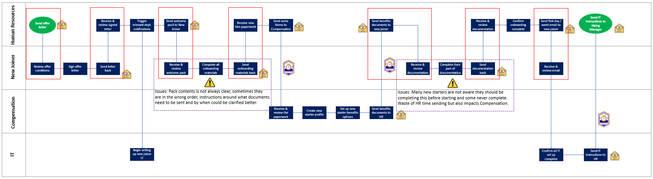

This is the current New Joiner Onboarding Process as it stands today. Detail included here is:

* Red boxes to highlight the hand offs between the business and the New Joiner.
* Explanation points to highlight where issues are plaguing the process.
* Clocks to identify the parts of the process with the longest waiting times.
* Email icons to highlight when an email has been used.

This level of information has been provided to assist the developers with their understanding of the “challenging” areas of the process we are trying to address (i.e. use of email, waiting time, hand offs with New Joiner etc.) These are currently the biggest pain points and time killers of the process and the biggest motivating factors behind the automation (removing these will help the internal team members with their roles but also improve the onboarding experience of the New Joiner).

# To-be Pre-process steps (Proposed solution)

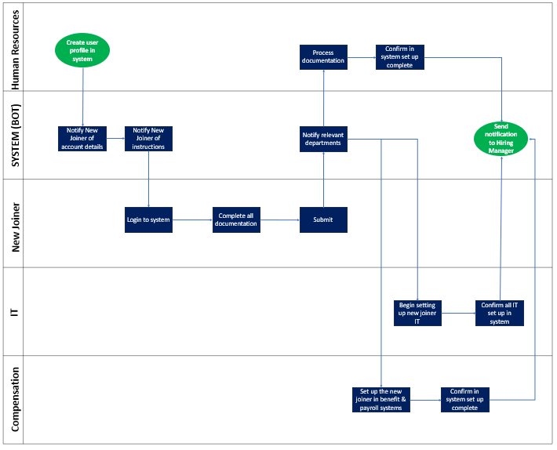

The to-be process we would like to see deployed is built around the automated solution. The automated solution is the part of the process which will receive all inputs, information and communication and will equally send it out. It will:

* Send out automated notifications to internal and external parties.
* Send out chasers on top of notifications which have not triggered a response.
* Be where documentation is sent and process.
* Ensure information flows to the relevant departments when the time is right to.

The to-be process will significantly scale back HR’s role, internal communication via email and communication with the New Joiner which is deemed as unnecessary. It will also automate the business rules.

# In Scope

The table below shows the high-level steps that are in scope for the automation.

|  |  |
| --- | --- |
| **Process step** | **Comments** |
| New Joiner: Review offer conditions through to send letter back | As-is: The new joiner currently conducts this activity within their email inbox using the documents sent over from the team internally.  To-be: This would be done in the automated solution system as part of a self-service option. |
| HR: Receive & review signed letter through to send welcome pack | As is: These steps are currently done in email and form the current New Joiner system.  To-be: All of this will be done inside the new automated solution system. |
| New Joiner: Receive & review welcome pack through to send onboarding materials back | As-is: The New Joiner receives and sends required documentation through email and completes the documents offline.  To-be: The New Joiner to receive, review, complete and submit in the automated solution system. |
| HR: Receive new hire paperwork to send forms to Compensation | As-is: Steps done via email.  To-be: Steps to be completed in new automated system. |
| Compensation: Receive & review paperwork & send benefits documents to HR | As-is: Steps done via email once HR notifies them.  To-be: Access the information from the new automated system once New Joiner has submitted their information and the system has notified Compensation.  *\*Creating New Starter profile and benefits not in scope.* |
| HR: Send benefits documents to New Joiner through to send IT instructions to Hiring Manager | As-is: Completed via email or off system.  To-be: To be completed in the system, with no need for documentation to be sent as it’ll be a self-service option / automated notifications. |
| New Joiner: Receive & review documentation through to receive & review email | As-is: Completed either via email or offline.  To-be: Completed in the automated system and submitted through there, triggering off any relevant notifications to other departments. |
| IT: Confirm all IT set up complete & send IT instructions to HR | As-is: Currently confirmed via email.  To be: Will confirm through the automation solution and send notification to relevant departments automatically.  *\*Setting up of New Joiner on their IT is out of scope.* |

# Out of Scope

Whilst the vast majority of the process that has been mapped is in scope for this work, there are two key elements on the process map which are not.

IT: Begin setting up new joiner IT: This is an important process run separately from the onboarding process. The onboarding process will notify IT that we have a New Joiner and that their IT profile will need setting up. IT will also need to feed into this process by informing HR that the IT profile has been set up. This feeding of information into and out of the process is in scope (as has been detailed above), but the actual act of IT setting up the IT profile is not in scope for this work.

Compensation: Create New Starter profile & Set up New Starter benefits options. These activities mark a separate process, where Compensation set up the New Joiner on their Payroll & Benefits systems. This process is run separate to the Onboarding process. As we saw with IT, the notifications to and from Compensation are what is in scope for this process only.

# Non-process requirements

## 8.1. Systems

|  |  |  |
| --- | --- | --- |
| **System** | **Usage** | **Frequency** |
| Email (Outlook) | To communicate with the New Joiner, other departments and HR | Frequent (7 – 10 times per case) |
| Onboarding system | To process documentation and send out notifications to other departments | Moderate 3 – 5 times per case |

The automated solution will seek to remove the need for email usage and remove the current onboarding system altogether, with the automated solution providing a system that processes the onboarding activities.

## 8.2. Reporting

|  |  |  |
| --- | --- | --- |
| **Report name** | **Source** | **Purpose** |
| Currently – NA. No reports are generated through this process. |  |  |
| Desired – Current onboarding status report | From the automated system | To inform HR of the progression of New Joiners through the onboarding process so it can be determined if there are any issues that need addressing. |
| Desired – Current individual onboarding status report | From the automated system | To inform the Hiring Manager of the progression of the New Joiner for their department through the onboarding process. They can then contact the New Joiner directly if needed. |

Currently, no reports are issued from this process. However, we would like the automated solution to provide us with the option of creating basic report structures. This basic reporting will include identifying the current status of individual New Joiners and the overall performance of the New Joiner Onboarding Process at any one time. This will give individual Hiring Managers and the wider business greater insight to make informed decisions.

## 8.3. Archiving

All information (New Joiner documentation) is currently stored in the onboarding system. Going forward, as this is being automatically sent to the new automated solution, it will exist there.

## 8.4. Security & data retention

The automated solution will be sending, processing and storing sensitive and confidential information. It may also need to have direct feeds to Payroll, Benefits, IT and HR profiles (if not today, then in the future). Given this, strong controls will need to be built into the process, the automated solution, any integrations, documentation etc. to make sure there is no breach of confidentiality or security.

We will need to engage with the Security and Data Team and IT to ensure all data is encrypted, securely transferred and that the storage and moving of the data is always done in line with security policies.

# Appendix

For security reasons, all documents related to this work are stored [HERE](PLAN.zip) and can be accessed using a separately provided password. To gain access to this password, please contact the Project Manager.

# Open Questions

|  |  |  |  |
| --- | --- | --- | --- |
| **Date written** | **Date of response** | **Question / comment** | **Response from reviewer** |
| May 5th | May 7th | Are we going to require a data lake to exist separately to the automated solution, or would an automated solution store all information itself? | A data lake would be a preferred option, to link directly with the automated solution through a connector. This would less likely slow the automated system down. |
| May 8th | - | Another benefit of automation would be to have a bot checker which checks all data and information flows into and out of the process. |  |

# Escalations

For immediate contacts for the process automation project, kindly contact the respective contact on the table below:

|  |  |  |
| --- | --- | --- |
| **Email Address** | **Roles** | **Responsibilities** |
| [robertchapman@company.com](mailto:robertchapman@company.com) | Project Manager | If any blockers come up which stop the progress of the work |
| [Harpreetsethi@company.com](mailto:Harpreetsethi@company.com) | Project Sponsor & Director of HR | For queries on budget & resource requirements / challenges |
| [kathywhite@company.com](mailto:kathywhite@company.com) | Business Analyst | Further clarification on process, business rules & scope of activities |

# 