Final exam

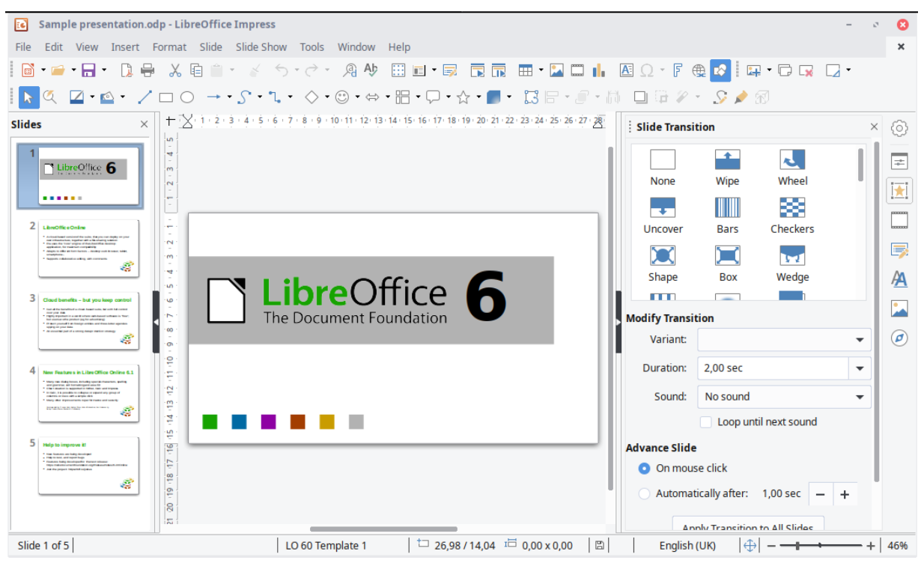

1. Affordance

Affordance refers to a property or feature of an object which presents a prompt on what can be done with this object. E.g. a knob icon give a clue than users can rotate it.

So as we can see in the left, there is a dark blue background of the current slide, therefore, users can know which is the current slide available for edit

1. Mapping is a design principle

The scroll bar can provide mapping in LibreOffice interface. It tells users where (which slides means which part of the whole ppt)he or she is in the whole slide. When there are many slides, it is easy for users to map, locate.

Users can use the scroll bar to up and down to choose which part of the slide he or she wants to edit.

1. Two heuristics of your choosing
2. Match between system and real world

The icon of operation like save is a disc, cut is a scissors; print is a printer, etc. They are real item in the real world.

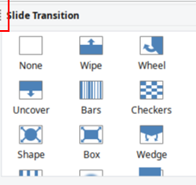

And the image of effect in the slide transition is also real in the real word.

1. Recognition rather than recall

The operation(saving/cut/print etc.) and effect of slide are all listed in the interface. So it is provide “recognition” for users to select. It is better than recall, users may have no idea what does he should do if just use recall.

* How do these two heuristics link into cognitive load theory

Linking heuristics/ design principle to cognitive load theory is very useful to improve the design. It works because ultimately they reduce the load on our limited working memories. In this way it is easier to process and make sense of information.

1. Two cognitive load effects of your choosing

The Split Attention Effect occurs when users have to refer to two different sources of information simultaneously when learning something. This creates an extra load on their brain as switching between tasks takes time, effort and energy.

Actually in the interface, there are too many things to select, they are in different area, but they are still very close. Most of them are in the form of text with image. All of these issue result in Split Attention Effect .

expertise reversal effect refers to instructional techniques that are highly effective with inexperienced learners. And instructional techniques may has less effectiveness or even lose their effectiveness and negative consequences with more experienced learners.

From my point of view, I haven’t see any shortcut path in this interface, there are many edit we can do for a slides, so the experienced user may feel tired repeat the action again and again, which result in less effectiveness in experienced users.

1. Two examples of visual design of your choosing

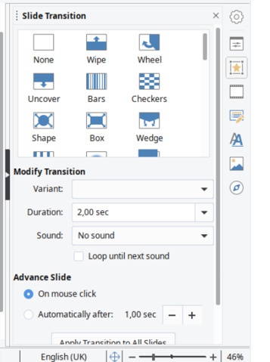

Item is in chunk and grid , around different effect, there are enough space around each one too, so it is visible for users to choose.

(icon of editing and operation) is Match between system and real world, and it is also visible, the heuristic can improve visible design.

1. An annotated sketch of how any issues you found can be improved (you will be able to upload a file to attach to this answer).

In this part too many operation is in the same area



I will use chunk to separate them, easy for users to recognize , more visible, enough space between each chunk

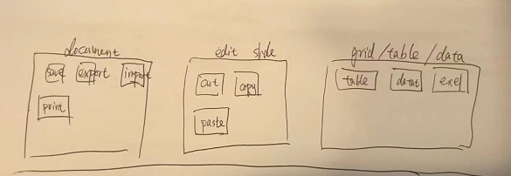

Give enough short path for experienced , there should be a page documentation about all short cut path.

