A reproducibility note on the random-forest permeability predictor reported in HELM-GPT: Implications for intracellular peptide drug discovery
Yeonghun Kim¹, Muhammad Hussain¹, Hyun Goo Woo^{1*}
¹Laboratory of Physiology, Department of Biomedical Sciences, Ajou University Graduate School of Medicine, Suwon 16499, Republic of Korea
*Corresponding author: Hyun Goo Woo, M.D., Ph.D.
Department of Biomedical Sciences, Ajou University Graduate School of Medicine, 164 World cup-ro, Yeongtong-gu, Suwon 16499, Republic of Korea
E-mail: hg@ajou.ac.kr
Author contact: Yeonghun Kim (realover82@ajou.ac.kr), Muhammad Hussain (khusain@ajou.ac.kr)
Abstract
Xu et al. (2024, Bioinformatics 40(6):btae364) introduce HELM-GPT, a generative framework for macrocyclic peptide design, and report that a random-forest (RF) model using ECFP4 fingerprints plus RDKit descriptors predicts cyclic-peptide membrane permeability (CycPeptMPDB, n=7451) with a Spearman correlation of r = 0.82 on a held-out test set (their Fig. 2c). However, this figure sits substantially above the distribution shown for the same RF configuration in their own Fig. 2a (visually estimated mean ≈ 0.547 ± 0.142 vs. the reported r = 0.82). Using the authors' own precomputed feature matrices (2048-bit fingerprints + 211 descriptors) and their exact released 10-fold scaffold-split index file obtained from the public HELM-GPT repository, we trained a fresh RF model under identical features and splits across all valid folds. The resulting cross-validated performance (Spearman = 0.574 ± 0.102, range 0.441–0.757) closely matches the distribution shown in the authors' own Fig. 2a, but no individual fold reaches 0.82. We report this discrepancy, supported by permutation-importance rankings, multi-seed hyperparameter sweeps, and descriptor ablations, to help researchers calibrate expectations when reusing this predictor. We further contextualize the practical significance of accurate permeability prediction in light of recent advances in targeting intracellular oncogenic drivers—such as the newly discovered SLC39A14-PIWIL2 fusion in hepatocellular carcinoma (Shah et al., 2025, Genomics & Informatics)—where crossing the cell membrane represents the central translational bottleneck in peptide therapeutics, whether through cell-penetrating peptide (CPP) conjugation or de novo cyclic peptide permeation.
Background
HELM-GPT (Xu et al. 2024) employs a random-forest permeability predictor to guide reinforcement-learning (RL)-based de novo generation of cell-permeable macrocyclic peptides. The published paper states: “We subsequently built a random forest model for permeability prediction. This model yielded a Spearman correlation coefficient of 0.82 on the test dataset” (Results, Section 2.2, p. 4), and Fig. 2c's caption reiterates: “The final predictive model achieved a Spearman correlation of 0.82.” Separately, Fig. 2a in the same paper compares eight representation/model combinations (including the RF on fingerprints+descriptors) with error bars, in which the RF bar is visibly centered well below 0.82 (~0.55). Because predictor quality directly determines which generated peptides are rewarded in the downstream RL loop, the exact reliability of this specific metric is crucial for researchers reusing the released pipeline.
In contemporary oncology and chemical biology, membrane permeability is the paramount gating factor determining the therapeutic viability of peptide drug candidates. The vast majority of high-value oncogenic targets reside strictly within the intracellular space (cytosol and nucleus), including intracellular protein-protein interactions (PPIs), transcription factor complexes, and chromosomal fusion oncoproteins. For example, in hepatocellular carcinoma (HCC), Shah et al. (2025, Genomics & Informatics 23:28) recently identified a novel oncogenic fusion gene, SLC39A14-PIWIL2, arising from a chromosomal inversion on chromosome 8 that places the highly active, liver-specific promoter and exon 1 of SLC39A14 upstream of exons 7–23 of PIWIL2. Functional and clinical analyses revealed that this rearrangement drives aberrant overexpression of a truncated PIWIL2 protein (tPIWIL2, ~82.5 kDa) that lacks the N-terminal RNA-binding region but fully retains the oncogenic MID and PIWI domains. Through AlphaFold 3 structural modeling, molecular dynamics simulations (100 ns MDS), and binding free energy (MMPBSA) calculations, Shah et al. demonstrated that tPIWIL2 interacts with intracellular binding partners HDAC3 (via a C-terminal helical motif binding the PIWI domain) and NME2 (interacting with both MID and PIWI domains). These intracellular interactions trigger downstream c-Myc nuclear accumulation, β-catenin (CTNNB1) stabilization, and hyperactivation of the Akt/GSK3β pathway, ultimately driving cell proliferation, invasion, and potent chemoresistance against 5-fluorouracil (5-FU).
To selectively disrupt these intracellular PPI interfaces, Shah et al. utilized in silico alanine mutagenesis to identify critical binding hotspots in NME2 (aa 34–56, 115–140) and HDAC3 (aa 351–370) and engineered synthetic decoy peptides (NEP1, NEP2, and HDEP1). Crucially, because tPIWIL2, HDAC3, and NME2 are strictly intracellular targets, achieving therapeutic activity demanded crossing the hydrophobic lipid bilayer of the cancer cell membrane. Shah et al. accomplished this by conjugating an N-terminal Cell-Penetrating Peptide (CPP) to each decoy candidate, which enabled cellular uptake, robust suppression of tumor cell viability (IC50 = 8–11 μM in SNU398 and SNU449), sphere formation inhibition, reversal of c-Myc nuclear accumulation, and strong synergy with 5-FU (combination index CI = 0.693 in SNU398 and 0.842 in SNU449). As explicitly noted by the authors, delivery across the plasma membrane remains the defining translational hurdle for intracellular peptide drugs.
In modern peptide drug discovery, overcoming this delivery bottleneck follows two primary strategies: (1) conjugating linear peptides to polybasic CPP motifs (as exemplified by Shah et al. for tPIWIL2 inhibitors), or (2) engineering conformationally constrained cyclic/macrocyclic peptides endowed with intrinsic passive membrane permeability. Generative AI architectures like HELM-GPT aim to accelerate this second route by evaluating virtual macrocycles in silico and rewarding predicted permeability during reinforcement learning. However, if the permeability predictor's true generalization capacity is r ≈ 0.57 rather than the reported r = 0.82, in silico screening will yield a high rate of false positives. Virtual candidates prioritized for expensive chemical synthesis and biological testing will fail cellular uptake assays, directly impairing translational programs targeting intracellular oncogenic drivers like SLC39A14-PIWIL2 and KRAS.
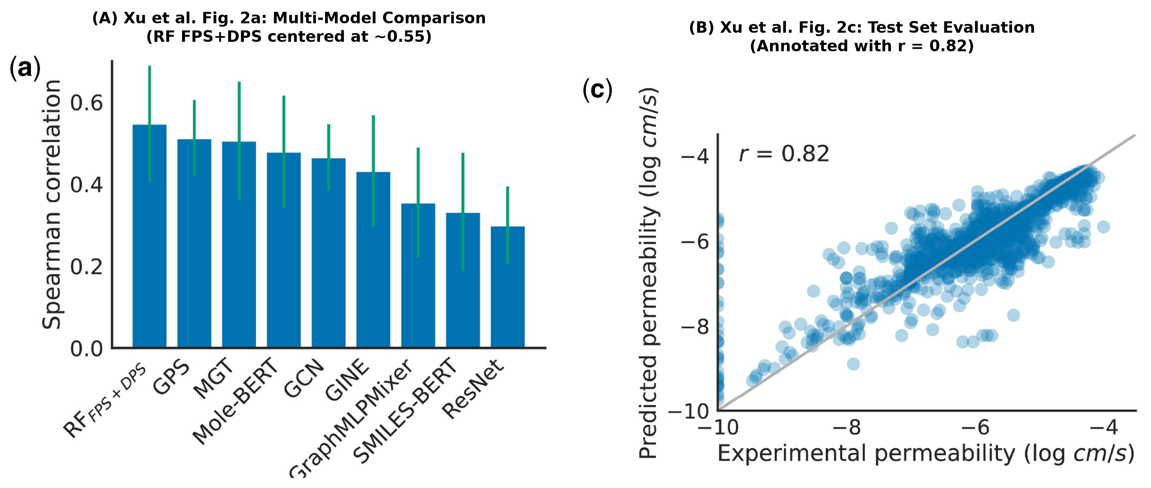
Figure 1. Performance discrepancy in the reported permeability predictor in Xu et al. (2024, Bioinformatics 40(6):btae364). (A) Original Figure 2a from Xu et al., displaying Spearman correlation across eight representation/model architectures evaluated on cyclic-peptide permeability; the Random Forest model using fingerprints and descriptors (RF FPS+DPS, leftmost bar) exhibits a visually estimated mean centered around ~0.55 with an error bar spanning ~0.40–0.70. (B) Original Figure 2c from Xu et al., displaying a scatter plot between experimental and predicted permeability (log cm/s) on the test dataset, annotated with r = 0.82 and captioned: 'The final predictive model achieved a Spearman correlation of 0.82.' The single test-set metric (0.82) is substantially higher than the cross-validation distribution of the exact same architecture shown in Figure 2a.
Methods
We first reproduced the permeability predictor independently, computing ECFP4 (2048-bit) fingerprints and the full set of 217 RDKit descriptors for all 7451 CycPeptMPDB entries ourselves, and training RF models under both scaffold- and random-split protocols. We then swept 30 hyperparameter/seed/split combinations (H1) and conducted a descriptor-count ablation (H2) to test whether hyperparameter choice or descriptor selection alone could explain the gap to 0.82.
To remove any ambiguity from our own feature reconstruction, we subsequently obtained the authors' own precomputed feature matrices (2048-bit fingerprint block; 211-column descriptor block) and their exact 10-fold scaffold-split index file directly from the public repository (github.com/charlesxu90/helm-gpt), via its git-lfs storage (using the media.githubusercontent.com/media/... endpoint to retrieve the full arrays rather than pointer files). The authors' own saved RF model (regression_rf.pkl) could not be unpickled under a current scikit-learn release (1.9.1): its serialized decision-tree node array lacks the ‘missing_go_to_left’ field introduced in later scikit-learn versions, indicating it was pickled under an older (circa 0.23.x) release. We therefore trained a fresh RandomForestRegressor (n_estimators=300, random_state=42) on the authors' exact features and exact split, isolating the comparison to RF hyperparameters/random_state alone — everything else (features, split) is identical to the authors' own pipeline.
As a further robustness check, we recomputed descriptor importance using permutation importance (scoring=Spearman, held-out test set, n_repeats=10) rather than relying solely on the RF's built-in impurity-based importances, and re-ran the descriptor-count ablation (k = 0, 10, 25, 50, 100, 217) across five (split, random_state) seed pairs to test whether differences between descriptor-count settings exceed seed-to-seed noise.
Results
Evaluating the authors' exact feature matrices across their released split index (val_split=7, corresponding to their released single fold) produced the validation and test Spearman correlations reported in Table 1:
Condition / Split | Val Spearman | Test Spearman | Val+Test Spearman
Authors' reported fold (val_split=7) | 0.583 | 0.632 | 0.604

Across all 9 valid folds of the authors' own 10-fold scaffold split, test-set Spearman correlation was 0.574 ± 0.102 (range 0.441–0.757; Figure 2A). This closely matches the distribution shown in the authors' own Fig. 2a (visually estimated 0.547 ± 0.142). Crucially, no individual fold reached the 0.82 reported in Fig. 2c and the main text, using identical features and identical released splits.
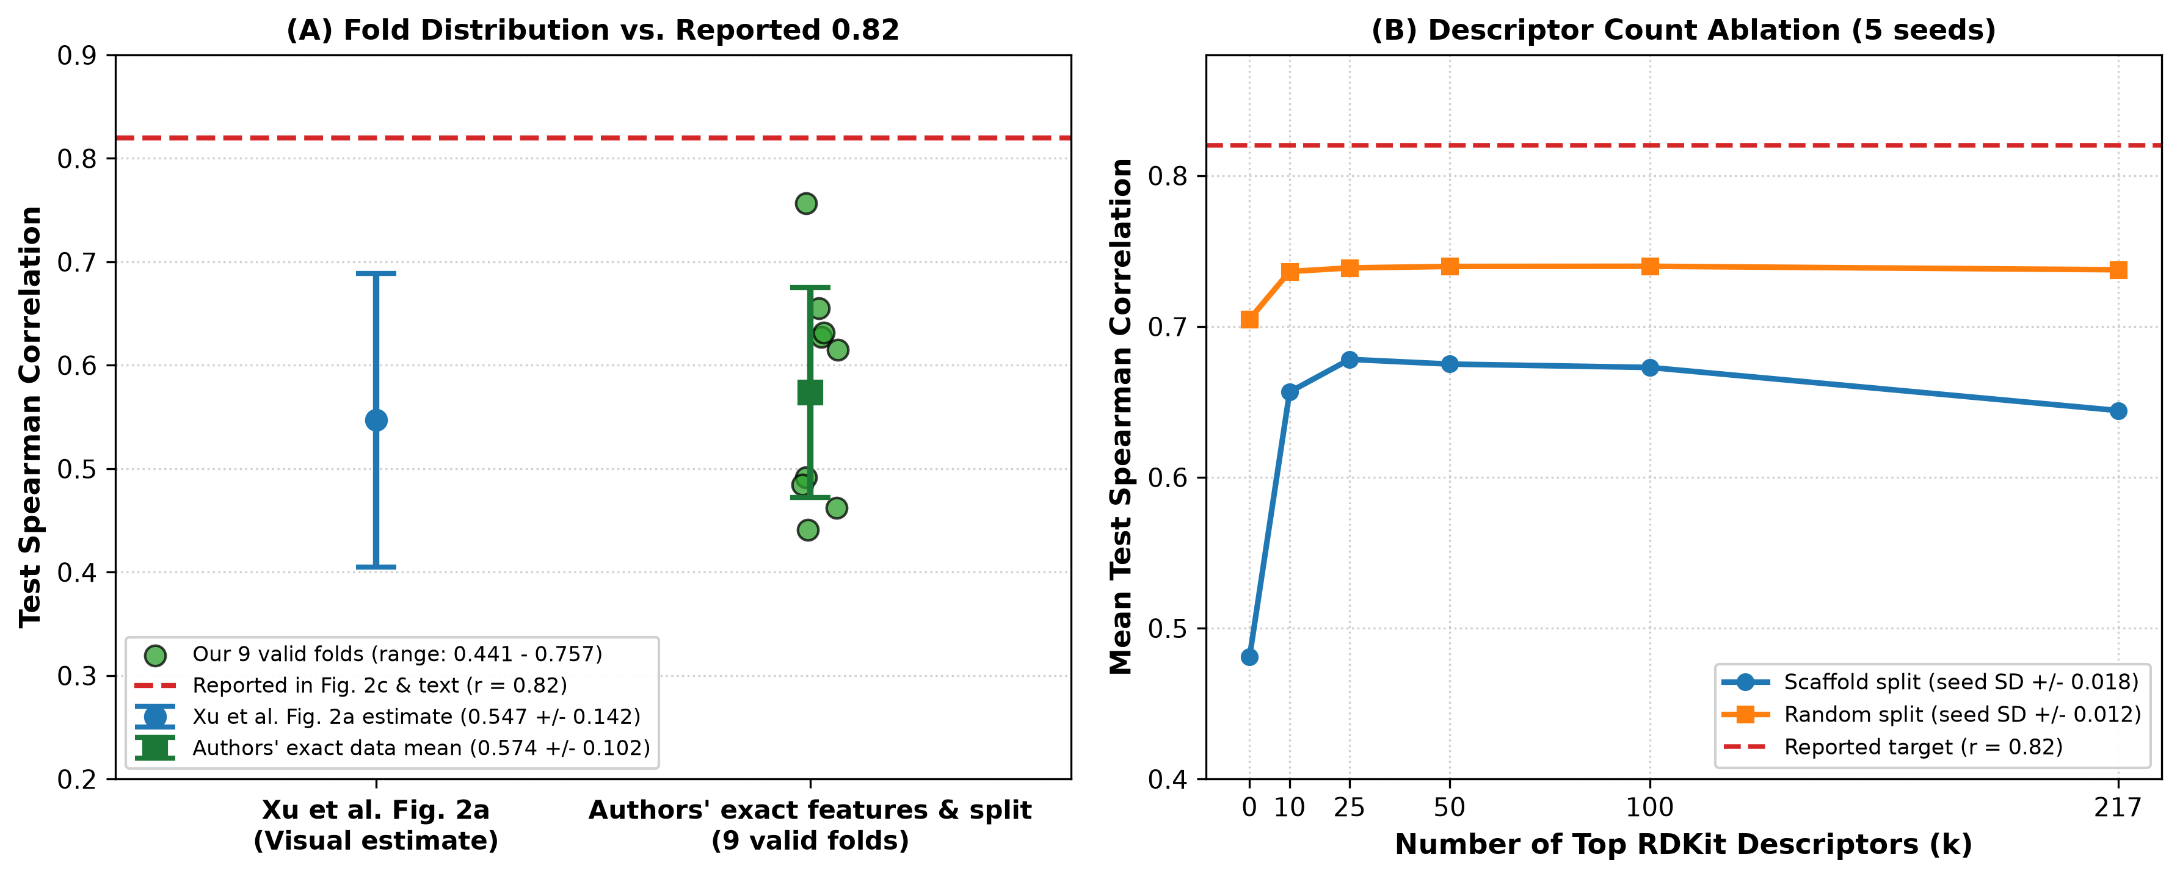
Figure 2. Independent reproduction and ablation of the HELM-GPT permeability predictor. (A) Distribution of test-set Spearman correlation across all nine valid folds of the authors' 10-fold scaffold split using their exact precomputed features (2048 fingerprints + 211 descriptors) and exact fold indices. Green circles represent individual fold test scores (range 0.441–0.757, mean ± SD: 0.574 ± 0.102). The visual estimate from Xu et al. Figure 2a (0.547 ± 0.142) is shown in blue. The red dashed line denotes the r = 0.82 metric reported in Figure 2c and the main text; no individual fold approaches 0.82. (B) Descriptor count ablation across five random seeds as a function of the number of top RDKit descriptors k (k ∈ {0, 10, 25, 50, 100, 217}) under scaffold split (blue) and random split (orange). Performance saturates at k = 25 (~0.68 for scaffold, ~0.74 for random), confirming that descriptor selection does not account for the gap to 0.82.
In our independently reconstructed feature pipeline, a hyperparameter/seed sweep (30 fits across 5 RF configurations x 3 seeds x 2 split types) produced Spearman values in the range 0.609–0.748, which also does not include 0.82 (best condition: random__n600_maxfeat0.3). A descriptor-count ablation showed performance saturating around the top 25 descriptors (by importance), with no further gain — and a slight decline — from using the full descriptor set, under either importance ranking (Table 2, Figure 2B):
Split Protocol | Mean Spearman by descriptor count k (0, 10, 25, 50, 100, 217) | Between-k SD | Within-k seed SD
Scaffold | 0.481, 0.657, 0.678, 0.675, 0.673, 0.644 | 0.076 | 0.018
Random | 0.705, 0.736, 0.739, 0.740, 0.740, 0.738 | 0.014 | 0.012

Under scaffold splitting, the effect of descriptor count on performance exceeded seed-to-seed noise by roughly 4.276x (a genuine effect, concentrated in the jump from fingerprint-only to the top 10–25 descriptors); under random splitting the same ratio was only 1.181x, close to noise level, because fingerprint-only features already perform well under random splitting (0.705). Permutation importance agreed with the RF's built-in (impurity-based) importance on the top two descriptors in both split types, but the two rankings diverged considerably further down the list (rank correlation 0.262 for scaffold, 0.124 for random), and the fingerprint block contributed only 0.715–1.713% of total permutation importance in both cases, confirming descriptors as the dominant predictive signal.
Performance Overview across Configurations
Evaluation Setting | Reported / Measured Spearman Correlation | Source / Reference
Xu et al. Figure 2a (RF FPS+DPS) | 0.547 ± 0.142 (mean ± SD across CV) | Original paper, Fig. 2a
Xu et al. Figure 2c & main text | 0.82 (single reported test set score) | Original paper, Fig. 2c & Section 2.2
Authors' features & split: 9 valid folds | 0.574 ± 0.102 (range: 0.441 – 0.757) | This study (re-evaluated on released data)
Authors' features & split: fold 7 | Val: 0.583, Test: 0.632, Val+Test: 0.604 | This study (released fold val_split=7)
Reconstructed pipeline: H1 sweep (30 fits) | 0.609 – 0.748 (none reaching 0.82) | This study (hyperparameter/seed sweep)
Descriptor ablation plateau (k=25) | Scaffold: 0.678 ± 0.018; Random: 0.739 ± 0.012 | This study (multi-seed ablation)

Discussion
Using the authors' own features and their own released 10-fold split, we are able to closely reproduce the distribution shown in the paper's own Fig. 2a (0.574 ± 0.102 vs. visually estimated 0.547 ± 0.142), but not the single 0.82 figure quoted in the main text and Fig. 2c. Because Fig. 2a (a multi-method comparison with error bars) and Fig. 2c (a scatter plot for one final chosen model) appear in the paper as two distinct analyses, we hypothesize that 0.82 corresponds to a specific evaluation configuration — e.g. a particular train/test partition, a different split proportion, or additional hyperparameter tuning — that is not fully specified in the main text or apparent from the released k-fold index file alone. We did not identify this configuration among the nine valid folds we were able to construct from the released split file. We want to be explicit that this is an unresolved hypothesis, not a claim that the reported number is incorrect: important methodological details (e.g. whether the 0.82 test set is itself one of the ten released folds, additional preprocessing, or the exact RF hyperparameters, which could not be recovered because the saved model pickle is incompatible with current scikit-learn) remain undisclosed, and we were not able to consult the original authors prior to this submission.
This empirical gap carries urgent practical consequences when viewed through the lens of translational oncology and peptide drug development. As illustrated by the therapeutic targeting of the SLC39A14-PIWIL2 oncogenic fusion in HCC (Shah et al., 2025), modern precision oncology increasingly seeks to drug 'undruggable' intracellular complexes that traditional small molecules cannot selectively bind. In Shah et al., the designed decoy peptides (NEP1, HDEP1) demonstrated micromolar in vitro efficacy against tPIWIL2-HDAC3 and tPIWIL2-NME2 interactions, but their biological activity was strictly contingent upon achieving intracellular delivery via an N-terminal CPP tag. To bypass the pharmacokinetics and potential immunogenicity liabilities associated with cationic CPP motifs in vivo, the field is actively transitioning toward generatively designed macrocyclic peptides that rely on intrinsic passive permeability (the explicit goal of HELM-GPT).
However, our findings reveal that the permeability prediction component of HELM-GPT operates at a true generalization correlation of r = 0.574 (±0.102) across scaffold splits, rather than r = 0.82. When generative AI algorithms use an in silico predictor with moderate correlation (r ≈ 0.57) as an unconditional fitness filter during reinforcement learning, a significant proportion of the designed molecules will be false positives—molecules predicted to be highly permeable that in reality possess inadequate cell penetration. For challenging intracellular oncogenic targets like SLC39A14-PIWIL2 or KRAS, such false predictions can result in failure during subsequent cell-based phenotypic or target-engagement assays, squandering significant experimental resources and time.
We emphasize that this note does not diminish the value of HELM-GPT's core generative and reinforcement-learning architecture, which represents an important methodological milestone. Rather, our goal is to provide researchers and drug discovery teams with a well-calibrated baseline: when deploying the HELM-GPT permeability predictor or similar random-forest models on cyclic peptides, expected test performance under structural scaffold splits is centered near ~0.57. For translational programs targeting intracellular oncogenic drivers, computational permeability scoring should be complemented by orthogonal in vitro permeability profiling (such as PAMPA or RRCK assays) and structural dynamics evaluations, alongside parallel delivery strategies such as CPP conjugation (Shah et al., 2025). Finally, we warmly invite the original authors to clarify the exact evaluation conditions and scripts that yielded the reported r = 0.82 metric.
Data and Code Availability
All reproduction code, intermediate result files (JSON), and the downloaded authors' feature/split artifacts used in this note are available at https://github.com/realover82/helm-gpt-reproducibility. The original HELM-GPT code and data are available at https://github.com/charlesxu90/helm-gpt.
Conflict of Interest
None declared.
References
1. Xu X, Xu C, He W et al. HELM-GPT: de novo macrocyclic peptide design using generative pre-trained transformer. Bioinformatics 2024;40(6):btae364. https://doi.org/10.1093/bioinformatics/btae364
2. Li J, Yanagisawa K, Sugita M et al. CycPeptMPDB: a comprehensive database of membrane permeability of cyclic peptides. J Chem Inf Model 2023;63:2240–50. https://doi.org/10.1021/acs.jcim.3c00424
3. Shah M, Moon SU, Choi JH, Kim MJ, Woo HG. Peptide-based therapeutics targeting the SLC39A14-PIWIL2 fusion in hepatocellular carcinoma. Genomics & Informatics 2025;23:28. https://doi.org/10.1186/s44342-025-00060-5

Supplementary Material: Original Paper Figure Overview
For complete contextual reference, Supplementary Figure S1 reproduces the full Figure 2 from Xu et al. (2024, Bioinformatics 40(6):btae364, p. 4), encompassing the entire cell permeability optimization pipeline of HELM-GPT, including predictive model comparisons (a, b), test correlation scatter plot (c), prior model distributions (d, e), RL optimization curve (f), and final agent permeability distributions (g, h).
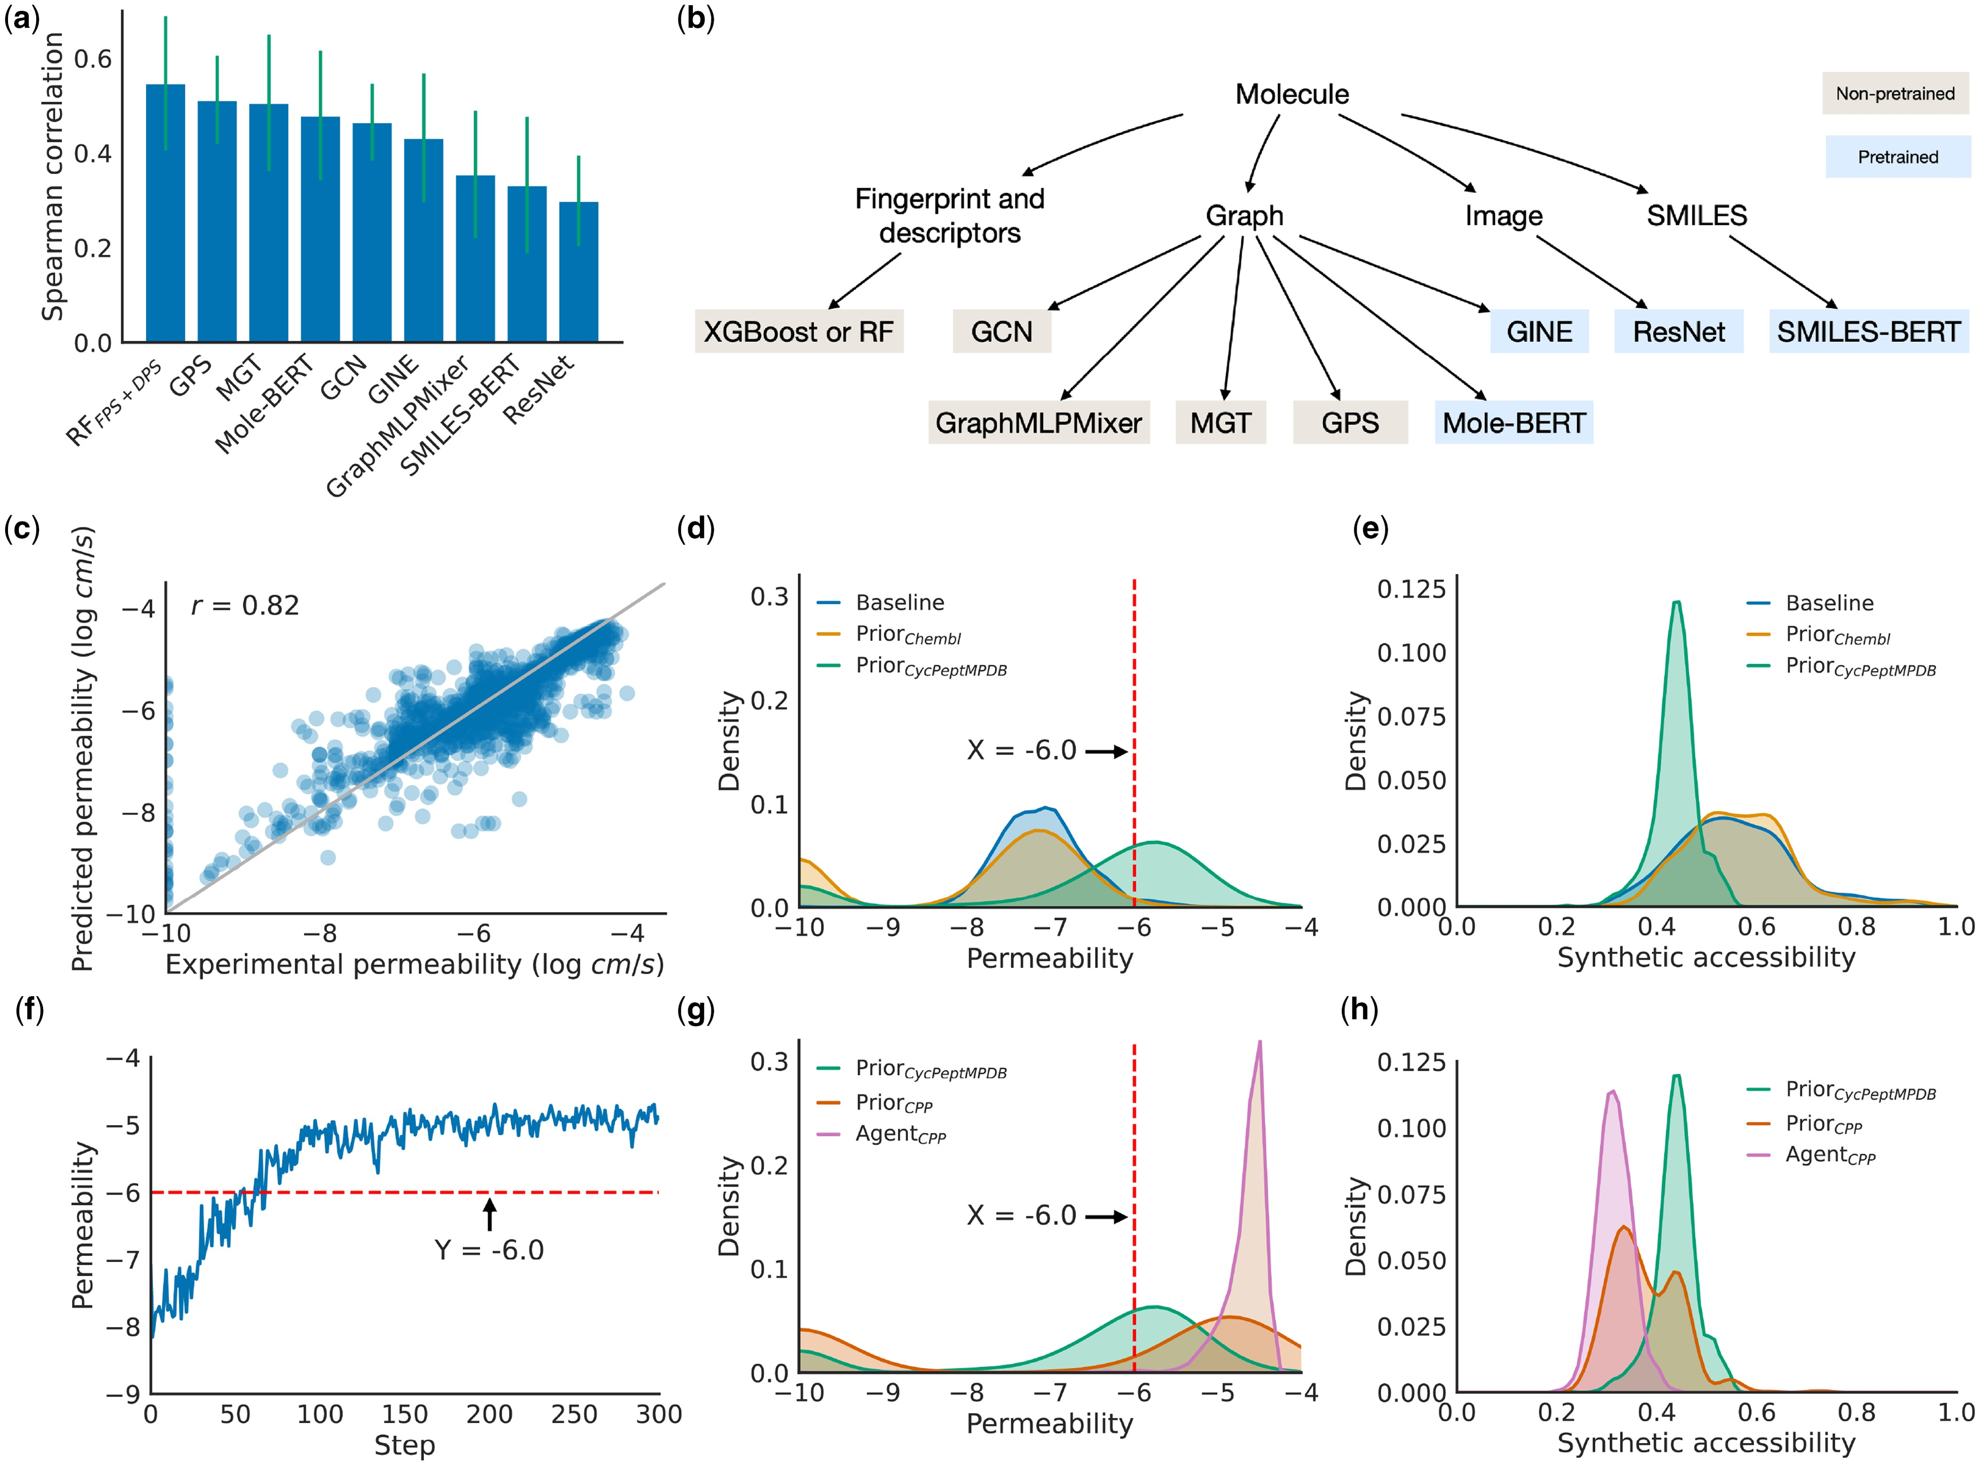
Supplementary Figure S1. Optimizing cell permeability of macrocyclic peptides with HELM-GPT (reproduced from Xu et al. 2024, Figure 2). (a) Comparison of predictive models for cell permeability prediction. Random forest model with fingerprints and descriptors as features showed a robust performance and was used in downstream tasks. (b) Classification of the predictive models evaluated. Fingerprints, descriptors, molecular graph, molecular image, and SMILES were evaluated as features. (c) Scatter plot of the predicted permeability and experimental permeability of macrocyclic peptides in the test dataset. The final predictive model achieved a Spearman correlation of 0.82. (d and e) The distribution of predicted permeability and synthetic accessibility of the molecules generated by the prior models. In total, 1000 molecules sampled from the ChEMBL database were evaluated as the baseline. (f) The mean predicted permeability of HELM-GPT generated molecules during the permeability optimization process. The model was able to generate molecules with high predicted permeability in 150 steps. (g and h) The distribution of predicted permeability and synthetic accessibility of the molecules generated by the final agent models in comparison to the prior models.

