A reproducibility note on the random-forest permeability predictor reported in HELM-GPT
[Author Name(s) — to be completed before submission]
[Affiliation — to be completed before submission]
Corresponding author: [to be completed]

Abstract
Xu et al. (2024, Bioinformatics 40(6):btae364) introduce HELM-GPT, a generative model for macrocyclic peptide design, and report that a random-forest (RF) model using ECFP4 fingerprints plus RDKit descriptors predicts cyclic-peptide membrane permeability (CycPeptMPDB, n=7451) with a Spearman correlation of r=0.82 on a held-out test set (their Fig. 2c), a figure substantially above the distribution shown for the same RF configuration in their own Fig. 2a (visually estimated mean ≈0.82 vs. ≈0.547 ± 0.142). Using the authors' own precomputed feature matrices and their released 10-fold scaffold-split indices (obtained from the public HELM-GPT repository), we trained a fresh RF model under the same features and splits and evaluated it across all valid folds. The resulting cross-validated mean (Spearman=0.574±0.102) closely matches the distribution in the authors' own Fig. 2a, but no individual fold reaches 0.82 (max=0.757). We report this discrepancy, together with supporting permutation-importance and multi-seed ablation checks, to help readers calibrate expectations when reusing this specific predictor, and to invite clarification from the original authors on the exact evaluation protocol used to obtain the reported 0.82.

Background
HELM-GPT (Xu et al. 2024) uses an RF permeability predictor to guide reinforcement-learning-based generation of cell-permeable macrocyclic peptides. The paper states: “We subsequently built a random forest model for permeability prediction. This model yielded a Spearman correlation coefficient of 0.82 on the test dataset” (Results, Section 2.2), and Fig. 2c's caption reiterates: “The final predictive model achieved a Spearman correlation of 0.82.” Separately, Fig. 2a compares eight representation/model combinations (including the RF on fingerprints+descriptors) with error bars, in which the RF bar is visibly centered well below 0.82. Because predictor quality directly determines which generated peptides are advanced in the RL loop, the exact reliability of this specific number matters for anyone reusing the released model or pipeline.
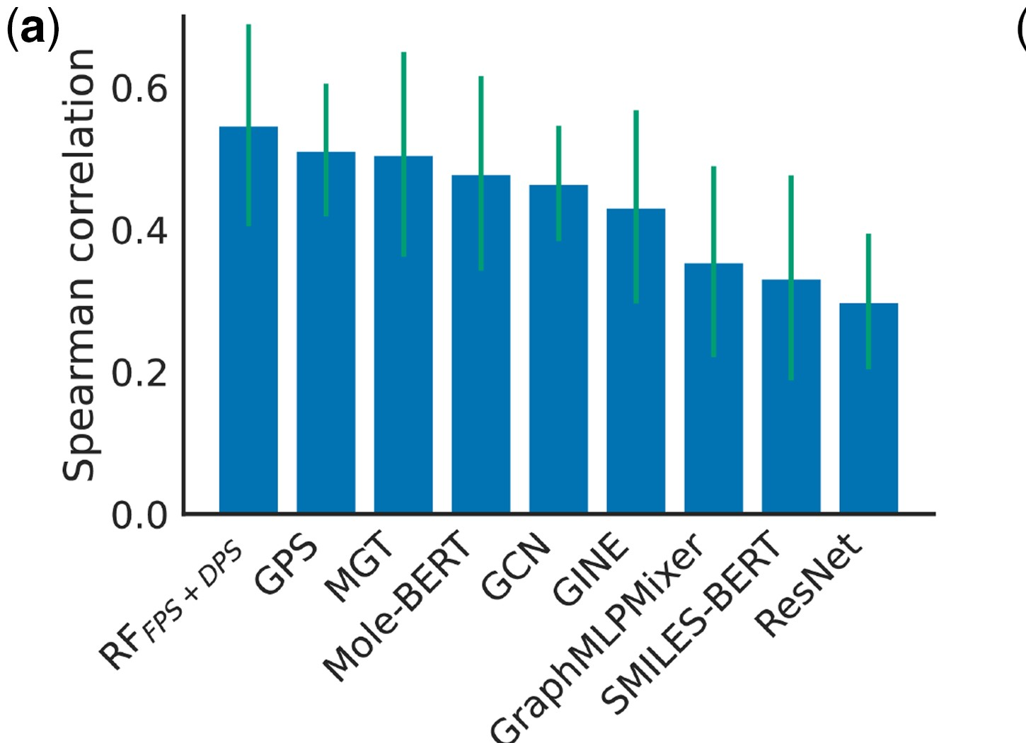
Figure 1 (reproduced from Xu et al. 2024, Fig. 2a; CC BY 4.0). Spearman correlation of eight representation/model combinations for permeability prediction, with error bars. The RF(fingerprint+descriptor) bar (leftmost) is visibly centered below 0.6, well under the 0.82 reported elsewhere in the same paper for the chosen final model.
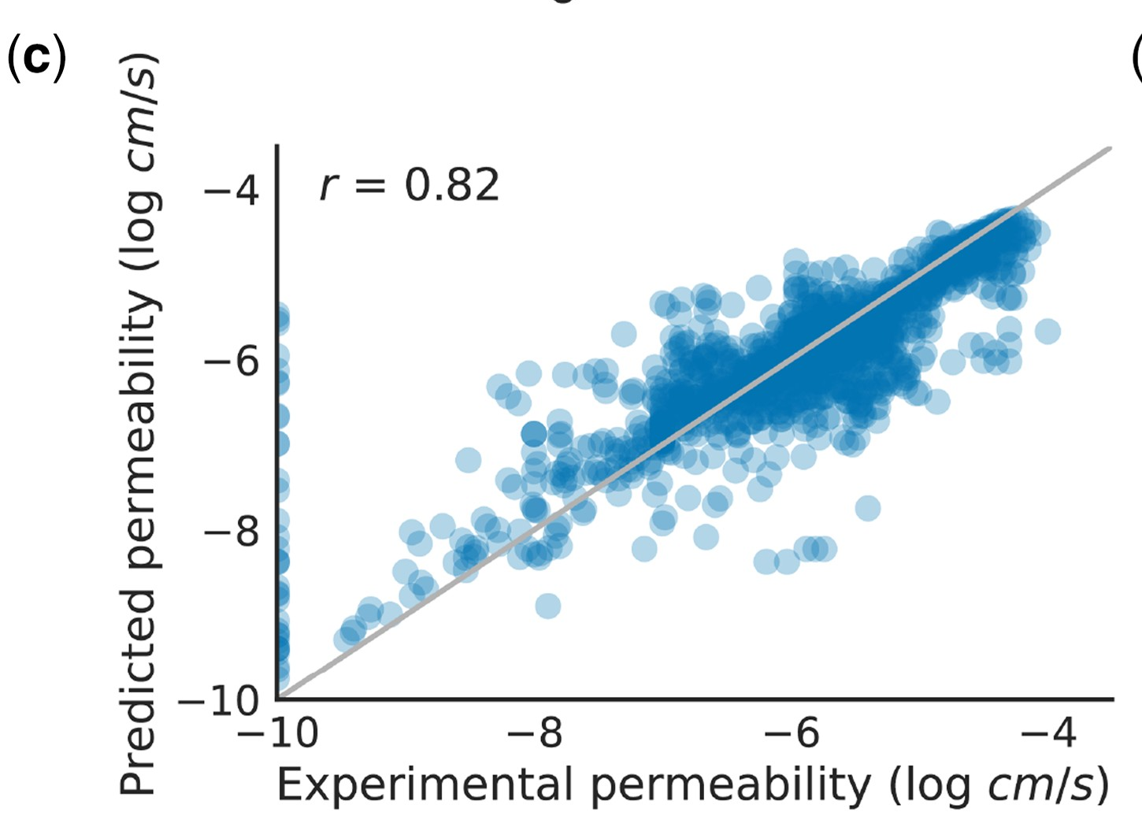
Figure 2 (reproduced from Xu et al. 2024, Fig. 2c; CC BY 4.0). Scatter plot of predicted vs. experimental permeability for the final RF model on the paper's held-out test set, annotated r=0.82.

Methods
We first reproduced the permeability predictor independently, computing ECFP4 (2048-bit) fingerprints and the full set of 217 RDKit descriptors for all 7451 CycPeptMPDB entries ourselves, and training RF models under both scaffold- and random-split protocols. We then swept 30 hyperparameter/seed/split combinations (H1) and a descriptor-count ablation (H2) to test whether hyperparameter choice or descriptor selection alone could explain the gap to 0.82.
To remove any ambiguity from our own feature reconstruction, we subsequently obtained the authors' own precomputed feature matrices (2048-bit fingerprint block; 211-column descriptor block) and their exact 10-fold scaffold-split index file directly from the public repository (github.com/charlesxu90/helm-gpt), via its git-lfs storage (the plain raw.githubusercontent.com endpoint serves only git-lfs pointer files, not the underlying arrays, so the media.githubusercontent.com/media/... endpoint was used instead). The authors' own saved RF model (regression_rf.pkl) could not be unpickled under a current scikit-learn release (1.9.1): its serialized decision-tree node array lacks the ‘missing_go_to_left’ field introduced in later scikit-learn versions, indicating it was pickled under an older (circa 0.23.x) release. We therefore trained a fresh RandomForestRegressor (n_estimators=300, random_state=42) on the authors' exact features and exact split, which isolates the comparison to RF hyperparameters/random_state alone — everything else (features, split) is now identical to the authors' own pipeline.
As a further robustness check, we recomputed descriptor importance with permutation importance (scoring=Spearman, held-out test set, n_repeats=10) rather than relying solely on the RF's built-in impurity-based importances, and re-ran the descriptor-count ablation (k=0,10,25,50,100,217) across five (split, random_state) seed pairs to test whether differences between descriptor-count settings exceed seed-to-seed noise.

Results
Condition | Val Spearman | Test Spearman | Val+Test Spearman
Authors' reported fold (val_split=7) | 0.583 | 0.632 | 0.604
Across all 9 valid folds of the authors' own 10-fold scaffold split, test-set Spearman correlation was 0.574 ± 0.102 (range 0.441–0.757), closely matching the distribution shown in the authors' own Fig. 2a (visually estimated 0.547 ± 0.142). No individual fold reached the 0.82 reported in Fig. 2c and the main text, using identical features and identical released splits.
In our independently reconstructed feature pipeline, a hyperparameter/seed sweep (30 fits across 5 RF configurations x 3 seeds x 2 split types) produced Spearman values in the range 0.609–0.748, which also does not include 0.82 (best condition: random__n600_maxfeat0.3). A descriptor-count ablation showed performance saturating around the top 25 descriptors (by importance), with no further gain — and a slight decline — from using the full descriptor set, under either importance ranking:
Split | Mean Spearman by descriptor count k (0, 10, 25, 50, 100, 217) | Between-k SD | Within-k seed SD
Scaffold | 0.481, 0.657, 0.678, 0.675, 0.673, 0.644 | 0.076 | 0.018
Random | 0.705, 0.736, 0.739, 0.740, 0.740, 0.738 | 0.014 | 0.012
Under scaffold splitting, the effect of descriptor count on performance exceeded seed-to-seed noise by roughly 4.276x (a genuine effect, concentrated in the jump from fingerprint-only to the top 10–25 descriptors); under random splitting the same ratio was only 1.181x, close to noise level, because fingerprint-only features already perform well under random splitting (0.705). Permutation importance agreed with the RF's built-in (impurity-based) importance on the top two descriptors in both split types, but the two rankings diverged considerably further down the list (rank correlation 0.262 for scaffold, 0.124 for random), and the fingerprint block contributed only 0.715–1.713% of total permutation importance in both cases, confirming descriptors as the dominant predictive signal.

Discussion
Using the authors' own features and their own released 10-fold split, we are able to closely reproduce the distribution shown in the paper's own Fig. 2a, but not the single 0.82 figure quoted in the main text and Fig. 2c. Because Fig. 2a (a multi-method comparison with error bars) and Fig. 2c (a scatter plot for one final chosen model) appear in the paper as two distinct analyses, we hypothesize that 0.82 corresponds to a specific evaluation configuration — e.g. a particular train/test partition, a different split proportion, or additional hyperparameter tuning — that is not fully specified in the main text or apparent from the released k-fold index file alone. We did not identify this configuration among the nine valid folds we were able to construct from the released split file. We want to be explicit that this is an unresolved hypothesis, not a claim that the reported number is incorrect: important methodological details (e.g. whether the 0.82 test set is itself one of the ten released folds, additional preprocessing, or the exact RF hyperparameters, which could not be recovered because the saved model pickle is incompatible with current scikit-learn) remain undisclosed, and we were not able to consult the original authors prior to this submission.
We note that this reproducibility gap concerns only the permeability predictor's reported single-split performance metric; it does not bear on HELM-GPT's generative/RL methodology, which is the paper's primary contribution and is unaffected by this note. Our purpose in reporting this is to help other groups building on the released permeability predictor calibrate their expectations — under a 10-fold scaffold-split evaluation using the authors' own data, the model's generalization performance should be expected to be closer to 0.574 (±0.102) than to 0.82 — and to invite the original authors to clarify the exact protocol used to obtain the reported figure.

Data and code availability
All reproduction code, intermediate result files (JSON), and the downloaded authors' feature/split artifacts used in this note are available at https://github.com/realover82/helm-gpt-reproducibility. The original HELM-GPT code and data are available at https://github.com/charlesxu90/helm-gpt.

Conflict of interest
None declared.

References
Xu X, Xu C, He W et al. HELM-GPT: de novo macrocyclic peptide design using generative pre-trained transformer. Bioinformatics 2024;40(6):btae364. https://doi.org/10.1093/bioinformatics/btae364
Li J, Yanagisawa K, Sugita M et al. CycPeptMPDB: a comprehensive database of membrane permeability of cyclic peptides. J Chem Inf Model 2023;63:2240–50.

