# Currency Analysis Project - TEAM 23

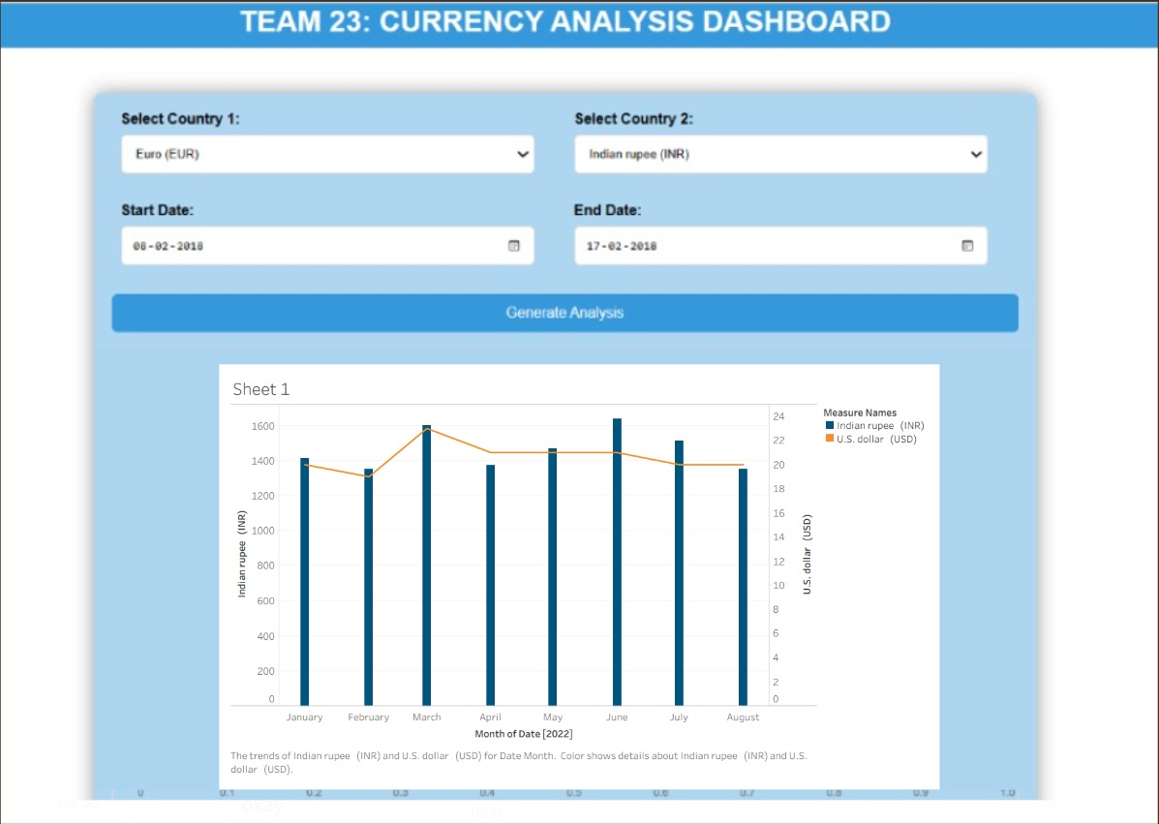

This project is aimed at providing users with a visual analysis of currency exchange rates between two selected countries over a specified time period. It employs two methods to achieve this: one using Express.js with JavaScript and API requests, and the other utilizing Matplotlib in Python to generate plots.

**## Method 1: Express with JavaScript (API Requests)**

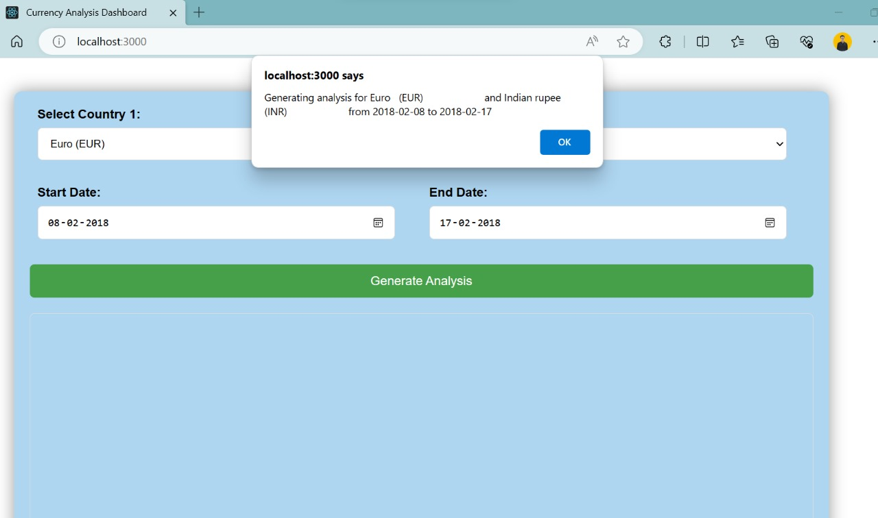

### Features:

- User-friendly web interface for selecting countries and date range.

- Fetches currency exchange rate data from an API.

- Utilizes Chart.js for dynamic chart visualization.

### Setup:

1. Install Node.js and npm.

2. Run `npm install` to install project dependencies.

3. Run the server using `node server.js`.

4. Open `index.html` in a web browser.

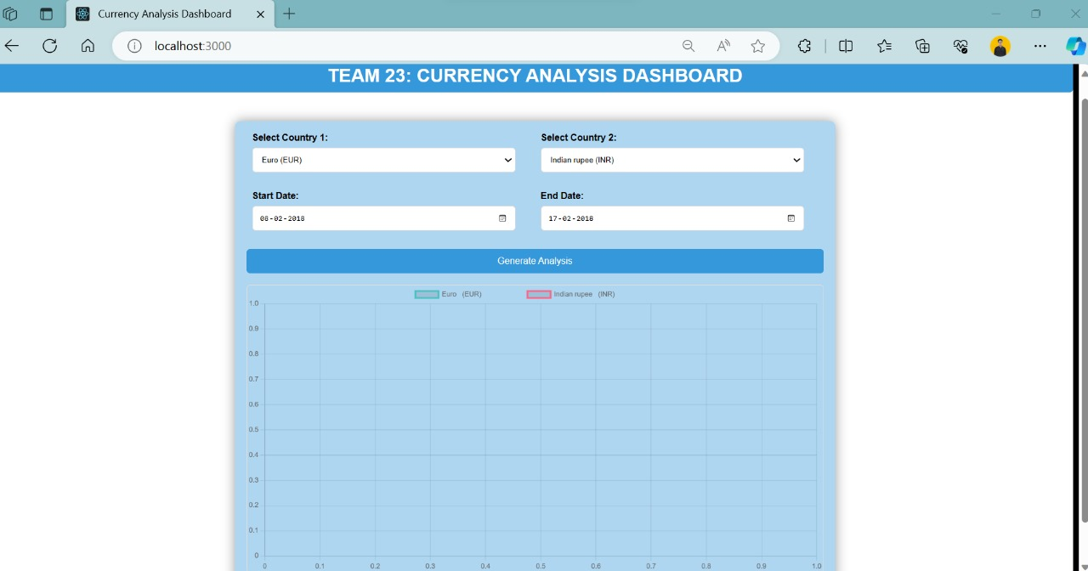

**## Method 2: Express with Matplotlib (Python)**

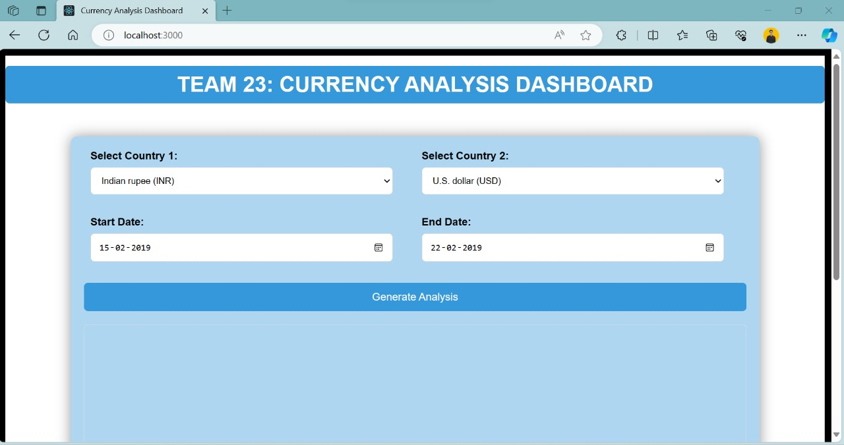

### Features:

- Generates currency exchange rate plots using Matplotlib.

- Integrates with Express.js to serve plots to the web interface.

### Setup:

1. Install Python and required packages (`matplotlib`, `pandas`).

2. Run `npm install` to install project dependencies.

3. Run the server using `node server.js`.

4. Open `index.html` in a web browser.

## How to Use:

1. **Select Countries:** Choose two countries from the dropdown menus.

2. **Select Date Range:** Specify the start and end dates for the analysis.

3. **Generate Analysis:** Click the "Generate Analysis" button to view the currency exchange rate plot.

**## Method 3: Python Models with JavaScript**



### Features: -

Leverages scikit-learn and other Python libraries for advanced data analysis. - Integrates machine learning models to predict currency trends. - Combines Python-generated insights with a user-friendly JavaScript interface.

### Setup:

1. Install Python and required packages (`scikit-learn`, `pandas`).

2. Run `npm install` to install project dependencies.

3. Run the server using `node server.js`.

4. Open `index.html` in a web browser.

## How to Use: 1.

**Select Countries:** Choose two countries from the dropdown menus.

2. **Select Date Range:** Specify the start and end dates for the analysis.

3. **Generate Analysis:** Click the "Generate Analysis" button to view the currency exchange rate plot.

**## Notes:**

- The JavaScript method fetches data dynamically from an API, providing real-time information.

- The Python method uses pre-existing CSV files and generates static plots based on the selected date range.

- Enhances analysis by integrating machine learning models, providing more in-depth insights into currency trends.

Feel free to explore and analyze currency exchange trends with this interactive tool!