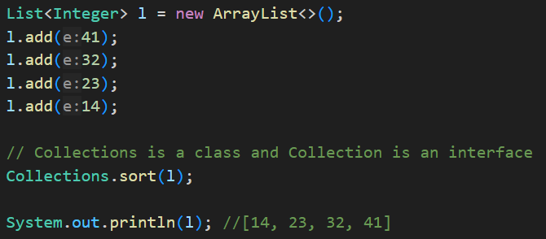

Now I want to sort it based on the last digit.

Sorting objects using Comparator Interface.

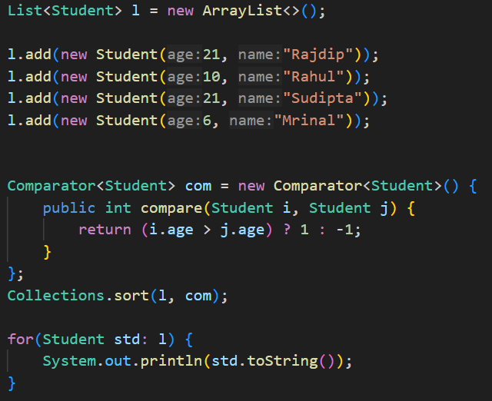

Sorting an object using Comparable Interface



