1. **Referencing Instance Variables**: Used to differentiate between instance variables and local variables.
2. **Calling Another Constructor**: Facilitates constructor chaining within the same class.
3. **Calling Another Method**: Can call other method inside a methods.
4. **Returning the Current Object**: Enables method chaining by returning the current object.
5. **Passing the Current Object**: Allows the current object to be passed as a parameter to other methods.

**Calling Another Constructor**:

* It is used to call another constructor in the same class. This is known as constructor chaining.

**Calling Another Method**:

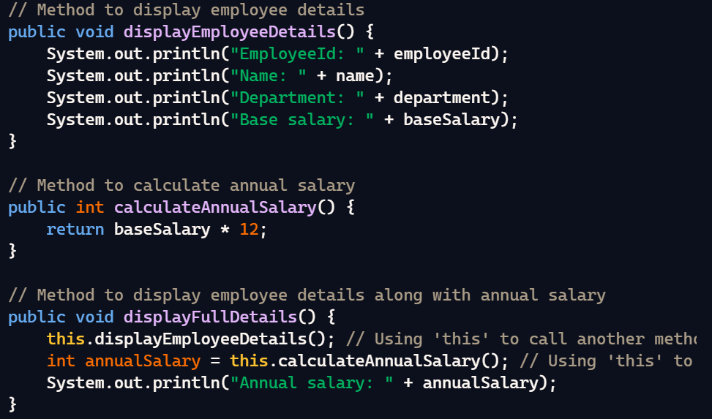

**Returning the Current Object**:

* It can be used to return the current object from a method.

**Passing the Current Object as a Parameter**:

* It can be used to pass the current object as a parameter to another method.

