List<Integer> l = Arrays.asList(1,2,3,4);

l.forEachI(n -> sout(n)); //better way to do this is first create a stream then use the method as once you consumed the stream you can’t reuse use it and list is not changed as a stream is created.

\*\*\*\*

ForEach does not returns anything .

Map returns a new stream.

Sorted returns a new stream.

Filter returns a new stream.

Reduce returns one single value.

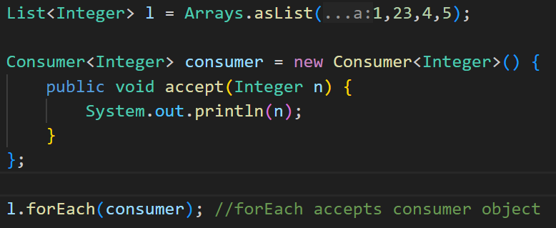

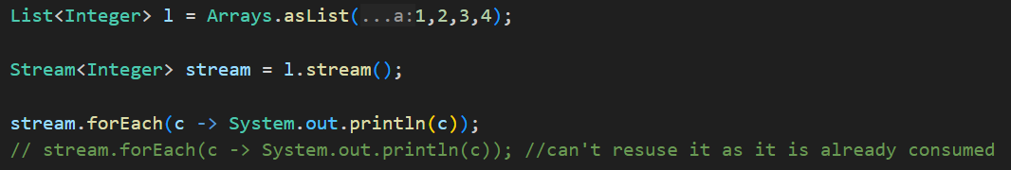

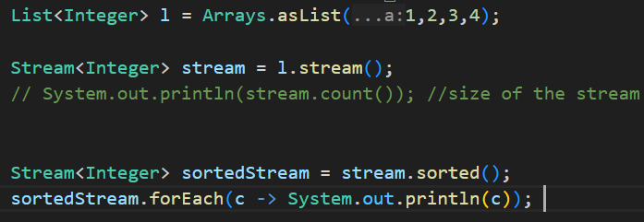

\*\*Decode Filter:

Filter accepts a functional Interface know as Predicate, Predicate have an abstract method called test. Filter is a method in stream Interface.

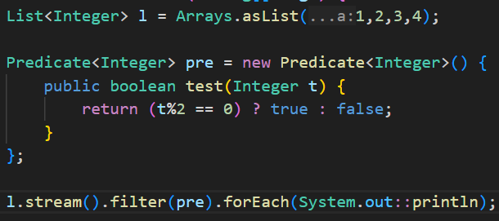

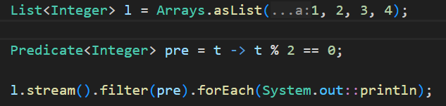

\*\*Decode Map

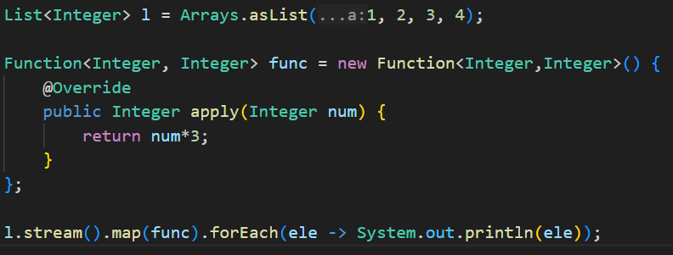

\*\*Reduce Method

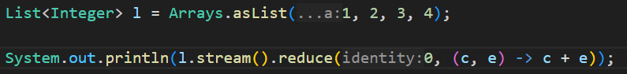

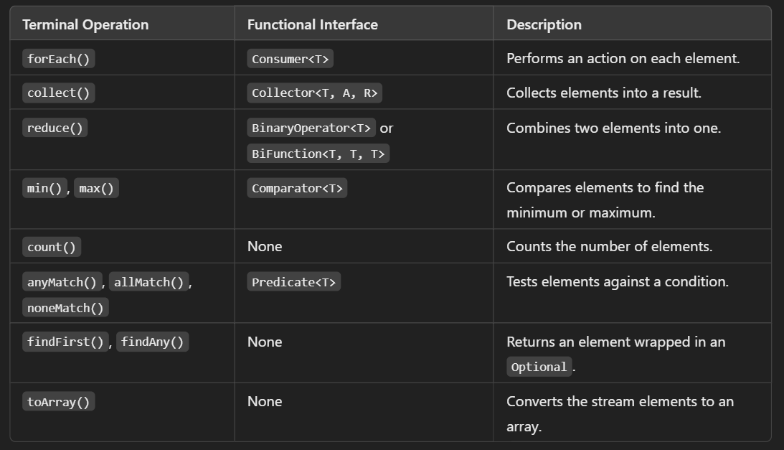

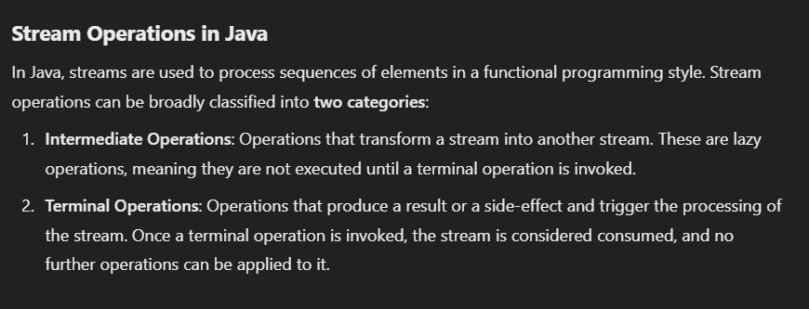

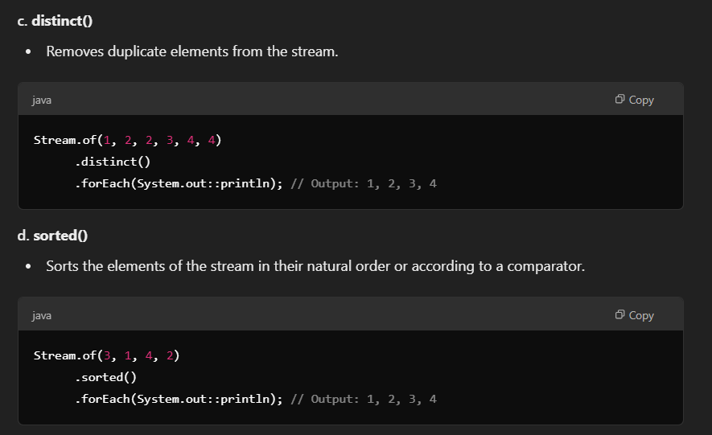

flatMap(list -> list.stream())

flatMap(Collection::stream)

