Bill Pugh Singleton Design

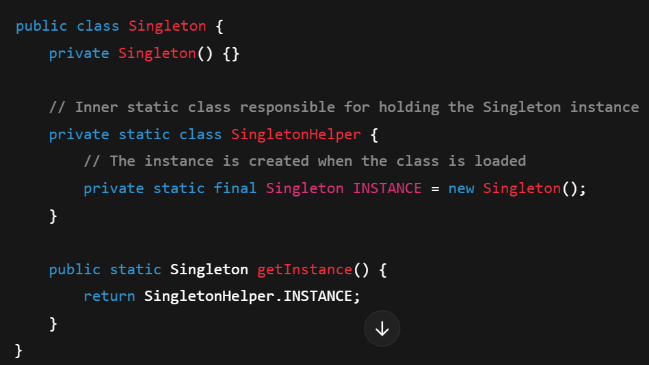

3 static

3 private

1 final

The SingletonHelper class is **loaded lazily**. The first time getInstance() is called, the class loader ensures that the INSTANCE is created exactly once, even in the case of multiple threads calling the method simultaneously.

The class loading mechanism in Java guarantees that a class is loaded in a thread-safe manner, meaning only one thread will initialize the instance of SingletonHelper.