git config --global user.name “Rajdip” //In place of global we can also add local

git config --global user.name “Rajdip@email.com”

git config --list 🡪 To show all the saved details

ls -a 🡪 Shows hidden files

git clone “link”

git status

add 🡪 adds new or changed files in your working directory to the Git staging area

git add . 🡪 Add all files to staged area

git add <File-1> <File-2> … <File-n>

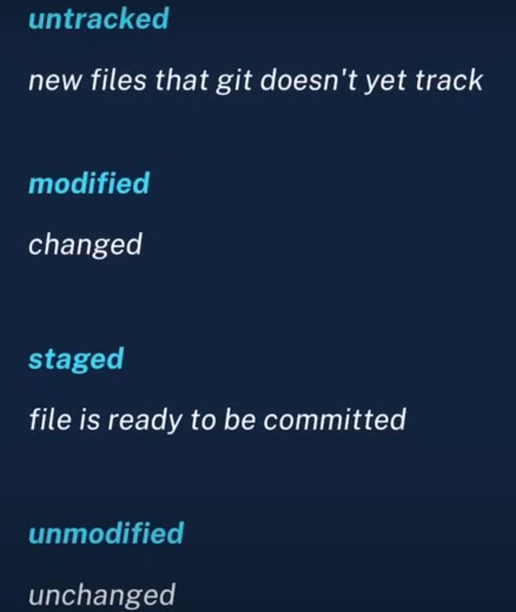

Git push 🡪 Upload local repo content to remote repo

git push origin main

git push origin <branch_name>

*If you don’t have any commit’s then no branches will be shown (by using git branch)

*Master is renamed to main in GitHub (but not in git) that’s why to avoid conflict we rename our local branch to main

*git push -u origin main 🡪 adding -u origin main in first time so that we can write only git push from next time.

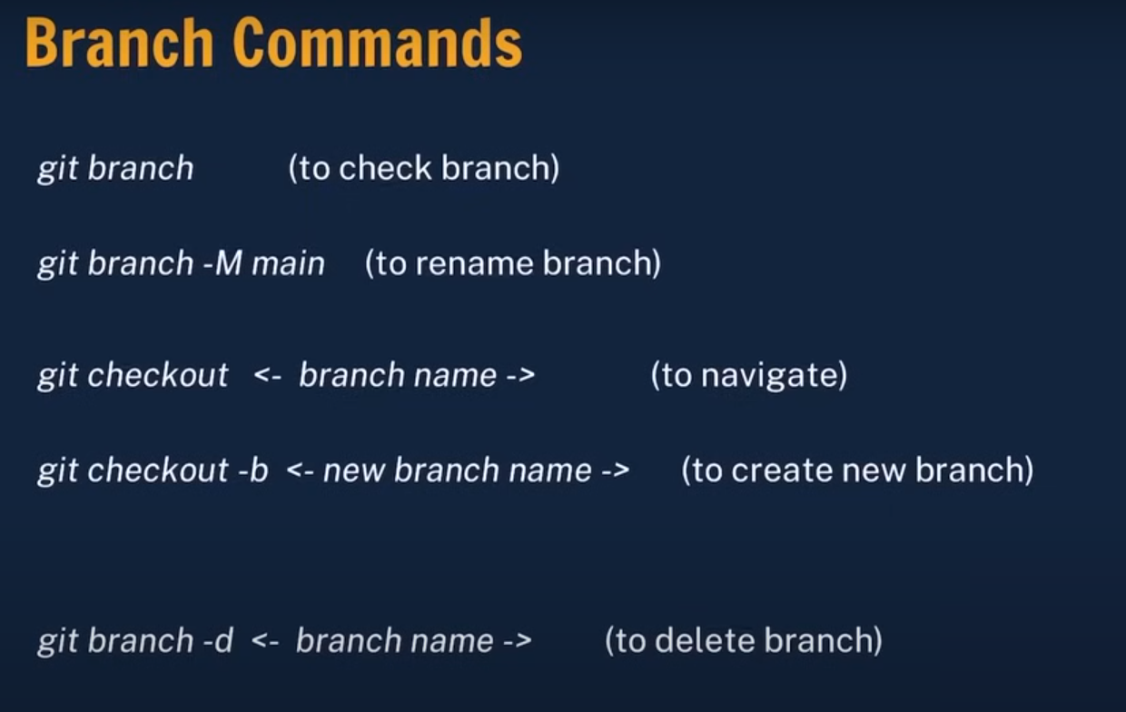

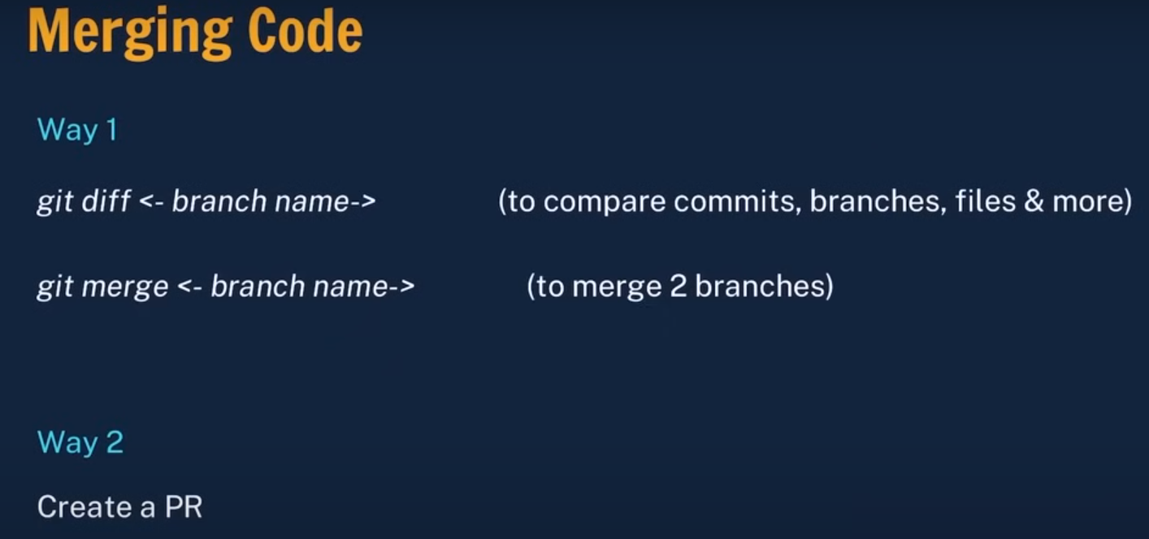

Before merging go to the branch you want to merge with,

Ex. Git checkout main

Git merge feature

Merge Conflicts

Main 🡪 style.css 🡪 a { colour: red}

Feature 🡪 style.css 🡪 a { colour: blue}

Now make the final changes 🡪 Add it to staging area 🡪 Commit it (git commit) 🡪 shift : wq

<<<<<<< HEAD

This is the content from the current branch.

=======

This is the content from the branch being merged in.

>>>>>>> branch-to-merge

