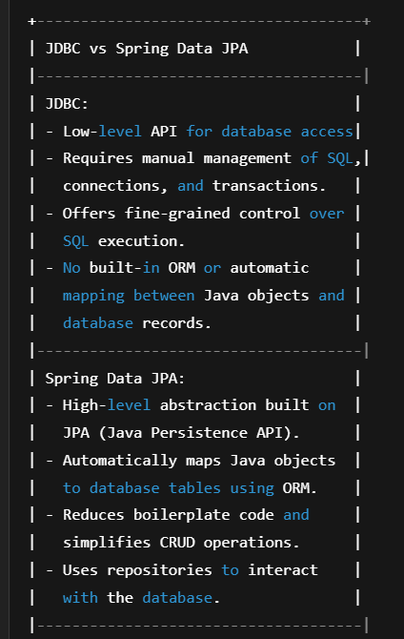

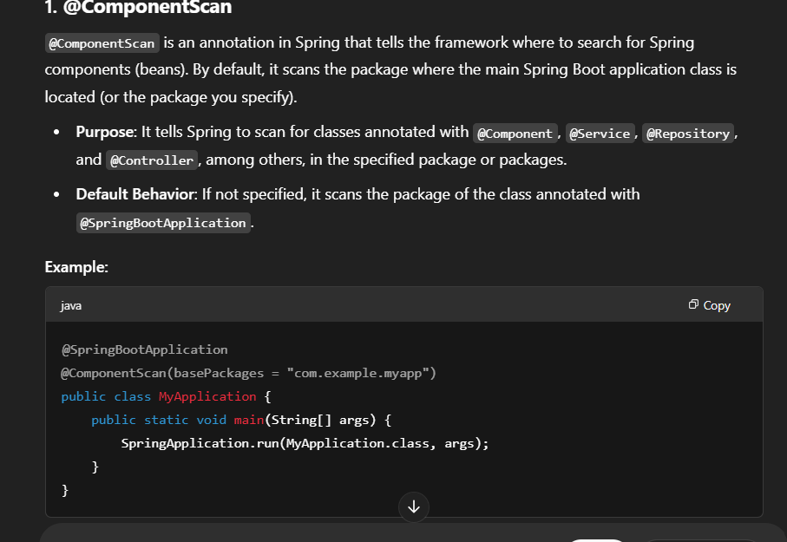

Serialization is the process of converting an object into a byte stream so that it can be easily stored (e.g., in a file) or transmitted (e.g., over a network). The serialized data can later be deserialized to reconstruct the object.

**Key points:**

* **Serializable Interface**: To make an object serializable in Java, the class of the object must implement the java.io.Serializable interface. This interface is a marker interface, meaning it doesn’t contain any methods. Its purpose is just to indicate that the object can be serialized.
* **Byte Stream**: The object is converted into a sequence of bytes that can be written to an output stream (like a file or network socket).