Initial experiments

Overview
One of the attempts to restore the users original voice that we have tried was WaveGlow, a flow-based generative network for speech synthesis [https://arxiv.org/abs/1811.00002].

The network uses 12 coupling layers together with the same number of 1x1 invertible convolutions. Each of the coupling layers have 8 dilated 512 filter convolutions, with gated hyperbolic tangent activation function. Where 512 of the channels are used for residual connections and 256 channels are used for skip connections. In addition 2 of the channels after each of the 4 couplings.

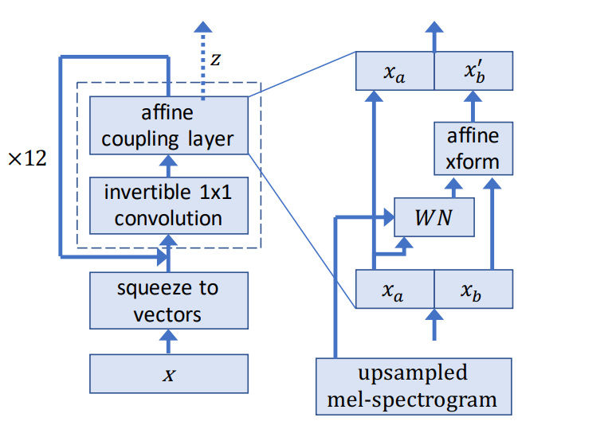

The network’s input is a waveform to which firstly a Short-time Fourier transformation is applied using filter length of 1024, hop length of 256 and window length of 1024. After which, we convert the STFT to Mel spectrogram of 80 channels clipped to f_{min} = 0 and f_{max} = 8000, the clipping is required for uniform normalization of [0, 1] of the tensors.

The network is trained with segments of 48000 length, given our 16 kHz input this means each of our training segments will be 3 seconds long. For audio clips shorter than 3 seconds we pad the remaining waveform with silence. For audio clips that are longer than 3 seconds we perform a random clip in the waveform so that every iteration a different part of the segment is used as training input.

When reconstructing longer than 3 second audio clips, the reconstruction is also made in 3 second segments.

To train a generative network, a loss function is used, where the first term comes from the log-likelihood of a spherical Gaussian. The σ² term is the assumed variance of the Gaussian distribution, where the remaining terms account for the change of the variables. In addition W denotes the weights of the convolution, for which a log-determinant of the Jacobian transformation is calculated and used in the training loss function as per WaveNet [https://arxiv.org/pdf/1609.03499v2.pdf].
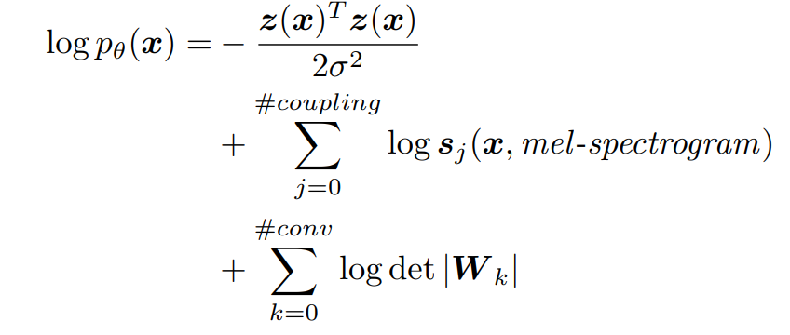

Dataset
We have trained the network by using our own collected control and LIEPA-2 [https://xn--ratija-ckb.lt/liepa-2/infrastrukturines-paslaugos/garsynas/] datasets containing Lithuanian speech phonetics. To use the datasets, we first had to normalized them by converting to the same sampling rate of 16 kHz and convert stereo voice recordings to mono-channel.

The datasets consists of 3647 LIEPA-2 recordings and 508 control group recordings, together spanning hours of voice clips that can be used for training our network.

In addition to the large dataset we have added additional augmentations to the voice clips which included simulation of audio polarity inversion, white-noise generation, gain randomization, high-low pass filtering, addition of reverberation and pitch shifting.

For validation dataset, we split the control group training dataset in 80:20 ratio giving us 102 control group voice clips that are never used in training, in addition to which validation dataset also used 77 voice clips containing various voice pathologies, totaling validation dataset with 179 elements.

Training parameters
The neural network was trained for 100k epochs, we found that while the loss seems to stabilize with time, the additional training time produces cleaner outputs. We chose the Adam optimizer with the initial learning rate of 1e-4 and optimizer σ of 1. We have used half-precision floating point training as we found no difference in terms of training quality with the reduced memory overhead. In addition we used batch size of 1, while the original paper uses batch size of 12 it was too much to fit in a single RTX 3070 memory, initially it was lowered to 4 which managed to fit in the limited 8GB VRAM limit, however, reducing to batch size of 1 had no negative training impact so it was decided to stay a lower batch size if network were to be expanded with additional layers of complexity.

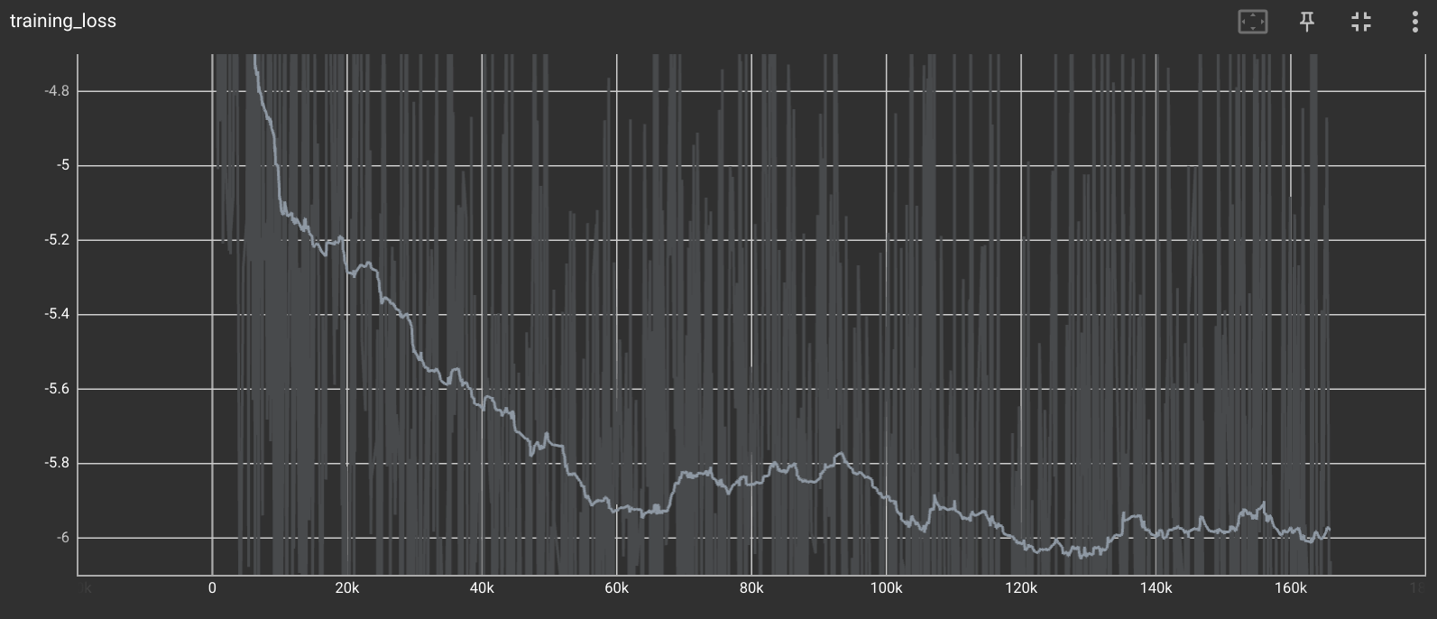

Results
We found that the reconstruction from mels spectrogram into waveform by the WaveGlow network after 100k to be audibly very accurate with only minor and rare reconstruction defects in form of quiet clicks. In addition we tried reconstructions at 25k, 50k and 75k epochs the reconstructions are already intelligible to be similar to the input voice clips but the lower the number of epochs the more defects the networks tended to suffer.

Unfortunately, we found that this WaveGlow approach is unable to remove the voice pathologies from the voice clips, meaning that the reconstructed voice clips have their original pathologies. We assume that this is because we cannot expose the network to the same voice before and after voice pathologies occurred and simulating them with pitch shifting is not sufficient, as such pathologies can involve not only have minor defects in the voice but in some cases make the voice line barely intelligible or even add temporal distortion where pronouncing a 4 word sentence takes 15 seconds, making any methods that focus only on voice segments unlikely candidate for a solution.

In addition we have tried the author given weights trained on English language dataset. However, the generated voice had the same additional noise in addition to lowering the pitch of the voice making all of the voices sound much deeper than the original.

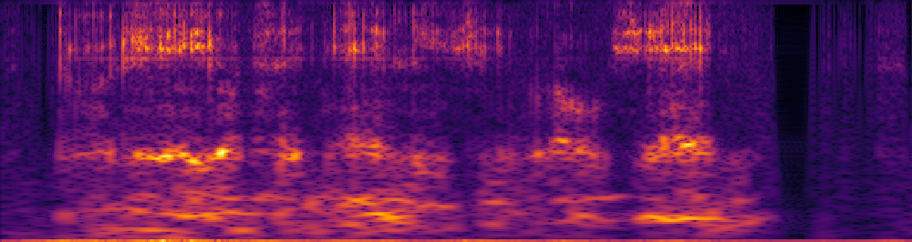
ltu

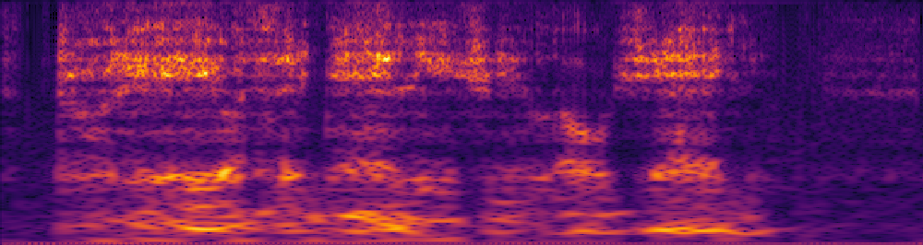
eng

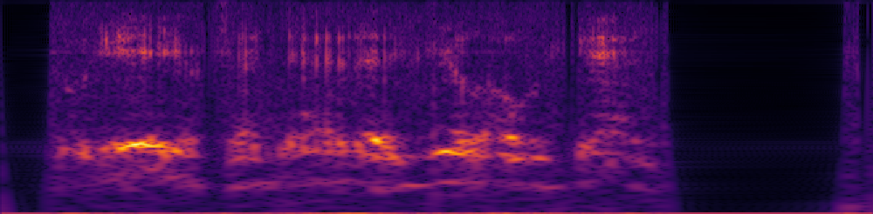
ltu

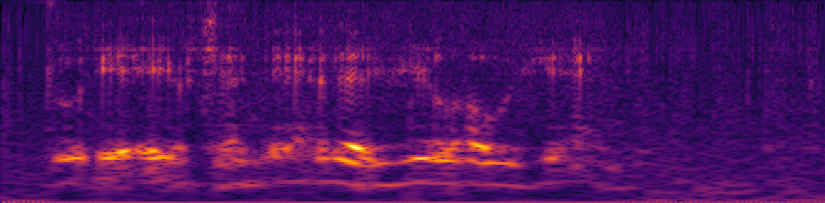
eng

As we can see both Lithuanian trained and English trained models generally produce same primary mels spectrogram features, but for example English model has more noise in the silent regions, whereas Lithuanian model is produces much less noise and is nearly completely silent where no voice-over is available.

Further steps
Because we have been successful at synthesizing voice from a mels spectrogram. One of potential solutions to our problem that we are currently exploring is capturing the voice profile from a limited voice clip segment and using it to synthesize a mels spectrogram for a given sentence. Which then in turn could be then used for the synthesis of the waveform itself a la deepfake.

Mels reconstruction bellow ordered as follows: input mels segment, reconstructed mels spectrogram, ground truth:

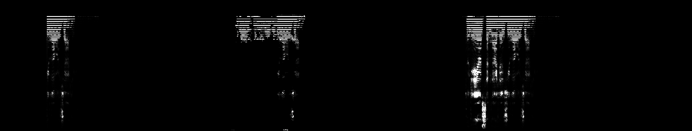

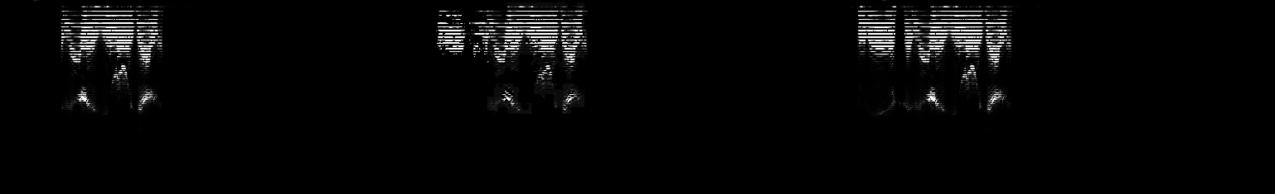

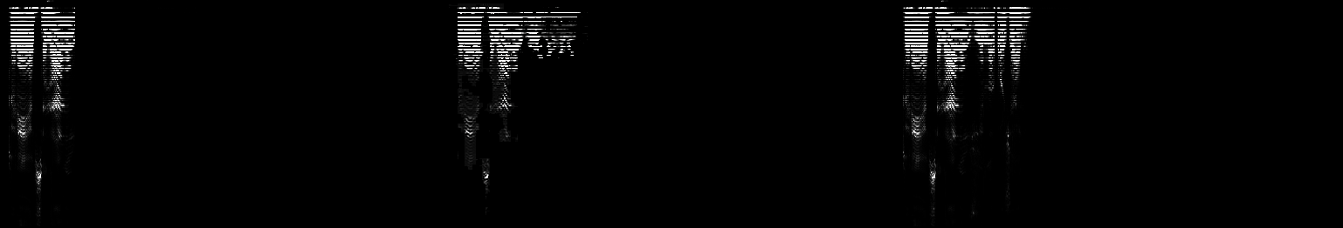

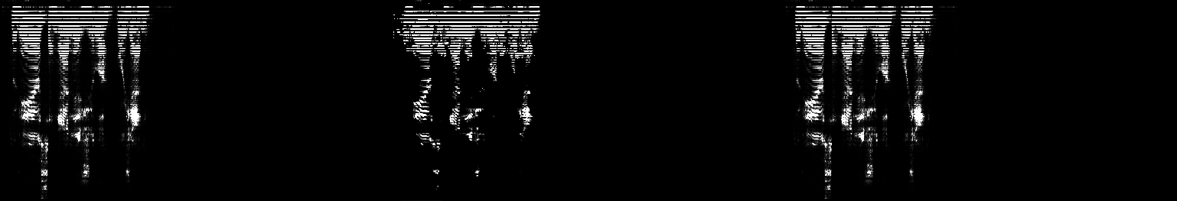

Issues encountered
Biggest issues with this approach was that the deep learning model was unable to properly fill in data from users sufficiently compounding with the fact that the both inputs and outputs were not normalized a significant data loss occurred which the model was not able to learn properly. Instead a different multiple stage approach was chosen due to previous research in real-time voice cloning applications.

New approach

Overview
To base our approach we have adapted SV2TTS (https://arxiv.org/pdf/1806.04558.pdf) voice cloning language model used for English speaking voice cloning. Because the English language phonemes differ greatly from Lithuanian have expanded the network to support additional phonemes such as “ą”, “č”, “ė”, etc., in addition because the original model used English speaker database for training we have opted to use LIEPA-2 for training our deep learning model (https://xn--ratija-ckb.lt/liepa-2/infrastrukturines-paslaugos/garsynas/).

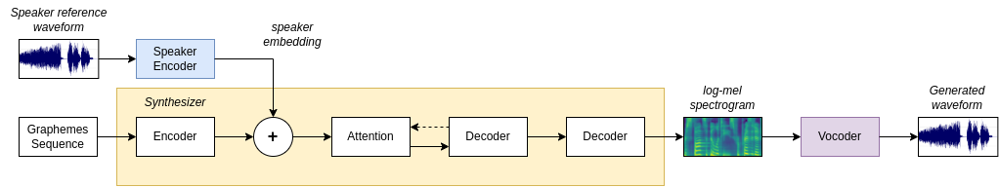

Dataset
Dataset consists of 1000 hours of audio recordings consisting of 2621 speakers. The breakdown of speakers by gender is 56% women and 44% men. To breakdown the speakers by age:
- 8% - up to 12 years old
- 3% - 13 to 17 years old
- 18% - 18 to 25 years old
- 61% - 26 to 60 years old
- 10% - over 61 years old
Each of the audio recordings is fully annotated, we have each of the audio recordings using annotations as grounds truths, where each of the segment would start and end when a speaker makes pause. This can be a comma, end of sentence or a speaker having to take a breath. Each of the sequences that contained no phonemes was automatically rejected. Only characters that were admitted into the text sequence were:
“AaĄąBbCcČčDdEeĘęĖėFfGgHhIiĮįYyJjKkLlMmNnOoPpRrSsŠšTtUuŲųŪūVvZzŽž!\'\"(),-.:;? “
Therefore, if the annotation sequence contained any of the illegal characters, the entire sequence would be rejected. This is important to filter such annotations as coughing, sneezing or taking a breath as these noises are annotated with “+” symbol for example “+breath+”, “+noise+”, etc. In addition we have rejected any waveform segments (utterances) that were shorter than 1.6 seconds to filter out any other potential issues in the dataset. Additionally, if a speaker would be left with less than 10 utterances we would completely reject the speaker to reduce class imbalance as an average speaker has around 100 valid utterances. This has left us with a total of 3098 valid recordings in the dataset, each averaging around 100 utterances.
Further improvements could be made to to the dataset by increasing class balance even more, however, this setup proved more than sufficient at the moment.

Training

Encoder
To train our deep learning model we started by training the encoder to be able to differentiate between the individual speakers and to create voice embeddings. Bellow are embedding results per iteration steps:
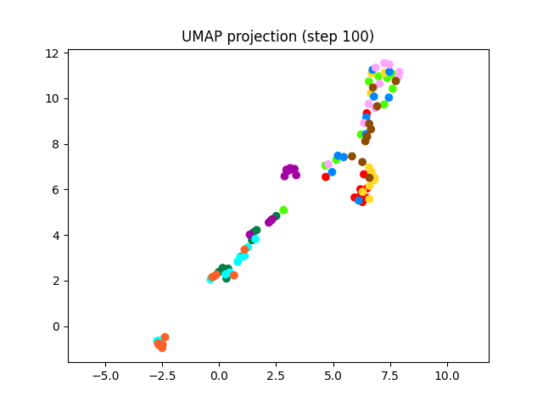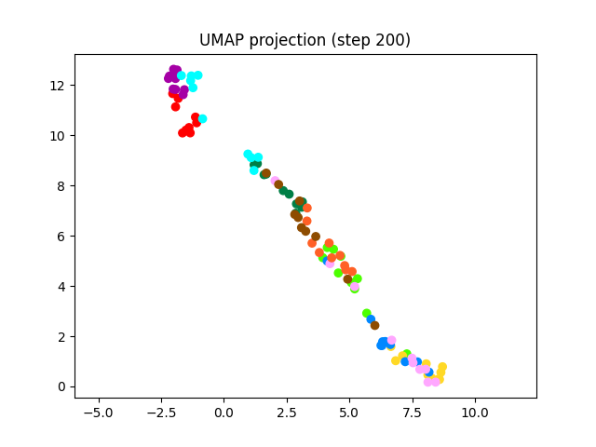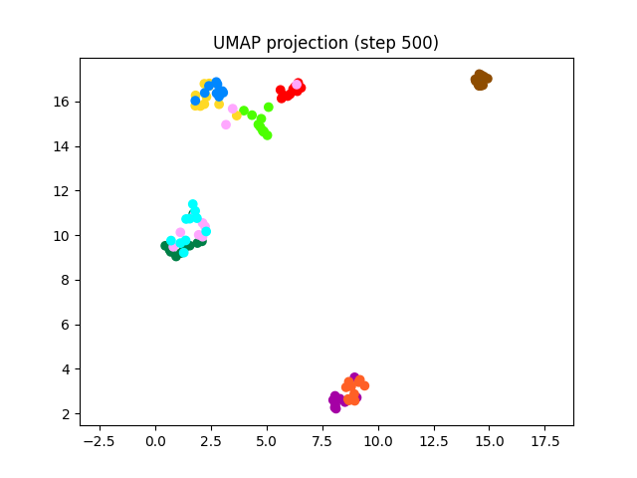
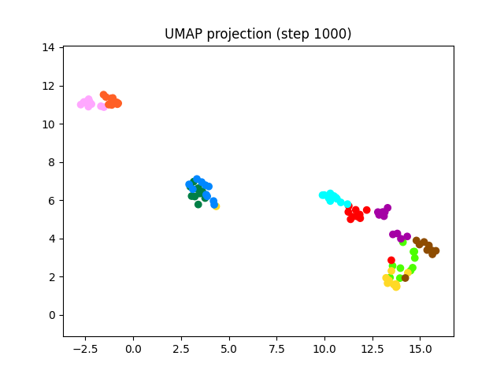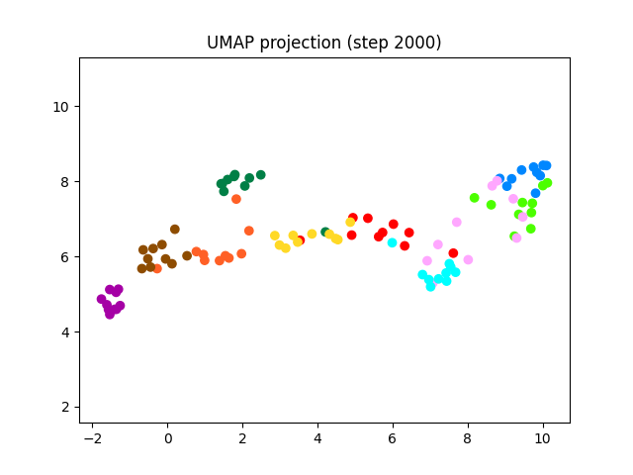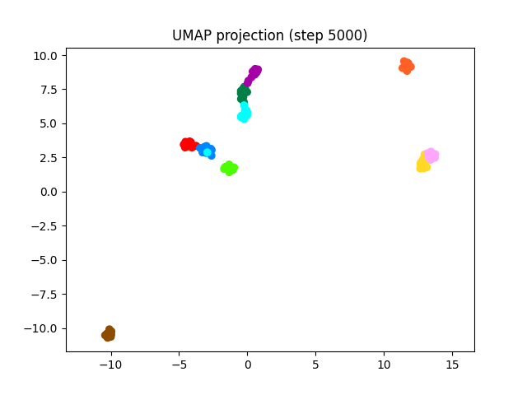
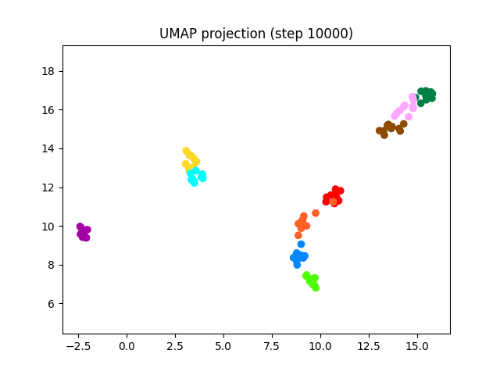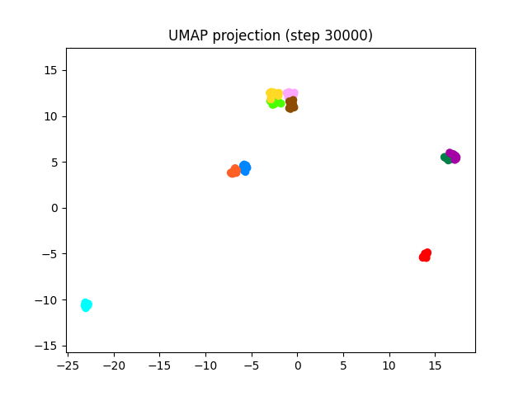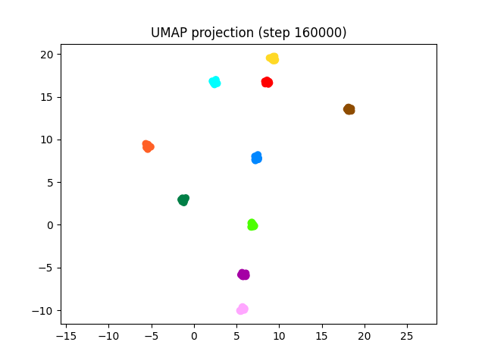
As we can see our encoder embeddings start scattered as the encoder network is not initially able to differentiate between the speakers, by the 5000 step the network starts convering on the solution and by step 160’000 the network has fully converged and is able to differentiate between the speakers.

Synthesizer
Once the speaker encoder has converged we need to train the synthesizer. We have two metrics to metrics to measure reconstruction accuracy, attention and mel-spectrogram loss. Attention layers are used within the synthesizer’s encoder network as per Tacotron2 implementation (https://paperswithcode.com/paper/natural-tts-synthesis-by-conditioning-wavenet), however, when attention is plotted as a graph it also lets us visually/quickly inspect how far the prediction is from ground truth without having to listen to each of the waveforms individually. Whereas, the mel-spectrogram loss lets us quantify this loss in absolute terms.

Attention
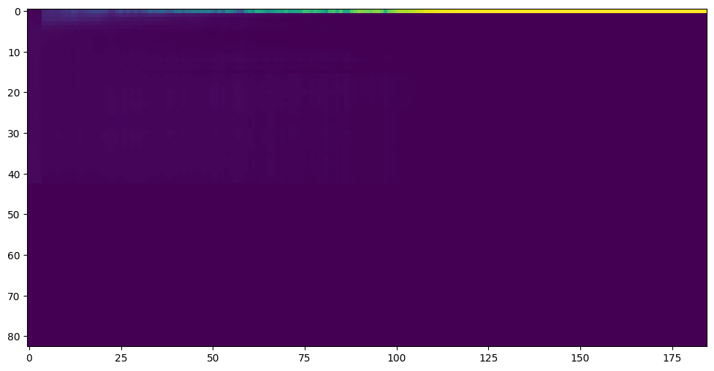Figure 1: Step 500

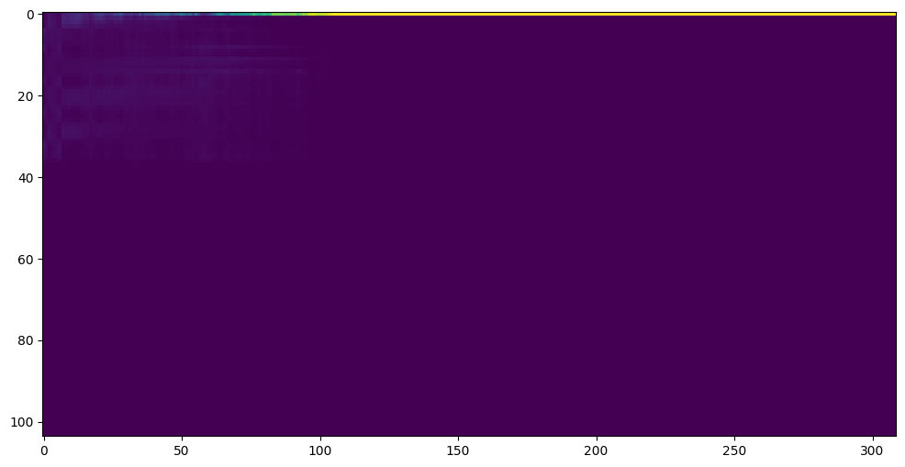Figure 2: Step 10'000

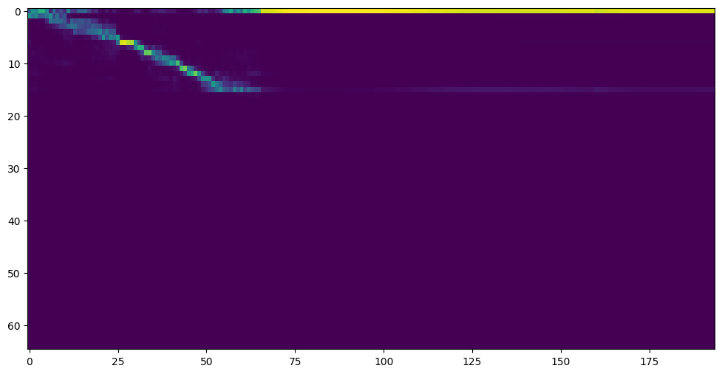Figure 3: Step 20’000

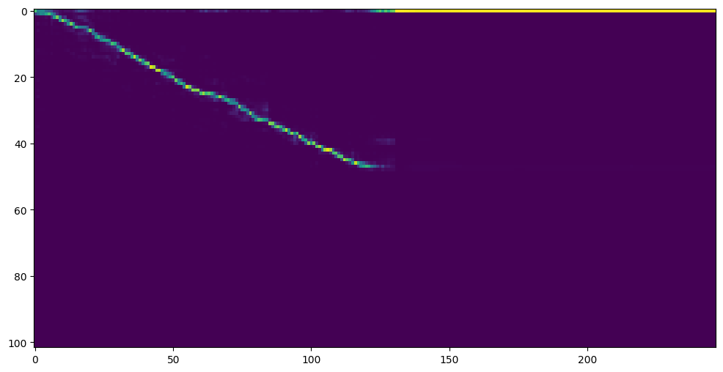Figure 4: Step 40'000
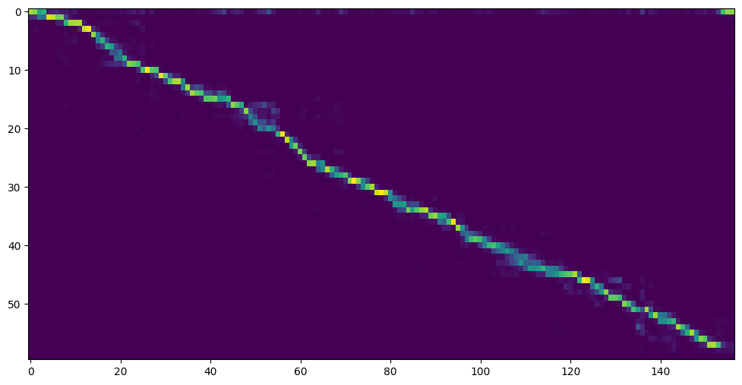Figure 5: Step 100'000
As we can see the longer the network trains the clearer the voice becomes, albeit there can be outliers when it comes to imbalanced classes for example a snapshot is taken at step 100’500 below:
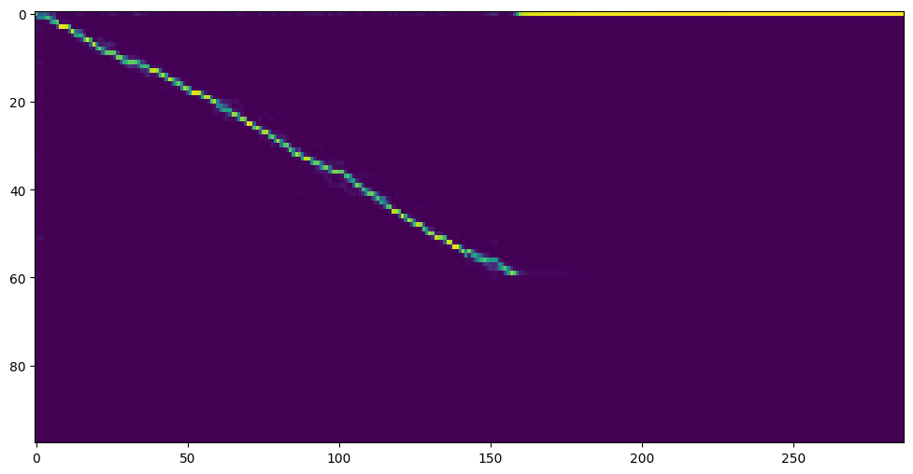Figure 6: Step 100’500
Here we can see that attention is far from diagonal, which indicates poor voice reconstruction. As a result this appears as robotic voice reconstruction in the waveform. However, this is generally an issue only with speakers that have very few utterances, as we set the minimum utterances per speaker to 10. Increasing the minimum would improve the reconstruction average quality, however, it would reduce the number of voices in the data bank, which could hurt true performance with new samples.

Mel-spectrogram
Mel-spectrogram loss gives us the quantitative metrics of how close we actually are to ground truth, which are necessary for training the deep neural network model, however, it takes longer to inspect them than attention graphs, however, they can help us quantify the results in true terms.
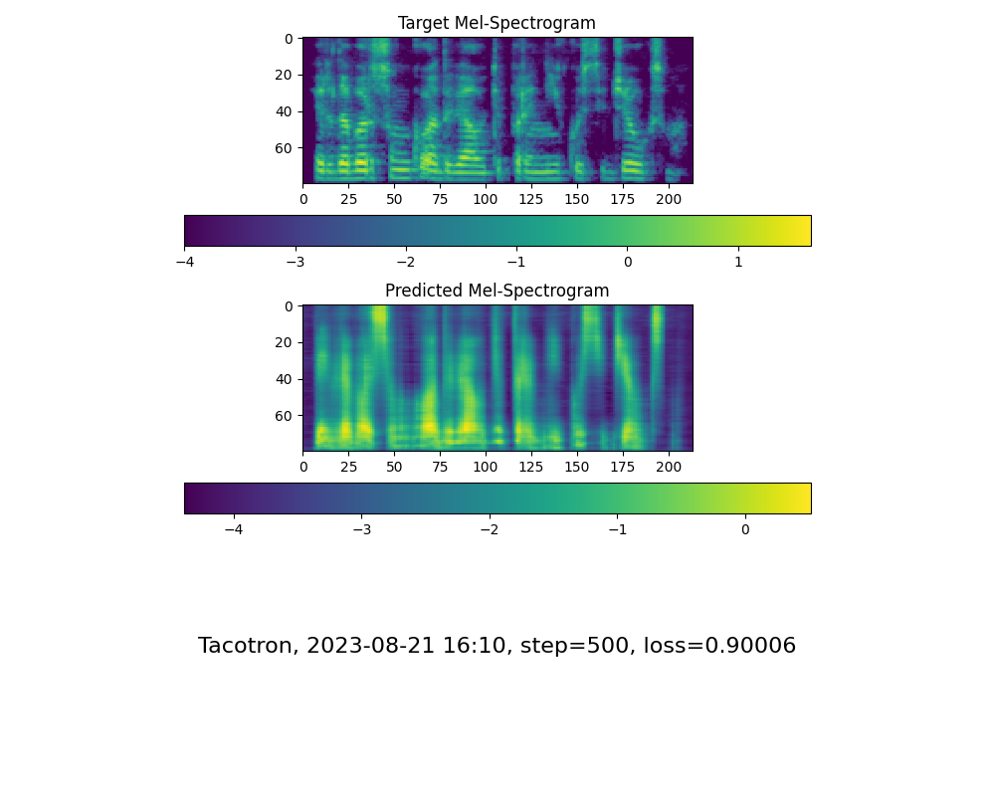
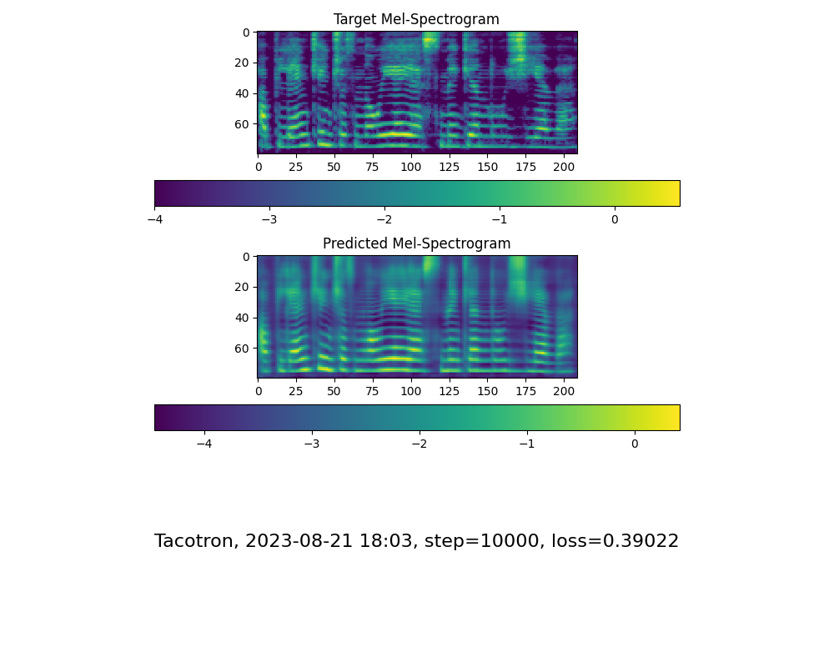
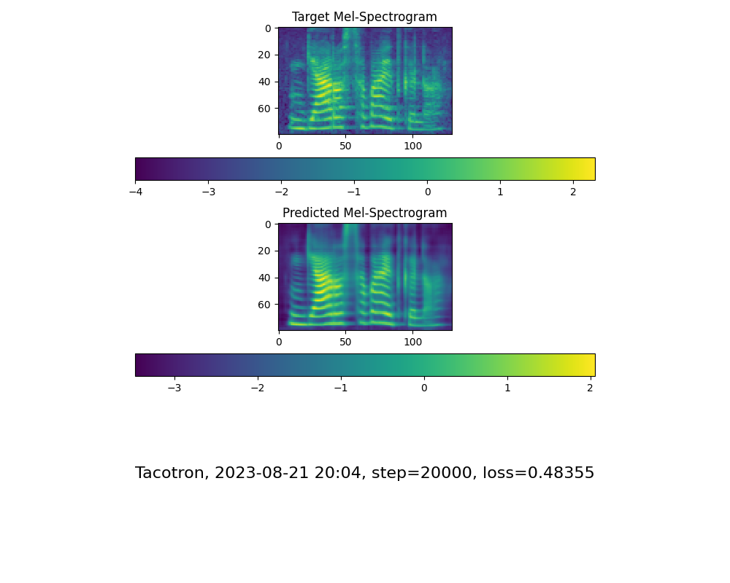
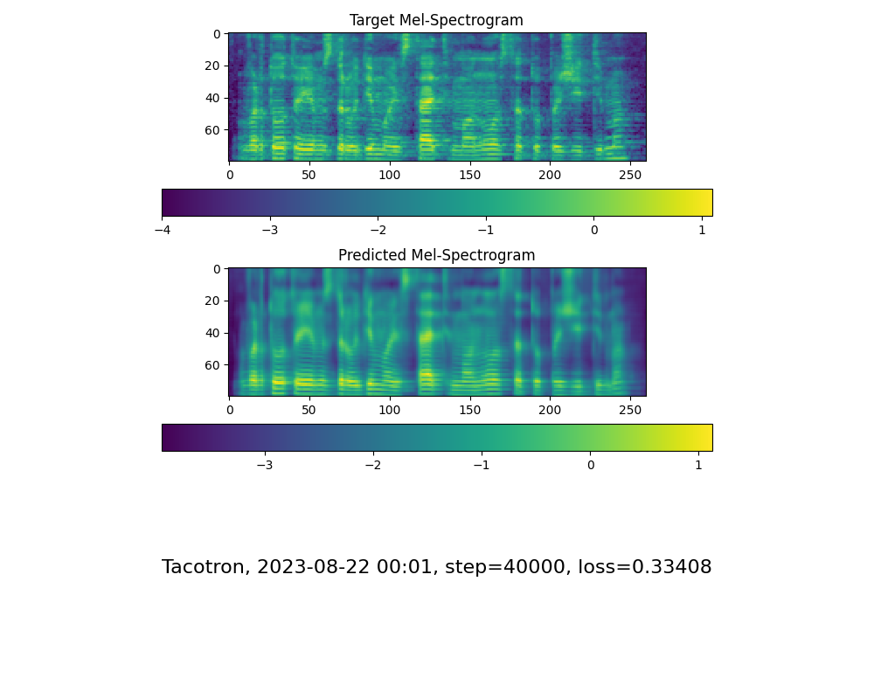
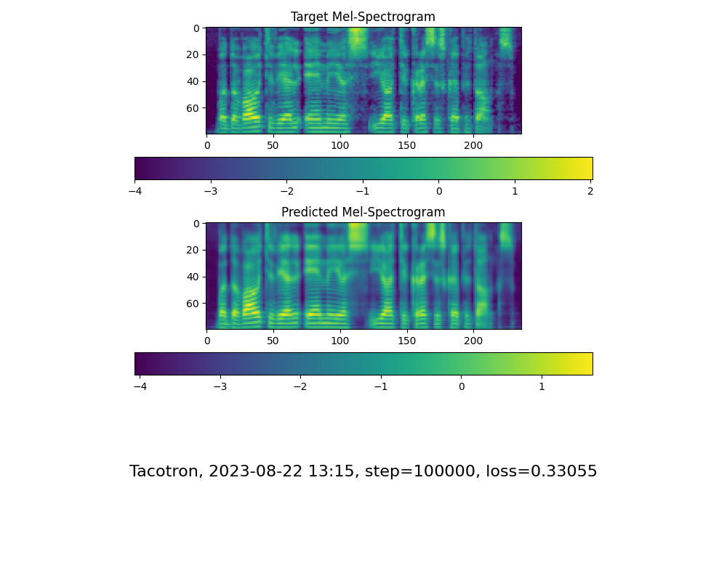

As we can see, that while loss gives us an absolute quantitative error, it’s hard to see the actual voice synthezation quality from the spectrograms themselves as it is with attention graphs.

Cloning
We have trained all three model stages (encoder, synthesizer, vocoder) with Liepa2 dataset in addition to training two stages (encoder and vocoder) with the original suggested LibriSpheech datasets in order to compare the voice reconstruction quality between Lithuanian and English speech datasets as the number of speakers and types of speech differ between the two. Training synthesizer with English dataset would add no benefit as not only the pronunciation of same tokens (phonemes) between the language differ, the languages also have tokens that are not in each other e.g., English has x, q which is not in Lithuanian, whereas Lithuanian language has accents e.g., ą, ū, etc. Therefore the synthesizer models not only are not compatible with each other in terms of pronunciation specifics but also they are structurally incompatible due to different architecture requirements needed for different languages. In our experiments we will refer to English encoder and vocoder stages as En-ENC and En-VOC respectively, and to Lithuanian encoder, synthesizer and vocoder stages as Lt-ENC, Lt-SYN, Lt-VOC respectively.
In our experiments we produced hybrids of models of models between English and Lithuanian models as follows:
- En-ENC | Lt-SYN | En-VOC – only Lithuanian synthesizer
- En-ENC | Lt-SYN | Lt-VOC – Lithuanian synthesizer and vocoder
- Lt-ENC | Lt-SYN | En-VOC – Lithuanian encoder and synthesizer
- Lt-ENC | Lt-SYN | Lt-VOC – fully Lithuanian model
From qualitative experiments we found very little difference in terms of produced produced audio quality, however, there was a definitely perceivable difference in the intonation when compared between. With model (a) producing some of the best results likely attributed to dataset quality used in training. In all four scenarios the models have managed to generate proper sentence of “turėjo senelė žilą oželį”, however, some voice robotization and rejuvenation can be perceived. In addition, subjects with very distorted voices have can sometimes produce sentences that hallucinate noise at the end of the sentence, especially in (d) model.

Original spectrogram examples:
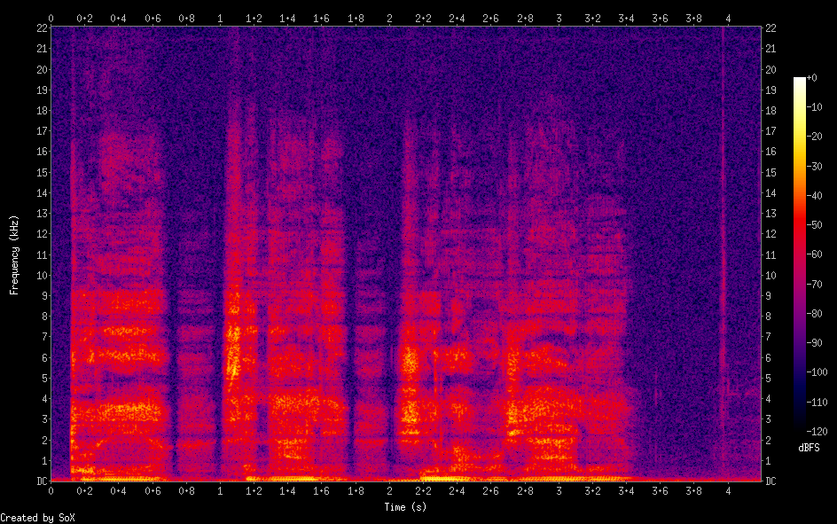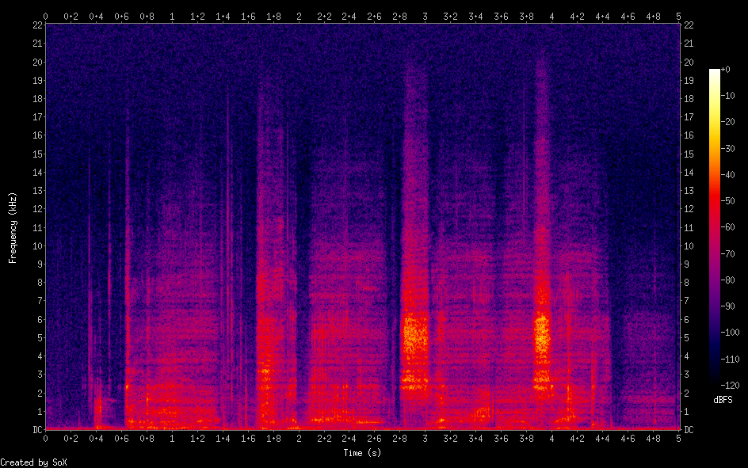
(a) spectrogram examples
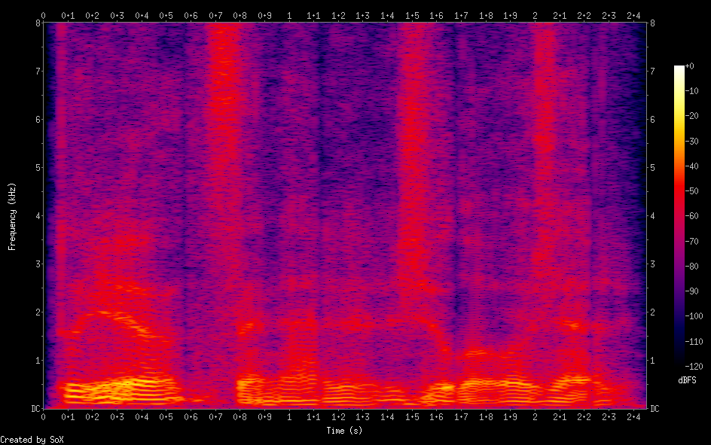
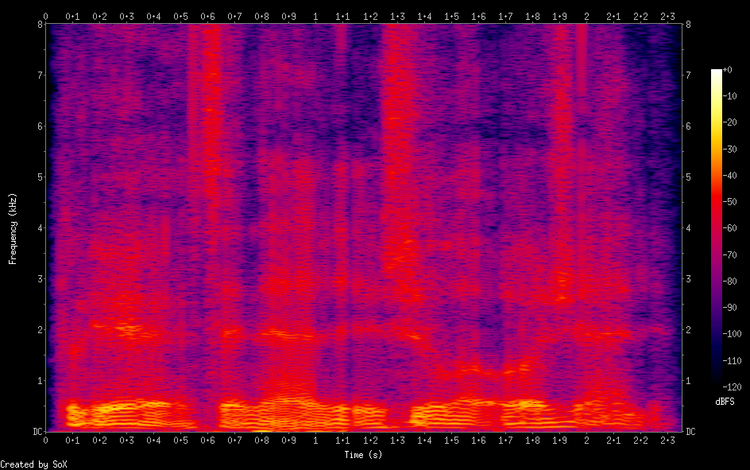

(b) spectrogram examples
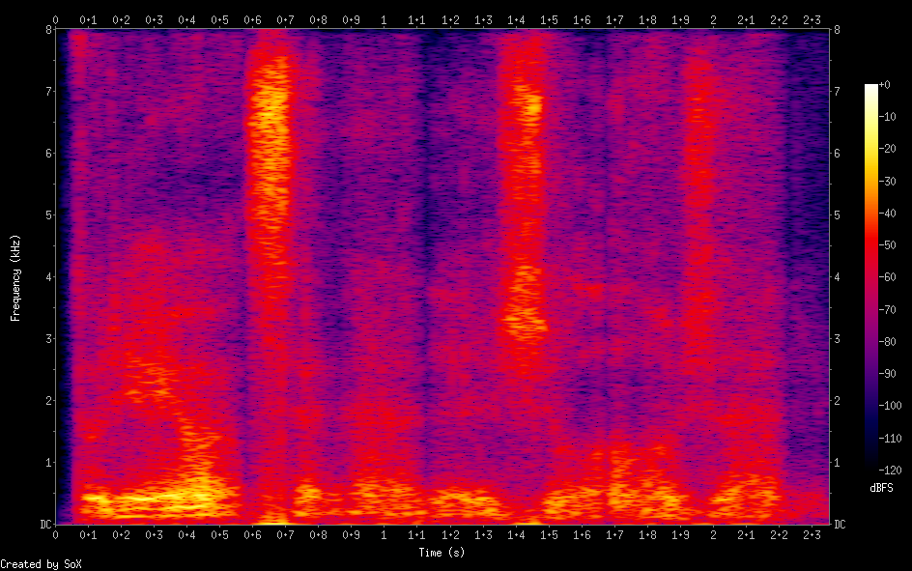
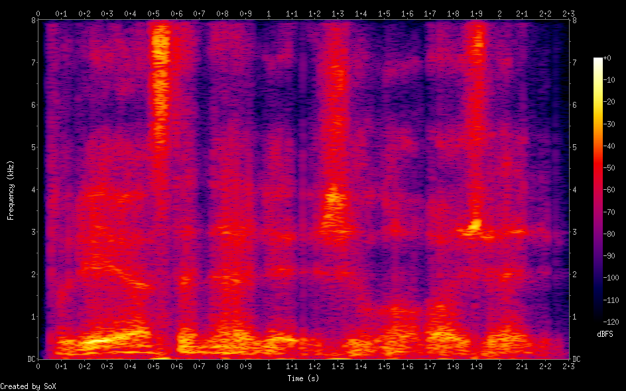
(c) spectrogram examples
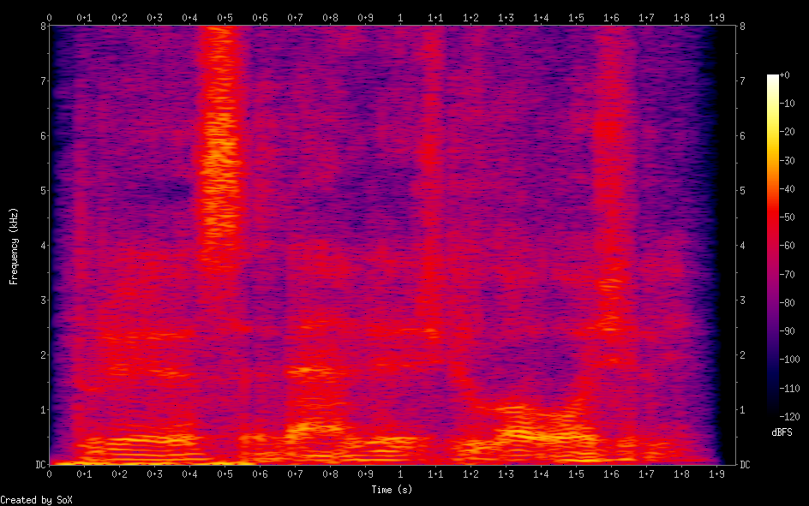
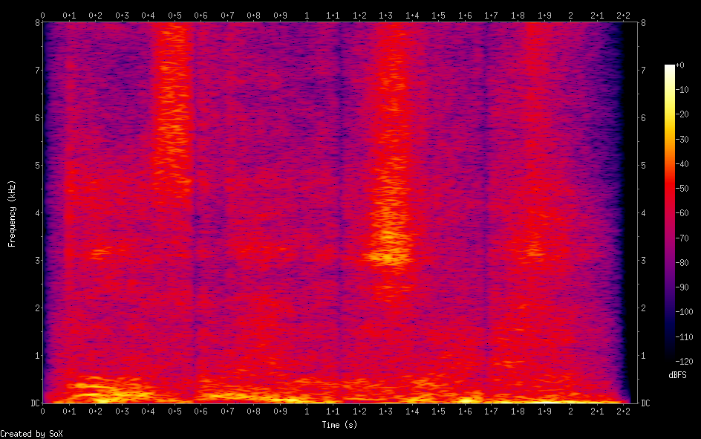
(d) spectrogram examples


