Cloud computing?

Cloud computing are services that are provided over the internet or a network which helps you to process the data by using paid or unpaid services. In cloud computing you pay for the services you are going to use (referred to as pay as you go model)

Definition
Cloud Computing is a technology that enables us to create, configure, and customize applications through an internet connection. It provides on-demand access to computing resources like servers, storage, databases, networking, and software over the internet on a pay-as-you-go basis.

Key Concept
"Cloud computing refers to the ability of a system to store data or applications on remote servers, process data or applications from servers, and access data and applications via the Internet."

Real-Time Examples

Consumer Applications:
- Gmail: Email service accessed through web browsers without installing software
- Netflix: Video streaming service delivering content on-demand from cloud servers
- Dropbox: File storage and synchronization across multiple devices
- Instagram: Photo sharing and storage in cloud infrastructure
- Spotify: Music streaming service with cloud-based music libraries

Business Applications:
- Salesforce: Customer Relationship Management (CRM) software delivered as a service
- Microsoft Office 365: Productivity suite accessible from any device
- Amazon Web Services (AWS): Infrastructure services for businesses
- Google Workspace: Collaborative tools for businesses

Why Cloud Computing?

Aspect | Traditional IT | Cloud Computing
Capital Investment | High upfront costs for hardware/software | Pay-as-you-use model
Scalability | Limited by physical infrastructure | Virtually unlimited scaling
Maintenance | In-house IT team required | Provider manages maintenance
Accessibility | Location-dependent | Access from anywhere with internet
Disaster Recovery | Expensive backup solutions | Built-in redundancy and backup
Time to Deploy | Weeks to months | Minutes to hours

Evolution of Cloud Computing

Historical Timeline

1950s - Mainframe Computing
- Concept: Powerful central computers accessed by multiple users through terminals
- Characteristics:
  - High processing power for bulk data operations
  - Very expensive to maintain
  - Centralized computing model
- Example: IBM System/360 used by large corporations and government agencies

1960s - Time Sharing Systems
- Innovation: Multiple users sharing computer resources simultaneously
- Impact: Foundation for modern cloud computing concepts

1990s - Grid Computing
- Concept: Distributed computing across different geographical locations
- Key Feature: Heterogeneous nodes connected via internet
- Example: SETI@home project using distributed computing for space research

1999 - Salesforce.com
- Milestone: First major Software-as-a-Service (SaaS) application
- Impact: Demonstrated viability of delivering business applications via web

2002 - Amazon Web Services (AWS)
- Launch: Amazon's internal infrastructure offered as web services
- Significance: Birth of modern cloud computing industry

2006 - Elastic Compute Cloud (EC2)
- Innovation: Virtual servers available on-demand
- Impact: Democratized access to computing infrastructure

2008-2010 - Google Cloud Platform & Microsoft Azure
- Expansion: Major tech companies entering cloud market
- Result: Increased competition and service diversity

Technological Drivers
- Internet Connectivity: High-speed, reliable internet made remote computing practical
- Virtualization: Technology to run multiple virtual machines on single physical hardware
- Distributed Systems: Ability to coordinate multiple computers as single system
- Service-Oriented Architecture (SOA): Modular approach to software design
- Web 2.0: Interactive web applications and user-generated content

Current Era (2010-Present)

Key Developments:
- Multi-cloud strategies: Organizations using multiple cloud providers
- Edge Computing: Processing data closer to source
- Serverless Computing: Function-as-a-Service (FaaS) models
- AI/ML Integration: Cloud-based artificial intelligence services
- Container Technologies: Docker and Kubernetes for application deployment

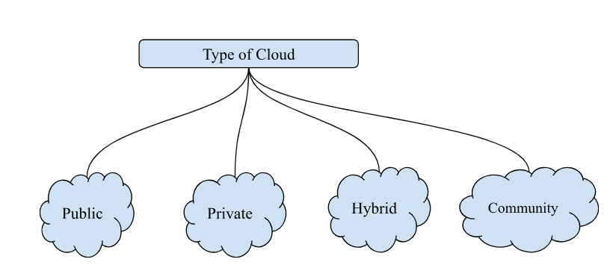
Cloud is further divided into four parts -
- Public
Here resources are open to all and the cloud infrastructure is made available to the general public. The resources are owned by a third party .
Cloud infrastructure made available to the general public, owned and operated by third-party cloud service providers.

Examples:AWS EC2, Google App
Benefits of Public Cloud
It is easier to scale up and down as per demand
Disadvantages
As it is public, security breach can happen
It is not 100% customized as per user requirement
Characteristics:
- Shared Infrastructure: Multiple organizations share the same physical resources
- Internet Access: Services accessed via public internet
- Third-party Management: Provider manages all infrastructure
- Pay-per-use: Cost based on actual usage

Real-Time Examples:
- Amazon S3: Object storage for websites and applications
- Google Drive: File storage and sharing service
- Microsoft Azure: Virtual machines and databases for businesses
- Heroku: Platform for deploying web applications

Use Cases:
- Startups: Cost-effective way to access enterprise-grade infrastructure
- E-commerce: Handling seasonal traffic spikes (Black Friday sales)
- Content Distribution: Delivering media content globally
- Development & Testing: Creating temporary environments

Advantages:
- Low upfront costs
- High scalability
- No maintenance required
- Global accessibility
- Latest technology access

Disadvantages:
- Limited control over security
- Potential compliance issues
- Internet dependency
- Vendor lock-in risks

Private
They are operated and owned by a single organization which is further divided into two parts
A. On Premises
B. Outsourced Private Cloud
Cloud infrastructure exclusively used by a single organization, offering greater control and security.
Benefits of Private Cloud:
It has high security as only authorized users can only access, these kinds of cloud are usually preferred in the banking sector
As it is owned by a single organization, it has full control over the resources.
Disadvantages
Only a skilled person can manage and operate these kinds of clouds. Scaling up and down is a bit difficult.
Types:

On-Premises Private Cloud
- Infrastructure: Hosted within organization's data center
- Control: Complete control over hardware and software
- Example: JPMorgan Chase's private cloud for financial data processing

Hosted Private Cloud
- Infrastructure: Third-party provider manages dedicated hardware
- Example: IBM's private cloud services for government agencies

Virtual Private Cloud (VPC)
- Infrastructure: Isolated section within public cloud
- Example: Amazon VPC providing isolated AWS environments

Real-Time Examples:

Healthcare - Mayo Clinic
Challenge: HIPAA compliance for patient data
Solution: Private cloud for electronic health records
Benefits: Data privacy, regulatory compliance, controlled access

Financial Services - Bank of America
Challenge: Strict regulatory requirements for financial data
Solution: On-premises private cloud with hybrid connectivity
Benefits: Enhanced security, compliance, performance optimization

Use Cases:
- Regulated Industries: Healthcare, finance, government
- Large Enterprises: Organizations with strict data governance
- High-Security Requirements: Defense contractors, legal firms
- Performance-Critical Applications: Real-time trading systems

Hybrid Cloud:

This kind of cloud is a combination of private and public cloud, which allows the user to share the data between them. These kinds of cloud are partially secure as one of the clouds is public.

This kind of cloud is a combination of 1 public 1 private, 2 or more private clouds, 2 or more public.
The workload between two cloud should be managed efficiently, the performance of hybrid cloud depends on deployment and management of its connection. The link between private and public cloud is done via LAN/VPN
Combination of public and private clouds, allowing data and applications to be shared between them.

Real-Time Examples:

Netflix Hybrid Model
Private Cloud: Content creation and proprietary algorithms
Public Cloud (AWS): Content delivery and user-facing applications
Integration: Seamless content distribution globally

General Electric (GE)
Private Cloud: Manufacturing data and industrial IoT
Public Cloud: Predix platform for analytics and customer services
Benefits: Data security + scalability for global operations
Benefits of Hybrid Cloud:
As it uses combination of public cloud it is easier to scale up and down
Disadvantages:
It is difficult to combine two cloud networks
Examples : Dedicated interconnection via Google Cloud, Direct Connected via AWS, Express Cloud via Azure.
Use Cases:
Seasonal Businesses: Retail, tourism, tax preparation
Data Sovereignty: Companies with international operations
Gradual Migration: Organizations transitioning to cloud
Disaster Recovery: Backup systems in different environments

Community Cloud

This kind of cloud allows systems and services to be accessible by groups of several organizations / users to share information between them.
It is owned and managed by many organizations. The infrastructure is shared among different organizations, these kinds of cloud are used in healthcare dept, media dept

Benefits of Community
1. Maintenance can be shared among the organization
2. It is less expensive than private cloud
Disadvantage
- It is difficult to distribute the responsibility among the organizations of the same community.

Selection Guidelines:
- Choose Public Cloud When:
  - Starting new projects with limited budget
  - Need rapid scaling capabilities
  - Non-sensitive data and applications
  - Focus on core business rather than IT management
- Choose Private Cloud When:
  - Strict regulatory compliance requirements
  - Highly sensitive or proprietary data
  - Predictable workloads with consistent performance needs
  - Strong internal IT capabilities
- Choose Hybrid Cloud When:
  - Variable workloads with predictable peaks
  - Gradual migration to cloud strategy
  - Data residency and compliance requirements
  - Need for both control and scalability
- Choose Community Cloud When:
  - Industry-specific applications and compliance
  - Limited budget but need specialized services
  - Benefit from peer collaboration and knowledge sharing
  - Common regulatory or operational requirements

Deployment Model Selection Criteria

Decision Matrix:
Factor Public Private Hybrid Community
Control Low High Medium Medium
Security Medium High High Medium-High
Cost Low High Medium Medium
Scalability High Medium High Medium
Compliance Medium High High High
Customization Low High Medium Medium
Maintenance Provider Internal Mixed Shared

Public | Private | Hybrid | Community
Host are service providers | Third party are the hosts | Third party are the hosts | Third party are the hosts
User are general public in this | Authorized users | Authorized users | Users that belong to same interest/group/community
Can be accessed through internet | Internet and VPN | Internet and VPN | Internet and VPN
Owners in public are service providers | Organizations are the owners | Organizations are the owners | Group / community are the owners

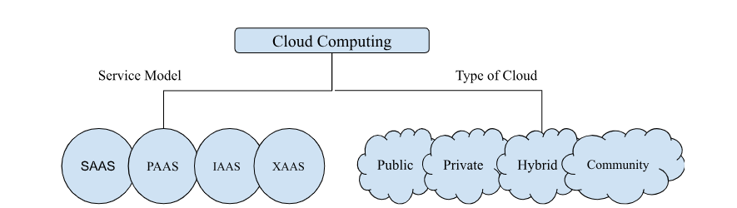

In cloud computing, computing means processing any data or modifying any data whereas cloud stands for network / internet that provides services virtually.

A Data Center is a facility that is used to store, manage and distribute large amounts of data. This is typically a location / center-point where a large number of computer systems, computing devices, networking equipment, storage devices work together to support processing and storing of data.

Benefits of Data Center
- Storing and Processing of Data
A data center is used to store and process large amounts of data which includes files, databases and other digital information.
- A data center can be used for backup and data recovery, these backups can be very useful during disasters.
- It allows the business to access computing resources over the internet,
- We can run applications like e-mail and any other social media platform services on data centers.
To maintain a data center we need cooling, electricity and power backup.
- On Premises - It is a traditional approach where all the data, hardware are hosted physically on an organization / for an organization
- Off Premises - Off premises means where the cloud provider provides the services which mean you have to pay for the services you are using. Off premises is virtually located that gives you computing and other services on demand

Difference between On Premises and Off Premises
On Premises | Off Premises
We need to buy all the licenses for software and to buy all the hardware | We rent the hardware and software according to our uses
It needs a lot of space and security to run and maintain | Here servers in data centers are managed by owners of the data centers
Backup is not centralized | Backup is centralized
We need people / team to maintain hardware and software | Service providers take care of management of servers and software.

Data Center comprises of

- Servers - They are used to process the request and delivery of the responses over cloud.
- Networking Equipment - These comprises of switches, routers that connects multiple networks to send and receive any data
- Server Rack - It is used to organize servers and another network equipments
- Cooling Devices and Power Rack

Data Center provides services under 4 tiers :
Tier 1 - It provides only power supply
Tier 2 - It provides power supply and cooling.
Tier 3 - It provides cooling, power supply along with maintenance
Tier 4 - It provides cooling, power supply, maintenance, backup and protection of data.

Types of Data Centers
The largest data center in the world is present in Beijing China and the largest in India is present in Yota Data center Panvel.

- Enterprise Data Centers
These kinds of data centers are owned by a particular organization and these are operated by those organizations. These kinds of data centers can be on premises and off premises, the primary function of these kinds of data centers is secure data and critical application that is essential for the organization.
Examples - Amazon, Apple, IBM, Tesla, Microsoft
- Cloud Data Centers
These kinds of data centers are owned and operated by cloud service providers like AWS, Azure, Google Cloud Computing. These data centers deliver cloud computing services like infrastructure, software to the organization over the network.
- CoLocation Data Centers
These kinds of data centers are hosted by third-party orgs and are used by an organization. The third party organization provides power and cooling to the data center while the organization provides server hardware, storage and network.The company can have equipment located at multiple locations and the company can have their devices maintenance and security.
Benefits of these kinds of data centers are
1. It is cheaper than any other data center as few of the resources are rented.
2. It can be located at any geographical location.
- Edge Data Centers
It is closely located to end user and the IoT devices they serve, Benefits of these kinds of data centers are
1. These are located closer to the organization so network latency is very less
- Hybrid Data Centers
These types of data centers are a combination of on premises and off premises data centers. These are integrated forms of data centers where traditional on premises provides infrastructure such as servers, storage, network equipment that is combined with cloud resources from one or more cloud service providers. These kinds of data centers dynamically allocate the load between on premises and off premises.

Cloud Service Models
Service models provide you services to process, store and compute data on the remote server. These cloud services are further divided into
Cloud service models define the level of control and management responsibility between cloud provider and customer.

Service Model Hierarchy
┌─────────────────────────────┐
│ SaaS (Software) │ ← End User Applications
│ Complete Apps │
├─────────────────────────────┤
│ PaaS (Platform) │ ← Development Platform
│ Runtime Environment │
├─────────────────────────────┤
│ IaaS (Infrastructure) │ ← Virtual Resources
│ Virtual Machines │
├─────────────────────────────┤
│ Physical Hardware │ ← Data Center
│ (Provider Managed) │
└─────────────────────────────┘

- Infrastructure as a Service (IaaS) :
These services provide a set of computing resources such as storage, network, processor that are provided virtually by cloud providers so that users can access and configure according to their uses.
In this users rent infrastructure and pay for the services based on their hourly, weekly, monthly usage. It also provides OS servers and database
Examples - EC2, Google Compute Engine and Digital Ocean
What Provider Manages:
- Physical hardware
- Hypervisors
- Physical networking
- Physical security
- Data center facilities

What Customer Manages:
- Virtual machines
- Operating systems
- Applications
- Data
- Network security settings

Key Components:

Virtual Machines (VMs)
- Purpose: Virtualized computing resources
- Scalability: Can be scaled up/down based on demand
- Example: Amazon EC2 instances with various configurations

Storage Services
- Block Storage: Virtual hard drives for VMs
  - Example: Amazon EBS (Elastic Block Store)
- Object Storage: Web-accessible file storage
  - Example: Amazon S3, Google Cloud Storage
- File Storage: Network-attached storage
  - Example: Amazon EFS (Elastic File System)

Networking
- Virtual Private Clouds: Isolated network environments
- Load Balancers: Distribute traffic across multiple servers
- CDN: Content Delivery Networks for global content distribution

Real-Time Examples:

Netflix on AWS
Infrastructure: Thousands of EC2 instances across multiple regions
Storage: Petabytes of content stored in S3
Networking: CloudFront CDN for global content delivery
Benefits: Global scale, cost optimization, fault tolerance

Spotify's Multi-Cloud Strategy
Primary: Google Cloud Platform for data analytics
Secondary: AWS for machine learning workloads
Storage: Massive audio file storage and streaming
Benefits: Avoid vendor lock-in, optimize costs, improve performance

Use Cases:
- Website Hosting: Scalable web server infrastructure
- Development/Testing: Temporary environments for software development
- Big Data Processing: High-performance computing for analytics
- Disaster Recovery: Backup infrastructure in different geographic regions

Pricing Models:
- Pay-per-hour: Based on actual usage time
- Reserved Instances: Discounted rates for long-term commitments
- Spot Instances: Unused capacity at reduced prices
Benefits of IaaS
Users can modify the architecture as per their requirements, users have complete control over computing resources and they do not have to worry about the maintenance.
Following are the companies that provide IaaS
AWS, Open Stack, Rack Space, IBM, VMWare
- Platform as a Service (PaaS) :
This provides the platform where developers can develop, test and manage their applications.
Provides complete development and deployment environment in the cloud, including infrastructure, middleware, development tools, and business intelligence services.
This service provides an on demand environment for developing any software application. These services are hosted on cloud and users can access these services through a browser.
The service provider hosts the hardware and software on their own infrastructure
Example - Windows Azure, Google App Engine, Open Swift
Benefits of PaaS
As the service provider provides the service (hardware and software) the developer only has to access the services and build the application. It is easier to deploy and application
Difficulty
To migrate from one service provider to another one is difficult to do.
What Provider Manages:
- Infrastructure (servers, storage, networking)
- Operating systems
- Middleware
- Runtime environments
- Development tools
- Database management systems

What Customer Manages:
- Applications
- Data
- User access management

Key Components:

Development Frameworks
- Programming Languages: Support for Java, Python, Node.js, .NET
- Development Tools: IDEs, debuggers, version control
- Example: Google App Engine supporting multiple languages

Database Services
- Managed Databases: Automated backup, scaling, and maintenance
- NoSQL Options: MongoDB, Cassandra as managed services
- Example: Amazon RDS, Google Cloud SQL

Application Runtime
- Container Services: Docker and Kubernetes management
- Serverless Computing: Function-as-a-Service execution
- Example: Azure Container Instances, AWS Lambda

Real-Time Examples:

Snapchat on Google Cloud Platform
Platform: Google App Engine for application hosting
Database: Google Cloud Datastore for user data
Analytics: BigQuery for data analysis
Benefits: Rapid scaling, managed services, focus on app development

Heroku (Salesforce Platform)
Use Case: Startup and medium business application deployment
Features: Git-based deployment, add-on marketplace
Languages: Ruby, Node.js, Python, Java, PHP, Go
Benefits: Easy deployment, managed infrastructure, developer-friendly

Airbnb Development Pipeline
Platform: Custom PaaS built on AWS
Deployment: Kubernetes for container orchestration
Database: Managed PostgreSQL and Redis
Benefits: Standardized deployment, developer productivity, scalability

Development Lifecycle on PaaS:
1. Code Development → 2. Source Control → 3. Automated Build →
4. Testing → 5. Deployment → 6. Monitoring → 7. Scaling
↑ ↓
└──────────── Feedback Loop ←─────────────────────────┘

Use Cases:
Web Application Development: Full-stack web applications
Mobile Backend: APIs and services for mobile apps
Microservices: Containerized service development
Data Processing: ETL pipelines and data analytics

- Software as a Service (SaaS):
This provides the user complete software application over the internet, all the infrastructure application tools are located at data centers and managed by service providers. The users don’t have to install any software, they only have to use it.
Example - GMail, GDrive, GDocs, Microsoft Teams
Vendors - Google Apps, Azure, Dropbox
SaaS is further divided into two parts :
A. Simple Multi Tenancy: This means each user will have independent resources that are different from other users
B. Fine Grain Multi Latency: This means each user will get shared resources where the resources are shared among multiple users.
Benefits of SaaS:
Easy to access application software.
Application can be accessed from multiple devices and it is low maintenance
Anything / Everything as a Service (XaaS)
Function as a Service (FaaS)

Provides virtualized computing infrastructure including servers, storage, networks, and operating systems.
Complete applications delivered over the internet, fully managed by the service provider.

What Provider Manages:
- Everything (infrastructure, platform, application)
- Updates and patches
- Security and compliance
- Data backup and recovery
- User management

What Customer Manages:
- User data and content
- User access and permissions
- Configuration settings within the application

Characteristics:
- Multi-tenancy: Single application instance serves multiple customers
- Subscription-based: Monthly or annual pricing models
- Automatic Updates: No manual software updates required
- Web-based Access: Accessible through web browsers

Real-Time Examples:

Salesforce CRM
Functionality: Complete customer relationship management
Users: Sales teams, marketing departments, customer service
Features: Lead management, opportunity tracking, reporting
Benefits: No software installation, automatic updates, mobile access
Pricing: Per user per month subscription

Microsoft Office 365
Applications: Word, Excel, PowerPoint, Outlook, Teams
Storage: OneDrive cloud storage integration
Collaboration: Real-time document editing, video conferencing
Benefits: Always latest version, cross-device synchronization
Deployment: Individual, business, enterprise plans

Zoom Video Conferencing
Service: Video meetings, webinars, phone system
Scale: Millions of concurrent users during COVID-19 pandemic
Features: Screen sharing, recording, breakout rooms
Benefits: Easy joining, reliable connectivity, scalable infrastructure

Slack Team Communication
Functionality: Team messaging, file sharing, integrations
Integration: 2,000+ third-party app integrations
Features: Channels, direct messaging, voice/video calls
Benefits: Improved team collaboration, reduced email dependency

SaaS Categories:

Business Applications:
- CRM: Salesforce, HubSpot
- ERP: SAP SuccessFactors, Workday
- Productivity: Google Workspace, Microsoft 365
- Project Management: Asana, Trello, Monday.com

Consumer Applications:
- Entertainment: Netflix, Spotify, YouTube Premium
- Social Media: Facebook, Twitter, LinkedIn
- Communication: WhatsApp, Telegram
- Personal Productivity: Evernote, Todoist

Industry-Specific:
- Healthcare: Epic MyChart, Cerner
- Education: Canvas, Blackboard, Google Classroom
- Finance: QuickBooks Online, Xero
- Legal: Clio, LexisNexis

Benefits:
- No Installation Required: Access via web browser
- Automatic Updates: Always latest features and security patches
- Scalability: Easy user addition/removal
- Cross-platform Access: Works on any device with internet
- Predictable Costs: Subscription-based pricing

4. Extended Service Models (XaaS)

Function-as-a-Service (FaaS) / Serverless
- Definition: Execute code without managing servers
- Examples: AWS Lambda, Azure Functions, Google Cloud Functions
- Use Cases: Event-driven applications, microservices, data processing

Database-as-a-Service (DBaaS)
- Definition: Managed database services
- Examples: Amazon RDS, MongoDB Atlas, Azure Cosmos DB
- Benefits: Automated backups, scaling, maintenance

Storage-as-a-Service (STaaS)
- Definition: Cloud storage solutions
- Examples: Amazon S3, Google Cloud Storage, Dropbox Business
- Types: Object storage, block storage, file storage

Security-as-a-Service (SECaaS)
- Definition: Outsourced security services
- Examples: Okta (identity), Cloudflare (DDoS protection), Symantec (endpoint protection)
- Benefits: Expertise access, cost efficiency, scalability

Service Model Comparison

Responsibility Matrix:
Component | On-Premise | IaaS | PaaS | SaaS
--------------------|------------|------|------|-----
Applications | Customer | Cust | Cust | Provider
Data | Customer | Cust | Cust | Shared
Runtime | Customer | Cust | Prov | Provider
Middleware | Customer | Cust | Prov | Provider
O/S | Customer | Cust | Prov | Provider
Virtualization | Customer | Prov | Prov | Provider
Servers | Customer | Prov | Prov | Provider
Storage | Customer | Prov | Prov | Provider
Networking | Customer | Prov | Prov | Provider

Selection Criteria:
Choose IaaS When:
- Need full control over computing environment
- Custom applications requiring specific configurations
- Migrating existing applications to cloud ("lift and shift")
- Unpredictable workloads requiring flexible scaling
Choose PaaS When:
- Focus on application development, not infrastructure management
- Need rapid application deployment and scaling
- Building cloud-native applications
- Require integrated development tools and services
Choose SaaS When:
- Need standard business applications
- Want minimal IT management overhead
- Require quick deployment and user adoption
- Budget-conscious with predictable costs

IAAS | PAAS | SAAS
It provides a virtual data center to store information and to provide a platform for testing development deployment. | It provides you virtual platform tools to test and deploy virtual applications. | It provides applications to compute business tasks.
It is used by system administrator | It is used by developers. | It is used by end user.
It provide infrastructure | It provides infrastructure and platform. | It provides infrastructure platforms and software.

On Premise | IAAS | PAAS | SAAS
This is managed by user or an organization | Till OS it is managed by user/organization | Till Data user/ organization manages everything | Everything is managed by vendors
Application | Application | Application | Application
Data | Data | Data | Data
Runtime | Runtime | Runtime | Runtime
Middleware | Middleware | Middleware | Middleware
OS | OS | OS | OS
Virtualization | Virtualization | Virtualization | Virtualization
Server | Server | Server | Server
Storage | Storage | Storage | Storage
Networking | Networking | Networking | Networking

Life Cycle of Cloud Solution:

Defining the Purpose —> Defining the Hardware —> Defining the Storage —--> Defining the Network—--> Defining the Security —--> Defining the Tool / Process

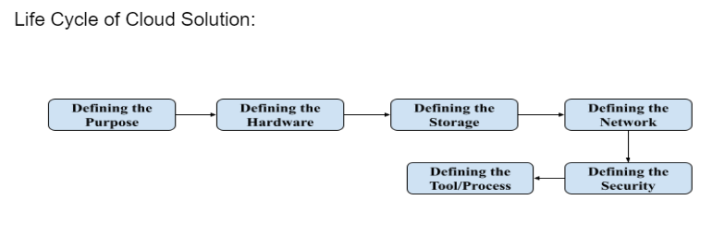

Defining the Purpose : This means to understand the requirement and what type of application or program user / organization needs to build

Defining the Hardware : In this stage You need to choose compute resources that provides you right support to scale up and scale down as per the requirement
Examples - EC2, Lambda, Elastic Container

Defining the Storage : You need to choose right compute services that will provide you right support to store data where you can create backups over the internet
Examples - S3, EFSA (Elastic Serverless File System ), Glacier
Defining the Network : It delivers data and application with low network latency and high speed performance
Examples - VPC(Virtual Private Cloud), Route 53, Direct Connection
Defining the Security : We defined security for authorisation and authentication of a user
Examples - IAM (Identity and Access Management),

Defining the Management Process / Tool : You can have full control over cloud management by defining the managing tools which monitors AWS Resources, Customer Applications running on the platform
Examples - CloudWatch this monitors and manages, services provided by cloud platform
AutoScaling - This continually monitors and checks whether the application is running properly or not

Virtualization:
It is a concept to create a virtual system which uses the host machine’s resources like storage, processor. A single machine can have multiple OS running at once parallelly because of this virtual layer.

Application
Operating System
Hardware(CPU,RAM,I/O)
Traditional System

Application
OS
Hardware(CPU,RAM,I/O)
Virtual System
Virtual Layer/VMWARE
OS
OS
Application
Application

Hypervisor :
It is a form of virtual software that is used to allocate resources. It is a hardware virtualization technique that allows you to have multiple OS running on the single host machine at the same time. It is also called as virtual machine manager

Hardware
Hypervisor
Host OS 1
OS 1
OS 2
OS 3
Host Machines

Type1:
Hardware
Hypervisor
OS3
OS2
OS1

This type of hypervisor runs directly on the host machine hardware where it has the direct access to resources, these kinds of hypervisors does not need any server based OS

Type2:

Host OS runs on Host system, these kinds of hypervisor needs host OS or application on the host machine
Examples : VMWare Workstation, Oracle Workbox

Hardware
Hypervisor
OS3
OS2
OS1
Host OS

Types of Virtualization

1. Server Virtualization

Definition
Creating multiple virtual machines (VMs) that run on a single physical server, each with its own operating system and applications.

Hypervisor Types:

Type 1 (Bare Metal Hypervisors)
- Direct Hardware Access: Runs directly on physical hardware
- Examples: VMware vSphere/ESXi, Microsoft Hyper-V, Xen
- Use Cases: Enterprise data centers, cloud providers
- Benefits: Better performance, security, and scalability

Type 2 (Hosted Hypervisors)
- Host OS Dependency: Runs on top of existing operating system
- Examples: VMware Workstation, Oracle VirtualBox, Parallels
- Use Cases: Desktop virtualization, development environments
- Benefits: Easy to install and use

Real-Time Examples:

Amazon EC2 Virtualization
Physical Server: High-end server with multiple CPUs, RAM, storage
Hypervisor: AWS proprietary Nitro hypervisor
Virtual Instances: Multiple customer VMs on same hardware
Isolation: Strong separation between customer workloads
Resource Allocation: Dynamic CPU, memory, network allocation

VMware vSphere in Enterprise
Scenario: Company consolidating 50 physical servers
Implementation: 10 physical servers running vSphere
Result: 200+ virtual machines on 10 servers
Benefits: 80% reduction in hardware costs, easier management
Management: vCenter Server for centralized control

2. Storage Virtualization

Definition
Abstracting physical storage resources to create a unified, flexible storage pool that can be managed centrally.

Types:

Block-Level Virtualization
- Function: Virtualizes storage at the block level
- Use Cases: Database storage, high-performance applications
- Example: Amazon EBS (Elastic Block Store)

File-Level Virtualization
- Function: Provides file system interface over network
- Use Cases: Shared file access, collaboration
- Example: Amazon EFS (Elastic File System)

Object Storage Virtualization
- Function: Data stored as objects with metadata
- Use Cases: Web applications, content distribution, backup
- Example: Amazon S3, Google Cloud Storage

Real-Time Examples:

Netflix Content Storage
Content Volume: Petabytes of video content
Storage Strategy: Object storage across multiple cloud regions
CDN Integration: Content cached in edge locations globally
Scalability: Automatic scaling based on demand
Redundancy: Multiple copies for availability and performance

Dropbox Storage Architecture
User Files: Stored as encrypted blocks in cloud storage
Deduplication: Identical files stored only once
Synchronization: Real-time sync across user devices
Backup: Multiple copies across different data centers
Access Methods: Web, mobile apps, desktop clients

3. Network Virtualization

Definition
Creating virtual networks that are independent of the underlying physical network hardware.

Components:

Virtual LANs (VLANs)
- Purpose: Segment network traffic logically
- Benefits: Improved security, reduced broadcast domains
- Example: Isolating development and production environments

Software-Defined Networking (SDN)
- Concept: Centralized network control through software
- Benefits: Dynamic network configuration, policy enforcement
- Example: OpenFlow protocol for network control

Network Function Virtualization (NFV)
- Purpose: Virtualize network services like firewalls, load balancers
- Benefits: Reduced hardware dependency, flexible deployment
- Example: Virtual firewalls in cloud environments

Real-Time Examples:

AWS Virtual Private Cloud (VPC)
Isolation: Logically isolated network within AWS cloud
Subnets: Public and private subnets for different tiers
Security Groups: Virtual firewalls for instance-level security
Route Tables: Control traffic routing within VPC
VPN/Direct Connect: Secure connectivity to on-premises networks

Google Cloud VPC
Global Network: Single VPC spans multiple regions
Subnet Regions: Subnets can span multiple zones within region
Firewall Rules: Centralized security policy management
Load Balancing: Integrated global and regional load balancers
Interconnect: Dedicated connections to on-premises networks

4. Application Virtualization

Definition
Separating applications from the underlying operating system, allowing applications to run in isolated environments.

Types:

Desktop Application Virtualization
- Method: Applications run on server, streamed to client
- Example: Citrix XenApp, Microsoft App-V
- Benefits: Centralized management, reduced client requirements

Container Virtualization
- Method: OS-level virtualization using containers
- Example: Docker containers, Kubernetes orchestration
- Benefits: Lightweight, fast deployment, microservices architecture

Benefits of Virtualization

1. Resource Optimization
- Server Consolidation: Reduce number of physical servers
- Higher Utilization: Better use of computing resources
- Cost Reduction: Lower hardware and operational costs

2. Flexibility and Agility
- Rapid Deployment: New virtual resources in minutes
- Easy Migration: Move workloads between physical hosts
- Testing Environments: Quick creation of development/test systems

3. Improved Availability
- Hardware Independence: VMs can run on different physical hosts
- Disaster Recovery: Easy backup and restore of virtual machines
- High Availability: Automatic failover capabilities

4. Simplified Management
- Centralized Control: Manage multiple VMs from single interface
- Automated Operations: Scripted deployment and management
- Standardization: Consistent virtual machine templates

Virtualization Challenges

1. Performance Overhead
- Hypervisor Layer: Additional software layer impacts performance
- Resource Contention: Multiple VMs competing for resources
- Solution: Hardware-assisted virtualization, proper resource allocation

2. Security Concerns
- VM Sprawl: Uncontrolled growth of virtual machines
- Hypervisor Security: Single point of failure for all VMs
- Solution: Security policies, regular updates, monitoring

3. Complexity
- Management Tools: Learning new virtualization management systems
- Network Configuration: Complex virtual networking setups
- Solution: Training, standardized processes, automation

Cloud-Specific Virtualization

Multi-Tenancy in Cloud
Physical Server
├── Hypervisor
├── Customer A VMs (Web servers, databases)
├── Customer B VMs (Applications, storage)
├── Customer C VMs (Development, testing)
└── Management VM (Monitoring, backup)

Elastic Resource Allocation
- Dynamic CPU: Adjust CPU allocation based on demand
- Memory Ballooning: Reclaim unused memory from idle VMs
- Storage Tiering: Move data between fast and slow storage automatically

Live Migration
- Zero Downtime: Move running VMs between physical hosts
- Load Balancing: Distribute workloads across available hardware
- Maintenance: Perform hardware maintenance without service interruption

Benefits and Challenges

Benefits of Cloud Computing

1. Cost Benefits

Capital Expenditure (CapEx) to Operational Expenditure (OpEx)
Traditional IT requires significant upfront investment in hardware, software licenses, and infrastructure. Cloud computing transforms these capital expenses into operational expenses with predictable monthly or usage-based costs.

Real-Time Example: Startup Cost Comparison
Traditional Setup:
- Server hardware: $50,000
- Software licenses: $25,000
- Network equipment: $15,000
- Data center setup: $30,000
- IT staff hiring: $200,000/year
Total First Year: $320,000

Cloud Setup:
- AWS/Azure services: $2,000/month
- SaaS applications: $500/month
- No hardware purchase needed
- Managed services reduce IT staff needs
Total First Year: $30,000 (90% cost reduction)

Pay-as-you-Use Model
Organizations only pay for resources they actually consume, eliminating waste from overprovisioned infrastructure.

Real-Time Example: E-commerce Seasonal Scaling
Traditional Approach:
- Size infrastructure for peak demand (Black Friday)
- 70% capacity sits idle most of the year
- Annual cost: $500,000 for always-on infrastructure

Cloud Approach:
- Scale up during peak seasons
- Scale down during normal periods
- Peak period (1 month): $100,000
- Normal periods (11 months): $20,000/month = $220,000
- Annual cost: $320,000 (36% savings)

Elimination of Maintenance Costs
Cloud providers handle hardware maintenance, software updates, and infrastructure management, reducing IT operational costs.

2. Scalability and Flexibility

Elastic Scaling
Cloud resources can be scaled up or down based on demand, providing flexibility that traditional infrastructure cannot match.

Real-Time Example: Video Streaming Service
Normal Day: 10,000 concurrent users
Streaming servers: 50 instances
Monthly cost: $15,000

Popular Show Release Day: 100,000 concurrent users
Auto-scaled servers: 500 instances (10x increase)
Daily spike cost: $5,000 additional
Benefit: No service degradation, customers satisfied

Global Reach
Cloud providers have data centers worldwide, enabling global application deployment without physical infrastructure investment.

Real-Time Example: Mobile Gaming Company
Player Base: Global audience across 5 continents
Traditional Challenge: Setting up data centers in each region
Cost: $2M+ per region, 12+ months deployment time

Cloud Solution: Deploy in 10+ regions simultaneously
Time to Deploy: 1 week
Cost: $50,000 setup + usage-based pricing
Result: Lower latency for players worldwide, better user experience

3. Reliability and Availability

Built-in Redundancy
Cloud providers offer multiple availability zones and regions, providing better disaster recovery capabilities than most organizations can achieve independently.

Real-Time Example: Banking Application
Traditional Setup:
- Single data center
- If data center fails, complete service outage
- Recovery time: 4-24 hours
- Impact: Customer complaints, regulatory issues, revenue loss

Cloud Setup:
- Multi-AZ deployment across 3 availability zones
- If one zone fails, traffic automatically redirected
- Recovery time: < 5 minutes (automatic failover)
- Impact: Minimal, most customers don't notice

Service Level Agreements (SLAs)
Major cloud providers offer 99.9% to 99.99% uptime guarantees with financial penalties for not meeting commitments.

4. Innovation and Speed

Rapid Deployment
New environments and applications can be deployed in minutes rather than weeks or months.

Real-Time Example: Software Development Team
Traditional Environment Setup:
- Purchase approval: 2 weeks
- Hardware delivery: 4 weeks
- Installation and configuration: 2 weeks
- Total time to productive environment: 8 weeks

Cloud Environment Setup:
- Resource provisioning: 5 minutes
- Application deployment: 30 minutes
- Total time to productive environment: 35 minutes
- Improvement: 99% faster deployment

Access to Latest Technologies
Cloud providers continuously update their services, giving organizations access to cutting-edge technologies without additional investment.

Real-Time Example: AI/ML Implementation
Traditional Approach:
- Purchase specialized hardware (GPUs): $100,000
- Hire ML engineers: $150,000/year
- Build ML infrastructure: 6 months
- Total investment before first model: $200,000+

Cloud Approach:
- Use managed ML services (AWS SageMaker, Google AI Platform)
- Pre-built algorithms and infrastructure
- First model deployed: 1 week
- Cost: $1,000/month usage-based
- Access to state-of-the-art ML tools immediately

5. Environmental Benefits

Resource Efficiency
Cloud data centers achieve better resource utilization than typical enterprise data centers.

Real-Time Example: Google's Environmental Impact
Google Data Centers:
- 50% more energy efficient than typical enterprise data centers
- 100% renewable energy for operations since 2017
- Advanced cooling systems reduce energy consumption
- Carbon-neutral since 2007

Customer Benefit:
- Moving to Google Cloud reduces carbon footprint by 65%
- Automatic participation in sustainable computing
- No need for individual renewable energy investments

Challenges and Risks

1. Security and Privacy Concerns

Data Location and Sovereignty
Organizations may not know where their data is physically stored, raising compliance and legal concerns.

Real-Time Challenge: European GDPR Compliance
Problem: EU company using US cloud provider
Issue: Data transferred to US servers may violate GDPR
Solution Options:
1. Choose EU-based cloud regions
2. Implement data residency controls
3. Use cloud providers with GDPR compliance certifications
Example: Microsoft Azure EU regions for GDPR compliance

Shared Responsibility Model Confusion
Misunderstanding of security responsibilities between cloud provider and customer can lead to vulnerabilities.

Real-Time Example: Capital One Data Breach (2019)
Issue: Misconfigured AWS S3 bucket exposed customer data
Root Cause: Customer responsible for proper configuration
Impact: 100 million customers affected
Lesson: Understanding shared responsibility model is critical
Prevention: Proper training, automated security scanning

2. Vendor Lock-in

Proprietary Services
Using cloud-specific services can make it difficult to switch providers or move back to on-premises infrastructure.

Real-Time Example: Multi-Cloud Strategy Challenge
Company A: Heavily invested in AWS-specific services
- AWS Lambda functions: 500+ serverless functions
- Amazon RDS: Proprietary database configurations
- AWS-specific APIs: Integrated throughout applications

Migration Challenge:
- Rewrite serverless functions for different platform
- Database migration complexities
- API changes required throughout codebase
- Estimated migration cost: $2M and 18 months

Data Portability
Moving large amounts of data between cloud providers can be expensive and time-consuming.

Real-Time Example: Data Migration Costs
Scenario: 100 TB of data migration between cloud providers
AWS Data Transfer Out: $9,000
Azure Data Transfer In: Included
Migration Time: 2 weeks with dedicated connection
Additional Costs: Downtime, testing, validation
Total Migration Cost: $50,000+ including labor

3. Internet Dependency

Connectivity Requirements
Cloud services require reliable internet connectivity; outages can impact business operations.

Real-Time Example: Internet Outage Impact
Scenario: Office internet outage for 4 hours
Traditional IT Impact:
- Local servers continue running
- Limited impact on core operations

Cloud-Dependent Operations Impact:
- Email (Office 365): Inaccessible
- File storage (Google Drive): Inaccessible
- Business applications (Salesforce): Inaccessible
- Development tools: Cannot deploy or access code
- Productivity loss: 90% for 4 hours

Latency Concerns
Applications requiring real-time responses may be affected by network latency.

4. Compliance and Regulatory Challenges

Industry-Specific Requirements
Some industries have strict requirements about data handling that may conflict with cloud computing models.

Real-Time Example: Healthcare HIPAA Compliance
Requirements:
- Patient data must be encrypted at rest and in transit
- Access logs must be maintained and auditable
- Business Associate Agreements (BAA) required with cloud providers
- Data breach notification within 72 hours

Cloud Considerations:
- Choose HIPAA-compliant cloud services
- Configure encryption properly
- Implement proper access controls
- Regular compliance audits
- Staff training on cloud security

5. Performance and Reliability Issues

Service Outages
Even major cloud providers experience outages that can impact multiple customers simultaneously.

Real-Time Examples of Major Outages:

AWS S3 Outage (2017)
Duration: 4 hours
Impact: Websites and applications using S3 storage went offline
Affected Companies: Netflix, Airbnb, Spotify, thousands of others
Root Cause: Human error during routine maintenance
Lesson: Need for multi-region redundancy strategies

Google Cloud Platform Outage (2019)
Duration: 4.5 hours
Impact: Google services including Gmail, YouTube, Google Drive
Affected Users: Millions of users globally
Root Cause: Network configuration error
Business Impact: Loss of productivity, revenue impact

Microsoft Azure AD Outage (2020)
Duration: 6 hours
Impact: Authentication services for Office 365, Teams
Affected Users: Remote workers during COVID-19 pandemic
Business Impact: Work-from-home productivity severely affected
Recovery: Gradual restoration over several hours

6. Cost Management Challenges

Unexpected Costs
Without proper monitoring and controls, cloud costs can spiral out of control.

Real-Time Example: Bill Shock Scenarios
Scenario 1: Cryptocurrency Mining
- Developer accidentally deployed crypto mining code
- Consumed massive compute resources overnight
- Monthly bill: $65,000 instead of usual $2,000
- Prevention: Cost alerts and resource limits

Scenario 2: Data Transfer Costs
- Application began transferring large datasets between regions
- Data transfer charges: $15,000 unexpected monthly cost
- Root Cause: Poor application architecture
- Solution: Redesign to minimize cross-region transfers

Scenario 3: Forgotten Resources
- Development instances left running after project completion
- 50 large instances running for 6 months unused
- Waste: $30,000 in unnecessary costs
- Prevention: Automated resource tagging and cleanup

Mitigation Strategies

1. Security Best Practices
- Implement zero-trust security model
- Use multi-factor authentication everywhere
- Regular security audits and penetration testing
- Employee security training programs
- Data encryption at rest and in transit
- Proper access control and role management

2. Vendor Lock-in Prevention
- Use cloud-agnostic technologies when possible
- Implement multi-cloud strategies
- Avoid proprietary services for critical functions
- Maintain data portability standards
- Regular vendor evaluation and negotiation

3. Cost Management
- Implement cost monitoring and alerting
- Use reserved instances for predictable workloads
- Regular cost optimization reviews
- Automated resource cleanup policies
- Tag-based cost allocation and tracking
- Regular usage and sizing optimization

4. Business Continuity
- Multi-region deployment strategies
- Regular disaster recovery testing
- Backup internet connections
- Hybrid cloud strategies for critical applications
- Service level agreement monitoring
- Incident response planning

Cloud Computing Architecture

Overview
Cloud computing architecture comprises loosely coupled components that work together to provide computing services. The architecture is divided into two main parts: Front End and Back End.

Visual Architecture Diagram
┌─────────────────┐ ┌─────────────┐ ┌─────────────────┐
│ FRONT END │ │ NETWORK │ │ BACK END │
│ │ │ │ │ │
│ ┌─────────────┐ │ │ ┌─────────┐ │ │ ┌─────────────┐ │
│ │Web Browsers │ │ │ │Internet │ │ │ │Data Centers │ │
│ │Mobile Apps │ │◄──►│ │Intranet │ │◄──►│ │Servers │ │
│ │Desktop Apps │ │ │ │VPN │ │ │ │Storage │ │
│ │Interfaces │ │ │ │ │ │ │ │Databases │ │
│ └─────────────┘ │ │ └─────────┘ │ │ │Security │ │
└─────────────────┘ └─────────────┘ │ │Middleware │ │
│ └─────────────┘ │
└─────────────────┘

Front End Components

1. Client Devices and Interfaces
- Thin Clients: Web browsers providing lightweight access
  - Example: Accessing Google Docs through Chrome browser
- Fat Clients: Rich applications with extensive functionality
  - Example: Adobe Creative Cloud desktop applications
- Mobile Applications: Native apps for smartphones and tablets
  - Example: Uber mobile app connecting to cloud backend

2. User Interface Elements
- Web Portals: Management consoles for cloud services
- APIs (Application Programming Interfaces): For programmatic access
- Command Line Interfaces: For technical users and automation

Back End Components

1. Physical Infrastructure
- Data Centers: Physical buildings housing servers and equipment
  - Real Example: Google's data center in Hamina, Finland uses seawater for cooling
- Servers: Physical and virtual machines providing computing power
- Storage Systems: Hard drives, SSDs, and storage arrays
- Networking Equipment: Routers, switches, and load balancers

2. Software Layer
- Hypervisors: Software for creating and managing virtual machines
  - Examples: VMware vSphere, Microsoft Hyper-V, KVM
- Operating Systems: Host and guest operating systems
- Middleware: Software connecting different applications and services
- Management Software: For resource allocation and monitoring

3. Security Layer
- Firewalls: Network security barriers
- Authentication Systems: User identity verification
- Encryption: Data protection in transit and at rest
- Access Control: Permission and privilege management

Network Connectivity

Types of Networks:
- Internet: Global public network
- Intranet: Private organizational networks
- Extranet: Extended networks for partners/suppliers
- VPN (Virtual Private Networks): Secure connections over public networks

Real-Time Example: Netflix Architecture
User Device (Smart TV) → Internet → Netflix CDN → AWS Cloud Infrastructure
↓ ↓ ↓
Stream Video ←─────────← Content Delivery ← Video Processing
Network & Storage Servers

EC2:

It is a web service that provides secure and resizable compute capacity in the cloud. EC2 allows you to configure the capacity and provides you complete control of computing resources. In this user can scale up and scale down as per their requirements, user can create an environment or instance as per their requirement.

EC2 is a virtual machine that is hosted on AWS

What is an EC2 instance ?
An EC2 instance acts as a virtual server in Elastic Cloud Compute (EC2), for running an application on AWS infrastructure.

The pricing options in EC2 are
- On Demand - These kinds of pricing are used for short term applications and for unpredictable workload, in this option we pay by hours, minutes and seconds depending upon the type of instance
- Reserved - When you have a fixed workload then you’ll use this kind of pricing option which is further divided into three parts.
A. Standard Reserved Pricing - This includes up to 70% of discount
B. Convertible Reserved Pricing - This is up to 50% of discount
C. Scheduled Reserved Pricing - This does not have any discount

Spot Instance - If you urgently need a large amount of computing capacity then this is the best instance you can purchase, unused capacity of up to 90% of discount. The fluctuation of price will also differ depending up on the supply and demand

Dedicated Instance - A physical EC2 is dedicated for the use of application, this is one of the most expensive options

Saving Plans - You can get up to 72% of discount regardless of instance type . But the user has to commit for the requirement for at least 2-3 years

Basic Terminology used in EC2
- Shared Instance
A.In this instance model multiple users share the same physical hardware resources such as CPU, memory and storage but they all are logically isolated from each other.
B.Each user's workload runs within its own virtual environment / container, ensuring that they can not directly access other users' data.
C. This is a multi-user environment which is most cost effective and good for resource utilization.
- Dedicated Instance
A.In this kind of instance model, the user has exclusive access to a portion of physical hardware resources. In this unlike shared instance the resources are dedicated to one user
B.This kind of instances can be used in a scenario where you need high security and high performance application or you need to handle sensitive data with high level of computation power
- Dedicated Host
This refers to a physical server that is dedicated to a single user / organization.
Instead of virtualization the server resources are shared among multiple users, A dedicated host is provided for exclusive access to the entire physical machine.
With dedicated hosts, users have the flexibility to deploy multiple VM’s / containers on the same physical server

Amazon Machine Images (AMI)
These are pre configured virtual machine images that you can use to launch EC2, you can create and customize your own AMI to save time and efforts in setting up a new instance. There are multiple images that are present
- Amazon Linux 2 / AMI 2023 - This is pre configured amazon linux OS
- Windows Server AMIs - These are pre configured images of Microsoft Windows server that are used to launch windows based applications.
- Database AMIs - These are popularly used to database’s such as MySQL, Oracle, Amazon RDS, MongoDB.
- Application AMIs - These are images of applications such as WordPress, Joomla and many others.
- Machine Learning AMIs - These are images of amazon machine learning environments such as SageMaker, TensorFlow, ApacheMXNet and others.
- Security AMIs - These are images of security focused software such as firewalls, intrusion detection systems.

Instance Types
AWS EC2 provides you a wide range of instance types to meet your requirements of compute, these instances differ in terms of CPU, Memory, Storage Networking Capacity following are the various types of instances.
- General Purpose (M-Series)
These instances provide you with a balanced combination of compute memory and network resources. These are widely used in applications like web servers, small to medium database, deployment and testing
Example - m5.large, mx.large
- Compute Optimizer (C-Series)
These kinds of instances are used for CPU intensive workload, these are good for doing tasks like data analysis, scientific modification and simulation
Example - c5.large, c48x.large
- Memory Optimizer (X and R-Series)
These are used for high memory capacity or for memory intensive applications, these are suitable in memory database, caching applications
Example - r4x.large, r5.large
- Storage Optimizer (R and D-Series)
These are designed for high input,output performance and storage capacity. These are used in data warehousing and big data workload
Example - i3.large, i3.8xlarge
- Accelerated Computing (P and G-Series)
These are used as graphic processing units and are suitable for Machine Learning, Deep Learning and High Performing Computing workloads
Example - p32x.large
- Burstable Performance (T Series)
These are used for high CPU performance and are used for web development and testing environments
- High Performance Computing (H Series)
These are used for high performing test loads like simulating.
Examples - h1.2xlarge
- Programmable Gate Array (F1 Series)
Examples - f2x.large

Load Balancer
It is a virtual machine that balances your web application load that could be http or http traffic, it balances load of multiple web servers so that no web server is loaded
Elastic Load Balancing (ELB)
This automatically manages the workload on your instance and distributes them to other instances. There are three types of load balancers .

- Application Load Balancer
- Network Load Balancer
- Classic Load Balancer
- Application Load Balancer : It is used to direct user traffic to public AWS cloud it is best suited for load balancing http traffic, these load balancers are intelligent in sending specific requests to specific servers
- Network Load Balancer : It makes routing decisions at the transport layer and handles millions of requests per second. It is best suited for http traffic when high performance is required

- Classic Load Balancer : It routes traffic between client and backend server based on IP address
Auto Scaling
It is used to scale up and scale down automatically as and when required. The application available at AWS requires space and load and the auto scaling helps by providing that there are a sufficient number of EC2 instances to handle the load. You can set a limit on EC2 instances such as the number that doesn’t go below threshold.

Autoscaling ensures that your group have sufficient number of servers

Elastic IPs
It is a static IPV4 address associated with your AWS account this can be dynamically assigned to any instance or resources within your VPC

Elastic Block Store (EBS)
It is a block level storage provided by AWS to use with EC2 instance

Commands Meaning:

yum update -y : yum is your package manager that will help you to install packages And -y is a flag for yes prompt.we are running this command to update packages that are created on ec2 to virtual machines.

yum install httpd -y: This command will install packages related to http server.

systemctl start httpd : This will start the http server on your system.In this command you are instructing the system and service manager of linux to services of http server.this will initiate the web server allowing it to listen to http request.

systemctl status httpd : This command used to check the status of http server.This will provide you the information whether the service is running
Properly or not.It will give you the current state ,recent lock and message related to the service.

systemctl enable httpd : This command is used to enable http server to start automatically at the time of boot.when we run this command it creates a symbolic link that instructs the system and service manager who start specific services when we start the services.

cd /var/www/html/ : We are moving to the html folder.

Search EC2
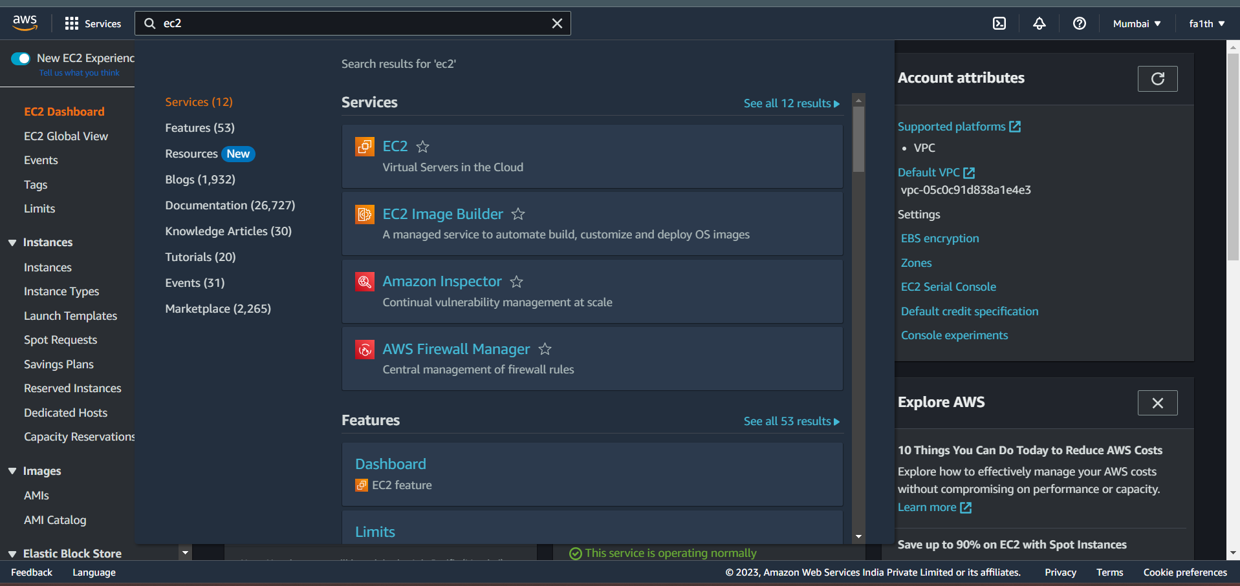
Dashboard
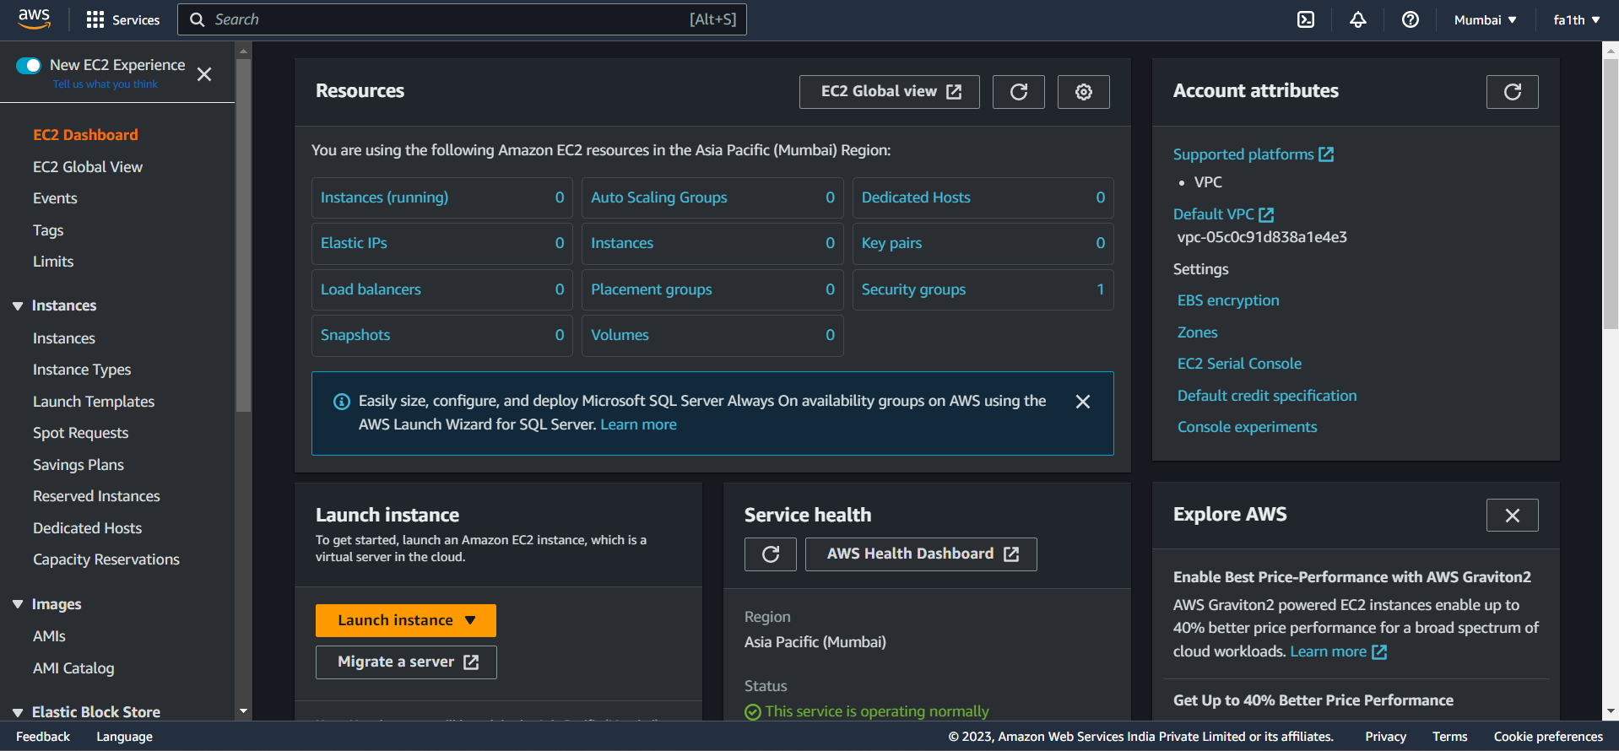

Click Launch Instance
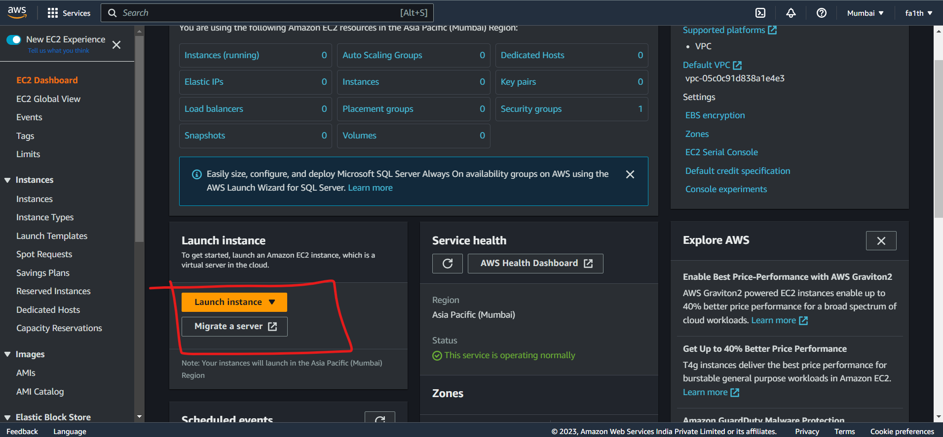
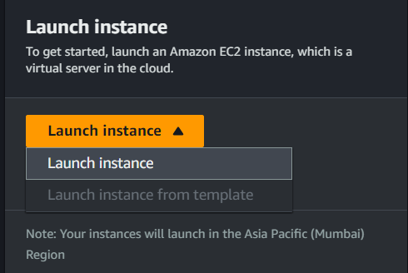
This screen will show up
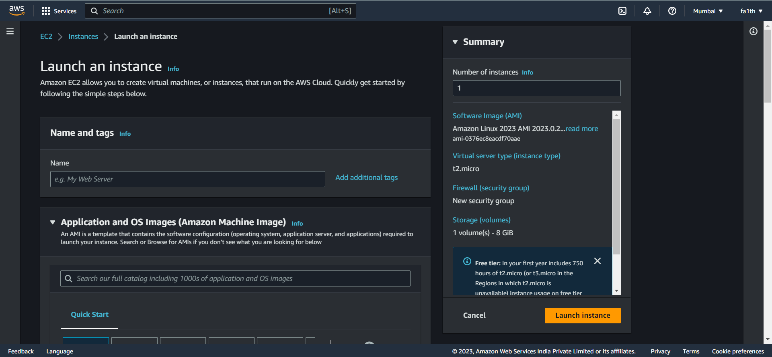
Give a suitable name to the instance

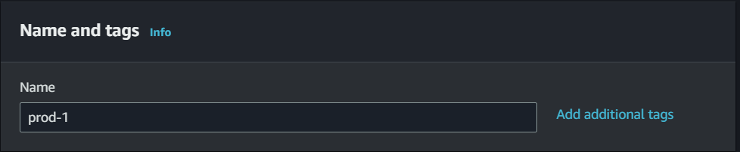
Select from variety of OS images (AMI- Amazon Machine Image)
Use free-tier eligible
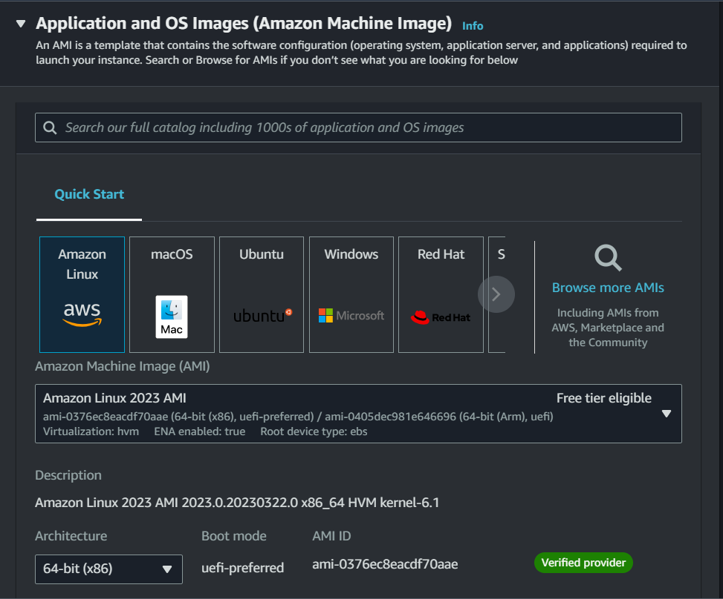

Select the instance type
Use free-tier eligible
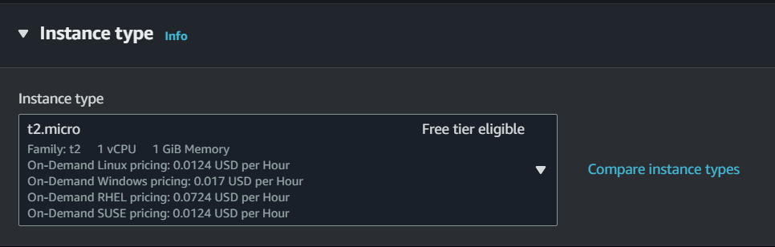
Select new key pair
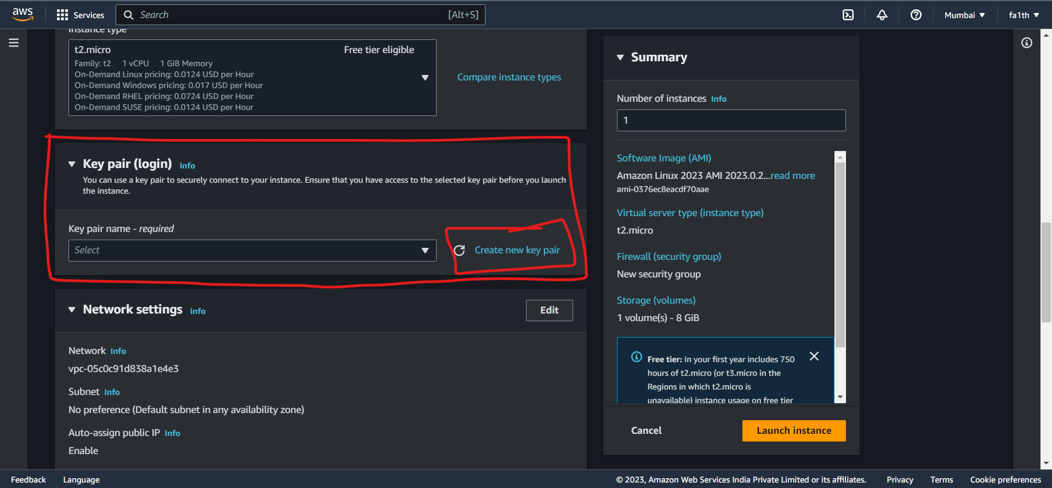

Give key pair name
Select .ppk
Save it in a safe folder

This key pair will be used to connect to the instance using putty.
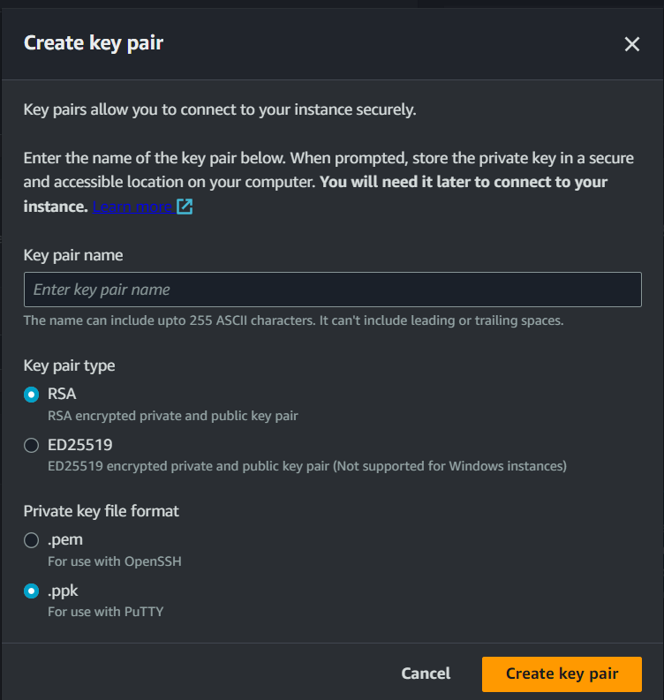
Click on create key pair
The key file will be downloaded
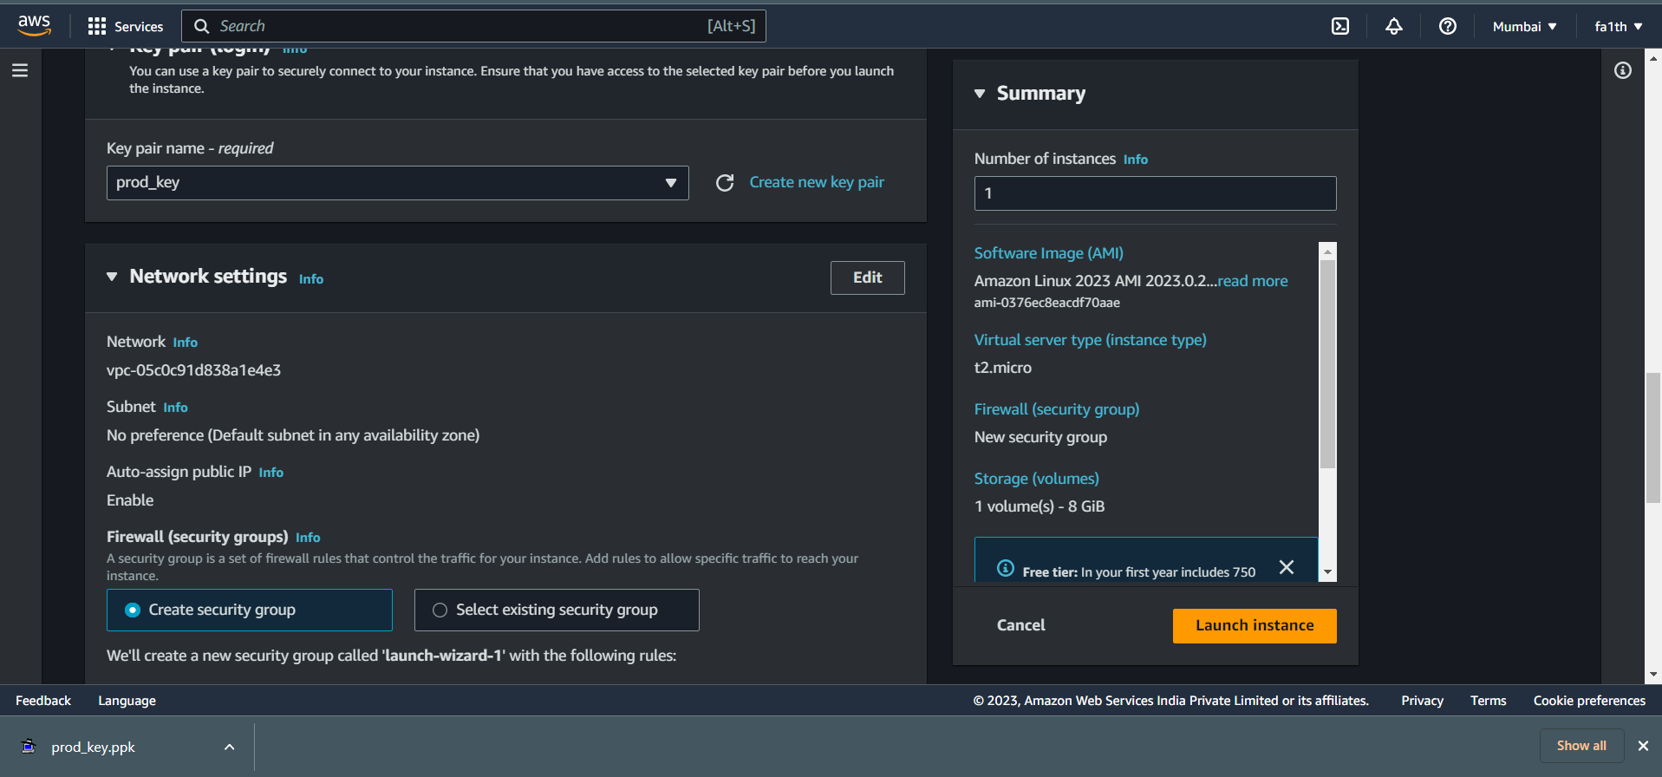

Keep the network settings as it is
Allow traffic - tick mark all 3 boxes
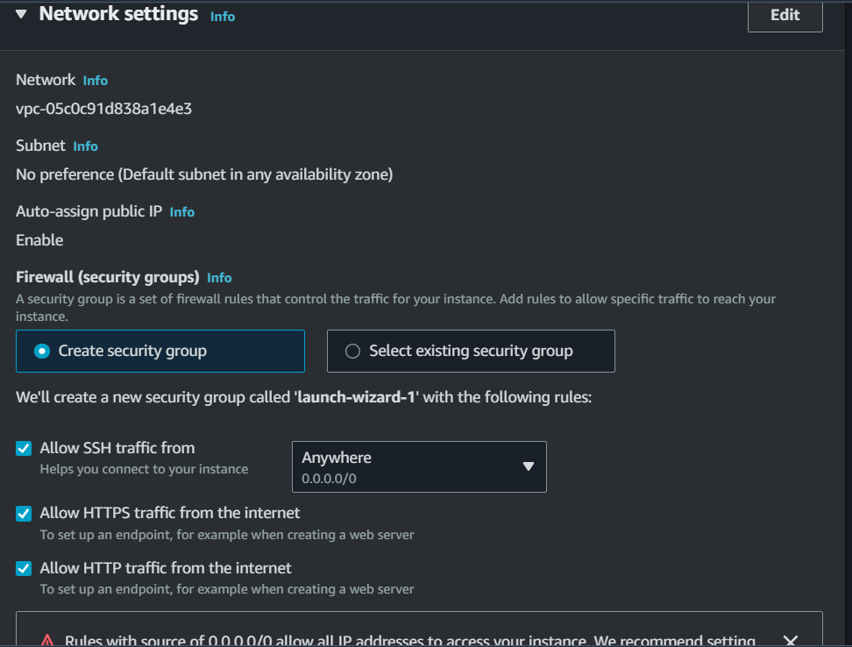

Keep rest of the settings same
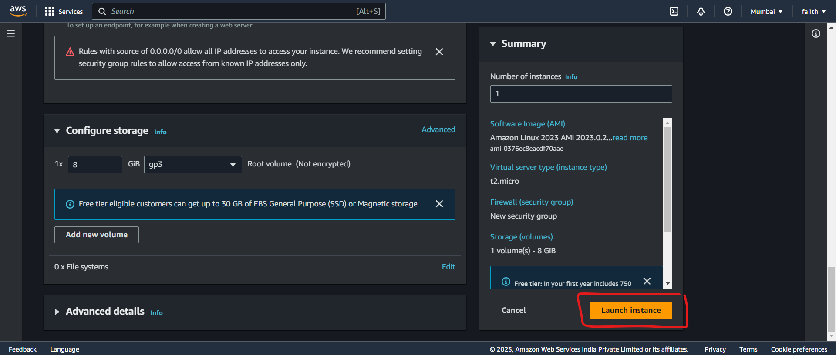
Launch instance
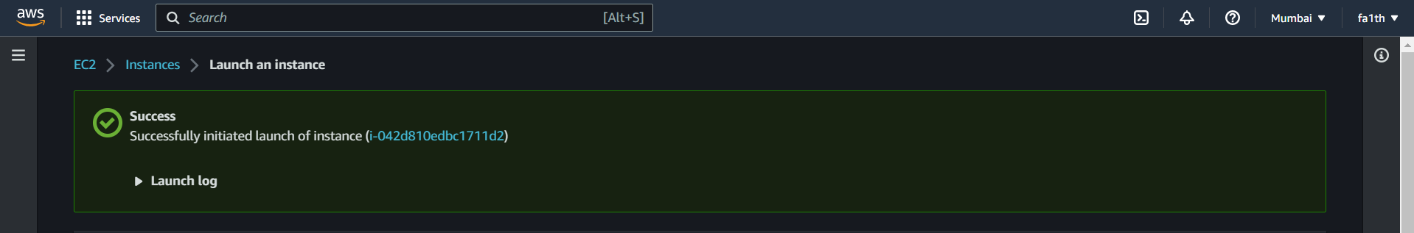
Go to dashboard and check if the instance is running

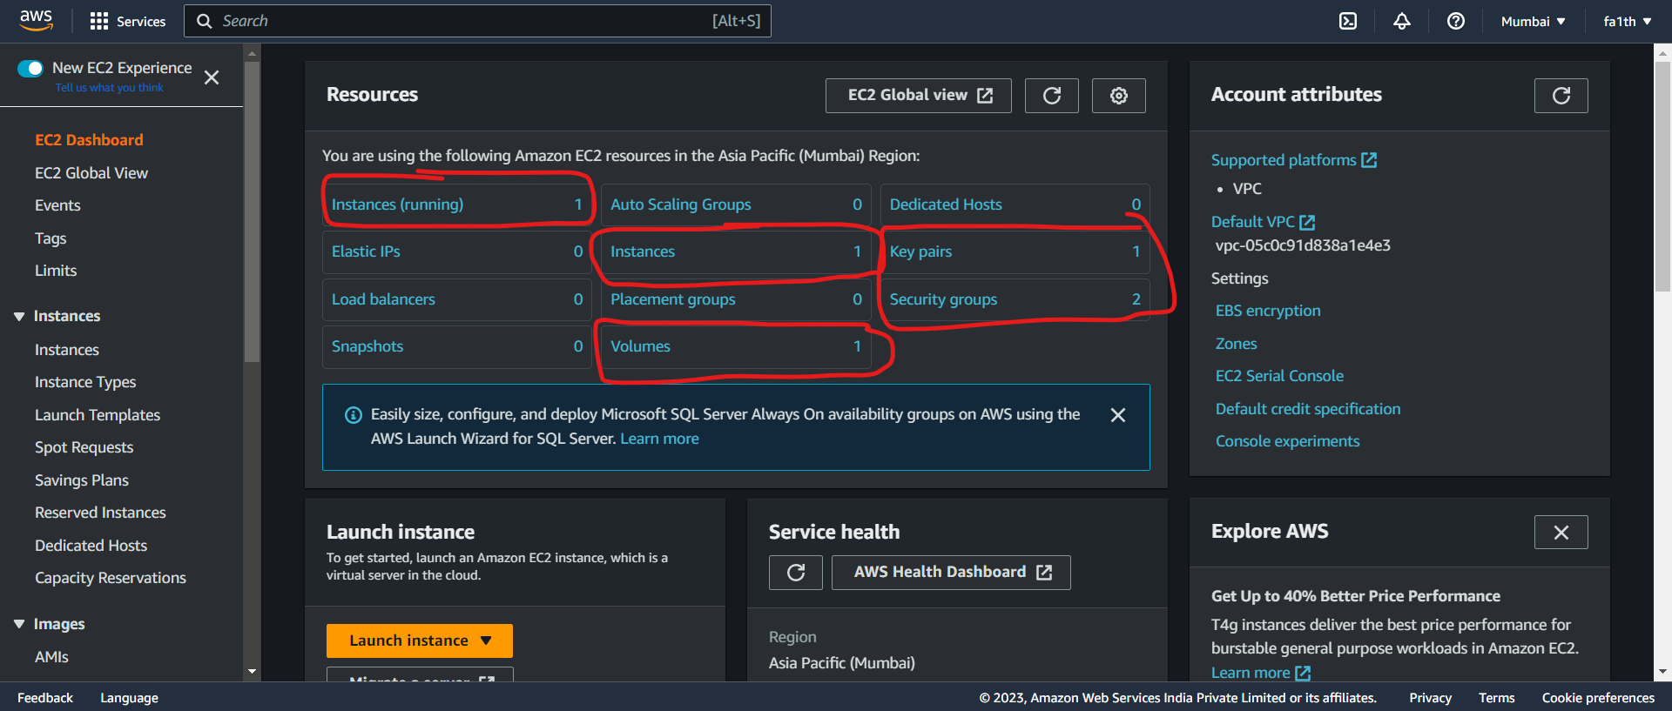
Click on running instances
Click on instance ID
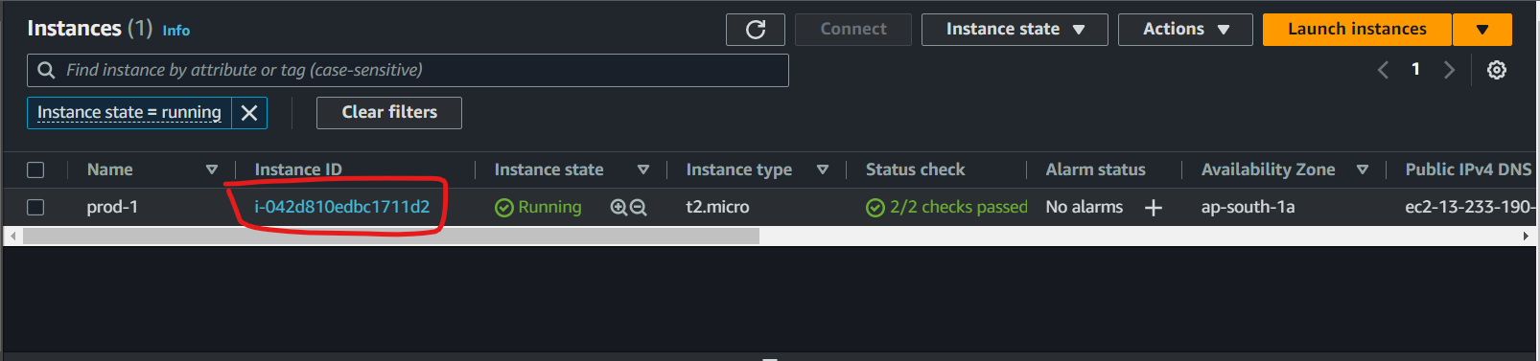
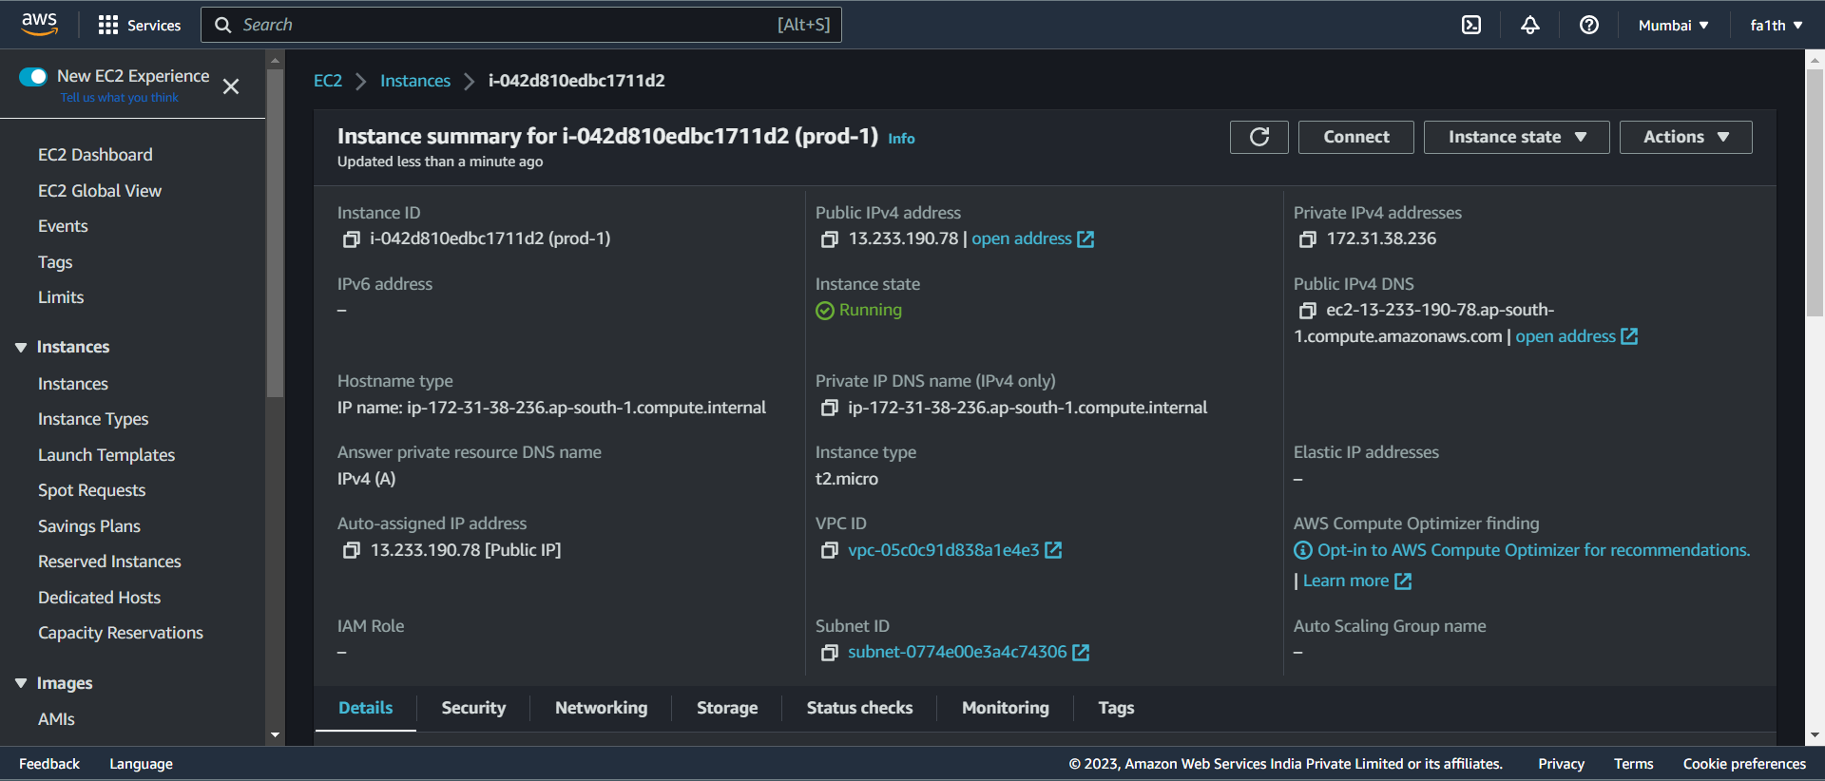
Copy Public ipv4 address
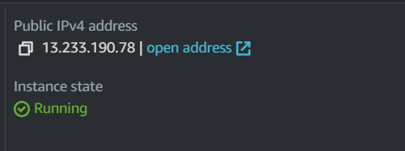
Open putty and write the ip in hostname
ec2-user@ipaddress
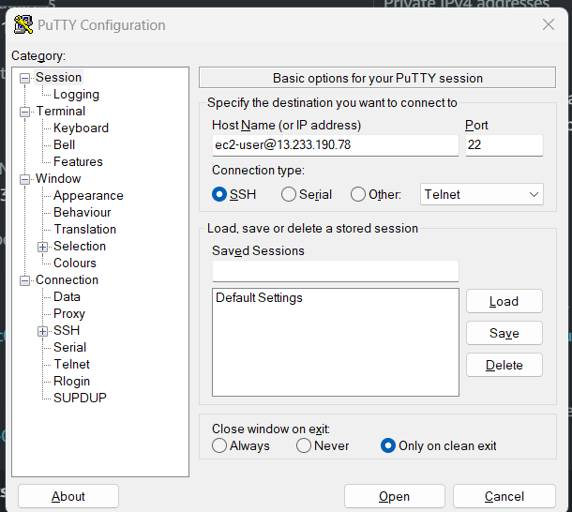
Add key and certificate
Select SSH from left panel
SSH>Auth>Credentials
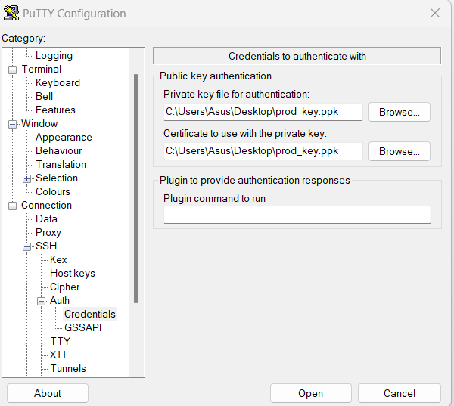
Hit open and it will open up
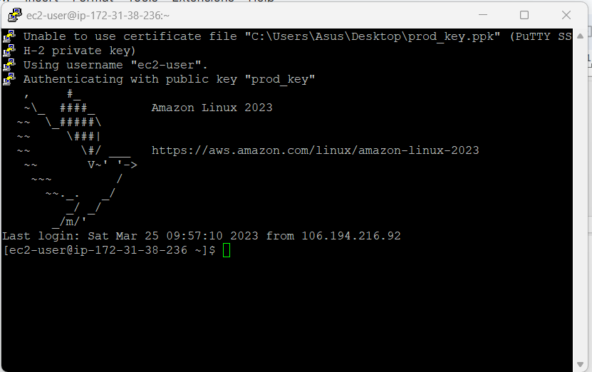
Enter root : sudo -i
Update : yum update -y
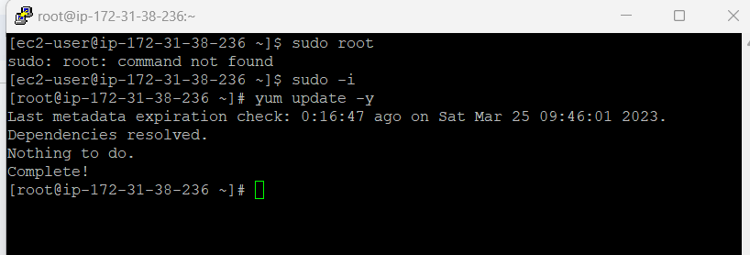
Install httpd : yum install httpd -y
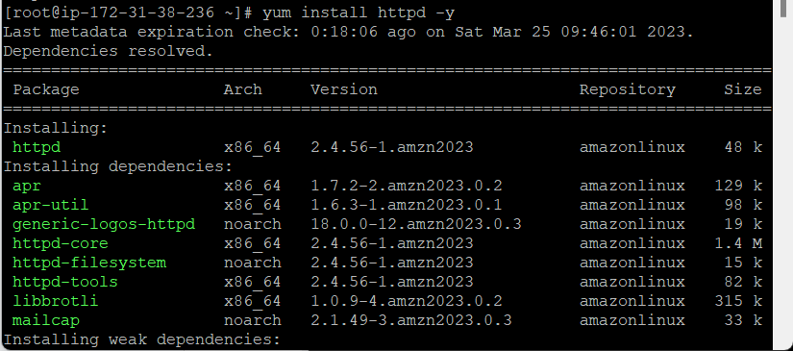
Install httpd : yum install httpd -y
Start httpd : systemctl start httpd
Check httpd service running : systemctl status httpd
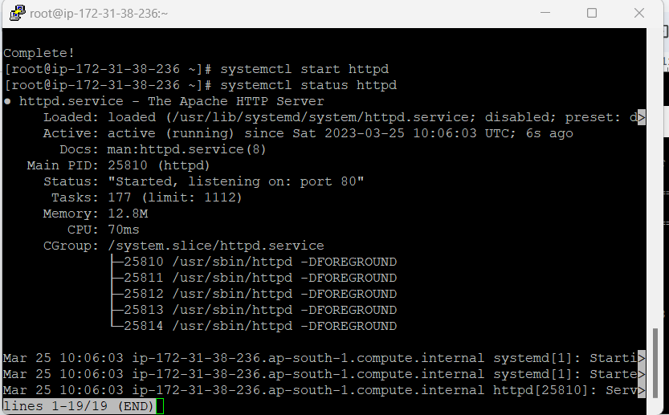
systemctl enable httpd
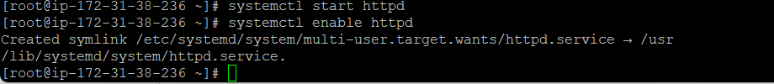
cd /var/www/html
vi index.html
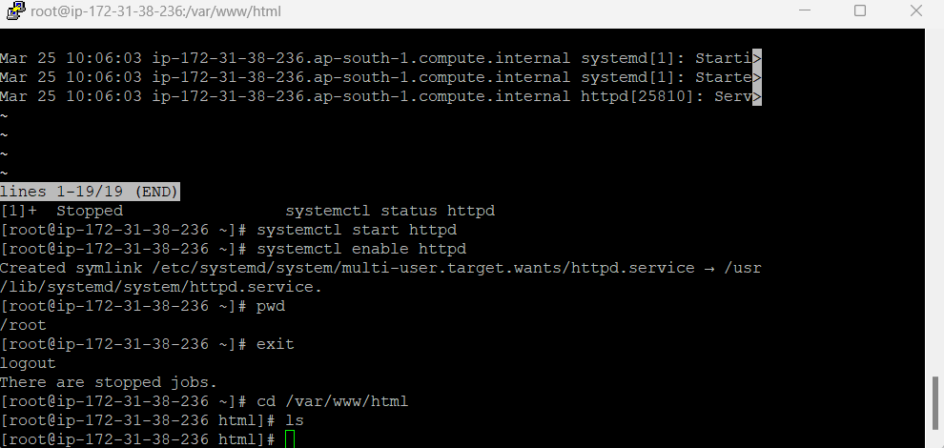
Write a small html code inside the file
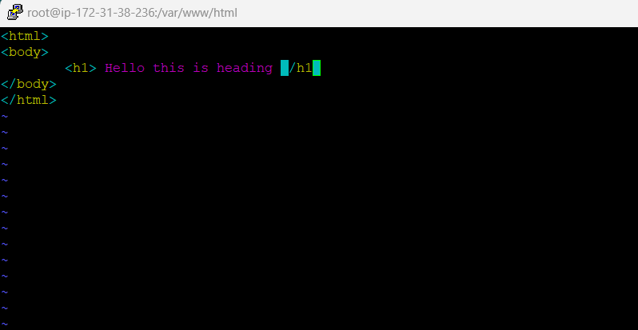
Note: Type this only when getting error
systemctl start httpd
systemctl enable httpd
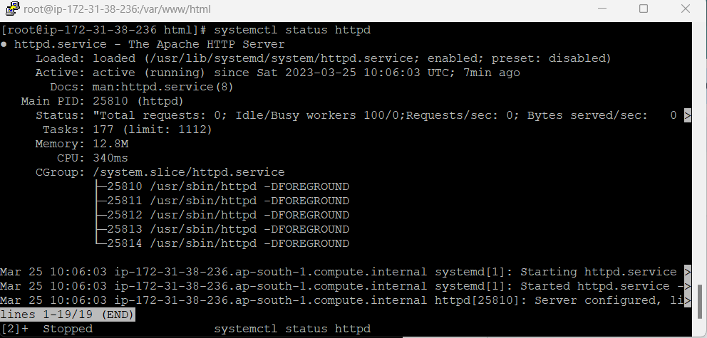

Open dashboard
Copy the public ip address

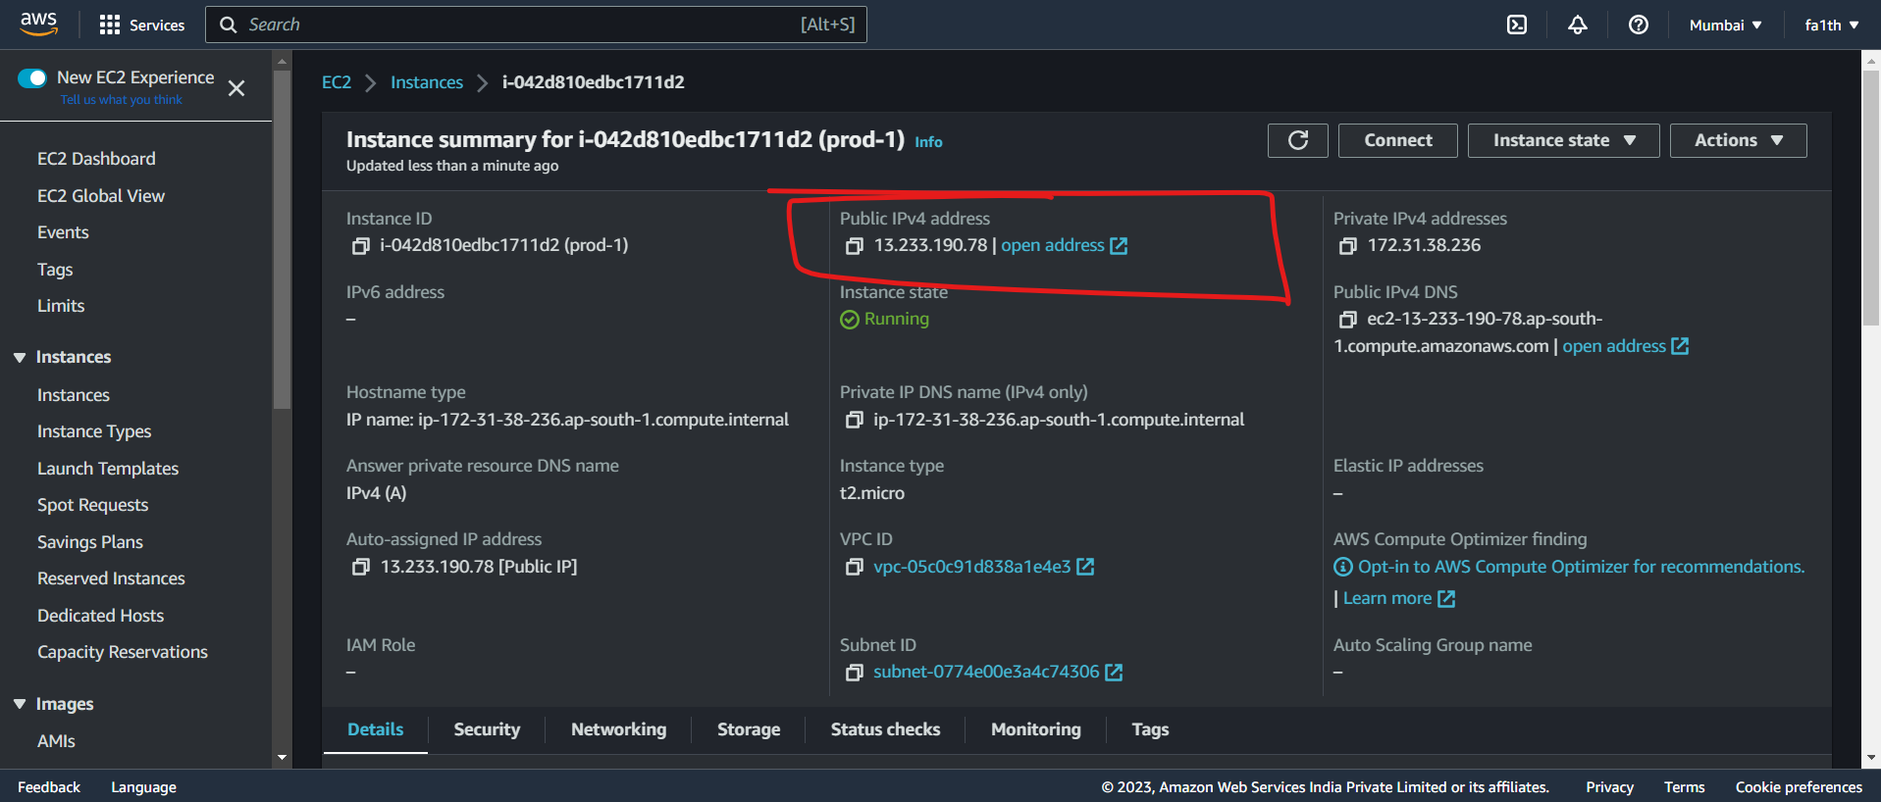
Paste it in browser
The html code will run and show the output
Security group:
Ek tarah ka firewal hai hai aur hum log allowed traffic ka rule likh sakte hai aur denied rule nahi likh sakte hai.

A security group controls the traffic that is allowed to reach and leave the resources that it is associated with. It performs the function of a virtual firewall, managing the inbound and outbound traffic for one or more Amazon EC2 instances or other AWS services within a VPC.

A security group acts as a virtual firewall for your EC2 instances to control incoming and outgoing traffic. Inbound rules control the incoming traffic to your instance, and outbound rules control the outgoing traffic from your instance.

When you launch an instance, you can specify one or more security groups. If you don't specify a security group, Amazon EC2 uses the default security group for the VPC. After you launch an instance, you can change its security groups.

AWS provides security groups as one of the tools for securing your instances, and you need to configure them to meet your security needs. If you have requirements that aren't fully met by security groups, you can maintain your own firewall on any of your instances in addition to using security groups.

You can associate each instance with multiple security groups, and you can associate each security group with multiple instances. You add rules to each security group that allow traffic to or from its associated instances. You can modify the rules for a security group at any time. New and modified rules are automatically applied to all instances that are associated with the security group. When Amazon EC2 decides whether to allow traffic to reach an instance, it evaluates all rules from all security groups that are associated with the instance.

For example, if the security group contains a rule that allows SSH traffic from your network, then you can connect to your instance from your computer using SSH. If the security group contains a rule that allows all traffic from the resources associated with it, then each instance can receive any traffic sent from the other instances
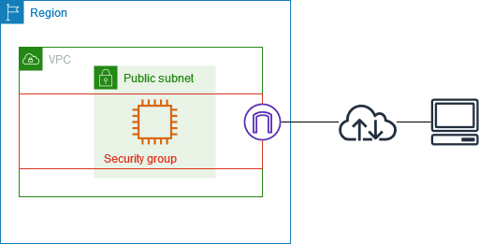

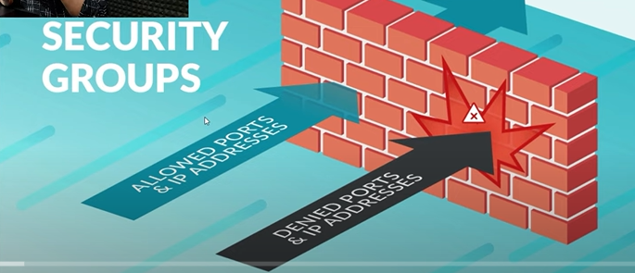
- Inbound Rules: These outline the types of traffic that are permitted to use the resources. It serves as a virtual firewall, controlling the traffic going in and coming out of a VPC for one or more Amazon EC2 instances or other AWS services.
- Outbound Rules: These regulate the traffic that is permitted to depart from the resources. The destination for incoming traffic is dealt with by outbound rules. They may be forwarded to an alternative Security Group, a CIDR block, a single IPv4 or IPv6 address, or all three.
Amazon EC2 is hosted in multiple locations world-wide. These locations are composed of AWS Regions, Availability Zones, Local Zones, AWS Outposts, and Wavelength Zones.
- Each Region is a separate geographic area.
- Availability Zones are multiple, isolated locations within each Region.
- Local Zones provide you the ability to place resources, such as compute and storage, in multiple locations closer to your end users.
- AWS Outposts brings native AWS services, infrastructure, and operating models to virtually any data center, co-location space, or on-premises facility.
- Wavelength Zones allow developers to build applications that deliver ultra-low latencies to 5G devices and end users. Wavelength deploys standard AWS compute and storage services to the edge of telecommunication carriers' 5G networks.
AWS operates state-of-the-art, highly available data centers. Although rare, failures can occur that affect the availability of instances that are in the same location. If you host all of your instances in a single location that is affected by a failure, none of your instances would be available.

AWS Region
An AWS region is a geographical location where AWS has one or more data centers. AWS regions are independent of each other, which means that resources in one region are not accessible from another region.
Each region is identified by a unique code, such as us-east-1, which represents the US East (N. Virginia) region. AWS regions are designed to provide low latency and high availability to customers in that region. For example, if a business has customers in Europe, they can deploy their applications in the AWS Europe (London) region to reduce latency and improve performance. 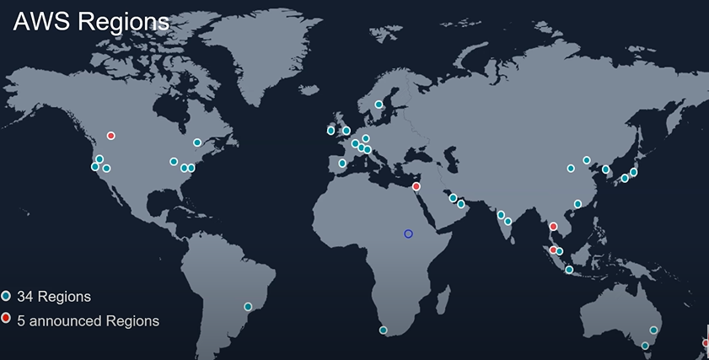

AWS Availability Zone
An AWS availability zone is a data center within an AWS region. Availability zones are physically separate from each other and are connected via a high-speed network. Each availability zone is designed to be independent of other availability zones in the same region, which means that if one availability zone fails, the other availability zones in the region continue to operate normally.
AWS availability zones are identified by a unique code, such as us-east-1a, which represents the first availability zone in the US East (N. Virginia) region.

Businesses can deploy their applications across multiple availability zones to improve fault tolerance and high availability.
Each Region has multiple, isolated locations known as Availability Zones. The code for an Availability Zone is its Region code followed by a letter identifier. For example, us-east-1a.
When you launch an instance, you select a Region and a virtual private cloud (VPC), and then you can either select a subnet from one of the Availability Zones or let us choose one for you. If you distribute your instances across multiple Availability Zones and one instance fails, you can design your application so that an instance in another Availability Zone can handle requests. You can also use Elastic IP addresses to mask the failure of an instance in one Availability Zone by rapidly remapping the address to an instance in another Availability Zone.
The following diagram illustrates multiple Availability Zones in an AWS Region. Availability Zone A and Availability Zone B each have one subnet, and each subnet has instances. Availability Zone C has no subnets, therefore you can't launch instances into this Availability Zone.
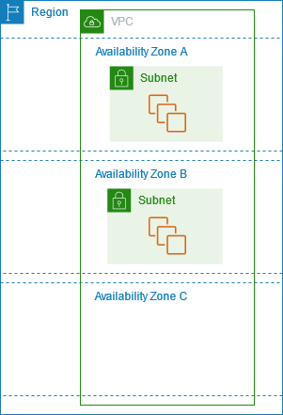

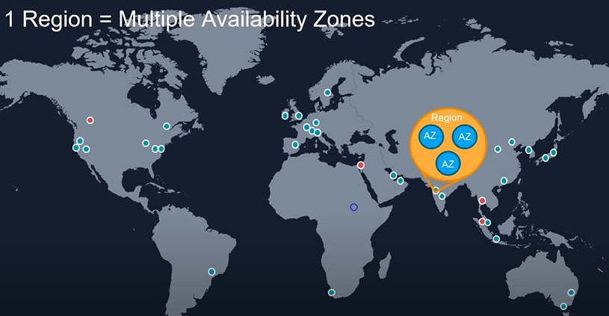
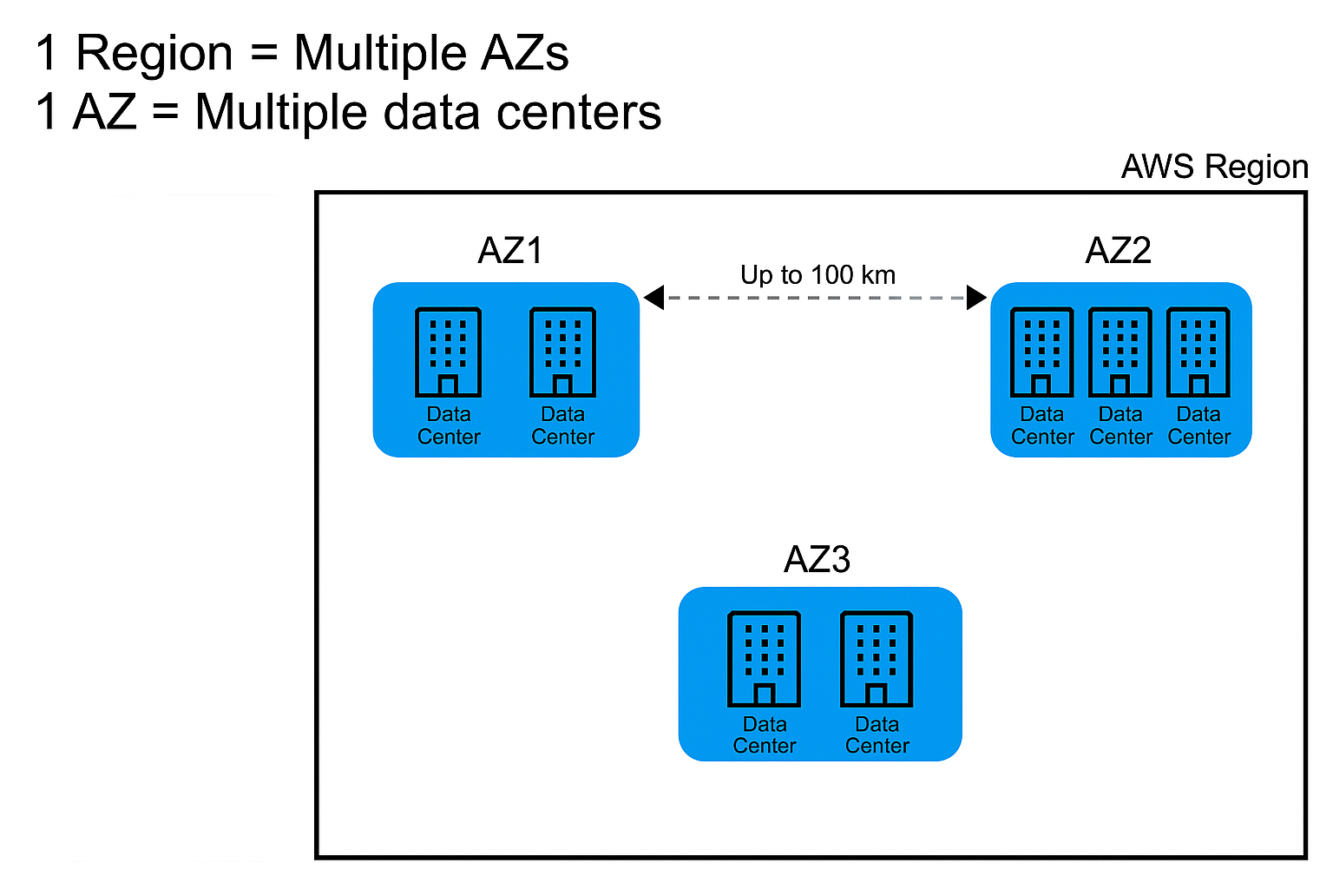
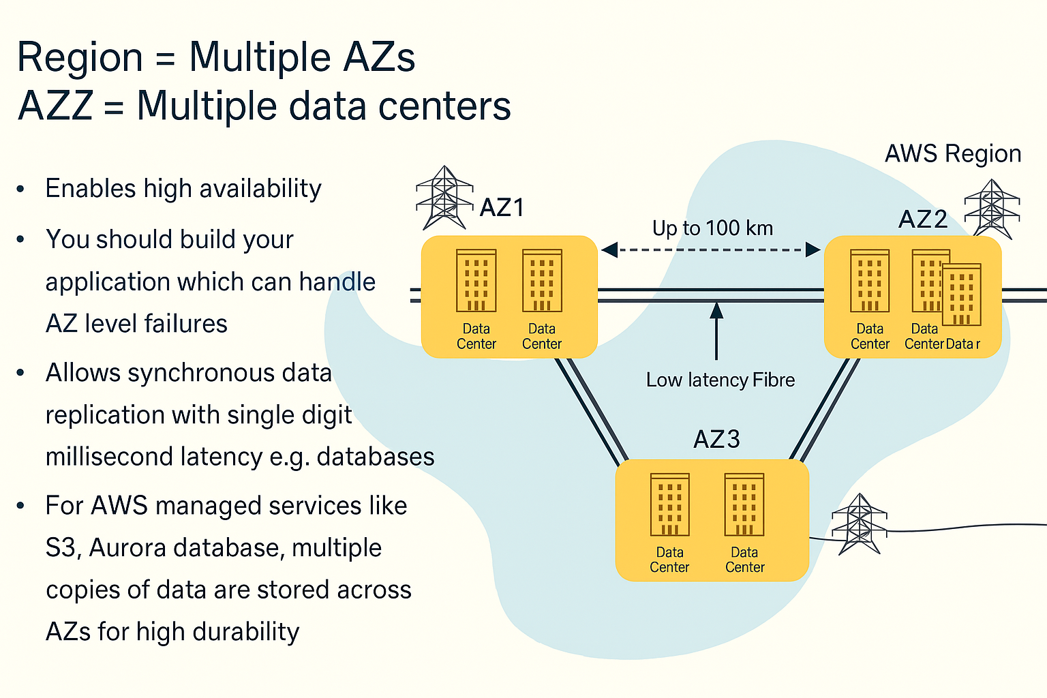

AWS Edge Location
An AWS edge location is a data center that is designed to provide low latency and high performance to users in a specific geographic area. Edge locations are used by AWS services such as Amazon CloudFront and AWS Global Accelerator to distribute content and improve performance.
Currently, AWS has more than 250 edge locations worldwide, which are located in major cities such as New York, London, and Tokyo. Edge locations are not the same as availability zones or regions, as they do not store data or provide computing resources. Instead, edge locations are used to cache data and improve performance for end-users.

An edge location is a site that Amazon CloudFront uses to store cached copies of your content closer to your customers for faster delivery. Edge Locations focus on one key task: content caching. They are typically positioned near major population centers to be geographically close to end users.
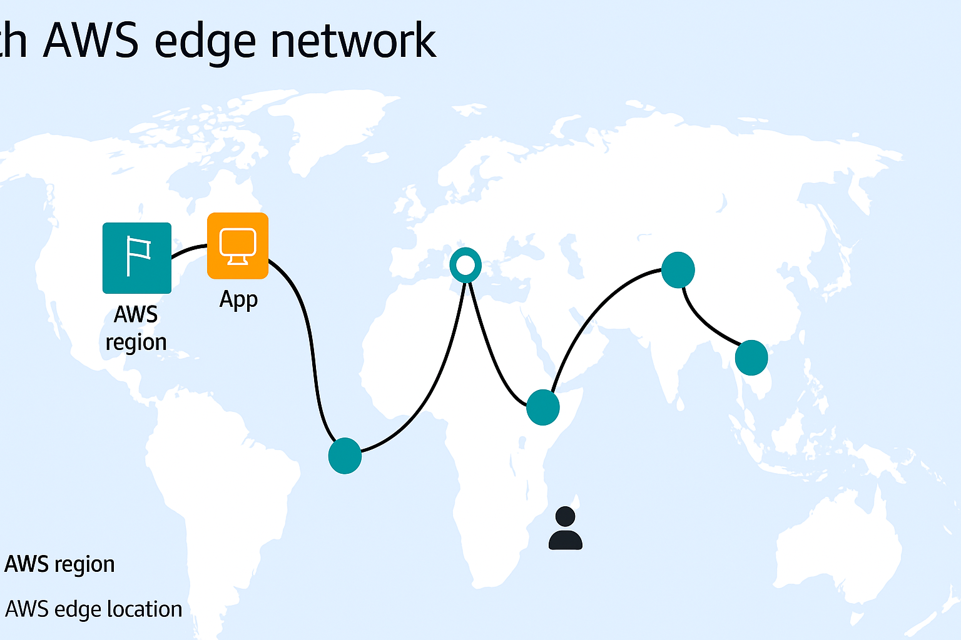
Why does AWS need Edge Locations?
- Suppose that your company’s data is stored in Brazil, and you have customers who live in India.
- To provide content to these customers, you don’t need to move all the content to one of the Indian Regions. Instead of requiring your customers to get their data from Brazil, you can cache a copy locally at an edge location that is close to your customers in India.
- When a customer in India requests one of your files, Amazon CloudFront retrieves the file from the cache in the edge location and delivers the file to the customer.
- The file is delivered to the customer faster because it came from the edge location near India instead of the original source in Brazil.
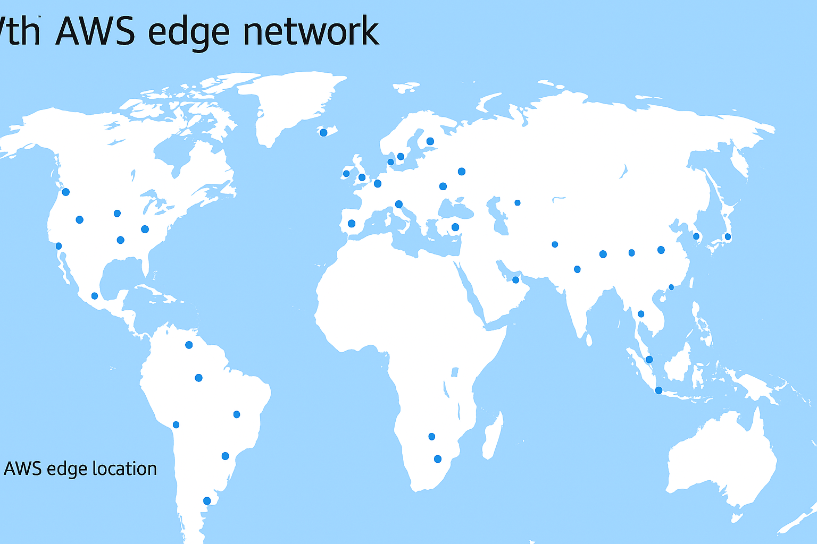

What are AWS Local Zones?
AWS Local Zones places compute, storage, database, and other select AWS resources close to large population and industry centers. You can use Local Zones to provide your users with low-latency access to your applications.
A Local Zone is an extension of an AWS Region in geographic proximity to your users. Local Zones have their own connections to the internet and support AWS Direct Connect, so that resources created in a Local Zone can serve local users with low-latency communications.
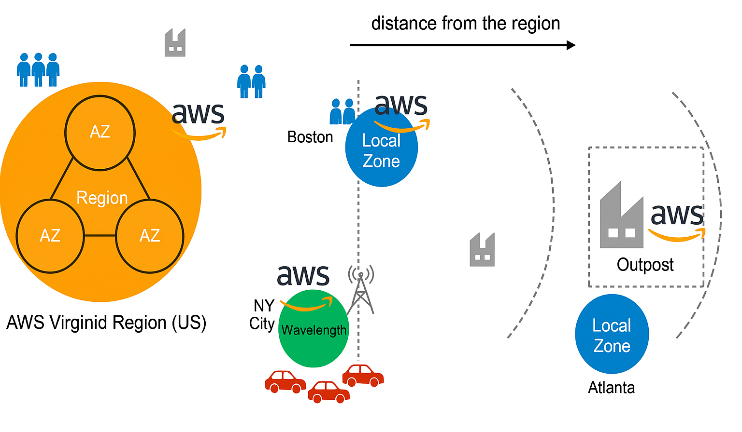

1. AWS Local Zones
Definition:
An AWS Local Zone is an extension of an AWS Region that places compute, storage, and select AWS services close to large cities. It allows applications that require single-digit millisecond latency to run closer to end-users.
Analogy:
Think of it as a mini AWS data center in your city, helping your apps run faster.
Example Scenario:
You’re in Boston, building a real-time multiplayer game or working on video editing. If your data has to travel all the way to North Virginia, it causes delays.
Solution:
AWS deploys a Local Zone in Boston. Now, your app runs fast with minimal lag!
Use for:
- Live gaming
- Media and entertainment
- Virtual desktops
- Industrial automation apps
- Any workload needing <10 ms latency

AWS Wavelength
Definition:
AWS Wavelength allows developers to build apps that deliver ultra-low latency (in single-digit milliseconds) by embedding AWS services directly inside telecom providers' 5G networks.
Analogy:
Imagine AWS computing resources inside a 5G tower. That’s what Wavelength does — bringing the cloud even closer, especially for mobile/IoT apps.
Example Scenario:
You’re in New York City building an autonomous vehicle app or AR glasses. These apps need lightning-fast response times.
Solution:
With AWS Wavelength zones integrated into 5G networks, your app responds almost instantly.
Use for:
- Smart vehicles / autonomous driving
- IoT (drones, robots)
- AR/VR applications
- Ultra-low latency mobile apps
- Smart cities and edge AI
AWS Outposts
Definition:
AWS Outposts extend AWS services to on-premises locations, enabling users to run AWS infrastructure and services within their own data centers. It provides a consistent hybrid experience.
Analogy:
Think of it as AWS moving into your office — giving you all its tools, but within your secure environment.
Example Scenario:
You're a bank or hospital that must keep sensitive data on-premises due to legal/compliance rules.
Solution:
AWS ships physical servers (Outposts) to your location. You run AWS services right there!
Use for:
- Data residency or regulatory compliance
- Healthcare, banking, government
- Hybrid cloud strategy
- Low-latency factory/plant automation
- Local ML inferencing

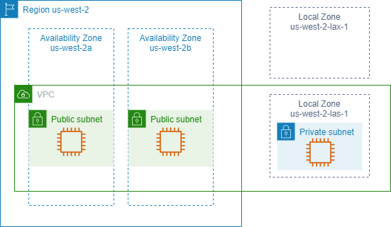

Elastic IP:

What is AWS Elastic IP?
Amazon Web Services (AWS) Elastic IP (EIP) is an EC2 service feature that allows you to allocate a static, public IPv4 address that can be associated with and disassociated from your AWS instances or AWS NAT Gateway. Once an Elastic IP is associated with an instance, it remains associated with it until it is either explicitly disassociated or the instance is terminated. If an instance fails or is terminated and a new one is launched, the Elastic IP address can be transferred to the new instance. This allows you to maintain the same stable static IP address for your application, even if the underlying instances change.
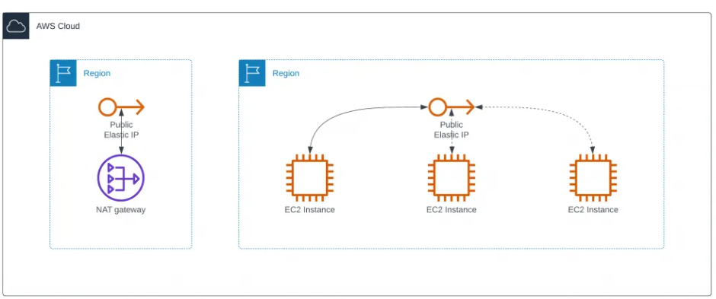

When should I use AWS Elastic IP?
You may need to use an AWS Elastic IP when you require static IP addresses for your Amazon EC2 instances. For example, if you need to connect to your instance from outside the Amazon network (bastion host or VPN Gateway) or if you want to run certain applications that require a static IP address.
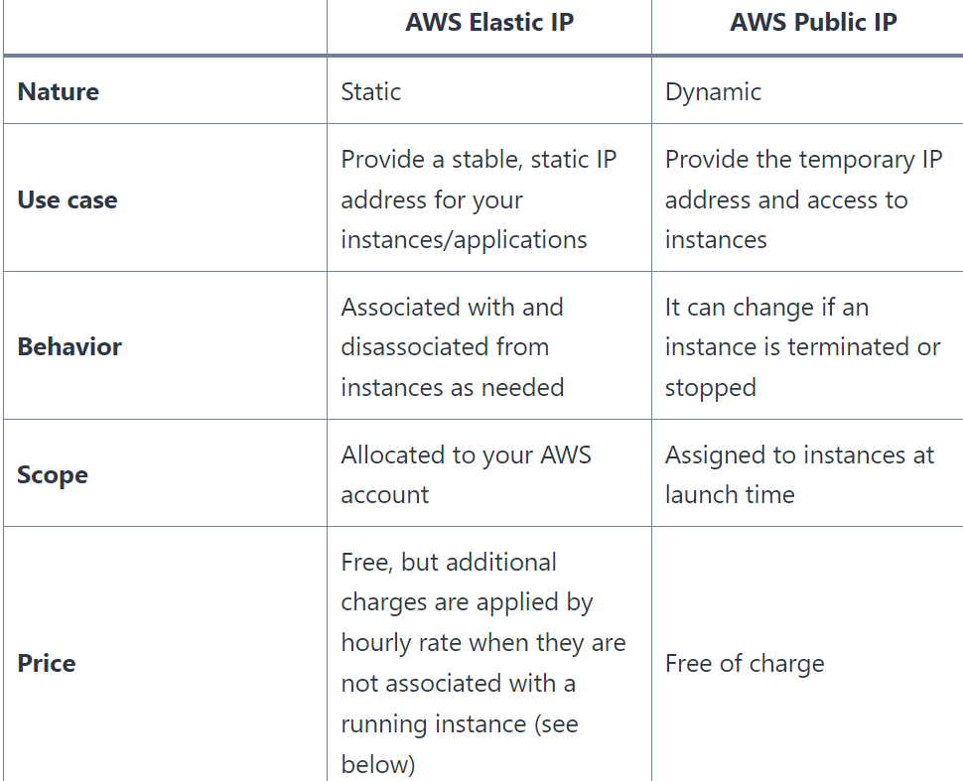

An Elastic IP address (EIP) is a static IPv4 address designed for dynamic cloud computing. It’s associated with your AWS account and can be assigned to any instance in a specific region.
Think of it like a permanent phone number for your cloud server — even if the server (EC2 instance) restarts or changes, the number stays the same.

Why Use an Elastic IP?
Normally, when you stop or terminate an EC2 instance and start it again, its public IP changes. This is a problem if you want to:
- Host a website with a fixed IP
- Whitelist IPs in firewalls
- Connect from external systems reliably
Elastic IP solves this by giving you a public IP that doesn't change — even if your instance does.

How It Works:
- You allocate an Elastic IP from AWS (you get 1 free per region).
- You associate it with your EC2 instance.
- If the instance is stopped or replaced, you can reassociate the same IP to a new instance.

Real-Life Example:
You’ve launched a web app on an EC2 instance.
You're using Route 53 to manage DNS, and you've whitelisted the IP in your office firewall.
Without Elastic IP:
Every time your server restarts, the public IP changes — breaking your DNS and firewall.
With Elastic IP:
Your app's IP remains constant, so no interruptions!

EBS:

What is AWS EBS?
- AWS EBS is also called AWS Elastic Block Store.
- EBS is a service that provides storage volumes.
- You can use provided storage volumes in Amazon EC2 instances.
- EBS volumes are used for data that needs to persist.
- It is important to backup the data with AWS EBS snapshots.

What are AWS EBS Snapshots?
- EBS snapshot is an incremental data backup.
- The first backup of a volume backups all the data.
- Every next backup copies only a block of data that has changed since the last snapshot.
- It saves on storage costs by not duplicating data.
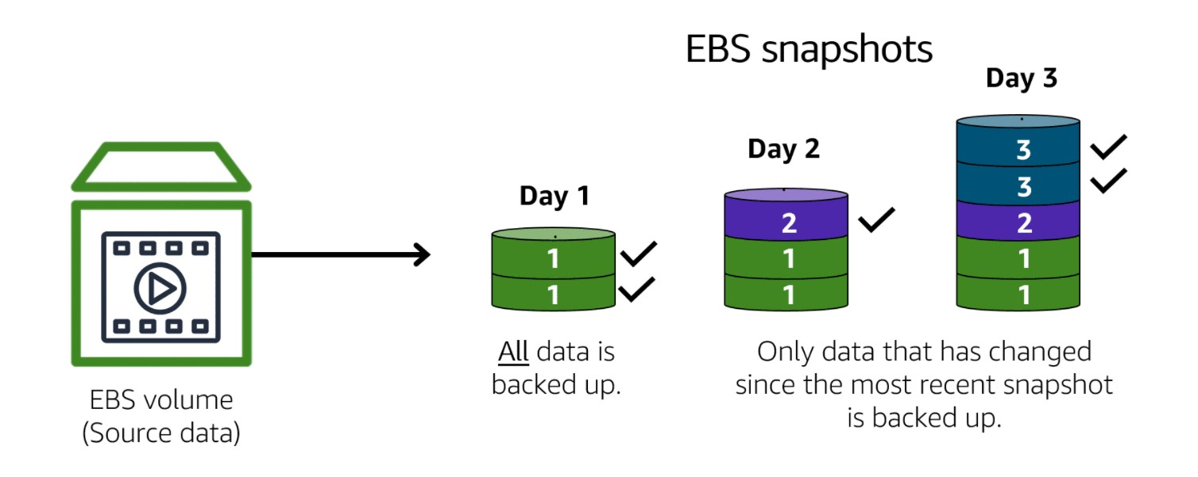
Image created by Amazon Web Services
The image illustrates how EBS Snapshots work.

