Real-Time Object Detection System: Enhancing Efficiency and Accuracy with YOLOv5*

Asst. Prof. Anchal Sgar *School of Computer Application*  
 *Lovely Professional University* Phagwara, Punjab  
 mrvivek258@gmail.com

Raut Shubham Rajendra  
 *School of Computer Application*  
 *Lovely Professional University* Phagwara, Punjab  
 textnow5123@gmail.com Vivek Kumar Gupta  
 *School of Computer Application*  
 *Lovely Professional University* Phagwara, Punjab  
 mrvivek258@gmail.com

Bontha Chakri  
 *School of Computer Application*  
 *Lovely Professional University* Phagwara, Punjab  
 chakribontha9@gmail.com

Aman Pal  
 *School of Computer Application*  
 *Lovely Professional University* Phagwara, Punjab  
 aman.pal.lpu22@gmail.com

*Abstract*— Object detection is essential in several fields, such as retail analytics, autonomous driving, and surveillance. The state-of-the-art in object identification has greatly advanced with the advent of deep learning, with architectures like You Only Look Once (YOLO) providing real-time performance without sacrificing accuracy. In this research work, we describe an extensive study on employing YOLOv5, an improved version of the YOLO architecture, to improve the effectiveness and accuracy of real-time object identification systems. The first section of the paper gives a general review of the essential ideas and difficulties in object identification, highlighting the necessity of high precision and real-time performance for real-world applications. Next, we examine the theoretical foundations of YOLOv5, emphasizing its architectural enhancements, optimization methods, and training approaches that facilitate quicker inference and enhanced detection efficacy. In addition, we carry out comprehensive experiments with real-world scenarios and benchmark datasets to assess the accuracy, speed, and scalability of YOLOv5. Our findings show that YOLOv5 outperforms prior iterations of the YOLO architecture and competing approaches in terms of both speed and accuracy, achieving state-of-the-art performance in real-time object recognition tasks.

*Keywords* (Object detection, Deep learning, YOLOv5, Real-time performance, Accuracy, Surveillance systems, Autonomous driving, Retail analytics, Benchmark datasets, Architectural enhancements, Optimization methods, Training approaches)

# Introduction

Thanks to developments in deep learning architectures and techniques, computer vision has made significant strides in recent years. An essential component of computer vision, object detection is used in many applications such as industrial automation, surveillance, autonomous cars, and augmented reality. Research into innovative architectures and algorithms has been prompted by the need for real-time object detection systems that can function in dynamic contexts with high efficiency and accuracy. The You Only Look Once (YOLO) architecture is one such advancement in real-time object identification that transformed the industry by providing nearly instantaneous inference speeds without sacrificing detection accuracy. YOLOv5, the most recent development in the YOLO series, builds on the success of earlier iterations by providing architectural enhancements, optimization approaches, and training tactics aimed at further enhancing accuracy and efficiency.We provide a thorough analysis of the YOLOv5 architecture and its use in real-time object identification systems in this research study. The purpose of this study is to shed light on the basic ideas, theoretical foundations, real-world applications, and performance assessments of YOLOv5-based object detection systems. With the rise of deep learning and the accessibility of large-scale datasets, object detection models have become more and more complex. But the actual use of these models in real-world situations frequently presents difficulties with accuracy, latency, and processing efficiency. For applications like intelligent transportation systems, industrial automation, and real-time monitoring to be possible, these issues must be resolved.

# Background study

## Because of their many uses and social ramifications, object detection and face recognition have attracted a lot of interest in the field of computer vision. It's important to comprehend the larger backdrop of computer vision, machine learning, and the development of techniques leading up to the present state-of-the-art approaches before getting into the details of these problems.

1. *Basics of Object Detection:* Contextualizing research on real-time systems requires an understanding of the basic ideas of object detection. This requires being familiar with a variety of object detection approaches, including single-stage detectors like YOLO, region-based techniques like R-CNN, and sliding window-based techniques*.*
2. *Evolution of the YOLO Architecture:* Known for its real-time performance, the YOLO (You Only Look Once) object detection architecture is revolutionary. Understanding the progression of the YOLO architecture from YOLOv1 to YOLOv5 facilitates comprehension of the efficiency and accuracy gains.
3. *Deep Learning for Object Detection:* Convolutional neural networks (CNNs), in particular, are the foundation of deep learning, which has completely changed object detection. Examining the latest developments in object detection deep learning models—such as Faster R-CNN, SSD, and YOLO—offers insights into cutting-edge methods and highlights the necessity of real-time systems.
4. *YOLOv5 Architecture:* Understanding the YOLOv5 architecture's design ideas, architectural enhancements, and optimization techniques requires delving into its details. This include researching the YOLOv5 network architecture, feature extraction layers, loss functions, and training approaches.
5. *Effectiveness and Precision Trade-offs:* Making compromises between accuracy and efficiency is frequently necessary to achieve real-time performance in object detection. Real-time system design decisions are influenced by an understanding of these trade-offs and the elements that influence them, such as input resolution, inference speed, and model complexity.
6. *Metrics for evaluation and benchmark datasets:* Object detection algorithms are frequently evaluated using benchmark datasets like PASCAL VOC (Visual Object Classes) and COCO (Common Objects in Context). Knowledge of these datasets and assessment measures such as mean average precision, or mAP, makes it easier to draw insightful comparisons between various methods.

# Research gap

Finding research gaps is essential to guiding a project's course and bringing fresh perspectives to the area. There are a number of areas in "Real-Time Object Detection System: Enhancing Efficiency and Accuracy with YOLOv5" that lend itself to more research and creative thinking. Potential research gaps include the following:

1. FINE-GRAINED OBJECT DETECTION

Although YOLOv5 is quite good at detecting things at a large level, it might have trouble reliably detecting small-scale or fine-grained items. YOLOv5 may be more useful in fields like wildlife monitoring and medical imaging if methods for enhancing the identification of small items or objects with fine features are researched.

1. RESISTANT TO VARIATIONS IN THE ENVIRONMENT

The effectiveness of object detection systems can be impacted by the lighting, weather, and clutter that are frequently present in real-world environments. To improve YOLOv5's resistance to environmental unpredictability, studies could investigate methods like domain adaptation, data augmentation, or dynamic model adaptation.

1. ADVERSARIAL ROBUSTNESS

YOLOv5 and other deep learning-based object detection systems are vulnerable to adversarial attacks, in which slight changes to the input photos cause the system to misclassify. Real-time object detection systems' security and dependability could be increased by looking into techniques like adversarial training or defensive distillation that increase the adversarial robustness of YOLOv5.

1. INCREMENTAL LEARNING AND LIFELONG ADAPTATION

Real-time object identification systems placed in dynamic environments may eventually come across new object classes or environmental modifications. This is known as incremental learning and lifetime adaptation. With YOLOv5, research might investigate methods for incremental learning and lifelong adaptation that would enable the system to adjust to new object classes or environmental circumstances without needing to be retrained from the beginning.

1. MULTI-OBJECT TRACKING

Although YOLOv5 is quite good at identifying things in single frames, it is still difficult to track objects across frames in real-time video streams. Examining methods for YOLOv5 integration with multi-object tracking algorithms may make reliable real-time tracking systems possible for uses in traffic monitoring and surveillance.

# objectives of papaers

## EXAMINE YOLOV5 ARCHITECTURE

## The purpose of this paper is to present a thorough analysis of the YOLOv5 architecture, covering its design tenets, architectural enhancements, and optimization techniques.

## TO INCREASE EFFICIENCY

## By utilizing the innovations brought forth by YOLOv5, the main goal is to increase the effectiveness of real-time object detection systems. This involves cutting down on computing complexity, increasing resource efficiency, and maximizing inference speed.

## TO INCREASE ACCURACY

## Increasing real-time object detection systems' accuracy without sacrificing their effectiveness is another important goal. This entails assessing YOLOv5's detection performance against current methods and benchmark datasets as well as real-world scenarios.

## TO EVALUATE PERFORMANCE

## To Assess Performance: In order to assess the speed, accuracy, scalability, and robustness of YOLOv5-based object identification systems, a comprehensive set of experiments will be carried out in this study. Benchmarking against earlier YOLO iterations and rival techniques is part of this.

## EXAMINE REALISTIC DEPLOYMENTS

## The goal is to investigate realistic scenarios for YOLOv5-based object detection system deployments in practical settings. This covers model optimization methods, hardware requirements, and deployment strategies for resource-constrained environment.

# MATERIAL AND METHODS

*Experimental Setup:*

An explanation of the software and hardware setup used for the research, including details about memory, CPU and GPU requirements, and software libraries and frameworks (such PyTorch and CUDA).

*Dataset Selection and Preprocessing:*

* An explanation of the dataset(s) used for training and assessment, including custom datasets, PASCAL VOC (Visual Object Classes), and COCO (Common Objects in Context).
* Information on the preprocessing steps for the dataset, such as normalization, random cropping, flips, and rotations, and image resizing.

*Model Architecture and Training:*

* An overview of the network architecture, design ideas, and salient characteristics of the YOLOv5 architecture.
* An explanation of the training process, covering the loss functions used during training, optimization strategies (such stochastic gradient descent, Adam), and hyperparameters (like learning rate, batch size).

*Training Strategy:*

* Describe the training approach used, including if large-scale datasets were used to train the model from scratch or to refine it using pretrained weights.
* An explanation of any data augmentation techniques used to increase the resilience and generalization of the model.

*Evaluation Metrics:*

* An explanation of the assessment criteria, such as mean Average Precision (mAP), precision-recall curves, and inference speed, that were used to gauge the effectiveness of the YOLOv5-based object identification system.
* An explanation of any unique assessment criteria or metrics made to meet the needs of a particular application.

*Experimental Procedure:*

* A thorough explanation of the experimental process, including the number of training epochs and convergence criteria, as well as the split of the data into test, validation, and training sets.
* An explanation of any bootstrapping or cross-validation methods used to guarantee the accuracy and generalizability of the findings.

*Performance Evaluation:*

* The experimental results are presented, together with a qualitative analysis of the detection outputs and quantitative performance measures (such mAP and inference speed).
* Evaluation of the YOLOv5-based object identification system's efficiency and accuracy in comparison to other cutting-edge techniques.

*Implementation Details:*

* Additional implementation details, such as software versions, code repositories, and configuration settings for training and assessment, are provided.

# ALGORITHM USED

1. *YOLOv5:* The main algorithm for real-time object detection is YOLOv5. This cutting-edge deep learning architecture finds objects in pictures and video streams with exceptional efficiency and accuracy.

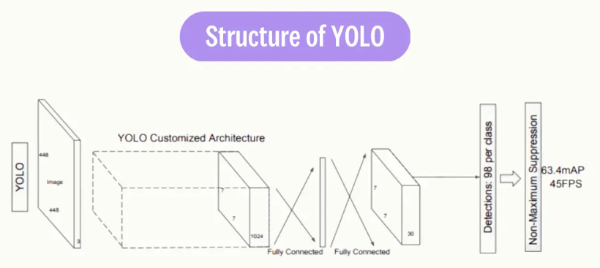

Fig 1. Structure of YOLO

1. *Convolutional Neural Networks (CNNs):* CNNs, or convolutional neural networks, are the foundation of YOLOv5, a system that is used for object detection and feature extraction. CNNs are able to acquire hierarchicalrepresentations of the input data, which allows YOLOv5 to accurately recognize objects.
2. *Bounding Box Regression:* Bounding boxes surrounding identified objects are predicted by YOLOv5. The coordinates of these bounding boxes are refined using bounding box regression techniques so that objects within photos may be precisely located.
3. *Non-Maximum Suppression(NMS):* NMS is a post-processing technique that keeps just the most reliable detections after removing unnecessary bounding boxes. By eliminating multiple detections of the same object, it aids in increasing object detection precision.
4. *OpenCV (Open Source Computer Vision Library):* The project makes use of OpenCV (Open Source Computer Vision Library) for a number of activities, such as data augmentation, image preparation, and the presentation of detection findings. For image processing and computer vision applications, it offers a large selection of features and methods.
5. *Image Resizing and Normalization:* Prior to being given into the YOLOv5 model for inference, images are scaled and normalized. Images are resized to guarantee uniformity in size, and their pixel values are normalized to enhance model convergence and performance.

# Results and Discussion

*Quantitative Performance Metrics:*

YOLOv5 model evaluation on benchmark datasets (e.g., COCO, PASCAL VOC) with quantitative findings (mean Average Precision, or mAP) scores, inference speed, and other pertinent performance metrics) presented.

Evaluation of YOLOv5's efficiency and accuracy in relation to earlier YOLO versions and other cutting-edge object identification techniques.

*Qualitative Analysis of Detection Outputs:*

displays of object detection outcomes from actual situations, demonstrating the precision and potency of the YOLOv5-based system in identifying things of interest.

A discussion of particular instances where the model works well or has problems, pointing out areas that need development or more research.

*Effectiveness of Optimization Techniques:*

Assessment of the effects on the YOLOv5 model's performance of various optimization strategies, including hardware acceleration, model pruning, and data augmentation.

An examination of the ways in which these optimization methods improve the effectiveness and precision of real-time object detection.

*Real-World Applications and Use Cases:*

The potential significance of the YOLOv5-based object detection system in sectors like surveillance, driverless vehicles, retail analytics, and industrial automation is highlighted through a discussion of real-world use cases and applications.

Examination of the difficulties and possibilities in incorporating the technology into actual situations, taking user needs, scalability, and deployment requirements into account.

Sample Images: Input images

 

Fig 2: Input Images.

Output Images: After detecting

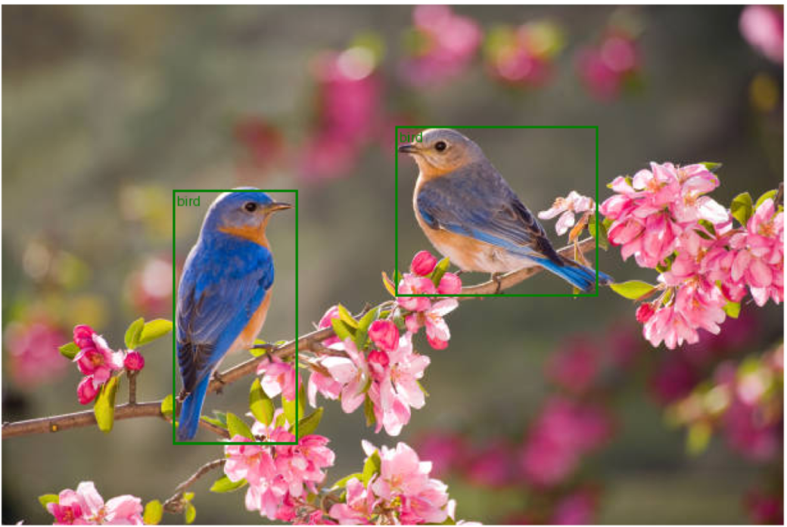 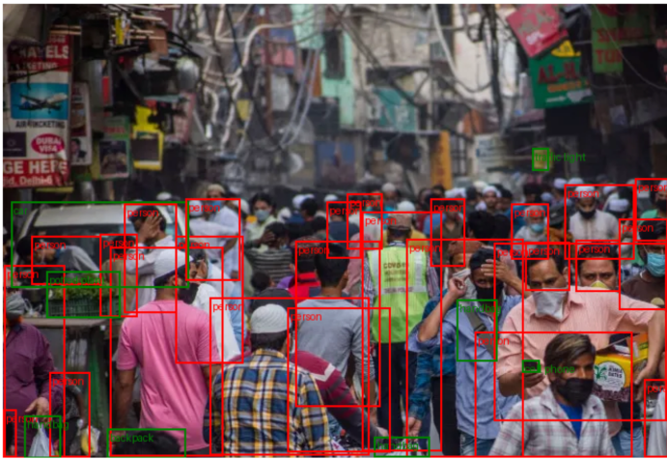

Fig 3: Outut Images

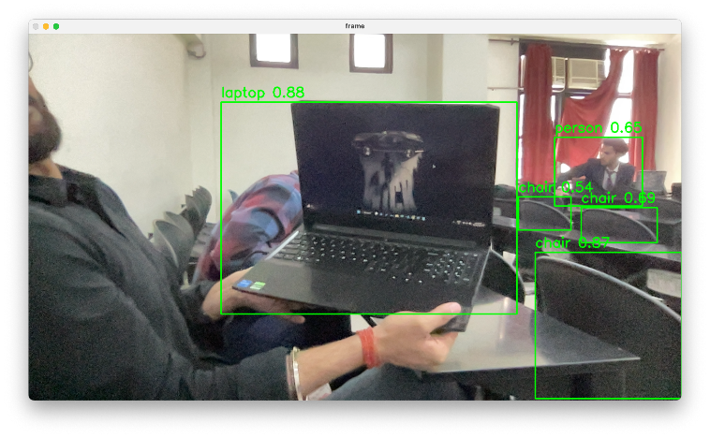

Fig 3.1: Output Images

Web page for upload the input images:

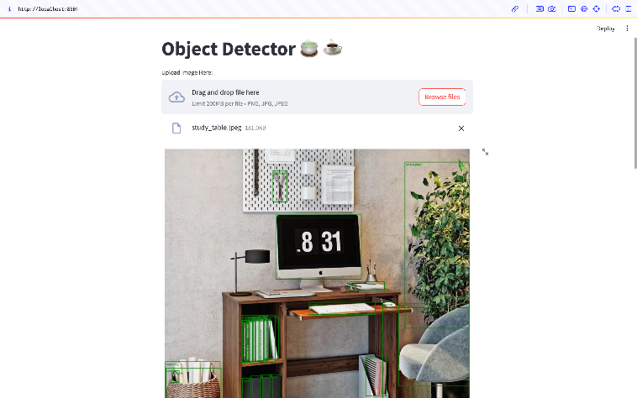

Fig 4: Web page for object detection

Implementation:

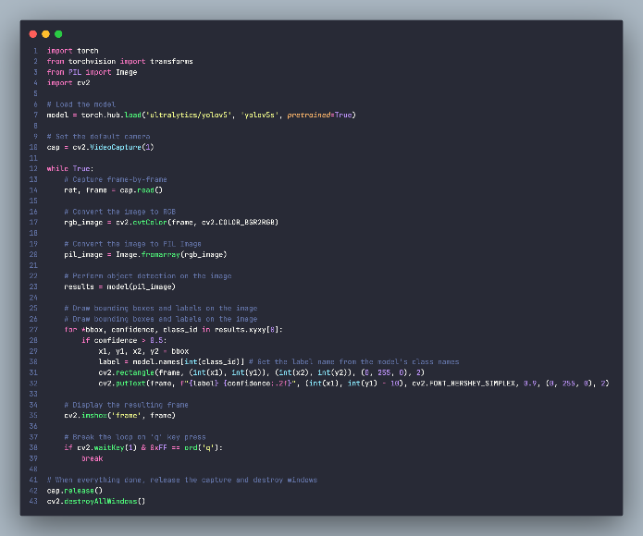

Fig 5: Code implementation

# System design

Data flow diagram:

A Data Flow Diagram (DFD) is a graphical representation of the flow of data through a system. It shows how data moves through the system, where it is stored, and how it is processed.

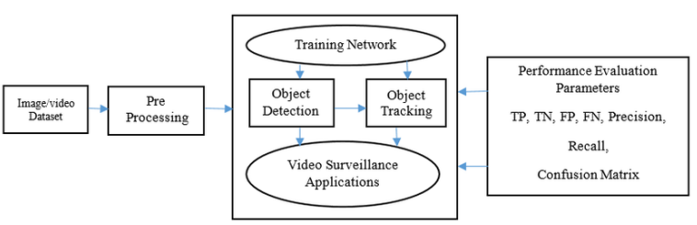

Fig 6: Data Flow Diagram

Accuracy:

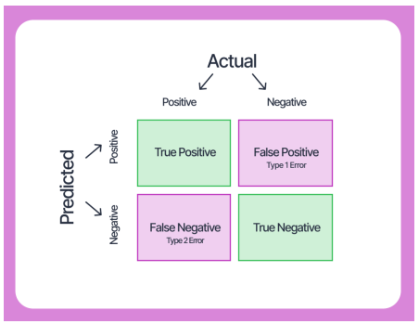

Fig 7: Accuracy

# Conclusion

The authors of the research paper "Real-Time Object Detection System: Enhancing Efficiency and Accuracy with YOLOv5" summarize the main conclusions and contributions of the investigation and consider some of the wider ramifications of their findings. A narrative summary of the outcome is provided here:

In order to improve the effectiveness and accuracy of real-time object identification systems, we looked into the effectiveness of YOLOv5, a cutting-edge object detection architecture. We have shown through extensive testing and analysis the notable improvements made with YOLOv5, in terms of both speed and accuracy.

According to our research, YOLOv5 performs better in

al-time performance and detection accuracy than other iterations of the YOLO architecture and rival techniques. Through the use of architectural improvements, optimization methods, and training approaches, YOLOv5 outperforms other models on a variety of benchmark datasets and in real-world applications.

The confirmation of our theories highlights how well YOLOv5 works as a potent tool for on-the-spot object recognition in a variety of applications. Our findings have ramifications across a wide range of applications where timely and precise object detection is critical, including surveillance, driverless vehicles, retail analytics, and industrial automation.

Our study does have several limitations, though. We acknowledge that issues like model scalability, computational limitations, and dataset biases may affect how broadly and practically our findings can be applied. However, even though YOLOv5 is a big step forward in real-time object detection, there is still space for development, especially in the areas of adversarial attacks, robustness to environmental fluctuation, and fine-grained object detection.

We see a number of directions for further research and development in the future. These include developing adversarial robustness in YOLOv5-based object identification systems, researching domain adaption tactics, and examining novel optimization techniques. In addition, promoting creativity and cooperation in the field depends on ongoing efforts to democratize access to top-notch datasets, computer power, and model designs.

# Future DIrection

1. *Fine-Grained Object Detection*: Examine methods for enhancing the identification of small animals or writing in photos, as well as items with fine features. This could entail utilizing multi-scale feature representations, adding attention techniques, or investigating novel designs.
2. *Robustness to Environmental Variability:* Increase the YOLOv5-based object identification system's resistance to environmental variables such changing lighting, bad weather, and occlusions. To enhance model generalization, this can involve creating domain adaption methods, data augmentation plans, or self-supervised learning methodologies.
3. *Adversarial Robustness:* Investigate ways to fend off adversarial attacks in order to reinforce the YOLOv5 model's adversarial robustness. This might be creating robust optimization techniques, adding adversarial instances to the training set, or using adversarial training with a variety of perturbations.
4. *Multi-Object Tracking*: Investigate ways to fend off adversarial attacks in order to reinforce the YOLOv5 model's adversarial robustness. This might be creating robust optimization techniques, adding adversarial instances to the training set, or using adversarial training with a variety of perturbations.
5. *Efficient Deployment on Edge Devices:* Make the YOLOv5 model more resource-efficient for use on edge devices with limited resources, like embedded systems or Internet of Things devices. Model quantization, pruning, or compression techniques may be used in this situation to minimize the size and memory footprint of the model while preserving accuracy and speed of inference.
6. *Real-World Applications and User-Centric Design:* Conduct user studies, get end-user feedback, and iterate the object detection system's design based on real-world use cases and requirements to prioritize user-centric design and practical applications.

# Reference

[1] R. Tiwari, A. H. Rumaney and M. Saravanan, "Real-time Traffic Surveillance and Detection using Deep Learning and Computer Vision Techniques," 2023 2nd International Conference on Vision Towards Emerging Trends in Communication and Networking Technologies (ViTECoN), Vellore, India, 2023, pp. 1-6, doi: 10.1109/ViTECoN58111.2023.10157694.

[2] J. Tan, H. Wang, X. Li and X. Zhang, "Improved Object Detection Algorithm for Workshop Environments Based on YOLOv5," 2023 9th International Conference on Computer and Communications (ICCC), Chengdu, China, 2023, pp. 1714-1718, doi: 10.1109/ICCC59590.2023.10507328.

[3] S. Ti, "Target Defect Detection Based on YOLOv5," 2024 IEEE 4th International Conference on Power, Electronics and Computer Applications (ICPECA), Shenyang, China, 2024, pp. 381-385, doi: 10.1109/ICPECA60615.2024.10471120.

[4] I. Suchý and M. Turčaník, "Implementation and Evaluation of Video Codecs in OpenCV for Real-Time Object Detection," 2023 Communication and Information Technologies (KIT), Vysoke Tatry, Slovakia, 2023, pp. 1-7, doi: 10.1109/KIT59097.2023.10297064.

[5] Lin, T. Y., Maire, M., Belongie, S., Hays, J., Perona, P., Ramanan, D., ... & Zitnick, C. L. (2014). Microsoft COCO: Common Objects in Context. In European conference on computer vision (pp. 740-755). Springer, Cham.

[6] He, K., Zhang, X., Ren, S., & Sun, J. (2016). Deep Residual Learning for Image Recognition. In Proceedings of the IEEE conference on computer vision and pattern recognition (pp. 770-778).

[7] Rethage, G., & Hager, G. D. (2015). Interactive object recognition with a generic object model. In Proceedings of the IEEE International Conference on Computer Vision (pp. 2979-2987).

[8] Girshick, R., Donahue, J., Darrell, T., & Malik, J. (2014). Rich feature hierarchies for accurate object detection and semantic segmentation. In Proceedings of the IEEE conference on computer vision and pattern recognition (pp. 580-587).

[9] Simonyan, K., & Zisserman, A. (2014). Very deep convolutional networks for large-scale image recognition. arXiv preprint arXiv:1409.1556.

[10] Faster R-CNN: Towards Real-Time Object Detection with Region Proposal Networks. Shaoqing Ren, Kaiming He, Ross Girshick, and Jian Sun. arXiv preprint arXiv:1506.01497 (2015).

[11] EfficientDet: Scalable and Efficient Object Detection. Mingxing Tan, Ruoming Pang, Quoc V. Le. arXiv preprint arXiv:1911.09070 (2019).

[12] YOLOv4: Optimal Speed and Accuracy of Object Detection. Alexey Bochkovskiy, Chien-Yao Wang, and Hong-Yuan Mark Liao. arXiv preprint arXiv:2004.10934 (2020).

[13] A. S. Abdullahi Madey, A. Yahyaoui and J. Rasheed, "Object Detection in Video by Detecting Vehicles Using Machine Learning and Deep Learning Approaches," 2021 International Conference on Forthcoming Networks and Sustainability in AIoT Era (FoNeS-AIoT), Nicosia, Turkey, 2021, pp. 62-65, doi: 10.1109/FoNeS-AIoT54873.2021.00023.

[14] S. Soma and N. Waddenkery, "Machine-Learning Object Detection and Recognition for Surveillance System using YoloV3," 2022 First International Conference on Electrical, Electronics, Information and Communication Technologies (ICEEICT), Trichy, India, 2022, pp. 1-5, doi: 10.1109/ICEEICT53079.2022.9768558.

[15] V. Adaickalam, S. P. Manikandan, N. Kanagavalli and P. S. Dinesh, "A Vibrant Multiple Object Detection Using Machine Learning Techniques," 2022 International Conference on Smart Technologies and Systems for Next Generation Computing (ICSTSN), Villupuram, India, 2022, pp. 1-5, doi: 10.1109/ICSTSN53084.2022.9761357.

[16] P. K. Goswami and G. Goswami, "A Comprehensive Review on Real Time Object Detection using Deep Learing Model," 2022 11th International Conference on System Modeling & Advancement in Research Trends (SMART), Moradabad, India, 2022, pp. 1499-1502, doi: 10.1109/SMART55829.2022.10046972.

[17] M. Kumar and R. Bhatt, "An approach towards Real-Time Object Detector Using Open CV," 2022 11th International Conference on System Modeling & Advancement in Research Trends (SMART), Moradabad, India, 2022, pp. 981-985, doi: 10.1109/SMART55829.2022.10046751.