EnsureStudy: AI-First Learning Platform
  - Comprehensive Technical Documentation
EnsureStudy Development Team
January 2026
Table of Contents

1 Executive Summary
EnsureStudy is an AI-first learning platform that combines intelligent multi-agent tutoring, real-time proctoring, and soft skills evaluation. The platform leverages cutting-edge AI technologies including:
- LangGraph for agent orchestration
- RAG (Retrieval-Augmented Generation) for context-aware responses
- Mistral 7B for language understanding and generation
- YOLO and MediaPipe for computer vision
- Apache Kafka and PySpark for real-time data pipelines
The system is designed for educational institutions seeking to provide personalized learning experiences at scale while maintaining academic integrity.

1.1 Key Statistics
Metric | Value
Backend Services | 2 (Core + AI)
Frontend Framework | Next.js 14
AI Agents | 8 specialized agents
Databases | 5 (PostgreSQL, Qdrant, Redis, MongoDB, Cassandra)
ML Models | 4+ (Mistral, YOLO, Whisper, FaceMesh)
API Endpoints | 50+

2 Part I: System Architecture

2.1 High-Level Architecture
The platform follows a microservices architecture with two primary backend services connected to a unified frontend.
[Diagram 1]

2.2 Service Responsibilities
Service | Port | Technology | Responsibilities
Core Service | 8000 | Flask, SQLAlchemy | Authentication, user management, classroom operations, file uploads, assessments
AI Service | 8001 | FastAPI, LangGraph | RAG queries, tutoring agents, proctoring, soft skills, document indexing
Frontend | 3000/4000 | Next.js 14, TypeScript | User interface, real-time updates, WebSocket connections

2.3 Request-Response Flow
A typical user query to the AI tutor follows this sequence:
[Diagram 2]

3 Part II: Multi-Agent System

3.1 Agent Classification (Russell & Norvig Taxonomy)
Agent Type | Description | Implementation
Type 1: Simple Reflex | Action based on current percept | Proctoring (YOLO detections)
Type 2: Model-Based | Maintains internal state | Session memory in Redis
Type 3: Goal-Based | Plans to achieve goals | Orchestrator, Research, Curriculum
Type 5: Learning | Improves over time | Tutor Agent with feedback loop

3.2 Agent Hierarchy
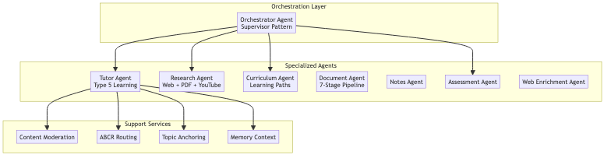
Diagram 3

3.3 Orchestrator Agent
The central coordinator using the Supervisor Pattern to route requests to specialized sub-agents.

3.3.1 Intent Classification
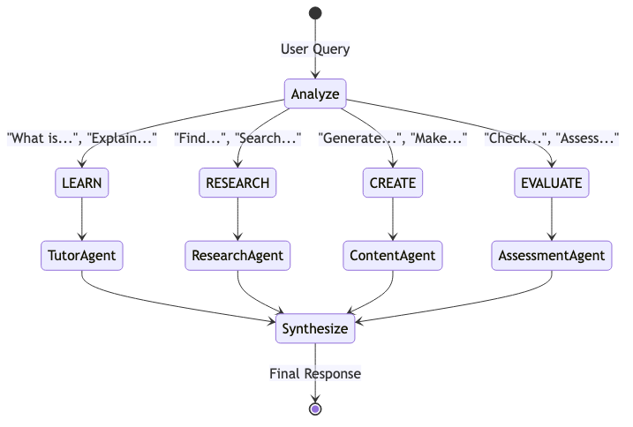
Diagram 4

3.3.2 Intent Keywords
Intent | Trigger Keywords
LEARN | what is, explain, how does, why, define, tell me about
RESEARCH | find, search, resources, pdf, download, look up
CREATE | create, generate, notes, quiz, summary, flashcards
EVALUATE | grade, check, evaluate, score, feedback, review

3.4 Tutor Agent (Type 5 Learning Agent)
The primary learning assistant with advanced context management and continuous improvement through feedback.

3.4.1 Core Components
Component | Full Name | Purpose
ABCR | Attention-Based Context Routing | Detects follow-up vs new topic queries
TAL | Topic Anchor Layer | Maintains topic continuity across turns
MCP | Memory Context Processor | Isolates web vs classroom content
Learning Element | Few-Shot Injector | Injects high-rated examples into prompts

3.4.2 Processing Pipeline
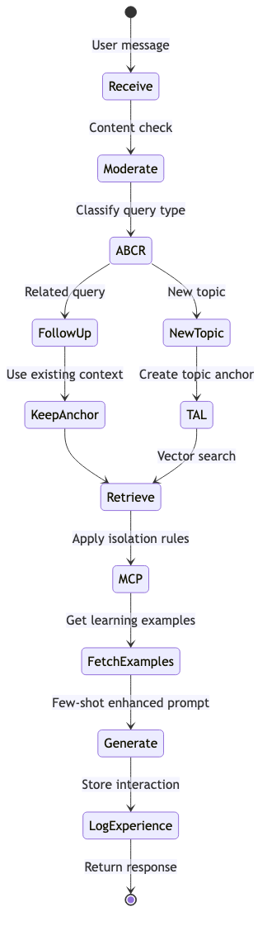
Diagram 5

3.4.3 Learning Loop Architecture
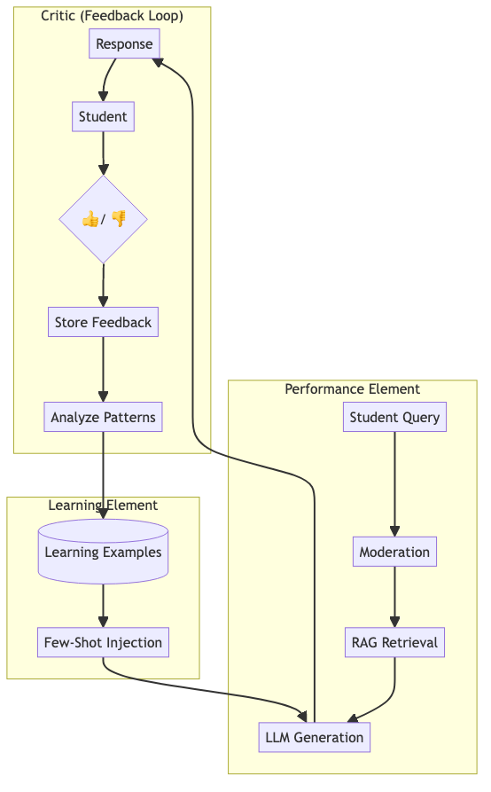
Diagram 6

3.4.4 ABCR Service (Attention-Based Context Routing)
Determines if a query is a follow-up using semantic similarity with hysteresis:
class ABCRService:
def __init__(self):
self.embedding_model = SentenceTransformer('all-MiniLM-L6-v2')
self.attention_threshold = 0.65
self.hysteresis_factor = 0.1
def is_followup(self, query: str, history: List[dict]) -> bool:
"""
Compare query embedding against recent turns.
Apply hysteresis to prevent rapid topic switching.
"""
if not history:
return False
recent_context = [h['content'] for h in history[-3:]]
scores = self.compute_attention_scores(query, recent_context)
max_score = max(scores)
adjusted_threshold = self.attention_threshold - self.hysteresis_factor
return max_score > adjusted_threshold

3.5 Research Agent
Discovers and indexes educational content from multiple sources.

3.5.1 Content Discovery Pipeline
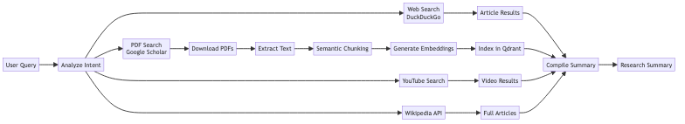
Diagram 7

3.5.2 Web Ingest Workers
Worker | Function
W1: Topic Extractor | Extracts key topics from query using LLM
W2: DuckDuckGo | Searches web for articles
W3: Wikipedia Search | Finds Wikipedia articles
W4: Wikipedia Content | Fetches full article content
W5: Parallel Crawler | Downloads pages concurrently (httpx)
W6: Content Cleaner | Removes boilerplate HTML
W6B: PDF Search | Searches and downloads educational PDFs
W7: Chunk & Embed | Splits text, generates embeddings, stores in Qdrant

3.6 Curriculum Agent
Creates personalized learning paths based on syllabus and student progress.

3.6.1 Learning Path Generation
Diagram 8

3.6.2 Schedule Output
class LearningPath:
topics: List[TopicSchedule]
total_hours: int
daily_hours: int
milestones: List[Milestone]
class TopicSchedule:
topic: str
day: int
duration_hours: float
resources: List[Resource]
prerequisites: List[str]

3.7 Document Processing Agent
Ingests and indexes documents for RAG retrieval.

3.7.1 7-Stage Pipeline
Diagram 9

3.7.2 Supported Formats
Format | Extraction Method
PDF (text) | PyMuPDF
PDF (scanned) | PyMuPDF + TrOCR
Images | TrOCR / Pytesseract
DOCX | python-docx
PPTX | python-pptx
Markdown | Direct parse

4 Part III: RAG Pipeline

4.1 Overview
The RAG (Retrieval-Augmented Generation) pipeline combines vector search with LLM generation for context-aware responses.
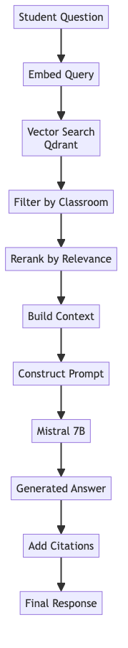
Diagram 10

4.2 Embedding Model
Property | Value
Model | sentence-transformers/all-MiniLM-L6-v2
Dimensions | 384
Distance Metric | Cosine Similarity
Context Window | 512 tokens

4.3 Retrieval Parameters
RETRIEVAL_CONFIG = {
"top_k": 5,
"score_threshold": 0.4,
"rerank": True,
"filters": {
"classroom_id": optional,
"document_type": optional
}
}

4.4 Context Assembly
The Model Context Protocol (MCP) assembles context with isolation rules:
Source Type | Isolation Rule
Classroom Materials | Highest priority, user-specific
Meeting Transcripts | Time-bounded, classroom-specific
Web Content | Lower trust, fact-check flag
General Knowledge | Fallback only

5 Part IV: Real-Time Features

5.1 Proctoring System
Real-time monitoring during assessments using computer vision.

5.1.1 Detection Pipeline
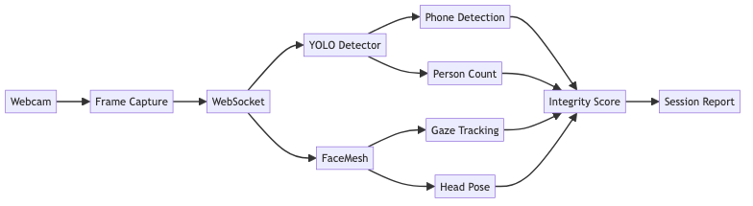
Diagram 11

5.1.2 Detection Thresholds
Detection | Model | Threshold
Multiple faces | YOLO person class | > 1 person
Mobile phone | YOLO cell phone class | confidence > 0.5
Gaze deviation | Eye landmarks | > 30 degrees
Face absence | FaceLandmarker | > 3 seconds

5.1.3 Violation Severity
Level | Violations | Score Impact
LOW | Slight gaze deviation | -5 points
MEDIUM | Looking away, face absence | -15 points
HIGH | Phone detected, multiple people | -30 points
CRITICAL | Repeated high violations | Session flagged

5.2 Soft Skills Evaluation

5.2.1 Metric Weights
Metric | Weight | Analysis Method
Fluency | 25% | Speech rate, filler words, pauses
Grammar | 20% | LanguageTool analysis
Vocabulary | 15% | Type-token ratio, word diversity
Eye Contact | 15% | Iris tracking vs camera position
Expression | 10% | Facial emotion detection
Posture | 10% | Body position stability
Confidence | 5% | Combined delivery metrics

5.2.2 Evaluation Pipeline
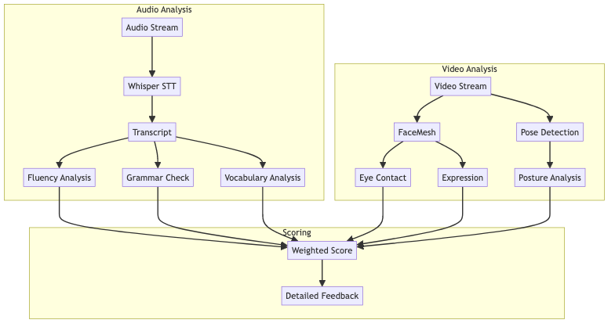
Diagram 12

6 Part V: Database Architecture

6.1 Overview
The platform uses 5 specialized databases, each optimized for specific data patterns.
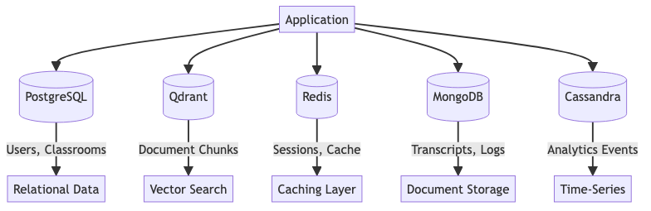
Diagram 13

6.2 Database Selection Criteria
Database | Type | Use Case | Consistency
PostgreSQL | Relational | Users, classrooms, assessments | Strong (ACID)
Qdrant | Vector | Document embeddings, RAG | Eventual
Redis | Key-Value | Sessions, cache, rate limits | Strong
MongoDB | Document | Transcripts, proctoring reports | Eventual
Cassandra | Time-Series | Analytics, event streams | Eventual

6.3 PostgreSQL Schema

6.3.1 Core Tables
-- Users
CREATE TABLE users (
id UUID PRIMARY KEY DEFAULT gen_random_uuid(),
email VARCHAR(255) UNIQUE NOT NULL,
password_hash VARCHAR(255) NOT NULL,
name VARCHAR(100),
role VARCHAR(20) NOT NULL DEFAULT 'student',
created_at TIMESTAMP DEFAULT NOW()
);
-- Classrooms
CREATE TABLE classrooms (
id UUID PRIMARY KEY DEFAULT gen_random_uuid(),
name VARCHAR(200) NOT NULL,
teacher_id UUID NOT NULL REFERENCES users(id),
join_code VARCHAR(8) UNIQUE,
subject VARCHAR(100),
created_at TIMESTAMP DEFAULT NOW()
);
-- Chat Conversations
CREATE TABLE chat_conversations (
id VARCHAR(36) PRIMARY KEY,
user_id VARCHAR(36) NOT NULL REFERENCES users(id),
title VARCHAR(200),
subject VARCHAR(50),
classroom_id VARCHAR(36),
created_at TIMESTAMP DEFAULT NOW(),
updated_at TIMESTAMP DEFAULT NOW()
);
-- Chat Messages
CREATE TABLE chat_messages (
id VARCHAR(36) PRIMARY KEY,
conversation_id VARCHAR(36) NOT NULL REFERENCES chat_conversations(id),
type VARCHAR(20) NOT NULL, -- 'user' or 'assistant'
content TEXT NOT NULL,
response_json JSONB,
timestamp TIMESTAMP DEFAULT NOW()
);

6.4 Qdrant Collections

6.4.1 Documents Collection
{
"collection_name": "documents",
"vectors_config": {
"size": 384, # all-MiniLM-L6-v2
"distance": "Cosine"
},
"hnsw_config": {
"m": 16,
"ef_construct": 128
}
}
# Point structure
{
"id": "uuid-string",
"vector": [0.1, 0.2, ...], # 384 dimensions
"payload": {
"text": "Chunk content...",
"classroom_id": "uuid",
"document_id": "uuid",
"document_type": "material",
"page_number": 5,
"chunk_index": 12
}
}

6.5 Redis Data Structures
Key Pattern | Type | TTL | Purpose
session:{id} | Hash | 1 hour | User sessions
ratelimit:{user}:{endpoint} | Counter | 1 minute | Rate limiting
chat:{session}:history | List | 2 hours | Chat history cache
cache:{query_hash} | String | 1 hour | Response cache

7 Part VI: Data Pipelines

7.1 Event Streaming Architecture
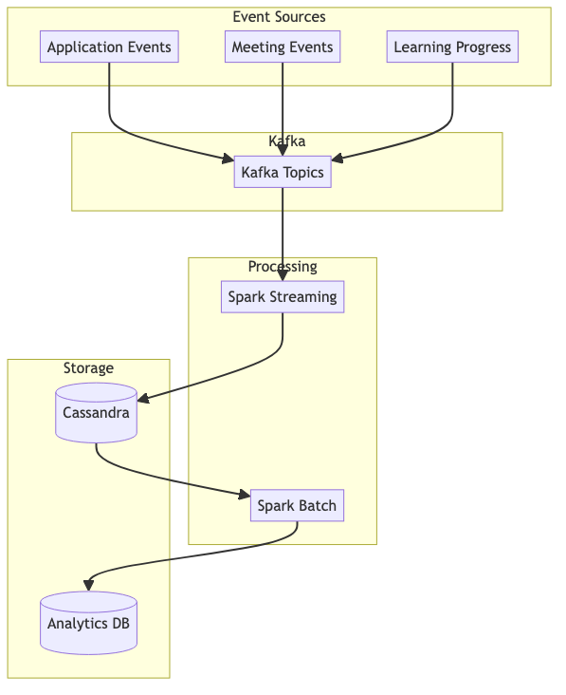
Diagram 14

7.2 Kafka Topics
Topic | Partitions | Retention | Producers
user-events | 6 | 7 days | Core Service
learning-progress | 3 | 30 days | AI Service
meeting-events | 3 | 7 days | Core Service
proctoring-events | 6 | 30 days | AI Service

7.3 Cassandra Analytics Tables
-- Page View Statistics
CREATE TABLE analytics.page_view_stats (
date date,
hour int,
page text,
view_count counter,
PRIMARY KEY ((date), hour, page)
);
-- Learning Progress
CREATE TABLE analytics.learning_progress (
user_id uuid,
subject text,
week_start date,
lessons_completed int,
time_spent_minutes int,
average_score double,
PRIMARY KEY ((user_id, subject), week_start)
);

8 Part VII: API Reference

8.1 Core Service Endpoints

8.1.1 Authentication
Method | Endpoint | Description
POST | /api/auth/signup | Register new user
POST | /api/auth/login | Login and get JWT
POST | /api/auth/logout | Invalidate session
GET | /api/auth/me | Get current user

8.1.2 Classrooms
Method | Endpoint | Description
GET | /api/classrooms | List user’s classrooms
POST | /api/classrooms | Create classroom
POST | /api/classrooms/join | Join with code
GET | /api/classrooms/{id} | Get classroom details

8.1.3 Chat History
Method | Endpoint | Description
GET | /api/chat/conversations | List conversations
POST | /api/chat/conversations | Create conversation
GET | /api/chat/conversations/{id} | Get with messages
POST | /api/chat/conversations/{id}/messages | Add message

8.2 AI Service Endpoints

8.2.1 Tutor
Method | Endpoint | Description
POST | /api/ai-tutor/query | Ask question
POST | /api/tutor/document-chat | Chat with PDF

8.2.2 Indexing
Method | Endpoint | Description
POST | /api/indexing/upload | Upload document
GET | /api/indexing/status/{id} | Check status

8.2.3 Proctoring
Method | Endpoint | Description
POST | /api/proctor/start | Start session
WS | /api/proctor/ws/{session} | Frame stream
GET | /api/proctor/result/{session} | Get results

8.2.4 Soft Skills
Method | Endpoint | Description
POST | /api/softskills/start | Start evaluation
POST | /api/softskills/analyze | Analyze recording

9 Part VIII: Deployment

9.1 Development Setup

9.1.1 Prerequisites
- Docker & Docker Compose
- Node.js 20+
- Python 3.11+
- HuggingFace API key

9.1.2 Quick Start
# 1. Clone repository
git clone https://github.com/ensurestudy/ensurestudy.git
cd ensurestudy
# 2. Configure environment
cp .env.example .env
# Edit .env with your API keys
# 3. Start infrastructure
docker-compose up -d
# 4. Run development servers
./run-local.sh

9.1.3 Service Ports
Service | Port | URL
Frontend | 4000 | http://localhost:4000
Core API | 9000 | http://localhost:9000
AI API | 8001 | http://localhost:8001
Qdrant | 6333 | http://localhost:6333
Kafka UI | 8080 | http://localhost:8080

9.2 Docker Compose Services
services:
# Databases
postgres:
image: postgres:15-alpine
ports: ["5432:5432"]
qdrant:
image: qdrant/qdrant:latest
ports: ["6333:6333", "6334:6334"]
redis:
image: redis:7-alpine
ports: ["6379:6379"]
mongodb:
image: mongo:7
ports: ["27017:27017"]
cassandra:
image: cassandra:4
ports: ["9042:9042"]
# Message Queue
kafka:
image: confluentinc/cp-kafka:7.5.0
ports: ["9092:9092"]
# Applications
core-api:
build: ./backend/core-service
ports: ["8000:8000"]
ai-service:
build: ./backend/ai-service
ports: ["8001:8001"]

10 Part IX: Configuration Reference

10.1 Environment Variables

10.1.1 Core Service
Variable | Description | Default
DATABASE_URL | PostgreSQL connection string | Required
REDIS_URL | Redis connection string | redis://localhost:6379
JWT_SECRET | JWT signing secret | Required
KAFKA_BOOTSTRAP_SERVERS | Kafka brokers | localhost:9092

10.1.2 AI Service
Variable | Description | Default
HUGGINGFACE_API_KEY | HuggingFace API key | Required
LLM_MODEL | LLM model name | mistralai/Mistral-7B-Instruct-v0.2
EMBEDDING_MODEL | Embedding model | all-MiniLM-L6-v2
QDRANT_HOST | Qdrant host | localhost
QDRANT_PORT | Qdrant port | 6333
CORE_SERVICE_URL | Core service URL | http://localhost:9000

10.1.3 Feature Flags
Variable | Description | Default
SKIP_MODERATION | Disable content moderation | false
ABCR_ENABLED | Enable ABCR routing | true
WEB_CRAWL_ENABLED | Enable web content ingestion | true

11 Part X: Monitoring & Operations

11.1 Key Metrics
Metric | Source | Threshold
API latency (p99) | FastAPI middleware | < 500ms
RAG retrieval time | AI Service | < 200ms
LLM response time | AI Service | < 5s
Cache hit rate | Redis | > 80%
Queue depth | Kafka | < 10,000 messages
Error rate | All services | < 1%

11.2 Health Checks
# Core Service
curl http://localhost:9000/health
# AI Service
curl http://localhost:8001/health
# Qdrant
curl http://localhost:6333/health

11.3 Failure Modes
Failure | Impact | Mitigation
PostgreSQL down | Auth fails | Read replicas, connection pooling
Qdrant down | RAG disabled | Fallback to keyword search
Redis down | No caching | Local cache, circuit breaker
Kafka down | Events queued | Local buffer, retry logic
LLM API down | No AI responses | Cached responses, fallback prompts

12 Appendices

12.1 Appendix A: Technology Stack Summary

12.1.1 Application Layer
Component | Technology
Frontend | Next.js 14, TypeScript, TailwindCSS
Core API | Flask, SQLAlchemy, JWT
AI API | FastAPI, LangGraph, LangChain

12.1.2 AI/ML Layer
Component | Technology
LLM | Mistral 7B via HuggingFace
Embeddings | all-MiniLM-L6-v2
Object Detection | YOLOv11
Face Analysis | MediaPipe FaceMesh
Speech-to-Text | Whisper
OCR | TrOCR, Pytesseract

12.1.3 Data Layer
Database | Purpose
PostgreSQL | Relational data
Qdrant | Vector embeddings
Redis | Caching, sessions
MongoDB | Documents, logs
Cassandra | Time-series analytics

12.2 Appendix B: Project Structure
ensureStudy/
├── backend/
│ ├── ai-service/
│ │ ├── app/
│ │ │ ├── agents/ # AI agents
│ │ │ ├── api/ # FastAPI routes
│ │ │ ├── proctor/ # Proctoring system
│ │ │ ├── rag/ # RAG pipeline
│ │ │ └── services/ # Business logic
│ │ └── Dockerfile
│ ├── core-service/
│ │ ├── app/
│ │ │ ├── models/ # SQLAlchemy models
│ │ │ ├── routes/ # Flask blueprints
│ │ │ └── utils/ # Utilities
│ │ └── Dockerfile
│ └── kafka/ # Kafka consumers
├── frontend/
│ ├── app/ # Next.js pages
│ ├── components/ # React components
│ └── hooks/ # Custom hooks
├── docs/ # Documentation
├── ml/ # ML models & training
├── scripts/ # Utility scripts
├── docker-compose.yml
└── README.md

12.3 Appendix C: Glossary
Term | Definition
ABCR | Attention-Based Context Routing - determines if a query is a follow-up
TAL | Topic Anchor Layer - maintains topic continuity
MCP | Memory Context Processor - manages conversation memory
RAG | Retrieval-Augmented Generation - combining search with LLM
Embedding | Numerical vector representation of text
Chunk | A segment of a document for indexing
Proctoring | Real-time monitoring during assessments

Document generated on January 2026
EnsureStudy Development Team

