Titanic Classification Project Report
Task 1
TITANIC CLASSIFICATION
Make a system that determines whether a person will be saved from sinking. What factors were most likely to lead to success: socio-economic status, age, gender, and more?
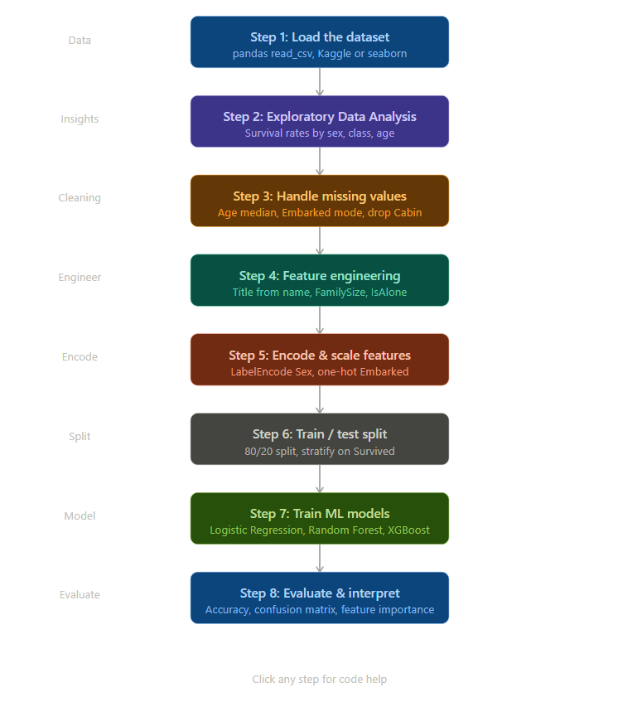

1. Project Overview
This project focuses on predicting passenger survival from the Titanic disaster using machine learning. The dataset contains demographic and socio-economic information of passengers, and the goal is to identify key factors influencing survival.

2. Objective
To build a predictive classification model that determines whether a passenger survived based on features such as age, gender, class, and family relations.

3. Dataset Description
The dataset includes features such as Passenger Class, Sex, Age, SibSp, Parch, Fare, Embarked, and Survived. The target variable is Survived (0 = Not Survived, 1 = Survived).

4. Methodology
- Importing required libraries such as pandas, numpy, seaborn, and matplotlib.
- Loading the Titanic dataset and performing initial inspection.
- Exploratory Data Analysis (EDA) to understand distributions and relationships.
- Handling missing values in the Age, Cabin, and Embarked columns.
- Encoding categorical variables into a numerical format.
- Splitting the dataset into training and testing sets.
- Training machine learning models, including Logistic Regression and Random Forest.
- Evaluating models using accuracy and classification metrics.

5. Machine Learning Models Used
1. Logistic Regression: A linear classification algorithm used as a baseline model.
2. Random Forest Classifier: An ensemble model used to improve prediction accuracy.

6. Conclusion
The project demonstrates how machine learning can be applied to historical data to predict survival outcomes. Feature analysis shows that gender, passenger class, and age significantly influence survival probability.

