**ENSF-381**: **Full Stack Web Development Laboratory**

**Lab03**

**Section: L02**

**Group information: G**

Kohinoor Chauhan (30204155)

Sabrina Li (30173044)

**GitHub Link:**

<https://github.com/realvegetablegummy/ensf381_lab3.git>

**Exercise 1 Output:**

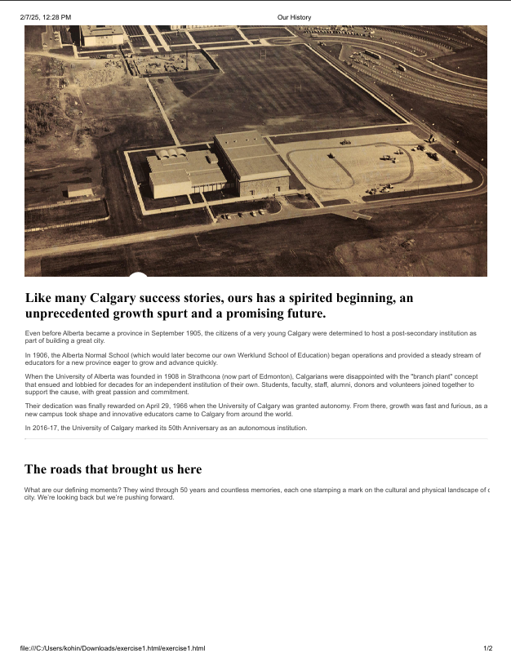

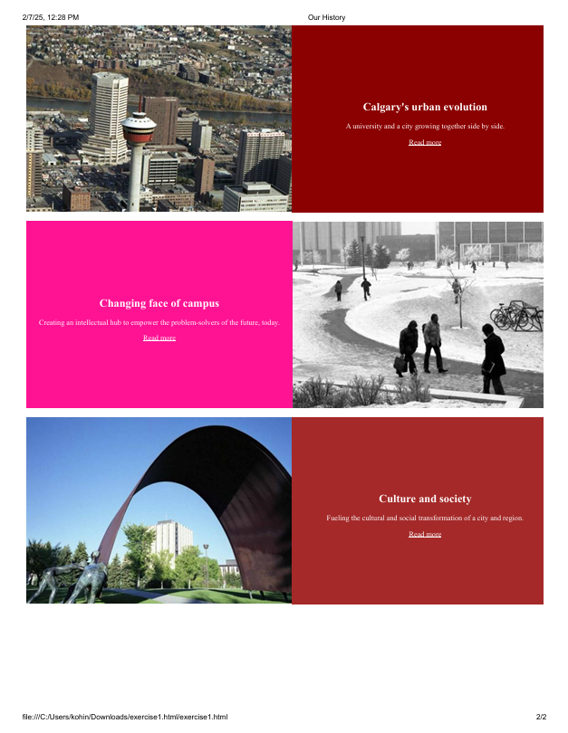

**Exercise 2 Output:**

**5) starting output**

**8) flex-direction: column**

**10)**

**a) flex-direction: row-reverse**

**b) flex-direction: column-reverse**

**13) flex-wrap: wrap**

**15) flex-wrap: wrap-reverse**

**17) item:nth-child**

**Exercise 3 Output:**