**ENSF-381**: **Full Stack Web Development Laboratory**

**Lab04**

**Section: L02**

**GitHub Link:**

<https://github.com/realvegetablegummy/ensf381_lab4.git>

**Group information: G**

Kohinoor Chauhan (30204155)

Sabrina Li (30173044)

**Exercise 1 Output:**

**Exercise 2:**

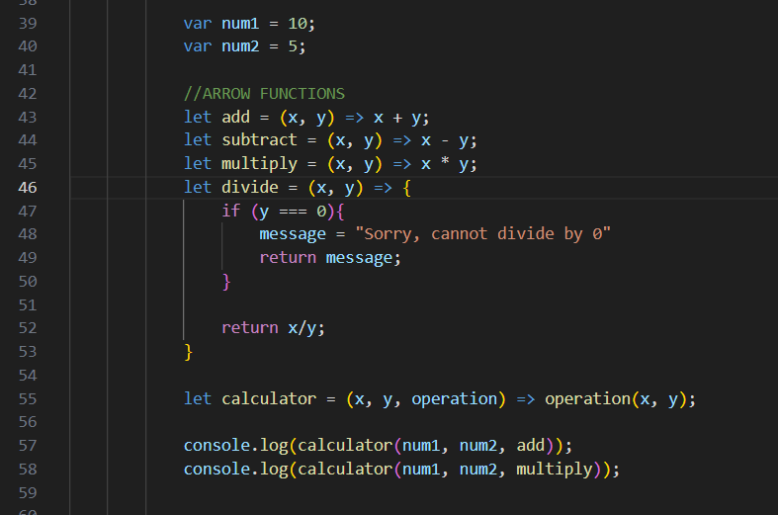

**Exercise 3:**